

**Placement Empowerment Program**

***Cloud Computing and DevOps Centre***

**Use Cloud CLI Tools Install the CLI for your cloud provider (e.g., AWS CLI). Use it to list resources, upload files to storage, and manage VMs.**

Name: Harivasan S

Department: ADS



**Introduction :**

Cloud CLI tools like AWS CLI provide a command-line interface for interacting with cloud services, facilitating automation and efficient resource management. This task includes installing the AWS CLI, setting it up with the appropriate AWS credentials, and executing fundamental operations such as listing resources, uploading files to S3, and managing EC2 instances. By offering a faster, scriptable alternative to the AWS Management Console, CLI tools enhance productivity and streamline cloud operations..

**Objective:**

1. Understand Cloud CLI Fundamentals – Install and set up AWS CLI to manage cloud resources through command-line commands.
2. Operate Cloud Resources – Utilize AWS CLI to retrieve resource lists, transfer files to S3, and control EC2 instances effectively.

3. Develop Automation Expertise – Acquire practical experience in automating cloud operations, optimizing workflows beyond manual AWS Console interactions.

**Step-by-Step Overview**

Step1:

Search for "AWS CLI Installer for Windows" on Google and click the first link to access the official website.

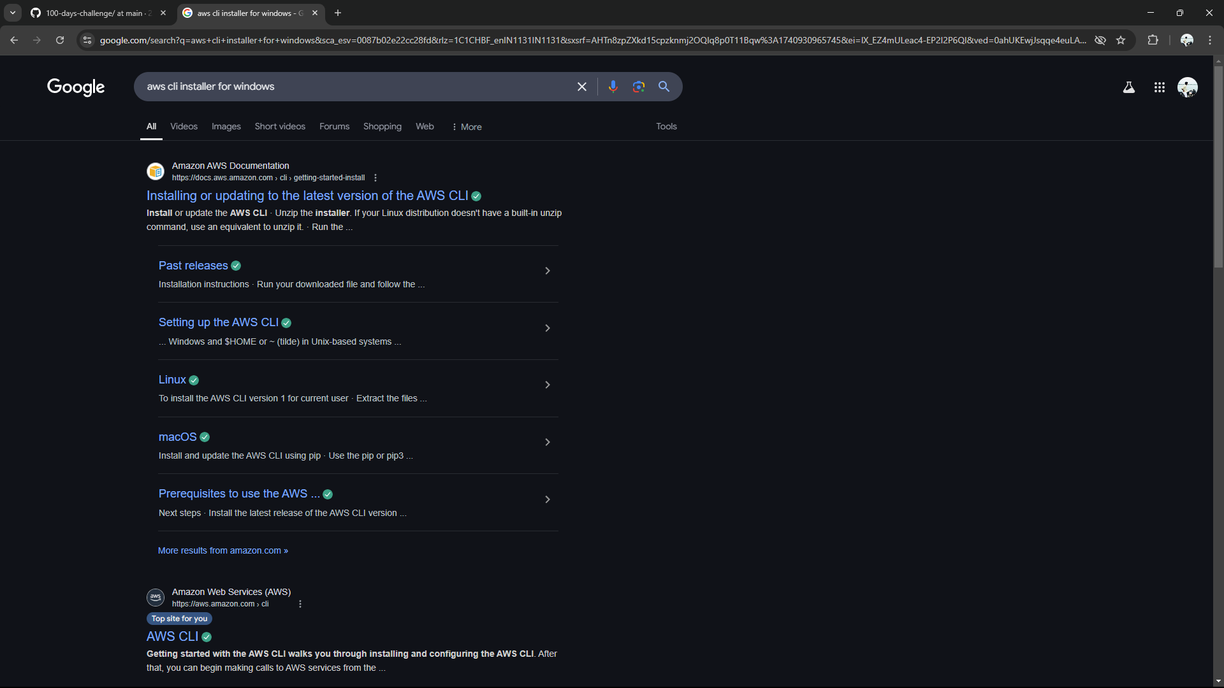

Step 2:

Click on the "Install/Update" option located on the left-hand side of the Apache Lounge website. Select the link regarding your OS, Install by using the link provided else use the ***msiexec*** command

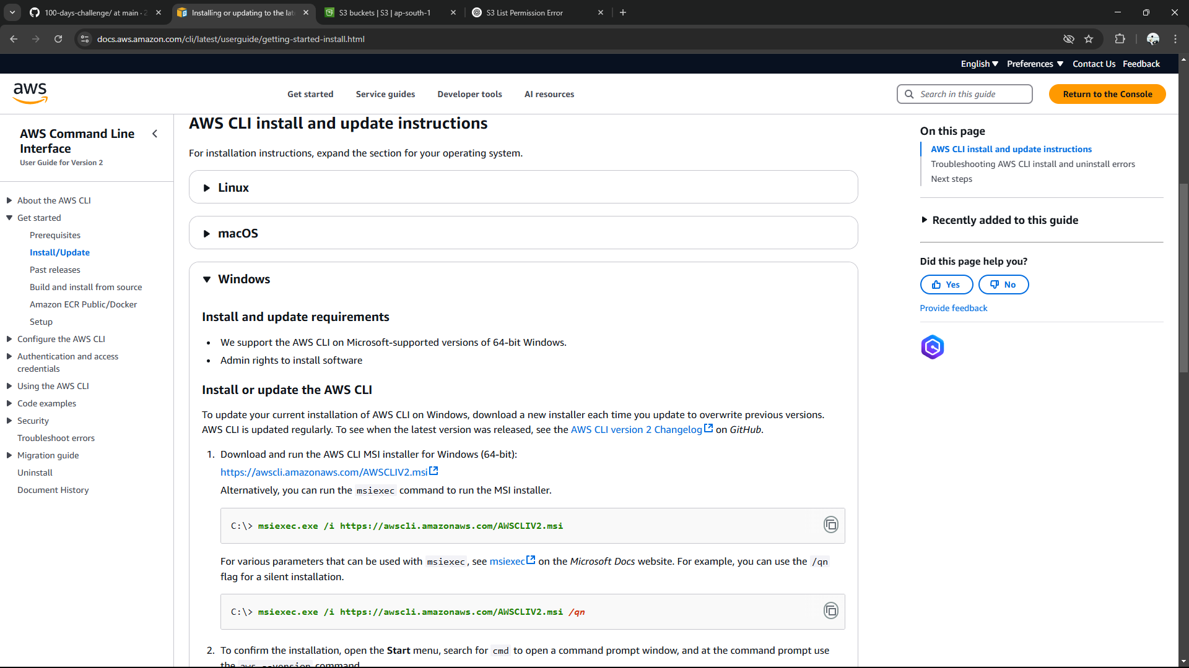

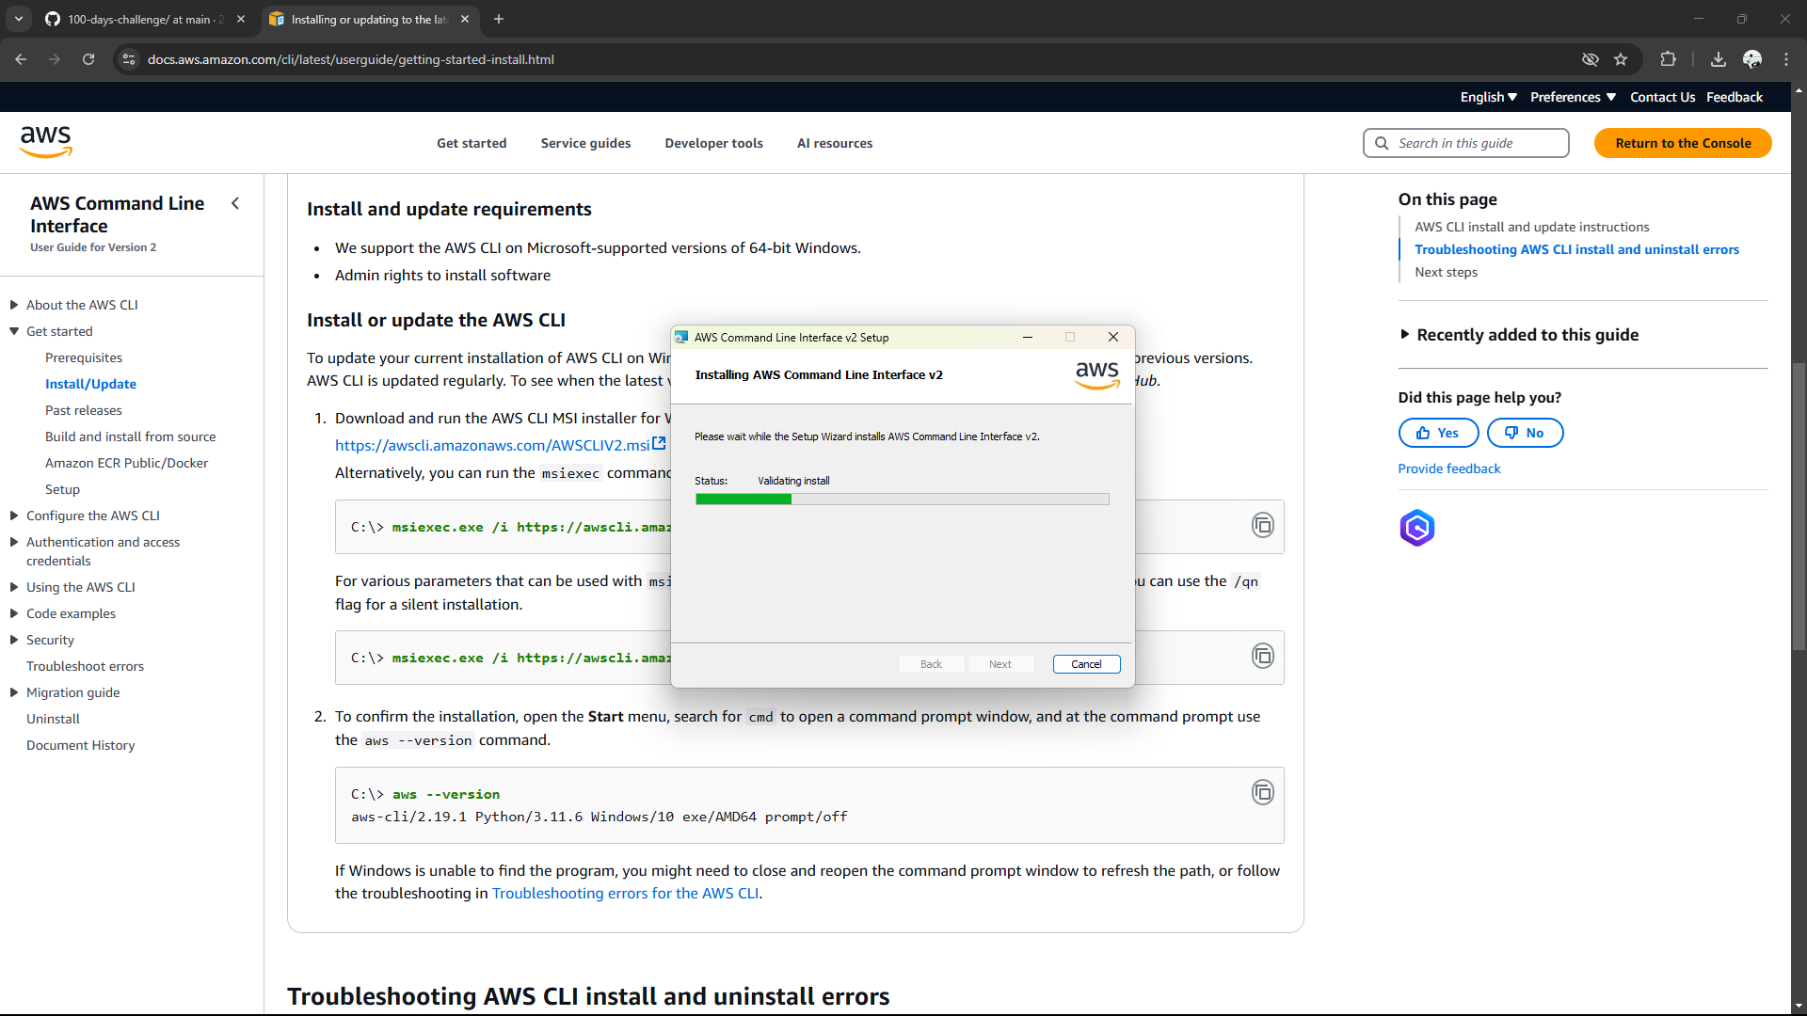

Step 3:

Once installed, verify the installation by opening Command Prompt (cmd) or PowerShell and running **aws --version**

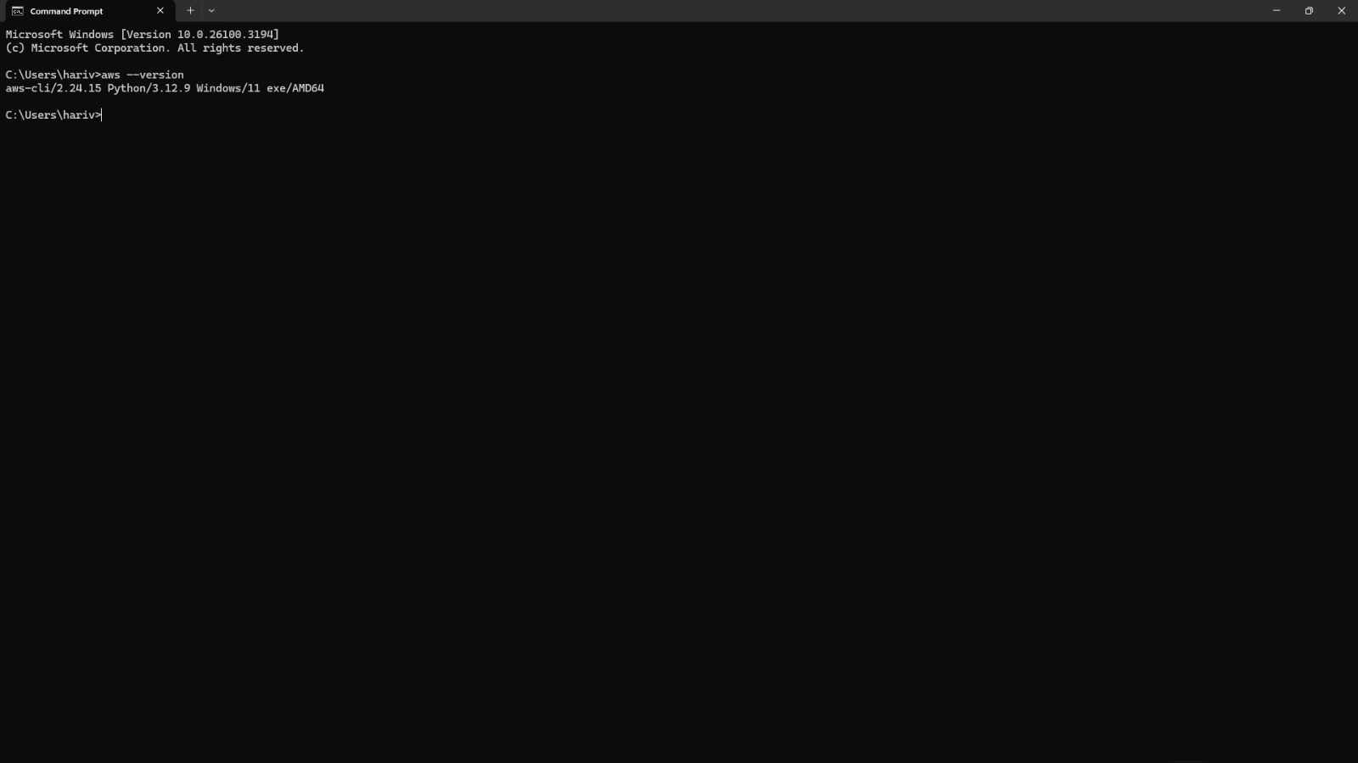

It should return something like

aws-cli/2.x.x Python/3.x.x Windows/x86_64

Step 4:

Before using AWS CLI, you need to configure it with your AWS credentials.

Open Command Prompt and type **aws configure**

It will ask for:

AWS Access Key ID → Get it from AWS IAM > Security Credentials

AWS Secret Access Key → Get it from AWS IAM > Security Credentials

Default region name → Example: us-east-1 (Find yours in AWS Console)

Default output format → Keep it as json or press Enter for default

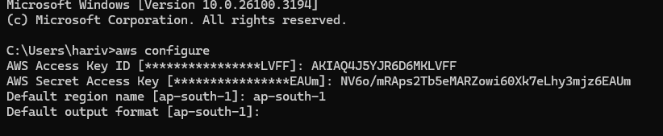

Step 5:

To see all storage buckets, Type **aws s3 ls** in cmd

To check running EC2 instances **aws ec2 describe-instances** in cmd

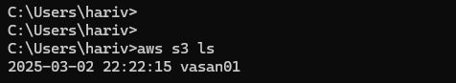

Step 6:

Create an S3 Bucket by typing **aws s3 mb s3://your-unique-bucket-name** in cmd

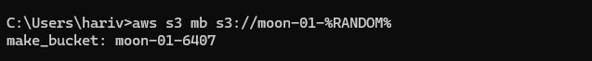

Upload a file to S3 Bucket by typing **aws s3 cp yourfile.txt s3://your-unique-bucket-name/** in cmd



Step 7:

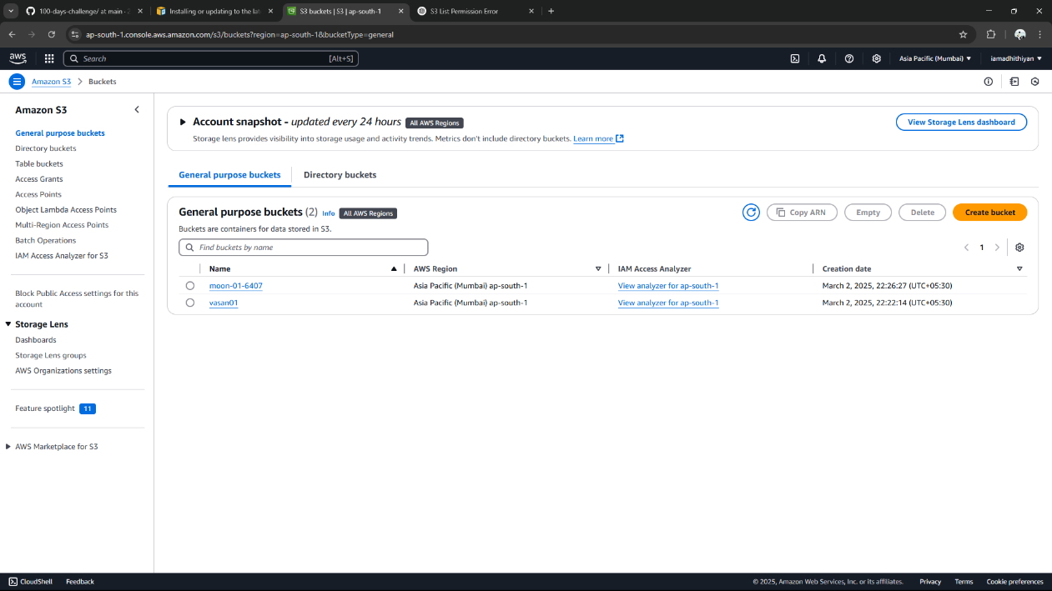

To Start an EC2 Instance, Type **aws ec2 start-instances --instance-ids <INSTANCE_ID>** in cmd

Replace <INSTANCE_ID> with your actual instance ID

**Expected Outcome**

1. **Proper AWS CLI Setup** – The AWS CLI will be successfully installed and configured with the correct credentials, enabling smooth interaction with AWS services.
2. **Cloud Resource Visibility** – You will be able to retrieve and display AWS resources such as S3 buckets, EC2 instances, and IAM users using command-line commands.
3. **S3 File Operations** – You will gain practical experience in uploading, downloading, and managing files in Amazon S3 through the CLI.
4. **EC2 Instance Management** – You will learn how to start, stop, and restart EC2 instances via the command line, enhancing your cloud administration skills.
5. **Enhanced Automation Proficiency** – By leveraging the CLI instead of the AWS Console, you will develop essential automation skills for DevOps and cloud computing.