

**Placement Empowerment Program**

***Cloud Computing and DevOps Centre***

Set Up a Local Git Repository: Initialize a Git repository locally and version control your static website

Name: Harivasan S

Department:ADS



# Introduction

# Version control is essential in software development for tracking changes, collaborating, and reverting to previous versions when needed. Git, a widely used system, offers efficiency, flexibility, and a distributed approach.

# This PoC demonstrates how to initialize a local Git repository to manage a static website. With Git, you can track file changes, experiment safely, and share your project effortlessly. Setting up a repository ensures a structured and reliable workflow, benefiting both individual developers and teams.

# 

# Overview

1. **Git Installation:** Verify that Git is installed on your system and configure it for use.

2. **Initializing a Repository:** Set up a local Git repository in the root directory of your static website.

3. **Tracking Changes:** Stage project files and commit them to the repository to preserve snapshots of your work.

**Step-by-Step Overview**  Step1:

Create a **new repository** file in github

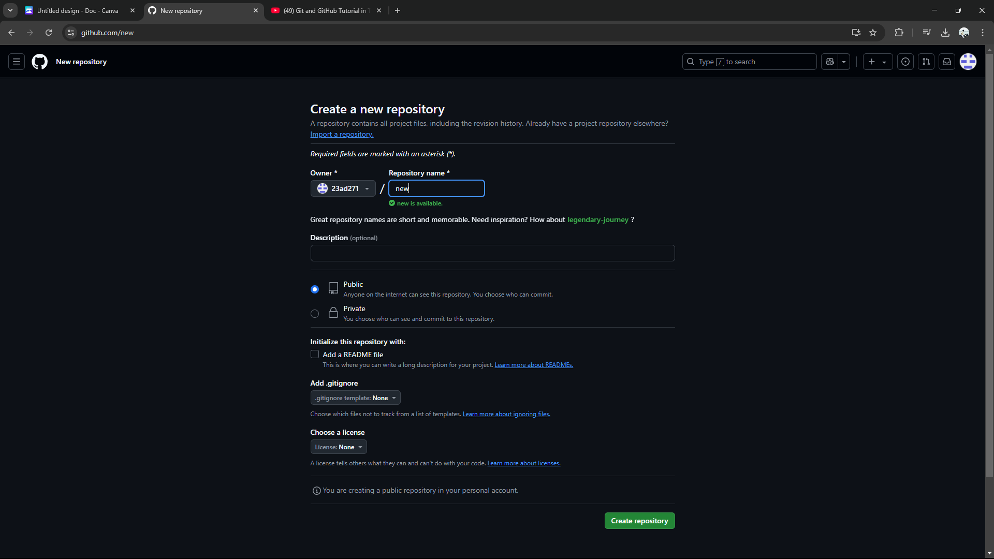

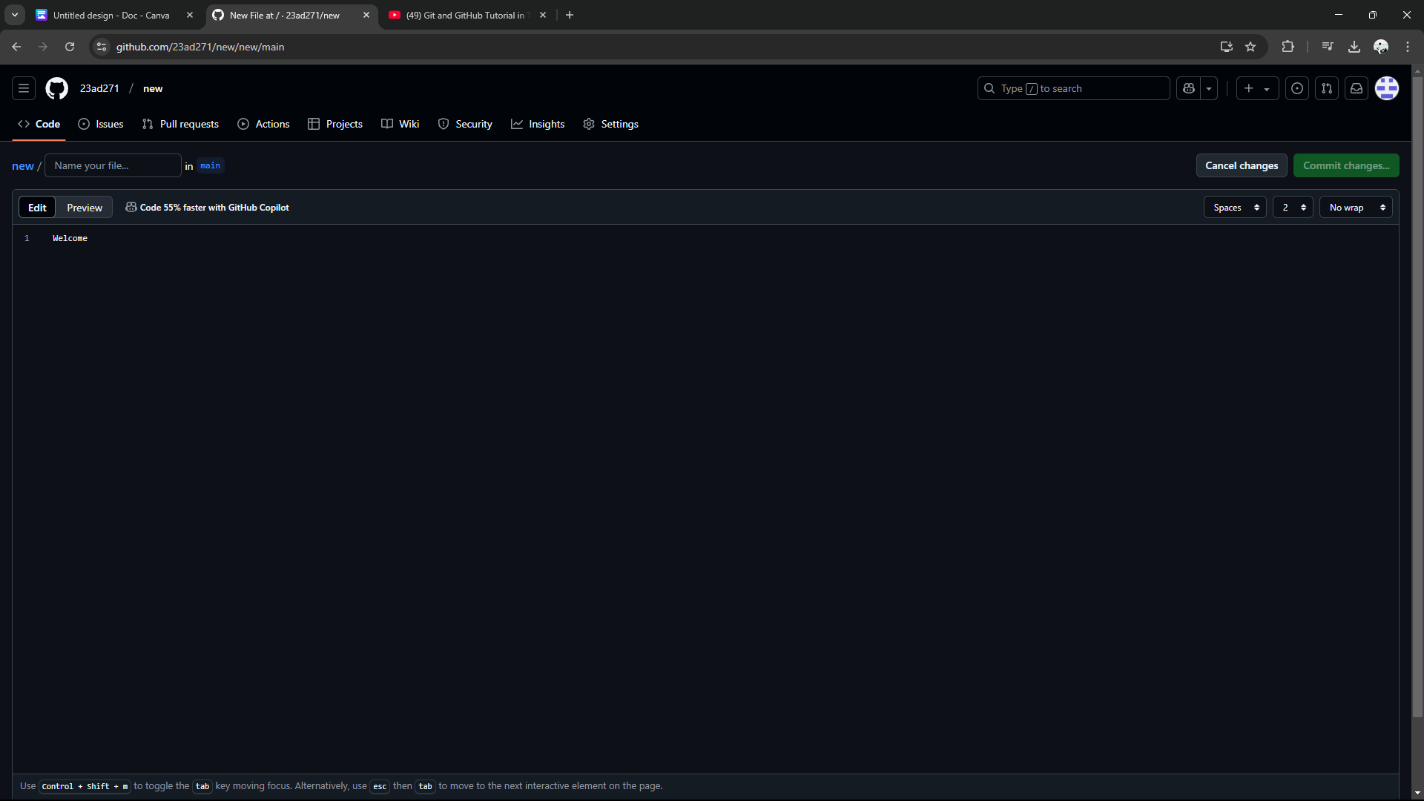

## Step 2:

Create a **new file in an new repository**

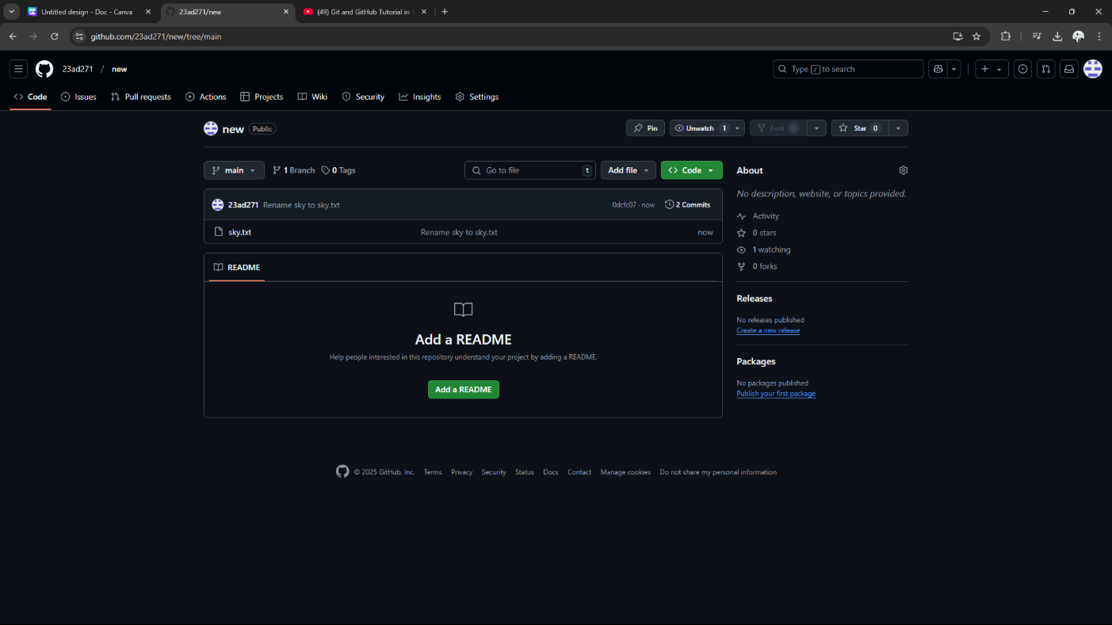

## Step 3

## Copy code to **clone** with an VS Code

## 

## 

## 

## 

## 

## Step 4

After cloning the file which already created in github is directly clone with an VS code.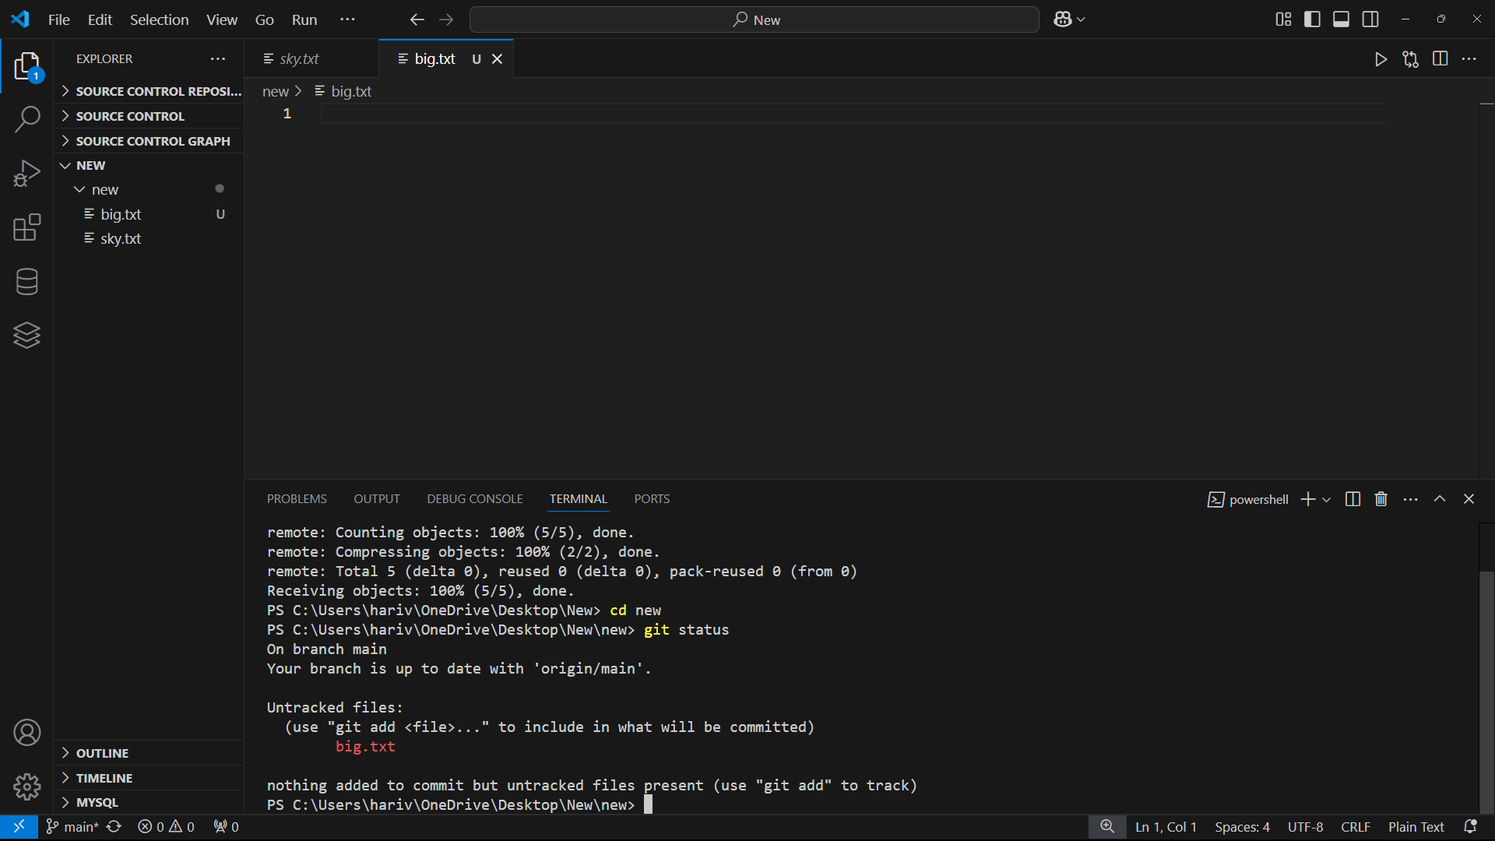

Step 5

## Now we can create one new file in VS code and merge With an github by using various commands.

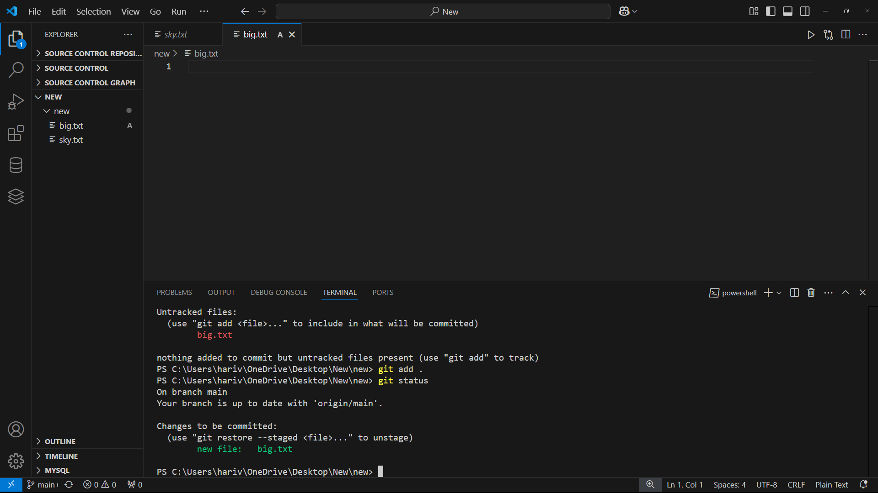

## Step 6

Now we commit the new file By using an comment **“ git commit-m”.**

After Commiting we can push the file by using **“git push origin main”.**

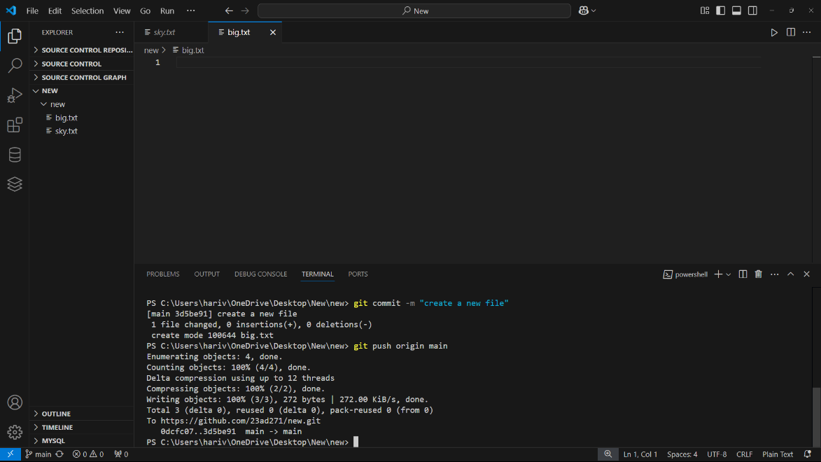

## Step 7

## The newfile **successfully** push into an github from VS code

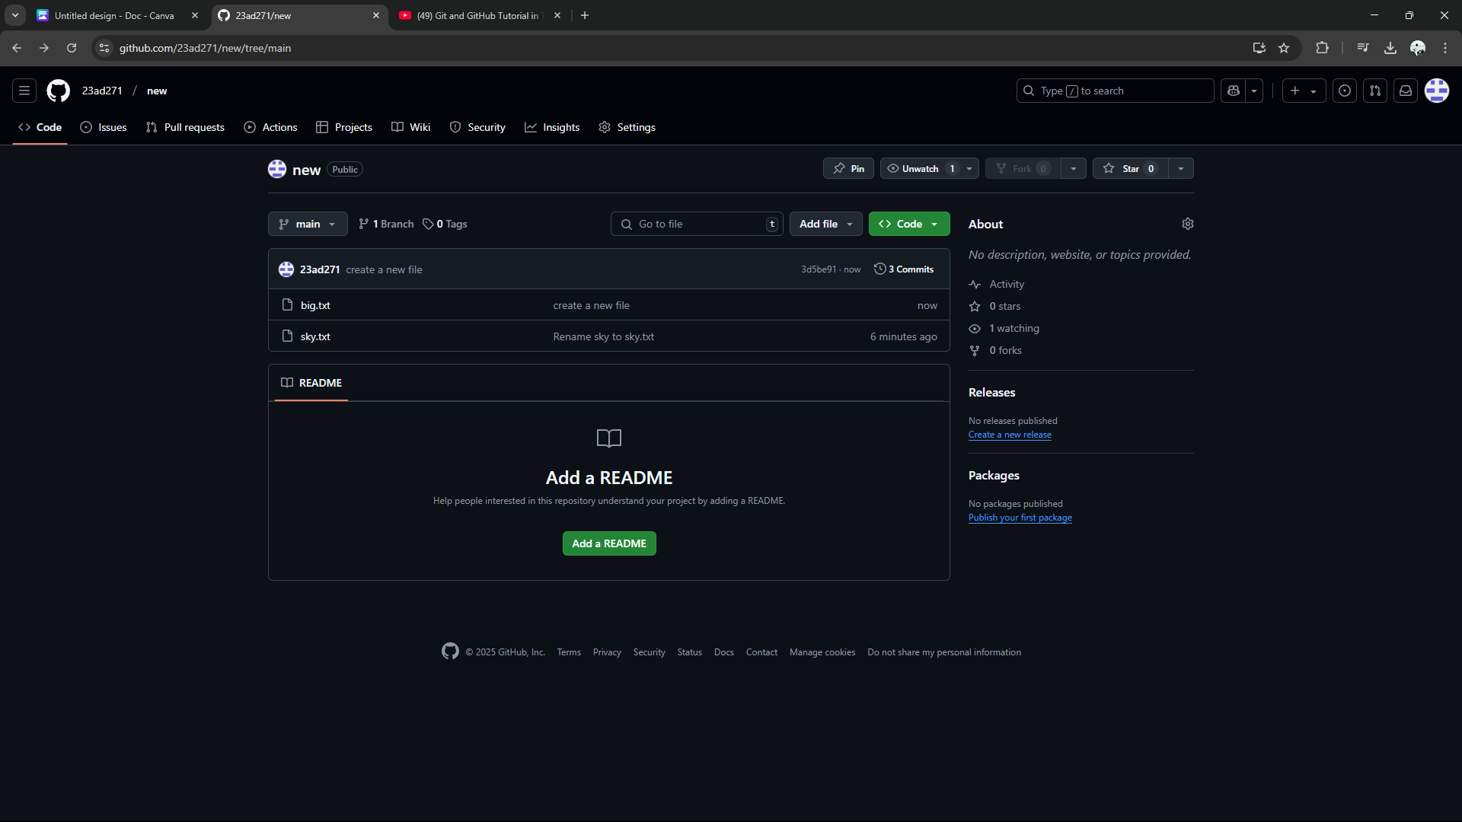

**Expected Outcome**:

1. **Set Up Version Control:** Initialize a Git repository in your static website folder to manage file changes.
2. **Track and Commit Changes:** Use Git to monitor updates to your website files (HTML, CSS, etc.) and commit them with clear messages.
3. **Learn Essential Commands:** Gain hands-on experience with basic Git commands like git init, git add, and git commit for efficient version control.