**ENVIRONMENT MONITORING**

**Phase 3: Project submission,**



**INTRODUCTION:**

* The integration of the Internet of Things (IoT) into environmental monitoring has ushered in a new era of data-driven insights and sustainability.
* In today's world, where environmental challenges are becoming increasingly pressing, IoT-based environmental monitoring systems have emerged as invaluable tools.
* we will explore the key components, benefits, and applications of IoT-based environmental monitoring systems that are reshaping our approach to environmental stewardship.

**CONTENT:**

Our project on 'Environmental Monitoring System in IoT' demonstrates the power of IoT technology in collecting and analyzing real-time data to address pressing environmental concerns, offering a data-driven solution for a more sustainable future.

**INNOVATION TO SOLVE THE PROBLEM:**

Environmental monitoring is critical in our collective efforts to address the pressing challenges of climate change, pollution, and biodiversity loss. Innovations in technology have paved the way for more effective and comprehensive environmental monitoring solutions. This article explores how innovative approaches to environmental monitoring can play a pivotal role in addressing these global problems.

***1*.*Temperature***

***2.Humidity sensor***

***1.TEMPERATURE:***

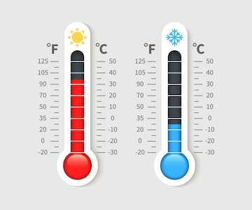

*A temperature sensor is a device used to measure temperature. This can be air temperature, liquid temperature or the temperature of solid matter.*

*There are different types of temperature sensors available and they each use different technologies and principles to take the temperature measurement****.***

***Different Types of Temperature Sensor:***

***Thermistors*** *can be very small in size. They consist of a sensing element which can be either glass or epoxy coated and have 2 wires so they can be connected to an electric circuit. They measure temperature by measuring the change in resistance of the electric current. Thermistors are available as either NTC or PTC and are often low cost.*

***RTDs or Resistance Temperature Detectors*** *work in a similar way to Thermistors and measure ohmic resistance to measure temperature. They are connected to a circuit in a similar way to a thermistor but they have a much wider temperature range and can measure extreme temperatures****.***

***Thermocouples*** *use two conductors, made up of different metals that are joined at the end to form a junction. When this junction is subjected to heat, a voltage is produced that is directly proportional to the temperature input. They are highly versatile as different metal combinations allow for different measurement ranges; however, they lack the fine accuracy of NTC’s and RTD’s making them the least precise out of the three types*

***Temperature Probes*** *are a very common and diverse type of temperature sensor. They consist of either a thermistor, a thermocouple or RTD sensing element and can be finished with a terminal head. All three types of sensor can be manufactured into a variety of housing types – stock and bespoke. This allows for enhanced utility, that may span over a multitude of different environments and media that they encounter.*

***2.HUMIDITY SENSOR:***

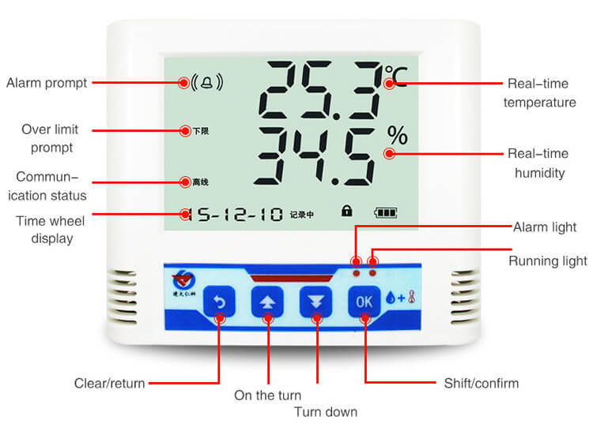

*A humidity sensor (or hygrometer) senses, measures, and reports both moisture and air temperature. The ratio of moisture in the air to the highest amount of moisture at a particular air temperature is called relative humidity. Relative humidity becomes an important factor when looking for comfort.*

*Humidity sensors work by detecting changes that alter electrical currents or temperature in the air.*

*There are three basic types of humidity sensors:*

*1.Capacitive*

*2.Resistive*

*3.Thermal*

*All three types of sensors monitor minute changes in the atmosphere in order to calculate the humidity in the air.*

***1. Capacitive:***

*A capacitive humidity sensor measures relative humidity by placing a thin strip of metal oxide between two electrodes. The metal oxide’s electrical capacity changes with the atmosphere’s relative humidity. Weather, commercial and industries are the major application areas.*

***2. Resistive:***

*Resistive humidity sensors utilize ions in salts to measure the electrical impedance of atoms. As humidity changes, so do the resistance of the electrodes on either side of the salt medium.*

***3. Thermal:***

*Two thermal sensors conduct electricity based upon the humidity of the surrounding air. One sensor is encased in dry nitrogen while the other measures ambient air. The difference between the two measures the humidity.*

***Tips on Humidity Sensor working:***

***Coulometric****: An electrolyte is formed by absorption of water resulting in a current level which is proportional to the moisture content in the air.*

***Gravimetric****: A drying agent is exposed to moist air, resulting in weight gain by the drying agent. The increased weight corresponds to the amount of moisture.*

***Microwave****/****Infrared****: A transmitted signal varies as the humidity increases. The attenuation is an indication of the moisture content in the medium.*

***PYTHON CODING****:*

*Python coding for iot device to send real time environmental data to the monitoring platform.*

1.Choose IoT Hardware: Select an IoT device with the necessary sensors (e.g., temperature, humidity, light, etc.) to collect environmental data. Common choices include Raspberry Pi, Arduino, or ESP8266/ESP32.

2.Set Up Sensors: Connect the environmental sensors to your IoT device. Ensure you have the required libraries and drivers for the sensors.

*import paho.mqtt.client as mqtt*

*import time*

*import json*

*import random*

*# Define the MQTT broker and topic*

*broker_address = "mqtt.example.com"*

*topic = "environment_data"*

*# Create an MQTT client*

*client = mqtt.Client("IoTDevice")*

*# Connect to the MQTT broker*

*client.connect(broker_address)*

*while True:*

*# Simulate environmental data (replace this with actual sensor readings)*

*temperature = random.uniform(20.0, 30.0)*

*humidity = random.uniform(40.0, 60.0)*

*# Create a JSON payload with the environmental data*

*payload = json.dumps({"temperature": temperature, "humidity": humidity})*

*# Publish the data to the MQTT topic*

*client.publish(topic, payload)*

*time.sleep(60) # Send data every minute*

*# Disconnect from the MQTT broker (ideally, use a proper exit strategy)*

*client.disconnect()*

***CONCLUSION:***

Development in environmental monitoring holds the key to addressing some of the world's most pressing challenges. Through advanced technology, collaborative efforts, and data-driven solutions, we can better understand, mitigate, and adapt to the environmental issues threatening our planet. These innovations offer hope for a more sustainable and resilient future, where human activities coexist harmoniously with the natural world, ensuring a healthier planet for current and future generations.