CS 475 Project

5/3/2026

  - Asmita Tamang

Abstract:
This report analyzes the developer_burnout_dataset_7000.csv dataset from Kaggle. It compares the prediction and classification of developer burnout level, low, medium, or high across 3 different machine learning model, Decision Tree, Logistic Regression, and K-Nearest Neighbors where k=6. The evolution metric used to discuss the differences between the models are F1-score with average=”macro”, meaning the average, unweighted F1-score is taken across the 3 different classes of burnout level. A confusion matrix was also used to along aside F1-score to better understand the results and for further support of F1-score.
Results showed that the Decision Tree model initially achieved perfect performance; however, further analysis showed that this was largely due to dominance of the stress level feature, indicating potential overfitting or feature dependency. After removing stress level, performance became more balanced across models, with the Decision Tree achieving the highest F1-score of approximately 0.984. The findings implied that stress level is highly influential in burnout prediction, but the result should be interpreted with caution due to class imbalance and feature dominance.

Dataset Description
The dataset, developer_burnout_dataset_7000.csv was taken from Kaggle and contains 6860 samples. It was created by ASIF Zaman, a CSE Undergraduate and competitive programmer focused on becoming an AI/ML engineer [1]. This dataset is a synthetic dataset generated using python, and it is modeling work habits, stress, and burnout patterns among software engineers [1]. The features were generated using statistical distribution and rule-based relationships, simulating realistic habits and stress dynamics of developers [1]. All the features and descriptions of them are shown in table 1. All features except the burnout_level were numerical type.

Feature | Description
age | Developer age
experience_years | Years of experience
daily_work_hours | Work hours per day
sleep_hours | Sleep duration
caffeine_intake | Cups per day
bugs_per_day | Bugs produced
commits_per_day | Git commits
meetings_per_day | Meetings attended
screen_time | Total screen time
exercise_hours | Physical activity
stress_level | Stress score (0–100)
burnout_level | Target variable (Low/ Medium/ High)

Table 1: Dataset features and descriptions [1]
Methodology
For the data wrangling step, all duplicates’ rows and rows with empty variables were removed. There were 1,370 rows with empty variables, but no duplicate records existed. Since all features except the label were numerical, no encoding was done.
Initially, for the features all available variables other than the label were selected. The chosen label was burnout level. To get a better sense of the impact of variables on the label data visualization was done. Boxplots were chosen for one of the visualization types, where a boxplot was created for each feature against the label. Figures 1, 2, and 3 shows plots of features that showed some of the most difference across the different burnout level of the label with its average clearly varying from across classes. There were also other features, which showed similar results, but these 3 were chosen to show for it being strongest differences across the burnout levels.
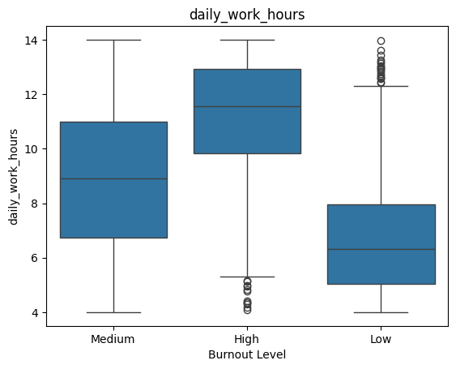
Figure 1. Stress level
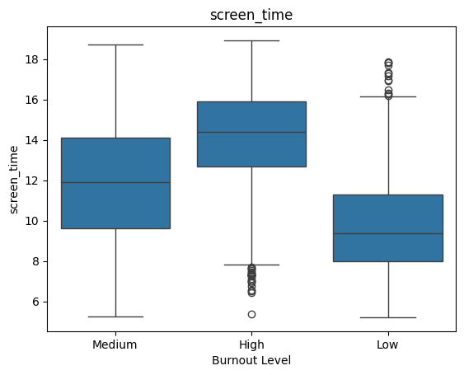
Figure 2. Screen time
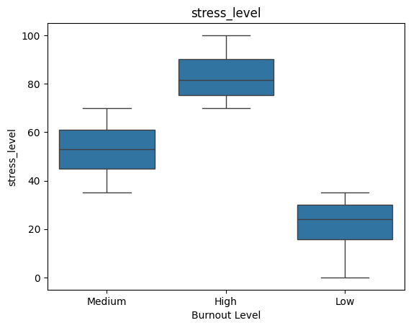
Figure 3. Stress level

Another visualization that was done was clustered bar chart, where the means of each feature was compared across the different levels of burnout. From looking at both visuals the variables, ages, experience years, commit per day, and exercise hours seem to have little to no difference across the different levels of burnout level, thus was excluded from the features list. The final testing features only include stress level, screen time, meetings per day, bugs per day, daily work hours, sleep hours, and caffeine intake. After, the data was then split into 20-70 splits with a random state of 42.

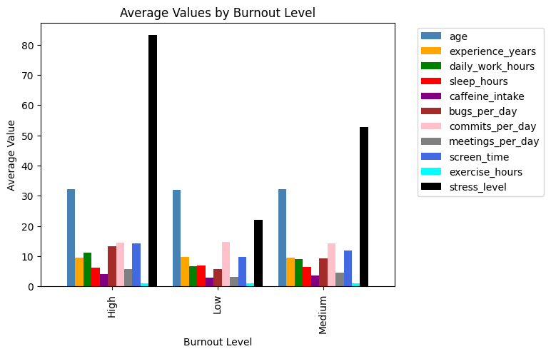
Figure 4

The first machine learning model used was a Decision Tree. One thing that was very notable was that when the feature importance was tested, stress level was scored 1 while the other features were 0. Also 2 evaluation metrics F1-score with average=”macro” and a confusion matrix were used. The F1-score result for the Decision Tree model was 1, meaning it resulted in a model that was both perfectly accurate and consistent. Moreover, when visualized with a confusion matrix, results support the score as all the prediction falls along the diagonal, showing models making no mistakes in classifying the developer in the correct burn out level.
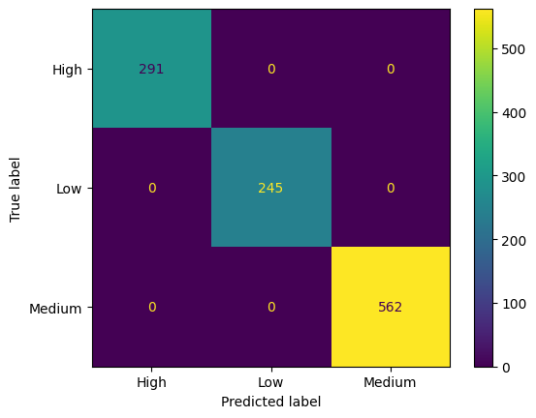

The second machine learning model used was Logistic Regression. Using the same spitted data, used to train and predict the Decision Tree model, the Logistic Regression model was fitted. The result was an F1-score of about 0.995. The confusion matrix here also showed good prediction results.

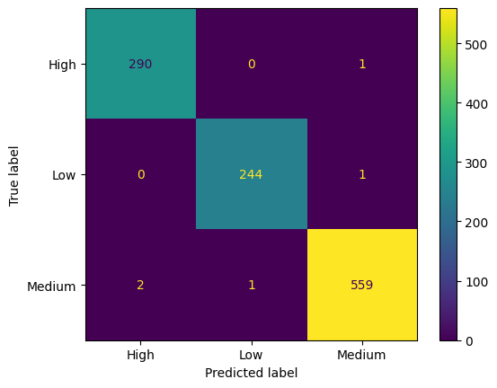

The third model I was K-Nearest Neighbors with k=6. Again, the same training and testing data split was used too. The F1-score I got was about 0.934. The confusion matrix supported the score and also showed good predictions across the diagonal.
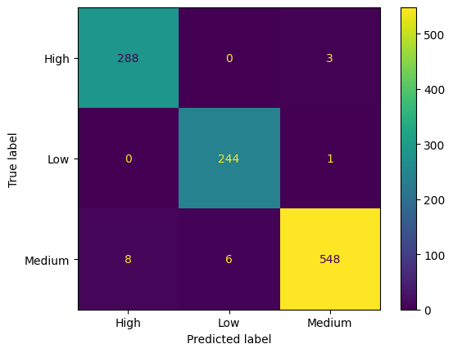

Results and Analysis
When comparing the F1-score and the Confusion matrix across the 3 different models the Decision Tree model has the highest score of 1 and a confusion matrix, which supports this by showing no misclassification. However, this seems a little too unrealistic, so there is probably a case of overfitting happening, which a decision tree is prone to especially when data contains strong feature dominance. For example, the result of dt.feature_importances_ was that stress level had 100 percent of the importance while the rest of the features showed 0, supporting the theory of something unusual happening. Also, the confusion matrix shows a unbalanced dataset showing majority of the classification of burnout level being medium, which could further skew the results.
It was worth trying to see the model without the stress level variable since the feature importance was super high. So, keeping the features same except for the removal of stress features, the dataset was trained across the 3 different machine learning models. The evaluation metrics result was more realistic than the models that utilized stress level as a feature. The decision tree models this time had a F1-score of around 0.984, The Logistic Regression has an F-score of about 0.798. and for K-Nearest Neighbors F1-score of about 0.7480. The Decision Tree model labeled bugs per day, daily work hours, and sleep hours as the top 3 features in terms of importance.
However, this is an unbalanced dataset and since the F1-score takes the unweighted average across the 3 different F1-scores of each class, it might affect the results. Therefore, the result should be interpreted in the context of class imbalanced and feature influence.

Conclusion
In conclusion, the label, burnout level seems to be most affected by the stress level of the developers. In the real world, this seems entirely plausible, in fact they might just be the different sides of the same coin. For instance, if stress level is high, a developer is likely experiencing high burnout; if stress level is medium, they are likely experiencing a moderate amount of burnout; and if stress level is low, burnout is most likely low.
In the future I would like to examine the stress level and burnout rate in general across all populations instead of focusing on developers since they seem to have such high correlation with each other.

References
[1] A. Zaman, “Developer Burnout Prediction Dataset (7000 Samples),” Kaggle. [Online]. Available: https://www.kaggle.com/datasets/asifxzaman/developer-burnout-prediction-dataset7000-samples/data. [Accessed: May 2, 2026].

Appendix

All box plots
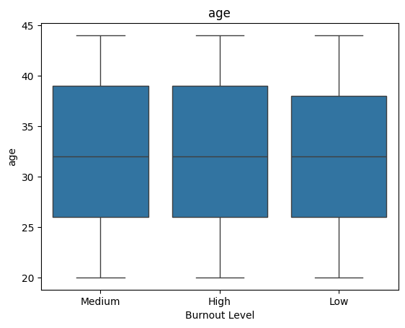

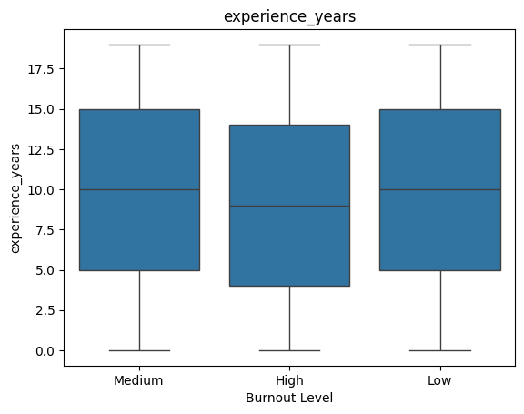
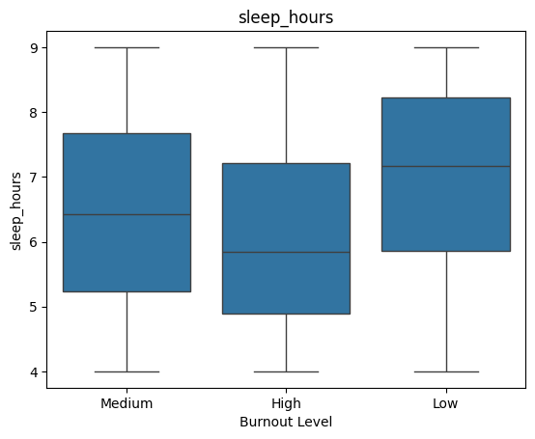

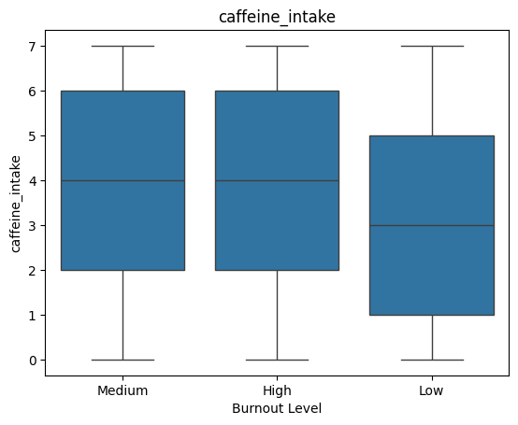
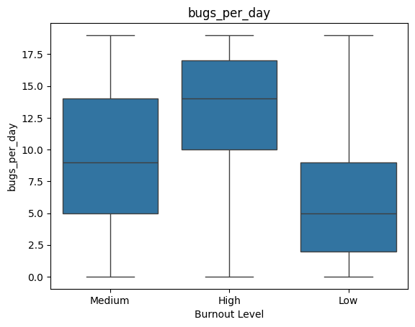
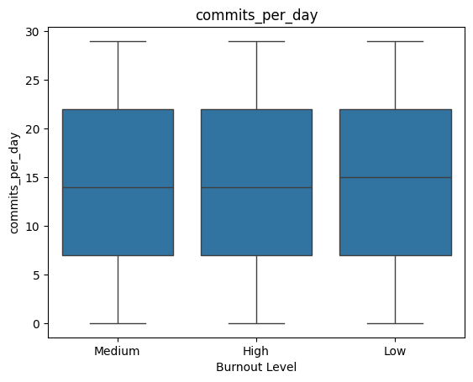
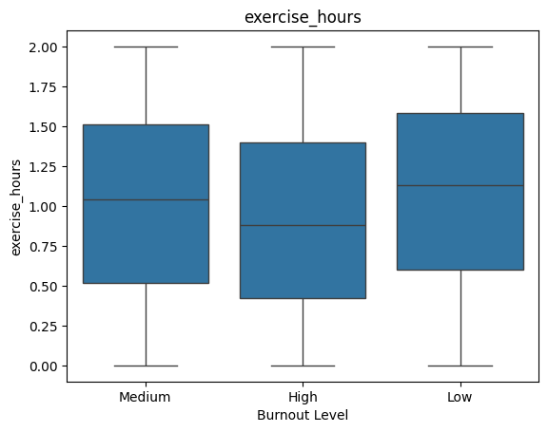
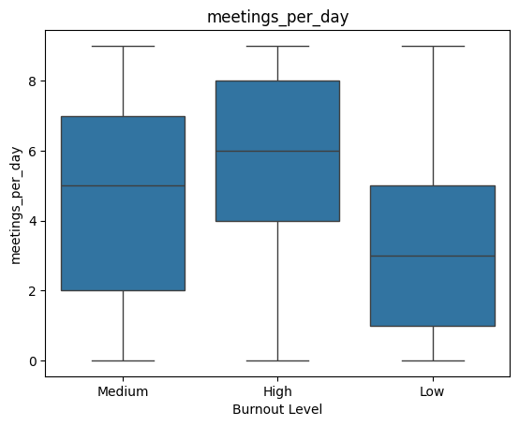

Decision Tree model without stress level
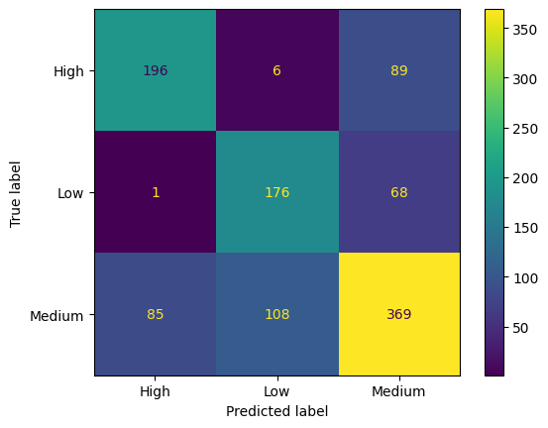
Logistic Regression model without stress level
KN-Neighbors without stress level
