**Citizen AI: Intelligent Citizen Engagement Platform Using IBM Granite**

**Project Documentation**

**Introduction**

**Project title:** Citizen AI: Intelligent Citizen Engagement Platform Using IBM Granite

**Team members:**

Team member 1: Lingeswaran K

Team member 2: Tinesh Kumar E

Team member 3: Manoj D

Team member 4: Aswathaman D

**Project Overview**

**Purpose:**

The purpose of Citizen AI is to provide users with an intelligent, AI-powered assistant capable of answering queries related to government services, civic issues, and public engagement. By leveraging IBM’s Granite LLM and real-time AI processing, the platform aims to deliver accurate, accessible, and user-friendly guidance while supporting authorities in improving transparency and citizen satisfaction.

**Features:**

**1.Conversational Interface:**

**Key Point:** Natural language interaction

**Functionality:** Users can ask questions about government services, policies, or civic issues and receive AI-generated responses.

**2.Service Guidance:**

**Key Point:** Citizen-focused information

**Functionality:** Provides step-by-step guidance for services like Aadhaar application, Voter ID registration, RTI queries, and transportation-related information.

**3.Quick Question Buttons:**

**Key Point:** Easy access to common queries

**Functionality:** Pre-set buttons for frequently asked topics such as Aadhaar, RTI Act, Voter ID, and Railway ticket booking.

**4.Chat Management**

**Key Point:** Enhanced user control

**Functionality:** Options to send queries, clear chat history, and download conversations as a text file.

**5.Gradio UI**

**Key Point:** User-friendly interface

**Functionality:** Gradient-based chatbot design with text input, quick action buttons, and real-time responses.

**Architecture:**

**Frontend (Gradio):**

Chat-based web interface with input textbox and functional buttons (Send, Clear, Download, Quick Questions).

**Inputs:** User queries in natural language.

**Outputs:** AI-generated responses displayed in the chat, with option to download as text.

**Backend (Python + Transformers):**

1.Processes user queries and generates AI responses using IBM Granite LLM.

2.Handles model loading and GPU optimization if available.

**LLM Integration (IBM Granite – Hugging Face Model):**

**Model:** ibm-granite/granite-1b-code-instruct (lightweight and efficient for Colab).

1.Performs natural language understanding and response generation. Deployment (Google Colab):

2.Runs in Google Colab with T4 GPU for smooth AI processing.

1. Application can be shared publicly using launch(share=True).

**Setup Instructions Prerequisites:**

1.Python 3.9 or later

2.pip for package installation

3.Internet connection (for downloading model)

4.GPU recommended for faster response (T4 GPU in Colab)

**Installation Process:**

1. Clone the repository.
2. Install dependencies: pip install transformers torch gradio
3. Run the Gradio app: python citizen_ai.py
4. Open the provided local URL or use the public share link

**Folder Structure:**

citizen_ai.py – Main Gradio app and UI layout

requirements.txt – Python dependencies

**Running the Application:**

1. Launch the Python script citizen_ai.py or run the notebook in Colab.
2. Gradio interface opens in the browser.
3. User flow: - Enter a query → Click Send → View AI response.
4. Use Quick Question Buttons for instant responses.
5. Use Clear Chat to reset conversation.

**API Documentation:**

(Note**:** Current version runs as a Gradio interface; no REST API implemented. Optional future enhancement could add FastAPI backend.)

**Inputs:** User query (Textbox or Quick Question button)

**Outputs:** AI response (Text), Chat history (Downloadable file)

**Authentication:**

1.Current version runs in an open environment.

2.No authentication implemented.

3.Future enhancement: Add login system and role-based access.

**User Interface:**

1.Minimalist chatbot interface with Gradio.

2.Includes: Text input field Action buttons (Send, Clear)

3.Quick Question buttons (RTI, Aadhaar, Voter ID, Railway)

4.Gradient-based background for improved visual appeal.

**Testing:**

**Unit Testing:**

Validate input handling and model response.

**Manual Testing:** Ask queries on government services and verify responses.

**Edge Case Handling:** Empty input, repeated queries, long text.

**Screenshots:**

**TOOLS:**

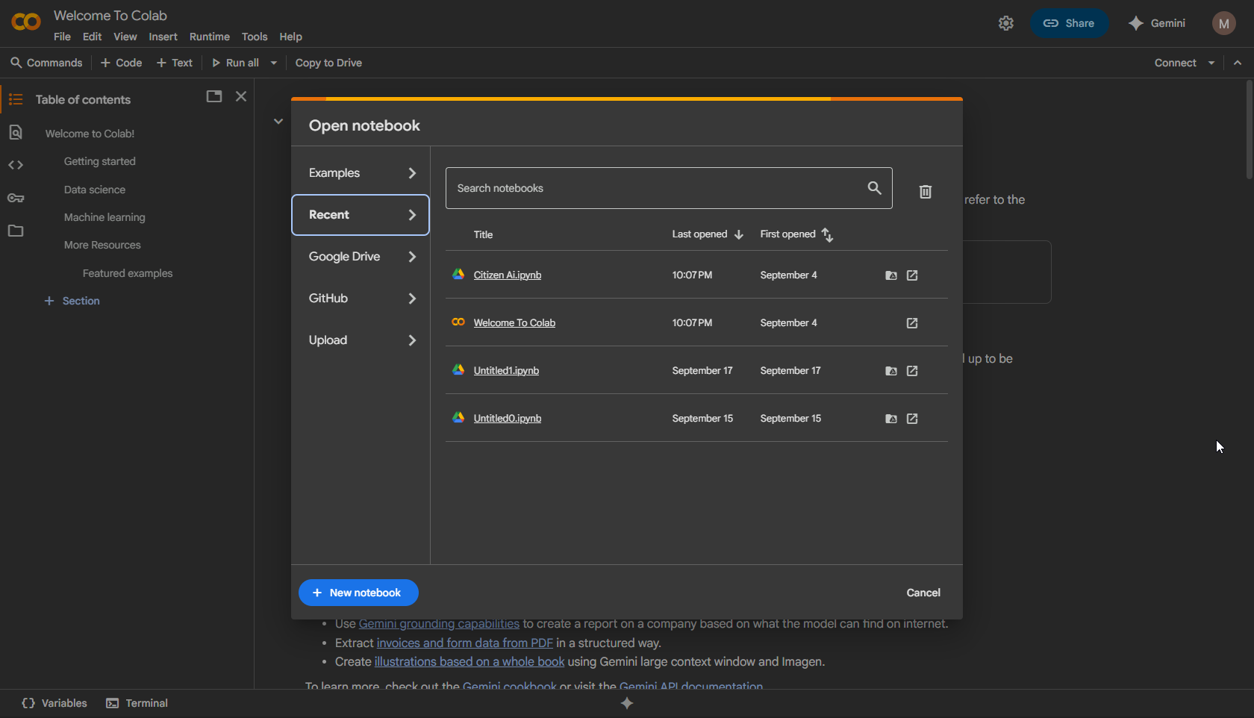

**CODING:**

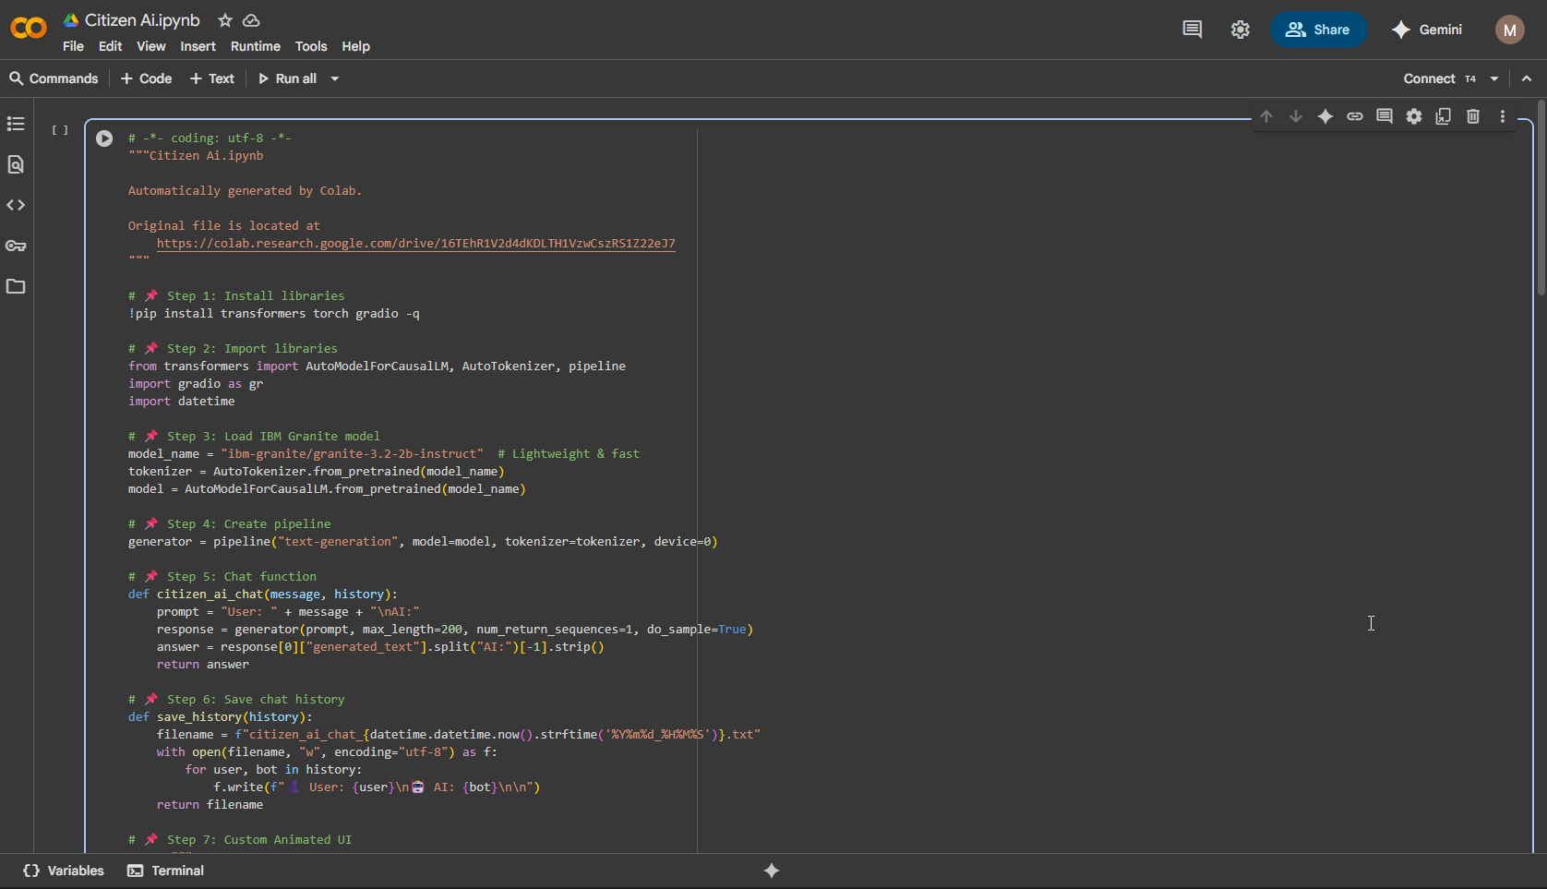

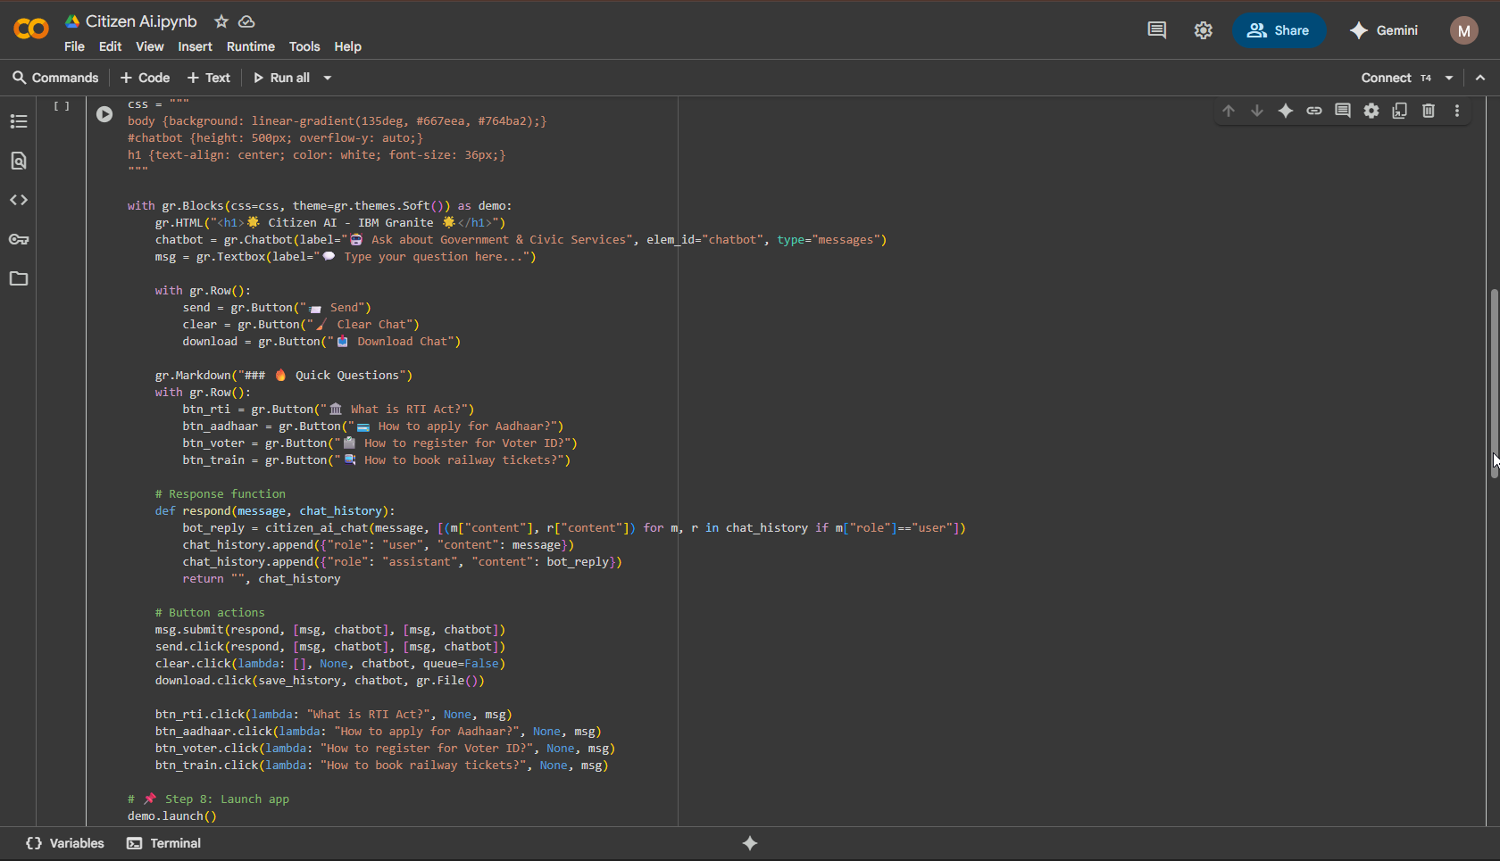

**OUTPUT LINK:**

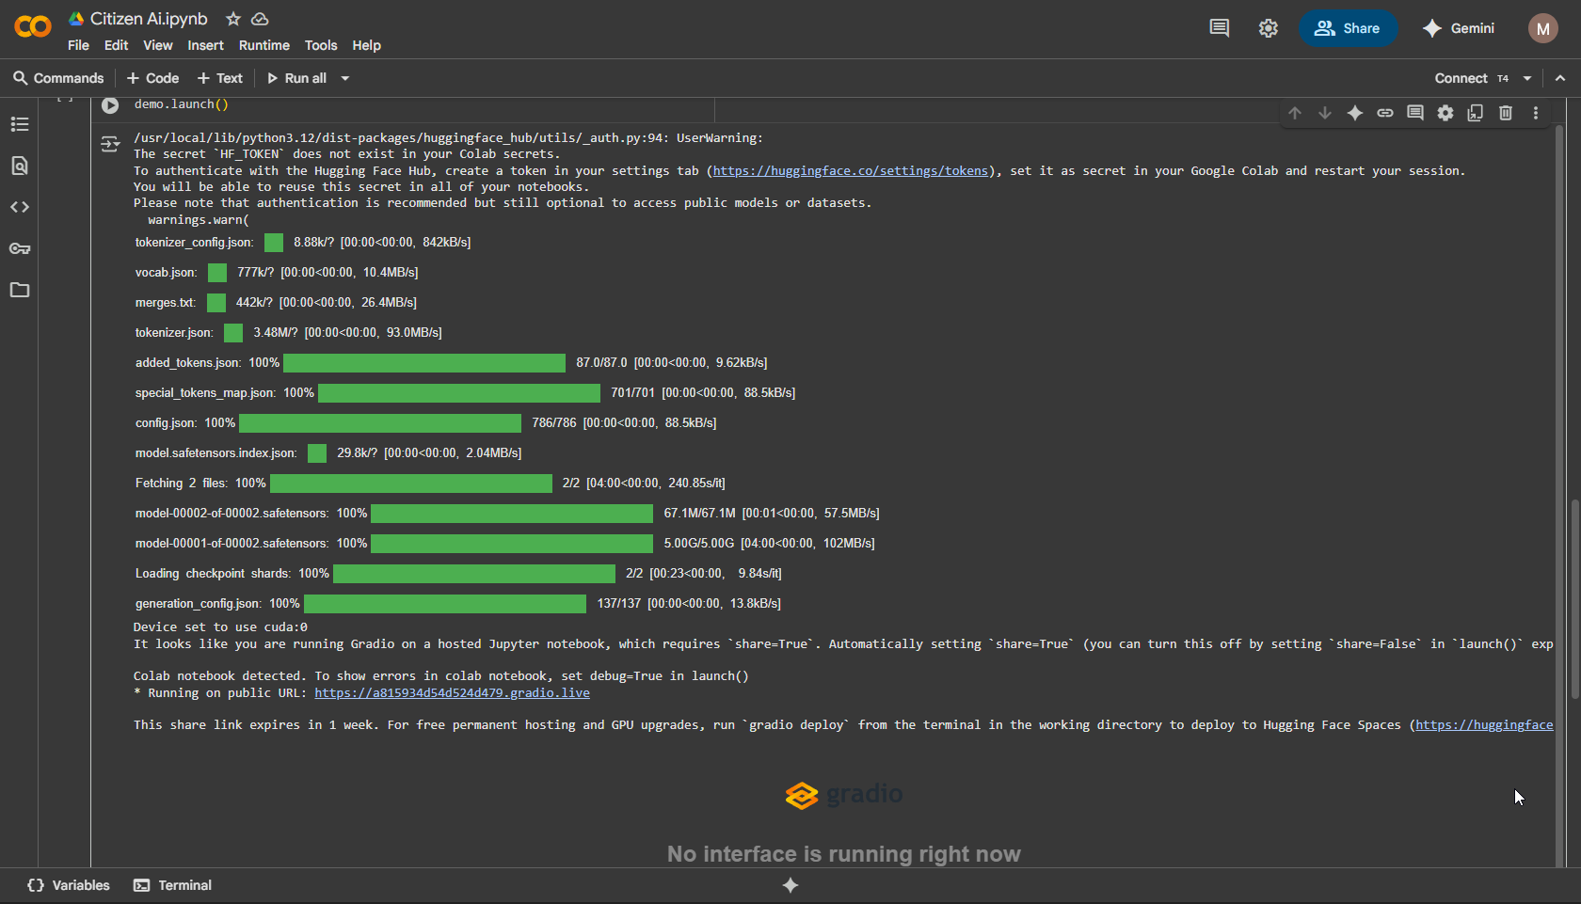

**FINAL OUTPUT:**  
  
Screenshots of Coding, Output Link, and Final Output:  
[Insert Screenshot 1: Coding Screenshot][Insert Screenshot 2: Output Link Screenshot][Insert Screenshot 3: Final Output (Gradio UI)]

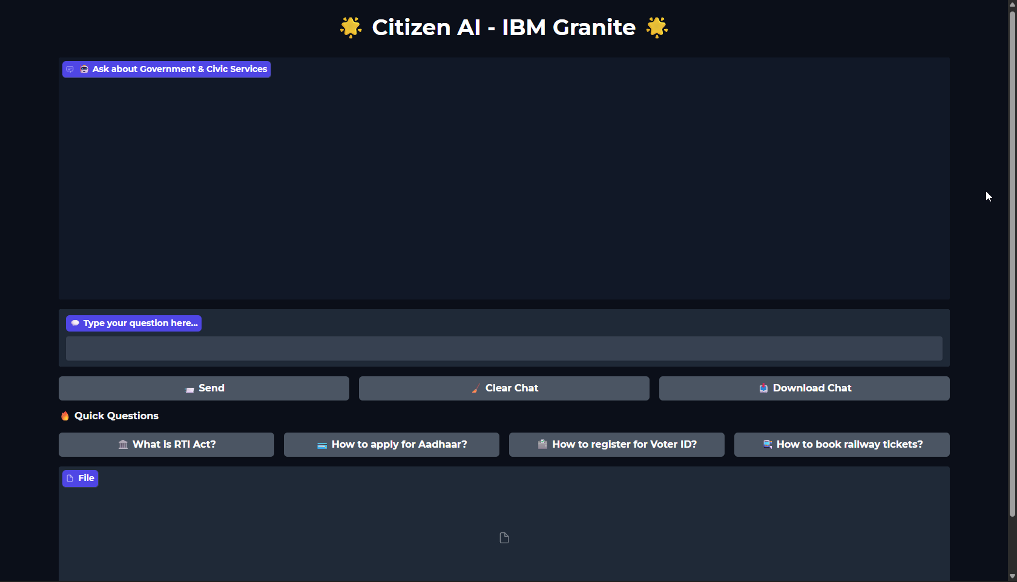

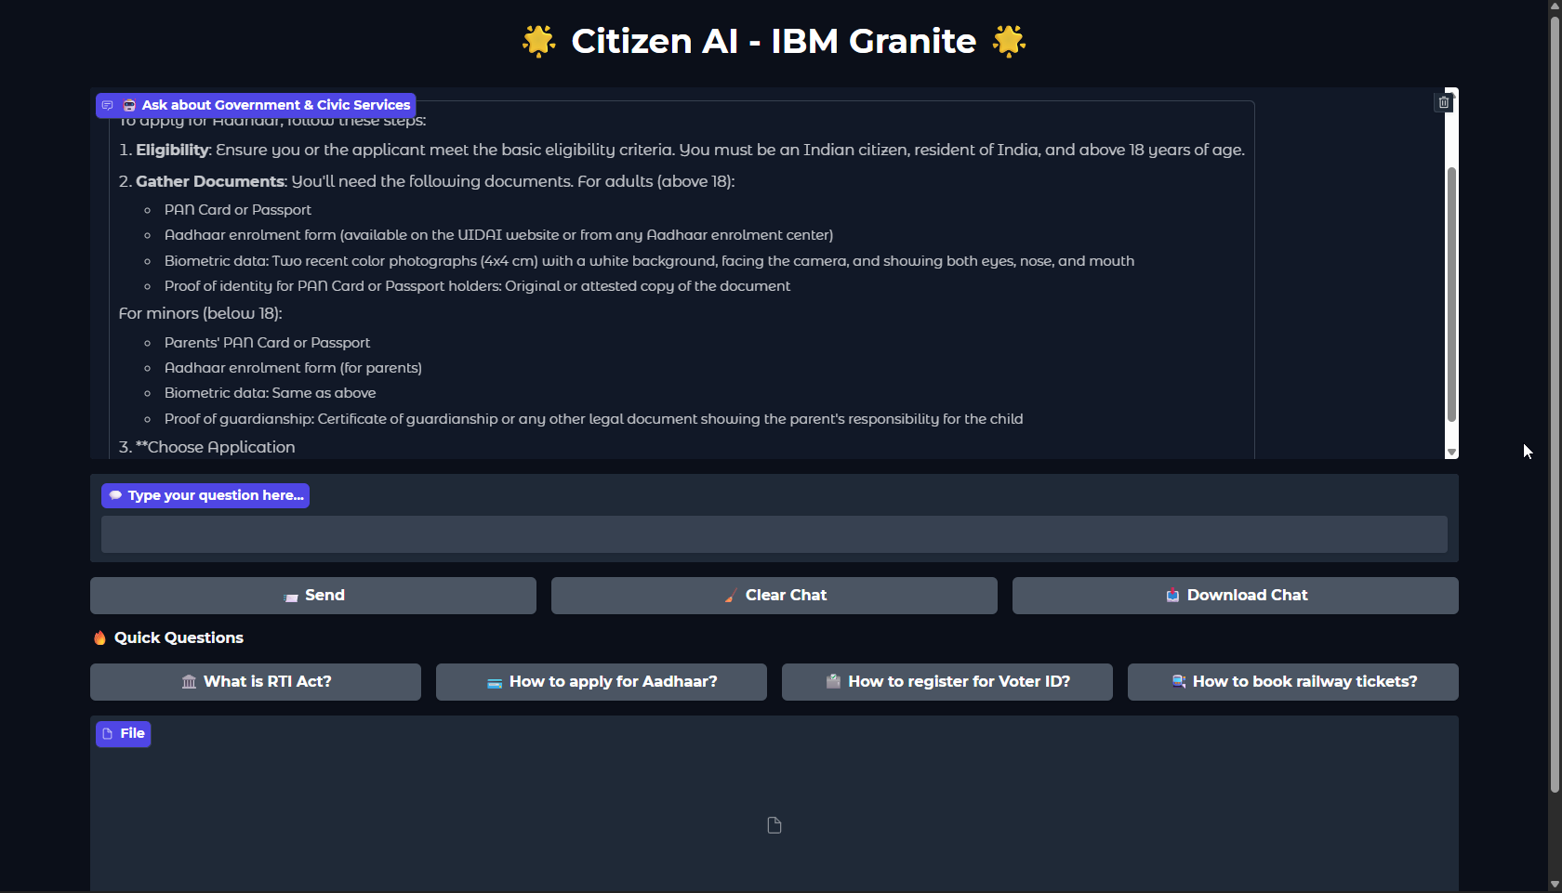

**Known Issues:**

1.Large queries may exceed model’s maximum token limit.

2.Some responses may be generic due to limited domain training.

3.Free Colab session may disconnect, stopping the app.

**Future Enhancements:**

1.Deploy permanently on Hugging Face Spaces or Streamlit Cloud.

2.Add voice input and voice output (speech-to-text and text-to-speech).

3.Add dashboard for sentiment analysis of citizen feedback. - Enable multilingual support (e.g., Tamil, Telugu, Hindi, etc.).