Project Title
NeuraCare(MigraHealth): AI-Powered Privacy-Preserving Healthcare Monitoring System for Migrant Workers

1. Problem Statement
Migrant workers often face significant challenges in accessing consistent and reliable healthcare due to frequent movement, lack of centralized medical records, and limited awareness of health risks. Traditional data collection methods are fragmented, slow, and often fail to capture real-time health trends.
Additionally, public health authorities struggle to detect early signs of disease outbreaks due to delayed reporting and lack of structured data, while concerns around data privacy and consent further limit the adoption of digital healthcare solutions.
There is a need for a secure, scalable, and intelligent system that enables real-time health monitoring, ensures data privacy, and supports early disease detection and intervention.

2. Objectives
- To develop a secure and user-centric platform for migrant workers to manage and share their health data with full consent control
- To enable healthcare providers to access patient records efficiently for better diagnosis and treatment
- To implement AI-based analysis for detecting disease patterns, anomalies, and potential outbreaks
- To provide real-time alerts and recommendations to workers, doctors, and public health authorities
- To ensure data privacy and anonymization, preventing exposure of personal information
- To support data-driven decision making for public health interventions and resource allocation

3. Methodology / Approach
🔹 Data Collection
- Migrant workers register via a React-based web application
- Health data is collected through:
  - Healthcare providers (symptoms, diagnosis, vitals, medicines)
  - Optional self-reporting by workers
- Data sharing is strictly controlled through user consent mechanisms (OTP/QR-based)
🔹 Data Storage & Access Control
- Backend built using Node.js and Express
- Data stored securely in MongoDB
- Role-based access control ensures:
  - Workers own their data
  - Providers access data only with consent
  - Authorities see only aggregated insights
🔹 AI Analysis
- Gemini AI processes anonymized data (no personal identifiers)
- Detects:
  - Symptom clusters
  - Sudden spikes in diseases
  - High-risk geographic areas
- Generates alerts and health recommendations
🔹 Alert & Insight Delivery
- Personalized alerts sent to workers (e.g., “High fever detected”)
- Decision support provided to healthcare providers
- Public health dashboards display:
  - Disease trends
  - Heatmaps
  - Outbreak warnings
🔹 Action & Response
- Authorities can initiate screening camps and advisories
- Providers can prepare for early diagnosis and treatment
- Workers receive early warnings and preventive guidance
Video Link - https://drive.google.com/file/d/1MSW_MMu5RDbCdTPsP_o9j361N8kAP50J/view?usp=sharing
Github Link - https://github.com/23bce1968/NeuraCare

Screenshot –
Home Page
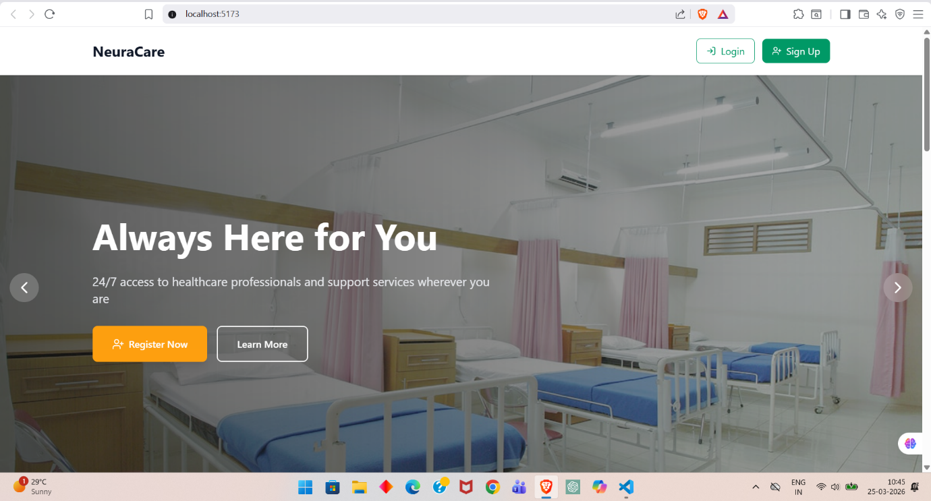

Signup page :-
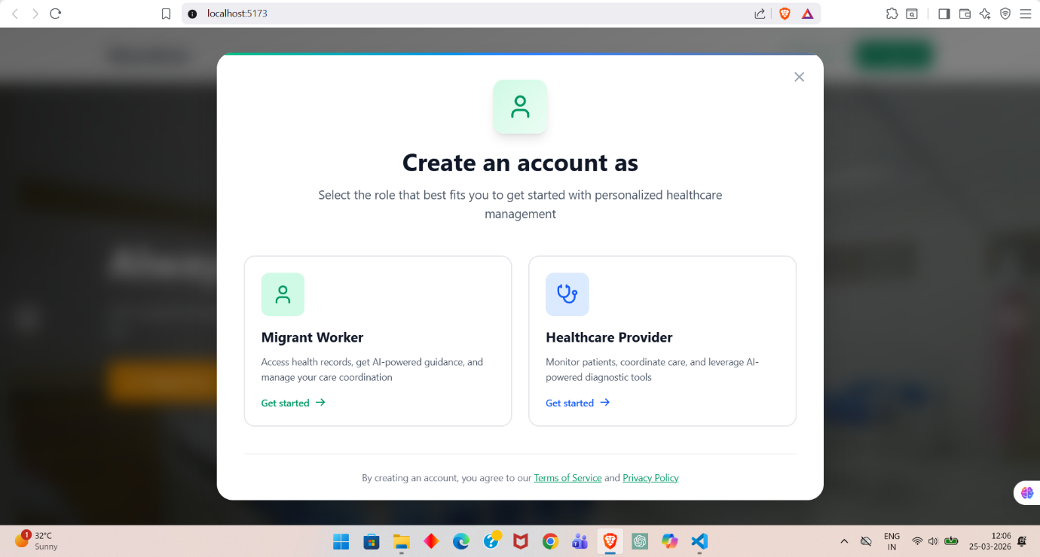

Doctors will be verified by admin within 24-48 hours :-
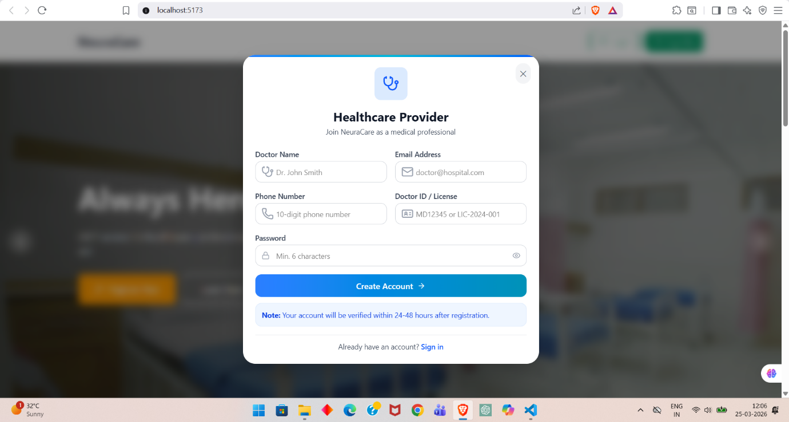

After signing in as worker you will have to fill these details (more fields are there (already mentioned in video)) :-
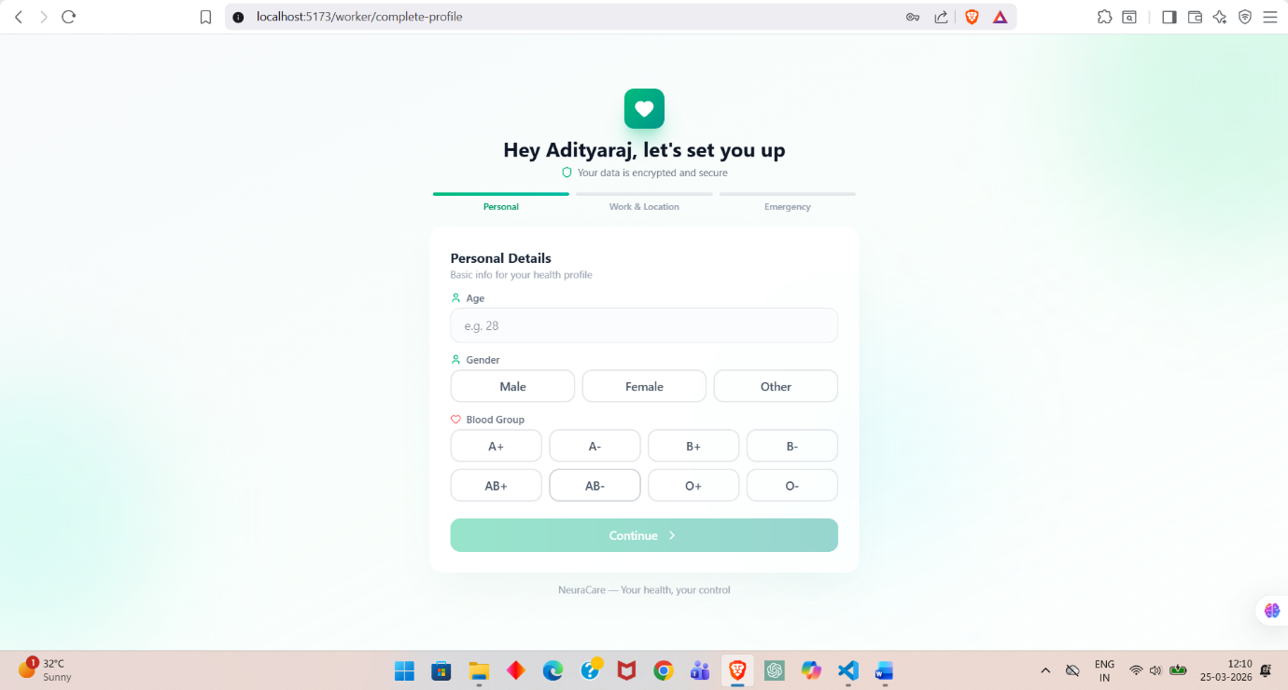
Worker page after filling the details :-

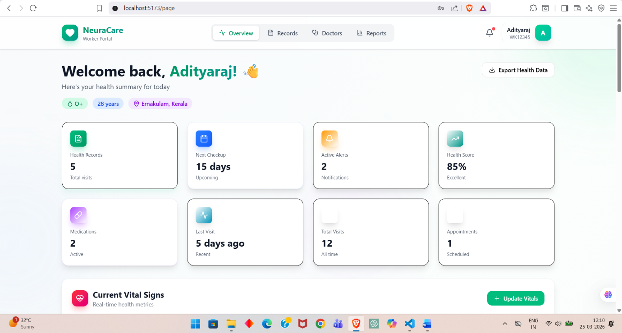

Consent management and available doctors :-
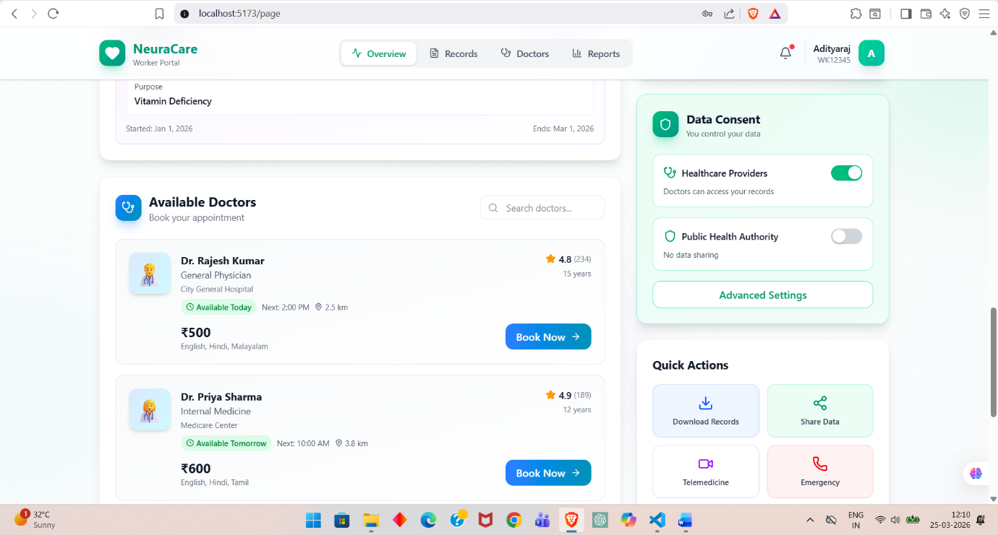

Admin page where admin can see request of doctors and admin will decide to approve or reject and admin will have AI insights :-
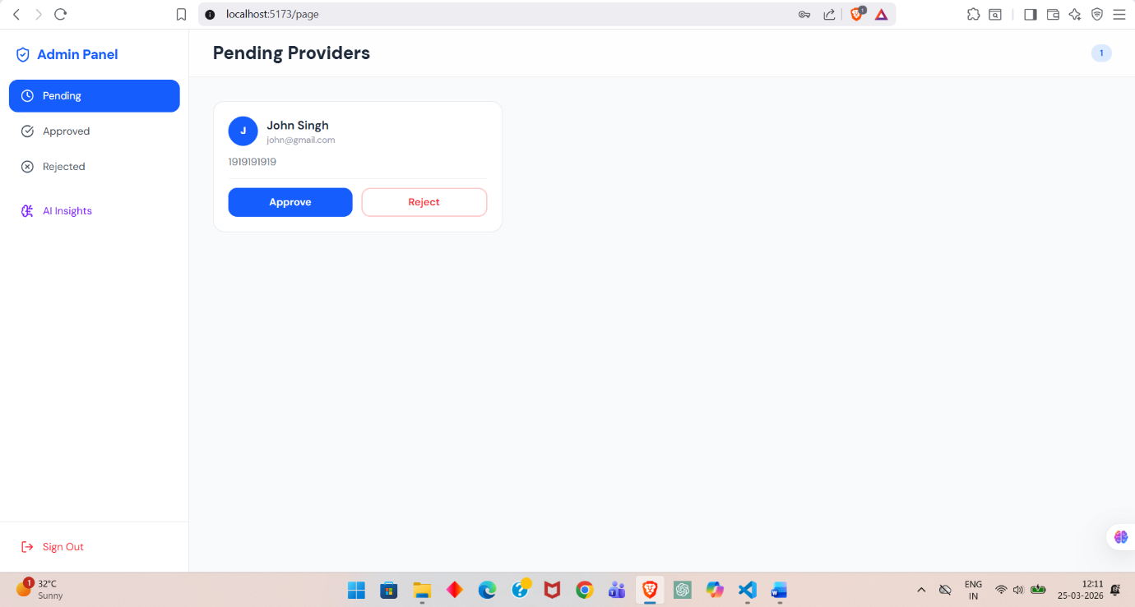

This is doctor page where doctors can see all the patients and their records registered under them:-
