NeuraCare: AI-Driven Migrant Healthcare Monitoring and Early Disease Detection System
Adityaraj Shrivastava
School of Computer Science and Engineering Vellore Institute of Technology, Chennai Email: adityaraj.2023@vitstudent.ac.in
Project Repository: https://github.com/23bce1968/NeuraCare
Demo Video: https://drive.google.com/file/d/1vlTEu1e3oY75frbI2lcU_688I2x43C9R/view?usp=drive_link

Abstract—Workers coming from other places often face challenges in accessing continuous and reliable services related to healthcare due to mobility, lack of centralized records related to medical field and infrastructure limitation. So, This paper shows an AI-driven healthcare system explicitly designed for migrant workers. It enables fully secure health data management, interaction between doctor and patient and AI-driven analysis of medical records.
Workers can perform various tasks such as registration, providing personal information, booking appointments etc. Doctors can upload clinical data, test reports, symptoms, vitals and medications.The system uses Gemini as AI to generate insights from the health data of migrant workers such as disease trends, severity distribution and alerts for outbreak.
A consent-based mechanism is also there which ensures that if the patient has given consent, then only their data is visible at Admin dashboard and that data will sent to AI for analysis. So, this system aims to enhance healthcare field, enable early disease detection and improve outcomes from public health.
- BACKGROUND
Migrant workers face lack of healthcare because they have to relocate frequently, lack of tracking of medical history, and limited healthcare infrastructure. Old healthcare systems do not provide centralized health records or cannot detect disease outbreaks early. The current system primarily focuses on individual treatment but lack AI-analysis and surveillance of public health. So, there is a need for a system that not only manages health records but also combines health records, identify patterns and give alerts if there is risk. So, this project addressess all these challenges by combining digital health records, role-based access, and AI-driven analytics to create a comprehensive healthcare monitoring system.
- Proposed System
The proposed system is a multiple role based platform which involves 3 roles - Workers, Doctors and Administrators.
- System Features
  - Secure authentication and role-based access
  - Worker profile management
  - Appointment booking
  - Doctor verification and management by admin
  - Health record management
  - AI-based insights and analytics
- Workflow
- Worker’s registers and logs into the system
- Worker books an appointment under a doctor verified by admin
- Doctor records health data of the patient after visit
- Data is stored securely in database
- Gemini AI processes health records
- Admin views AI insights and takes actions
- Novelty
The system introduces:
  - Consent-driven data sharing model
  - Integration of AI for real-time analytics
  - Combined EHR and public health monitoring
- System Architecture
The architecture consists of four main layers:
- Frontend
Implemented using React.js, providing user interfaces for workers, doctors, and admins.
- Backend
Developed using Node.js and Express.js to handle API requests and business logic.
- Database
MongoDB is used to store user data, health records, appointments, and consent information.
- AI
Gemini API is used to analyze anonymized health data and generate insights.
- Protocol Stack
The system follows a layered protocol structure:
- Application Layer
Handles user interactions, data visualization, and API requests.
- Transport Layer
Uses HTTP/HTTPS for secure communication.

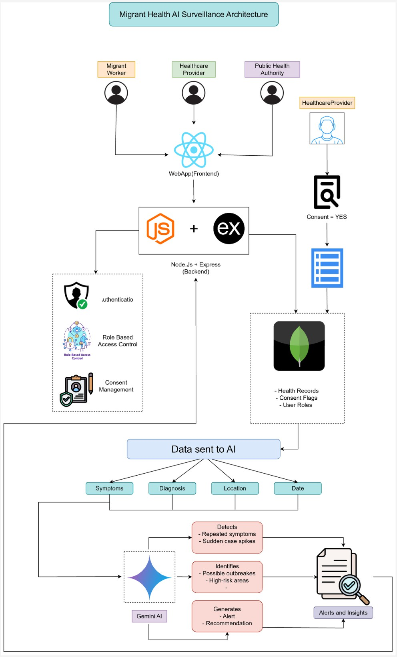
VI. Experimental Setup
A. Tools Used

Fig. 1. System Architecture Diagram

- Network Layer
Ensures data transmission between client and server.
- Data Layer
Stores structured data using MongoDB collections.
- AI Processing Layer
Analyzes data and generates insights using Gemini AI.
- Database Design
The system uses a modular schema design:
- Worker: Authentication details
- WorkerProfile: Personal information
- Doctor: Healthcare provider details
- Appointment: Links workers and doctors
- HealthRecord: Stores medical data
- Consent: Controls data access
This modular design improves scalability and maintainability.
- Frontend: React.js, Tailwind CSS
- Backend: Node.js, Express.js
- Database: MongoDB
- AI: Gemini API
B. Dataset
- Real-time generated health records from user interactions
- Includes symptoms, diagnosis, vitals, and severity levels
C. Environment
- Localhost development setup
- REST API testing using Postman
- Browser-based user interface testing
Testing is conducted in a local development environment using browser-based interaction and API testing tools.
VII. Results and Conclusion
The system successfully demonstrates:
- End-to-end healthcare workflow
- Efficient doctor-patient interaction
- Secure data handling with consent
- AI-generated insights including:
  - Disease trends
  - Severity distribution
  - Alerts for potential outbreaks
The results indicate that the system can effectively monitor health patterns and support early intervention.
This paper presents a scalable and intelligent healthcare monitoring system tailored for migrant workers. By integrating electronic health records, appointment systems, and AI-driven analytics, the system provides a comprehensive solution for both individual healthcare and public health monitoring.
The proposed system demonstrates the potential of combining modern web technologies with artificial intelligence to improve healthcare accessibility and enable proactive intervention. The images are given below :-
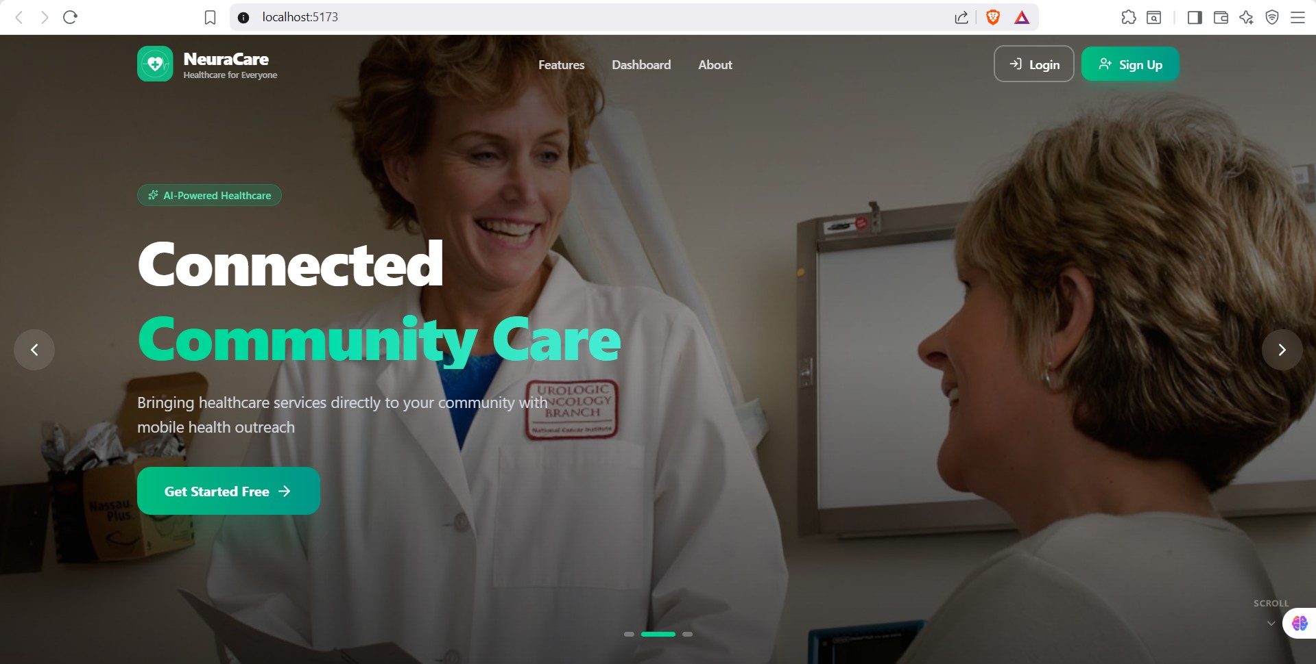
Fig. 2. This is landing page which first everyone will irrespective of role

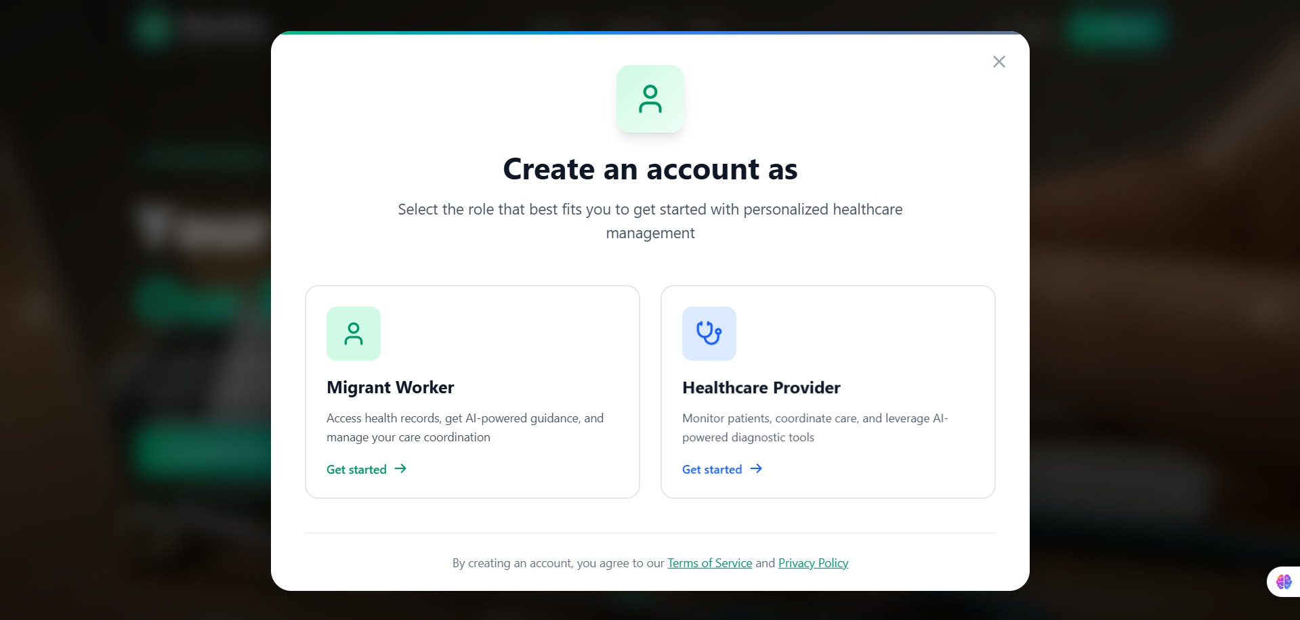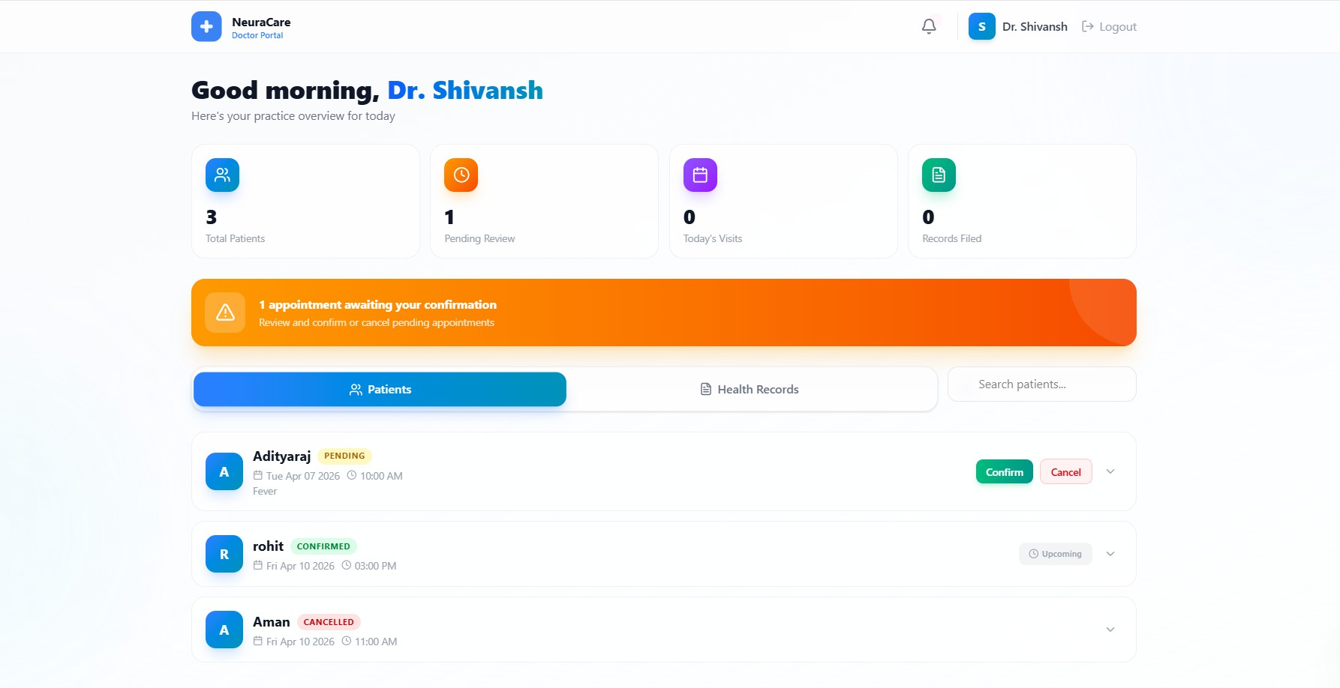

Fig. 3. User can signup based on role

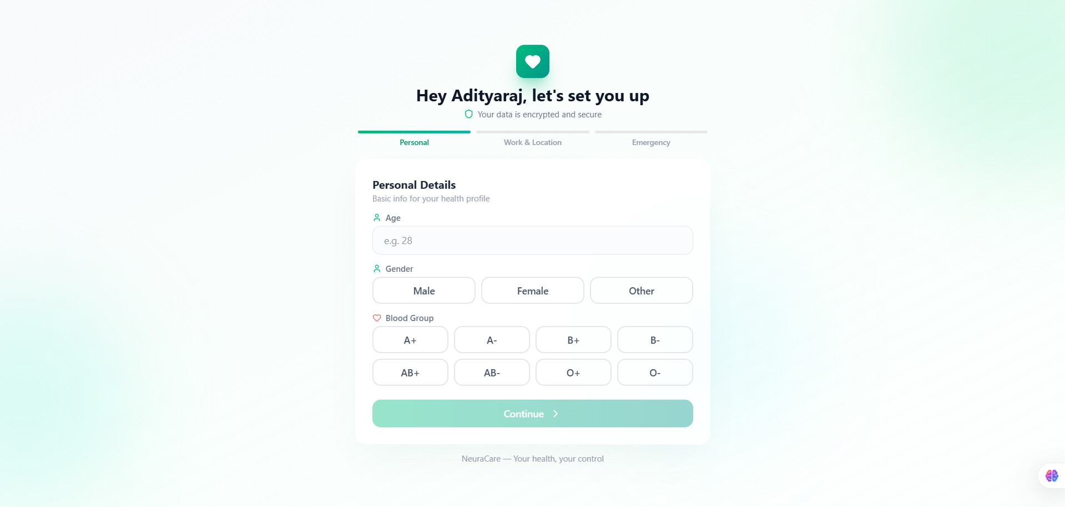

Fig. 4. When patient creates fresh account, they will have to fill their details before going to patient dashboard

Fig. 7. Once the patient has booked appointment under certain doctor, the respective doctor can see it

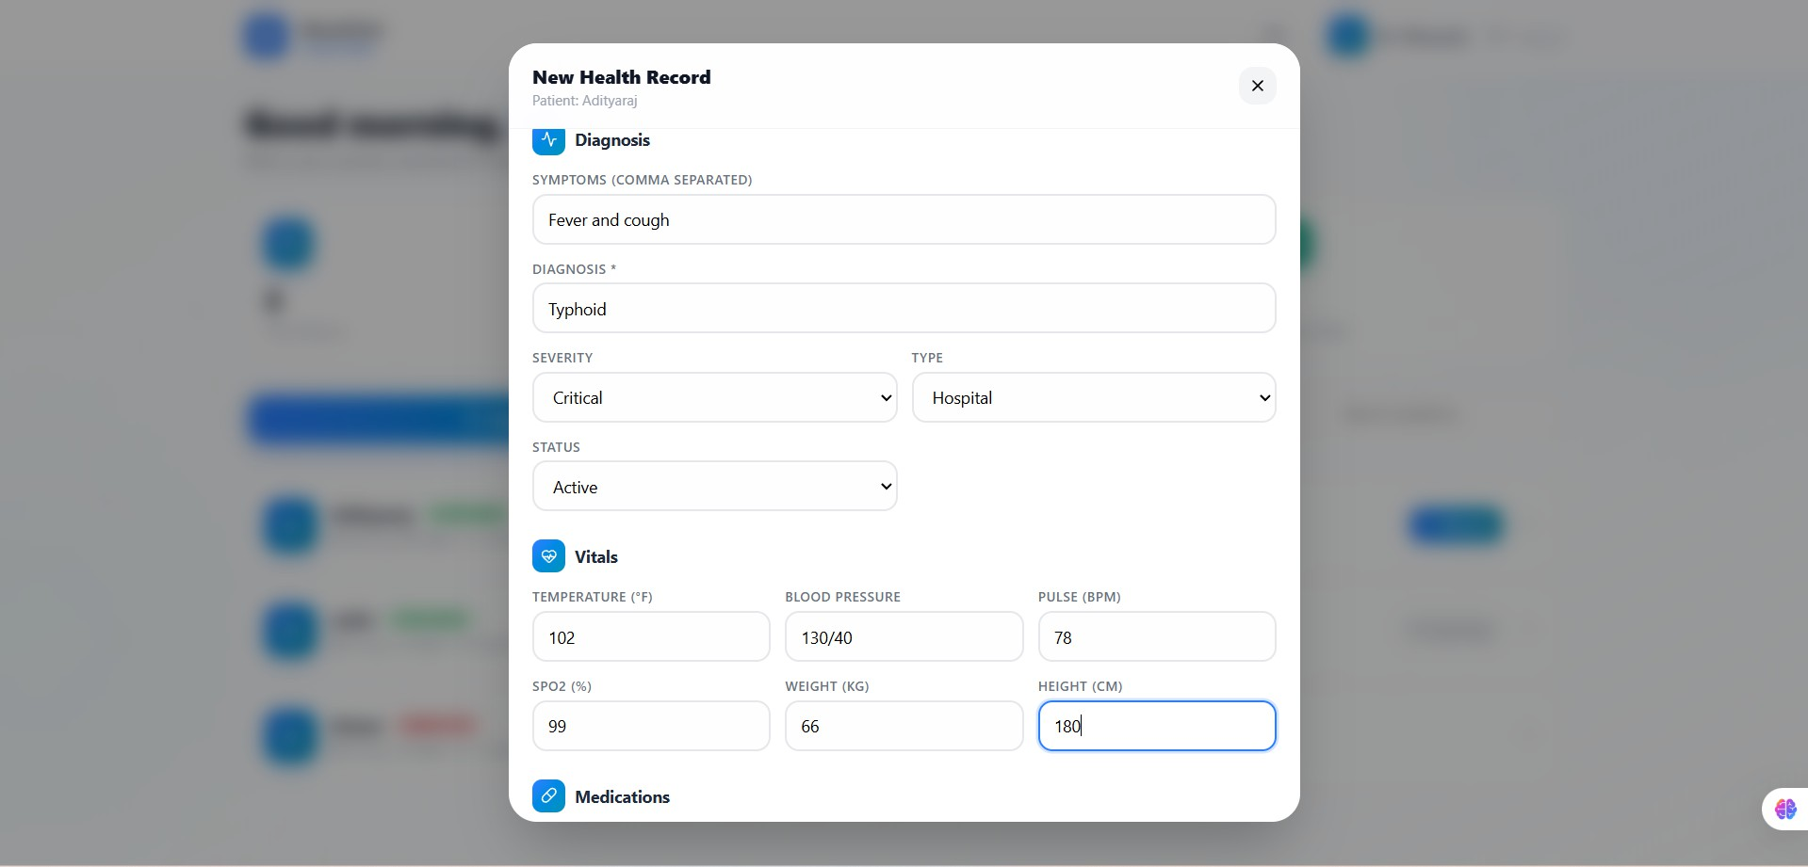

Fig. 8. After diagnosis, the doctor can add the test results and medications

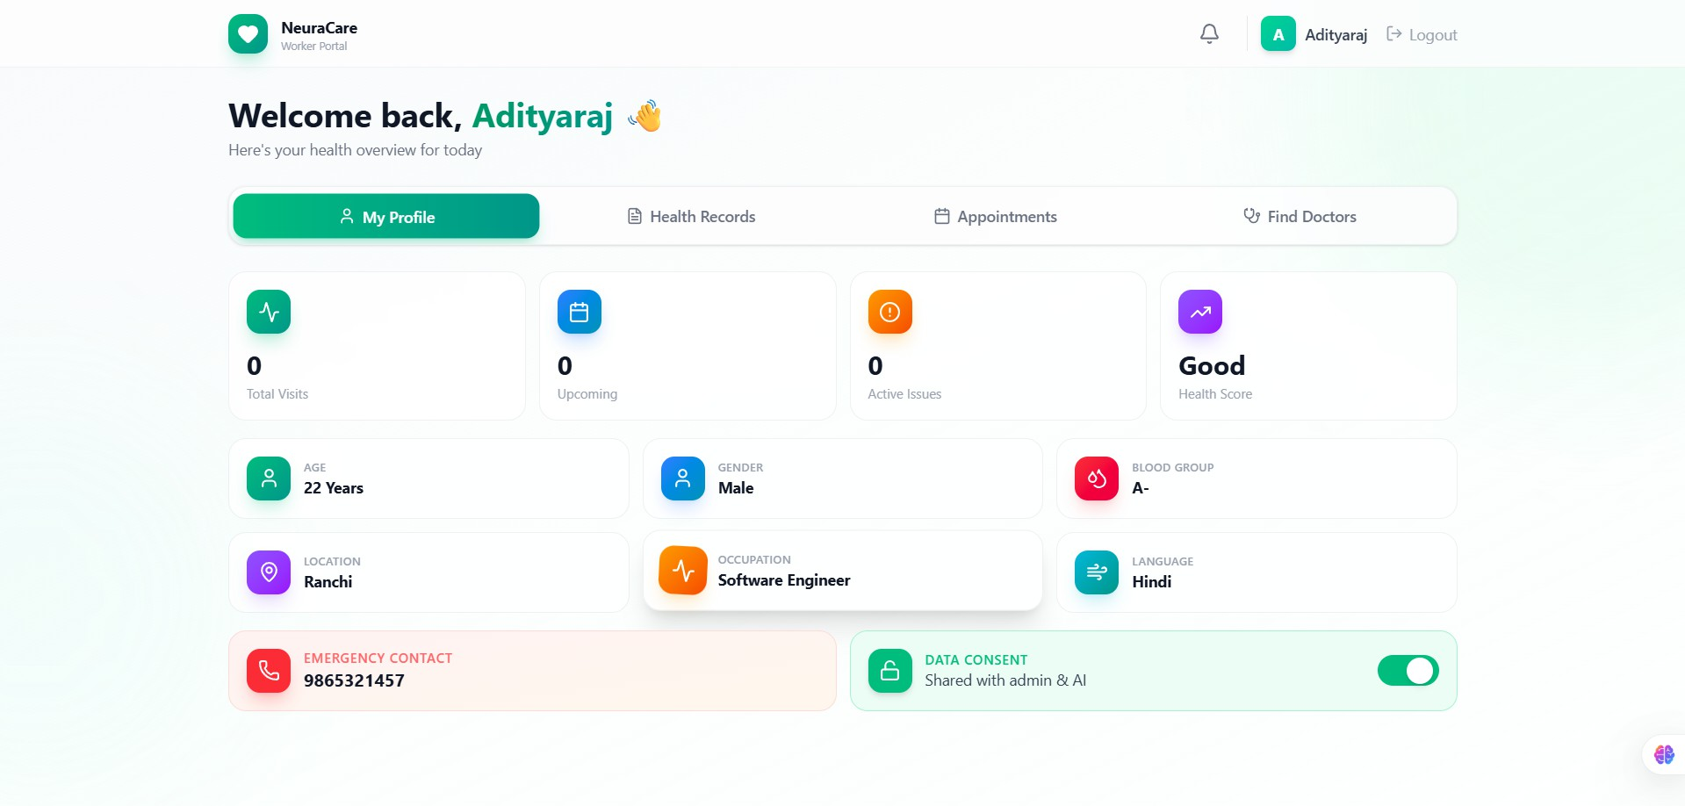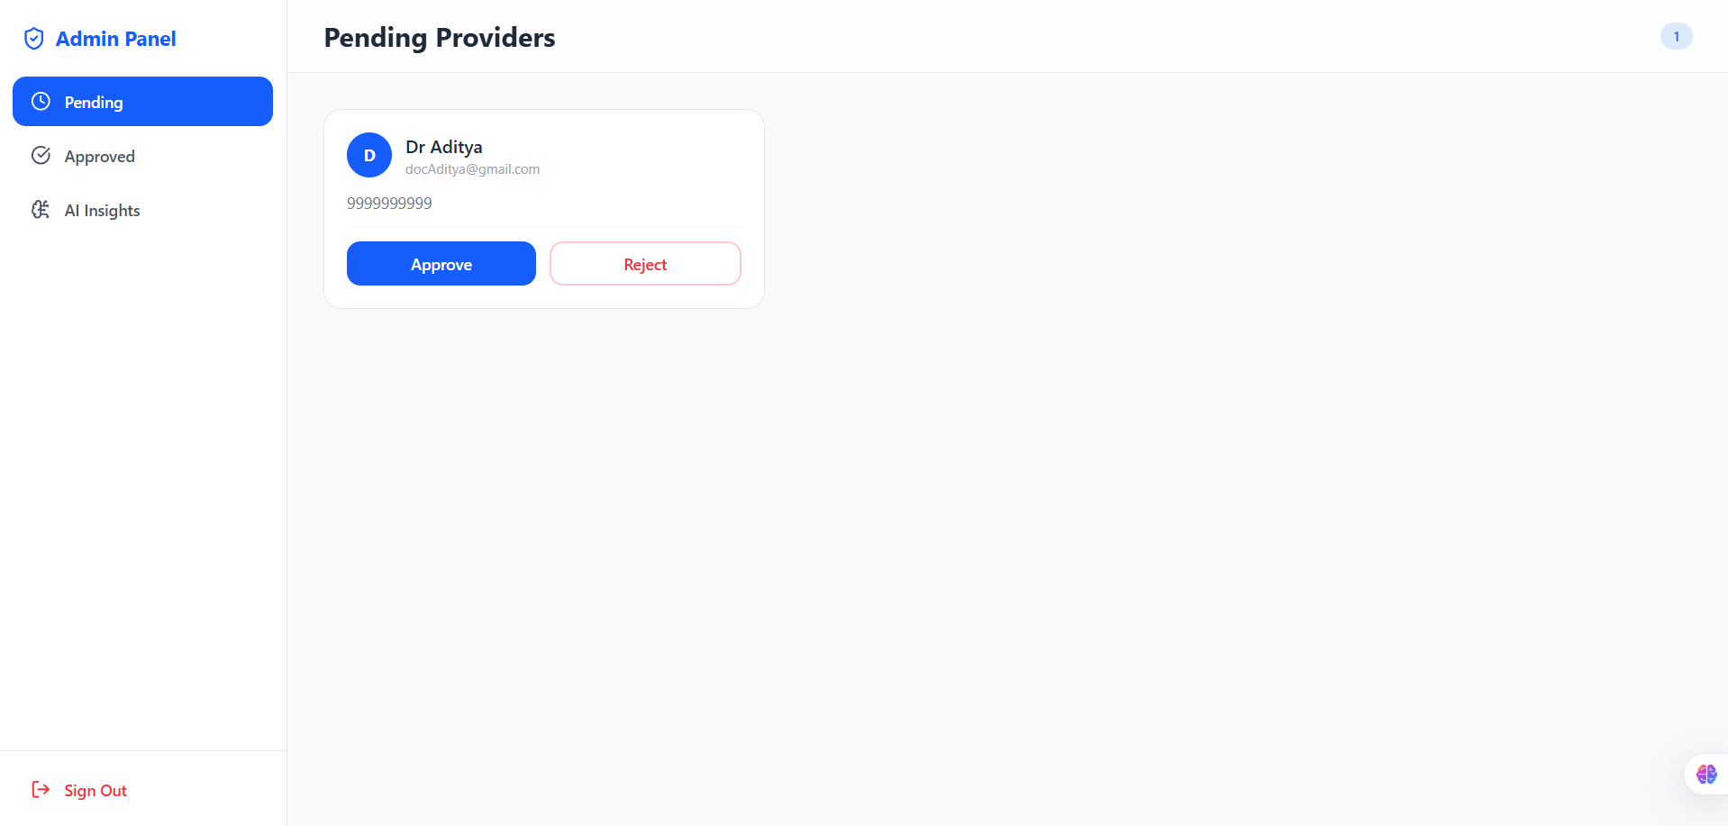

Fig. 5. After they have filled their details, then they will come to dashboard
Fig. 9. Admin dashboard where admin can approve or reject doctor.

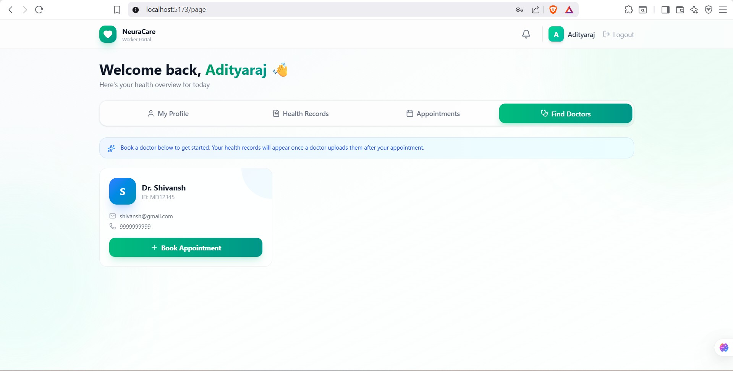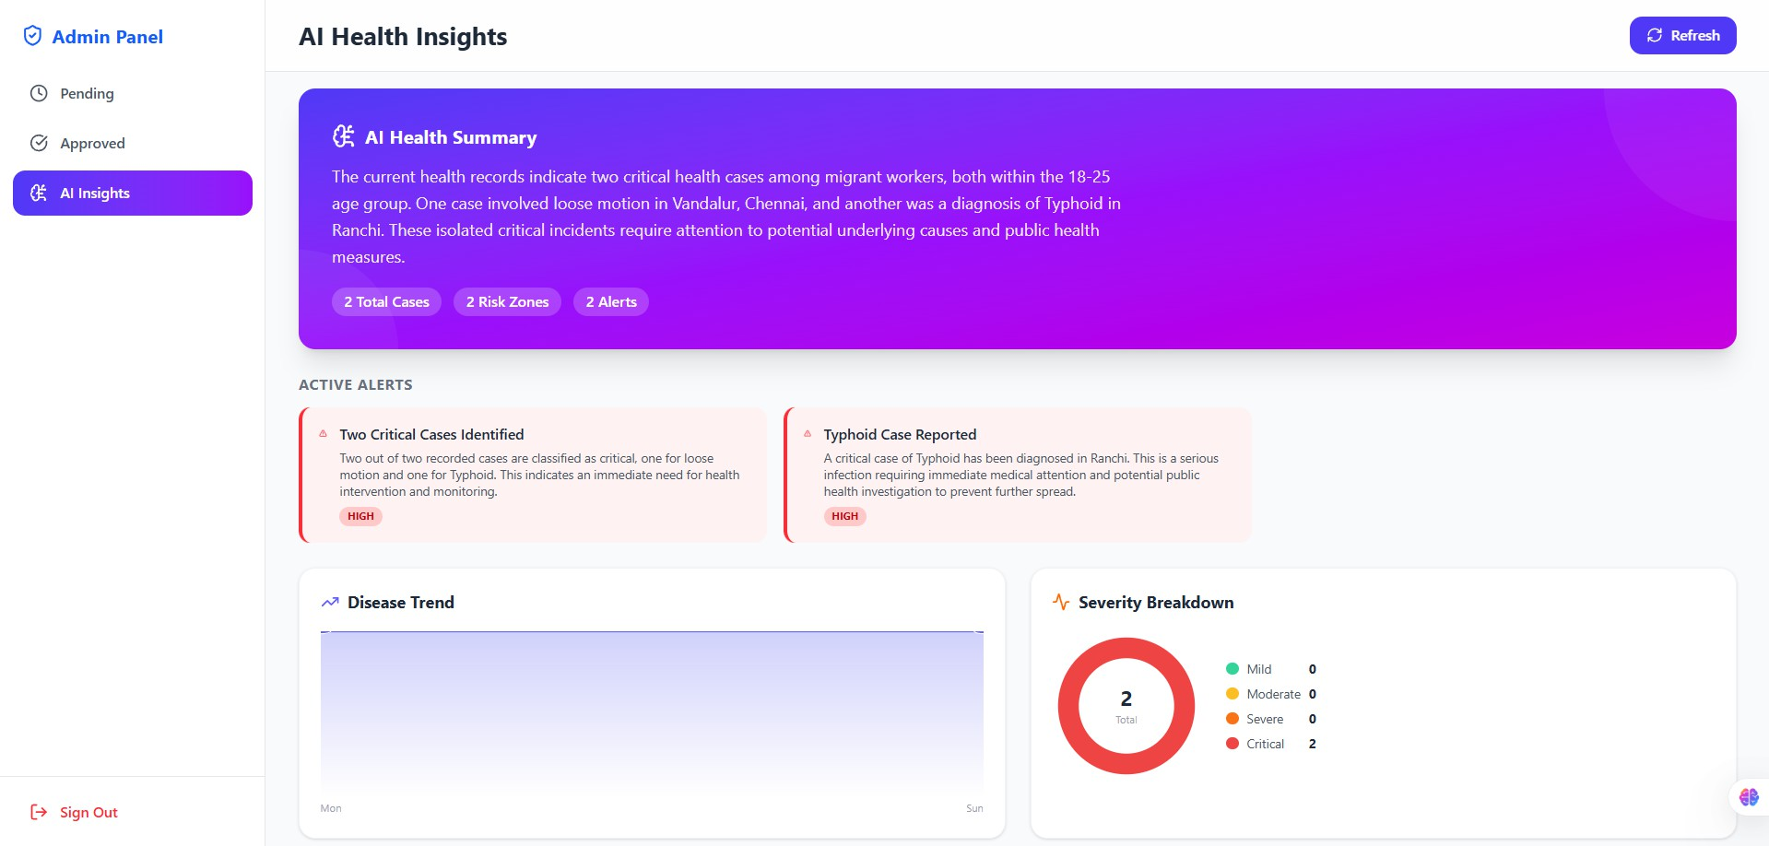

Fig. 6. Patient’s can find doctor according to their health condition
Fig. 10. AI insights tab where admin can see summary, severe diseases and disease trend graph

