Implement and Manage Zero Trust Network Access (ZTNA) with Zscaler: Identity-Based Secure Remote Access

S.No | NAME | COLLEGE NAME | CONTACT
1. | PRIYADHARSHINI S | SRI KRISHNA ADITHYA COLLEGE OF ARTS AND SCIENCE | 23bscs142priyadharshinis@skacas.ac.in
2. | SRI SANGARI R | SRI KRISHNA ADITHYA COLLEGE OF ARTS AND SCIENCE | 23bscs155srisangarir@skacas.ac.in
3. | SOWMIYA UD | SRI KRISHNA ADITHYA COLLEGE OF ARTS AND SCIENCE | 23bscs154sowmiyaud@skacas.ac.in
4. | SRI SARAN V | SRI KRISHNA ADITHYA COLLEGE OF ARTS AND SCIENCE | 23bscs156srisaranv@skacas.ac.in
5. | SUDHARSAN RA | SRI KRISHNA ADITHYA COLLEGE OF ARTS AND SCIENCE | 23bscs157sudharsanra@skacas.ac.in

Project details

Title: Zero Trust Network Access (ZTNA) with Zscaler: Identity-Based Secure Remote Access

Identity-Based Secure Remote Access (IBSRA)
Identity-Based Secure Remote Access (IBSRA) is a modern security framework that focuses on verifying user identity before granting access to remote systems, applications, and organizational networks. Instead of relying solely on traditional network-based security methods such as VPNs or static passwords, IBSRA uses identity-centric authentication techniques—such as multi-factor authentication (MFA), behavioral analysis, and contextual access policies—to ensure that only authorized users can securely connect to resources from remote locations.
IBSRA is crucial for modern digital environments where employees, partners, and users frequently access systems from different locations and devices. Traditional perimeter-based security models are no longer sufficient because cyber attackers often exploit stolen credentials, phishing attacks, and unsecured remote connections. By focusing on verifying who the user is rather than where the connection originates, IBSRA strengthens security while enabling flexible remote work. This approach helps organizations prevent unauthorized access, protect sensitive data, and maintain secure remote connectivity by continuously validating user identity and access permissions throughout the session.

Abstract
The rapid expansion of remote work and cloud-based services has exposed the limitations of traditional network-centric security approaches such as legacy VPN architectures. These systems often grant users broad network access once authenticated, increasing the risk of lateral movement, unauthorized access, and data breaches. To address these challenges, modern security models emphasize identity as the primary control point for granting and managing remote access to organizational resources.
This project focuses on the design and implementation of an Identity-Based Secure Remote Access (IBSRA) framework that prioritizes user identity and contextual verification before allowing access to internal applications and services. Instead of providing full network-level connectivity, the system establishes secure, application-specific connections based on authenticated user identity, device posture, and access policies. By integrating identity providers, multi-factor authentication, and endpoint security mechanisms, the architecture ensures that only verified and authorized users can remotely access organizational resources.
The framework also supports centralized monitoring and security integration through logging and threat intelligence systems, enabling continuous evaluation of user activity and adaptive access control. This approach minimizes the exposure of internal systems, reduces the potential attack surface, and strengthens protection against credential misuse and cyber threats. The resulting solution provides a scalable and resilient security architecture that enforces least-privilege access while ensuring secure and efficient remote connectivity for users.

Use Case Scenarios
Scenario 1: Secure Remote Access for Employee to Internal HR Application
An employee working remotely needs to access the organization’s internal Human Resource (HR) application to update personal records and view payroll information. Using an Identity-Based Secure Remote Access framework, the employee connects securely to the application without gaining full access to the internal corporate network. The system verifies the user’s identity through the organization’s identity management system with Multi-Factor Authentication (MFA) and checks the device’s security posture before granting access.
Output:
User identity verified through the organizational identity provider
Device posture validated (antivirus active, operating system updated)
Secure connection established only to the HR application
Internal corporate network remains hidden and inaccessible to the user
Scenario 2: Remote Developer Accessing Internal Development Server
A software developer working remotely needs access to a specific internal development server to update application code. Through Identity-Based Secure Remote Access, the developer establishes a secure connection directly to the required server rather than accessing the entire network. Access policies ensure that the developer can only reach the authorized development resource.
Output:
Developer identity authenticated using corporate credentials and MFA
Access policy enforced allowing connection to the Development Server only
Other internal systems remain inaccessible and hidden
Unauthorized access attempts to additional resources automatically blocked
Scenario 3: Student Access to University Learning Management System (LMS)
Students require remote access to the university’s Learning Management System (LMS) to attend online classes, access study materials, and submit assignments. The Identity-Based Secure Remote Access system verifies student identities through the institutional login system and allows access only to the LMS portal while restricting access to sensitive administrative systems.

Output:
Student identity verified through institutional authentication system
Secure connection established only to the LMS application
Access to administrative databases and internal servers restricted
Internal infrastructure remains hidden from public internet exposure
Scenario 4: IT Administrator Accessing Server Management Interface
An IT administrator needs to perform maintenance on an internal application server. Using Identity-Based Secure Remote Access, the administrator connects securely to the server management interface without obtaining unrestricted network access. Continuous monitoring ensures that all actions comply with organizational security policies.
Output:
Administrator identity verified using Multi-Factor Authentication
Secure connection established only to the server management interface
Administrative actions recorded for auditing and compliance
Attempts to access unauthorized servers automatically denied
Scenario 5: Temporary Vendor Access to Internal Application
A third-party vendor hired for system maintenance requires limited, temporary access to a specific internal application. Through Identity-Based Secure Remote Access, the organization provides time-restricted, identity-based access that allows the vendor to connect only to the required system without exposing the internal network.
Output:
Vendor identity verified using temporary authenticated credentials
Access restricted to the maintenance application only
All user activities recorded in the security monitoring system
Access privileges automatically revoked after the authorized period ends

Stage-1

Title Of the Project: -

Zero Trust Network Access (ZTNA) with Zscaler: Identity-Based Secure Remote Access

Overview
The project aims to design and implement a secure remote access framework based on an identity-centric security model using the principles of Zero Trust. Traditional network security mechanisms often rely on perimeter-based protection methods such as Virtual Private Networks (VPNs), where users gain broad connectivity once authenticated. This approach increases the risk of unauthorized access and potential security breaches because access decisions are often based on network location rather than verified user identity.
To address these limitations, the proposed system focuses on Identity-Based Secure Remote Access, where user identity becomes the primary factor for granting and controlling remote connectivity. Instead of trusting users simply because they are connected to the network, every access request is evaluated based on verified identity attributes. This approach ensures that only authenticated and authorized users are allowed to establish remote sessions, thereby strengthening the overall security of the system.
The main objective of this project is to implement a secure identity-driven access mechanism using the Zscaler cloud security platform. Access decisions are determined through strong identity verification processes that confirm the legitimacy of the user before remote access is granted. By prioritizing identity validation, the system ensures that user privileges are assigned according to authenticated identity profiles and predefined security policies.
The system integrates an identity provider such as Azure Active Directory to perform secure user authentication. Advanced authentication mechanisms, including Multi-Factor Authentication (MFA), are implemented to provide additional layers of security. These methods verify user identity through multiple authentication factors such as passwords, authentication applications, or biometric verification, thereby reducing the risk of credential compromise.
Another important feature of the system is continuous identity verification. Instead of validating identity only at the initial login stage, the system continuously evaluates user identity throughout the entire remote session. Contextual parameters such as user identity attributes, device status, login location, and behavioral patterns are analyzed to determine whether the session remains trustworthy. If suspicious activity or unusual behavior is detected, the system can immediately restrict or terminate the session to prevent potential security threats.
Monitoring and logging mechanisms are also integrated into the framework to provide visibility into authentication and access activities. Security administrators can monitor identity-based events, review authentication attempts, and generate security reports through centralized management dashboards. Integration with Security Information and Event Management (SIEM) systems further enhances the ability to detect anomalies and respond quickly to identity-related security incidents.

The project also focuses on protecting data security and user privacy by encrypting all communication channels used during remote access sessions. All authentication requests and identity verification processes are transmitted through secure encrypted connections to ensure that sensitive identity information cannot be intercepted or compromised. Encrypted communication channels help maintain confidentiality and integrity of user credentials and authentication data during remote access operations.
Secure connection mechanisms ensure that identity verification traffic is transmitted through protected communication paths without exposing sensitive authentication systems to the public internet. By protecting identity infrastructure and authentication endpoints, the system minimizes the possibility of unauthorized access attempts and reduces the risk of identity-based attacks.
Scalability and reliability are important design considerations for the proposed system. The Zscaler cloud platform provides a globally distributed architecture capable of supporting a large number of remote users who require secure identity verification and authentication services from different geographic locations. Distributed cloud gateways and intelligent load balancing mechanisms ensure consistent authentication performance and reliable identity verification even during high user activity periods.
Security compliance and governance are maintained through strict identity-based access control policies that follow the principle of least privilege. Each user is granted only the minimum level of access permissions required according to their verified identity and role within the organization. This identity-driven access control approach helps prevent privilege misuse and limits the impact of potential security incidents.
Monitoring, logging, and auditing mechanisms are integrated into the system to maintain transparency and accountability. Authentication attempts, identity verification events, and user access activities are recorded in centralized logs. These audit trails help organizations meet regulatory compliance requirements while also enabling security administrators to investigate suspicious behavior and respond to potential identity-related threats.
The cloud-based architecture further improves the flexibility and adaptability of the system by allowing organizations to scale identity verification services dynamically based on user demand. Continuous threat intelligence updates strengthen the platform’s ability to detect suspicious authentication attempts, compromised credentials, and identity-based attacks.
Overall, the proposed system demonstrates how an identity-based security model supported by the Zscaler cloud platform can provide secure remote access by emphasizing strong identity verification, encrypted communication, continuous monitoring, and proactive threat detection mechanisms.

List of Vulnerability Table:

S.no | Vulnerability Name | CWE - No
1 | Improper Ownership Management | CWE-282
2 | Clear text Storage of Sensitive Information in a Cookie | CWE-315
3 | Use of Unmaintained Third Party Components | CWE-1104
4 | Insufficient Entropy | CWE-331
5 | Unchecked Error Condition | CWE-391
6 | Embedded Malicious Code | CWE-506
7 | Missing Encryption of Sensitive Data | CWE-311
8 | Missing XML Validation | CWE-112
9 | Missing Critical Step in Authentication | CWE-304
10 | Insufficient Logging | CWE-778

REPORT: -

Vulnerability Name: Improper Ownership Management

CWE/CVE: CWE-282

OWASP/SANS Category: A01:2025-Broken Access Control

Description: Improper Ownership Management occurs when a system fails to correctly assign or enforce ownership permissions for resources such as files, applications, or data. In such situations, unauthorized users may gain the ability to access, modify, or delete resources that should be restricted to specific owners or administrators. This vulnerability often arises due to incorrect configuration of access controls, weak permission management, or improper handling of user roles and privileges. Attackers may exploit this weakness to manipulate ownership settings, leading to unauthorized control over critical system resources.
Business Impact: If ownership management is not properly enforced, attackers or unauthorized users may gain access to sensitive resources and perform actions that compromise system integrity. This can result in unauthorized modification or deletion of important data, disruption of business operations, and potential data breaches. Additionally, organizations may face financial losses, legal consequences, and reputational damage if sensitive information or critical systems are compromised due to improper access control mechanisms.
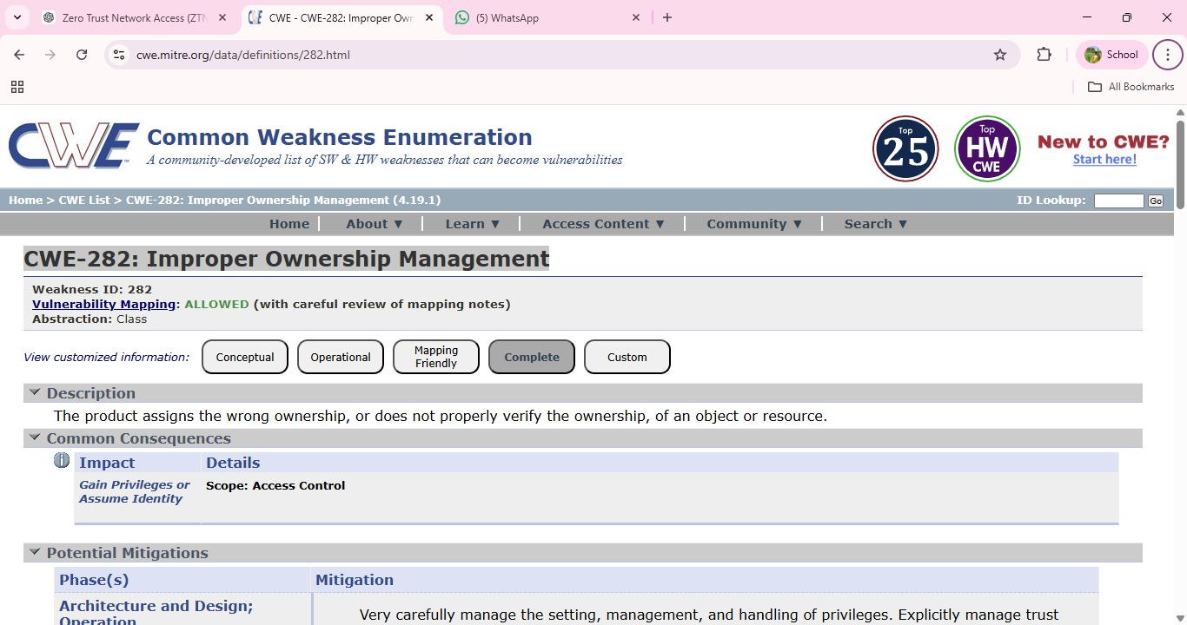

Vulnerability Name: Cleartext Storage of Sensitive Information in a Cookie

CWE/CVE: CWE-315

OWASP/SANS Category: A02:2025-Security Misconfiguration

Description: Cleartext Storage of Sensitive Information in a Cookie occurs when an application stores confidential data such as user credentials, session identifiers, or personal information in browser cookies without encryption. Since cookies are stored on the client side, they can be accessed by attackers through browser vulnerabilities, cross-site scripting (XSS) attacks, or by intercepting network traffic. If sensitive information is stored in plain text, attackers can easily read and misuse the data to gain unauthorized access to user accounts or application resources.
Business Impact: Storing sensitive information in cleartext cookies can lead to serious security risks such as session hijacking, unauthorized account access, and data breaches. Attackers may impersonate legitimate users and gain access to confidential information or internal systems. This can result in financial loss, legal liabilities, and damage to the organization's reputation, especially if customer or employee data is exposed.

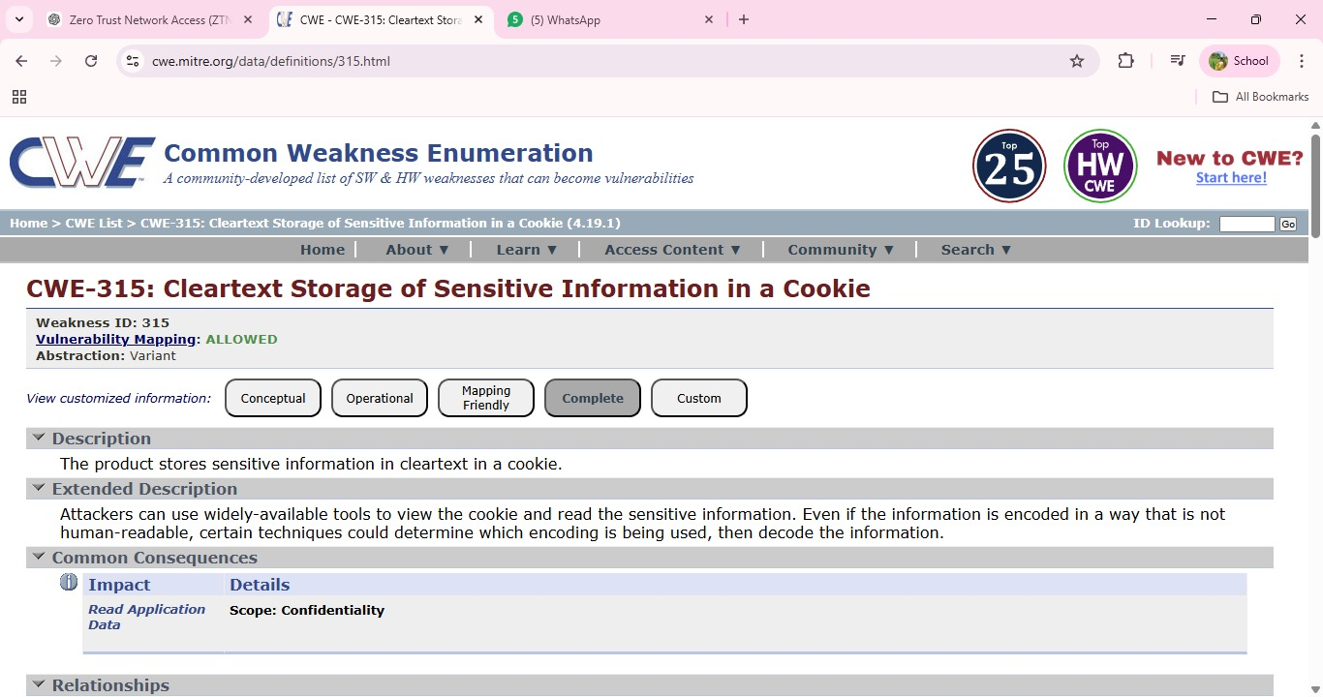

Vulnerability Name: Use of Unmaintained Third Party Components

CWE/CVE: CWE-1104

OWASP/SANS Category: A03 :2025-Software Supply Chain Failures

Description: Use of Unmaintained Third Party Components occurs when an application depends on external libraries, frameworks, or software components that are no longer actively maintained or updated by their developers. These outdated components may contain known security vulnerabilities that remain unpatched, making the application susceptible to exploitation. Attackers often scan systems for such components and exploit their weaknesses to gain unauthorized access, execute malicious code, or compromise the system.
Business Impact: Using unmaintained third-party components can expose an organization to significant security risks. Attackers may exploit known vulnerabilities to compromise applications, leading to data breaches, service disruptions, or unauthorized system access. This can result in financial losses, regulatory compliance issues, and damage to the organization's reputation. Maintaining updated and supported software components is therefore essential for ensuring long-term system security.

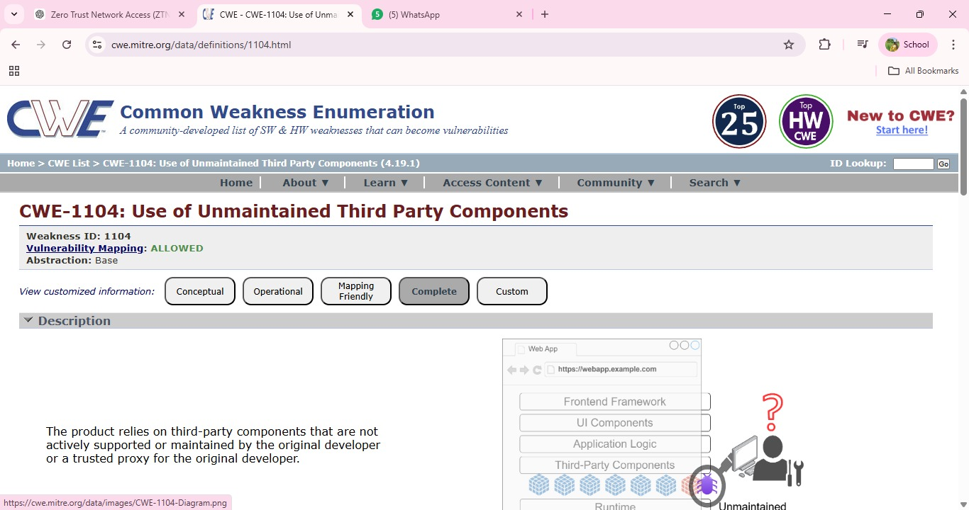

- Vulnerability Name: Insufficient Entropy
CWE/CVE: CWE-331
OWASP/SANS Category: A04 :2025-Cryptographic Failures

Description: Insufficient Entropy occurs when a system generates random values, such as cryptographic keys, session IDs, or tokens, using weak or predictable sources of randomness. Entropy refers to the level of unpredictability in generated values. When entropy is insufficient, attackers may be able to predict or reproduce these values, allowing them to bypass security mechanisms. This vulnerability often appears in authentication systems, encryption processes, or session management where strong randomness is required to maintain security.

Business Impact: If attackers can predict security tokens, session identifiers, or cryptographic keys, they may gain unauthorized access to user accounts or sensitive systems.This can lead to session hijacking, data breaches, and unauthorized transactions. For organizations, such incidents may result in financial losses, legal consequences, and damage to customer trust and reputation. Ensuring strong random number generation is essential to maintain system security.

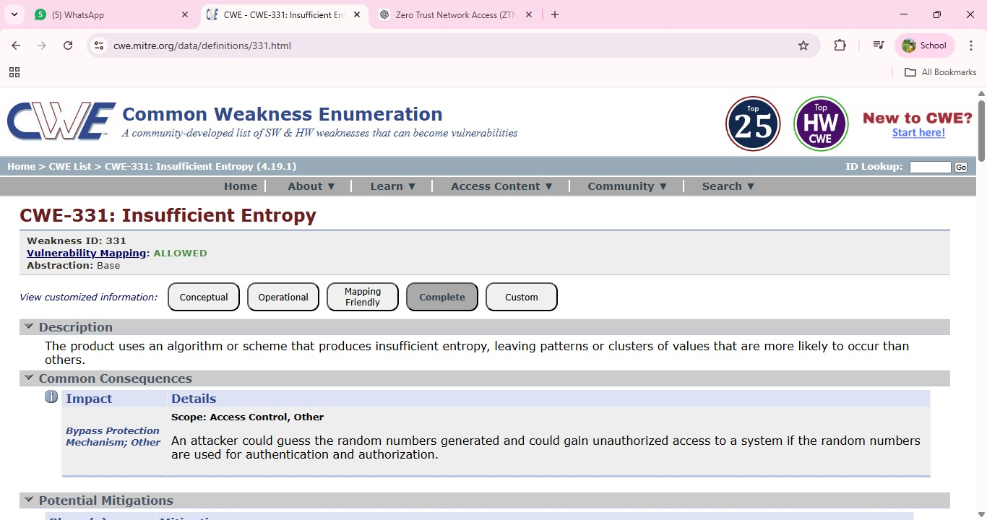

Vulnerability Name: Unchecked Error Condition

CWE/CVE: CWE-391
OWASP/SANS Category: A10 :2025-Mishandling of Exceptional Conditions

Description: Unchecked Error Condition occurs when a system or application fails to properly handle errors that occur during program execution. Instead of detecting and responding to these errors appropriately, the system may ignore them or continue processing without taking corrective action. This can lead to unexpected system behavior, incorrect outputs, or security weaknesses. Attackers may exploit such situations to trigger abnormal conditions, potentially bypassing security controls or causing the application to behave in unintended ways.
Business Impact: Failure to properly handle errors can result in system instability, data corruption, or unauthorized system behavior. Attackers may exploit these weaknesses to disrupt services, manipulate application functionality, or gain access to sensitive information. For organizations, this can lead to operational downtime, financial losses, and damage to reputation due to unreliable or insecure systems. Proper error handling and monitoring mechanisms are essential to maintain application reliability and security.

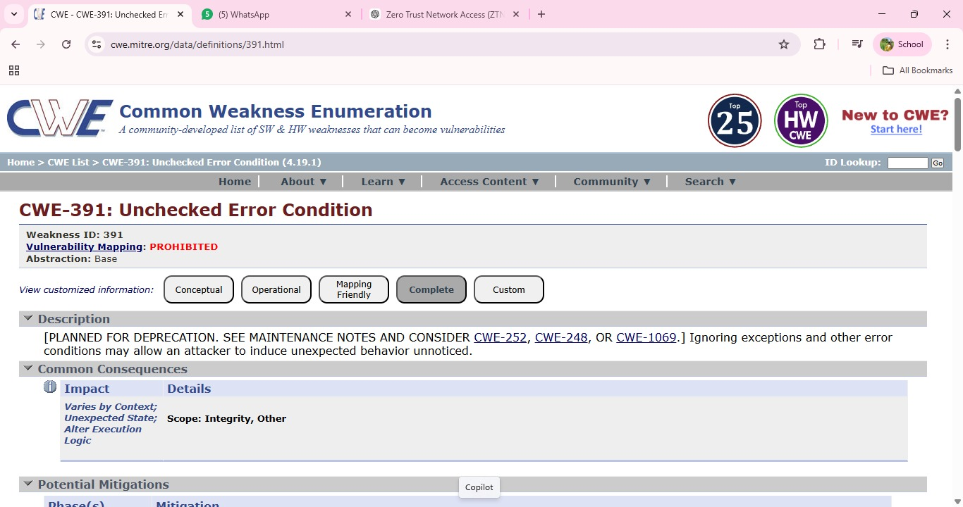
- Vulnerability Name: Embedded Malicious Code
CWE/CVE: CWE-506
OWASP/SANS Category: A08 :2025-Software or Data Integrity Failures

Description: Embedded Malicious Code refers to the presence of intentionally harmful code hidden within an application or software component. This malicious code may be inserted by attackers, compromised third-party libraries, or during insecure development practices. Such code can perform unauthorized actions such as stealing sensitive information, creating backdoors, or executing harmful operations without the user’s knowledge. Because the code is embedded within legitimate software, it may remain undetected for long periods and can be triggered under specific conditions.
Business Impact: The presence of embedded malicious code can severely compromise the security and reliability of an organization’s systems.Attackers may use it to steal confidential data, gain unauthorized access, or disrupt system operations. This can lead to data breaches, financial losses, operational downtime, and reputational damage. In critical environments, malicious code may also affect the integrity of applications and undermine trust in the organization’s software systems.
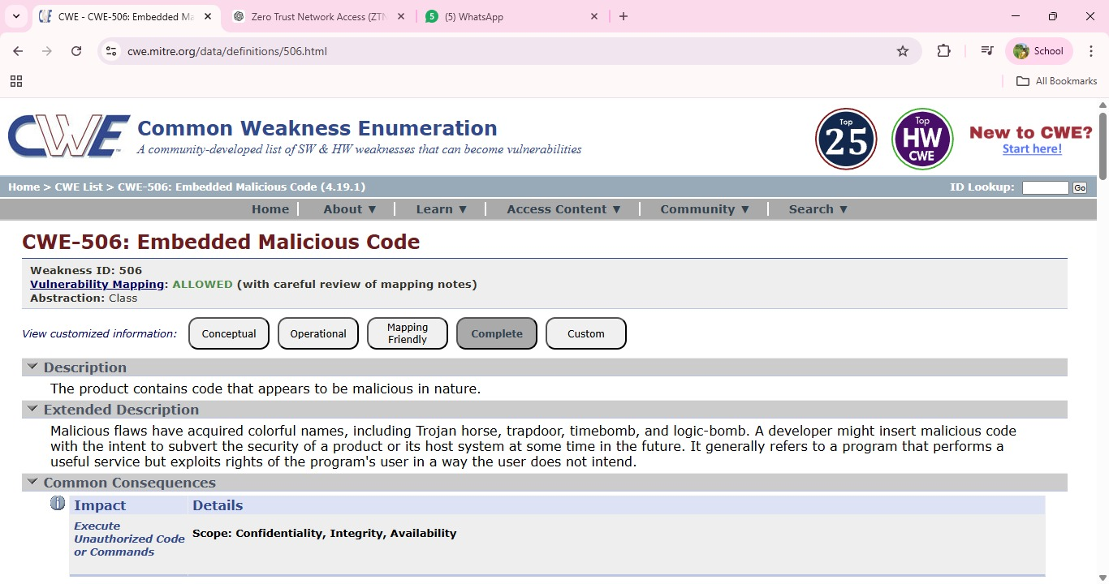

Vulnerability Name: Missing Encryption of Sensitive Data

CWE/CVE: CWE-311

OWASP/SANS Category: A06 :2025-Insecure Design

Description: Missing Encryption of Sensitive Data occurs when an application or system transmits or stores confidential information without using proper encryption mechanisms. Sensitive data such as user credentials, financial records, personal information, or internal system details may be exposed in plain text. If this data is intercepted during transmission or accessed by unauthorized users, attackers can easily read and misuse the information. This vulnerability often arises due to poor security configuration or failure to implement secure communication protocols.
Business Impact: Missing Encryption of Sensitive Data occurs when an application or system transmits or stores confidential information without using proper encryption mechanisms. Sensitive data such as user credentials, financial records, personal information, or internal system details may be exposed in plain text. If this data is intercepted during transmission or accessed by unauthorized users, attackers can easily read and misuse the information. This vulnerability often arises due to poor security configuration or failure to implement secure communication protocols.

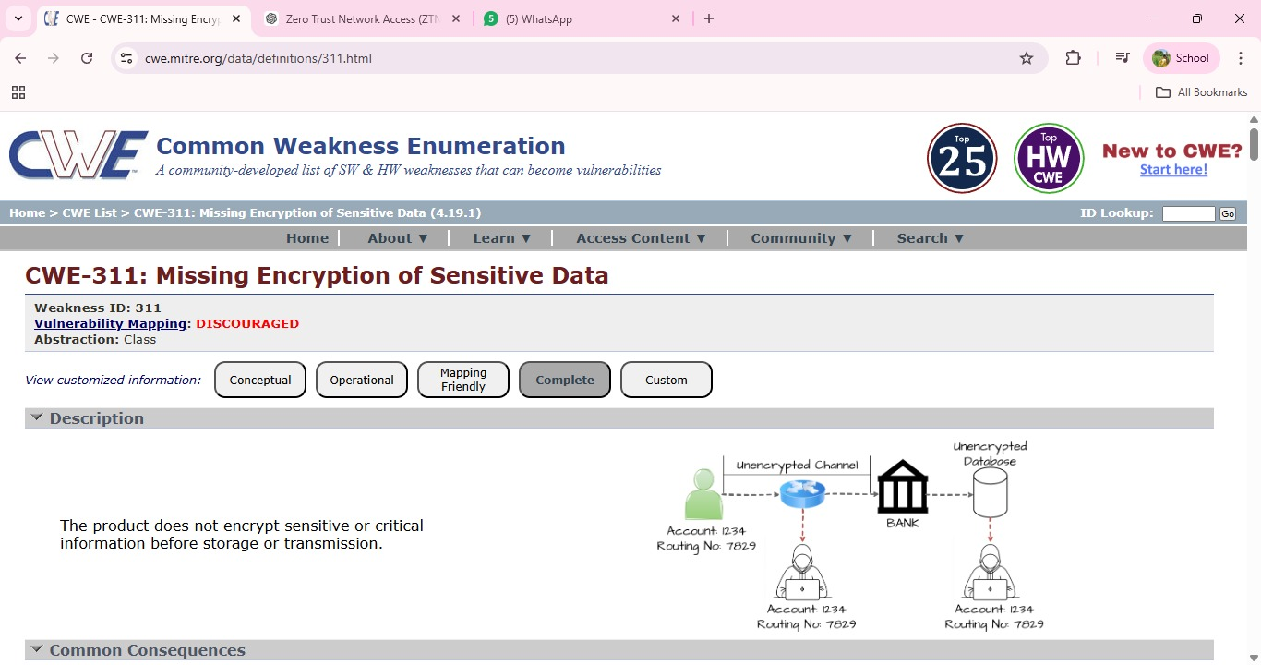

Vulnerability Name: Missing XML Validation

CWE/CVE: CWE-112

OWASP/SANS Category: A05 :2025-Injection

Description: Missing XML Validation occurs when an application processes XML input without properly validating its structure or content. XML is widely used for data exchange between systems, and if proper validation mechanisms are not implemented, attackers may send specially crafted XML data to manipulate application behavior. Without validation, the system may accept malicious or malformed XML input that can lead to security vulnerabilities such as XML injection, data manipulation, or unauthorized access to system resources.

Business Impact: If XML inputs are not properly validated, attackers may exploit this weakness to alter application data, bypass security checks, or disrupt normal system operations. This can lead to data integrity issues, service interruptions, and potential exposure of sensitive information. For organizations, such incidents may result in operational disruptions, financial losses, and reduced trust from customers or partners due to compromised system security.

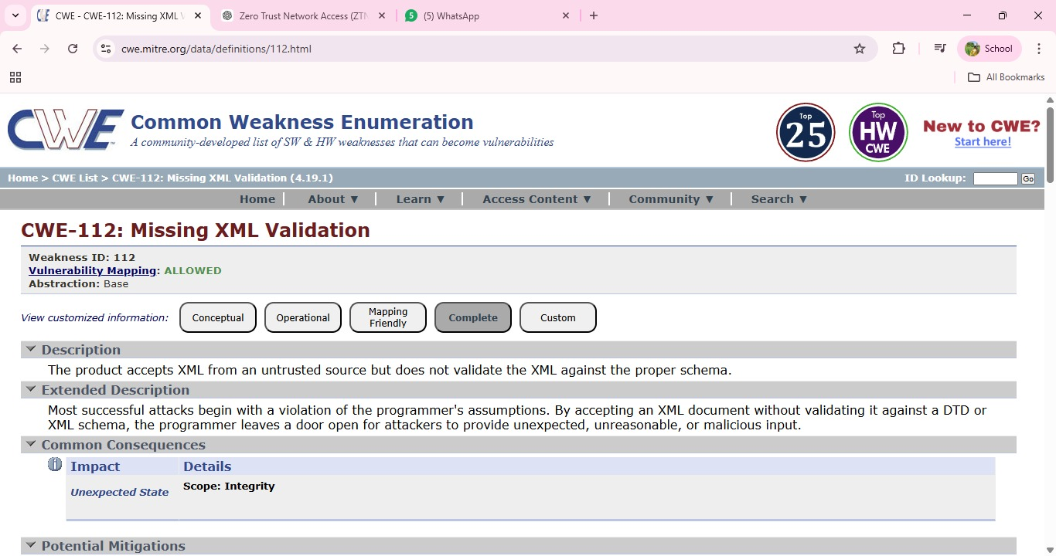

- Vulnerability Name: Missing Critical Step in Authentication
CWE/CVE: CWE-304
OWASP/SANS Category: A07 :2025-Authentication Failures

Description: Missing Critical Step in Authentication occurs when an application fails to enforce an essential step in the authentication process required to verify a user's identity. This may happen when security mechanisms such as multi-factor authentication, verification tokens, or session validation are skipped or improperly implemented. As a result, attackers may bypass authentication controls and gain unauthorized access to protected resources or user accounts. Such vulnerabilities often arise due to poor authentication logic or incomplete implementation of security checks.

Business Impact: If critical authentication steps are missing, attackers may successfully bypass login protections and gain unauthorized access to sensitive systems or user accounts.This can lead to data breaches, unauthorized transactions, and compromise of confidential information. For organizations, the impact may include financial losses, legal consequences, and damage to their reputation due to the failure to properly protect user authentication processes.

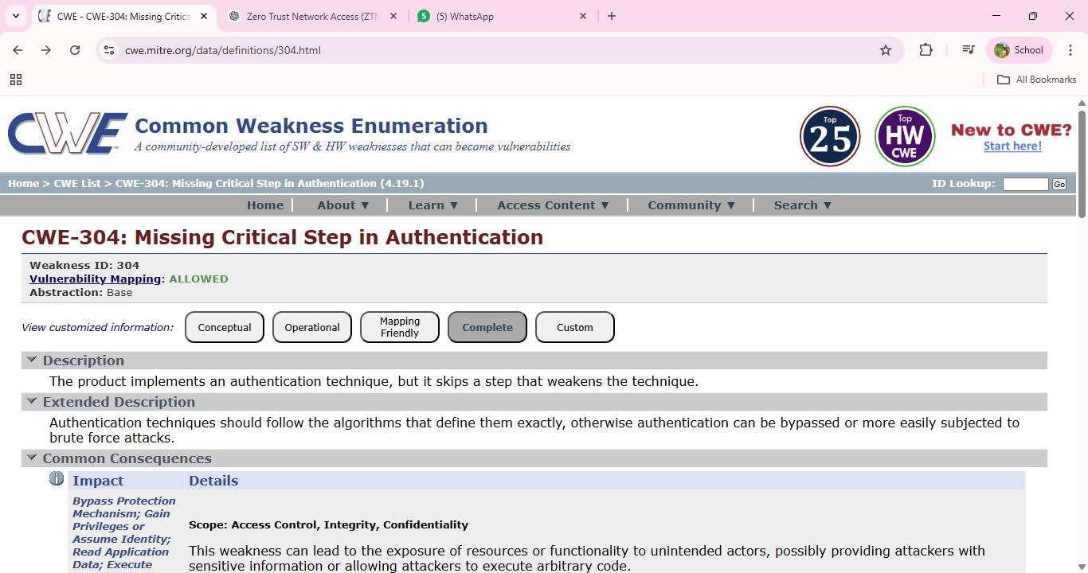

Vulnerability Name: Insufficient Logging

CWE/CVE: CWE-778

OWASP/SANS Category: A09 :2025-Security Logging and Alerting Failures

Description: Insufficient Logging occurs when an application or system fails to properly record security-related events such as login attempts, access requests, system errors, or configuration changes. Without adequate logging mechanisms, it becomes difficult to detect suspicious activities, unauthorized access attempts, or potential security breaches. Attackers may exploit this weakness to perform malicious actions without leaving sufficient evidence for administrators to identify or investigate the incident.
Business Impact: Lack of proper logging can significantly delay the detection of security incidents and make it difficult for organizations to respond effectively to cyber threats. Without accurate logs, identifying the source and impact of an attack becomes challenging, which may result in prolonged system compromise or data breaches. This can lead to operational disruptions, financial losses, regulatory compliance issues, and damage to the organization’s reputation.

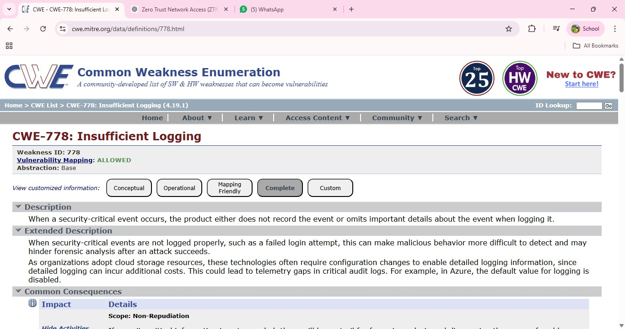

Stage 2

Overview
Nessus is one of the most widely used vulnerability scanning tools developed by Tenable, Inc.. It is designed to identify security weaknesses in systems, networks, and applications before attackers can exploit them. In environments that implement Identity-Based Secure Remote Access, vulnerability assessment tools such as Nessus play an important role in ensuring that authentication systems, servers, and network services remain secure.
Nessus functions as a remote vulnerability scanner, meaning it can evaluate systems across a network without requiring installation on the target devices. By sending different types of network requests and analyzing system responses, Nessus detects vulnerabilities that could potentially compromise authentication mechanisms, identity management systems, or remote access infrastructure.
The primary goal of Nessus is to help organizations maintain a secure IT environment by continuously identifying weaknesses in operating systems, software applications, and network services. Security administrators use Nessus to perform vulnerability assessments and prioritize remediation efforts based on the severity of identified issues. This process helps ensure that the infrastructure supporting identity verification and secure remote connectivity remains protected from potential attacks.

Working Principle of Nessus
Nessus operates using a plugin-based architecture. Plugins are specialized scripts designed to test for specific vulnerabilities. These plugins contain information about known security flaws, system misconfigurations, outdated software, and policy violations that may affect system security.
During a scan, Nessus first performs host discovery to determine whether a target system is active on the network. Once the system is identified, the scanner gathers information such as the operating system type, open ports, and running services. This information helps the tool understand the system configuration and identify potential attack points.
After the discovery phase, Nessus executes relevant plugins to test the system for known vulnerabilities. These plugins simulate security checks to detect weaknesses that could compromise network services, authentication mechanisms, or remote access systems.
Nessus then analyzes the responses received from the target system and compares them with its vulnerability database. If a vulnerability is detected, the system records the issue and provides detailed information about the vulnerability along with recommended remediation steps.

Steps Involved in Nessus Scanning
Connection to Target Host
Nessus establishes communication with the target system using network protocols such as TCP, UDP, and ICMP.
Host Discovery and Information Gathering
The scanner identifies the operating system, open ports, and active services running on the target system.

Plugin Execution
Nessus runs a set of vulnerability detection plugins to test for known security weaknesses.
Vulnerability Detection and Analysis
The tool analyzes responses from the target system and identifies potential vulnerabilities by comparing them with known vulnerability signatures.
Report Generation
Nessus generates a detailed vulnerability report containing severity levels, descriptions of vulnerabilities, and recommended remediation strategies.

Features of Nessus
Nessus provides several important features that support security assessment processes.
Extensive Vulnerability Database
Nessus includes thousands of plugins that detect vulnerabilities across operating systems, applications, and network services.
User-Friendly Interface
The web-based interface allows security administrators to easily configure scans and analyze vulnerability results.
Detailed Reporting
Nessus generates comprehensive reports with severity ratings, technical descriptions, and mitigation recommendations.
Flexible Scanning Options
It supports scanning individual systems, entire networks, or specific services depending on assessment requirements.
Scheduled Scanning
Security teams can automate scans to run periodically in order to continuously monitor system security.

Importance of Nessus in Security Assessment
Nessus plays a critical role in proactive cybersecurity management. By identifying vulnerabilities early, organizations can take corrective actions before attackers exploit security weaknesses. In environments that implement Identity-Based Secure Remote Access, vulnerability assessments help ensure that the infrastructure supporting authentication systems, identity management platforms, and remote access services remains secure.
Regular vulnerability scanning helps maintain system integrity, supports compliance with security standards, and strengthens the overall protection of organizational networks and remote access environments.

Target Website :- https://ginandjuice.shop
Target Ip Address:- 34.246.169.176

List of vulnerability:-

s.no | Vulnerability name | Severity | plugins
1 | HSTS Missing From HTTPS Server (RFC 6797) | MEDIUM | 142960
2 | HyperText Transfer Protocol (HTTP) Information | INFO | 24260
3 | SSL Cipher Block Chaining Cipher Suites Supported | INFO | 70544
4 | SSL/TLS Recommended Cipher Suites | INFO | 156899
5 | TLS ALPN Supported Protocol Enumeration | INFO | 84821
6 | Web Server Crafted Request Vendor/Version Information Disclosure | INFO | 11239
7 | Web Server No 404 Error Code Check | INFO | 10386
8 | Service Detection | INFO | 22964
9 | Nessus SYN scanner | INFO | 11219
10 | TLS NPN Supported Protocol Enumeration | INFO | 87242

REPORT: -

- Vulnerability Name: - HSTS Missing From HTTPS Server (RFC 6797)
Severity: - MEDIUM
Plugin: - 142960
Port: - 443
Description: - The remote web server is not enforcing HSTS, as defined by RFC 6797. HSTS is an optional response header that can be configured on the server to instruct the browser to only communicate via HTTPS. The lack of HSTS allows downgrade attacks, SSL-stripping man-in-the-middle attacks, and weakens cookie-hijacking protections.
Solution: Configure the remote web server to use HSTS (HTTP Strict Transport Security) so that browsers automatically enforce HTTPS communication.
Business Impact: If HSTS is not enabled, attackers may downgrade secure HTTPS connections to HTTP and intercept user data through man-in-the-middle attacks. This could lead to data leakage, session hijacking, and loss of user trust in the organization’s website security.

Vulnerability Name: - HyperText Transfer Protocol (HTTP) Information Severity: -INFO
Plugin: - 24260

Port: - 80
Description: - This test gives some information about the remote HTTP protocol such as the version used and whether HTTP Keep-Alive is enabled. This test is informational only and does not denote any security problem.

Solution: - No action is required as this is an informational finding. However, administrators should ensure that the HTTP service is properly configured and secured according to best practices.
Business Impact: This vulnerability does not pose a direct security risk. It simply provides information
about the HTTP service running on the server, which may help administrators
understand the system configuration.

Vulnerability Name: - SSL Cipher Block Chaining Cipher Suites Supported

Severity: - LOW
Plugin: - 70544

Port: - 443
Description: - The remote host supports the use of SSL ciphers that operate in Cipher Block Chaining (CBC) mode. These cipher suites offer additional security over Electronic Codebook (ECB) mode, but have the potential to leak information if used improperly.
Solution: - Configure the server to prefer modern and secure cipher suites such as AES-GCM and disable outdated or weaker CBC-based cipher suites where possible..
Business Impact: - Improper use of CBC cipher suites may expose encrypted communications to certain cryptographic attacks, potentially leading to information leakage and weakening the overall security of secure communications.

Vulnerability Name: - SSL/TLS Recommended Cipher Suites

Severity: - INFO
Plugin: - 156899

Port: - 443
Description: The remote host has open SSL/TLS ports which advertise discouraged cipher suites. It is recommended to only enable support for strong and secure cipher suites to maintain better encryption standards.
Solution:Configure the server to disable weak or discouraged cipher suites and enable only strong and recommended cipher suites such as AES-GCM and TLS 1.2 or TLS 1.3 based ciphers

Business Impact: Using discouraged or weak cipher suites can reduce the strength of encrypted communications and may make the system more vulnerable to cryptographic attacks, potentially exposing sensitive data.

Vulnerability Name: - TLS ALPN Supported Protocol Enumeration

Severity: - INFO
Plugin: - 84821

Port: - 443
Description: - The remote host supports the TLS ALPN (Application-Layer Protocol Negotiation) extension. This plugin enumerates the protocols supported by the server through this extension.
Solution: - No immediate action is required as this is an informational finding. However, administrators should ensure that only necessary and secure protocols are enabled on the server.
Business Impact: - This is an informational result and does not indicate a direct security vulnerability. However, knowledge of supported protocols may help administrators review and maintain secure protocol configurations.

Vulnerability Name: - Web Server Crafted Request Vendor/Version Information Disclosure

Severity: - INFO
Plugin: - 11239

Port: - 443
Description: - The web server running on the remote host appears to be hiding its version or name, which is a good security practice. However, by sending a specially crafted request, the scanner was able to retrieve the vendor or version information of the web server.

Solution: - Configure the web server to fully disable server version disclosure by modifying server configuration settings and removing detailed version information from HTTP responses.
Business Impact: - If server vendor or version information is disclosed, attackers may use this information to identify known vulnerabilities associated with that specific server version and plan targeted attacks against the system.

Vulnerability Name: - Web Server No 404 ErrorCodeCheck

Severity: - INFO
Plugin: - 10386

Port: - 80
Description: - The remote web server is configured such that it does not return a “404 Not Found” error code when a nonexistent file is requested. Instead, the server may return a site map, search page, or authentication page.

Solution: - Configure the web server to return proper HTTP status codes, especially the 404 Not Found response when a requested resource does not exist.
Business Impact: - Improper HTTP error handling can make it difficult to identify invalid resources and may help attackers perform automated scanning or enumeration of web directories, potentially exposing hidden resources on the server.

Vulnerability Name: - Service Detection

Severity: - INFO

Plugin: - 22964

Port: - 443

Description:
Nessus was able to identify the remote service by analyzing the service banner or by examining the error message returned when the server received an HTTP request..

Solution: Configure the server to minimize service banner information and disable unnecessary banner disclosures in the server configuration.

Business Impact: If service details are exposed through banners or error messages, attackers may use this information to identify the underlying technologies and target known vulnerabilities related to those services.
9)Vulnerability Name:- Nessus SYN Scanner
Severity: - INFO
Plugin: - 11219

Port: - 80
Description: - This plugin performs a SYN “half-open” port scan to identify open ports on the target system. It is generally faster than a full TCP connection scan and is commonly used for network reconnaissance. SYN scans are less intrusive but may leave half-open connections on the target if the network is heavily loaded.

Solution: - Restrict unnecessary open ports using firewall rules and configure intrusion detection or prevention systems to monitor and control unauthorized port-scanning activities.
Business Impact: - Open port detection can reveal network services running on the server. Attackers may use this information to identify potential entry points and attempt exploitation of vulnerable services.

10)Vulnerability Name: - TLS NPN Supported Protocol Enumeration

Severity: - INFO
Plugin: - 87242

Port: - 443
Description: - The remote host supports the TLS NPN (Next Protocol Negotiation) extension. This plugin enumerates the protocols supported by the server through this extension during the TLS handshake process.

Solution: - Ensure that only necessary and secure protocols are enabled on the server and disable deprecated protocol negotiation mechanisms if they are not required.

Business Impact: -This is an informational finding and does not indicate a direct vulnerability. However, knowing the supported protocols may help attackers understand the server configuration and identify potential weaknesses if outdated protocols are enabled.
NESSUS SCAN REPORT:-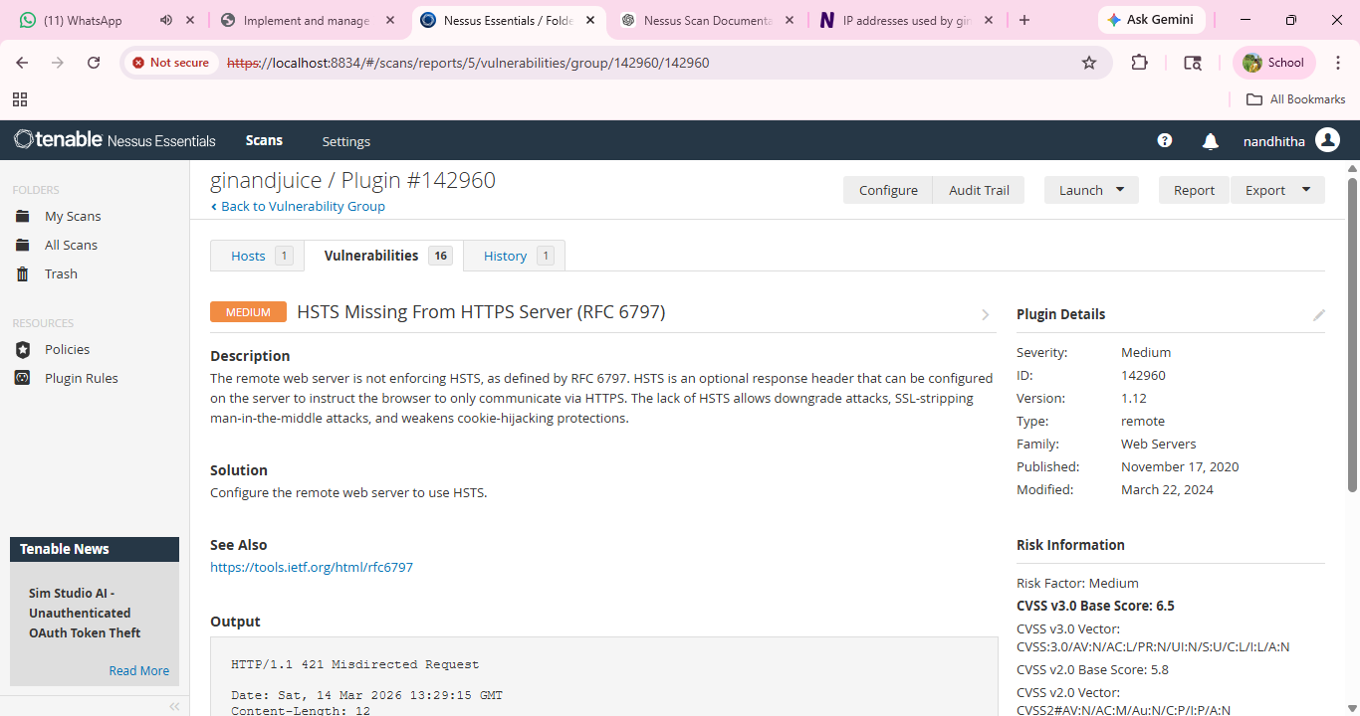
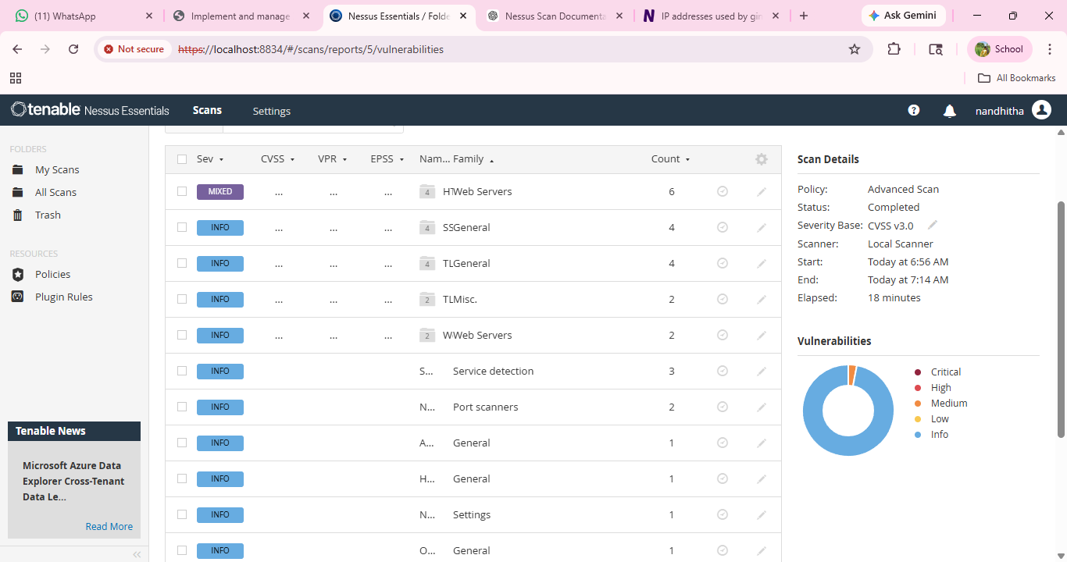

Report: -

Stage-3

Title: - Implementing Zero Trust Network Access (ZTNA) with Zscaler: Identity-Based Secure Remote Access

Zero Trust Network Access (ZTNA)
Zero Trust Network Access (ZTNA) is a modern cybersecurity framework designed to provide secure remote access by verifying user identity before granting connectivity. Traditional security models often rely on Virtual Private Networks (VPNs), where users receive broad network connectivity once authenticated. This approach can increase security risks because a compromised account or device may allow unauthorized access to sensitive systems.
ZTNA follows the principle of “Never Trust, Always Verify.” In this model, trust is never assumed based on network location or device connection. Instead, every access request is validated using identity verification mechanisms. Users are authenticated and authorized based on verified identity attributes, device status, and predefined security policies.
Identity plays a central role in the ZTNA framework. Access decisions are determined by confirming the legitimacy of the user through strong authentication mechanisms. Technologies such as identity providers, Multi-Factor Authentication (MFA), and identity-based policy enforcement ensure that only verified users can establish secure remote sessions. This approach ensures that access privileges are granted according to the user’s identity and role.
ZTNA establishes secure encrypted communication channels after successful identity verification. These secure connections ensure that authentication data and user sessions remain protected from interception or unauthorized monitoring. Continuous validation mechanisms monitor identity-related factors during the session to confirm that the user remains trustworthy throughout the connection.
This identity-centric security model significantly reduces the risk of unauthorized access and credential misuse. If suspicious login attempts, abnormal behavior, or compromised credentials are detected, the system can immediately restrict or terminate the connection to prevent potential security incidents.

ZTNA has become an essential component of modern security architectures, especially in environments where users frequently access systems remotely. By prioritizing identity verification, continuous authentication, and strict access control policies, organizations can ensure secure and reliable remote access while maintaining strong protection against identity-based cyber threats.

The ZTNA Access Cycle
The ZTNA access cycle represents the process through which users securely establish remote access through identity verification. Each access request goes through multiple stages of authentication and validation to ensure that only legitimate users are allowed to connect. The cycle includes identity authentication, policy evaluation, continuous verification, and activity monitoring to maintain a secure remote access environment.
A user initiates a remote access request from any location such as home, office, or another remote environment. The request begins when the user attempts to authenticate into the system using their registered identity credentials. Since the system follows an identity-based security model, the access process begins with verifying the legitimacy of the user's identity.
Before granting remote connectivity, the system performs strong authentication procedures to validate the user. This typically includes Multi-Factor Authentication (MFA), where the user must provide multiple verification factors such as a password, authentication application, or biometric verification. These mechanisms ensure that the person requesting access is the legitimate owner of the identity credentials.
At the same time, the system evaluates the device used for authentication to ensure that it meets organizational security requirements. Device posture verification checks whether the system has appropriate security configurations such as updated antivirus software, firewall protection, and operating system updates. This helps ensure that only trusted and secure devices are allowed to complete the authentication process.
The system then evaluates predefined identity-based access policies to determine whether the user should be granted remote access. These policies consider several contextual factors including the verified identity of the user, their organizational role, device compliance status, login location, and time of access. This policy-based evaluation ensures that access decisions are consistent with the organization's security policies.
If the authentication and policy evaluation processes are successfully completed, a secure encrypted connection is established for the remote session. This connection ensures that identity verification data and user communication remain protected from interception or unauthorized monitoring during the session.
During the active session, the system continuously monitors identity-related parameters and user behavior. Continuous verification ensures that the user remains trustworthy throughout the session. If suspicious behavior, unusual login patterns, or abnormal activity is detected, the system can immediately terminate the session to prevent potential security threats.
All authentication attempts, identity verification events, and user activities are recorded in centralized logs. These logs provide valuable information for security monitoring, auditing, and improving identity-based security policies. Administrators can analyze these records to detect anomalies, investigate incidents, and strengthen the overall security posture of the system.

Zscaler (Zscaler Internet Access / Zscaler Private Access)
Zscaler is a cloud-based cybersecurity platform that provides secure remote access services using an identity-driven security approach. Instead of relying on traditional on-premise security hardware, Zscaler delivers security and authentication services through a globally distributed cloud infrastructure. This cloud-based architecture enables organizations to manage remote access security more efficiently and securely.
For implementing identity-based remote access, Zscaler provides services such as Zscaler Private Access (ZPA). ZPA enables secure connectivity by verifying user identity before establishing remote sessions. Rather than granting broad network connectivity, the system authenticates users and allows remote access only after successful identity verification and policy validation.
The Zscaler platform integrates with various identity management and security systems to strengthen authentication and access control. Through integration with identity providers and authentication frameworks, the platform ensures that only verified users with valid credentials can establish secure remote connections. This integration allows organizations to enforce strong identity verification mechanisms, continuous monitoring, and centralized access management.

Identity Providers (IdP)
Identity Providers are systems responsible for verifying and managing user identities during the authentication process. Platforms such as Microsoft Azure Active Directory or Okta authenticate users by validating their credentials and confirming their identity before granting remote access. These systems support strong authentication mechanisms, including Multi-Factor Authentication (MFA), to ensure that only legitimate users can access organizational resources. Identity providers play a central role in identity-based remote access by establishing trust through verified user identities.

Device Security Tools
Device security tools are endpoint protection solutions used to verify the security status of devices attempting to authenticate. Solutions such as Microsoft Defender or CrowdStrike evaluate whether a device complies with organizational security policies. These checks ensure that the device has updated antivirus protection, firewall configurations, and operating system security patches. Verifying device health adds an additional security layer by ensuring that authentication requests originate from trusted and secure devices.

Internal Business Systems
Organizations operate various digital systems and services that support business operations. These systems may include enterprise portals, databases, management platforms, and other digital services hosted within organizational infrastructure or cloud environments. Secure remote access mechanisms ensure that only authenticated and authorized users with verified identities are able to interact with these systems.

Zscaler App Connectors
Zscaler App Connectors are lightweight software components deployed within an organization's infrastructure to enable secure connectivity through the Zscaler cloud platform. These connectors establish outbound secure connections to the Zscaler cloud, ensuring that access requests can be processed without exposing internal infrastructure directly to external networks. This design enhances security by preventing unauthorized discovery of internal systems.
Zscaler enforces security policies that are primarily driven by verified user identity and access requirements. The platform ensures that security decisions are made based on authenticated identity information and contextual parameters. Key policy capabilities include:
- Identity-based access control
- Application-level segmentation
- Least privilege access

The Zscaler ZTNA Cycle
The Zscaler ZTNA cycle represents the operational process through which identity-based remote access is established and managed using the Zscaler cloud platform. Each access request goes through several verification and evaluation stages to ensure that only authorized users are granted secure connectivity.
User Login and Authentication:
A user initiates a remote access request and provides identity credentials. The request is redirected to the organization's Identity Provider (IdP), where the user completes authentication procedures, including Multi-Factor Authentication (MFA). The identity provider verifies the credentials and confirms the authenticity of the user.
Device Posture Verification:
The system communicates with integrated endpoint security solutions to evaluate the security posture of the user’s device. This verification confirms that the device complies with required security standards such as updated antivirus protection and appropriate security configurations.
Policy Evaluation and Access Decision:
The Zscaler cloud platform evaluates the authentication request against predefined identity-based access policies. The system verifies whether the authenticated user, device status, and contextual factors such as login location or time satisfy the organization’s security requirements.
Secure Connection Establishment:
Once the user’s identity and device compliance are successfully validated, the system establishes a secure encrypted communication channel through the Zscaler cloud infrastructure. This encrypted session allows the authenticated user to interact with authorized organizational systems while ensuring that communication remains protected.
Traffic Monitoring and Inspection:
During the active session, the platform can analyze traffic to detect potential security risks such as malware or unauthorized data transfers. Continuous monitoring helps maintain a secure environment throughout the session.
Logging and Security Analytics:
All authentication events, identity verification activities, and user interactions are recorded within the centralized Zscaler cloud management platform. These logs support security monitoring, auditing, compliance reporting, and advanced threat analysis, enabling administrators to maintain strong oversight of identity-based remote access activities.

The network infrastructure includes several core components that support internal communication and digital services within the organization. These components typically consist of core routers and switches responsible for high-level network traffic management, distribution routers and switches that handle communication between different network segments, and wireless access points that provide connectivity to users across the campus environment. Security mechanisms such as firewalls and Intrusion Detection Systems (IDS) are also deployed to monitor network traffic and detect potential threats.
Internal systems support various organizational functions and services. These systems may include platforms used for academic management, digital library resources, research data storage, and administrative operations. These systems are critical for daily operations and require secure access mechanisms to ensure that only authorized users with verified identities can interact with them.
A legacy Virtual Private Network (VPN) concentrator is often used to provide remote connectivity for faculty, staff, and other users who need to access institutional systems from outside the campus network. While VPN technology enables remote connectivity, it typically grants users broad network-level access once they are authenticated. This traditional approach presents several security and operational challenges.
One major limitation of the VPN model is over-permissioned access. When users connect through a VPN, their devices become part of the internal network. If a device or user account becomes compromised, attackers may attempt to explore or attack other parts of the network, increasing the risk of lateral movement and potential data breaches.
Another challenge arises when external collaborators require limited access to specific systems. In many cases, research partners or external contributors need to access certain services, but granting full network access through a VPN creates unnecessary security risks.
User experience can also be negatively affected by legacy VPN solutions. VPN connections may introduce latency, require complex configurations, or route all user internet traffic through the institutional network, which can reduce performance and create additional overhead for network administrators.
To address these limitations, an identity-based remote access approach can be implemented using the Zscaler platform. This approach focuses on securing user access through identity verification rather than providing full network connectivity. Access decisions are based on authenticated identity, user role, and security policies.
The deployment process begins by identifying the digital systems and services that require controlled remote access and the users who need access to them. Instead of protecting the entire network, the focus shifts toward protecting access through verified identity authentication and role-based authorization.
Application discovery is an important step in the implementation process. All internal systems and services are identified and cataloged to determine which resources require secure remote access. This process helps administrators understand how users currently access systems and which services should be protected through identity-based controls.
User segmentation is then defined to organize users into logical groups based on their roles and responsibilities. These groups may include students, faculty members, administrative staff, information technology personnel, and external collaborators. Access permissions are assigned based on the identity of the user and the specific services required for their role.
Zscaler App Connectors are deployed within the institutional infrastructure to establish secure communication with the Zscaler cloud platform. These connectors create secure outbound connections that allow the platform to manage authentication requests and access sessions without exposing internal infrastructure directly to external networks.
The Zscaler platform is integrated with the institution’s Identity Provider, such as Microsoft Azure Active Directory. This integration allows the system to use existing identity credentials, authentication policies, and Multi-Factor Authentication (MFA) mechanisms to verify user identities during the login process.
Access control policies are then configured within the Zscaler management portal. These policies define which authenticated users are permitted to access specific systems and under what conditions. Policies can incorporate factors such as user identity, role within the organization, device security status, and authentication requirements.
To enable secure connectivity, users install the Zscaler Client Connector on their laptops, tablets, or mobile devices. The client software communicates with the Zscaler cloud platform and ensures that remote access requests are processed through the identity verification system. This mechanism ensures that authenticated users can securely access authorized services while maintaining strong security controls.
Threat intelligence capabilities further strengthen the system by continuously monitoring authentication attempts, user activity patterns, and potential security threats. These capabilities help detect suspicious login attempts, compromised credentials, and abnormal user behavior, enabling administrators to respond quickly to potential security incidents and maintain a secure identity-based remote access environment.

In the context of Zscaler and identity-based remote access, threat intelligence is used to gain deeper insight into who is attempting to access systems, what resources are being requested, and from where the access request originates. Instead of relying only on basic identity authentication, threat intelligence enables security systems to evaluate contextual risk factors and make more informed access decisions.
Threat intelligence is collected from multiple sources that provide information about user activity, authentication patterns, and emerging cyber threats.
One important source is Zscaler cloud logs. These logs provide real-time information about user authentication activities, including which users are attempting to access systems, the devices they are using, and the geographic locations from which requests are made. This data helps security teams monitor identity-related access behavior and detect unusual patterns.
External threat intelligence feeds also contribute valuable information about newly discovered cyber threats. These feeds may contain data about malicious domains, phishing campaigns, malware distribution networks, and command-and-control servers used by attackers. By integrating this intelligence, the security platform can identify and block potentially harmful communication attempts.
Identity provider logs are another critical source of threat intelligence. These logs record authentication attempts and identity verification activities. Unusual login behavior, such as a user attempting to authenticate from two geographically distant locations within a short period of time, may indicate that the user’s credentials have been compromised.
Threat intelligence is used to enhance security in several ways.
Adaptive access control is one important application. When threat intelligence indicates a potential risk, the system can apply additional verification requirements. For example, if a login attempt originates from a suspicious location or device, the system may require additional authentication steps or temporarily block the request.
Threat intelligence also helps security teams identify compromised user accounts. By analyzing authentication logs and access patterns, administrators can detect abnormal behavior, such as a user attempting to access systems or services that they have never previously used. Such behavior may indicate credential theft or unauthorized account usage.
Another important use of threat intelligence is blocking malicious communication. Security systems can use intelligence feeds to prevent connections to known malicious domains, suspicious IP addresses, or compromised infrastructure. This prevents users from unknowingly interacting with harmful external systems that may attempt to steal credentials or distribute malware.

Threat Intelligence Integration
Threat intelligence integration plays a critical role in strengthening security within an identity-based remote access environment. It provides continuous information about emerging cyber threats and helps security systems proactively detect and respond to suspicious activity.
Security platforms can integrate threat intelligence feeds to identify malicious domains, suspicious IP addresses, and known attack patterns. When this information is combined with identity-based authentication systems, organizations can detect potential threats earlier and prevent harmful activity before it impacts users or systems.
Threat intelligence data may be obtained from several sources, including internal security monitoring tools that track user activity and authentication events, external threat intelligence platforms that provide global threat data, and identity provider activity logs that record authentication attempts and login behavior. By combining information from these sources, organizations can improve their ability to detect identity-related threats and maintain a secure remote access environment.

Protecting Remote Access using Identity-Based Secure Remote Access
Modern organizations rely heavily on remote connectivity to access internal systems and digital services. Employees, administrators, and authorized collaborators often need to connect from different locations such as homes, offices, or remote environments. This increasing reliance on remote connectivity expands the potential attack surface and requires strong security mechanisms to ensure that only legitimate users can access organizational resources.
A typical organizational network includes several components that support daily operations. These components may include core network infrastructure responsible for traffic management, wireless access points that provide connectivity for users, firewalls and intrusion detection systems that monitor network activity, internal servers that host organizational services, and administrative or database systems that store critical operational data.
Traditional remote access methods often rely on Virtual Private Network (VPN) technology. In these environments, once a user is authenticated, they are usually granted broad connectivity to the internal network. This model introduces significant security risks because if a user device becomes compromised, attackers may attempt to explore or attack other systems within the network.
Identity-Based Secure Remote Access addresses these challenges by ensuring that access decisions are based primarily on verified user identity rather than network connectivity. Instead of granting broad network access, the system authenticates users and allows them to interact only with the specific services required for their role. This identity-driven approach reduces the possibility of unauthorized exploration and improves overall system security.

Deployment Approach for Identity-Based Secure Remote Access
Implementing Identity-Based Secure Remote Access requires a structured deployment strategy that ensures authentication, authorization, and monitoring mechanisms are properly integrated.
1. System Identification
The first step is identifying the internal systems and services that require controlled remote access. This process involves cataloging organizational resources and determining which users require remote connectivity.
2. User Segmentation
Users are categorized into groups according to their roles and responsibilities within the organization. Typical groups may include administrators, employees, technical staff, and external collaborators. Access permissions are defined according to the verified identity and operational needs of each group.
3. Secure Connectivity Architecture
Secure communication mechanisms are implemented to allow remote users to establish protected sessions with organizational systems. These connections ensure that authentication data and communication traffic remain encrypted and protected during remote access.
4. Identity Integration
Identity management systems are integrated into the remote access architecture to verify user credentials. Centralized identity platforms manage user authentication and enforce strong authentication requirements such as Multi-Factor Authentication, ensuring that only verified identities are allowed to establish remote sessions.
5. Access Policy Configuration
Access policies are configured to control how authenticated users interact with organizational systems. These policies define which users can access specific services and under what conditions. Policy decisions may consider identity attributes, user roles, device security status, login location, and other contextual factors.
6. Client Deployment
Secure client software is deployed on user devices to enable communication with the identity-based access platform. These clients facilitate encrypted connections and ensure that authentication requests are processed securely.

Incident Response in an Identity-Based Remote Access Environment
Identity-Based Secure Remote Access systems improve incident response capabilities by providing detailed visibility into authentication activities and user behavior. Monitoring tools and logging systems help security teams detect suspicious activity and respond quickly.
1. Detection
Security teams monitor authentication logs, system alerts, and user activity records to detect unusual behavior such as abnormal login attempts, suspicious authentication locations, or unexpected access patterns.
2. Containment
If suspicious activity is detected, administrators can immediately revoke or restrict access for compromised accounts or devices. This action prevents unauthorized users from continuing to access organizational systems.
3. Investigation
Security teams analyze authentication records, system logs, and access patterns to determine the source and scope of the security incident. This analysis helps identify compromised identities or devices and understand how the incident occurred.
4. Recovery
Once the threat has been contained, affected systems and user accounts are restored after security verification and remediation steps are completed.
5. Post-Incident Review
After resolving the incident, administrators review and update security policies and monitoring procedures to prevent similar incidents in the future.

Conclusion
In conclusion, the project on Identity-Based Secure Remote Access highlights the importance of using identity verification as the foundation for protecting remote connectivity in modern organizations. By emphasizing strong authentication mechanisms, identity-driven access policies, encrypted communication, and continuous monitoring, organizations can create a secure remote access environment. This approach minimizes the risks associated with traditional network-based access models and strengthens protection against identity-related cyber threats while supporting secure and efficient remote operations.

In Stage 1, the study focused on identifying and understanding common web and network vulnerabilities that can threaten secure remote access environments. By analysing major security weaknesses based on OWASP Top 10 categories and Common Weakness Enumeration (CWE) vulnerabilities, this stage highlighted the importance of proactively identifying security risks that may compromise user identities, authentication systems, and remote access infrastructure. Understanding these vulnerabilities provides a strong foundation for implementing secure identity-based access controls and strengthening overall system security.
In Stage 2, the project explored vulnerability scanning using the Nessus vulnerability assessment tool. By analysing Nessus scan results and plugin severity levels, potential weaknesses within network infrastructure, authentication systems, and remote access components could be identified. The detailed vulnerability reports provided insights into threat severity, affected components, and recommended remediation strategies. This stage emphasized the importance of continuous vulnerability scanning to ensure that identity verification systems and remote access environments remain protected from emerging threats.
In Stage 3, the project focused on implementing Identity-Based Secure Remote Access as a modern cybersecurity approach for protecting organizational systems. This stage demonstrated how remote access security can be strengthened by prioritizing identity verification rather than relying on traditional network-based trust models. Strong authentication mechanisms, identity-driven access policies, and continuous monitoring ensure that only verified users can establish secure remote sessions. By limiting access according to verified user identity and role, the system significantly reduces security risks such as unauthorized access and misuse of credentials.
Overall, the project demonstrates how combining vulnerability assessment practices with identity-based remote access security models can significantly improve the protection of organizational systems and digital resources. This integrated approach strengthens security by identifying vulnerabilities early, enforcing strict identity verification mechanisms, and maintaining continuous monitoring of remote access activities.

Future Scope
The future of cybersecurity will continue to evolve as organizations increasingly adopt cloud computing, remote work environments, and digital transformation strategies. In such environments, protecting remote access to organizational systems will depend heavily on strong identity verification mechanisms and intelligent security monitoring. Identity-Based Secure Remote Access models will play a critical role in ensuring that only authenticated and authorized users can access organizational resources.
1. AI-Driven Security Monitoring
Artificial Intelligence and Machine Learning technologies are expected to enhance security monitoring by analysing user behavior patterns and identifying unusual authentication activities. These systems can automatically detect suspicious login attempts, abnormal user actions, or compromised credentials and respond to potential threats in real time.
2. Advanced Identity-Based Security Architecture
Future identity-based security architectures will incorporate continuous authentication, behavioural analysis, and contextual risk assessment. Access privileges may be dynamically adjusted based on factors such as user identity, login location, device condition, and activity patterns, ensuring that access permissions remain aligned with security requirements.
3. Integration with Cloud Security Platforms
As organizations migrate more services to cloud environments, identity-based remote access solutions will integrate more closely with cloud security platforms. Unified security frameworks will provide centralized identity management, authentication monitoring, and secure access control across both on-premise and cloud-hosted systems.
4. Automated Vulnerability Management
Future vulnerability assessment tools will incorporate automation and intelligent analysis to identify security weaknesses more efficiently. Automated scanning systems will help detect vulnerabilities affecting authentication systems, identity management platforms, and remote access infrastructure, enabling faster remediation and stronger protection.
5. Enhanced Threat Intelligence Integration
Threat intelligence capabilities will continue to improve by integrating data from global threat intelligence platforms, security monitoring systems, and authentication logs. These integrations will help organizations identify emerging cyber threats, detect suspicious login behavior, and automatically block malicious activity targeting identity systems.
6. Improved Remote Access Security
With the continued growth of remote connectivity, identity-based access systems will evolve to provide stronger identity verification, improved device validation, and continuous monitoring of user sessions. These advancements will help organizations maintain secure remote access environments while supporting flexible working conditions.

Topics Explored
The following key topics were explored during the development of this project:
- Web Application Vulnerabilities and Security Risks
- OWASP Top 10 Security Risks
- Common Weakness Enumeration (CWE) Vulnerabilities
- Vulnerability Assessment and Penetration Testing
- Nessus Vulnerability Scanning and Plugin Analysis
- Severity Classification of Vulnerabilities
- Identity-Based Security Architecture
- Identity-Based Secure Remote Access
- Zscaler Private Access (ZPA)
- Identity-Based Access Control
- Secure Remote Access Mechanisms
- Threat Intelligence and Security Monitoring
- Incident Detection and Response Strategies

Tools Explored:-
During this project, several cybersecurity tools and technologies were studied and analyzed to understand their role in protecting internal applications and identifying vulnerabilities.
- Nmap – Network scanning tool used for discovering hosts and services in a network
- Nessus – Vulnerability scanning tool used to identify security weaknesses in systems and applications
- Metasploit Framework – Penetration testing framework used to simulate cyberattacks and exploit vulnerabilities
- Kali Linux – A cybersecurity-focused operating system containing various penetration testing tools
- OWASP ZAP – Open-source web application security testing tool used to detect vulnerabilities in web applications
- Burp Suite – Web application security testing platform used for analysing and testing HTTP traffic

**********THE END************

