

COLLEGE CODE:9129
COLLEGE NAME: ULTRA COLLEGE OF ENGINEERING AND TECH. DEPARTMENT : COMPUTER SCIENCE AND ENGINEERING STUDENT NM-ID : F444D237EFABA78BEAC4E55364 424317
ROLL NO:912923104021
DATE : 29.09.2025

Completed the project named as Phase 5: PROJECT DEMONSTRATION & DOCUMENTATION
TECHNOLOGYPROJECT NAME: PRODUCT CATALOG PROJECT

SUBMITTED BY
NAME: I.RAGURAM
MOBILENO:8148653622
PHASE 5: PROJECT DEMONSTRATION & DOCUMENTATION

Product Catalog Project Documentation

1. Introduction
- Overview of the project
- Purpose and objectives
- Target users and stakeholders
2. Project Scope
- Features included (e.g., product listing, categories, search, filtering, sorting)
- Exclusions (what’s not included)
3. System Architecture
- High-level design
- Technologies used (e.g., frontend, backend, database)
- Third-party tools or APIs integrated
4. Features and Functionality
- Product listing and details
- Category and sub-category navigation
- Search and filters
- User interface design highlights
- Admin features (if any)
5. User Guide / Demo Walkthrough
- Step-by-step guide on how to use the catalog
- Screenshots or screen recordings of key features

Screenshots / API Documentation

1. Screenshots for Product Catalog Project Demo
- Home page or main catalog page
Shows the list of products or categories.
- Category page
Demonstrates product filtering by category.
- Product details page
Shows product description, images, pricing, and other attributes.



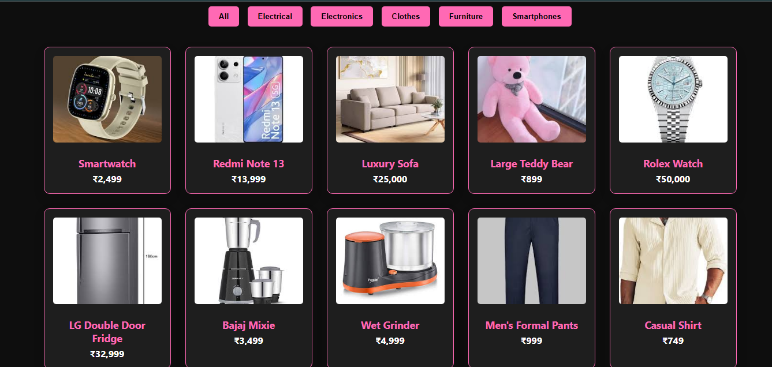

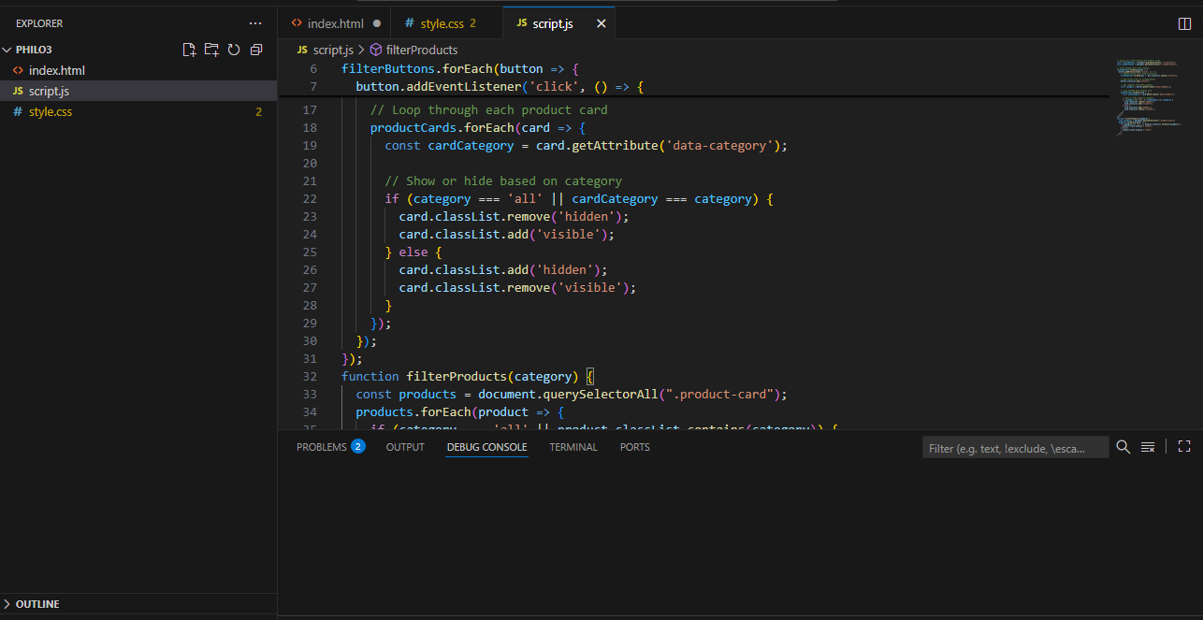

- Search results page
Illustrates how the search functionality works.
- Filter and sort options
Displays available filters (price, brand, rating, etc.) and sorting.
- Admin panel (if applicable)
Product management (add/edit/delete products).

2. API Documentation for Product Catalog

  - Get All Products
  - Endpoint: /products
- Method: GET
- Description: Fetches a list of all products. Supports optional query parameters for filtering and pagination.
- Query Parameters:
  - category (string) — Filter by category
  - search (string) — Search by product name or description
  - page (integer) — Pagination page number
  - limit (integer) — Number of items per page

Challenges & Solutions

Efficient Product Search and Filtering
- Implemented indexed database queries to optimize search performance.
- Added pagination to limit the number of products loaded at once.
- Used caching mechanisms (e.g., Redis or in-memory cache) to store frequent queries and reduce database hits.
- Implemented debouncing on the search input to minimize unnecessary API calls while typing.

Managing Product Images
- Integrated image optimization tools to compress images without quality loss.
- Used a Content Delivery Network (CDN) to deliver images faster globally.
- Implemented lazy loading for images to improve page load speed.
- Stored images in cloud storage with secure access URLs.

API Security and Access Control
- Implemented authentication using JWT (JSON Web Tokens) for protected routes.
- Added role-based access control to differentiate between admin users and regular users.
- Used HTTPS to encrypt data in transit.

1.Challenge: Managing Large Product Data
Problem:
When there are hundreds or thousands of products, keeping data (price, stock, details, images) updated becomes .
Solution:
- Use a database management system (DBMS) or API for centralized storage.
- Automate updates using scripts or content management systems (CMS).
- Maintain data consistency with regular synchronization.

2. Challenge: Poor Product Search and Filtering
Problem:
Users struggle to find products quickly if filters or search options are limited.
Solution:
- Implement advanced filters (category, price, brand, rating).
- Add real-time search suggestions using JavaScript.
- Use AI or keyword-based search optimization for better results.

3. Challenge: Unattractive or Confusing Design
Problem:
If the design is cluttered or not user-friendly, users leave the site.
Solution:
- Use a clean UI/UX layout (grid view, high-quality images).
- Maintain consistent color themes (e.g., black & pink as you planned 🎨).
- Add animation effects (hover, fade-in, transition) to make it interactive.

4. Challenge: Slow Loading Time
Problem:
High-resolution images and heavy scripts slow down page loading.
Solution:
- Use compressed images (WebP format).
- Apply lazy loading for product images.
- Optimize CSS, JS, and use CDN hosting.

5. Challenge: Maintaining Accurate Pricing and Availability
Problem:
Prices and stock details change often, leading to outdated info.
Solution:
- Integrate with real-time inventory systems.
- Set up auto-sync with backend databases or APIs.
- Display “Out of Stock” or dynamic pricing updates clearly.

6. Challenge: Mobile Responsiveness
Problem:
Catalogue may not display properly on phones and tablets.
Solution:
- Use responsive design (CSS Flexbox/Grid).
- Test on different screen sizes using media queries.
- Optimize buttons and images for touch interaction.

7. Challenge: Security of Product Data
Problem:
Unauthorized access or tampering with product details.
Solution:
- Use secure login and admin panels.
- Encrypt sensitive data.
- Limit access rights (only admin can modify data).

8. Challenge: User Engagement
Problem:
Visitors browse products but don’t interact or buy.
Solution:
- Add wishlists, reviews, and recommendations.
- Use AI-based personalization (show related products).
- Add clear “Add to Cart” and “Buy Now” buttons.

Product Catalog Project

Features
- Browse products by category
- Search and filter products
- View detailed product information
- Admin panel for product management (add, update, delete)
- Responsive design for mobile and desktop
- Secure API with authentication

Tech Stack
- Frontend: React / Angular / Vue (choose yours)
- Backend: Node.js + Express / Django / Flask / Spring Boot (choose yours)
- Database: MongoDB / MySQL / PostgreSQL (choose yours)
- Authentication: JWT
- Image storage: AWS S3 / Cloudinary / Local (choose yours)
- Others: Redis for caching, Swagger for API docs (optional)

Demo
Live Demo Link (if applicable)Screenshots

API Documentation
See the API Docs for detailed endpoints and usage.

Setup Guide

Prerequisites
- Node.js v14+ (or your backend language runtime)
- npm or yarn
- Database (MongoDB/PostgreSQL/MySQL) installed and running
- (Optional) AWS account or other cloud storage for images

Final Submission Checklist — Product Catalog Project

1. GitHub Repository
- Complete README.md with:
- Well-structured folder organization (e.g., /backend, /frontend, /docs, /screenshots)
- Clean, commented code
- .gitignore in place (exclude node_modules, environment files)

2. Deployment
- Backend deployed (e.g., Heroku, AWS, Vercel functions, DigitalOcean)
- Frontend deployed (e.g., Netlify, Vercel, Firebase Hosting)
- Database hosted or accessible (MongoDB Atlas, AWS RDS, etc.)
- Test the live app URL to ensure it’s working fine
- Add the live app link prominently in your README

Final Submission (Repo + Deployed Link)
Github Repository: https://github.com/23cse21-sudo/product-catalogue-fillters-raguram.git
Live Demo : https://product-catalogue-fillters-raguram.netlify.app/

