1. Introduction

Gujarati Script Recognition System is a software which takes image of a Gujarati script as an input and returns editable text of script in the image. This is done by pre-processing the input image using Image Processing techniques followed by extraction of text using Deep Neural Network.

2. Prerequisites

To ensure the proper working of this software on any machine, the following prerequisites needs to be installed on the system beforehand:

- Ubuntu 18.04
- OpenCV 3.4.1
- QT 5.9.0
- python3 and its libraries
a. Tensorflow
b. Pandas
c. Sklearn
d. Matplotlib
e. Python3-tk
- SQLite database

Following is a quick guide to install the above mentioned dependencies:

2.1 Ubuntu 18.04 alongside windows 10

- Login into your Windows 10 system. Once done, we need to open Disk Management Console. To open Disk Management console, open run prompt (by pressing Windows Key + R or by typing ‘run’ in search bar) & type ‘diskmgmt.msc‘

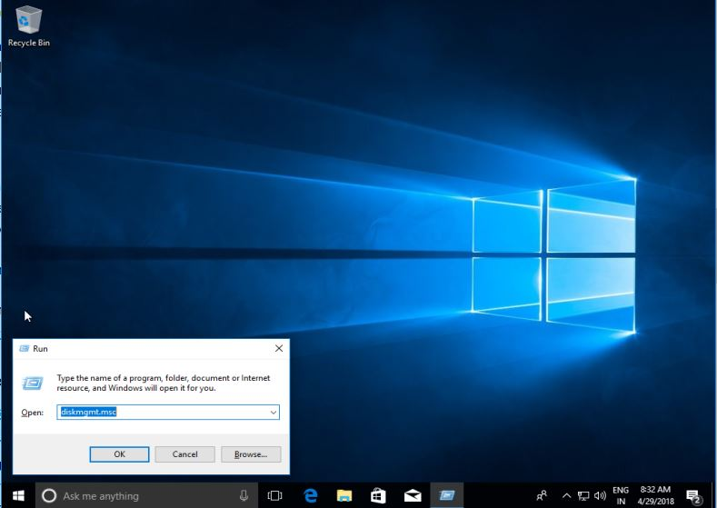
- We need to free up some space from our HDD, we will do it by shrinking the volume that has some free space. Select the partition with some free space (at least 25 Gb), right click & select ‘Shrink Volume‘
- On next screen, select the amount you want to shrink and press ‘Shrink’. For our tutorial, we will be using 40 GB
- As shown is the screenshot below, we now have 40 GB of unallocated space that will be used for Ubuntu 18.04 installation

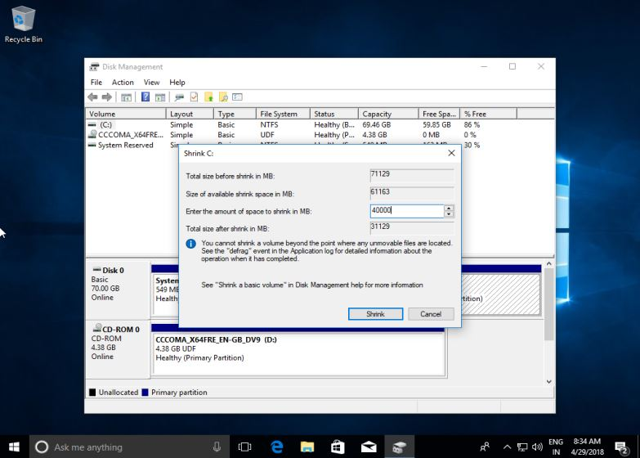
- Next step is to shutdown your system & insert a bootable USB or a Live DVD for Ubuntu 18.04 onto the system & than boot the system into the Ubuntu image.

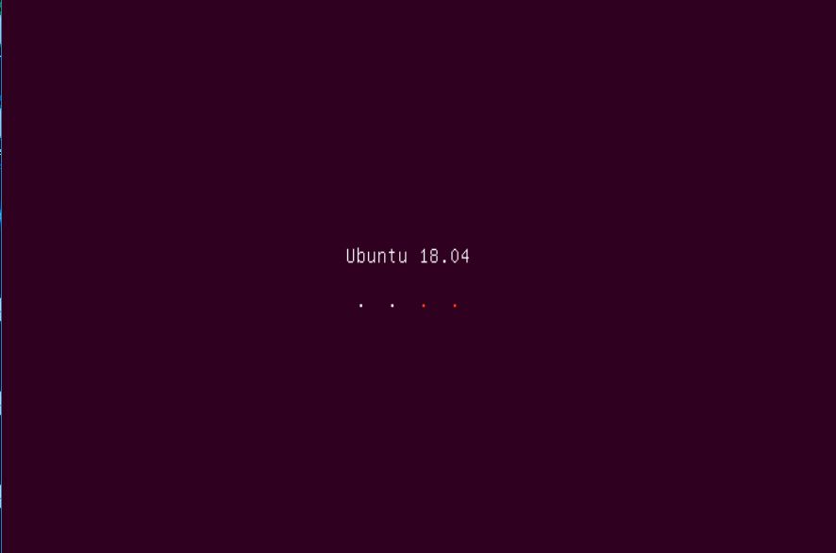

- Once the Ubuntu image has been booted up, we should see the following options. Select ‘Install Ubuntu’

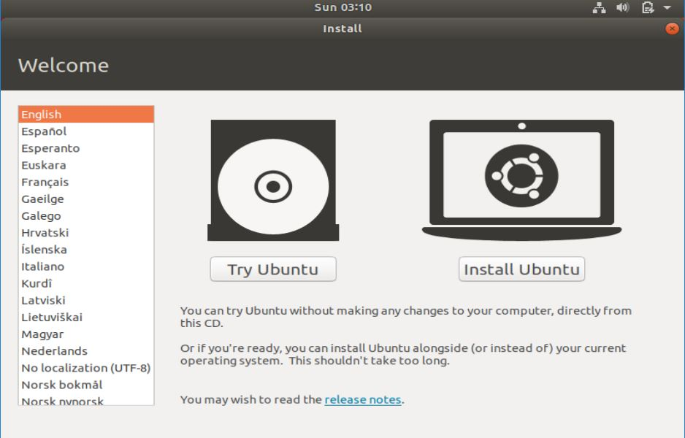
- On the next screen we are introduced to a little change, we have an extra option to select what apps we need to install on our system & we can either select Normal installation with all the default applications or we can also select Minimal Installation with only a web browser & some basic utilities. Select the option, you see fit & press ‘Continue’.
- On the next screen, we will select the installation type. Since we are dual booting with Window 10, we will select the first option ‘Install Ubuntu alongside Windows 10′, rest options can be chosen when we are installing Ubuntu afresh.
- On the following screen, press ‘Write changes to disk‘ to proceed further with the installation.
- Now we would be asked about our Geographical location, select your country & proceed by clicking on the Continue button. Now comes the part of installation, where we need to create information about our User, our computer name & password etc. Enter all the requested information & once done, press ‘Continue’.
- We have now entered all the needed information, Ubuntu will now proceed with the installation & depending on the allocated system resources it can take anywhere between 5 to 20 mins.
- Once the installation has been completed, we will be asked to restart our system. Press on ‘Restart Now’. Also remove the installation media from system before restarting the system.

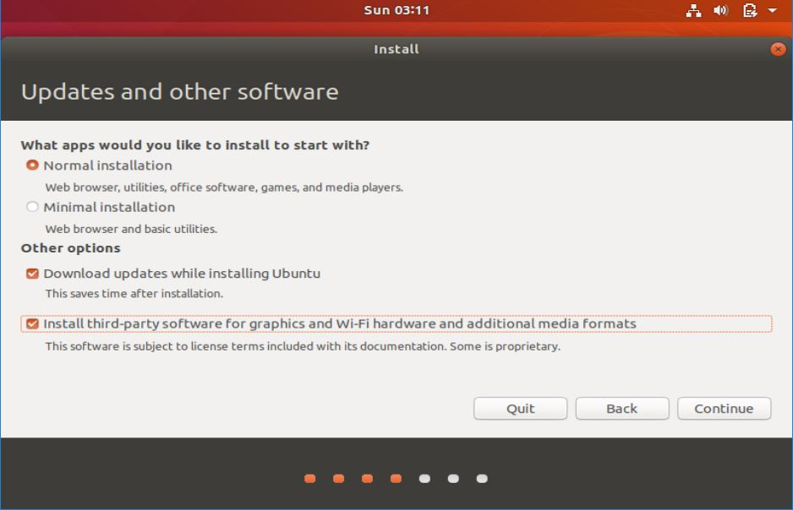

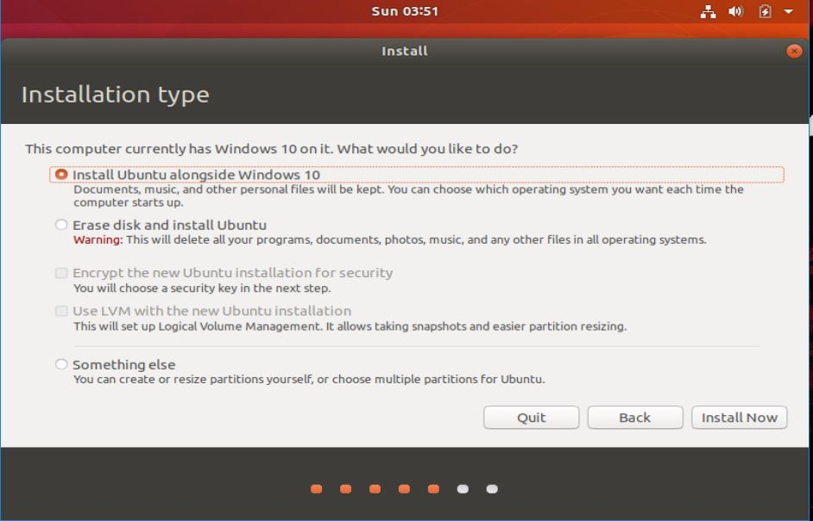

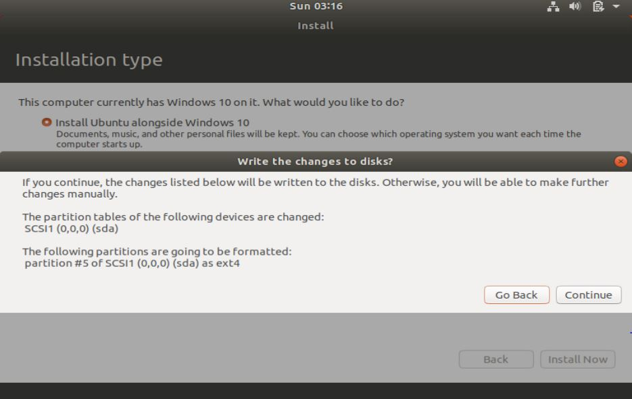

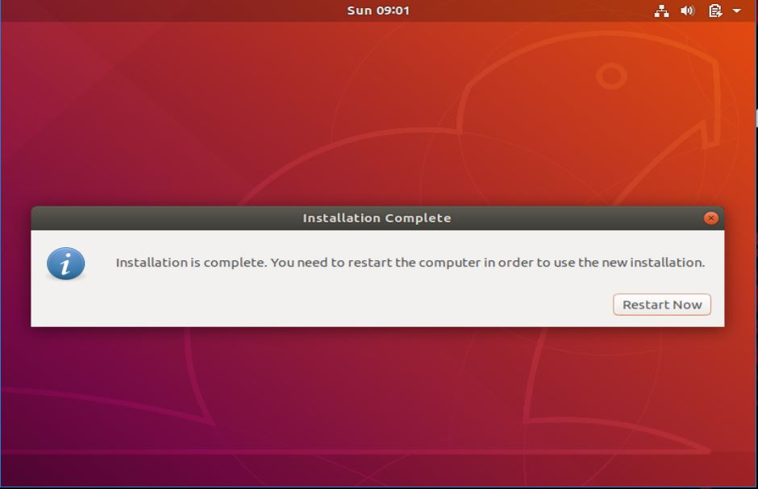

- Now when the system is restarted, we will see the following boot menu first. Here we can either opt to login to Ubuntu by selecting the first option or we can also boot into Windows 10 by selecting the last option. We will boot into Ubuntu.
2.2 OpenCV4

OpenCV (Open Source Computer Vision Library) is an open source computer vision,
image processing and machine learning software library.

To install OpenCV follow these steps:
- Update your system. Run the following commands one by one
sudo apt-get update
sudo apt-get upgrade

- Install the dependencies. Run the following commands one by one
a. sudo apt-get install build-essential unzip pkg-config
b. sudo apt-get install cmake
c. sudo apt-get install gcc g++
d. sudo apt-get install python-dev python-numpy
e. sudo apt-get install python3-dev python3-numpy
f. sudo apt-get install libavcodec-dev libavformat-dev libswscale-dev
g. sudo apt-get install libgstreamer-plugins-base1.0-dev
libgstreamer1.0-dev
h. sudo apt-get install libgtk2.0-dev
i. sudo apt-get install libgtk-3-dev
j. sudo apt-get install libpng-dev
k. sudo apt-get install libjpeg-dev
l. sudo apt-get install libopenexr-dev
m. sudo apt-get install libtiff-dev
n. sudo apt-get install libwebp-dev

- Download and install OpenCV4.(Note- Run the below commands in the terminal by right clicking on desktop and selecting Open Terminal. Don’t cd anywhere.)
a. Install git
i.sudo apt-get install git
b. Clone OpenCV.
i. git clone ​ https://github.com/opencv/opencv.git
ii. git clone ​ https://github.com/opencv/opencv_contrib.git
c. Change the version to 4.2.0
i. cd opencv
ii. git checkout 4.2.0
iii. cd ..
iv. cd opencv_contrib/
v. git checkout 4.2.0
vi. cd ..
d. Create build folder
i. cd ~/opencv
ii. mkdir build && cd builde.
e. Make OpenCV
i. cmake -D CMAKE_BUILD_TYPE=RELEASE -D
CMAKE_INSTALL_PREFIX=/usr/local -D WITH_CUDA=OFF -D
INSTALL_PYTHON_EXAMPLES=ON -D
OPENCV_EXTRA_MODULES_PATH=~/opencv_contrib/modules
-D OPENCV_ENABLE_NONFREE=ON -D BUILD_EXAMPLES=ON
-D OPENCV_GENERATE_PKGCONFIG=ON ~/opencv/
f. Start the compilation process.
i. make -j8
Modify the -j flag according to your processor. If you do not know the number of cores your processor, you can find it by typing ​ nproc​ .
eg- use ​ make -j6 ​ if you have 6 processors.
g. Install.
i. sudo make install
h. Verify. Run the following command
pkg-config --modversion opencv4
The output should be ​ 4.2.0.

References -
https://www.pyimagesearch.com/2018/05/28/ubuntu-18-04-how-to-install-opencv/
https://docs.opencv.org/3.4/d2/de6/tutorial_py_setup_in_ubuntu.html
https://linuxize.com/post/how-to-install-opencv-on-ubuntu-18-04/

2.3 QT5.9.0

- Go to https://www.qt.io/download-qt-installer?hsCtaTracking=9f6a2170-a938-42df-a8e2-a9f0b1d6cdce%7C6cb0de4f-9bb5-4778-ab02-bfb62735f3e5 and download Qt for your required OS.
- Open terminal and enter:
➔ cd Downloads
➔ ls (to know the name of downloaded qt file)
➔ chmod a+x qt-opensource...(press tab to enter name of the file)
➔ ./qt-opensource-linux-x64-1.6.0-4-online.run
- Then a setup window will open, click on next.
- Select the destination of installation and click next.
- Select version 5.3 and click next. Qt version should be 5.9.0.
- It will download some repositories and will launch Qt creator.

2.4 python3 and its libraries

- To install python3 enter the following command in terminal: sudo apt-get install python3.6
- Verify the installation by: python3 -V

- TensorFlow

a. TensorFlow installation requires pip version 19 or higher. Run the following command to upgrade pip to the latest version: pip install --upgrade pip

b. Installing Tensorflow: pip install --upgrade tensorflow

c. To verify the installation use the following command which will print the TensorFlow version: python -c 'import tensorflow as tf; print(tf.__version__)'

- Pandas - Enter the following command in terminal to install pandas:

pip3 install numpy
pip3 install pandas

To verify the installation, open the Terminal and type python3
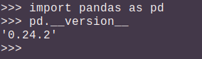
Then type the following python script:

- Sklearn - Enter the following command in terminal to install sklearn : pip3 install sklearn

To verify the installation:
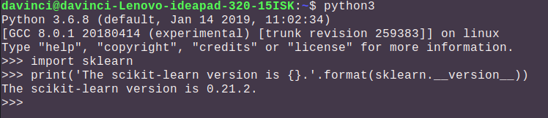

- Matplotlib - Enter the following command in terminal to install matplotlib: pip3 install matplotlib

To verify the installation:
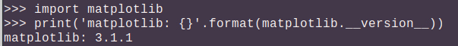

- Python3-tk - Enter the following command in terminal to install python3-tk: sudo apt-get install python3-tk

To verify the installation:
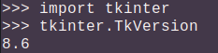

2.5 SQLite Database

- To install SQLite Database, use the following command: sudo apt-get install sqlite3

