App Development Project Report

1. Student Details
Name: Joham Chouhan
Roll Number: BS23f1002307
Email: 23f1002307@ds.study.iitm.ac.in
About Me:
I am a learner and explorer with a passion for developing accessible and practical web applications. My focus is on building solutions that integrate usability, accessibility, and clean backend logic.

2. Project Details
Project Title:
MediSync — A Role-Based Medical Appointment Management System

Problem Statement:
To design and develop a Flask-based web application that provides an integrated platform for managing hospital operations involving doctors, patients, and administrators. The goal is to ensure seamless appointment scheduling, patient record management, and availability tracking.

Approach:
To begin with, the application is designed keeping in mind the required tables and their relationships with one another. It uses Flask as the backend framework with SQLAlchemy ORM and follows a role-based access control (RBAC) structure. It includes separate dashboards for Admin, Doctor, and Patient. Each dashboard has a simple to navigate UI and has been broken down into categories for better reference.

3. AI/LLM Declaration
I used ChatGPT to assist me in understanding how date to day conversions work in python, style the html templates for better esthetics, and generating images used in the project. Approximately 15–20% of the project involved AI-assistance.

4. Technologies and Frameworks Used
Technology | Purpose
Flask | Core backend web framework
SQLAlchemy | ORM for SQLite database
Jinja2 | Dynamic HTML templating
NVDA | Accessibility testing
SQLite | Relational database backend
CSS | For styling
Git Hub | To push and work on separate features independently and track progress

5. Database Schema / ER Diagram
The system stores data in five main tables: Doctor, Patient, Appointment, Availability, and Treatment. Relationships include One‑to‑Many (Doctor→Appointment, Doctor→Availability, Patient→Appointment) and One‑to‑One (Appointment→Treatment).

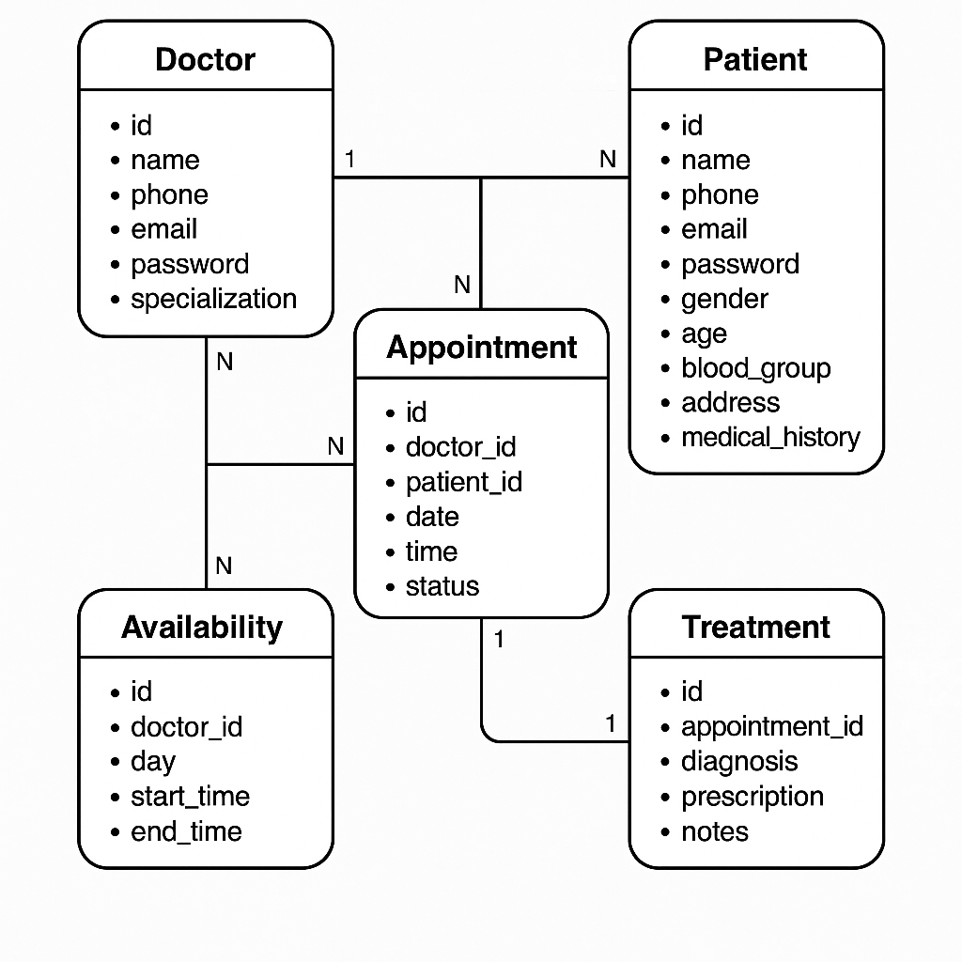

6. Application routes
Route | Function name | Purpose / Description
/ | index | Home page (renders index.html).
/register/patient | patient_registeration | Patient registration form — creates new Patient on POST and redirects to login.
/doctor_registeration | doctor_registeration | Doctor registration form — creates new Doctor on POST and redirects to admin dashboard.
/login | login | Login form for roles (admin, doctor, patient). Validates credentials and redirects to the appropriate dashboard.
/patient/dashboard/<int:patient_id> | patient_dashboard | Patient dashboard: shows patient profile, lists all_doctors, and separates upcoming/past appointments for that patient.
/update/patient/<int:patient_id> | update_patient | Edit/update patient profile; saves changes and redirects back to patient dashboard.
/find/doctor/<int:patient_id> | find_doctor | Patient-side search: find doctors by name or specialization and render filtered results on patient dashboard.
/book/appointment/<int:patient_id>/<int:doctor_id> | book_appointment | Book an appointment: validates doctor availability, slot conflicts, then creates an Appointment.
/doctor/dashboard/<int:doctor_id> | doctor_dashboard | Doctor dashboard: shows doctor profile, their appointments and availabilities.
/view_appointment/details/<int:appointment_id> | view_appointment_details | Shows appointment details and controls for an individual appointment.
/update/status/<int:appointment_id> | update_status | Used by doctor to mark an appointment cancelled or completed.
/treatment_entry/<int:appointment_id> | treatment_entry | Doctor enters treatment details (diagnosis/prescription/notes) for an appointment.
/update/availability/<int:availability_id> | update_availability | Edit an existing doctor availability (day, start/end times).
/add/availability/<int:doctor_id> | add_availability | Add a new availability entry for a doctor (day + time window).
/admin/dashboard | admin_dashboard | Admin dashboard: shows tables for Doctors, Patients, Appointments and offers search/CRUD.
/update/doctor/<int:doctor_id> | update_doctor | Admin updates doctor profile fields.
/delete/doctor/<int:doctor_id> | delete_doctor | Admin deletes (blacklists) a doctor.
/search/doctor | search_doctor | Admin search for doctors by name or specialization; renders filtered admin dashboard.
/delete/patient/<int:patient_id> | delete_patient | Admin deletes a patient record.
/search/patient | search_patient | Admin search for patients by name/contact/id; renders filtered admin dashboard.
/error | error | Generic error page (renders error.html for failed conditions).

7. Architecture and Features
The architecture includes clearly separated routes, models, templates, and static resources. Dashboards are customized for each user type, with complete CRUD functionality for admin, appointment management and available time slot scheduling for doctors, and profile/appointment/doctor viewing for patients.

8. Video Presentation
Drive Link: https://drive.google.com/file/d/1Nn6d2g9gtvS8KP2nBo_zj-ZdIJNDvS7R/view?usp=sharing

