MAD 1 Project Report
PlaceWise — Campus Placement Portal

1. Student Details
Name: Vibhaw Singh
Roll Number: 23f2003056
Email: 23f2003056@ds.study.iitm.ac.in
About Me: I am a student in the IIT Madras BS Degree Programme with an interest in web application development and backend systems.

2. Project Details
Project Title: PlaceWise — Campus Placement Portal

Problem Statement
Many institutes manage campus recruitment through spreadsheets and emails, making it difficult to coordinate between students, companies, and the placement cell. This project aims to build a role-based web application to streamline company registrations, placement drives, and student applications.

Approach
The application was built using Flask as the backend with SQLite for data storage. Three roles are supported — Admin, Company, and Student — each with dedicated dashboards and access controls. All pages are rendered server-side using Jinja2 templates. Bootstrap 5 is used for the frontend layout and styling.

3. AI/LLM Declaration
I used Claude (Anthropic) to assist in styling and layout (Bootstrap for icons and CSS for layout, and authentication. The extent of AI/LLM usage is approximately 20-25%. All logic, debugging, database design, and final integration were manually implemented by me.

4. Technologies and Frameworks Used
Technology | Purpose
Flask | Core backend web framework
Jinja2 | Template engine for server-side HTML rendering
Bootstrap 5 | Frontend styling and responsive layout
SQLite | Lightweight local database
Werkzeug | Password hashing and file upload utilities
Bootstrap Icons | Icon set used in the UI

5. Database Schema / ER Diagram

Tables
- admins — pre-seeded admin user (id, name, email, password)
- students — student profiles (id, name, email, department, cgpa, status, ...)
- companies — company profiles (id, company_name, email, hr_contact, status, ...)
- placement_drives — job drives by companies (id, company_id FK, job_title, deadline, status, ...)
- applications — student applications (id, student_id FK, drive_id FK, status, applied_at)

Relationships
- One-to-Many: Company → Placement Drives
- One-to-Many: Placement Drive → Applications
- One-to-Many: Student → Applications

ER Diagram
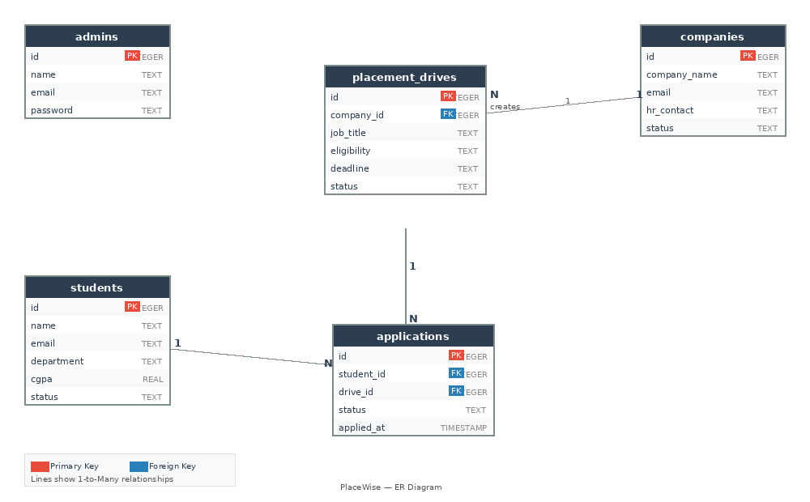

6. API Resource Endpoints
Endpoint | Method | Description
/api/students | GET | List all students (admin only)
/api/companies | GET | List all companies (admin only)
/api/drives | GET | List all approved placement drives
/api/drives/<id> | GET | Get details of a specific drive
/api/applications | GET | Get applications for the logged-in student
/api/applications | POST | Submit an application for a drive
YAML API definition file included separately as api.yaml in the submission ZIP.

7. Architecture and Features

Project Structure
- app.py — main Flask application with all routes
- database.py — database initialization and connection helper
- templates/ — Jinja2 HTML templates organized by role (admin/, company/, student/)
- templates/base.html — shared base layout with navbar and sidebar
- static/uploads/resumes/ — uploaded student resume files

Implemented Features
- Role-based login for Admin, Company, and Student
- Admin can approve/reject company registrations and placement drives
- Admin can search, blacklist, and delete students and companies
- Companies can create, edit, close, and delete placement drives
- Companies can update applicant status (Shortlisted / Selected / Rejected)
- Students can apply for approved drives with duplicate prevention
- Students can upload a resume and edit their profile
- Students can view full application history
- Admin dashboard shows live stats for students, companies, drives, and applications

8. Video Presentation
Drive Link: https://drive.google.com/file/d/1JRDQAF5YcWsJt3C2F6CAxXriArM0F9Wn/view?usp=sharing

