Smart MCQ Solver Challenge
ABSTRACT
The goal of this competition is to develop AI based models that accurately rank the most probable answers for multiple choice questions using the provided dataset. The dataset contains multiple-choice questions with their corresponding answer options and correct answer labels for training. During analysis, it was observed that many questions in the validation split were highly similar to those in the training data after random splitting , which leaded to overly optimistic validation results. Therefore, greater emphasis was placed on the Kaggle leaderboard score obtained from the hidden test set, as it provides a more reliable measure of model performance.
Three different approaches were explored in this project. First, a traditional machine learning model was developed using TF-IDF feature extraction combined with Logistic Regression. Next, pre-trained transformer models, including BERT and DistilBERT, were fine-tuned using the Hugging Face Transformers library and PyTorch. Finally, a TextCNN architecture was implemented and trained from scratch to evaluate the performance of a custom deep learning model.
Among all the models, the TF-IDF with Logistic Regression approach achieved the best overall performance, obtaining a Kaggle leaderboard score of 0.75477. The fine-tuned transformer models produced competitive results, while the TextCNN model achieved comparatively lower performance. The experimental results indicate that, for this dataset, LR model performance suggests that the dataset contains strong word-level correlations that can be effectively exploited by traditional machine learning methods. This approach may have limited generalization to datasets containing more diverse wording or requiring deeper semantic reasoning,but it works.
INTRODUCTION
- Problem statement :
The Smart MCQ Solver Challenge is a Natural Language Processing (NLP) task that aims to develop AI-based models capable of predicting the correct answer to multiple-choice questions. Each sample consists of a question prompt and five answer options (A–E). The training dataset contains labeled questions, while the test dataset is used to evaluate model performance on the Kaggle leaderboard.
- Project objective :
The objective of this project was to experiment with different machine learning and deep learning models to evaluate their performance on unseen multiple-choice questions.Also understanding Embeddings and transformer architecture that is backbone of Artificial Intelligence.
- Report Structure: This report begins with an overview of the dataset, preprocessing, and tokenization techniques used for preparing the data. It then presents the implementation and evaluation of different machine learning and deep learning models, followed by a comparative performance analysis. Finally, the report concludes with the key findings, future work, and references.

Dataset & Preprocessing
- Dataset description :
The Smart MCQ Solver Challenge dataset consists of multiple-choice questions, where each sample contains a question prompt, five answer options (A–E), and the correct answer label in the training set. The test dataset has the same structure but does not include the correct answers. The objective is to train a model using the labeled training data and predict the most probable answers for the unseen test questions.
Given Dataset Shape : (2000, 8)
Columns description :

Sr. No. | Column | Description | Type
1 | id | Unique question identifier | Numeric
2 | prompt | Question text | Categorical
3 | A–E | Five answer choices | Categorical
4 | answer | Correct option (training only) | Categorical
- Exploratory Data Analysis
An initial analysis was performed to understand the dataset characteristics. The class distribution was nearly balanced across all five answer classes. However, many questions in the validation split were highly similar to those in the training data, which resulted in overly optimistic validation scores.
Also found duplicates after removing id column.And found that after grouping using clustering similar questions founded that the dataset has majority questions related to physics , biology , Mathematics ,etc.
Therefore, the Kaggle leaderboard score on the hidden test set was considered the primary evaluation metric.
- Data Preprocessing
Before training, the dataset was preprocessed to convert the text into a suitable format for the models. For transformer models, the question prompt and answer options were combined into a single input sequence and tokenized using the corresponding pretrained tokenizer.Labels Converted into new formulation based binary labels. Sequence padding and truncation were applied to ensure a fixed input length. For the TF-IDF model, the combined text was vectorized using TF-IDF feature extraction. Since the dataset was reformulated as a question–answer pair classification task, binary labels were assigned to each pair. The correct answer was labeled as 1, while the remaining incorrect answers were labeled as 0. This enables the transformer model to learn the semantic relationship between a question and an individual candidate answer and predict the probability that the pair represents the correct answer.As Suggested in Research Paper “BERT: Pre-training of Deep Bidirectional Transformers for Language Understanding. NAACL-HLT. Devlin, J., Chang, M. W., Lee, K., & Toutanova, K. (2019)”.

Tokenization Strategy
Two different tokenization strategies were used in this project depending on the model architecture. For the pre-trained transformer models (BERT and DistilBERT), the WordPiece tokenizer provided by the Hugging Face Transformers library was used through BertTokenizerFast.from_pretrained(). WordPiece divides words into subword units, enabling the model to handle unseen or rare words while preserving contextual information. Each question–answer pair was tokenized into input IDs, attention masks, and token type IDs, with padding and truncation applied to obtain fixed-length input sequences.
For the custom TextCNN model, a custom word-level tokenizer was implemented. The training corpus was split into individual words, and a vocabulary was created by assigning a unique integer index to each word. Each question–answer pair was then converted into a sequence of word indices, which served as the input to the embedding layer (nn.Embedding). Unlike WordPiece tokenization, this approach learns word representations from scratch during model training and does not utilize any pre-trained language knowledge.

Modeling & Experimentation
Model 1 : Dummy Classifier (Baseline)
A Dummy Classifier was implemented as the baseline model for comparison with more advanced machine learning and deep learning models. The model does not learn from the training data; instead, it predicts the same answer for every question regardless of the input. This provides a simple reference point to evaluate whether the proposed models are learning meaningful patterns from the dataset.Used Constant Strategy ,thus the dummy classifier always predicted the same answer for every question using a constant prediction strategy.
Model 2 : TF-IDF + Logistic Regression
he TF-IDF with Logistic Regression model was implemented as a traditional machine learning approach for binary classification. First, each question–answer pair was converted into a TF-IDF feature vector, which represents the importance of words based on their frequency in the corpus. These feature vectors were then used to train a Logistic Regression classifier to predict whether a candidate answer was correct (label 1) or incorrect (label 0). Logistic Regression was selected because it is computationally efficient, performs well on high-dimensional sparse text features, and serves as a strong baseline for text classification tasks.
Model 3 : Fine-Tuned BERT
BERT (Bidirectional Encoder Representations from Transformers) is a pre-trained transformer model developed by Google for Natural Language Processing tasks. It uses a bidirectional self-attention mechanism to understand the contextual meaning of words by considering both the left and right context simultaneously. In this project, BERT was fine-tuned for binary classification using the transformed question–answer pair dataset.
Each question–answer pair was tokenized using the BertTokenizerFast, which automatically applies the WordPiece tokenization algorithm. The tokenized input was passed through the pre-trained BERT encoder, and the contextual representation of the [CLS] token was fed into a classification layer to predict whether the candidate answer was correct (label 1) or incorrect (label 0). During inference, the probabilities of all five candidate answers were computed, and the answer with the highest probability was selected as the final prediction.
In addition to fine-tuning the BERT model, several hyperparameters, including the learning rate, batch size, number of training epochs, and maximum sequence length, were tuned to improve model performance. Different validation strategies like GroupShuffleSplit and StratifiedGroupKFold were also explored to obtain a more reliable estimate of the model's generalization performance. A stricter validation split was created by reducing the similarity between the training and validation sets. However, this approach reduced the diversity and size of the training data, limiting the model's ability to learn from unique examples. As a result, the validation and Kaggle MAP@3 scores decreased compared to the original validation strategy. Finally, a confusion matrix was used to analyze the model's predictions on the test set, providing insights into the model's ability to correctly distinguish between positive (correct answer) and negative (incorrect answer) question–answer pairs.
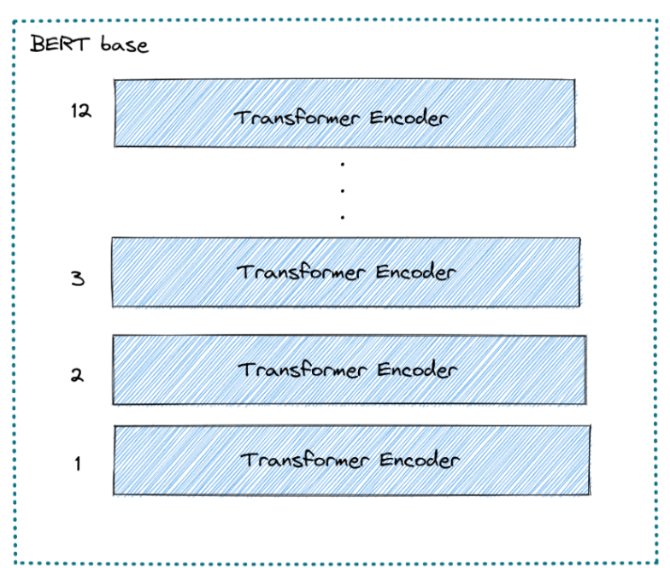
Figure 1 : Bert Architecture
Model 4 : TextCNN
The TextCNN model implemented in this project was inspired by the CNN-based architecture proposed by Chaturvedi et al. (2018) for text-based multiple-choice question answering. Similar to their approach, convolutional layers were employed to extract local textual features from question–answer pairs. However, a simplified architecture was adopted in this work, consisting of an embedding layer, parallel one-dimensional convolutional layers with kernel sizes of 2, 3, and 4, global max pooling, dropout, and a fully connected output layer for binary classification. Also Trained TextCNN with Attention Layer But it reduces the test score so as concluded because of small dataset it reduced the score and predictability.
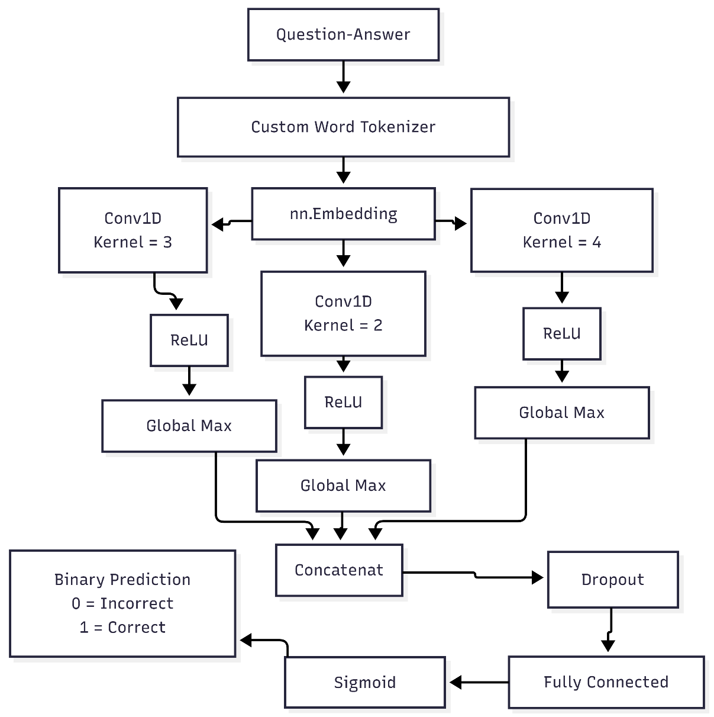

Figure 2 : Text Cnn Architecture (Scratch Model)
Model 5 : RAG (Retrieval Augmented Generation) Experimented Only
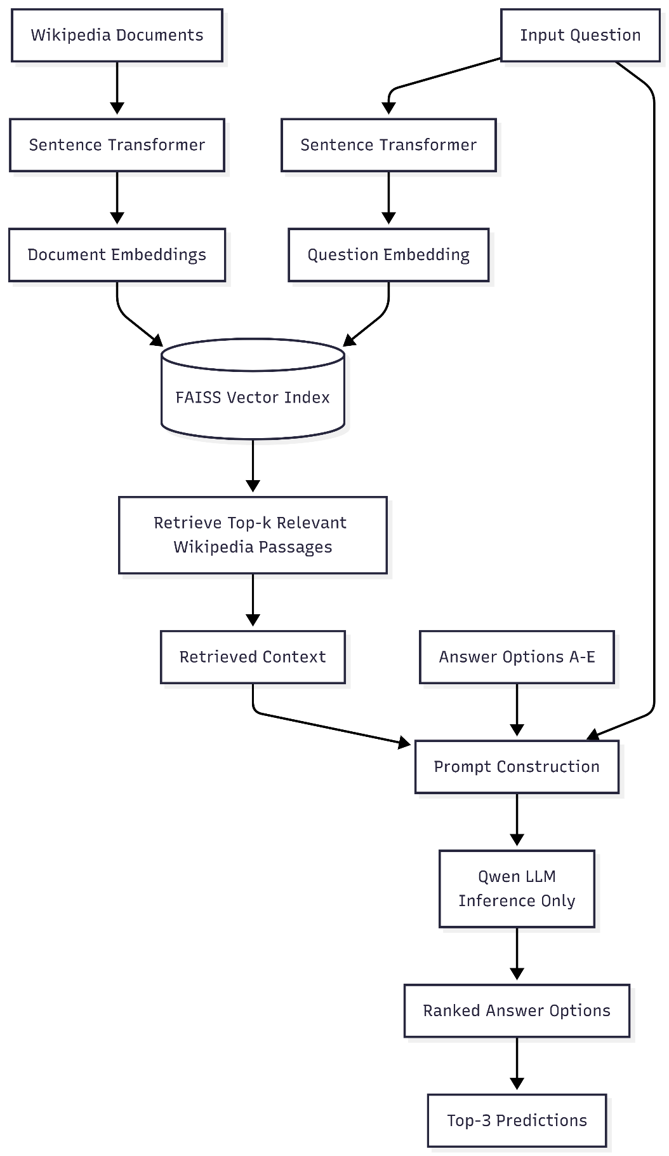
A Retrieval-Augmented Generation (RAG) approach was explored to improve multiple-choice question answering by combining semantic retrieval with a Large Language Model (LLM). Unlike the previous models, no model training or fine-tuning was performed. Instead, a Sentence Transformer was used to generate dense vector embeddings for the training question–answer pairs, which were stored in a vector database. During inference, the embedding of the input question was compared with the stored embeddings to retrieve the most semantically similar examples. Achieved 0.83 MAP@3 score is validation set but not tested in Test data.

Figure 3 : RAG Model (Experimental)
Performance & Comparative Analysis
- Evaluation Metrics :
The models were evaluated using Mean Average Precision at 3 (MAP@3), which was the official evaluation metric of the Kaggle competition. MAP@3 measures whether the correct answer appears within the top three predicted options while rewarding higher-ranked correct predictions. For the BERT model, a confusion matrix was also generated on the validation set to analyze the binary classification performance of the model.
- Comparative Performance :

Model | Approach | MAP@3
Dummy Baseline | Constant prediction | 0.35245
TF-IDF + Cosine Similarity |  | 0.35203
  Similarity-based retrieval
TF-IDF + Logistic Regression | Traditional Machine Learning | 0.75477
BERT (Learning Rate = 2 × 10⁻⁵) | Fine-Tuned Transformer | 0.75103
BERT (Learning Rate = 3 × 10⁻⁵) | Fine-Tuned Transformer | 0.73000
TextCNN | CNN Trained from Scratch | 0.70199
TextCNN + Attention | CNN with Attention Mechanism | 0.69210
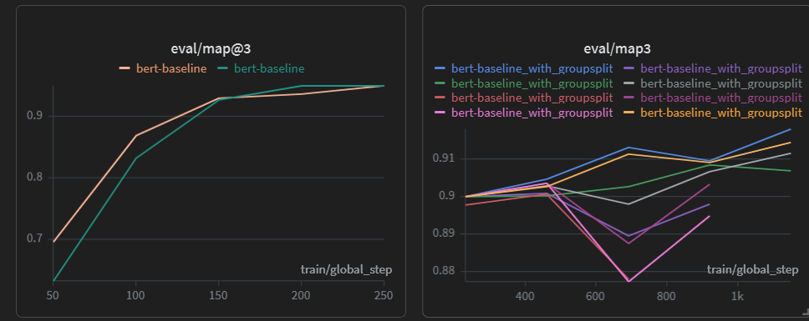
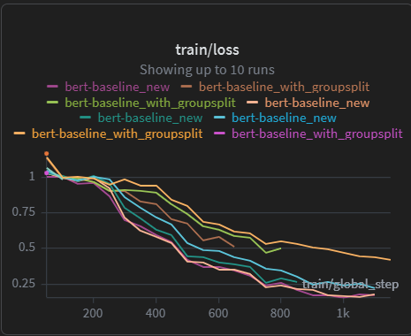
- Training Performance of Bert (Graphs):
Figure 4 : Train Loss of Bert
Figure 5 : Map Score of in evaluation Mode (Grouped split set and raw splitting)
The standard validation split produced slightly higher validation scores than the group-based split. The group-based validation strategy reduced data leakage between the training and validation sets, providing a more reliable estimate of the model's generalization performance. However, grouping similar questions also reduced the diversity and number of training examples available to the model. As a result, the model had fewer unique samples to learn from, leading to a slight decrease in both the validation and Kaggle MAP@3 scores. Nevertheless, the evaluation loss consistently decreased during training, indicating stable convergence of the optimization process.

Conclusion & Future Work
Conclusion :
This project explored multiple approaches for multiple-choice question answering, ranging from traditional machine learning to transformer-based and custom deep learning models. Among all the approaches, TF-IDF with Logistic Regression achieved the highest MAP@3 score, while the fine-tuned BERT model produced competitive performance with better semantic understanding. The TextCNN model demonstrated the feasibility of learning directly from the training data but was unable to match the performance of pre-trained models. Overall, the experiments highlight that selecting an appropriate model depends on the characteristics of the dataset rather than simply choosing the most complex architecture.
Challenges Faced :
- High similarity between training and validation questions resulted in optimistic validation scores.
- Hyperparameter tuning required multiple experiments to obtain stable performance.
- Training deep learning models from scratch required significantly more data than was available.
- Designing an effective validation strategy without losing useful training examples was challenging.
Areas for Improvement :
Although the proposed approaches achieved competitive performance, several improvements can be explored in future work. additional validation strategies should be explored to address the high similarity between training and validation questions. Developing a validation split that reduces data leakage while preserving sufficient training data may provide a more accurate estimate of real-world performance. Finally, further hyperparameter optimization and ensemble techniques combining traditional machine learning and transformer-based models could be investigated to improve overall prediction accuracy. Retrieval-Augmented Generation (RAG) pipeline should also explored more as it has more architectures as well.
REFERENCES
- Kim (2014). Convolutional Neural Networks for Sentence Classification.
- Hugging Face Transformers Documentation.
- PyTorch Documentation.
- Wolf et al. (2020). Transformers: State-of-the-Art Natural Language Processing.
- Devlin et al. (2019). BERT: Pre-training of Deep Bidirectional Transformers for Language Understanding.
- Kim (2014). Convolutional Neural Networks for Sentence Classification.
- Lewis et al. (2020). Retrieval-Augmented Generation for Knowledge-Intensive NLP Tasks.

