

M a h a r a s h t r a S t a t e E l e c t r i c i t y D i s t r i b u t i o n C o. L t d.

| **Renewable Energy Generating System**  **Annexure-I**  **(Commissioning Report for RE System)** | | | | | |
| --- | --- | --- | --- | --- | --- |
| **S No.** | **Particulars As commissioned** | |  | |
| 1 | Name of the Consumer BHARTI PARAS PARDHI | | |  | | | | |
| 2 | Consumer Number 110363099084 | | |  | | | | |
| 3 | Mobile Number 9096917057 | | |  | | | | |
| 4 | E-mail | | |  | | | | |
| 5 | Address of Installation addressline | | |  | | | | |
| 6 | RE Arrangement Type Net Metering Arrangement | | |  | | | | |
| 7 | RE Source Solar | | |  | | | | |
| 8 | Sanctioned Capacity (KW) 5 KW | | |  | | | | |
| 9 | Capacity Type Rooftop | | |  | | | | |
| 10 | Project Model Capex | | |  | | | | |
| 11 | RE installed Capacity (Rooftop)(KW) 3 KW | | | q | | | | |
| 12 | RE installed Capacity (Rooftop + Ground) (KW) NA | | |  | | | | |
| 13 | RE installed Capacity (Ground)(KW) NA | |  | | | |
| 1. Installation date 1/09/2025 2. **Solar PV Details**  * Inverter Capacity (KW) 5 KW * Inverter Make WAAREE SOLAR * No of PV Modules 06 * Module Capacity (KW) 3.3 KW | |  | | | | | |

**To be uploaded separately:**

1. Self-certification of safety of the installation of the RTS system along with the test report of the Licensed Electrical Contractor (Proforma-A).
2. Electrical Inspector permission if System is above 200 KW (Mandatory if system is above 200KW only)
3. Third party leasing agreement if Model selected is RESCO.
4. Photograph of the system commissioned.

.. . . . …..

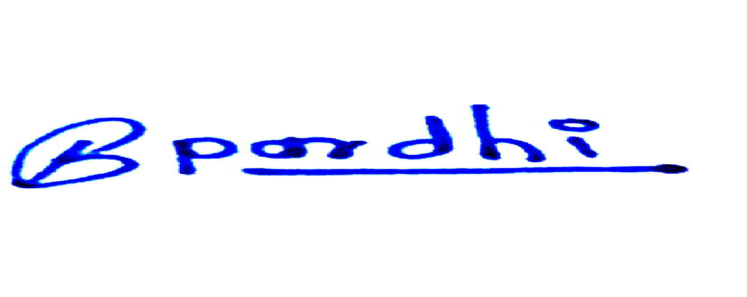

**Signature of Consumer**

**Date: 31/7/2025**



**Renewable Energy Generating System**

**Proforma-A**

**COMMISSIONING REPORT (PROVISIONAL) FOR GRID CONNECTED SOLAR**

**PHOTOVOLTAIC POWER PLANT (with Net-metering facility)**

Certified that a Grid Connected SPV Power Plant of **3 KWp** capacity has been installed

at the site **addressline**

District **district variable** of MAHARASHTRA which has been installed by M/S **Avidor Innovation Pvt Ltd**

On **1/09/2025** The system is as per BIS/MNRE specifications. The system has been checked for its performance on **PerformanceCheckDatePlaceholder** with installation of bi-directional meter and it is working satisfactorily.



**Signature of the beneficiary**



**Signature of the agency**

**With name, seal and date**

**Signature of the MSEDCL Officer**

**With name, date and seal**