# Work Completion Report for Solar Power Plant

| **Sr. No** | **Component** | **Observation** |
| --- | --- | --- |
| 1 | Name | BHARTI PARAS PARDHI |
| 2 | Consumer number | 110363099084 |
| 3 | Site/Location With Complete Address | Addressvariable   |  | | --- | |
| 4 | Category: Govt/Private Sector | Private Sector |
| 5 | Sanction number |  |
| 6 | Sanctioned Capacity of solar PV system (KW) Installed | 5 KW |
| Capacity of solar PV system (KW) | 3 KW |
| 7 | **Specification of the Modules** | |
| Make of Module | WAAREE POWER |
| ALMM Model Number | WAAREE 560-144M (560 Wp ) |
| Wattage per module | 560 Wp |
| No. of Module | 06 |
| Total Capacity (KWP) | 3.3 KW |
| Warrantee Details (Product + Performance) | 12+13 Year |
| 8 | **PCU** | |
| Make & Model number of Inverter | WAAREE B05F502049EA222 |
| Rating | 5.3 |
| Type of charge controller/ MPPT | MPPT |
| Capacity of Inverter | 5 KW |
| HPD | 30% |
| Year of manufacturing | 2025 |
| 9 | Earthing and Protections | |
| No of Separate Earthings with earth Resistance | THREE . AC 1.5 Ω DC 1.3 Ω |
| It is certified that the Earth Resistance measure in presence of Licensed Electrical Contractor/Supervisor and found in order i.e. < 5 Ohms as per MNRE OM Dtd. 07.06.24 for CFA  Component. | |
| Lightening Arrester | 4 OHM |

We **Avidor Innovation Pvt Ltd** [Vendor] & **BHARTI PARAS PARDHI** [Consumer] bearing Consumer Number **110363099084** Ensured structural stability of installed solar power plant and obtained requisite permissions from the concerned authority. If in future, by virtue of any means due to collapsing or damage to installed solar power plant, MSEDCL will not be held responsible for any loss to property or human life, if any. This is to Certified above Installed Solar PV System is working properly with electrical safety & Islanding switch in case of any presence of backup inverter an arrangement should be made in such way the backup inverter supply should never be synchronized with solar inverter to avoid any electrical accident due to back feeding. We will be held responsible for non-working of islanding mechanism and back feed to the de-energized grid.

 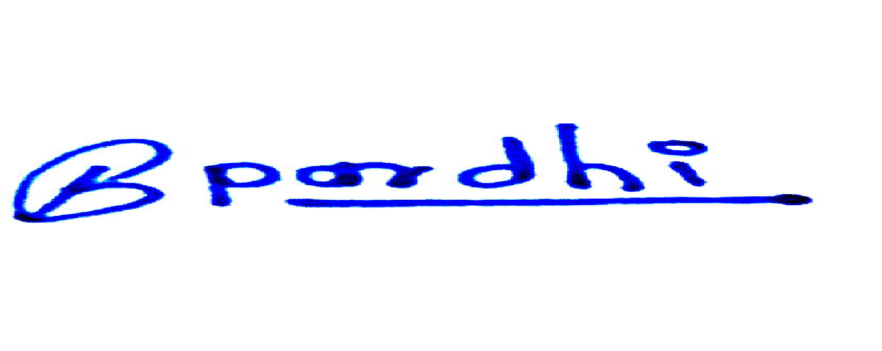

Signature [Vendor] Signature [Consumer]

**Guarantee Certificate Undertaking to be submitted by VENDOR AVIDOR INNOVATION PVT LTD**

The undersigned will provide the services to the consumers for repairs/maintenance of the RTS plant free of cost for 5 years of the comprehensive Maintenance Contract (CMC) period from the date of commissioning of the plant. Non performing/under-performing system component will be replaced/repaired free of cost in the CMC period

 Signature [Vendor] Stamp & Seal

Identity Details of Consumer : - BHARTI PARAS PARDH0049

Aadhar Number : 3655 9447 0923