./lablauncher_updated init
./lablauncher_updated start
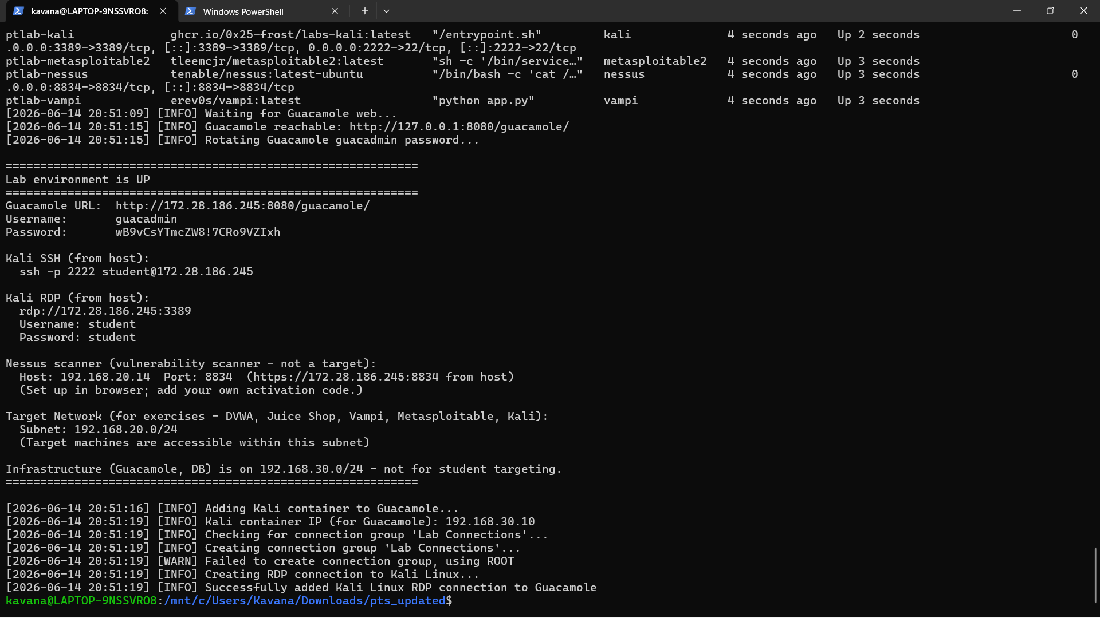
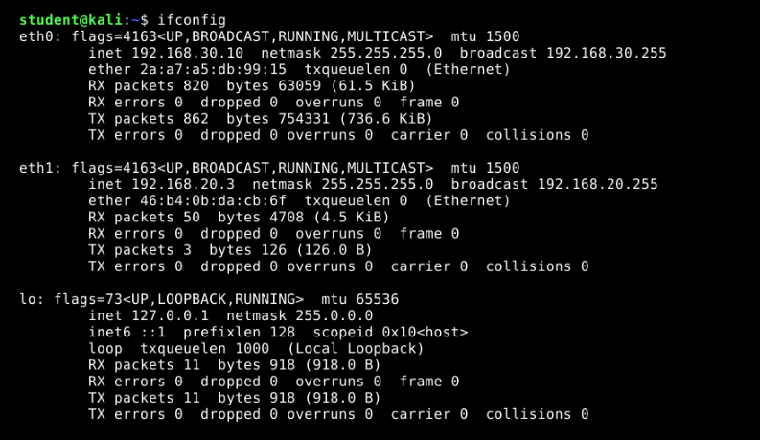

eth1 = 192.168.20.3
Subnet = 192.168.20.0/24
Discover the targets: sudo nmap -sn 192.168.20.0/24
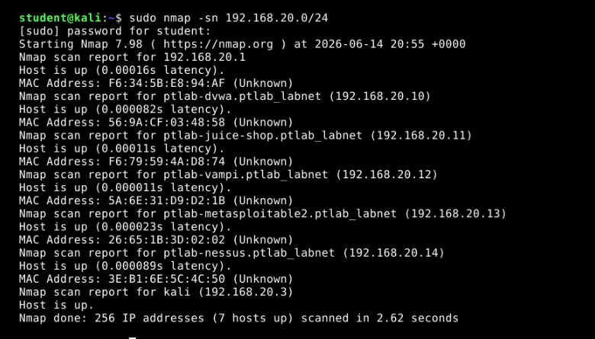
sudo nmap -sV 192.168.20.10-14

for juice-shop open http://192.168.20.11:3000 in kali-browser
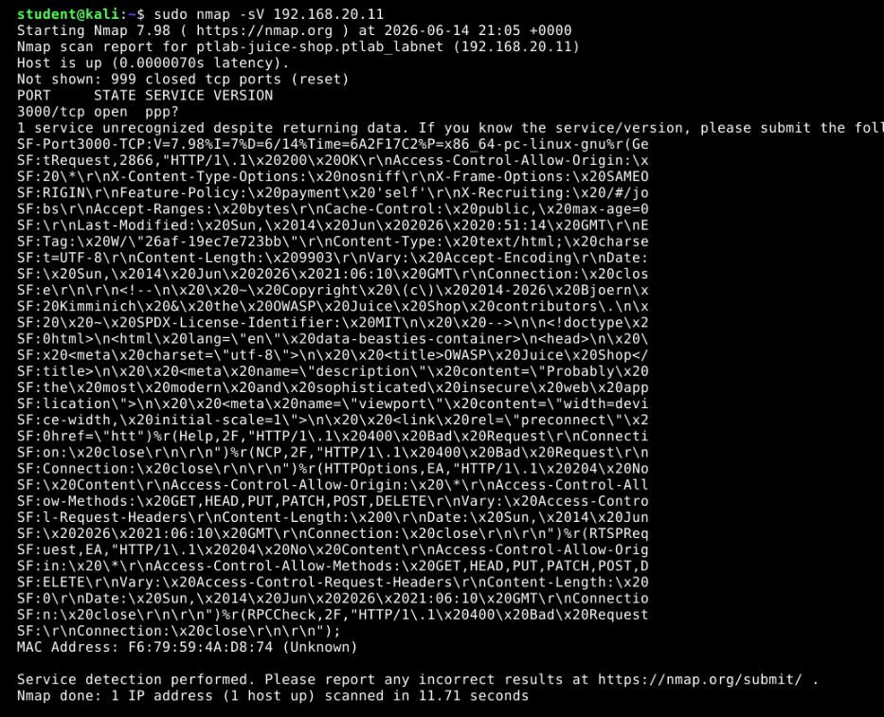

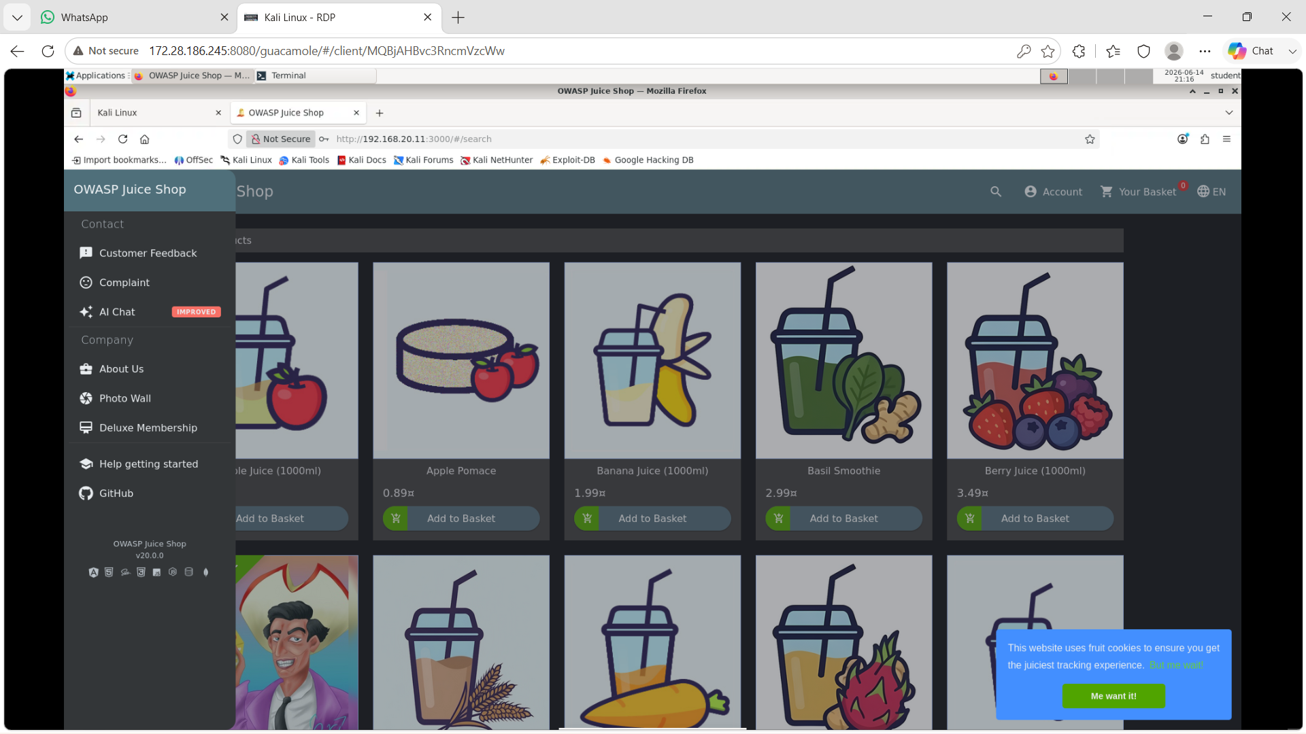
Log in, it has hidden scoreboard
Search http://192.168.20.11:3000/#/score-board
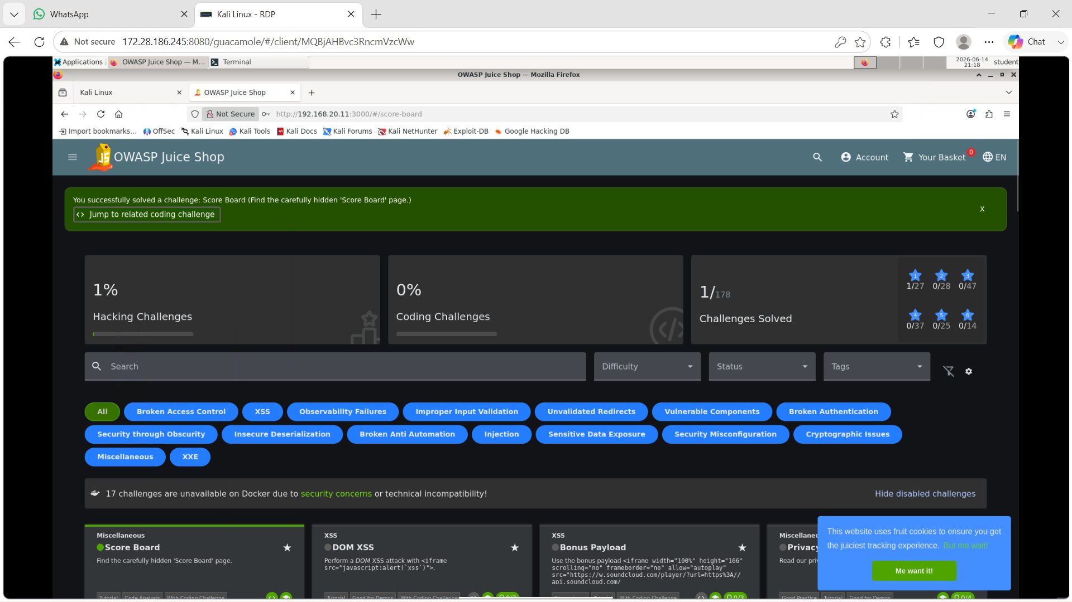
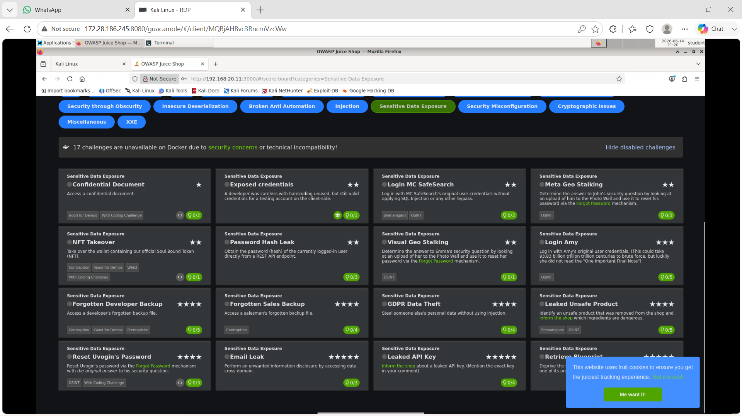
For first task open http://192.168.20.11:3000/ftp
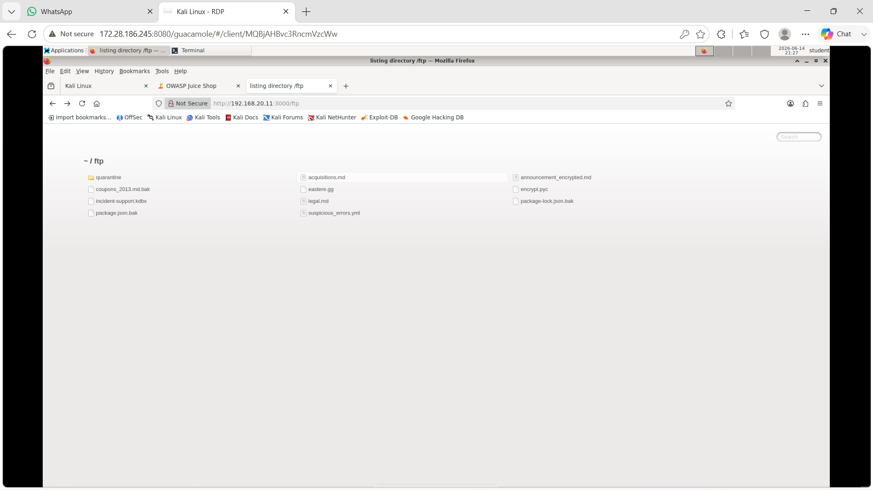
1. Complete Task 1 (Confidential Document)
- Click on acquisitions.md in the middle column of the file list.
- This will open/download the confidential file and complete Task 1.

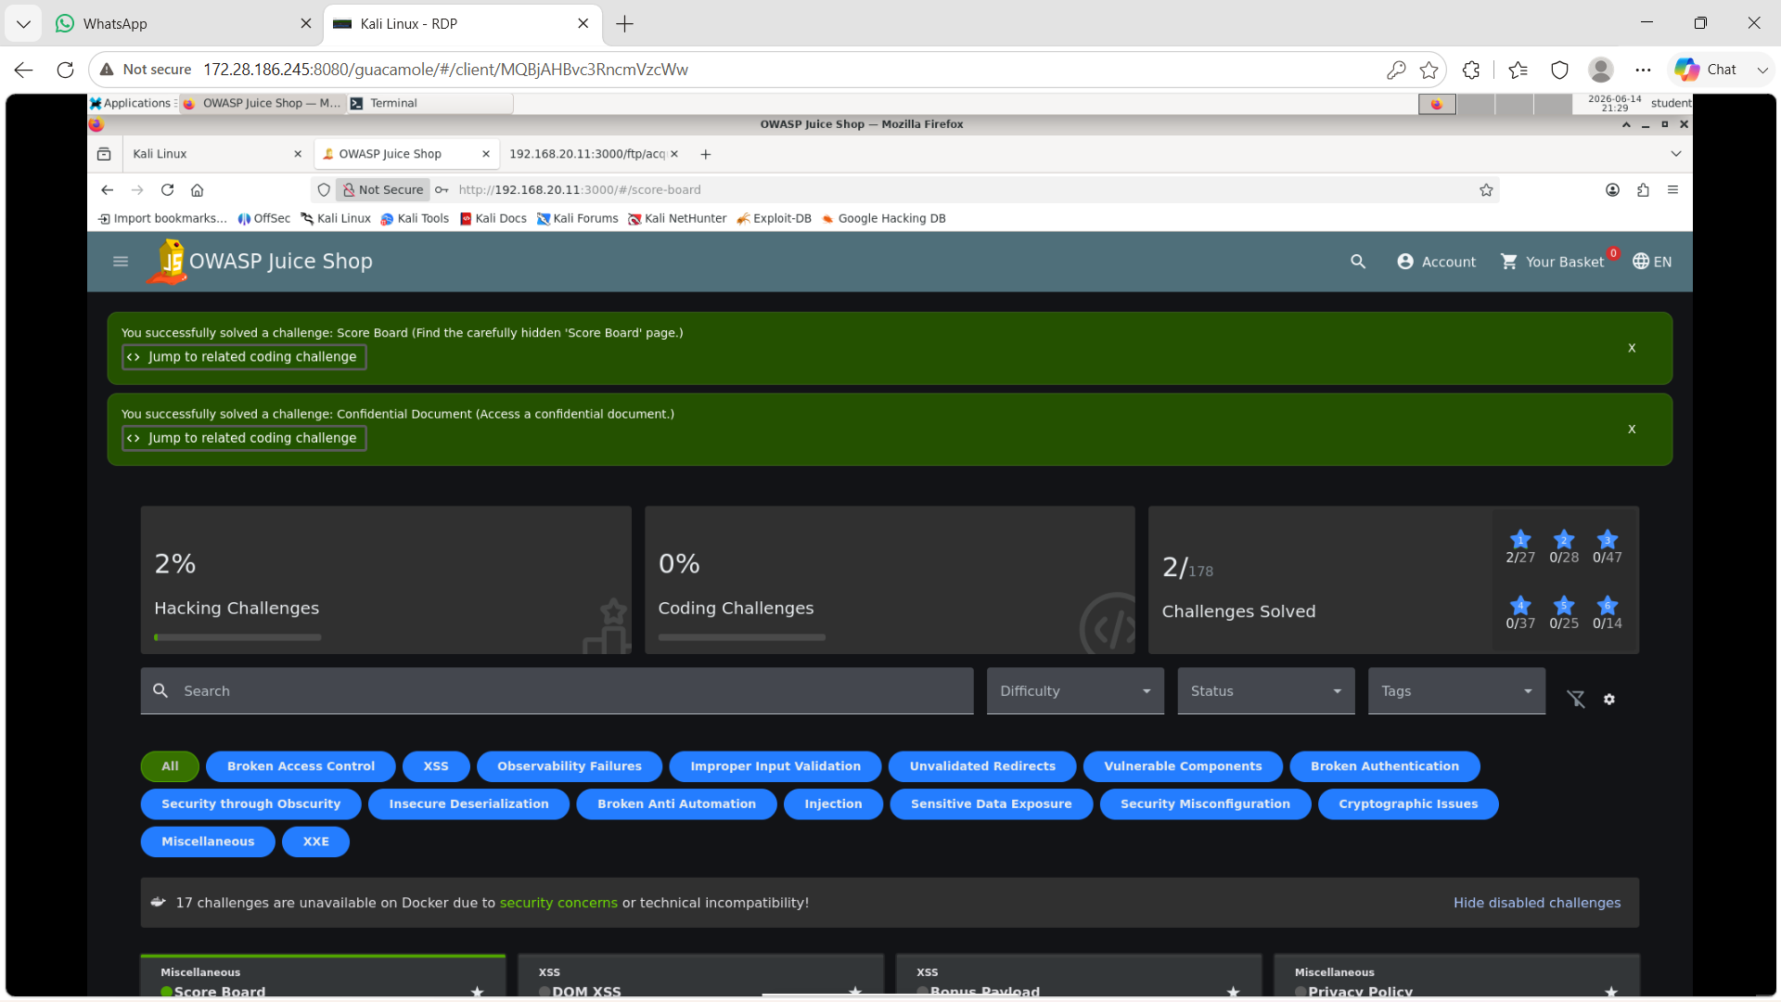
2. Move to Task 2: Security Misconfiguration
The requirement for Task 2 is: Discover and reach the unauthenticated application metrics endpoint.
Replace /ftp with /metrics—this completes the second task

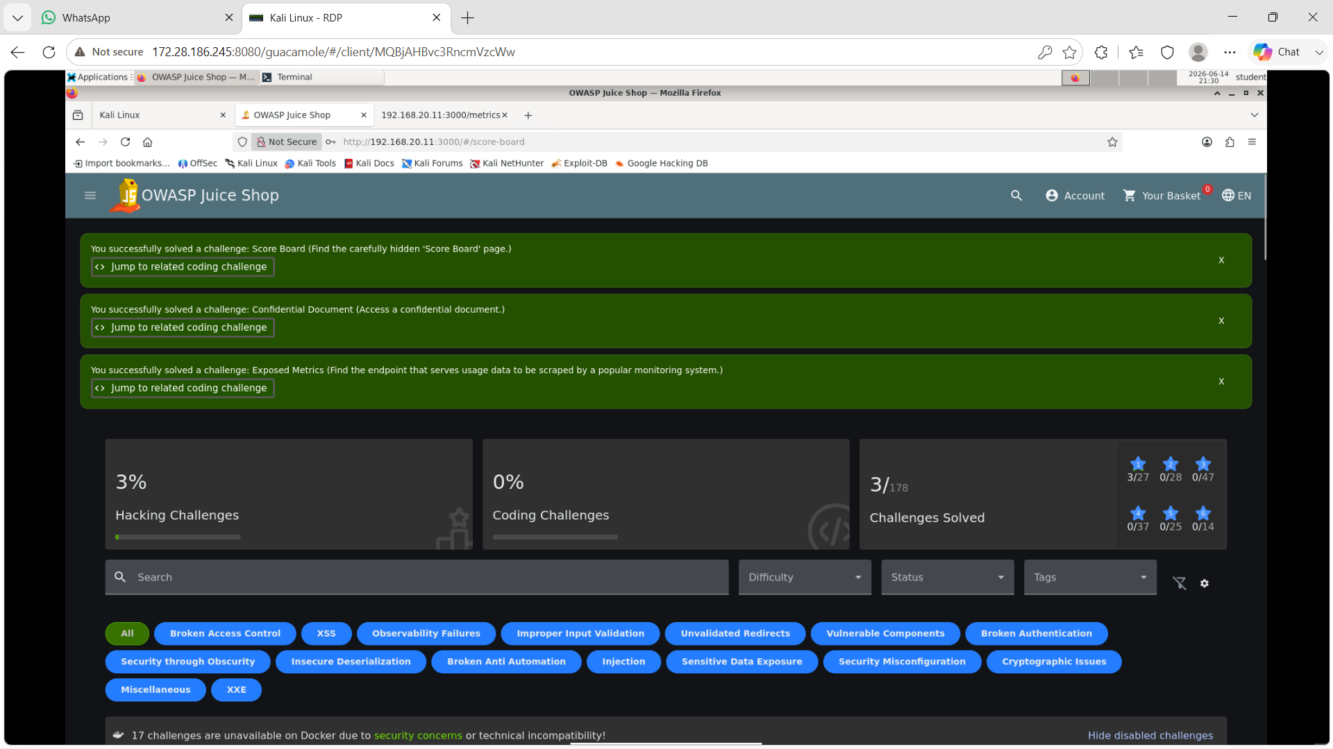

Task 3: Injection – SQL
Login admin: admin@juice-sh.op' –
Password: anything
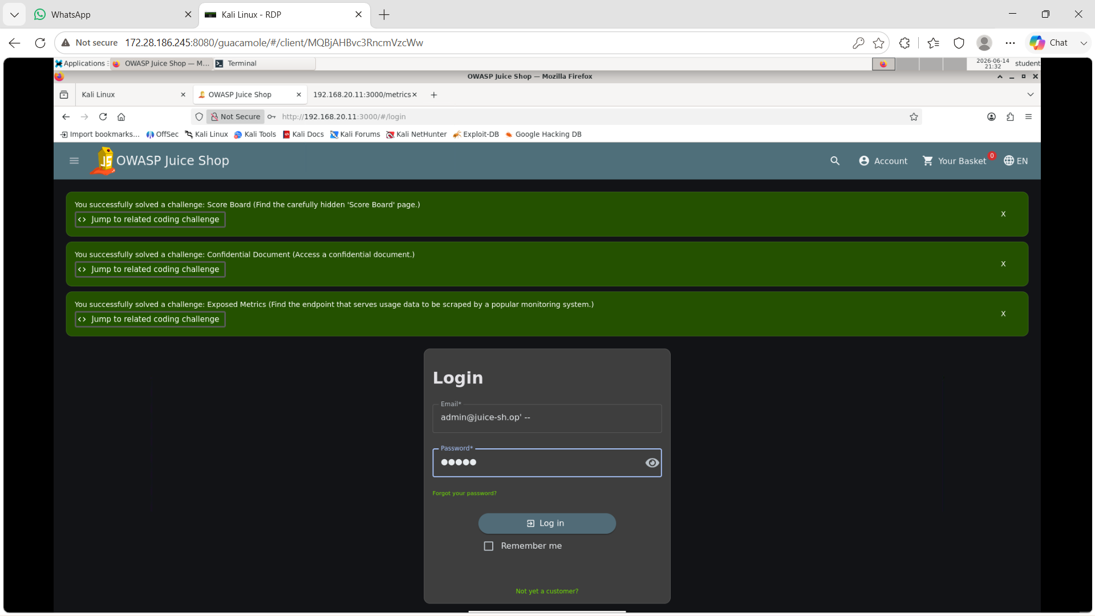
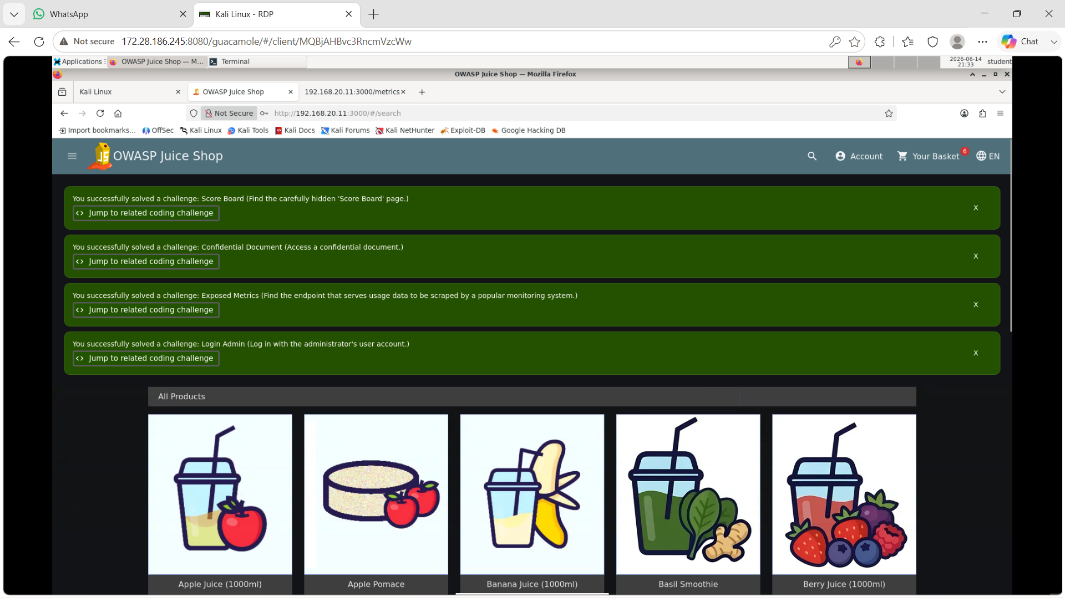

Task 4: Broken Access Control – IDOR
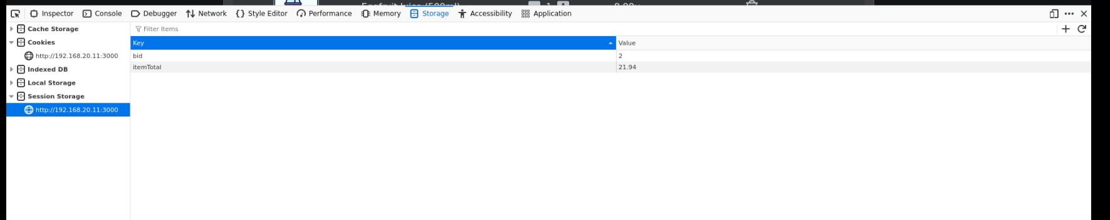
Inspect—storage—session storage—change bid value from 1-2, enter, click on window—refresh
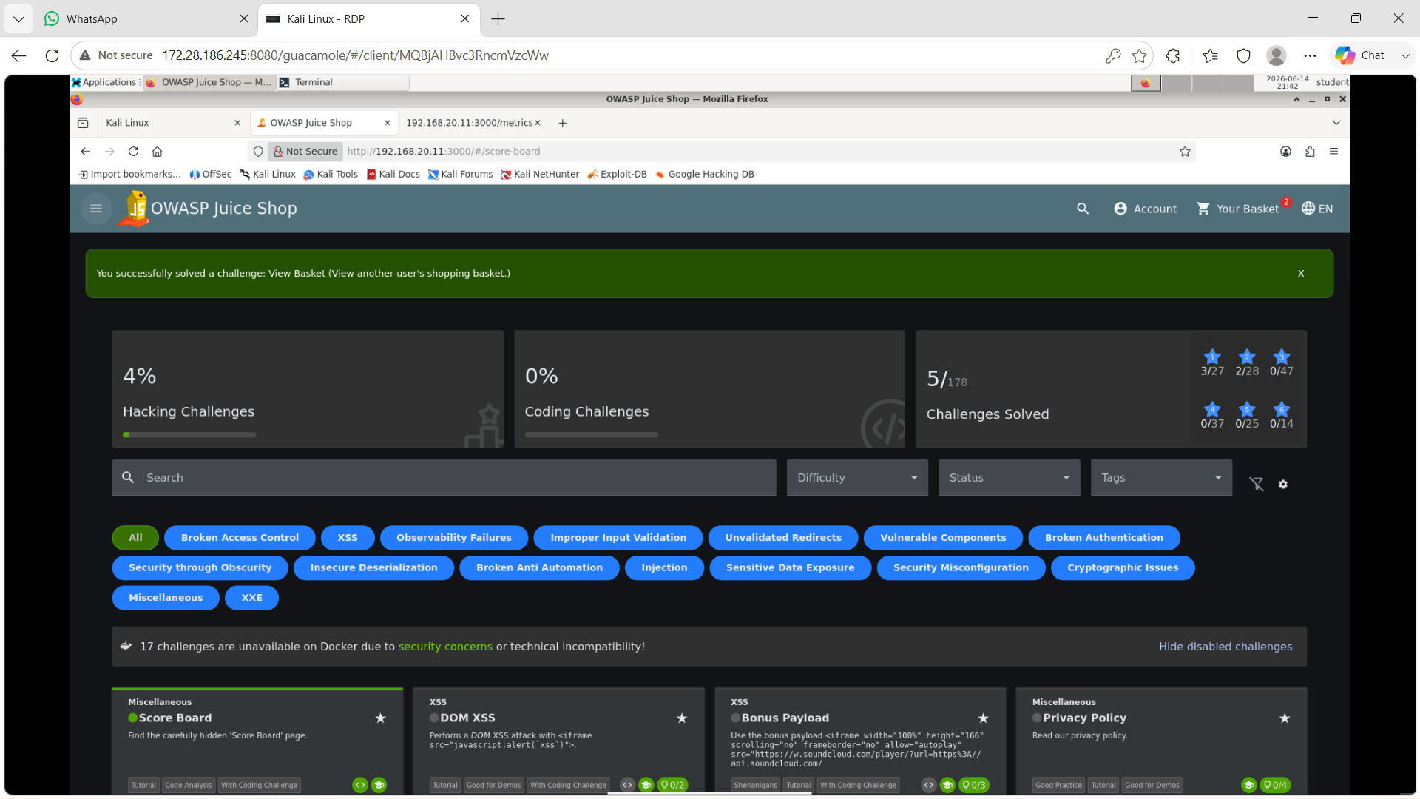
Task 5: Injection – SQL (A03). The goal is to extract the database schema using a UNION-based SQL injection in a search/query parameter.
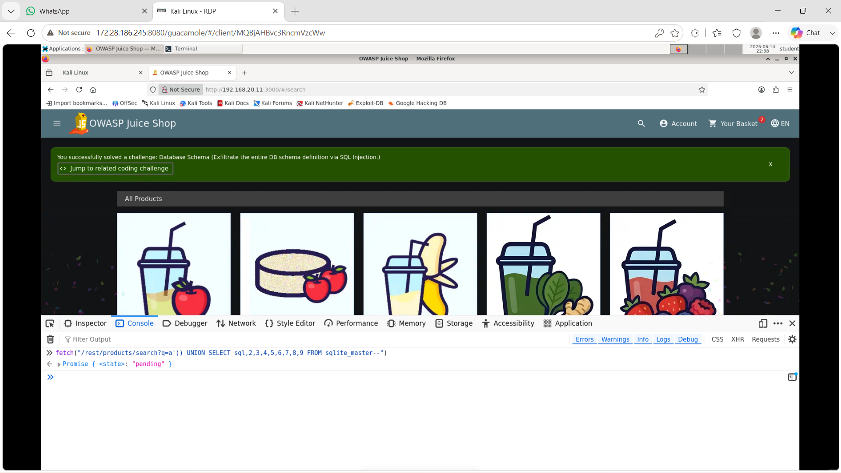
Inside console type: fetch("/rest/products/search?q=a')) UNION SELECT sql,2,3,4,5,6,7,8,9 FROM sqlite_master--") enter

Task 6:
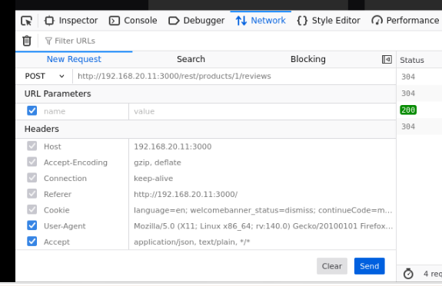
Change 200 get to post
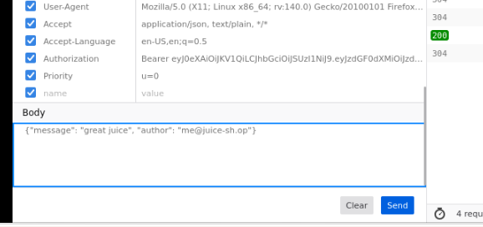
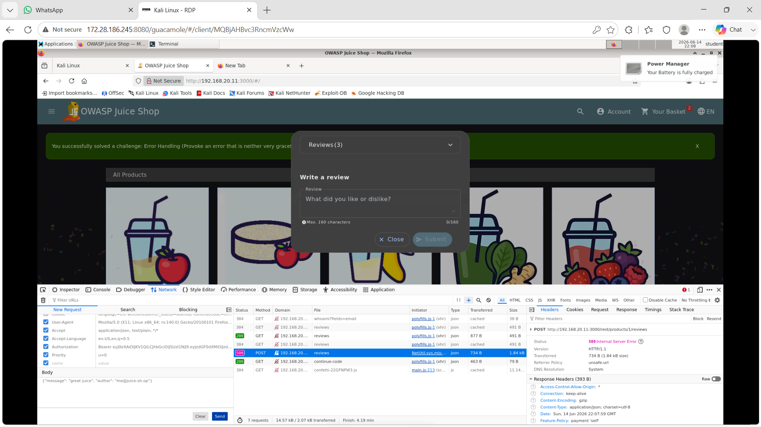
Done

For shepherd (iam using examlauncher)
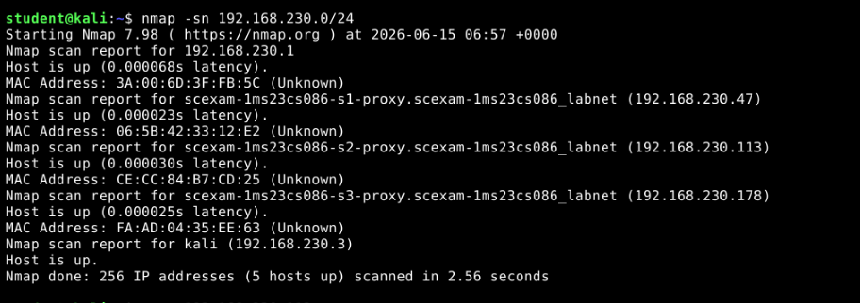
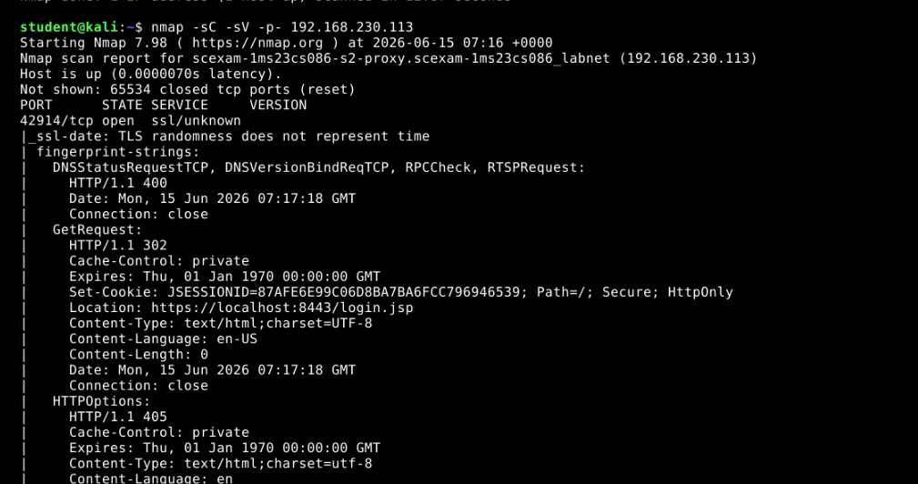
Open https://192.168.230.113:42914/ advanced,accept the risk and continue
Singup and login
Get next challenge
3. Use: <img src=x onerror=alert(1)> in searchterm
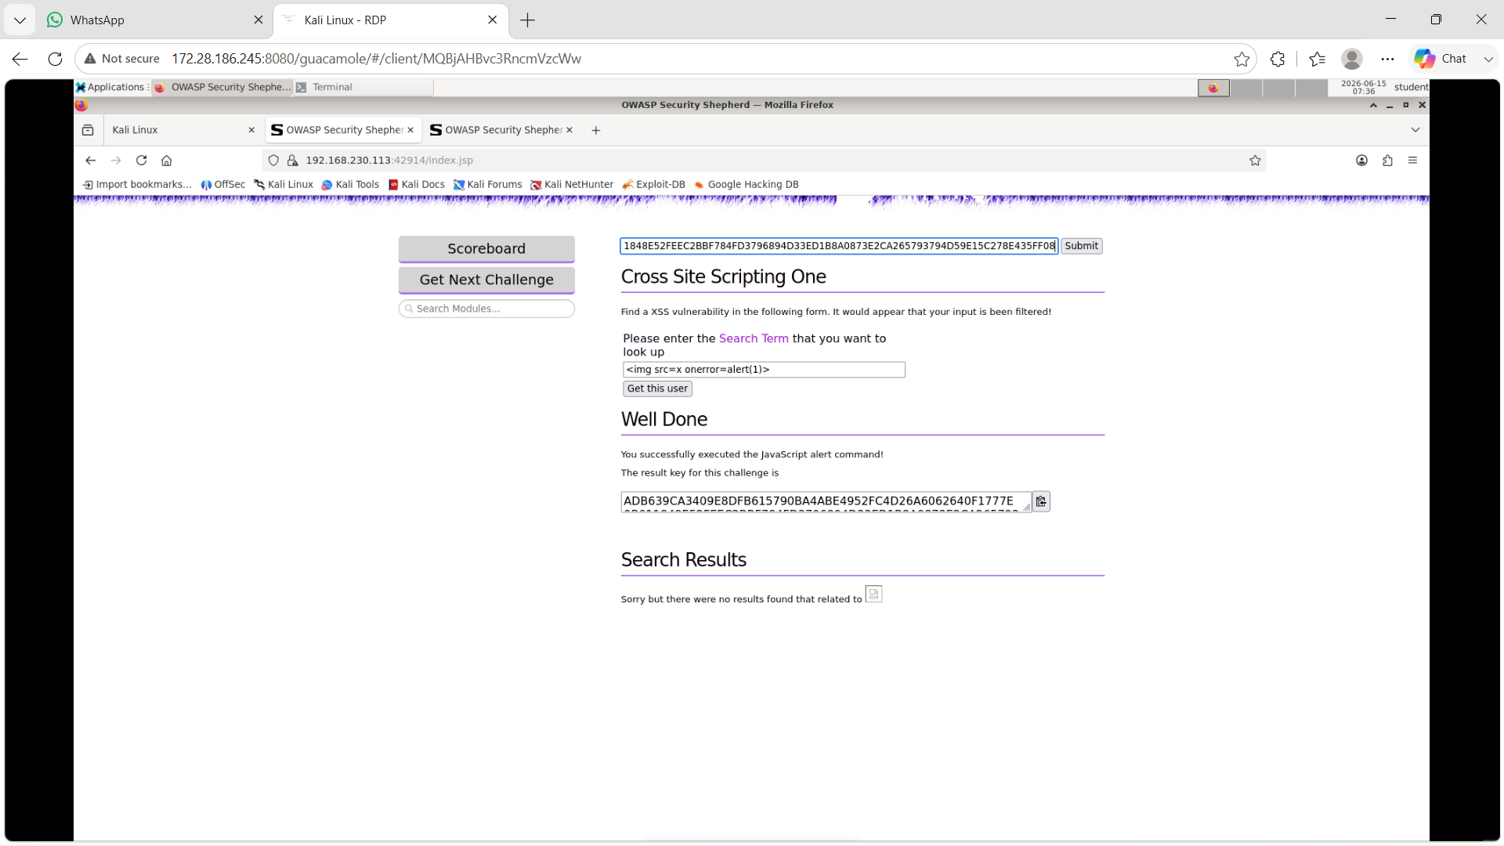
Copy string click submit

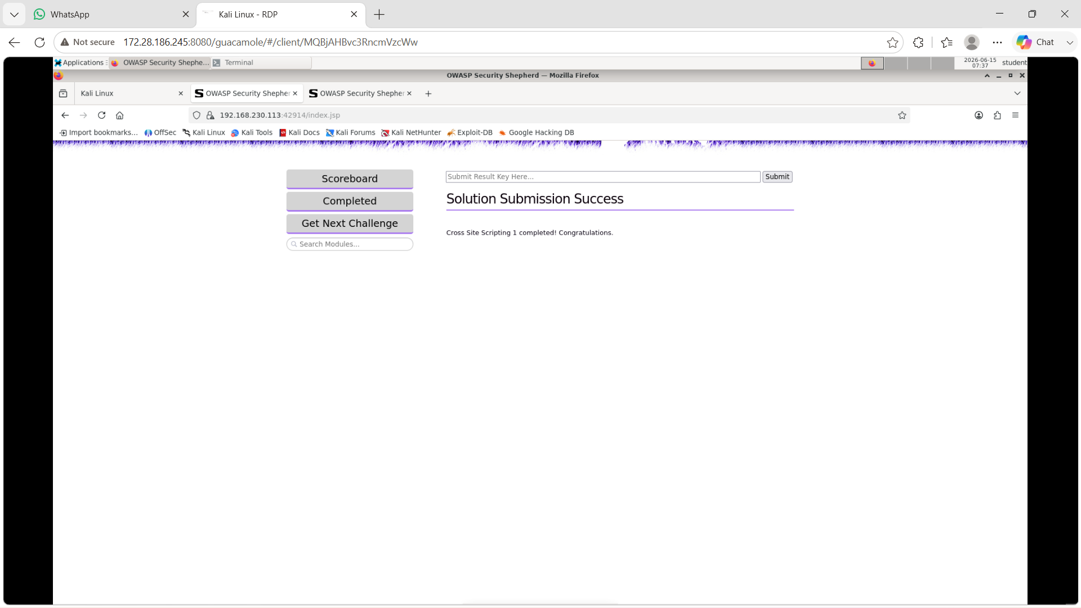
Get next challenge
2. Type “ OR 1=1 – (two dashes afterwards space)
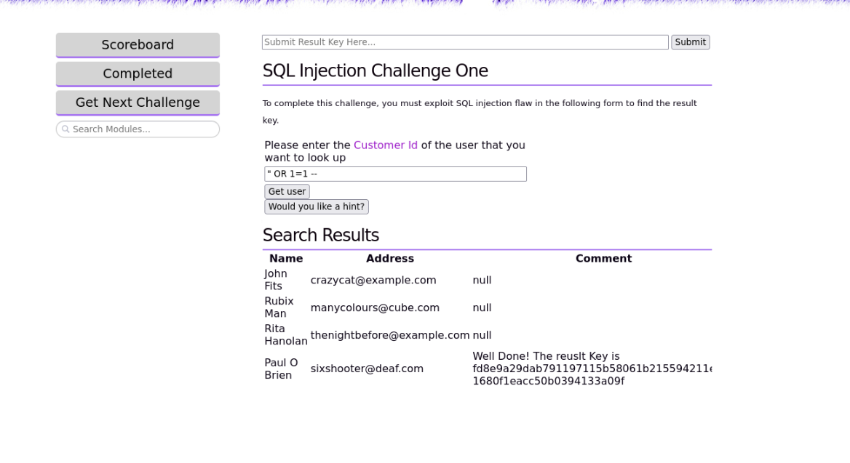
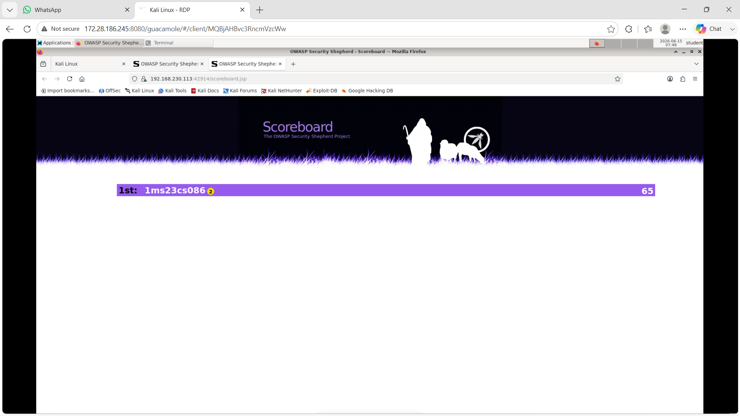
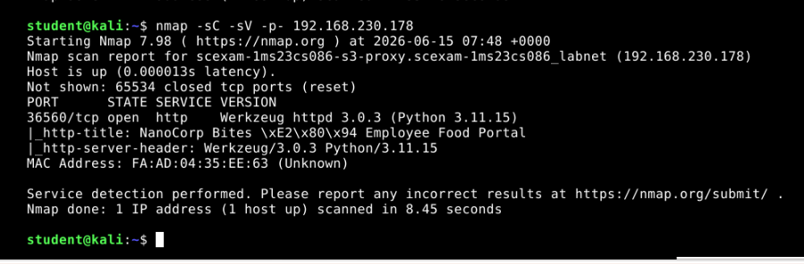
Open http://192.168.230.178:36560/
Signup and login
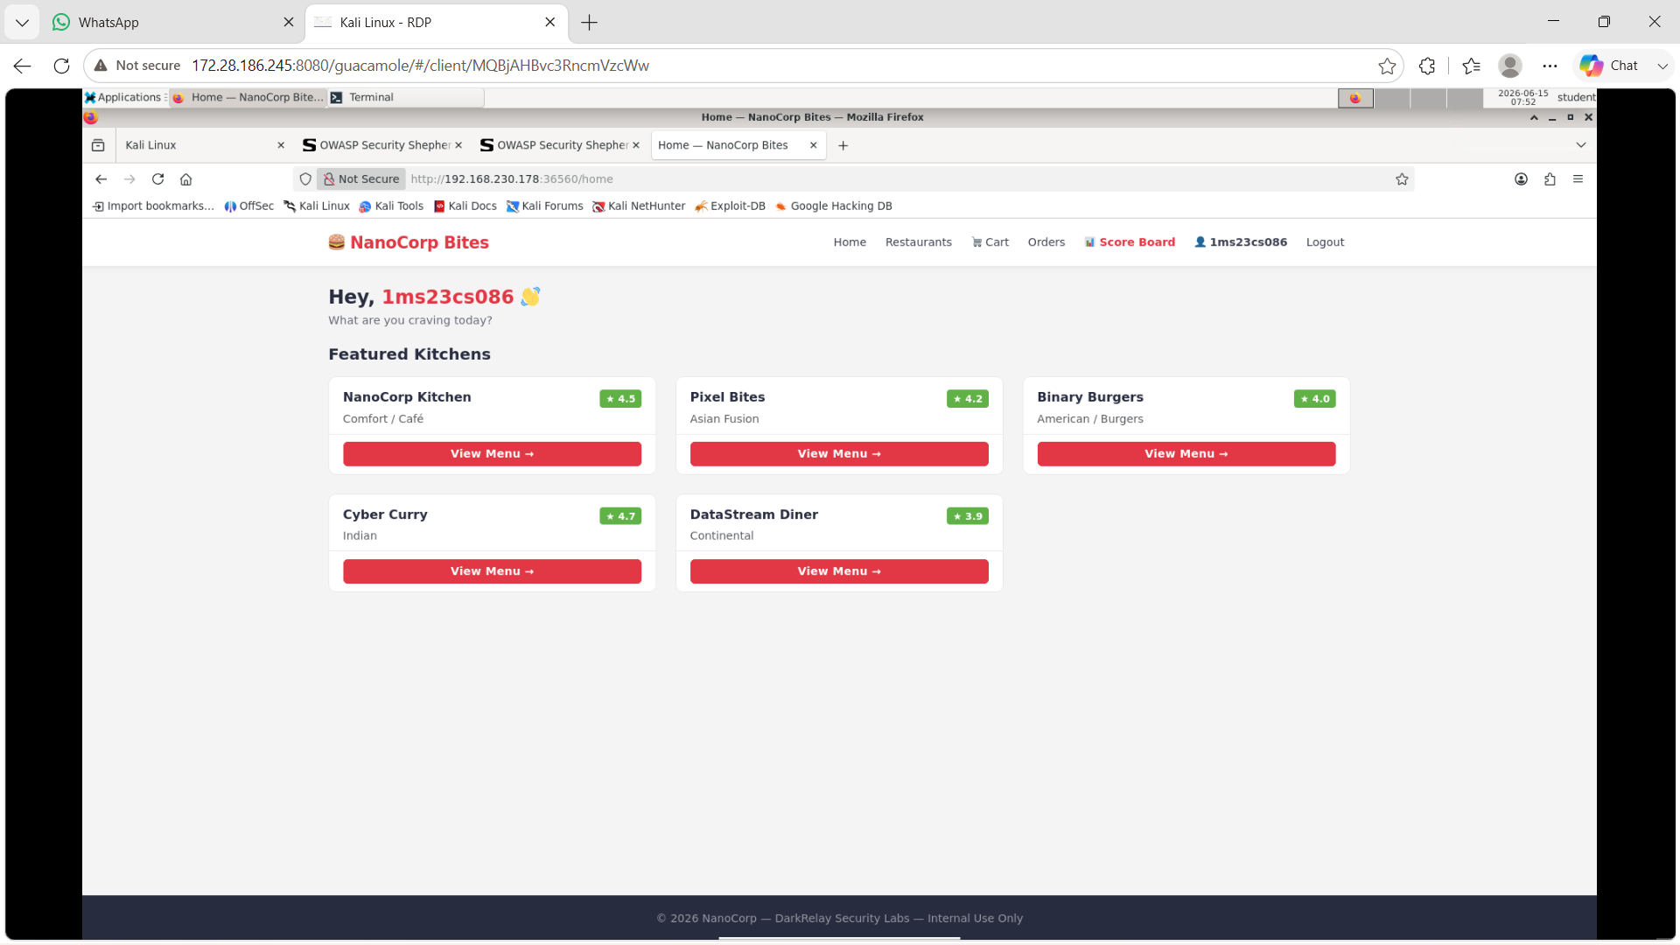
Click on the Restaurants link in the top menu bar (next to Home).
Look for the search bar/box on that page.
Paste exactly this text into the search bar:
<script>alert(1)</script>
Click ok,ok, go to scoreboard
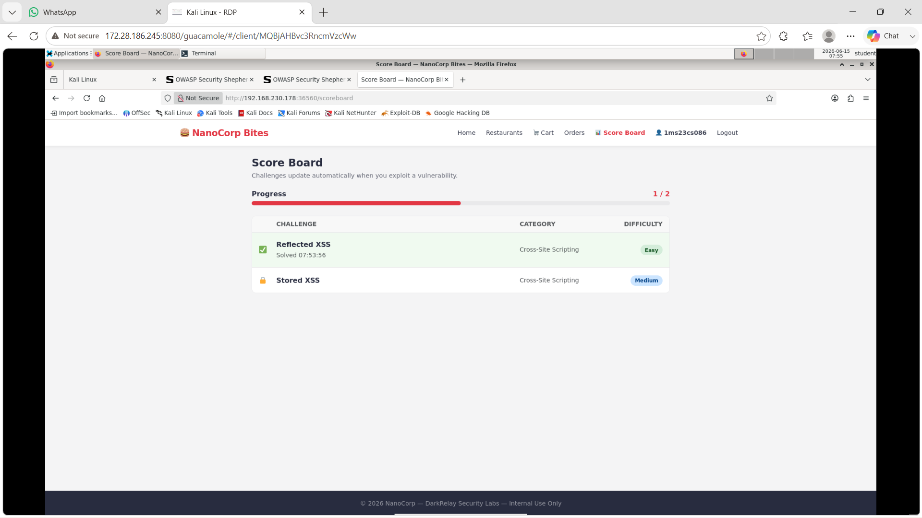
Go to profile(1ms23cs086)
In display name enter <script>alert(1)</script>
Save and update, ok,ok , go to scoreboard
