Total images: 14154(around 7GB) — the code walked the whole tree and found 14,154 image files. For a 15-class problem that's roughly 940 images per class on average — a healthy amount for transfer learning (fine-tuning a pretrained network like ResNet or EfficientNet). It's on the small side for training a big model from scratch, but you almost never do that anyway.

The three splits are the standard ML partition, and each has a distinct job:
split train val test
label
aphid 903 20 50
black_rust 576 20 50
blast 647 20 50
brown_rust 1271 20 50
common_root_rot 614 20 50
fusarium_head_blight 611 20 50
healthy 1000 20 50
leaf_blight 842 20 50
mildew 1081 20 50
mite 800 20 50
septoria 1144 20 50
smut 1310 20 50
stem_fly 234 20 50
tan_spot 770 20 50
yellow_rust 1301 20 50

Classes missing from a split: none ✅

- train (13,104 ≈ 92.6%) — the images the model actually learns from; it sees these and adjusts its weights.
- val (300 ≈ 2.1%) — validation. The model never trains on these; you use them during training to tune choices (learning rate, when to stop, which architecture) and to catch overfitting.
- test (750 ≈ 5.3%) — held out until the very end, touched once, to report the honest final accuracy.

One thing worth flagging for modeling: val and test are tiny per class. From Output 3 we'll confirm it's exactly 20 val and 50 test images per class. That matters because a per-class accuracy measured on 20 images moves in jumps of 5% (one image = 1/20), so validation metrics will be noisy — a class scoring 85% vs 90% between epochs might be luck, not real change. we may later want to enlarge val by carving a bit more out of train.

Class distribution & imbalance

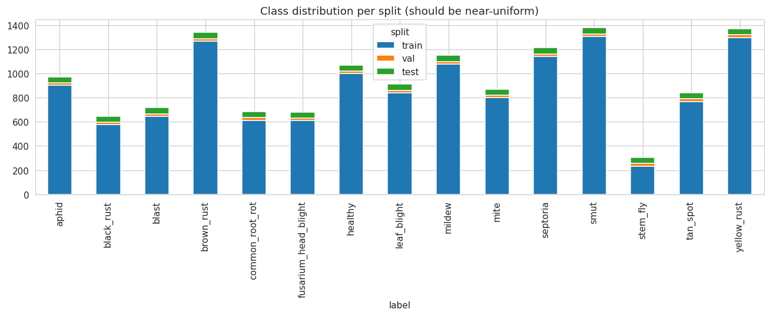
Train imbalance ratio: 5.6 —
It's computed as:
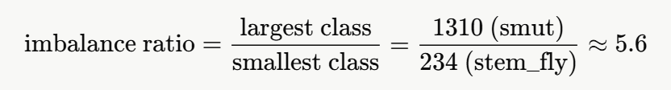
Why this matters for a disease detector: a model trained on imbalanced data becomes biased toward the majority classes. It learns that guessing "smut" or "yellow_rust" is often a safe bet, and it gets comparatively little practice on stem_fly and black_rust.
The usual symptom is that overall accuracy looks fine while the rare classes quietly have poor recall — the model misses them. In an agricultural setting that's the worst failure mode: missing a real infection (a false negative) is more costly than a false alarm, and the diseases that have least data on are exactly the ones the model will be weakest at flagging.
Is 5.6 bad? It's mild-to-moderate, not severe. For scale: ratios under ~3 are usually ignorable, 3–10 is the "handle it, but routine" zone, and ratios of 100+ (like fraud detection) are where things get genuinely hard. So 5.6 is very manageable — you don't need exotic techniques, just a couple of standard levers:
- Class weights — tell the loss function to penalize mistakes on stem_fly more heavily, proportional to its rarity. One line in most frameworks; usually the first thing to try.
- Weighted / oversampling — sample rare classes more often per epoch so the model sees them as much as common ones.
- Targeted augmentation — apply more aggressive augmentation (flips, rotations, crops, color jitter) to the small classes to synthetically pad them.
And a measurement warning that follows from this: because of the imbalance, plain accuracy will lie. If we report a single accuracy number, the big classes dominate it and mask the weak rare ones. When we evaluate, we have to look at per-class recall, macro-F1, and the confusion matrix instead of overall accuracy — macro-averaging weights every disease equally regardless of size, which is what we actually care about here.
Sample images description
- The "diseases" are actually a mix of disease types.
aphid, mite, and stem_fly are pests (you can see insects / insect damage), while black_rust, yellow_rust, brown_rust, septoria, tan_spot, leaf_blight, blast, mildew are foliar diseases (lesions, pustules, discoloration on leaves), and fusarium_head_blight and smut show up on the wheat head/spike, not the leaf. common_root_rot targets a different plant part again, and healthy is the negative class.
So model has to key off very different visual cues per class — leaf texture for rusts, insect shapes for pests, spike appearance for FHB/smut.

- The rust classes will be the hard part.
Black, brown, and yellow rust look genuinely similar to each other (pustules differing mainly in color and arrangement). Expect these three to be the model's most common confusions — worth watching specifically in the confusion matrix later.

- healthy looks clean and varied,
which is good — a well-populated, diverse negative class helps the model learn "absence of disease" rather than memorizing one background.

What this means for training your detector:
- Background is a leakage risk. When a class is dominated by one kind of background (say, most smut shots are field photos and most healthy are lab close-ups), the model can cheat by learning the background instead of the disease. Your grids suggest backgrounds do vary within classes, which reduces this risk — but it's the reason techniques like segmentation-first or attention matter.
- Heavy scale variation argues for aggressive augmentation. Single-leaf close-ups vs whole-field shots means the diseased region occupies wildly different fractions of the frame. Random resized crops, scale jitter, and rotation/flip augmentation will help the model generalize across that range.
Image size, resolution, format & corruption

Block 1 — Corrupt/unreadable images: 0

Block 2 — the describe() table
This is a five-number summary (plus mean and std) for four properties of every image. Here's how to read each statistic, using the width column as the example:
whole table :
stat | width | height | aspect | size_kb
median (50%) | 276 | 256 | 1.00 | 74 KB
mean | 716 | 674 | 1.21 | 454 KB
min → max | 44 → 6016 | 31 → 6600 | 0.09 → 18.23 | 2.6 KB → 10.6 MB

Block 3 — Modes (color channel layout)
RGB 12492 (88.3%)
RGBA 1613 (11.4%)
P 47
CMYK 2
Mode = how each pixel's color is stored. This matters because a neural network expects every input to have the same number of channels (almost always 3 = RGB).
- RGB — standard 3-channel color. Fine as-is.
- RGBA — RGB + an Alpha (transparency) channel = 4 channels. If fed raw, this breaks a model expecting 3. Must be converted.
- P — "Palette" mode: the image stores an index into a small color table instead of raw RGB. Also must be converted.
- CMYK — a 4-channel print color space (Cyan-Magenta-Yellow-blacK). Rare, but breaks things if not handled.
The fix is one line, and it's non-negotiable: call .convert("RGB") on every image before it enters the model. That collapses RGBA, P, and CMYK all down to clean 3-channel RGB. (EDA sampling code already did this, which is why the color stats worked — but training loader must do it too, or ~13% of images will crash or corrupt.)

Block 4 — Formats and Top resolutions
Formats: JPEG 9076 | PNG 5027 | WEBP 37 | GIF 10 | MPO 4
The file encodings are mixed but harmless — PIL/OpenCV decode all of these transparently, so once loaded they're just pixel arrays and the original format doesn't matter. Two minor notes: GIF can be animated (you'd only ever use frame 1), and MPO is a multi-picture format from some cameras (again, first frame is used). With only 14 of those combined, it's a non-issue. The .convert("RGB") step handles them all anyway.

What this whole cell means for our model
- Pick a fixed input size and resize everything to it. Given the median is ~256 and the single most common size is already 256×256, 224×224 or 256×256 is the natural choice — it matches most pretrained backbones (ResNet, EfficientNet, ViT) and doesn't force you to massively downscale the bulk of the data. Upscaling the tiny 44px images will look soft, but there are few of them.
- Always .convert("RGB") — handles the 1,662 non-RGB images.
- Decide what to do with the extreme aspect ratios. A plain resize to square will badly distort the 18:1 panorama and the multi-panel collages. Options: center-crop, letterbox/pad, or (cleanest) find and remove the handful of composite/multi-panel images, since a stitched figure of 5 sub-photos isn't a good single training example anyway. The aspect outliers (below ~0.5 or above ~2.0) are a good filter to surface them.
- The 6000×4000 originals are memory-heavy if loaded at full size — but since you resize on load, they cost decode time, not training memory. Fine to keep.
- No corruption handling needed — 0 bad files.

Duplicate detection & train/test leakage

Potential duplicate groups: 2177 | 6279 images
Example group: septoria_352.png, septoria_894.png, septoria_513.png (all train)
⚠️ Hashes appearing in >1 split (leakage risk): 646
This is the cell that decides whether we can trust your future accuracy numbers. Let me explain the method first, because the interpretation depends entirely on how it works.

How the detection works: average hash (aHash)
For every image the code does this: shrink it to 8×8 grayscale (64 pixels), compute the average brightness, then record for each pixel whether it's brighter or darker than that average. That yields a 64-bit fingerprint — a compact signature of the image's coarse light/dark layout. Two images with the same fingerprint have essentially the same overall structure, even if one is resized, re-compressed, or slightly recolored. That's why it's called a perceptual hash: it catches near-duplicates, not just byte-identical files.
The key limitation to keep in mind: because it's only 8×8, it's coarse. Two genuinely different images that happen to share a simple layout — e.g. a leaf centered on a plain white background — can collide and look like duplicates when they aren't. So every number below is an upper bound: real duplicates plus some false positives.

What the numbers mean
2177 duplicate groups | 6279 images — 6,279 images (about 44% of the dataset) share a fingerprint with at least one other image, clustered into 2,177 groups (so ~2.9 images per group on average). That is a lot. Even discounting false positives from plain backgrounds, it says this dataset has heavy internal redundancy — the same or very similar photos appear many times over. That's common in scraped agricultural datasets, where the same reference photo gets reposted across sources.
The example group — three septoria files (_352, _894, _513), all in train. Duplicates within train are relatively benign: they don't corrupt evaluation, they just mean the model sees those images extra times (a mild, unintended oversampling). Not great, but not dangerous.
Hashes appearing in >1 split: 646 — this is the headline, and it's the dangerous one. It means 646 distinct image-patterns each show up in two or more of train/val/test. In other words, images that are near-identical to training images are sitting in your validation and/or test sets.

How worried to be, and what to do
- Verify, don't just trust the count. aHash false-positives from plain backgrounds mean 646 is an overestimate. A quick verification cell can re-check the cross-split matches with a stricter method — either a larger perceptual hash (16×16, or phash/dhash from the imagehash library) or a direct pixel comparison of the flagged pairs — to get the true leakage count.
- Then de-duplicate and re-split cleanly. The robust fix is to ignore the author's provided splits, pool all 14,154 images, remove exact/near duplicates, and make our own stratified train/val/test split with a guarantee that no fingerprint crosses splits. That single step is what converts this dataset from "will give me misleading numbers" to "trustworthy."
- At minimum, if we keep the given splits, delete the test/val images whose fingerprints also appear in train. That directly removes the leakage even if you do nothing else.

Color & brightness per class

What the table is
For each class, the code sampled ~150 images and averaged their mean pixel values per color channel. Every number is on a 0–255 scale, where 0 = black and 255 = fully saturated in that channel. The four columns:
- R, G, B — average redness, greenness, blueness across the class.
- brightness — perceived lightness, computed as 0.299·R + 0.587·G + 0.114·B (green is weighted most because human eyes are most sensitive to it). Low = dark image, high = bright image.

Reading numbers
Two patterns hold across almost every class:
Green dominates, blue is lowest. For nearly all 15 classes, G > R > B. That's the unmistakable signature of vegetation — chlorophyll reflects green, foliage scenes contain little blue. This is a good sanity check: it confirms these really are plant/field images and not something mislabeled.
Everything sits in the darker half. Brightness runs from 85.6 (mildew) to 138.1 (blast), with most classes clustered around 110–128. On a 0–255 scale where 128 is the midpoint, that means your images are generally medium-to-dark — expected for greens, browns, and soil under field lighting.
Now the two ends of the range, which are the interesting part:
mildew is the darkest by a wide margin (85.6). This is not biology — it's a background artifact. If you look back at the sample grid, most mildew images were leaf close-ups on a solid black background. Those black pixels drag the whole class's brightness down. This is a red flag: it means "darkness" is accidentally correlated with the mildew label. A model can exploit that shortcut — learning "dark image → mildew" instead of learning what mildew lesions actually look like. That shortcut evaporates the moment a farmer photographs mildew in daylight, and the model fails.
blast is the brightest (138.1) with the highest blue (112.7). Also partly a background effect — the blast samples included pale mature-wheat field shots and white-background multi-panel figures, both of which push brightness and blue up.
Subtle disease signal is visible too. Notice that for the browning diseases, red creeps up relative to green: black_rust (R 122.8 ≈ G 121.4) and brown_rust (R 130.5 > G 125.3) have red equal to or above green, whereas healthy vegetation keeps green clearly on top (healthy G 123 > R 118). That's plausibly the real disease showing through — necrosis and chlorosis turn tissue yellow-brown, which raises red and lowers green. So color carries some genuine signal, not just background noise.

What this means for our model
- Color alone is a weak separator — and that's fine. The whole brightness range across 15 classes is only ~53 points (85→138). Classes overlap heavily in color space. So your model will have to rely on texture and shape (lesion patterns, pustule arrangement, insect morphology), not color histograms. Good to know — don't expect simple color features to do much work.
- Watch out for background-driven shortcuts. The mildew-is-dark and blast-is-bright effects are exactly the kind of spurious cue that inflates lab accuracy and collapses in the field. Two defenses: color jitter augmentation (randomly shift brightness/contrast/hue during training, so the model can't lean on absolute brightness), and ideally segmentation or cropping to reduce how much background the model sees — both of which are already in your project's architecture plan.
- These numbers feed normalization. Neural nets train best on normalized inputs. You can compute a global mean/std across the dataset from this kind of per-channel data and standardize every image by it. However — if we fine-tune an ImageNet-pretrained backbone, you should normalize with ImageNet's mean/std instead, because the pretrained weights expect that. Either way, this cell is where "what do my pixel values actually look like" gets answered.

Blur / sharpness (Laplacian variance)

What "Laplacian variance" actually measures
The Laplacian is an edge-detector: it's a filter that responds strongly wherever brightness changes sharply — edges, textures, fine detail — and responds near-zero across smooth, flat regions. Run it over a grayscale image and you get a map of "how much sharp detail is here."
Then you take the variance of that map — how spread out those responses are:
- A sharp, in-focus image is full of crisp edges → the Laplacian fires a lot → high variance.
- A blurry image has soft, smeared transitions → the Laplacian barely fires → low variance.
So the rule is simple: low Laplacian variance = blurry, high = sharp. This is the standard, cheap blur-detection trick.

Reading numbers
Blurriest samples: brown_rust 1.01
brown_rust 2.69
leaf_blight 3.03
...
septoria 4.05
The scale here is relative, not absolute — but for context, a genuinely crisp photo usually scores in the hundreds or thousands. Values of 1–4 are extraordinarily low, meaning these images are almost featureless: either badly out of focus, or dominated by a large flat/uniform region (a plain or black background with very little in it). The single worst, brown_rust at 1.01, is essentially detail-free.
One important caveat: low variance doesn't always mean "bad blur." An image can score low simply because it's mostly smooth background — remember those black-background mildew shots and plain-backdrop close-ups from earlier.
So this metric is a flag for review, not an automatic verdict. A score of 1.01 is worth looking at; it might be a useless blur, or it might be a legitimately clean macro shot of a leaf on white.
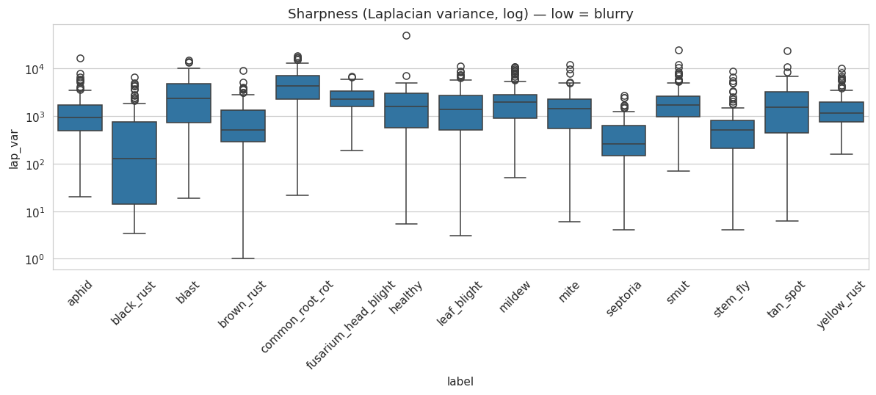
The boxplot (log-scaled y-axis, because values span several orders of magnitude) shows the sharpness distribution per class. Most classes have healthy median sharpness with a long tail down toward these low outliers — i.e. most images are fine, a handful per class are suspect. brown_rust, leaf_blight, black_rust, and septoria supplied the bottom ten, though that's from a 120-image-per-class sample, not the full set.
One small practical note: the index numbers (446, 417, 840…) are positions in the sampled blur dataframe, not the master df. To actually open and inspect those specific images you'd map them back via filepath.

What this means for our model
- A few blurry images are not a crisis — and can even help. Real farmers take shaky, out-of-focus phone photos. Keeping moderately soft images in training makes the model more robust to exactly that. we do not want a model that only works on tripod-quality shots.
- But the extreme cases (lap_var in single digits) are worth filtering. An image with essentially no detail carries almost no learnable disease signal and, worse, may have been mislabeled (you can't tell what's wrong with a leaf you can't see). Setting a low threshold — say, drop images below a small cutoff after visually confirming a sample of them — cleans out the genuine junk without touching useful "phone-quality" images.
- Don't over-filter. The goal is removing near-blank images, not sanitizing the dataset into a lab-clean set that won't generalize. A light touch here is correct.

The things to fix before training, in priority order:
- Leakage (highest priority) — 646 flagged cross-split collisions. Verify, then de-duplicate and re-split, or your test accuracy will lie to you.
- Preprocessing — resize to 224²/256², and .convert("RGB") on every image (fixes the ~1,662 RGBA/P/CMYK files).
- Extreme aspect ratios — find and handle the multi-panel collages and thin panoramas (aspect < 0.5 or > 2.0).
- Background shortcuts — defend against the mildew-is-dark / blast-is-bright effect with color jitter and cropping/segmentation.
- Mild imbalance (ratio 5.6) — class weights or weighted sampling; and evaluate with macro-F1 + confusion matrix, not plain accuracy.
- A few blurry images — filter only the near-blank extremes.

