1. Disease detection that works in a real field, not a lab.
Models trained on the standard PlantVillage dataset hit ~98–99% accuracy on its clean lab images (one diseased leaf, plain background) but collapse in the field: when test images come from different real fields, macro-F1 drops from 98–99% down to roughly 50–88%, and even the original 2016 PlantVillage paper found accuracy fell to around 41% on real-world images. The cause is mundane and real — complex backgrounds, variable lighting, and tiny symptom regions that lab images don't have. A farmer photographing a leaf with their phone, in sunlight, against soil, is exactly the failure case. Building a detector that survives this is a genuine contribution, and almost no student project bothers — they report 99% on PlantVillage and stop.

2. Advice that's grounded and knows when it's wrong. General-purpose LLMs generate plausible-sounding but agriculturally incorrect advice — the hallucination problem, which is dangerous when the output is "spray X at Y concentration." Interestingly, a 2025 KCC study found that retrieval-only answering achieved near-perfect accuracy with zero hallucination in a closed domain, while the generative RAG layer introduced hallucination. That tension — fluency vs. faithfulness — is something you can measure, not just hand-wave.

Datasets :
PlantVillage
KCC

The datasets you're missing (all public, all real field conditions)
Dataset | Size | Crops / classes | What it actually is
Cassava Leaf Disease (Makerere/Kaggle) | 21,367 labeled images Wiley Online Library | 1 crop, 5 classes | Photos taken by farmers on mobile phones in Uganda, labeled by experts at the national crop research institute — i.e. your exact deployment scenario
PlantWild (2024) | 18,542 images arxiv | 89 classes (33 healthy, 56 diseased), 33 species arxiv | Largest in-the-wild multi-crop set, with text descriptions per class (multimodal)
FieldPlant (2023) | 5,170 images arxiv | 27 classes | Field images annotated by plant pathologists
PlantDoc (2020) | 2,598 in-the-wild images ResearchGate | 13 crops, 17 disease classes ResearchGate | The standard "field" benchmark; captures real-field conditions unlike PlantVillage Nature
PlantSeg (2025) | large | multi-crop | In-the-wild with segmentation masks (useful if you do background removal)

continuing from our previous chat, i want understand how our solution would look like. i mean what capabilities it would be having. explain with variety of scenarios, user - application interaction, so that i get an understanding of what exactly we have to build, before explaining i say that do a deep research about ai in agriculture how it being employed all around the world, what use cases are being discussed or researched upon or currently being employed. then give detailed understanding.

Motivation/ Why we chose this Problem?
The scale of the problem is staggering. The global population is moving toward 9.7 billion by 2050, and food demand is expected to rise by at least 70% during that same period. Meanwhile, the agricultural sector faces a defining challenge — feeding more people without cultivating more acres. The answer isn't more farmland; it's smarter farming. NCHStats|World Economic Forum

AI in agriculture has crossed the experimentation threshold. The global AI in agriculture market reached $3.37 billion in 2026, up from $2.71 billion in 2025, and is projected to hit $8.23 billion by 2030. If 2025 was the year of exploration, 2026 is shaping up to be the year of execution and resilience — farmers are no longer asking "What can this technology do?" but "How does this pay off today?" NCHStats|ICL Group

The critical gaps your project addresses — even with all this activity, three problems remain largely unsolved at the student/research level and even at the deployed-system level:
- Disease detection accuracy collapses in real field conditions (the lab-to-field domain gap)
- LLM advisory systems hallucinate treatment advice — dangerous when recommending pesticide dosages
- Systems don't know when they're wrong — no confidence calibration or graceful abstention

a field-robust, confidence-aware, faithfulness-grounded crop advisory

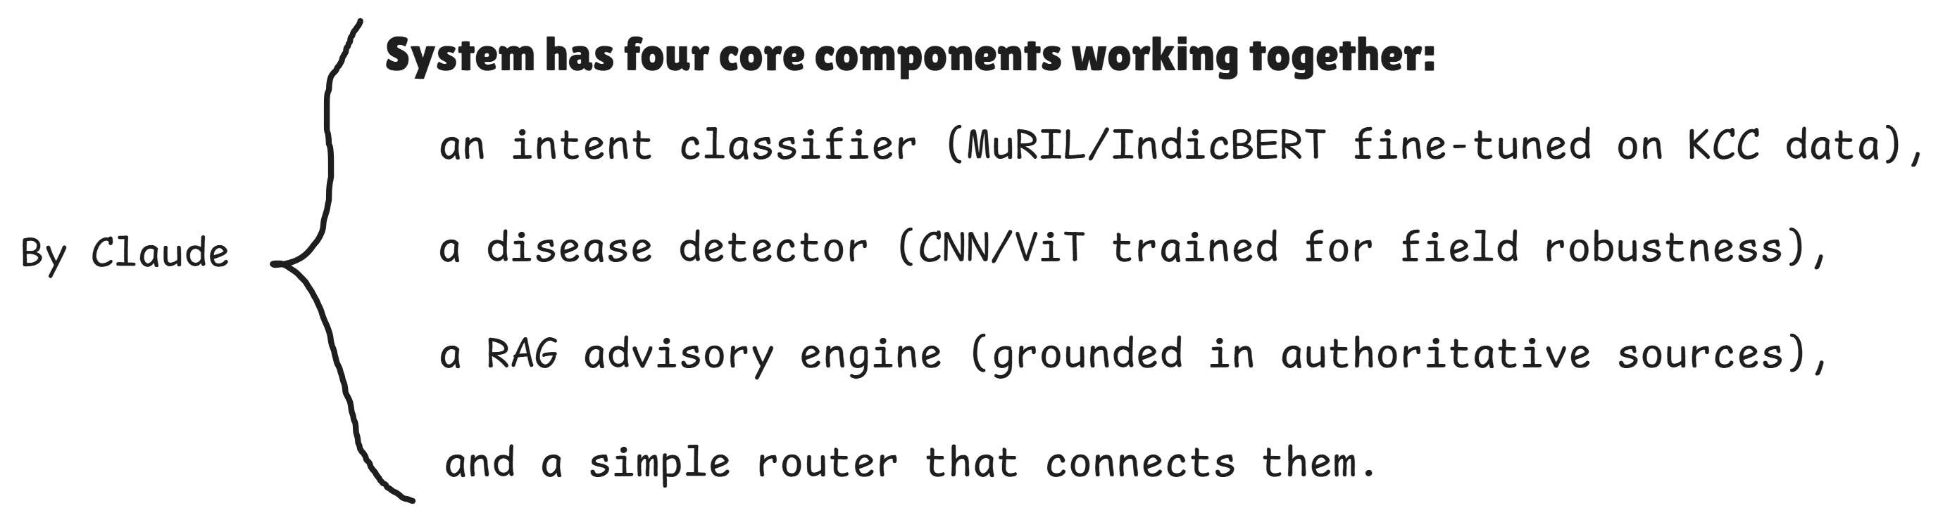

SCENARIO 1: "My tomato leaves have spots — what's happening?"
The image-based disease detection flow.
A tomato farmer in Rajasthan notices yellow-brown spots on several leaves. He opens the app on his phone, takes a photo of one affected leaf — outdoors, in bright afternoon sun, with soil visible in the background. This is exactly the failure case that kills most disease detectors trained on clean PlantVillage images.
What happens inside the system:
The router sees image input → routes to the disease detector. The model processes the photo, but instead of just outputting "Early Blight — 97% confidence" like a naïve PlantVillage model would, your system does two things differently.
First, because you've trained with aggressive field-realistic augmentation and tested against real-field datasets (PlantDoc, Cassava), the model has actually seen complex backgrounds before.
Second, it produces a calibrated confidence score. Let's say it returns: "Early Blight (Alternaria solani) — confidence: 82%."
Because 82% is above your abstention threshold (say, 60%), the system proceeds. The detected disease becomes a structured query into the RAG engine: it searches the vector store (ChromaDB/FAISS) over ICAR advisories and historical KCC answers for "Early Blight + Tomato + treatment."
What the farmer sees on screen:
🍅 Detected: Early Blight (Alternaria solani)
Confidence: High (82%)
Recommended action (source: ICAR advisory, Rajasthan state agricultural university):
Remove and destroy affected leaves. Apply Mancozeb 75% WP at 2.5 g/litre of water. Repeat spray after 10–15 days if symptoms persist. Ensure proper spacing between plants for air circulation.
⚠️ This advice is retrieved from ICAR published guidelines. Consult your local KVK for dosage confirmation specific to your soil conditions.
The key here: every fact in the response traces back to a retrieved source document. The LLM didn't invent the dosage "2.5 g/litre" — it pulled it from an ICAR advisory. Your faithfulness metric measures exactly this: did the generated answer contain anything not in the retrieved documents?

SCENARIO 2: "The photo is blurry and the system isn't sure"
The confidence-aware abstention flow.
A different farmer takes a photo of a wheat leaf, but it's taken in low light, the leaf is partially folded, and there's heavy motion blur. The disease detector runs and returns: "Rust — confidence: 38%."
38% is below the abstention threshold. Instead of confidently saying "This is rust, spray X," the system does something most student projects (and frankly most deployed apps) never do — it admits uncertainty.
What the farmer sees:
📷 I couldn't identify the disease with enough certainty from this photo.
Tips for a clearer photo:
• Hold the phone 15–20 cm from the leaf
• Use natural daylight, avoid shadows
• Place the leaf against a plain surface if possible
If the problem is urgent, contact your nearest Krishi Vigyan Kendra (KVK) or call the Kisan Call Centre at 1800-180-1551.
This is a genuine contribution. It's measurable (you can report what percentage of inputs trigger abstention, and whether those abstentions were correct using held-out labeled data), and it's a safety feature — telling a farmer "spray Mancozeb" when you're only 38% sure the disease is even correctly identified is actively harmful.

SCENARIO 3: "My cotton crop has some pest problem, what should I do?"
The text-based intent classification + RAG flow.
A farmer types (or speaks, if voice is added as a stretch goal): "Meri kapas mein koi keeda lag gaya hai, kya karu?" (My cotton has some pest, what should I do?)
What happens inside the system:
The router sees text input → routes to the intent classifier. The fine-tuned MuRIL model classifies this query into the category: pest management. This classification matters because it determines which subset of the knowledge base the RAG engine queries. Instead of searching the entire corpus, the system narrows to pest-related advisories for cotton.
But there's a subtlety: the query is vague. "Koi keeda" (some pest) doesn't name a specific pest. The RAG engine retrieves the most common cotton pests from KCC historical data (bollworm, whitefly, jassid, aphid) along with their differentiating symptoms and recommended actions.
What the farmer sees:
You mentioned a pest issue in cotton. Here are the most common possibilities:
1. Bollworm — Look for: holes in bolls, frass (insect droppings) near flowers.
Treatment: Spray Emamectin Benzoate 5% SG at 4 g per 10 litres. (Source: KCC advisory, Maharashtra)
2. Whitefly — Look for: tiny white insects on underside of leaves, sticky honeydew.
Treatment: Spray Diafenthiuron 50% WP at 12 g per 10 litres. (Source: ICAR CICR advisory)
3. Jassid/Aphid — Look for: leaf curling, yellowing from edges.
Treatment: Spray Imidacloprid 17.8% SL at 3 ml per 10 litres. (Source: KCC advisory, Gujarat)
Can you describe or photograph the pest for a more specific recommendation?
Notice: the system gives multiple grounded answers ranked by likelihood, each traced to a source, and asks for more information rather than guessing. It doesn't hallucinate a single confident answer when the query is ambiguous.

SCENARIO 4: "What's the price of wheat in the mandi today?"
The out-of-scope detection flow.
A farmer asks about today's wheat price. The intent classifier processes this and classifies it as market/price query.
Now here's where your system's scope boundaries matter. In the core build (no live APIs), the system doesn't have real-time mandi price data. Your intent classifier's out-of-scope detection kicks in — it recognizes this is a valid agricultural query but outside the system's current capabilities.
What the farmer sees:
I understand you're asking about current wheat market prices. I don't have access to live mandi prices at the moment.
You can check today's prices at:
• eNAM portal: enam.gov.in
• Agmarknet: agmarknet.gov.in
• Or call the Kisan Call Centre at 1800-180-1551
I can help with crop disease identification, pest management, and treatment advice — feel free to ask!
If you implement the mandi-price stretch goal (a tool that fetches from Agmarknet API), the same query would instead trigger the router to call the price-fetching tool and return:
Wheat prices today (nearest mandis to your region):
• Jaipur mandi: ₹2,450/quintal
• Kota mandi: ₹2,420/quintal
• MSP (2025-26): ₹2,425/quintal
Prices suggest selling at Jaipur mandi would give you ₹25/quintal above MSP.

SCENARIO 5: "I want to know about PM Fasal Bima Yojana"
The government-scheme query flow.
The intent classifier categorizes this as a scheme/policy query. The RAG engine searches over government scheme documents indexed in the vector store.
What the farmer sees:
Pradhan Mantri Fasal Bima Yojana (PMFBY)
This is a crop insurance scheme that covers losses from natural calamities, pests, and diseases.
Key details (Source: Department of Agriculture, GoI):
• Premium: Kharif crops — 2% of sum insured; Rabi crops — 1.5%
• Coverage: Drought, flood, hailstorm, cyclone, pest/disease
• Enrollment: Through your bank (if you have a crop loan, enrollment may be automatic) or Common Service Centres (CSC)
• Deadline: Typically 2–3 weeks before crop season; check your local deadline
For enrollment help, visit your nearest CSC or contact the Kisan Call Centre.
This scenario shows how the same RAG architecture serves entirely different knowledge domains — you don't need separate systems for disease advice vs. scheme information. The intent classifier routes to the right chunk of the knowledge base.

SCENARIO 6: "My field has this — [uploads image of a non-plant object]"
The out-of-distribution detection flow.
A farmer accidentally uploads a photo of their tractor, or a selfie, or an image of something that isn't a plant leaf at all.
What happens inside:
The disease detector's OOD (out-of-distribution) detection recognizes that this image doesn't resemble any plant/leaf in its training distribution. The confidence for all disease classes is extremely low.
What the farmer sees:
This doesn't appear to be a photo of a crop or plant leaf. I can only identify diseases from clear photos of affected plant parts.
Please upload a close-up photo of the affected leaf, stem, or fruit, and I'll try to identify the problem.
Simple, but most systems just confidently classify any input into some disease category — your system recognizing "this isn't even a leaf" is a differentiation point.

SCENARIO 7: "Mere gehu mein kuch pila pad raha hai, aur barish bhi bahut ho rahi hai"
The multi-signal, context-aware query flow.
The farmer is describing yellowing wheat during heavy rain — this could be multiple things (rust, waterlogging, nutrient deficiency). The intent classifier tags it as disease/crop health.
The RAG engine retrieves multiple relevant advisories for "wheat + yellowing + excessive rain" and the LLM synthesizes a grounded response:
What the farmer sees:
Yellowing in wheat during heavy rain could indicate:
1. Waterlogging (most likely given heavy rain) — Excess water suffocates roots and causes yellowing from the bottom up. Ensure field drainage channels are clear. If standing water is present for more than 48 hours, damage may be significant.
(Source: ICAR-IIWBR wheat advisory)
2. Yellow Rust — Look for yellow-orange powdery stripes on leaves running parallel to the leaf vein. If confirmed, spray Propiconazole 25% EC at 1 ml per litre.
(Source: KCC advisory, Punjab)
3. Nitrogen Deficiency — Heavy rain can leach nitrogen. If lower leaves yellow first while upper leaves stay green, consider top-dressing with urea at 25 kg/acre after rain stops.
(Source: ICAR soil health advisory)
To narrow this down: can you upload a photo of the affected leaves?
The system handles ambiguity by presenting ranked possibilities with clear differentiators, all grounded in authoritative sources, and prompts for more information (the image route) to narrow down.

SCENARIO 8: "What should I plant next season?"
The boundary of your system — honest limitation.
This is a crop planning query that requires soil data, historical yields, market forecasts, weather predictions, and local agro-climatic zone information — far beyond your current scope.
What the farmer sees:
Choosing the best crop for next season depends on your soil type, water availability, climate zone, and market prices — factors I don't have full data on right now.
For personalized crop planning, I'd recommend:
• Contact your local KVK (Krishi Vigyan Kendra) for soil-testing and crop recommendations
• Check the ICAR crop calendar for your agro-climatic zone
• For market trends, check eNAM portal
I'm best at helping with crop disease identification, pest management advice, and government scheme information. Ask me about those anytime!
Honesty about boundaries is itself a design decision — and a safety feature.

Doubts related to above scenarios :

Doubt-1 :
first thing i do not understand is that why we are fine-tuning MuRIL model, cannot model understand the query intent and route and response accordingly, as far as i know LLM model are good at understand the intent.

Solution :
The rubric reason (the real driver): Your capstone milestones M3–M5 require a trainable model with architecture justification, hyperparameter experiments, and quantitative evaluation (F1, confusion matrix, error analysis). An LLM doing intent classification via prompting gives you nothing to put in those milestones — there's no training, no hyperparameters to tune, no loss curves to show. The fine-tuned MuRIL classifier exists primarily because the rubric demands a model you actually train. Without it, your M3–M5 sections are thin.
The practical reason: A fine-tuned MuRIL classifier is about 200MB, runs in milliseconds on a CPU, works completely offline, and costs nothing per query. An LLM API call for intent classification adds 1–3 seconds of latency, costs money per call, requires internet, and is overkill for what is essentially a 5-class categorization task. In a deployed system serving thousands of rural farmers with patchy connectivity, the small local model is genuinely better engineering for this specific subtask.
But here's the nuance you're touching on: if you're already calling an LLM for the final response generation (which you are, for the RAG-grounded advisory), then having it also understand intent during that same call is practically free. You could architect it so the LLM does intent understanding + response generation in a single pass, and the separate classifier becomes unnecessary.
The honest answer for your project: keep the MuRIL fine-tune because the rubric demands it, but acknowledge in your report that in a production system, the LLM could handle intent classification directly. Frame the fine-tuned classifier as a lightweight, offline-capable, low-latency alternative — which is a genuine engineering trade-off worth discussing, not a made-up justification. Your evaluator will respect that honesty.

Doubt-2 :
second thing, what i understand is the when ever image is uploaded then it is assumed that it is crop diseases related query and routed to diseases detector, if image is not relevent like if tractor image uploaded then in that case it is assigned as out-of-distribution, here i do not understand why it is classified as out-of-distribution since the VLM model has vast knowledge, trained on huge image corpus then why we are not allowing model answer about that image, it feels like are not using capabilities of the model.

Solution :
The smart hybrid: Use the specialized disease detector(CNN/ViT) as your trainable core (for M3–M5), but wrap it inside a VLM-aware routing layer. The VLM first understands "what am I looking at?" — if it's a plant leaf, route to your specialized detector for precise disease classification with calibrated confidence. If it's something else agricultural (soil, pest, equipment), let the VLM handle it directly with its general knowledge. This gives you the best of both worlds: a trainable model for the rubric, and a capable system that doesn't waste the VLM's broader understanding.

Addition :
why VLM just route image to diseases detector model, it should also predict the disease along with confidence score and we have two predictions with confidence score, which will reduce the ambiguity further and response will be more precise with high confidence.
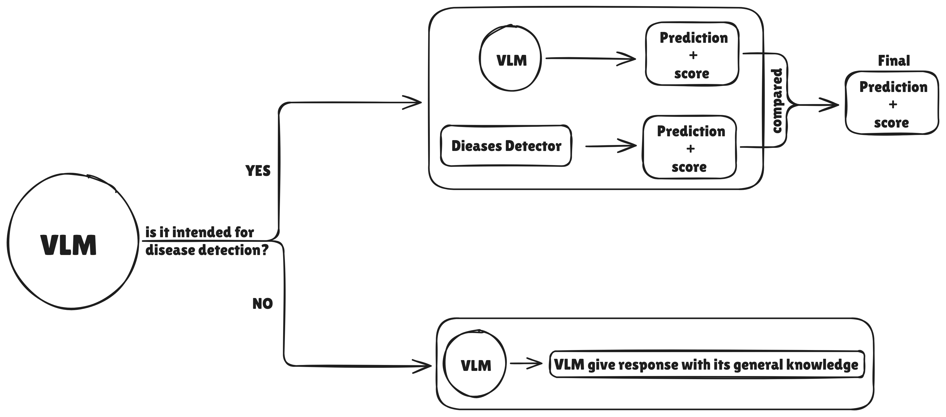

Doubt-3 :
third thing is why we are not collecting user data on follow up to a query which requires user data like location, soil, etc. we can give options or text box to user to give more details, similar to what claude does, as it asks follow up questions when it feels that it need more information. doing so we can personalize the query as farmer specific and on top that response would be precise instead being general response and in some situation a solution might work at some location and not other so such scenarios would be avoided. as a extension later we could add data collection via speech.

Solution :
What you're describing is essentially context elicitation — the system asking follow-up questions to personalize its response before answering. This is exactly what good advisory systems do, and you're correct that Claude does this too.
Here's how it should work in your system:
When a farmer asks "what should I spray for early blight on tomato?", the answer genuinely depends on where they are (different states have different approved pesticides), what growth stage the crop is in (spraying recommendations differ pre-flowering vs fruiting), whether they practice organic farming, what they've already tried, and what's available in their local market.
The flow should be:
First interaction — farmer asks the question.
System recognizes it needs more context before giving a precise answer, and prompts:
Before I recommend a treatment, a few quick details will help me give you the right advice:
📍 Which state/district are you in? [text input or location picker]
🌱 What growth stage is your crop? [Options: Seedling / Flowering / Fruiting / Harvesting]
🧪 Do you prefer organic or chemical treatment? [Options: Organic / Chemical / No preference]
After the farmer responds — say they pick "Rajasthan, Flowering, Chemical" — the system gives a location-specific, stage-specific answer:
For Early Blight on tomato at flowering stage in Rajasthan:
Apply Mancozeb 75% WP at 2.5 g/litre. Avoid spraying during peak flowering hours (morning 8–11 AM) to protect pollinators.
(Source: Rajasthan State Agricultural University advisory)
vs. if they picked "Organic":
For organic management of Early Blight: Apply Trichoderma viride at 4 g/litre as a foliar spray. Alternatively, neem oil 5% at 5 ml/litre.
(Source: ICAR organic farming package)
You should store this context for the session (and optionally across sessions if the farmer creates a profile), so they don't have to re-enter their location and preferences every time. Over time, the system builds a profile: "This farmer is in Barmer district, Rajasthan, grows tomato and mustard, prefers organic." Every subsequent query uses this context automatically.
This is a genuinely good extension and it directly strengthens both the product and the novelty angle. Existing agri-chatbots mostly give generic pan-India answers. A system that personalizes by location + crop stage + farming method is closer to what the GAIA Phase II project is researching, and you'd be demonstrating it.
For the core build, start with simple text-based elicitation. As a stretch goal, add voice-based context collection and a persistent farmer profile.
Question raised :
if it profile storage, then what if model gives response based on previous profile info. For example in previous query user gave info for one piece of land where he does organic farming and other piece of land he does chemical. Since user first asked query where he mentioned chemical but in later he did not mention about the type of farming he does and model assumed previous info and gave response based on previous info, what’s solution in that case? Do we ask for each query?

Doubt-4 :
->fourth is regarding RAG, i wonder how much documentation would be needed for RAG, i want to get an idea about how much space would be required and all, yes i understand RAG is important to give grounded response and cite the source, but i have doubt cannot we cite resource without RAG. what happens if classified query's material is not there in RAG, will it not responded, if not then again we are wasting model knowledge, i understand response might not grounded and response might less confiddent but we can transparent about that and we can use model knowledge and response. for example user query is related about seed selection then what happens to this query, according to me it should be answered and before answering application should prompt user for more information so that model suggest right seed varity specific that user.

Solution :

This has several sub-questions, so let me take them one by one.
Sub_Question : How much documentation and storage does RAG need?
Less than you might think. Your primary corpus would be:
The KCC dataset (Kisan Call Centre historical Q&A pairs) — this is lakhs of text records, mostly short text pairs. Even a million Q&A pairs, when chunked and embedded, would be roughly 2–5 GB of vector storage (embeddings) plus maybe 500 MB–1 GB of raw text. The ICAR advisories, state agricultural university guidelines, and government scheme documents are probably another few hundred MB of text at most. Your total vector database would comfortably fit in under 10 GB, easily hosted on a free-tier cloud instance or even a laptop.
For context: ChromaDB or FAISS can handle millions of vectors on a single machine. This is not a "big data" problem at all.
Addition :
- Kisan Call Centre historical Q&A pairs,
- ICAR advisories,
- state/central agricultural university guidelines, and
- state/central government scheme documents
- may be detailed pest control medication details, how and when to use them details,
- seed variety detailed documentation(for seed selection purpose)
etc....

Sub_Question : Can you cite sources without RAG?
Solution :
Technically, an LLM can say "according to ICAR guidelines..." but here's the critical problem: without RAG, you have no way to verify the citation is real. The LLM might generate "ICAR recommends Mancozeb at 2.5 g/litre" — and that might be correct. Or it might hallucinate "ICAR recommends Carbofuran at 10 g/litre" — a dosage that could damage the crop or harm the farmer. Without RAG, you literally cannot distinguish real citations from hallucinated ones. That's the entire danger.
RAG solves this because the response is constructed from retrieved documents. The citation isn't decorative — it's the actual source from which the answer was built.
Addition :
so what i understand is that we would have RAG documents according to available resource and for certain type of queries like seed suggestion, dieases prediction and remedies suggestion,.. etc and for rest of queries we can be transparent about hallucination problem to user.

Sub_Question : What if the query's material isn't in the RAG corpus?
Solution :
The solution is a tiered response strategy:
Tier 1 — High confidence, grounded (RAG hit): The query matches content in your knowledge base. The response is generated strictly from retrieved documents, with source citations. The system says this is verified information.
Tier 2 — Model knowledge with transparency (RAG miss): The query is valid and agricultural, but your corpus doesn't cover it well. Instead of refusing, the system falls back to the LLM's general knowledge but tells the farmer explicitly:
I don't have a verified advisory source for seed selection for rabi wheat in your specific region. Based on my general knowledge:
For Rajasthan's arid/semi-arid zones, commonly recommended wheat varieties include HD 2967, Raj 4120, and Lok-1, chosen for heat tolerance and shorter duration.
⚠️ This recommendation is based on general knowledge and has not been verified against a specific advisory document. Please confirm with your local KVK or seed dealer before purchasing.
This is exactly the transparency you're describing — use the model's knowledge, but be honest about the confidence level. The farmer gets a useful answer rather than a dead end, and knows to double-check.
Tier 3 — Truly outside scope: "What's the score of today's cricket match?" → The system recognizes this is completely non-agricultural and redirects.
Your seed selection example is perfect for this. The system should first ask contextual questions (your point #3 — location, soil type, irrigation availability, preferred crop duration), then check RAG for specific seed advisories for that region. If RAG has a match, great — grounded answer. If not, the LLM generates a recommendation from its training knowledge, clearly marked as unverified, and suggests the farmer confirm with their local KVK.
This tiered approach is more honest, more useful, and more respectful of the LLM's capabilities than a binary "RAG or nothing" design. And it gives you a great evaluation dimension for M5: you can measure what percentage of queries fall into each tier, and whether the Tier 2 (model knowledge) answers are actually correct by manually verifying a sample.
Addition :
as mentioned in last paragraph regarding evaluation.
We can evaluate what percentage of queries fall into each tier.
Whether Tier-2 (model knowledge) answers are actually correct by manually verifying a sample.
In this way we can evaluate our solution in terms credibility of response.

Doubt-5 :
->fifth is that does claude classifies every query before giving a response. does claude uses RAG, if yes explain how.

Solution :
I can speak to how I work at a general level.
Intent classification: I don't use a separate classifier model the way your system would. I'm a single large language model, and I understand intent within the same forward pass that generates the response. When you ask me a question, I don't first run a classifier that says "this is a coding question" and then switch to a different model — I understand the intent and generate the response in one unified process. This is exactly the point you were making in question #1: LLMs are good at intent understanding natively.
That said, there is routing and tool selection happening. When you ask me something that requires current information, I recognize that intent and decide to use web search. When you upload an image, I process it directly. When you ask me to create a file, I use computer tools. This routing is part of how I'm built and instructed — it's not a separately trained classifier, but it's intent-driven behavior nonetheless.
RAG: I use web search as a form of retrieval when I need current or specific information I might not have reliably. When I search and then answer, the citations I give you trace back to actual retrieved documents — that's essentially RAG in practice. For questions I can answer from my training knowledge reliably, I don't need retrieval. For questions where accuracy matters and my knowledge might be stale or incomplete, I retrieve first and ground my answer in what I find. This is actually close to the tiered approach I recommended for your system — grounded retrieval when available, transparent model knowledge when not.
The key difference between my architecture and yours: I'm a single massive model that handles everything (intent understanding, retrieval decisions, response generation, image understanding) in one system. Your project uses specialized smaller models for specific subtasks (MuRIL for intent, CNN/ViT for disease detection) orchestrated by a router, with an LLM handling the final response generation. Both architectures are valid — yours is more modular and has independently trainable components (which is what your rubric needs), while mine is more unified.

Addition :
Can we use web search tool along with stored documents for RAG?
Question arises then why we are even storing vectorized docs, when we can get them via web search tool, also there is plus point here that we can fetch latest version of documents. Is it that model becomes more grounded on stored RAG vs web search RAG?
How different will responses be?

Doubt-6 :
i want to understand one more thing that there is documents stored as vector database, now when a user query comes then how does model decides that i should generate the response from my knowledge or i have to pull content from stored documents via RAG. is it here intent classification necessary, for example query classified as 'pest control' then it checks in vector database for content? or i am misunderstanding something here critically analyze and explain.

Solution :

How RAG Actually Works, Step by Step
The process is simpler and more mechanical than you might think.
Step 1 — The query gets converted into a vector (embedding).
When the farmer types "mere tamatar mein keeda lag gaya hai, kya spray karu?" — before anything else happens, an embedding model (like all-MiniLM-L6-v2 or a multilingual equivalent) converts this text into a numerical vector — a list of, say, 384 numbers. This vector is a mathematical representation of the meaning of the query.
Step 2 — That vector is compared against ALL vectors in the database.
Your vector database (ChromaDB/FAISS) already contains pre-computed vectors for every chunk of every document you've indexed — ICAR advisories, KCC Q&A pairs, scheme documents, everything. The system doesn't "go to the pest control section" — it runs a similarity search across the entire database and finds the top-K chunks (say, top 5) whose vectors are closest to the query vector in mathematical distance.
This is pure math — cosine similarity or dot product. There's no "understanding" happening here. The system is just asking: "which stored text chunks have the most similar meaning-vector to this query?"
Step 3 — The retrieved chunks + the original query are sent to the LLM together.
This is the key insight. The LLM receives a prompt that looks roughly like this:
You are an agricultural advisory assistant. Answer the farmer's question using ONLY the information provided in the context below. If the context doesn't contain relevant information, say so.

CONTEXT (retrieved from authoritative sources):
[Chunk 1: "For tomato pest management, Emamectin Benzoate 5% SG at 4g/10L is recommended for fruit borer..." Source: ICAR advisory, 2023]
[Chunk 2: "Whitefly in tomato can be controlled with Diafenthiuron 50% WP at 12g/10L..." Source: KCC advisory, Maharashtra]
[Chunk 3: "Neem oil 5% spray at 5ml/L is effective against sucking pests in tomato under organic management..." Source: ICAR organic farming package]

FARMER'S QUESTION: mere tamatar mein keeda lag gaya hai, kya spray karu?
Provide a helpful response citing the sources above.

Step 4 — The LLM generates a response grounded in those retrieved chunks.
The LLM reads the retrieved context, understands the query, and composes a natural-language answer that synthesizes the relevant information from those chunks. It's not inventing from its own knowledge (if prompted correctly) — it's acting as an intelligent summarizer and synthesizer of the retrieved documents.
So Where Does Intent Classification Fit?
Reason 1 — Filtered retrieval for precision. If your vector database has 500,000 chunks covering diseases, pests, schemes, weather, prices, and general farming — a broad similarity search might return some relevant chunks mixed with noise. For instance, a query about "tomato leaf spots" might retrieve chunks about tomato diseases (relevant) but also about tomato market prices (irrelevant, but the word "tomato" pulled it in). If you first classify the intent as "disease," you can filter the vector search to only look within disease-related documents, improving retrieval precision. This is metadata filtering — each chunk has a tag (disease, pest, scheme, price) and you restrict the search to chunks matching the classified intent.
Reason 2 — Different response strategies for different intents. A disease query should trigger image request + treatment advice. A scheme query should give eligibility criteria + enrollment steps. A price query might need a live API call instead of RAG. The intent tells the system how to behave, not just what to retrieve.
The "When to Use RAG vs Model Knowledge" Decision
Approach 1 — Always retrieve .
Approach 2 — Retrieve, then check relevance scores.
Approach 3 — Classify first, then decide.
Intent classifier runs first → if intent is "disease" or "pest" or "scheme," trigger RAG because you know you have content for these. If intent is "crop planning" or "seed selection," skip RAG and use LLM knowledge directly because you know your corpus doesn't cover this well.

A Concrete Example to Make This Tangible
Query: "Which variety of wheat seed should I plant for rabi season?"
Here's what happens step by step:
The intent classifier tags this as "crop planning / seed selection." The query is embedded and searched against the vector DB. Let's say the top chunk returned has similarity score 0.42 — it's a vaguely related ICAR document about wheat cultivation generally, but doesn't specifically address variety selection for the farmer's region.
The system sees the low relevance score and makes the decision: RAG can't ground this answer reliably. It switches to the tiered approach. First, it asks the farmer for context (location, irrigation type, preferred crop duration). Then, using that context plus the LLM's training knowledge, it generates a response about suitable wheat varieties, clearly marked:
Based on general agricultural knowledge (not a specific verified advisory):
For your region (Barmer, Rajasthan) with limited irrigation, consider short-duration, drought-tolerant varieties like Raj 4120 (110-115 days) or HI 1544 (108-112 days).
⚠️ Please verify with your local KVK or seed dealer, as variety availability and performance varies year to year.
Now imagine a different query: "How to control early blight in tomato?"
Intent classifier tags it as "disease / pest management." The query is embedded and searched. Top chunk has similarity score 0.89 — a direct match from ICAR tomato disease advisory. The system uses RAG confidently:
Early Blight (Alternaria solani) — Treatment:
Apply Mancozeb 75% WP at 2.5 g/litre of water at first appearance of symptoms. Repeat after 10-15 days.
(Source: ICAR-IIVR Tomato Advisory, 2023)
No disclaimer needed. The answer is grounded, cited, and verified.

the pipeline i am talking about is rough structural flow of solution that i have attached. it is very rough, built on what i have understood so far as well as my team understanding, obviously it can improved, enhance and made more capable and precise.

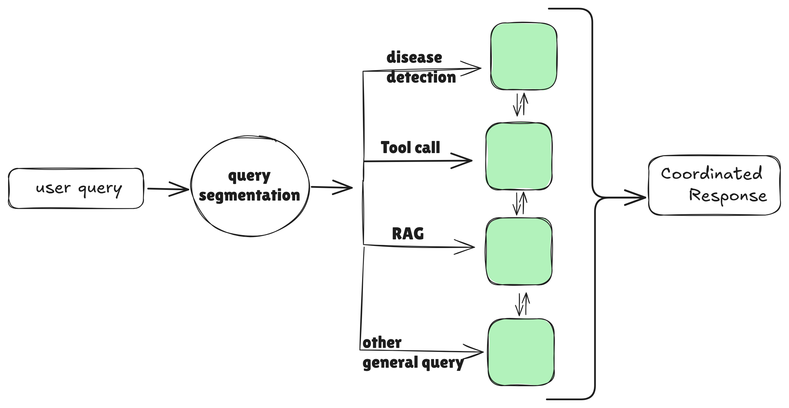
Your flow is: user query → query segmentation (the LLM understanding intent natively) → four possible paths (disease detection, tool calls, RAG, general/other queries) → agents that can communicate with each other (the bidirectional arrows between the green boxes) → coordinated response.
This is a sound instinct. The inter-agent communication arrows are especially smart — you're recognizing that a disease detection result needs to flow into RAG (to fetch treatment advice for the detected disease), and that tool call results (like mandi prices) might need to be combined with RAG content (like storage advisories). The green boxes are agents that collaborate rather than work in isolation.
The key improvement I'd suggest on the structural level: the "query segmentation" doesn't need to be a separately trained model — as you've already concluded, the LLM handles this natively. It's a routing decision the LLM makes, not a classification task requiring its own model.

One Bonus Thought on Your Diagram
Your diagram shows the agents communicating with each other (the bidirectional arrows). This is a genuinely good insight, but I'd refine what flows between them:
The disease detection agent doesn't just output "Early Blight" — it outputs a structured object: {disease: "Early Blight", confidence: 0.82, crop: "Tomato"}. This object flows into the RAG agent as a structured query, enriching the embedding search. The RAG agent retrieves treatment documents and passes them to the response generation agent. If the user's profile/context is available (location, organic preference), that also flows into the response agent. The response agent synthesizes everything into the final coordinated answer.
The tool call agent (mandi prices, weather) operates independently — its results are merged into the final response alongside RAG content.
This coordination is what makes it a system rather than a collection of independent models — and that's the story worth telling in your presentation.

yes i understand the need of intent classification, and fine-tuning/training a VLM for intent classification seems weird as we talked earlier, so i would like find a legitimate case where we can employ fine-tuning/training in this pipeline/solution. i know that M3-M5 require something trainable. one we already have a diseases classifier(CNN/ViT) and it feels legitimate. likewise where there is some legitimate reason and interesting reason for training/fine-tuning or we can create such situation/scenario where it becomes must.

Candidate 1 — Fine-tune an NER model to extract crops, pests, symptoms, locations from farmer queries.
The idea: farmers write messy, mixed-language queries like "mere jodhpur wale khet mein tamatar pe safed makhi aa gayi hai" — a named entity recognition model would extract: crop = tamatar (tomato), pest = safed makhi (whitefly), location = Jodhpur. These structured entities feed into RAG as precise filters.
Why it's okay but not great: NER is well-studied, doesn't feel novel, and honestly, a good LLM extracts these entities just fine through prompting. You'd be training a model to do something the LLM already does — the same awkwardness as the intent classifier.
Candidate 2 — Train a hallucination/faithfulness detector.
The idea: a small classifier that takes (retrieved context + generated response) as input and predicts whether the response is faithful to the context — essentially a "did the LLM make something up?" detector.
Why it's interesting but problematic: this directly ties to your novelty angle (faithfulness-grounded advisory). But building the training data is the killer — you'd need hundreds of (context, response, faithful/unfaithful) labeled examples, which means manually generating and labeling hallucinated responses. That's a lot of annotation work for a tight timeline, and the model might not generalize well with limited training data.
Candidate 3 — Fine-tune the embedding model for agricultural domain retrieval.
This is the one. Let me explain why this is both legitimate and genuinely necessary.

The Winner: Domain-Adapted Embedding Model
Here's the problem this solves, and it's a real problem, not a manufactured one.
Your RAG pipeline depends entirely on the quality of retrieval. Retrieval depends on the embedding model converting queries and documents into vectors that are "close" when semantically similar. You'd start with a general-purpose embedding model like all-MiniLM-L6-v2 or sentence-transformers/paraphrase-multilingual-MiniLM-L12-v2.
These general models work well for everyday English. But your system operates in a completely different linguistic space. Consider what a farmer actually types or says:
"Makka mein tana chhedak ka upchar batao" (Tell me the treatment for stem borer in maize)
The general embedding model sees "makka" — does it understand this means maize? "Tana chhedak" — does it know this is stem borer? "Upchar" — does it associate this with treatment/remedy? What about "davai" (medicine/pesticide), "phaphund" (fungus), "geela sadan" (wet rot), "khat-patwar" (weeds)?
Agricultural Hindi/regional terminology is a domain where general-purpose embedding models systematically fail. They were trained on Wikipedia, web crawls, and general text — not on ICAR advisories, KCC conversations, or mandi terminology. The semantic distance between a farmer's query and the relevant document chunk is artificially large because the embedding model doesn't understand domain-specific vocabulary.
This isn't a hypothetical problem — it's the exact reason GAIA Phase II is investing in "refining small language models for low-resourced languages" and why Digital Green is working on domain-specific fine-tuning. Agricultural terminology in Indian languages is genuinely underrepresented in the training data of standard multilingual models.
What you'd actually do:
Take your KCC dataset — lakhs of real farmer Q&A pairs, already labeled by crop and category. These are natural training pairs: the question and its correct answer are semantically related. A question about "tamatar mein jhulsa rog" (blight in tomato) should be close to the advisory document about tomato blight management.
You fine-tune the embedding model using contrastive learning: push the question embedding and its correct answer embedding closer together, while pushing unrelated pairs apart. The training data is your KCC pairs — you already have it, no new labeling needed.
Why this is a legitimate, interesting trainable model:
Architecture decisions are real and meaningful. You choose between fine-tuning MiniLM-L12 vs. multilingual-e5-base vs. IndicBERT-based embeddings. Each has different strengths for Hindi/multilingual agricultural text — that's a genuine M3 architecture justification.
Hyperparameter experiments are natural. Learning rate, batch size, number of hard negatives per positive pair, contrastive loss function (triplet loss vs. InfoNCE vs. MultipleNegativesRankingLoss) — these all materially affect performance. That's your M4.
Evaluation is clean and quantitative. You measure retrieval quality: Recall@5, Recall@10, Mean Reciprocal Rank (MRR), nDCG. You create a test set of farmer queries with known relevant documents, and you measure: does the fine-tuned model retrieve the correct advisory more often than the generic model? You can show a direct before/after comparison — "generic embeddings retrieved the correct advisory 62% of the time; after domain fine-tuning, 84%." That's a powerful M5 with clean numbers, confusion analysis ("which query types improved most, which still fail"), and direct impact on system quality.
The training pipeline already exists. The sentence-transformers library has built-in support for fine-tuning with contrastive loss. You can train on a Colab T4 GPU in under an hour. The code is roughly 50 lines.
Why this feels legitimate and not forced: without this fine-tuning, your RAG literally retrieves worse results for Hindi agricultural queries. The system gets measurably worse. That's a real dependency, not a manufactured one. You can demonstrate this empirically: run the same 200 test queries through generic embeddings vs. domain-adapted embeddings, measure retrieval recall, show the improvement. The model earns its place in the pipeline.

Your Updated Pipeline with Both Trainable Models
Let me redraw the conceptual flow incorporating both trainable models naturally:
Trainable Model 1 — Disease Classifier (CNN/ViT):
Lives in the disease detection path. When an image arrives, this model identifies the disease with calibrated confidence. You train it on PlantVillage, augment for field robustness, test on PlantDoc/Cassava for the domain gap evaluation. This is your computer vision trainable core.
Trainable Model 2 — Domain-Adapted Embedding Model:
Lives inside the RAG retrieval step. Every time a query (text or disease name from the detector) needs to search the vector database, the embeddings are generated by your fine-tuned model, not a generic off-the-shelf one. This directly improves retrieval quality for agricultural Hindi queries. This is your NLP trainable core.
The rest of the pipeline uses the LLM's native capabilities: intent understanding (query segmentation in your diagram), response generation, context elicitation, and general knowledge fallback. No forced fine-tuning on tasks the LLM already handles.
Here's how it maps to your diagram:
User query → Query segmentation (LLM natively decides the path) → branches to disease detection (Trainable Model 1 — CNN/ViT) and/or RAG retrieval (Trainable Model 2 — domain-adapted embeddings power the vector search) and/or tool calls (mandi API, weather API) and/or general LLM knowledge → agents coordinate, combining disease detection results with RAG-retrieved advisories and user context → coordinated response with citations and confidence levels.
Both trainable models are invisible to the farmer but measurably improve the system. The disease classifier makes disease identification more accurate under field conditions. The embedding model makes retrieval more accurate for agricultural terminology. Both have clean training pipelines, architecture decisions, hyperparameter experiments, and quantitative evaluations.

How Your M3–M5 Story Now Looks
M3 (Architecture):
Model 1 — justify CNN architecture choice (EfficientNet-B0 vs ResNet-50 vs ViT-Small) for disease classification, considering mobile deployment constraints, field-image augmentation strategy, and confidence calibration method.
Model 2 — justify embedding model choice (MiniLM-L12 vs multilingual-e5 vs IndicBERT-embedding) for agricultural Hindi retrieval, considering vocabulary coverage, vector dimensionality, and inference speed. Explain why domain fine-tuning is necessary with examples of agricultural terms the generic model misembeds.
M4 (Training):
Model 1 — train disease classifier with experiments: augmentation strategies (background randomization, lighting variation, blur), learning rate schedules, regularization (dropout, weight decay). Show training curves, validation accuracy at each epoch.
Model 2 — train embedding model with experiments: loss functions (triplet vs InfoNCE), number of hard negatives, learning rates, training set size ablation (does more KCC data help, or does it plateau?). Show training loss curves and retrieval metrics improving during training.
M5 (Evaluation & Error Analysis):
Model 1 — accuracy/F1 on PlantVillage (lab images) vs PlantDoc/Cassava (field images). Quantify the domain gap. Show which diseases are confused most (confusion matrix). Report confidence calibration (are the confidence scores reliable? ECE — Expected Calibration Error).
Model 2 — Recall@5, Recall@10, MRR for generic vs fine-tuned embeddings on a held-out test set of farmer queries. Show which query types improved most (pest queries improved 30%, scheme queries improved only 5% — because scheme terminology is more standard). Analyze failure cases: which queries still retrieve wrong documents, and why.
This is rich, quantitative, and honest. Every metric measures something that matters for the system's real-world performance.

Addition :
i also find Candidate 2 — Train a hallucination/faithfulness detector interesting because this trained classifier can be used to test and evaluate our solution on hallucination/faithfulness parameter.
Here's how it works: after your system is built and generating responses, you take a sample of, say, 200 (retrieved context + generated response) pairs. You manually label each one as faithful or unfaithful — did the response contain anything not in the retrieved context? This labeled set becomes both your test set for measuring system faithfulness and the training data for a small faithfulness classifier.
You wouldn't need hundreds of examples to be useful as an evaluator. Even 150–200 labeled pairs would let you train a lightweight classifier (a fine-tuned small BERT or even a logistic regression on features like n-gram overlap, entailment score, entity match rate) and then run it against the rest of your system's outputs to estimate faithfulness at scale. It gives you a quantitative faithfulness metric for M5 that goes beyond "we manually checked 50 responses" — you can say "our trained faithfulness detector evaluated 1,000 responses and found 94% were grounded in retrieved sources."
This isn't a third trainable model for the rubric (you already have two strong ones), but it's a powerful evaluation methodology that strengthens your M5 significantly.

Updated Architecture :

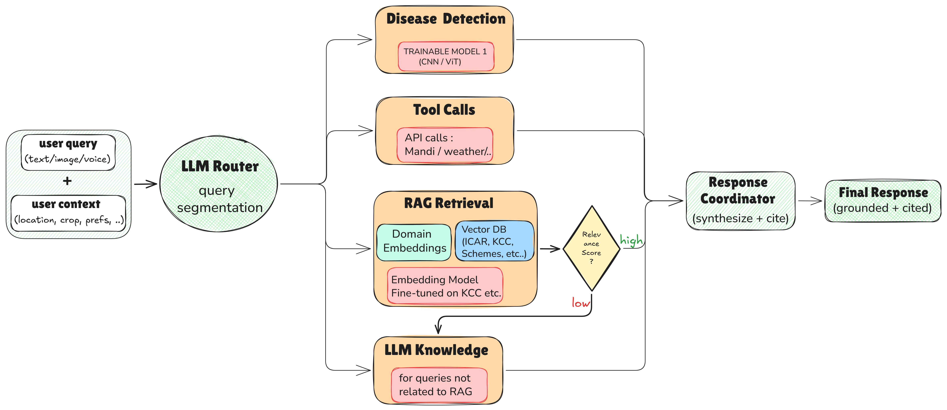

Literature Review-1

How AI is enabling agricultural intelligence and revolutionizing farming
source : world economic forum

Key takeways :

Benefits of innovation to agriculture
Growers today are utilizing smart platforms to take a bird’s eye view of their crops and soil, quickly identifying a plant’s nutrient deficiencies or the earliest signs of disease and pest infestations.

Analysing detailed data, such as weather patterns and soil conditions, simplifies key decisions like seed selection.
What many don't realize is that farmers today can choose from hundreds of varieties within each crop – corn seed that withstands wind or drought better, varieties suited to different soil types, or hybrids optimized for specific climates. This precision ensures that each and every acre is used to its fullest potential.

Literature Review-2

Shaping the Deep-Tech Revolution in Agriculture
source : world economic forum report

Generative AI (GenAI): Offers use-cases ranging from tailored farmer advisory and pest management to agentic AI systems and climate risk simulations.

However, despite these advances and the growing adoption of GenAI, the lack of high-quality data for training hyperlocal models remains a barrier to usability

Computer vision: Provides use cases such as rapid pest and disease identification or plant stress detection.

However, unlike in industrial units, on-field variability (for instance, variations in on-field lighting and plant appearance between growth stages) restricts its applicability for agriculture.

Generative AI
Use cases extend beyond farmers as end users. For instance, GenAI can support the development of macro crop plans for governments, simulate climate risks for businesses and accelerate the development of new crop varieties (by identifying desirable genes or predicting gene-editing outcomes).

Integration of GenAI: Before and after
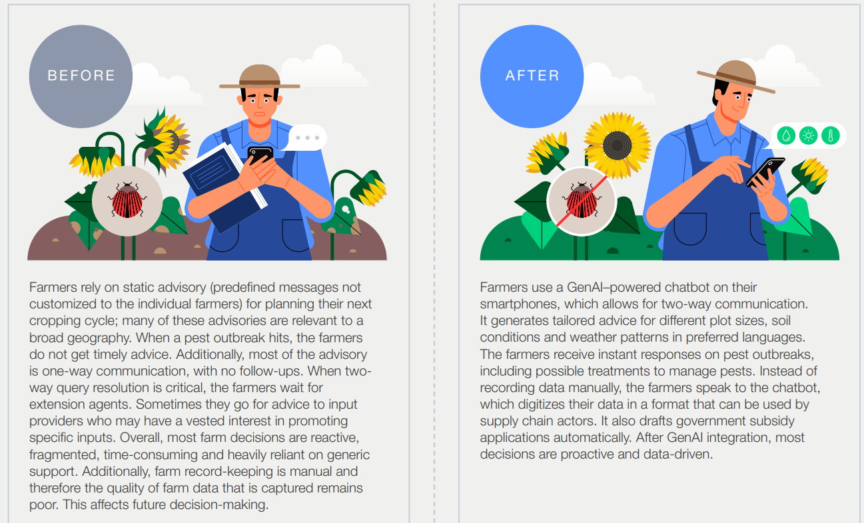
Before :
Farmers rely on static advisory (predefined messages not customized to the individual farmers) for planning their next cropping cycle; many of these advisories are relevant to a broad geography.
When a pest outbreak hits, the farmers do not get timely advice.
Additionally, most of the advisory is one-way communication, with no follow-ups. When twoway query resolution is critical, the farmers wait for extension agents. Sometimes they go for advice to input providers who may have a vested interest in promoting specific inputs.
Overall, most farm decisions are reactive, fragmented, time-consuming and heavily reliant on generic support.
Additionally, farm record-keeping is manual and therefore the quality of farm data that is captured remains poor. This affects future decision-making.

After:
Farmers use a GenAI–powered chatbot on their smartphones, which allows for two-way communication.
It generates tailored advice for different plot sizes, soil conditions and weather patterns in preferred languages.
The farmers receive instant responses on pest outbreaks, including possible treatments to manage pests.
Instead of recording data manually, the farmers speak to the chatbot, which digitizes their data in a format that can be used by supply chain actors.
It also drafts government subsidy applications automatically.
After GenAI integration, most decisions are proactive and data-driven.

BARRIERS

Data quality issues: While the availability of data for agriculture is increasing, accessing quality data is still challenging, especially in smallholder contexts. This decreases the reliability of content created through GenAI models.

Hallucinations and errors: GenAI sometimes produces information that sounds convincing but is factually incorrect or irrelevant. Without robust validation, farmers risk acting on false insights that may harm yields or incomes and affect continued use.

Model transferability across domains and regions: While GenAI chatbots have reported success in certain pilots, their transferability for use in domains such as regenerative agriculture or across value chains is limited. The reliance on LLMs also limits the availability of context-specific recommendations and impairs farmer trust and adoption.

CASE STUDY 1 Improving agricultural data collection and quality through GenAI – Wadhwani Institute for Artificial Intelligence, India

Data collection in smallholder farming ecosystems is a critical barrier to high-quality service delivery.
In many economies, agricultural data collection is still manual and paper-based or conducted using basic software, and is prone to errors and inefficiencies. These systems also result in the exclusion of farmers with low literacy. To address this, the Wadhwani Institute for AI developed AgriAI Collect.
AgriAI Collect uses automatic speech recognition to transcribe multilingual voice inputs, LLMs to extract structured responses and a human-in-the-loop system to validate low-confidence entries.
Data is timestamped and securely stored via a cloud-based platform. The Institute has onboarded 32,000 users; the data collected will be piloted for use cases such as organic certification. Such applications show the potential of GenAI to improve agricultural data collection, which can further enhance agricultural service delivery.

Computer vision
In agriculture, computer vision can be used to detect plant diseases, weeds or pests and to monitor crop stress in real time.

Integration of computer vision: Before and after
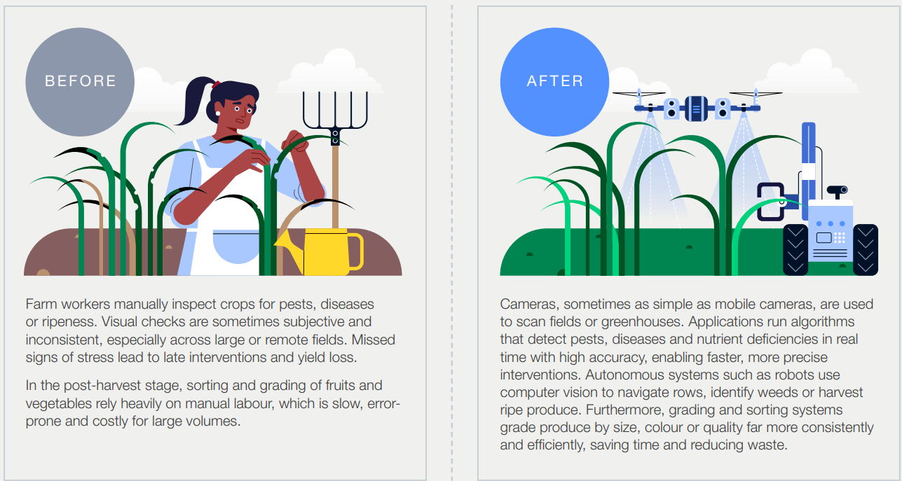
Before:
Farm workers manually inspect crops for pests, diseases or ripeness. Visual checks are sometimes subjective and inconsistent, especially across large or remote fields. Missed signs of stress lead to late interventions and yield loss.

After:
Cameras, sometimes as simple as mobile cameras, are used to scan fields or greenhouses. Applications run algorithms that detect pests, diseases and nutrient deficiencies in real time with high accuracy, enabling faster, more precise interventions.

BARRIERS
On-field variability: Unlike industrial processes, which can be consistent and uniform across stages, agricultural production often demonstrates varied visual elements throughout a crop’s growth cycle. The ability to adapt models for agriculture is challenging. Models trained under ideal conditions may often fail in agriculture.

Lack of training data: Like other areas of AI, developing computer vision use cases such as pest identification involves highly robust databases with large repositories of images of target subjects. Such databases are not readily available.

High investment costs: The integration of computer vision still relies on some form of capital investment, which may be challenging for smallholder farmers from emerging economies.

CASE STUDY 2 Computer vision to reduce food waste – Intello Labs

Assessment of horticultural produce often entails manual inspection, which is subjective, time-consuming and prone to human error. This process can result in a demand–supply mismatch when assessing produce quality and lead to wastage. To address this challenge, Intello Labs has developed an AI and computer vision-based solution for quality assessment referred to as Fruitsort. The solution uses advanced cameras and machine learning to rapidly analyse fresh produce, identifying defects, size and ripeness with objective precision. The solution can be implemented on sorting lines or handheld devices, providing an objective, data-driven assessment of quality in real time that is claimed to be 40x faster than manual sorting. By using computer vision, the solution enables buyers to obtain the required quality of produce, reducing rejection, while farmers receive fair prices pegged to quality.

Literature Review-3

Syngenta’s solutions
source : Syngenta
