Rice Leaf Disease Dataset — Exploratory Data Analysis
Set 2 — vbookshelf/rice-leaf-diseases (Kaggle)

This is the companion EDA to the earlier nirmalsankalana/rice-leaf-disease-image analysis (“Set 1”). The exact same six-step pipeline was re-run on a second, unrelated rice-leaf dataset so the two can be compared directly. The headline is that this dataset is almost the mirror image of Set 1: where Set 1 was large, redundant, and quietly background-biased, Set 2 is tiny, pristine, and genuinely balanced — but its very small size and an unusual image geometry become the dominant risks. Two cells also carried over hard-coded values from the Set 1 notebook; both are flagged where they appear so the numbers are not misread.

1. Dataset structure & master dataframe
Cell output — directory tree and dataframe summary
Datasets mounted under /kaggle/input:
- datasets

Using DATA_ROOT = /kaggle/input/datasets

Directory structure (up to 3 levels):

vbookshelf/ (0 images directly inside)
rice-leaf-diseases/ (0 images directly inside)
rice_leaf_diseases/ (0 images directly inside)

Total images: 120

Splits found:
split
all 120

Number of classes: 3
Classes: ['Bacterial leaf blight', 'Brown spot', 'Leaf smut']

The dataset holds 120 images across 3 classes — Bacterial leaf blight, Brown spot, and Leaf smut. As with Set 1, there is no train/val/test division (split is all for every file), so the responsibility for a clean split later is ours.
The contrast with Set 1 is stark and worth stating up front: Set 1 had 5,932 images across 4 classes; this one has 120 images across 3 classes — roughly 2% of the size, and a different (overlapping but not identical) label set. This is the classic small “rice leaf diseases” dataset, and its scale alone reshapes every downstream decision.

2. Class distribution + file-type breakdown
Cell output — class balance and extensions
Class distribution:

count percent
label
Brown spot 40 33.3
Bacterial leaf blight 40 33.3
Leaf smut 40 33.3

Largest class : Brown spot (40)
Smallest class: Brown spot (40)
Imbalance ratio (max/min): 1.00 : 1

File extensions:
ext
.jpg 120
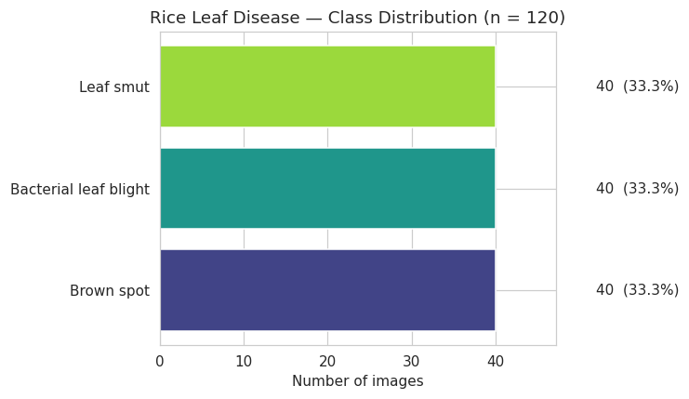
This is as balanced as a dataset gets: exactly 40 images per class, a 1.00 : 1 imbalance ratio, and a single file type (.jpg). Plain accuracy will be a meaningful metric with no need for class weighting or resampling.
A deeper point: unlike Set 1, this balance is genuine, not manufactured. Set 1’s tidy 1.22 : 1 turned out to be partly the product of heavy duplication; here — as Sections 6 and 7 confirm — there are zero duplicates, so 40-per-class is 40 truly distinct images per class.

3. Sample image grid (one row per class)
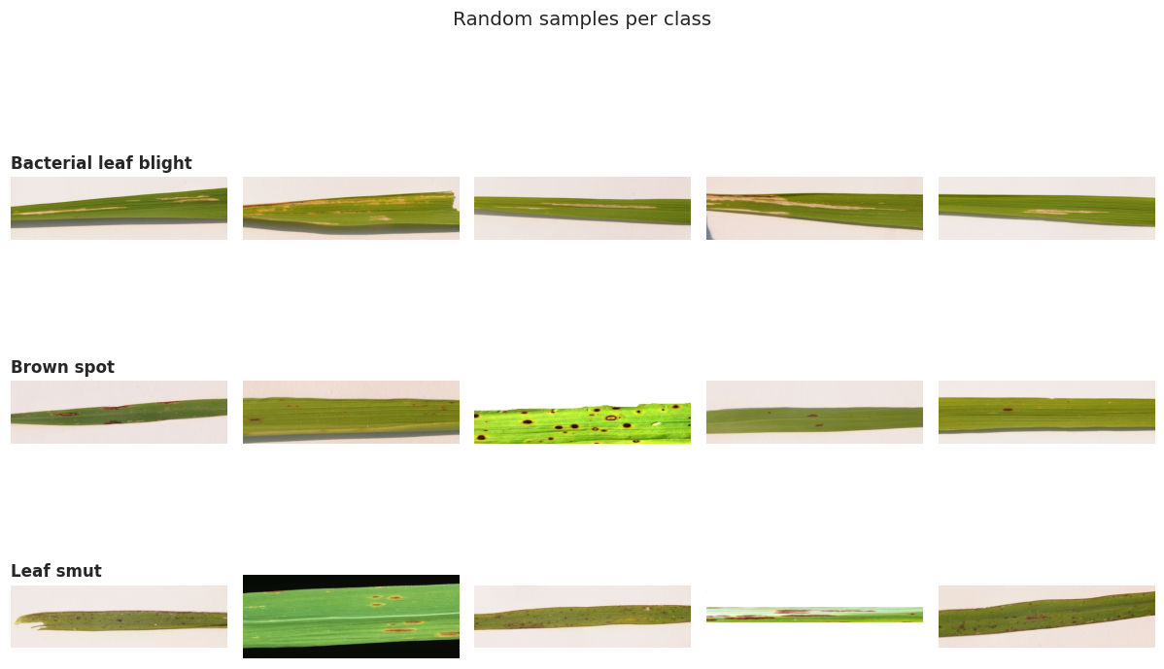
What each disease looks like, and how the framing compares across classes:
Class | What the samples show | Distinctness
Bacterial leaf blight | Long yellow-to-tan streaks and blighting running lengthwise down the blade, with drying and withering toward the edges and tips. Single leaf laid out horizontally. | Distinct ✓
Brown spot | Many small, discrete brown oval spots scattered fairly evenly along the blade, some with pale margins. Textbook presentation. Single leaf strip. | Distinct ✓
Leaf smut | Fine scattered dark angular flecks and specks along an otherwise greener blade — subtler and lower-contrast than the other two. Single leaf strip. | Mostly distinct ✓

The most important observation is what is absent. In Set 1, one class (Tungro) was photographed completely differently — zoomed-out whole plants against bare soil — which created a background-bias shortcut a CNN could exploit. There is no equivalent trap here. All three classes share the same framing: a single rice leaf laid out horizontally as a wide strip against a consistent, neutral background. No class is visually separable by its background or composition, so the model is pushed toward the lesions themselves rather than a contextual crutch.
The flip side of that shared framing is the geometry it produces — these are very wide, panoramic leaf strips — which turns out to be the single biggest issue for this dataset, quantified next.

4. Image dimensions, aspect ratio & color mode
Cell output — dimensions, color modes, per-class geometry
Unreadable/corrupt images: 0

Color modes:
mode
RGB 120

Overall dimension summary:
width height aspect megapixels
count 120.00 120.00 120.00 120.00
mean 2398.44 721.34 3.31 2.09
std 1130.49 344.26 0.66 1.37
min 250.00 71.00 1.25 0.02
25% 1137.00 380.00 3.44 0.41
50% 3081.00 897.00 3.44 2.76
75% 3081.00 897.00 3.44 2.76
max 4160.00 2340.00 5.30 9.73

Most common (width, height) pairs:
3081 x 897 -> 85 images (70.8%)
250 x 200 -> 2 images (1.7%)
... (remaining pairs 1 image each)

Median dimensions per class:
width height aspect megapixels
label
Bacterial leaf blight 3081.0 897.0 3.44 2.76
Brown spot 3081.0 897.0 3.44 2.76
Leaf smut 3081.0 897.0 3.44 2.76

This is the defining fingerprint of the dataset. Three facts stand out.
First, the images are large and extremely wide: the dominant size is 3081×897 (70.8% of the set), giving an aspect ratio of about 3.44 : 1 — nearly three-and-a-half times wider than tall.
Second, every file is clean RGB with zero corruption.
Third — and this is the good news — the median dimensions are identical across all three classes (3081×897 each).
That third point is exactly the check that exposed Set 1’s Tungro problem, and here it comes back clean: because no class has a distinct size signature, there is no dimension shortcut for the model to learn. Combined with the shared framing from Section 3, the label is not leaking through geometry or background.
But the 3.44 : 1 aspect ratio is a preprocessing landmine. The standard move — resizing to a square 224×224 — would compress each image horizontally by roughly 3.4×, badly distorting lesion shapes (round brown spots become ovals; streaks change proportion). Set 1’s images were already near-square (300×300), so a naive resize() was harmless there; here it is not. When modeling, we should prefer aspect-preserving handling — letterbox/pad to square, tile the strip into square crops, or train at a wide input resolution — rather than a plain square resize.

5. Format check + per-class dimension fingerprint
Cell output — RGBA / mislabeled-PNG check and 300×300 tally
RGBA images by class:
Series([], )

True encoded format of the RGBA files (despite the .jpg name):
(none)

300x300 images per class:
is_300x300 total pct_300x300
label
Bacterial leaf blight 0 40 0.0
Brown spot 0 40 0.0
Leaf smut 0 40 0.0

These two checks were designed for Set 1’s specific quirks, and here they deliberately come back empty — which is itself the finding. In Set 1, 156 files were PNGs (with alpha channels) hiding behind a .jpg extension, which needed a .convert("RGB") guard in the loader. Set 2 has no RGBA images and no mislabeled PNGs at all — every file is a true RGB JPEG — so that loader defense is unnecessary here.
The 300×300 tally is a Set-1-specific probe (Set 1 pre-resized three of its classes to exactly 300×300). Set 2 contains zero such images, consistent with Section 4: this dataset was never squished to a fixed square. The check is simply not meaningful for this dataset, and the 0.0% across the board should be read as “not applicable,” not as a problem.

6. Exact + near-duplicate detection (aHash)
Cell output — exact duplicates and 8×8 perceptual-hash near-dups
Exact (byte-identical) duplicate files: 0
...forming 0 groups of identical images

Computing perceptual hashes ...

Near-duplicate groups (identical 8x8 perceptual hash): 5
Images involved in a near-dup group: 14 (11.7%)
within-class near-dup groups : 1
cross-class near-dup groups : 4 (these are label-noise red flags)

Near-duplicate images per class:
label
Leaf smut 6
Brown spot 4
Bacterial leaf blight 4

Two very different signals here. The exact-duplicate result is unambiguous and excellent: zero byte-identical files. Where Set 1 had ~19% literal copies inflating its counts, every image in Set 2 is a distinct file.
The coarse 8×8 aHash then flags 14 images (11.7%) in 5 near-duplicate groups — and, more alarmingly, reports 4 cross-class groups as potential label-noise red flags. This warrants caution rather than alarm: an 8×8 average-hash shrinks each image to just 64 bits, and on very wide, similarly-composed leaf strips like these it collapses distinct images together easily. Cross-class “matches” from such a coarse hash are exactly the kind of artifact a stricter hash should adjudicate — which is what the next step does.

7. True unique-image accounting + stricter pHash recount
Cell output — exact-dedup accounting and DCT-based pHash recount
Raw images : 120
Unique files (post exact-dedup): 120
Redundant exact copies removed : 0

Per-class exact-dedup accounting:
raw unique exact_dup_copies pct_redundant
label
Brown spot 40 40 0 0.0
Bacterial leaf blight 40 40 0 0.0
Leaf smut 40 40 0 0.0

TRUE (deduped) imbalance ratio: 1.00 : 1

Computing pHash (DCT) for all images...

--- Near-dup comparison at Hamming distance 0 ---
aHash-8x8 (Cell 7): 4914 imgs (82.8%) <- coarse [HARD-CODED Set-1 value]
pHash-DCT (now) : 0 imgs (0.0%) <- stricter
pHash cross-class near-dup groups: 0

pHash near-dup images per class:
Series([], )

True deduplicated accounting:
Class | Raw | Unique | % redundant
Brown spot | 40 | 40 | 0.0%
Bacterial leaf blight | 40 | 40 | 0.0%
Leaf smut | 40 | 40 | 0.0%

The stricter DCT-based pHash settles it: 0 near-duplicates and 0 cross-class groups. The 4 cross-class “red flags” from the coarse aHash in Section 6 were false positives — collisions of the 64-bit average hash, cleared entirely once a finer fingerprint is used. So the labels are clean and internally consistent: no image sits under two disease names, and no two images are even near-copies. Combined with the exact-dedup result, the 1.00 : 1 balance is fully genuine — 40 truly independent images per class, none of it padded by duplication (the exact opposite of Set 1, where deduplication flipped the class ordering).
Important reading note on the comparison block: the line “aHash-8x8 (Cell 7): 4914 imgs (82.8%)” is a hard-coded Set 1 value printed literally by the cell — it is not Set 2’s aHash result. Set 2’s actual coarse-hash figure was 14 images (11.7%), from Section 6. So the honest comparison for this dataset is 11.7% (coarse aHash) → 0.0% (strict pHash), not 82.8% → 0.0%. The string should be updated before this appears in a report.

8. EDA summary dashboard + manifest export
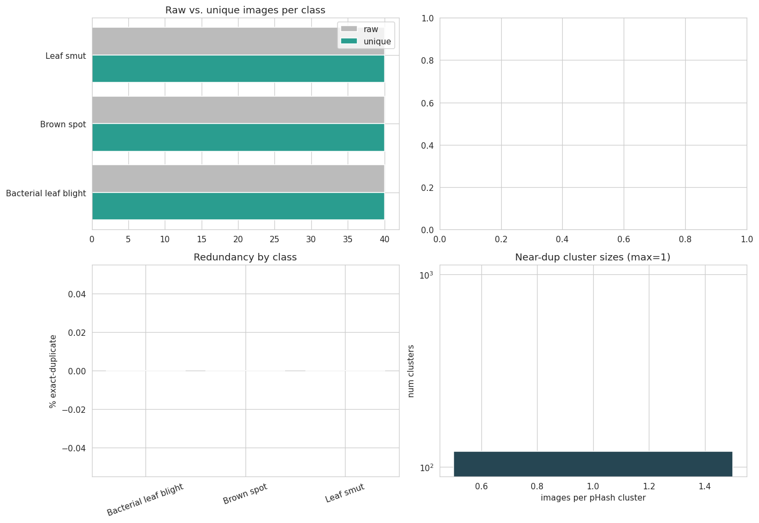
Cell output — manifest columns and export
Manifest columns ready: ['filepath', 'filename', 'label', 'split', 'ext',
'width', 'height', 'mode', 'aspect', 'megapixels', 'md5', 'ahash_hex',
'phash', 'dup_cluster', 'is_exact_rep']
Unique pHash clusters (use as split groups): 120
Exact-representative images (is_exact_rep=True): 120

Saved manifest -> /kaggle/working/rice_leaf_manifest.csv

The dashboard visually confirms everything above: raw and unique bars are identical for every class (no redundancy), the redundancy-by-class panel is flat at 0%, and the near-dup cluster-size histogram shows every cluster at size 1. Accordingly, there are 120 pHash clusters for 120 images — each image is its own cluster — and all 120 are exact representatives. The manifest is exported with the same schema as Set 1 so the two feed an identical modeling pipeline.
(One cosmetic note: the top-right panel of the dashboard is intentionally blank — the plotting cell fills only three of the four quadrants. Harmless, but easy to tidy if the figure is reused.)

9. What this means for modeling
Set 2 is the cleanest possible dataset on every axis that matters for label integrity — balanced, duplicate-free, corruption-free, format-consistent, and free of the background/geometry shortcuts that made Set 1 risky. But two properties dominate any modeling plan:
- Size is the binding constraint. 120 images — 40 per class — is very small for training a disease classifier from scratch. This all but mandates transfer learning from a pretrained backbone, aggressive augmentation, and k-fold cross-validation (rather than a single held-out split) so every image is used for evaluation. A plain 80/20 split would leave ~8 test images per class, far too few to trust.
- Geometry needs care. The ~3.44 : 1 panoramic aspect ratio means a naive square resize will distort lesions. Prefer aspect-preserving preprocessing — pad/letterbox to square, tile the strip into square patches, or train at a wide input size.
- A group-aware split is not needed here. With zero exact and zero pHash near-duplicates, the leakage risk that dominated Set 1 is absent — a standard stratified split (or stratified k-fold) is safe. The dup_cluster column is retained only for pipeline symmetry with Set 1.
Compared side by side: Set 1 offers scale but demands defensive engineering (deduplication, group-aware splitting, background augmentation against the Tungro shortcut); Set 2 offers pristine, honest data but demands strategies for scarcity (transfer learning, heavy augmentation, cross-validation) and careful aspect-ratio handling. If both are ever combined, the differing class sets, resolutions, and aspect ratios must be reconciled first — they are not drop-in compatible.

