1.
import pandas as pd
import numpy as np

s=pd.Series([3,9,-2,10,5])
print(s.sum())
print(s.min())
print(s.max())

o/p:
25
-2
10

2.
import pandas as pd
import numpy as np

data=[['Dinesh',10],['Nithya',12],['Raji',13]]
df=pd.DataFrame(data,columns=['Name','Age'])
print(df)

o/p:
Name Age
0 Dinesh 10
1 Nithya 12
2 Raji 13

3.
import pandas as pd
import numpy as np

data={'Name':['Kavitha','Sudha','Raju','Vignesh'],'Age':[28,34,29,42]}
df=pd.DataFrame(data,index=['rank1','rank2','rank3','rank4'])
print(df)

o/p:
Name Age
rank1 Kavitha 28
rank2 Sudha 34
rank3 Raju 29
rank4 Vignesh 42

4.
import pandas as pd
import numpy as np

df1=pd.DataFrame({'A':pd.Timestamp('20130102'),'B':np.array([3]*4,dtype='int32'),'C':pd.Categorical(['Male','Female','Male','Female'])})
print(df1)

o/p:
A B C
0 2013-01-02 3 Male
1 2013-01-02 3 Female
2 2013-01-02 3 Male
3 2013-01-02 3 Female

5.
import pandas as pd
import numpy as np

df1=pd.DataFrame({'A':pd.Timestamp('20130102'),'B':np.array([3]*4,dtype='int32'),'C':pd.Categorical(['Male','Female','Male','Female'])})
print(df1)

print(df1.shape)

print(df1.dtypes)

print(df1.head())

print(df1.tail())

print(df1.describe())

o/p:
A B C
0 2013-01-02 3 Male
1 2013-01-02 3 Female
2 2013-01-02 3 Male
3 2013-01-02 3 Female
(4, 3)
A datetime64[ns]
B int32
C category
dtype: object
A B C
0 2013-01-02 3 Male
1 2013-01-02 3 Female
2 2013-01-02 3 Male
3 2013-01-02 3 Female
A B C
0 2013-01-02 3 Male
1 2013-01-02 3 Female
2 2013-01-02 3 Male
3 2013-01-02 3 Female
A B
count 4 4.0
mean 2013-01-02 00:00:00 3.0
min 2013-01-02 00:00:00 3.0
25% 2013-01-02 00:00:00 3.0
50% 2013-01-02 00:00:00 3.0
75% 2013-01-02 00:00:00 3.0
max 2013-01-02 00:00:00 3.0
std NaN 0.0

6.
import pandas as pd
import numpy as np

dates=pd.date_range('20130101',periods=100)

df=pd.DataFrame(np.random.randn(100,4),index=dates,columns=list('ABCD'))

print("\n\nhead: ",df.head())

print("\n\ntail: ",df.tail())

print("\n\nindex: ",df.index)

print("\n\ntranspose: ",df.T)

print(df.sort_index(axis=1,ascending=False))

print(df.sort_values(by='B'))

print(df[0:3])

o/p:
head: A B C D
2013-01-01 0.311143 -0.048104 1.128781 0.884662
2013-01-02 -0.795259 1.489299 -1.480818 0.780246
2013-01-03 -1.031443 0.413172 1.160798 -0.085446
2013-01-04 0.145353 0.771381 0.092569 1.877665
2013-01-05 -0.340308 -0.269570 0.587272 0.895024

tail: A B C D
2013-04-06 -1.873716 1.464170 1.154544 1.388587
2013-04-07 -0.859750 0.399916 0.406935 -0.111557
2013-04-08 1.601155 0.363866 0.696998 -0.085353
2013-04-09 0.886337 0.164256 -0.259079 0.739414
2013-04-10 2.128585 -0.726379 1.511242 -0.089539

index: DatetimeIndex(['2013-01-01', '2013-01-02', '2013-01-03', '2013-01-04',
'2013-01-05', '2013-01-06', '2013-01-07', '2013-01-08',
'2013-01-09', '2013-01-10', '2013-01-11', '2013-01-12',
'2013-01-13', '2013-01-14', '2013-01-15', '2013-01-16',
'2013-01-17', '2013-01-18', '2013-01-19', '2013-01-20',
'2013-01-21', '2013-01-22', '2013-01-23', '2013-01-24',
'2013-01-25', '2013-01-26', '2013-01-27', '2013-01-28',
'2013-01-29', '2013-01-30', '2013-01-31', '2013-02-01',
'2013-02-02', '2013-02-03', '2013-02-04', '2013-02-05',
'2013-02-06', '2013-02-07', '2013-02-08', '2013-02-09',
'2013-02-10', '2013-02-11', '2013-02-12', '2013-02-13',
'2013-02-14', '2013-02-15', '2013-02-16', '2013-02-17',
'2013-02-18', '2013-02-19', '2013-02-20', '2013-02-21',
'2013-02-22', '2013-02-23', '2013-02-24', '2013-02-25',
'2013-02-26', '2013-02-27', '2013-02-28', '2013-03-01',
'2013-03-02', '2013-03-03', '2013-03-04', '2013-03-05',
'2013-03-06', '2013-03-07', '2013-03-08', '2013-03-09',
'2013-03-10', '2013-03-11', '2013-03-12', '2013-03-13',
'2013-03-14', '2013-03-15', '2013-03-16', '2013-03-17',
'2013-03-18', '2013-03-19', '2013-03-20', '2013-03-21',
'2013-03-22', '2013-03-23', '2013-03-24', '2013-03-25',
'2013-03-26', '2013-03-27', '2013-03-28', '2013-03-29',
'2013-03-30', '2013-03-31', '2013-04-01', '2013-04-02',
'2013-04-03', '2013-04-04', '2013-04-05', '2013-04-06',
'2013-04-07', '2013-04-08', '2013-04-09', '2013-04-10'],
dtype='datetime64[ns]', freq='D')

transpose: 2013-01-01 2013-01-02 2013-01-03 ... 2013-04-08 2013-04-09 2013-04-10
A 0.311143 -0.795259 -1.031443 ... 1.601155 0.886337 2.128585
B -0.048104 1.489299 0.413172 ... 0.363866 0.164256 -0.726379
C 1.128781 -1.480818 1.160798 ... 0.696998 -0.259079 1.511242
D 0.884662 0.780246 -0.085446 ... -0.085353 0.739414 -0.089539

[4 rows x 100 columns]
D C B A
2013-01-01 0.884662 1.128781 -0.048104 0.311143
2013-01-02 0.780246 -1.480818 1.489299 -0.795259
2013-01-03 -0.085446 1.160798 0.413172 -1.031443
2013-01-04 1.877665 0.092569 0.771381 0.145353
2013-01-05 0.895024 0.587272 -0.269570 -0.340308
... ... ... ... ...
2013-04-06 1.388587 1.154544 1.464170 -1.873716
2013-04-07 -0.111557 0.406935 0.399916 -0.859750
2013-04-08 -0.085353 0.696998 0.363866 1.601155
2013-04-09 0.739414 -0.259079 0.164256 0.886337
2013-04-10 -0.089539 1.511242 -0.726379 2.128585

[100 rows x 4 columns]
A B C D
2013-03-18 0.163720 -2.018041 -0.651025 1.896652
2013-01-08 -1.820895 -1.675470 0.839905 -1.239074
2013-01-16 -1.143325 -1.531645 -1.664564 0.127979
2013-02-08 0.287188 -1.355822 0.994441 0.887817
2013-03-17 0.764649 -1.156029 1.561939 0.085355
... ... ... ... ...
2013-01-29 0.265249 1.473608 0.160818 0.482710
2013-01-02 -0.795259 1.489299 -1.480818 0.780246
2013-02-07 -0.213624 1.908901 -0.141359 -0.566299
2013-03-28 -0.063682 1.953537 0.458433 0.973257
2013-01-23 0.283585 2.244246 0.108514 -1.069880

[100 rows x 4 columns]
A B C D
2013-01-01 0.311143 -0.048104 1.128781 0.884662
2013-01-02 -0.795259 1.489299 -1.480818 0.780246
2013-01-03 -1.031443 0.413172 1.160798 -0.085446

7.
import pandas as pd
import numpy as np

dates=pd.date_range('20130101',periods=100)

df=pd.DataFrame(np.random.randn(100,4),index=dates,columns=list('ABCD'))
print(df['20130105':'20130110'])

print("1st row: ",df.iloc[0])

print("1st row first 2 col: ",df.iloc[0,:2])

print("1st ele: ",df.iloc[0,0])

print(df['A'])

print(df[['A','B']])

print(df[['A','B']][:5])

o/p:
2013-01-05 0.210519 -0.306026 0.065581 -0.765137
2013-01-06 -1.401994 -0.601584 -0.545925 0.954518
2013-01-07 -0.404646 -0.375825 -2.498917 1.424672
2013-01-08 1.472928 -2.274183 -1.195404 0.320027
2013-01-09 0.648707 -0.073562 -1.445962 1.636943
2013-01-10 -0.645495 -1.514765 -0.101239 -0.490331
1st row: A -0.636936
B -1.491191
C 0.243024
D -1.144091
Name: 2013-01-01 00:00:00, dtype: float64
1st row first 2 col: A -0.636936
B -1.491191
Name: 2013-01-01 00:00:00, dtype: float64
1st ele: -0.6369357981862208
2013-01-01 -0.636936
2013-01-02 -0.694400
2013-01-03 -0.444719
2013-01-04 1.541037
2013-01-05 0.210519
...
2013-04-06 -1.276402
2013-04-07 -0.280076
2013-04-08 0.179566
2013-04-09 0.090769
2013-04-10 0.234080
Freq: D, Name: A, Length: 100, dtype: float64
A B
2013-01-01 -0.636936 -1.491191
2013-01-02 -0.694400 0.029922
2013-01-03 -0.444719 -0.520639
2013-01-04 1.541037 -1.039970
2013-01-05 0.210519 -0.306026
... ... ...
2013-04-06 -1.276402 1.054936
2013-04-07 -0.280076 -1.640714
2013-04-08 0.179566 -0.707346
2013-04-09 0.090769 1.643091
2013-04-10 0.234080 0.413948

[100 rows x 2 columns]
A B
2013-01-01 -0.636936 -1.491191
2013-01-02 -0.694400 0.029922
2013-01-03 -0.444719 -0.520639
2013-01-04 1.541037 -1.039970
2013-01-05 0.210519 -0.306026

8.

import pandas as pd
import numpy as np
import matplotlib.pyplot as plt

df=pd.read_csv('xyz.csv',header=None)
df.columns=['preg','glu','bp','sft','ins','bmi','dpf','age','class']

plt.scatter(df['bmi'],df['glu'])
plt.xlabel('bmi')
plt.ylabel('Glucose')
plt.show()

df['age'].hist()
plt.show()

o/p:

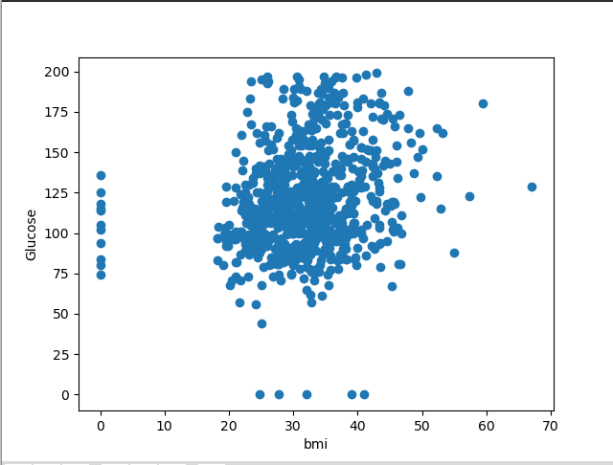

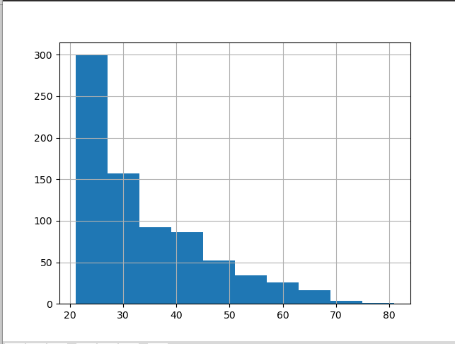
9.

import pandas as pd
import numpy as np
import matplotlib.pyplot

G=pd.read_excel('German Credit_for_Week2.xlsx',sheet_name='Sheet1')
print(G.head())

o/p:

Creditability CreditAmount DurationOfCreditInMonths
0 1 1049 18
1 1 2799 9
2 1 841 12
3 1 2122 12
4 1 2171 12

10.

