**Digital Asset Management – Data Model**

1. Entity – Asset ID and File Attachment

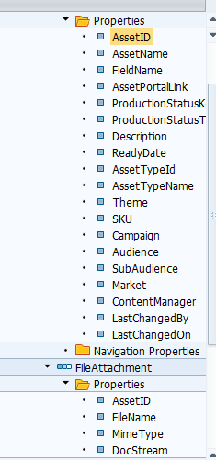

1. Entity Asset Properties

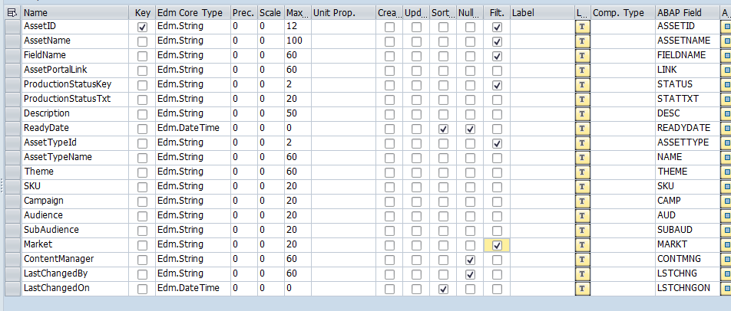

1. Entity FileAttachment Properties

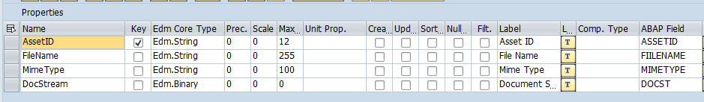

**OData service method implementations:**

1. /IWBEP/IF_MGW_APPL_SRV_RUNTIME~CREATE_STREAM

  METHOD /iwbep/if_mgw_appl_srv_runtime~create_stream.  
  
    DATA: lv_assetid(8),  
          lv_filename    TYPE char255,  
          lv_slug        LIKE iv_slug,  
          lv_docid       TYPE saeardoid,  
          ls_asst_entity TYPE zcl_zasset_mpc_ext=>ts_fileattachment.  
  
*   Get file name and Asset ID details passed in SLUG  
    IF iv_entity_name EQ zcl_zasset_mpc_ext=>gc_fileattachment.  
      DATA(lv_flen) = xstrlen( is_media_resource-value ).  
      SPLIT iv_slug AT '@' INTO DATA(lv_assid) lv_filename.  
      lv_assetid = |{ lv_assid ALPHA = IN }|.  
      ls_asst_entity-assetid = lv_assetid.  
      ls_asst_entity-fiilename = lv_filename.  
      ls_asst_entity-docst = is_media_resource-value.  
      ls_asst_entity-mimetype = is_media_resource-mime_type.  
  
*     Make table entry for new file  
      INSERT INTO zasset_file_table VALUES ls_asst_entity.  
  
      IF sy-subrc <> 0.  
        DATA(lv_msg) = 'Error in document upload'.  
        RAISE EXCEPTION TYPE /iwbep/cx_mgw_busi_exception  
          EXPORTING  
            textid  = /iwbep/cx_mgw_busi_exception=>business_error  
            message = lv_msg.  
      ELSE.  
        ls_asst_entity-assetid = lv_assetid.  
        copy_data_to_ref( EXPORTING is_data = ls_asst_entity  
                          CHANGING  cr_data = er_entity ).  
      ENDIF.  
    ENDIF.  
  
  ENDMETHOD.

1. /IWBEP/IF_MGW_APPL_SRV_RUNTIME~GET_STREAM

  METHOD /iwbep/if_mgw_appl_srv_runtime~get_stream.  
  
    DATA : ls_header   TYPE  ihttpnvp,  
           lv_filename TYPE char255,  
           ls_stream   TYPE /iwbep/if_mgw_appl_types=>ty_s_media_resource.  
    CONSTANTS : lc_asseitid(40) VALUE 'ASSETID'.  
  
    LOOP AT it_key_tab ASSIGNING FIELD-SYMBOL(<lfs_key_tab>).  
      CASE <lfs_key_tab>-name.  
        WHEN lc_asseitid.  
          DATA(lv_assetid) = <lfs_key_tab>-value.   " get Asset ID  
        WHEN OTHERS.  
      ENDCASE.  
    ENDLOOP.  
  
*   Read file details from custom table based of Asset id passed in get stream call  
    SELECT fiilename, mimetype, docst FROM zasset_file_table  
        INTO @DATA(ls_file_data)  
         WHERE assetid = @lv_assetid.  
    ENDSELECT.  
  
    IF ls_file_data-fiilename IS NOT INITIAL.  
      ls_stream-mime_type =  ls_file_data-mimetype.  
      ls_stream-value     = ls_file_data-docst.  
      lv_filename = ls_file_data-fiilename.  
      lv_filename = escape( val = lv_filename  
                           format = cl_abap_format=>e_url ).

*    set header to http framework  
      ls_header-name = 'Content-Disposition'.  
      ls_header-value = |inline; filename="{ lv_filename }"|.  
      set_header( is_header = ls_header ).  
  
*   Pass MIME type and stream value to result  
      copy_data_to_ref( EXPORTING is_data = ls_stream  
                        CHANGING  cr_data = er_stream ).  
    ENDIF.  
  
  ENDMETHOD.

1. ASSETSET_CREATE_ENTITY

  METHOD assetset_create_entity.  
*Work area ------------------------------------------------------------*  
    DATA: ls_entity    LIKE er_entity,  
          ls_asset     TYPE zasset_details,  
          ls_return    TYPE bapireturn1,  
          lv_msg(100),  
          lv_number(4) TYPE n.  
  
*Object References ----------------------------------------------------*  
    DATA lo_message_container TYPE REF TO /iwbep/if_message_container.  
  
    " Instantiate the Message Container  
    CALL METHOD me->/iwbep/if_mgw_conv_srv_runtime~get_message_container  
      RECEIVING  
        ro_message_container = lo_message_container.  
  
    io_data_provider->read_entry_data( IMPORTING es_data = ls_entity ).  
    ls_asset = CORRESPONDING #( ls_entity ).  
  
*    generate number range for asset id  
    CALL FUNCTION 'NUMBER_GET_NEXT'  
      EXPORTING  
        nr_range_nr             = '01'  
        object                  = 'ZASST'  
      IMPORTING  
        number                  = lv_number  
      EXCEPTIONS  
        interval_not_found      = 1  
        number_range_not_intern = 2  
        object_not_found        = 3  
        quantity_is_0           = 4  
        quantity_is_not_1       = 5  
        interval_overflow       = 6  
        buffer_overflow         = 7  
        OTHERS                  = 8.  
  
    IF sy-subrc EQ 0.  
      CONCATENATE 'AST' sy-datum+0(4) lv_number INTO ls_asset-assetid.  
    ENDIF.  
    ls-asset-contmng = sy-uname.  
    ls-asset-lstchng = sy-uname.  
    ls-asset-lstchngon = sy-datum.  
  
*    Make entry in custom table  
    INSERT zasset_details FROM ls_asset.  
  
    IF sy-subrc <> 0.  
      lv_msg =    'Error in creation'.  
      RAISE EXCEPTION TYPE /iwbep/cx_mgw_busi_exception  
        EXPORTING  
          textid            = /iwbep/cx_mgw_busi_exception=>business_error  
          message_container = lo_message_container  
          entity_type       = iv_entity_name  
          message           = lv_msg.  
    ELSE.  
      ls_entity = CORRESPONDING #( ls-asset ).  
      er_entity = ls_entity.  
    ENDIF.  
  
  ENDMETHOD.

1. ASSETSET_GET_ENTITY

  METHOD assetset_get_entity.  
  
    DATA: lt_keys              TYPE /iwbep/t_mgw_tech_pairs,  
          ls_key               TYPE /iwbep/s_mgw_tech_pair,  
          ls_entity            TYPE zcl_zasset_mpc=>ts_asset,  
          ls_return            TYPE bapiret2,  
          err_msg              TYPE string,  
          lo_message_container TYPE REF TO /iwbep/if_message_container.  
  
    DATA: ls_message TYPE scx_t100key.  
  
*   Cathch exception if key value is not provided  
    TRY.  
        DATA(lv_assetid) = it_key_tab[ name = 'ASSET_ID' ]-value.  
      CATCH cx_sy_itab_line_not_found.  
    ENDTRY.  
  
*   Read from table based on Asset ID.  
  SELECT SINGLE * FROM zasset_details INTO @DATA(ls_item)  
      WHERE assetid = @lv_assetid.  
  
    IF sy-subrc EQ 0.  
      ls_entity = CORRESPONDING #( ls_item ).  
    ENDIF.  
    er_entity = ls_entity.  
  
  ENDMETHOD.

1. ASSETSET_GET_ENTITYSET

  METHOD assetset_get_entityset.  
  
    DATA :ls_entity    TYPE zcl_zasset_mpc=>ts_asset,  
          lv_assetid   LIKE ls_entity-assetid,  
          lv_assetname LIKE ls_entity-assetname,  
          lv_statuskey LIKE ls_entity-status,  
          lv_audience  LIKE ls_entity-aud,  
          lv_market    LIKE ls_entity-markt,  
          lt_entity    TYPE zcl_zasset_mpc=>tt_asset.  
*Object References ----------------------------------------------------*  
  
*   Get filter values  
    IF line_exists( it_filter_select_options[ property = 'AssetID' ]-select_options[ 1 ] ).  
      lv_assetid = it_filter_select_options[ property = 'AssetID' ]-select_options[ 1 ]-low.  
    ENDIF.  
  
    IF line_exists( it_filter_select_options[ property = 'AssetName' ]-select_options[ 1 ] ).  
      lv_assetname = it_filter_select_options[ property = 'AssetName' ]-select_options[ 1 ]-low.  
    ENDIF.  
  
    IF line_exists( it_filter_select_options[ property = 'ProductionStatusKey' ]-select_options[ 1 ] ).  
      lv_statuskey = it_filter_select_options[ property = 'ProductionStatusKey' ]-select_options[ 1 ]-low.  
    ENDIF.  
  
    IF line_exists( it_filter_select_options[ property = 'AssetTypeId' ]-select_options[ 1 ] ).  
      lv_audience = it_filter_select_options[ property = 'AssetTypeId' ]-select_options[ 1 ]-low.  
    ENDIF.  
  
    IF line_exists( it_filter_select_options[ property = 'Market' ]-select_options[ 1 ] ).  
      lv_market = it_filter_select_options[ property = 'Market' ]-select_options[ 1 ]-low.  
    ENDIF.

*   Select all entries from table as per filter value given  
    SELECT * FROM zaaset_details INTO TABLE @DATA(lt_asst_data)  
           WHERE assetid EQ @lv_assetid  
            AND assetname EQ @lv_assetname  
            AND status EQ @lv_statuskey  
            AND assettype EQ @lv_audience  
            AND markt EQ @lv_market.  
    IF sy-subrc = 0.  
      SORT lt_asst_data DESCENDING BY readydate.  
    ENDIF.  
  
*   Pass selected data to result entity  
    et_entityset[] = CORRESPONDING #( lt_asst_data ).  
  
  ENDMETHOD.

1. ASSETSET_UPDATE_ENTITY

  METHOD assetset_update_entity.  
  
    DATA: lt_keys              TYPE /iwbep/t_mgw_tech_pairs,  
          ls_key               TYPE /iwbep/s_mgw_tech_pair,  
          ls_return            TYPE bapiret2,  
          err_msg(100),  
          ls_message           TYPE scx_t100key,  
          lo_message_container TYPE REF TO /iwbep/if_message_container.  
  
*   Read key from update call  
    TRY.  
        DATA(lv_assetid) = it_key_tab[ name = 'ASSET_ID' ]-value.  
      CATCH cx_sy_itab_line_not_found.  
    ENDTRY.  
  
*   Read asset details from custom table  
    SELECT SINGLE * FROM zasset_details INTO @DATA(ls_item)  
    WHERE assetid EQ @lv_assetid.  
  
    ls_item-lastchangedby = sy-uname.  
    ls_item-lastchangedon = sy-datum.  
  
*   Update table entry  
    UPDATE zasset_details FROM ls_item.  
  
*   If update is not successful handle exception  
    IF sy-subrc NE 0.  
      err_msg = 'Error while updating'.  
      RAISE EXCEPTION TYPE /iwbep/cx_mgw_busi_exception  
        EXPORTING  
          textid  = /iwbep/cx_mgw_busi_exception=>business_error  
          message = err_msg.  
    ENDIF.  
  ENDMETHOD.