**SHE SECURE 2K25​  
Mental Health & Well-Being​**

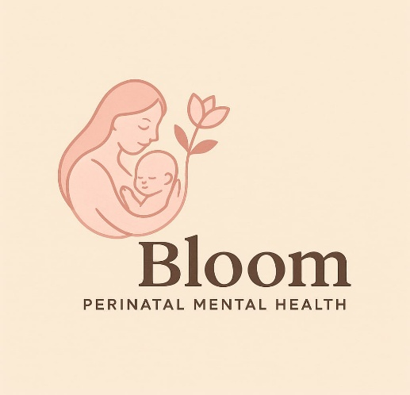

***Bloom – Perinatal Mental Health***

**GROUP MEMBERS:**

Rajeshwari. H. M

Kaveri

Savani. C. Patil

Vathsala. S. H

**Problem Statement: New and expecting mothers are at a heightened risk of experiencing perinatal mood and anxiety disorders (PMADs), including postpartum depression and anxiety. These conditions often go undiagnosed and untreated due to stigma, lack of awareness, limited access to specialized care, and feelings of isolation. This can have significant negative impacts on the mother's well-being, the infant's development, and the family unit**

**Solution**: Bloom is a comprehensive mobile application and platform designed to provide accessible and timely mental health support for new and expecting mothers. It offers a supportive community, connects users with vetted professionals, provides self-care resources, and facilitates early identification of potential issues through tracking features.

**Key Features**

**🔐 Simple Login/Signup Flow**

* Clean, user-friendly login and signup screens for easy onboarding.
* Stores basic info to personalize the experience (e.g., stage: pregnancy/postpartum).
* Secures access to **chat history, tracking, and recommendations**.

**🤖 Intelligent Mood Analysis**

* Uses sentiment analysis to categorize user input into **Positive**, **Concerning**, or **Urgent** moods.
* Helps **detect emotional states** and suggest appropriate responses or resources.
* Enhances **user safety** by flagging critical mental health signals early.

**💬 Chat History with Local Storage**

* All chat conversations are stored **locally in the browser** (localStorage).
* Ensures users can **review past conversations** even after refreshing or closing the app.
* Supports **privacy** by not storing data on external servers (unless extended).

**🔊 Voice-Based Responses (Speech Synthesis)**

* The chatbot can **speak responses aloud** using browser-based speech synthesis.
* Offers a **more comforting, hands-free experience**, especially helpful for new moms multitasking or with screen fatigue.

**🌗 Dark Mode**

* Toggle option for **light/dark themes**.
* Reduces **eye strain**, especially when using the app during night feeds or low-light conditions.
* Enhances accessibility and personalization.

**🧠 Resource Recommendations Based on Emotional State**

* Based on mood analysis, the app suggests **relevant mental health resources**:
  + Positive: Encouraging content or self-care tips
  + Concerning: Stress relief strategies, support articles
  + Urgent: Crisis hotline, professional support links

**📊 Tracking for Early Detection**

* **Mood, Sleep, Feeding Logs:** Simple inputs, trends, & insights
* **Reminders:** For self-care, appointments, meds
* **Alerts:** Identify patterns & suggest seeking help (non-diagnostic)

**🛠️ Tech Stack**

* **Frontend:** React.js, Tailwind CSS
* **Backend:** Node.js + Express.js

• **Language:** JavaScript​

• **Voice output:** Web speech API

• **Routing/Auth:** React Router

• **Tools:** Visual Studio Code, PowerShell​

**🎯 Target Users**

* Pregnant & postpartum individuals
* Families and partners of new mothers

**❤️ Impact & Value**

* **Access & Connection:** Private, stigma-free support
* **Early Help:** Track changes, spot issues early
* **Better Outcomes:** Healthier moms, healthier babies

**💬 Demo**

* Quick walkthrough of:
  + Welcome → Signup → Login → Dashboard → Chatbot
  + Typing and getting intelligent emotional responses
  + Voice reply and dark mode in action

**Sample Chat Flow​**

* You: I feel anxious​
* Bot: 😟 It sounds like you're going through something. It's okay to talk about it — support is available.​
* You: 😊​
* Bot: 😊 That’s great to hear! Keep taking care of yourself.​

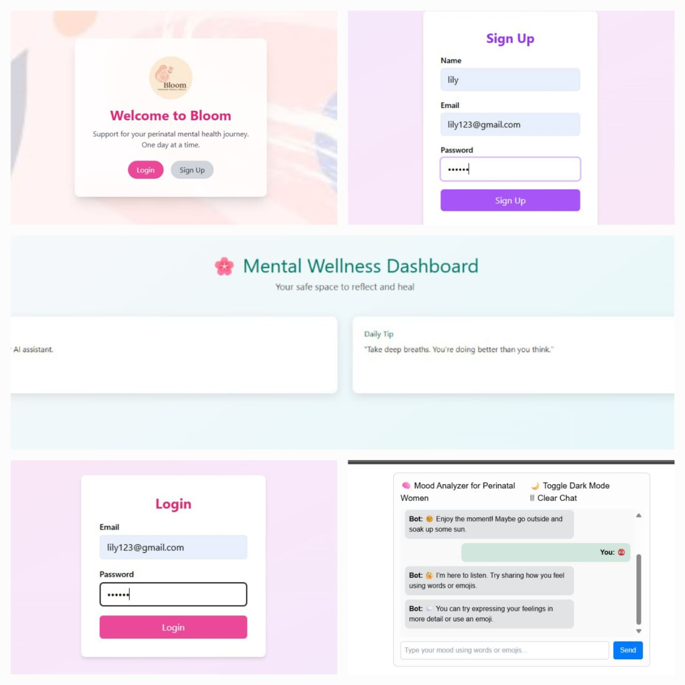**OUTPUT**