1. Basic Linux Commands

Study of a terminal based text editor such as Vim or Emacs. (By the end of the course, students are expected to acquire following skills in using the editor: cursor operations, manipulate text, search for patterns, global search and replace)

Basic Linux commands, familiarity with following commands/operations expected

* 1. man
  2. ls, echo, read
  3. more, less, cat,
  4. cd, mkdir, pwd, find
  5. mv, cp, rm ,tar
  6. wc, cut, paste
  7. head, tail, grep, expr
  8. chmod, chown
  9. Redirections & Piping
  10. useradd, usermod, userdel, passwd
  11. df,top, ps
  12. ssh, scp, ssh-keygen, ssh-copy-id

1. **pwd (Print Working Directory):** Use the pwd command to find outthe path of the current working directory (folder) you’re in. The command will return an absolute (full) path, which is basically a path of all the directories that starts with a forward slash (/). An example of an absolute path is 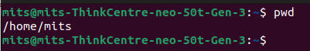/home/username.
2. **history :** When you have been using Linux for a certain period oftime, you will quickly notice that you can run hundreds of commands every day. As such, running history command is particularly useful if you want to review the commands you haveentered before.

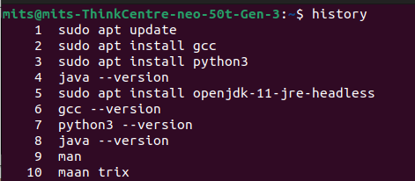

1. **man :**by using this command you can easily learn how to use
2. **cd** :To navigate through the Linux files and directories, use the cd .It requires either the full path or the name of the directory, depending on the current working directory that you’re in.



1. **ls**:The ls command is used to view the contents of a directory. By default, this command will display the contents of your current working directory.If you want to see the content of other directories, type ls and then the directory’s path.

There are variations you can use with the ls command:

* + ls -R will list all the files in the sub-directories aswell
  + ls –l – long listing
  + ls -a will show the hidden files
  + ls -al will list the files and directories with detailed informationlike the
  + permissions, size, owner, etc.
  + ls -t lists files sorted in the order of “lastmodified”
  + ls -r option will reverse the natural sorting order. Usually used incombination with other switches such as ls -tr. This will reverse thetime-wise listing.

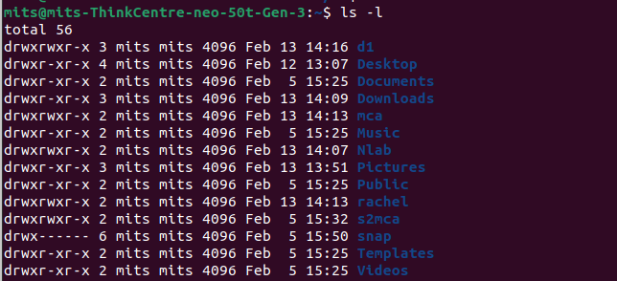

1. **mkdir :** Use mkdir command to make a new directory — if you type mkdir Music it will create a directory called Music.To generate a new directory inside another directory, use this Linux basic command.

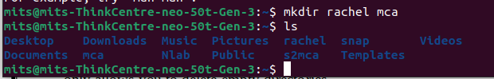

1. **rmdir:**If you need to delete a directory, use the rmdir command.However, rmdir only allows you to delete empty directories.

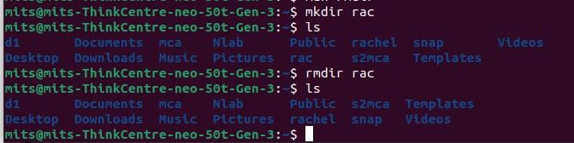

1. **touch:**The touch command allows you to create a blank new filethrough the Linux command line.

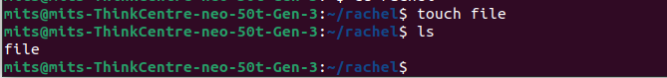

1. **rm :** The rm command is used to delete directories and the contents within them. If you only want to delete the directory —as an alternative to rmdir — use rm -r.Be very careful with this command and double-check which directory you are in. This willdelete everything and there is no undo. To remove a file use rm filename.

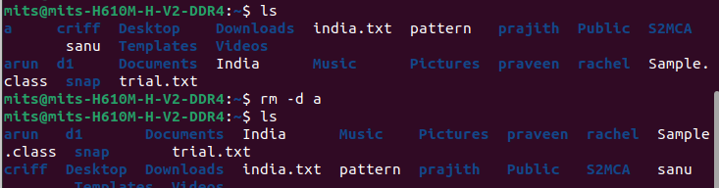

1. **cat:**cat (short for concatenate) is one of the most frequently used commands in Linux. It is used to list the contents of a file on the standard output stdout . To run this command, type cat followed by the file’s name and its extension.

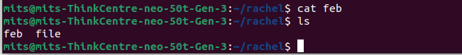

1. **echo:** echo command is used to move some data into a file. If you want to add the text, “Hello, my name is John” into a file called name.txt, you would typeecho Hello, myname is John

>> name.txt 2. head.



1. **head:** The head command is used to view the first lines of any text file. By default, it will show the first ten lines, but you can change this number to your liking. If you only want to show the first five lines, type head -n 5 filename.txt.



1. **tail:** This one has a similar function to the head command, but instead of showing the first lines, the tail command will display the last ten lines of a text file. tail -n filename.txt.

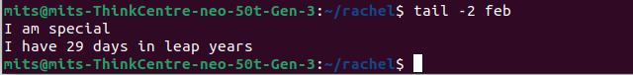

1. **read:** read the contents of a line into a variable. The read command can be used with and without arguments. read command is used to read [options] [name...] . $read $read var1 var2 var3. $echo &quot;[$var1] [$var2] [$var3].
2. **more:** Like cat command, more command displays the content of a file. Only difference is that, in case of larger files, &#39; cat&#39; command output will scroll off your screen while &#39; more&#39; command displays output one screenful at a time. Enter key
3. **less:** The 'less' command is same as 'more' command but include some more features. It automatically adjusts with the width and height of the terminal window, while 'more' command cuts the content as the width of the terminal window get shorter.
4. **cut :** The cut command is used for cutting out the sections from each line offiles and writing the result to standard output. It can be used to cut parts of aline by byte position, character and file.

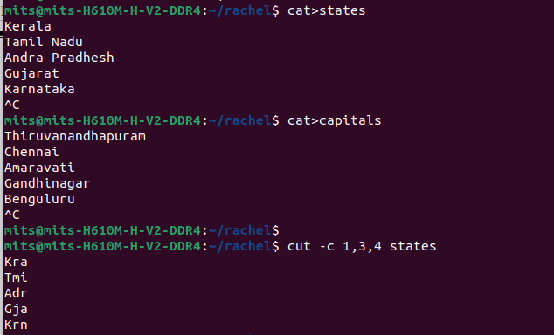

1. **paste :** It is used to join files horizontally (parallel merging) by outputting lines consisting of lines from each file specified, separated by tab as delimiter, to the standard output. paste [OPTION]... [FILES]...$ paste state.txt capital.txt.



1. **uname :** The uname command, short for Unix Name, will print detailed information about your Linux system like the machine name, operating system, kernel, and so on

$uname, $uname-r

1. **cp :** cp command issued to copy files from the currentdirectorytoa different directory. For instance, the command cp scenery.jpg

/home/username/Pictures would create a copy of scenery.jpg (from your current directory) into the Pictures directory. cp -i will ask for user’s consent in case of a potential file overwrite. cp -p will preserve source files’mode, ownership and timestamp. cp -r will copy directories recursively. cp -u copies files only if the destination fileisnotexistingor thesource file is newer than the destination file.



1. **mv :** The primary use of the mv command is to move files, it can alsobeusedtorename files.Theargumentsinmvaresimilartothecp command. Youneed to type mv, the file’s name, and the destination’s directory. mv file.txt

/home/username/Documents .To rename files, the Linux is mv oldname.ext newname.ext.

1. **locate :**To locate a file, just like the search command in Windows. What’smore, using the -i argument along with this command will make it caseinsensitive, so you can search for a file even if you don’t remember its exact name. To search for a file that contains two or more words, use an asterisk (*). For example, locate -i school*note command will search for any file that contains the word “school” and “note”, whether it is uppercase or lowercase.
2. **Find** : Similartothelocatecommand,usingfindalsosearchesforfiles and directories. The difference is, you use the find command to locate fileswithin a given directory. As an example, find /home/ -name notes.txt command will search for a file called notes.txt within the home directory andits subdirectories. Other variations when using the find are: To find files in the current directory use, find . -name notes.txt .To look for directories use, / -type d -name notes. txt.
3. **grep :** Another basic Linux command that is undoubtedly helpful for everyday use is grep. It lets you search through all the text in a given file. Toillustrate, grep blue notepad.txt will search for the word blue in the notepadfile. Lines that contain the searched word will be displayed fully. Usually output of a previous command is piped into the grep command. For example, ls -l |grep “kernel”.

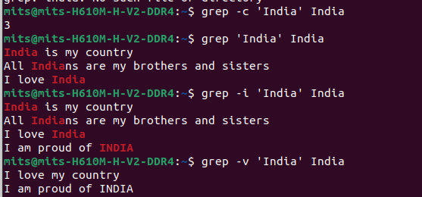

1. **df :** Use dfcommand to get a report on the system’s disk space usage, shown inpercentage and KBs. If you want to see the report in megabytes, type df – m.

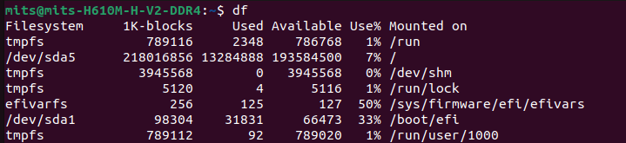

1. **du :** If you want to check how much space a file or a directory takes, the du (Disk Usage) command is the answer. However, the disk usage summary will show disk block numbers instead of the usual size format. If you want to see it in bytes, kilobytes, and 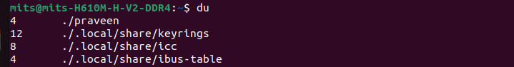megabytes, add the -h argument to the command line.
2. **useradd :** This is available only to system admins .Since Linux is a multi- user system, this means more than one person can interact with the same system at the same time. useradd is used to create a new user, while passwd is adding a password to that user’s account. To add a new person named John type, useradd John and then to add his password type, passwd 123456789.



1. **userdel :**Remove a user is very similar to adding a new user. To delete theusers account type, userdel UserName.



1. **sudo :** Short for “SuperUser Do”, this command enables you to perform tasks that require administrative or root permissions. You must have sufficient permissions to use this command.
2. **passwd :** Changes passwords for user accounts. A normal user may onlychange the password for their own account, while the superuser may changethe password for any account.

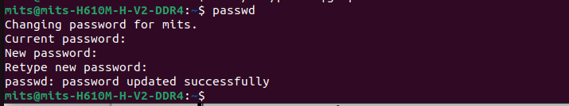

1. **usermod :** usermod command is used to change the properties of a userin Linux through the command line command-line utility that allows you to modify a user’s login information.
2. **Groupadd :** groupadd command creates a new group account using the values specified on the command line and the default values from the system.

# Syntax:

groupadd [option] group_name

1. **groups :** print the groups a user is in#groups alice.

# Syntax:

groups [username]...

1. **groupdel :** groupdel command modifies the system account files, deleting all entries that refer to group. The named group must exist #groupdel marketin.

# Syntax:

groupdel [options] GROUP

1. **groupmod :** The groupmod command modifies the definition of thespecified group by modifying the appropriate entry in the group database. # groupmod -n group1 group2.

# Syntax:

groupmod [option] GROUP

1. **chmod :** To change directory permissions of file/ Directory in Linux. #chmod whowhatwhich file/directory chmod +rwx filename to addpermissions. chmod -rwx directoryname to remove permissions. chmod +x filename to allow executable permissions. chmod -wx filename totake out write and executable permissions. #chmod u+x test #chmod g- rwx test #chmod o-r test 4
2. **chown :** The chown command allows you to change the user and/orgroup ownership of a given file, directory. #chownTom Test
3. **id :** id command in Linux is used to find out user and group names and numeric ID's (UID or group ID) of the current user.
4. **ps :** The ps command, short for Process Status, is a command line utility that is used to display or view information related to the processes running in a Linux system. PID

– This is the unique process ID TTY– This is the type of terminal that the user is logged in to . TIME – This is the time in minutes and seconds that the process has been running .CMD – The command that launched the process

# Syntax:

ps [options]

1. **top :** top command is used to show the Linux processes. It provides a dynamic real- time view of the running system

# Syntax:

top [options]

1. **wc :** wc stands for word count. Used for counting purpose. It is used to find out number of lines, word count, byte and characters count in the files specified in the file arguments. #wc state.txt 6 8 54 state.tx . #wc state.txt capital.txt wc -l state.txt wc

-w state.txt capital.txt wc -c state.txt .wc -m state.txt

1. **tar :** The Linux ‘tar’stands for tape archive, is used to createArchive and extract theArchive files Linux tar command to create compressed or uncompressed Archive files.
2. **expr :** The expr command evaluates a given expression and displays its corresponding output. It is used for: . Basic operations like addition, subtraction, multiplication, division, and modulus on integers. Evaluating regular expressions,string operations like substring, length of strings etc. Performing operations on variables inside a shell script.

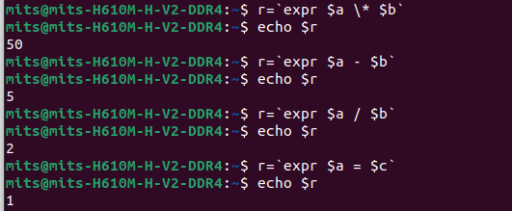

1. **Redirections & Piping :** A pipe is a form of redirection to send the output of one command/program/process to another command/program/process for further processing. Pipe is used to combine two or more commands, the output of one command acts as input to another command, and this command’s output may act as input to the next command and so on.
2. **ssh :** ssh stands for “Secure Shell”. It is a protocol used to securely connect to a remote server/system. ssh is secure in the sense that it transfers the data in encrypted form between the host and the client. It transfers inputs from the client to the host and relays back the output. ssh runs at TCP/IP port 22.
3. **scp :** SCP (secure copy) is a command-line utility that allows you to securely copy files and directories between two locations. With scp, you can copy a file or directory: From your local system to a remote system. From a remote system to your local system. Between two remote systems from your local system. Remote file system locations are specified in format [user@]host:/path Syntax: scp [OPTION] [user@]SRC_HOST:]file1 [user@]DEST_HOST:]file2 $scp

/etc/yum.config /etc/hosts

ServerX:/home/student $scp ServerX:/etc/hostname/home/student.

1. **ssh-keygen :** ssh-keygen command to generate a public/private authentication key pair. Authentication keys allow a user to connect to a remote system without supplying a password. Keys must be generated for each user separately. If you generate key pairs as the root user, only the root can use the keys. $ssh-keygen -t rsa.
2. Create six files with name of the form songX.mp3
3. Create six fileswith name of the form snapX.mp3
4. Create six files with name of the form filmX.mp3 (In each set, replace X with the numbers 1 through 6)
5. From your home directory, move the song files into your music subdirectory, the snapshot files into your pictures subdirectory, and the movie files into videos subdirectory
6. Copy song files to the friends folder and snap files to family folder
7. Attempt to delete both family and friends projects with a single rmdir command.
8. Use another command that will succeed in deleting both the family and friends folder
9. Redirect a long listing of all home directory files, including hidden, into a file named all files.txt. Confirm that the file contains the listing.
10. In the command window, display today’s date with day of the week, month, date and year
11. Add the user Juliet
12. Confirm that Juliet has been added by examining the /etc/passwd file
13. Use the passwd command to initialize Juliet’s password
14. Create a supplementary group called Shakespeare with a group id of 30000
15. Create a supplementary group called artists.
16. Confirm that Shakespeare and artists have been added by examining the /etc/group file.
17. Add the Juliet user to the Shakespeare group as a supplementary group
18. Confirm that Juliet has been added using the id command.
19. Add Romeo and Hamlet to the Shakespeare group
20. Add Reba, Dolly and Elvis to the artists group.
21. Verify the supplemental group memberships by examining the /etc/group file
22. Attempt to remove user Dolly.