PDS LAB END-SEM CAPSTONE PROJECT

E-SHOPPING PLATFORM MANAGEMENT SYSTEM IN C

Team members:

Sayantani Modak



**ABSTRACT**

This project is a web based shopping site .The project objective is to deliver the online shopping application into android platform. This project is an attempt to provide the advantages of online shopping to customers and e-shop platform to vendors. It helps in selling and buying the products anywhere through internet by using an android device. Thus the customer will get the service of online shopping and home delivery. This system can be implemented to any shop in the locality or to multinational branded shops having retail outlet chains. If shops are providing an online portal where their customers can enjoy

easy shopping from anywhere, the shops won’t be losing any more

customers. Since the application is available in smart devices it is easily accessible and always available.

Why I chose this project?

Online shopping is the process whereby consumers directly buy goods, services etc. from a seller interactively in real-time without an intermediary service over the internet.

Online shopping is the process of buying goods and services from merchants who sell on the Internet. Since the emergence of the World Wide Web, merchants have sought to sell their products to people who surf the Internet.

Shoppers can visit web stores from the comfort of their homes and shop as they sit in front of the computer. Consumers buy a variety of items from online stores.

OBJECTIVE:

To shop wile in the comfort of your own home , without having to step out of the door.

Sell at lower rate due to less over head, Provide home delivery free of cost, Secured Transaction.

Important highlights of project

Sign up/login feature

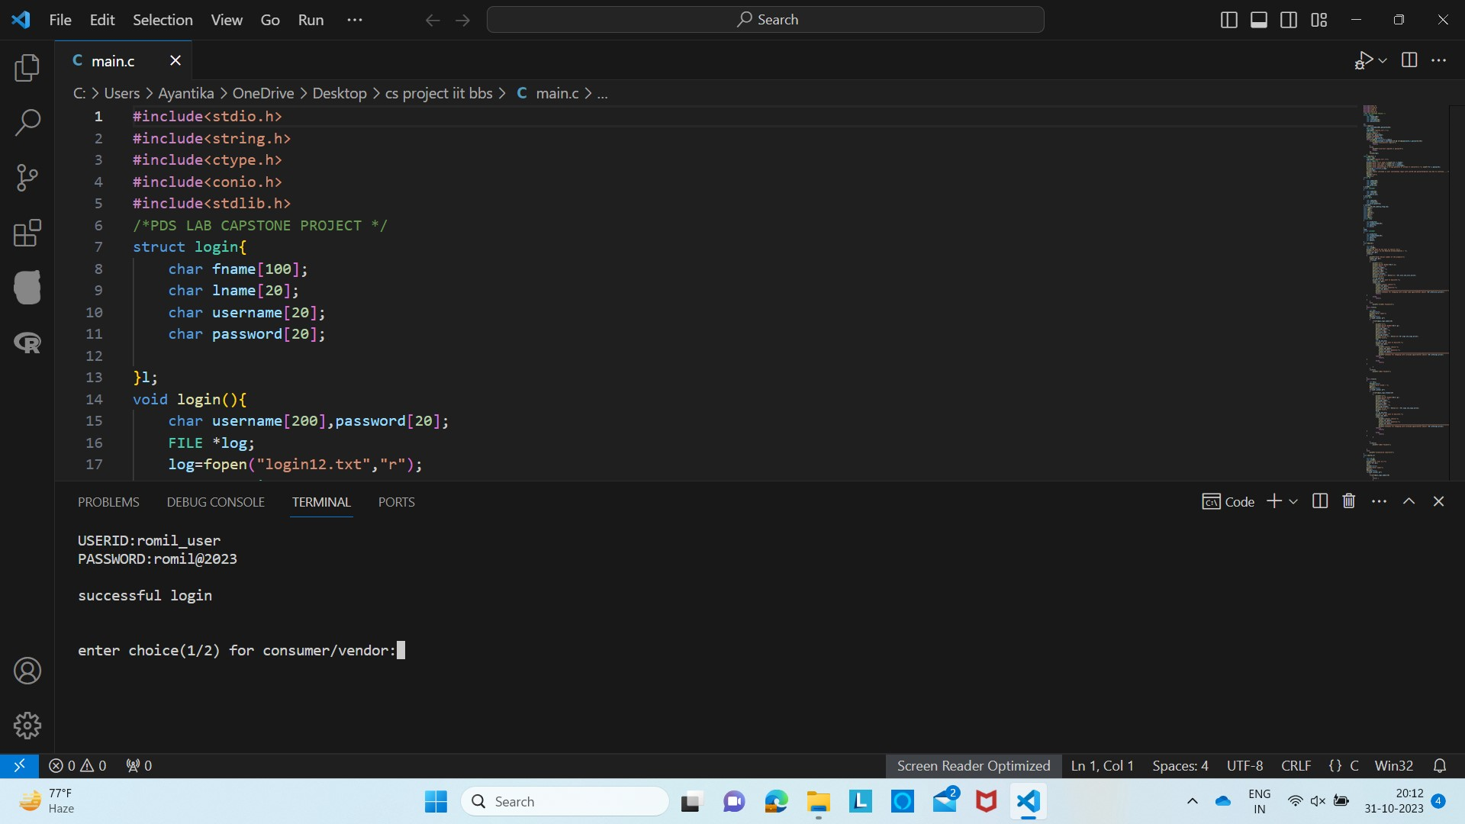

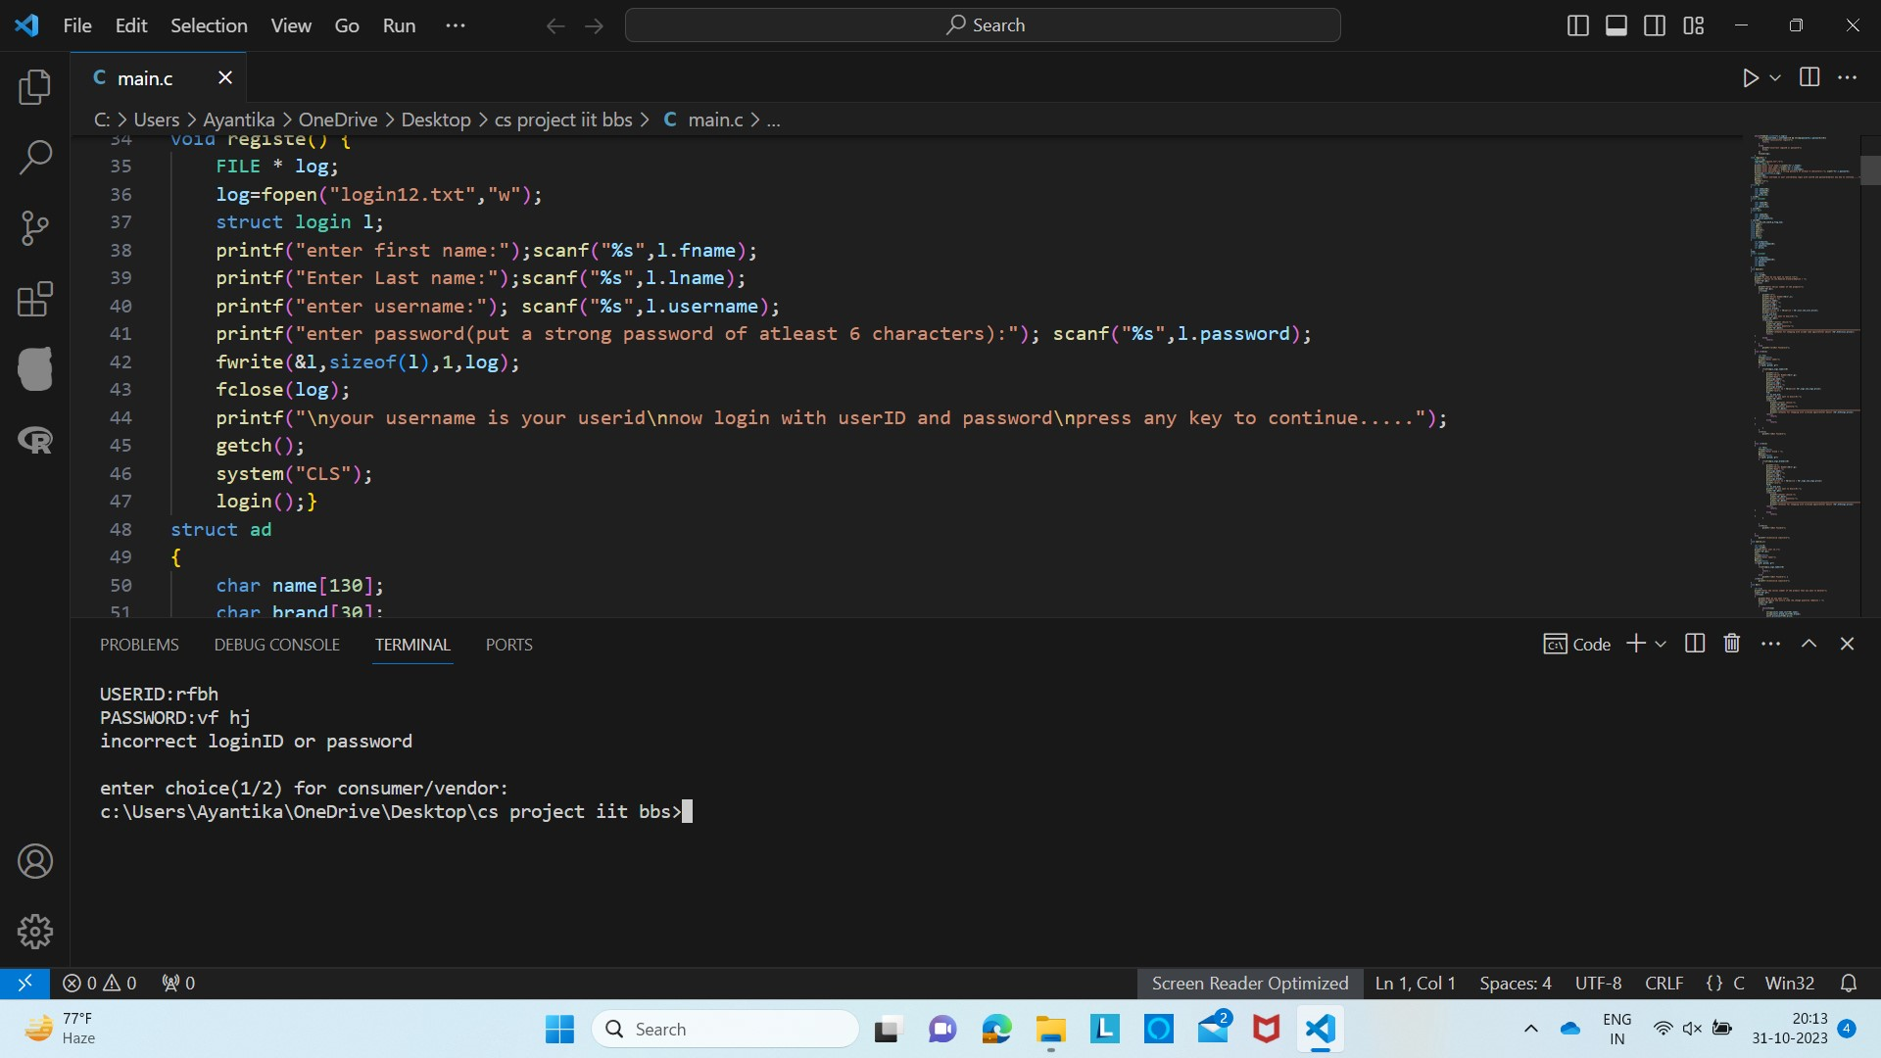

Invoice generation

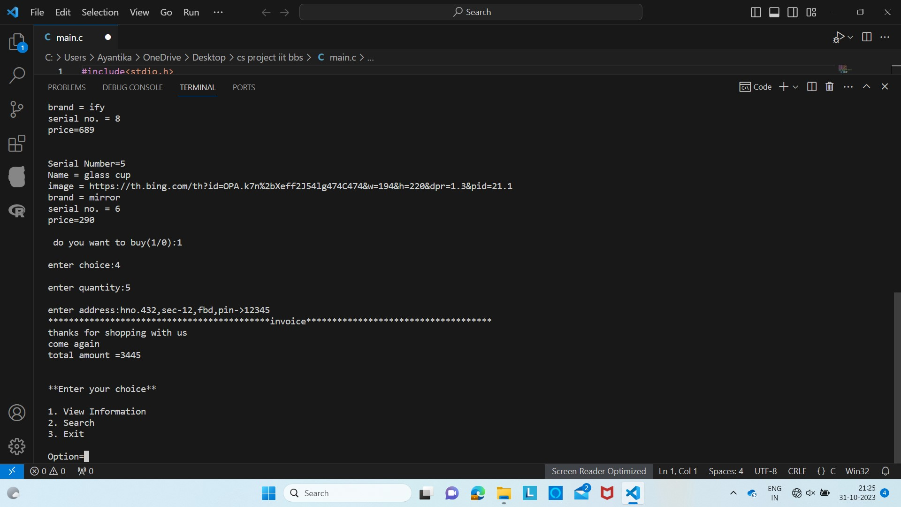

Image hyperlink feature

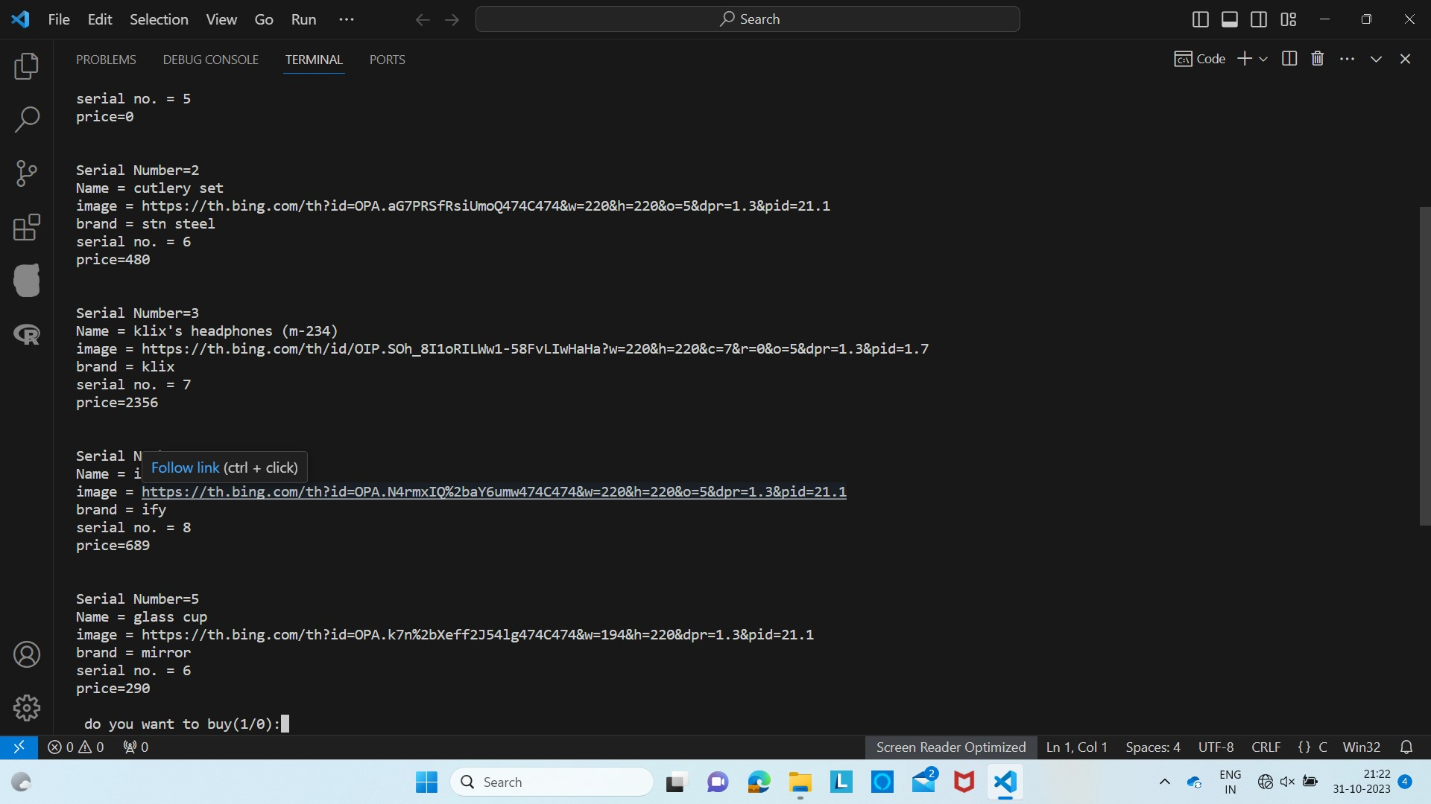

New concepts of c learned to use in the project:

File handing in C is the process in which we create, open, read, write, and close operations on a file. C language provides different functions such as fopen(), fwrite(), fread(), fseek(), fprintf(), etc. to perform input, output, and many different C file operations in our program.

**Why do we need File Handling in C?**

So far the operations using the C program are done on a prompt/terminal which is not stored anywhere. The output is deleted when the program is closed. But in the software industry, most programs are written to store the information fetched from the program. The use of file handling is exactly what the situation calls for.

In order to understand why file handling is important, let us look at a few features of using files:

* **Reusability:**The data stored in the file can be accessed, updated, and deleted anywhere and anytime providing high reusability.
* **Portability:**Without losing any data, files can be transferred to anotherin the computer system. The risk of flawed coding is minimized with this feature.
* **Efficient:**A large amount of input may be required for some programs. File handling allows you to easily access a part of a file using few instructions which saves a lot of time and reduces the chance of errors.
* **Storage Capacity:**Files allow you to store a large amount of data without having to worry about storing everything simultaneously in a program.
* A file can be classified into two types based on the way the file stores the data. They are as follows:
* **Text Files**
* **Binary Files**

**Text Files**

A text file contains data in the **form of ASCII characters** and is generally used to store a stream of characters.

* Each line in a text file ends with a new line character (‘\n’).
* It can be read or written by any text editor.
* They are generally stored with **.txt**file extension.
* Text files can also be used to store the source code.

# C Structures

The structure in C is a user-defined data type that can be used to group items of possibly different types into a single type. The **struct keyword**is used to define the structure in the C programming language. The items in the structure are called its **member** and they can be of any valid data type and accessed individually.

## C Structure Declaration

We have to declare structure in C before using it in our program. In structure declaration, we specify its member variables along with their datatype. We can use the struct keyword to declare the structure in C using the following syntax:

### Syntax

**struct** structure_name {

*data_type member_name1;*

*data_type member_name1;*

....

....

};

The above syntax is also called a structure template or structure prototype and no memory is allocated to the structure in the declaration.

Areas of improvement

* To insert captcha for added security

CAPTCHAs' purpose is to prevent spam on websites, such as promotion spam, registration spam, and data scraping, and bots are less likely to abuse websites with spamming if those websites use CAPTCHA. Many websites use CAPTCHA effectively to prevent bot raiding. CAPTCHAs are designed so that humans can complete them, while most robots cannot. Newer CAPTCHAs look at the user's behaviour on the internet, to prove that they are a human. A normal CAPTCHA test only appears if the user acts like a bot, such as when they request webpages, or click links too fast.

* To have sort option of products into->

* Telecom
* Food
* Clothing and lifestyle
* Furniture

For user friendly interface

* wider range of products to serve wider range of customers

* Wider range of payments options

* Credit and debit cards Credit and debit cards are the most common payment methods for ecommerce transactions. They allow customers to make payments quickly and conveniently.
* Digital wallets Digital wallets, such as PayPal, Apple Pay, and Google Pay, have become increasingly popular. ...
* Bank transfers ...
* Cash on delivery (COD) ...
* Mobile payments ...
* Buy now, pay later ...
* Cryptocurrency ...
* Prepaid cards ...

FUTURE SCOPE:

This product has great future scope. Online shopping Internet software developed on and for the Windows and later versions environments and Linux OS.

This project also provides security with the use of Login-id and Password, so that any unauthorized users can not use your account. The only Authorized that will have proper access

authority can access the software.

The potential for e-commerce development is enormous. Now a days one can buy products online through some sites like Flipkart and Amazon. In the age of e-commerce everything from gym equipment to laptops are available online. E-Commerce is a super set of business cases. It includes E-trading, E-Franchising, E-Mailing, E-Engineering etc. Scope of e-commerce can be enumerated as follows:

1. Exchange of digitized information

2. Technology-enabled

3. Customers retention

4. Accounting

5. Supplier integration

6. Support the exchange

The code, demo video , project report was prepared by team member->

Sayantani Modak.

