Ubuntu 20.04 Remote Desktop from Windows 10 step by step instructions
First step is to install Remote Desktop Protocol (RDP) server xrdp on the Ubuntu 20.04 desktop. To do so execute the following command:
$ sudo apt install xrdp

Enable to start after reboot and run the remote desktop sharing server xrdp:
$ sudo systemctl enable --now xrdp

下一步可省略
Still on the Ubuntu 20.04 desktop, open a firewall port 3389 for an incoming traffic:
$ sudo ufw allow from any to any port 3389 proto tcp

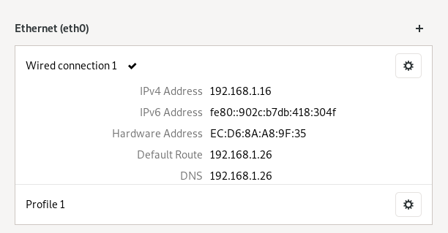
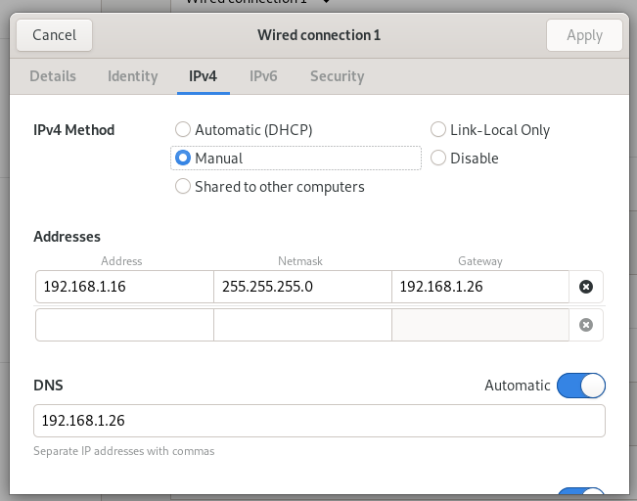
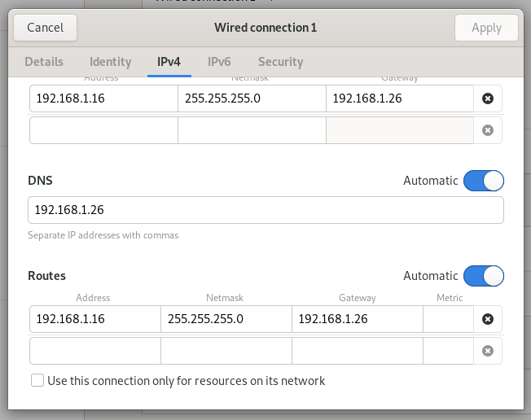

Windows上
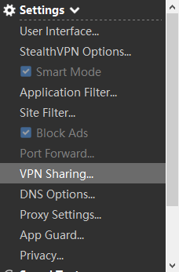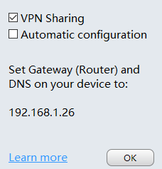

然后用remote连接192.168.1.16即可。

ubuntu端需要logout才行

