Title : IMPLEMENT AND MANAGE ZERO TRUST NETWORK ACCESS (ZTNA) USING ZSCALER

S.no | Name | College name | Contact
1 | SARATHI.N | Pollachi college of arts and science | 23nmsarathi@gmail.com  9342459143
2 | KARTHIKEYAN.M | Pollachi college of arts and science | 23nmcsskarthikeyan@gmail.com  9025481573
3 | MUGILNILAVAN.M | Pollachi college of arts and science | 23nmcsmugilnilavan@gmail.com  8778628570
4 | DINESHKUMAR.M | Pollachi college of arts and science | 23nmcsdinesh@gmail.com  9003745945
5 | MANOJ KUMAR.C | Pollachi college of arts and science | 23nmcsmanojkumar@gmail.com  9025496795

Project details
Title : IMPLEMENT AND MANAGE ZERO TRUST NETWORK ACCESS (ZTNA) USING ZSCALER

Into :
AI-Enhanced User Protection (AIUP) is a next-generation security framework
that leverages artificial intelligence and machine learning to verify user identities
and protect online platforms from cyber threats. Unlike traditional security
measures that rely on static credentials like passwords or even two-factor
authentication (2FA), AIUP continuously analyzes user behavior to create a
dynamic, evolving "trust score" for each individual.
AIUP is essential for modern online security because it addresses the limitations
of perimeter-based defenses. As cyber threats become more sophisticated—with
attackers using stolen credentials, phishing, and social engineering—relying
solely on "what you know" (passwords) or "what you have" (tokens) is no longer
sufficient. AIUP adds a third, continuous layer: "who you are" based on how you
behave. This system helps organizations prevent account takeovers, reduce fraud,
and ensure that the person interacting with a platform is genuinely who they claim
to be, throughout their entire session.

Abstract
The limitations of legacy VPN architectures in addressing modern security threats, particularly lateral movement and over-privileged network access, necessitate paradigm shift towards Zero Trust principles. This project details the comprehensive design, deployment, and management of a Zero Trust Network
Access (ZTNA) solution leveraging Zscaler Private Access (ZPA) within a large-
scale institutional network. The project aims to replace broad network-level access
with application-specific, identity-driven connectivity. By deploying Zscaler App
Connectors within the data center and integrating the platform with existing
Identity Providers (Azure AD) and endpoint security tools, the architecture ensures
that all user-to-application connections are established through a cloud-native
broker. This approach renders internal applications "invisible" to the internet,
eliminating the attack surface. Furthermore, the project explores the integration of
Zscaler with security ecosystems, including SIEM platforms (like QRadar) for
centralized logging and MISP for consuming threat intelligence to enable adaptive
access policies. The result is a robust, scalable security framework that enforces
least-privilege access, provides comprehensive audit trails, and significantly
enhances the institution's resilience

Use case senarios:
1 . Secure Remote Access for Faculty to ERP System
A faculty member working from home needs to access the university's ERP system to upload student grades. Using Zscaler Private Access (ZPA), they connect securely without being placed on the internal network. The system verifies their identity via Azure AD MFA and checks their device posture before granting access.
2 . External Researcher Accessing a Specific Database
An external research collaborator from another institution requires temporary access to a single research database hosted on VIT's servers. The administrator creates a time-limited, application-specific policy in Zscaler. The researcher accesses only the authorized database without any visibility into the rest of the VIT network.
3 . Student Access to Online Examination Portal
During final exams, thousands of students simultaneously access the internal online examination portal from various locations. Zscaler ZPA ensures that only authenticated students with compliant devices can reach the exam server. The system prevents DDoS attacks on the login page and blocks any attempts to access other internal resources.
4 . IT Administrator Performing Server Maintenance
An IT administrator needs to perform critical updates on an internal application server. Instead of connecting via VPN and gaining full network access, they use ZPA to connect directly to the specific server's management interface. The session is monitored in real-time, and any anomalous behavior (e.g., accessing unauthorized servers) is automatically terminated.
5 . Mergers and Acquisitions – Temporary Contractor Access
A contractor hired during a university system upgrade needs temporary access to a specific file server to migrate data. Using Zscaler ZPA, the contractor is granted application-specific access without being added to the university's Active Directory or given VPN credentials. The access is revoked automatically after the project timeline.

Stage 1
Title: owasp to 10
Overview:
Introducing the OWASP Top 10:2025
- Broken Access Control: When users can access data or functions that they are not authorized to use.
- Security Misconfiguration: Security weaknesses caused by improper system or application configuration.
- Software Supply Chain Failures: Vulnerabilities introduced through third-party software or external components.
- Cryptographic Failures: Failure to properly protect sensitive data using strong encryption methods.
- Injection: Attackers insert malicious code or commands into a system through user input.
- Insecure Design: Security flaws caused by poor system design without proper security planning.
- Authentication Failures: Weak authentication mechanisms allow attackers to gain unauthorized access.
- Software or Data Integrity Failures: Lack of verification allows unauthorized modification of software or data.
- Security Logging & Alerting Failures: Systems fail to record or alert administrators about suspicious activities.
- Mishandling of Exceptional Condition: Improper handling of errors or unexpected situations in software.

S.No | Vulnerability name | CWE/CVE no
1 | Absolute Path Traversal | CWE 36
2 | Sensitive Cookie in HTTPS Session Without 'Secure' Attribute | CWE 614
3 | Use of Unmaintained Third Party Components | CWE 1104
Report:
Vulnerability name Absolute Path Traversal
CEW/cve number: CEW 36
Owasp category : A01:2025 Broken Access Control
Description : The product uses external input to construct a pathname that should be within a restricted directory, but it does not properly neutralize absolute path sequences such as "/abs/path" that can resolve to a location that is outside of that directory.
Business impact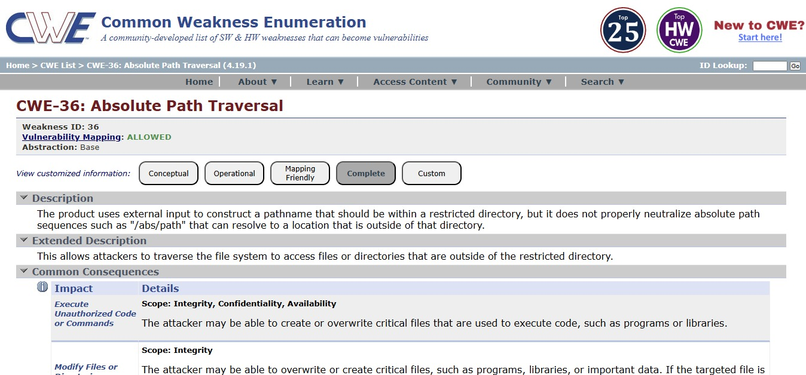

Stage 2:
Title: nessus scan
Overview:
Nessus scans targets (servers, PCs, websites, or networks) and checks them against a large database of known vulnerabilities.
How a Nessus Scan Works
- Target Selection – Define the IP address, domain, or network to scan.
- Scanning – Nessus runs automated tests using plugins to detect vulnerabilities.
- Analysis – The scanner analyzes services, ports, software versions, and configurations.
- Report Generation – Results are categorized by severity (Critical, High, Medium, Low, Informational).
What Nessus Can Detect
- Open ports and exposed services
- Missing security patches
- Misconfigurations
- Known software vulnerabilities
- Weak SSL/TLS settings

S.no | Vulnerability name | severity | piugins
1 | Traceroute Information | INFO | 10287
2 | TCP/IP Timestamps Supported | INFO | 25220
3 | SSL/TLS Diffie-Hellman Modulus <= 1024 Bits (Logjam) | LOW | 83875
4 | shor's Harvest Now Decrypt Later | INFO | 298387
5 | Service Detection | INFO | 22964
6 | Remote Services Not Using Post-Quantum Ciphers | INFO | 227650
7 | OS Identification | INFO | 11936
8 | OS Fingerprints Detected | INFO | 209654
9 | Open Port Re-check | INFO | 10919
10 | Nessus SYN scanner | INFO | 11219
11 | Nessus Scan Information | INFO | 19506
12 | Device Type | INFO | 54615
13 | Common Platform Enumeration (CPE) | INFO | 45590
14 | Apache Tomcat Detection | INFO | 39446
15 | Additional DNS Hostnames | INFO | 46180
16 | TLS Version 1.0 Protocol Detection | MEDIUM | 104743
17 | TLS Version 1.1 Deprecated Protocol | MEDIUM | 157288
18 | TLS Version 1.1 Protocol Detection | INFO | 121010
19 | TLS Version 1.2 Protocol Detection | INFO | 136318
20 | SSL Certificate Information | INFO | 10863
21 | SSL Cipher Block Chaining Cipher Suites Supported | INFO | 70544
22 | SSL Cipher Suites Supported | INFO | 21643
23 | SSL Perfect Forward Secrecy Cipher Suites Supported | INFO | 57041
24 | SSL / TLS Versions Supported | INFO | 56984
25 | SSL/TLS Recommended Cipher Suites | INFO | 156899
26 | TLS Supported Groups | INFO | 277654
27 | HTTP Server Type and Version | INFO | 10107
28 | HyperText Transfer Protocol (HTTP) Information | INFO | 24260
29 | HSTS Missing From HTTPS Server | INFO | 84502
30 | SSL Certificate Signed Using Weak Hashing Algorithm (Known CA) | INFO | 95631
31 | SSL Root Certification Authority Certificate Information | INFO | 94761

Stage 3
Title : implement and mange zero trust network access (ZTNA) using Zscaler: securing user-to-Application connectivity
Overview:
Zero Trust Network Access (ZTNA) is a modern security approach that ensures secure connectivity between users and applications without trusting any user or device by default. Instead of giving full network access, it verifies multiple security factors before allowing access to applications. Platforms like Zscaler help organizations implement ZTNA by continuously checking identity, device security, and application risks to protect sensitive data and systems.
Key Components:
Identity:
Access is granted only after verifying the user’s identity through authentication methods such as username, password, or multi-factor authentication.
Device Posture:
The system checks the security status of the device (antivirus, OS updates, compliance) before allowing it to connect to the application.
Application Risk:
Applications are evaluated for potential security risks, ensuring users access only safe and authorized applications.
Context-Aware Access:
Access decisions are made based on contextual factors such as user location, device type, network status, and time of access.
Conclusion:
Implementing Zero Trust Network Access using Zscaler strengthens organizational security by ensuring that only verified users with secure devices can access specific applications. This approach reduces the risk of unauthorized access, protects sensitive data, and provides a secure and flexible way for users to connect to applications from anywhere.

Conclusion

Stage 1: The OWASP Top 10 identifies the most critical security risks for web applications, highlighting vulnerabilities such as injection flaws, broken access controls, and security misconfigurations. It emphasizes that many risks stem from poor coding practices, outdated components, and weak authentication. By raising awareness and promoting secure design, proper access controls, patch management, and regular testing, the Top 10 helps organizations prioritize security efforts. Ultimately, it serves as a practical guide for preventing attacks and protecting the confidentiality, integrity, and availability of web applications.
Stage 2: A Nessus scan provides a comprehensive view of an organization’s security posture by automatically identifying vulnerabilities, misconfigurations, and missing patches across systems, networks, and applications. The scan categorizes findings by severity, helping security teams prioritize remediation efforts efficiently. Regular Nessus scans enable proactive risk management, reduce the likelihood of exploitation, and support compliance with regulatory standards. Overall, Nessus is an essential tool for maintaining visibility into vulnerabilities and strengthening an organization’s defenses before attackers can exploit weaknesses.
Stage 3
The implementation of Zero Trust Network Access using Zscaler provides a strong and modern approach to securing user-to-application connectivity. By continuously verifying user identity, checking device posture, evaluating application risks, and applying context-aware access policies, organizations can ensure that only authorized and secure users gain access to critical applications. This security model eliminates the traditional concept of trusted networks and focuses on strict verification at every access request. As a result, ZTNA improves overall network security, minimizes the risk of cyber threats, and enables safe access to applications from any location or device.

Future Scope
Stage 1 – OWASP Top 10 Security Awareness
In the future, the study of the OWASP Top 10 can be expanded by implementing practical security testing tools and automated vulnerability scanners. Organizations and developers can integrate secure coding practices, regular security audits, and real-time monitoring systems to reduce common web application vulnerabilities. Training programs and awareness sessions can also be developed to help developers understand and prevent these security risks effectively.
Stage 2 – Advanced Security Implementation
Future improvements can include integrating advanced security mechanisms such as automated threat detection, penetration testing, and security analytics. Organizations may adopt Artificial Intelligence and Machine Learning techniques to detect abnormal behavior and prevent attacks before they cause damage. Cloud-based security platforms and continuous monitoring systems can also be implemented to strengthen overall application and network security.
Stage 3 – Zero Trust Network Access (ZTNA) Implementation
The future scope of Zero Trust Network Access using Zscaler includes expanding the Zero Trust model across entire enterprise networks, cloud services, and remote work environments. Organizations can integrate biometric authentication, AI-based risk analysis, and automated access control systems to improve security. This approach will allow secure access to applications from any device and location while continuously verifying identity and device posture, making enterprise networks more secure and flexible.

Topics explored: owasp top 10 , scanning, vulnerability, awareness, identity
Tools explored: Zscaler, nessus, Owasp, hackthissite

