CAREERPATH ANALYTICS
Analyzing Career Progression Data to Support
Career Guidance and Workforce Planning
PROJECT REPORT
Submitted as part of the HCL Data Analytics Course
Submitted by
Kadimisetti Nikitha
Institution / Organization: Vishnu Institute of Technology, Bhimavaram
Submission Date: 10-12-2026
TABLE OF CONTENTS
01 | Abstract
02 | Introduction
03 | Problem Statement
04 | Objectives
05 | Dataset Description
06 | Tools and Technologies
07 | Methodology
08 | System Design – The Six Modules
09 | Results
10 | Recommendations
11 | Advantages of the System
12 | Limitations
13 | Future Enhancements
14 | Conclusion
15 | Project Structure and Reproducibility
16 | Deployed Application & GitHub Repository
17 | Reproducibility & Submission Checklist
18 | References
19 | Appendix: Screenshots

1. Abstract
CareerPath Analytics is an interactive data analytics and machine learning project that explores employee career indicators, workforce distribution, job satisfaction and attrition. It is developed with Python, Pandas, NumPy, scikit-learn, Plotly and Streamlit using the IBM HR Analytics Employee Attrition dataset. The dashboard contains six modules: Executive Overview, Career Progression, Workforce Planning, ML Attrition Lab, Recommendations & Limitations, and Career Assistant. The ML Attrition Lab compares Logistic Regression and Random Forest and now includes Explainable AI capabilities using SHAP and LIME. SHAP provides global feature-importance and summary explanations as well as individual-profile explanations; LIME provides a local explanation for a selected profile. Random Forest is selected based on ROC-AUC (0.841 vs 0.802), while Logistic Regression has higher recall (68.2% vs 44.5%). The dataset includes resampled profiles, so the results are educational and do not establish real-world predictive performance.

2. Introduction
Every organization holds employee records covering roles, qualifications, salary, experience, satisfaction and working conditions. When this data grows large, manually spotting patterns in career growth, department composition or attrition becomes slow and unreliable. CareerPath Analytics converts raw employee data into interactive visual insights and a machine learning demonstration so that users can explore workforce questions quickly.

3. Problem Statement
Organizations collect large amounts of employee data, but analyzing it to understand career progression, workforce distribution, job satisfaction and attrition is difficult. Traditional manual methods rarely reveal clear patterns or support timely decisions. The problem addressed here is to develop a data analytics system that analyzes employee data, identifies workforce patterns, classifies employee attrition, and provides insights that support career guidance and workforce planning.

4. Objectives
- Understand workforce distribution by department, job role and job level.
- Explore career indicators such as total experience, years at the company, years in the current role and years since last promotion.
- Compare training frequency and compensation across workforce groups.
- Explore attrition patterns across departments, roles, overtime status and satisfaction levels.
- Train and compare Logistic Regression and Random Forest models for the dataset's attrition label.
- Present group-level insights, recommendations and limitations through an interactive dashboard.

5. Dataset Description
The project uses the IBM HR Analytics Employee Attrition & Performance dataset (Kaggle, fictional data created for educational use). The original file contains 1,470 records. For this project the working file hr_data.csv was expanded to 16,000 rows and 35 columns by the script expand_dataset.py, which keeps all original rows and adds 14,530 rows sampled with replacement from them and assigns new employee IDs. The original data is preserved in hr_data_original_backup.csv.
Item | Value
Original records | 1,470
Working dataset | 16,000 rows × 35 columns
Numeric / categorical columns | 26 / 9
Missing values | 0
Attrition (Yes) share | 16.2% (original: 16.1%)
Repeated profiles (excluding EmployeeNumber) | 14,530
Key attributes used:
Attribute | Description
Department, JobRole, JobLevel | Organizational position
MonthlyIncome | Monthly salary
TotalWorkingYears, YearsAtCompany | Experience and tenure
YearsInCurrentRole, YearsSinceLastPromotion | Career progression indicators
TrainingTimesLastYear | Training frequency
JobSatisfaction, EnvironmentSatisfaction, WorkLifeBalance | Satisfaction measures
OverTime, DistanceFromHome, BusinessTravel | Working conditions
Attrition | Target label (Yes = left, No = stayed)
Important: the 14,530 added records are resampled copies, not independent employees. The 16,000 rows must therefore not be read as 16,000 separate employees (see Section 12).

6. Tools and Technologies
Technology | Purpose
Python | Main programming language
Pandas, NumPy | Data loading, cleaning, transformation and numerical operations
Scikit-learn | Preprocessing pipelines, classification models and evaluation metrics
Streamlit | Interactive dashboard
Plotly | Interactive workforce charts and model visualizations
Joblib | Saving and loading trained model artifacts
VS Code, GitHub | Development environment and source-code version control
SHAP | Global and individual feature-contribution explanations for the Random Forest model
LIME | Local, profile-level explanation of an individual model prediction
Matplotlib | Generation of SHAP and LIME explanation plots

7. Methodology
- Data loading and validation: the CSV is loaded, column names are stripped and the Attrition column is checked for both classes.
- Data quality check: check_data_quality.py reports row count, missing values, repeated profiles and the attrition distribution, and compares the working file with the original backup.
- Target preparation: Attrition is mapped to Yes = 1 and No = 0.
- Feature selection: identifiers and constant columns (EmployeeNumber, EmployeeCount, Over18, StandardHours) were removed. Age, Gender, MaritalStatus and EducationField were also excluded from the model to avoid using demographic attributes in the demonstration. This leaves 26 features.
- Preprocessing pipeline: numeric features use median imputation and standard scaling; categorical features use most-frequent imputation and one-hot encoding.
- Leakage-aware split: because the data contains repeated profiles, a grouped split (GroupShuffleSplit, 75/25, random state 42) was used so that identical profiles cannot appear in both training and test sets. This gave 11,959 training rows and 4,041 test rows, and the script confirms there is no overlap between groups.
- Model training: Logistic Regression (max 2,000 iterations, balanced class weights) and Random Forest (250 trees, max depth 8, min samples per leaf 3, balanced class weights).
- Evaluation: accuracy, balanced accuracy, precision, recall, F1-score, ROC-AUC, confusion matrix and classification report on the held-out test set.
- Model selection: the model with the higher test ROC-AUC is saved with Joblib.
- Feature importance: permutation importance (scored by ROC-AUC, 5 repeats) is calculated for the selected Random Forest model. SHAP is additionally used to calculate global feature contributions and individual-profile explanations.
- Explainable AI analysis: SHAP TreeExplainer explains the saved Random Forest model globally and for a selected employee profile. LIME Tabular Explainer generates a local explanation for a selected profile. Explanation outputs are saved as plots and CSV/JSON/HTML reports.
Dashboard development: workforce analysis, model evaluation, global SHAP visualizations, individual SHAP and LIME explanations, recommendations and rule-based assistant responses are presented in the Streamlit application.

8. System Design – The Six Modules
# | Module | What it provides
1 | Executive Overview | KPI cards (total records, attrition, departments), job level and department distribution, attrition by department, tenure by job level, data quality information
2 | Career Progression | Years since last promotion by job level, experience versus job level, years in current role
3 | Workforce Planning | Department by job level composition, average monthly income by job level, training frequency distribution
4 | ML Attrition Lab | Model comparison, confusion matrices, permutation feature importance, global SHAP feature importance and beeswarm plot, plus individual-profile SHAP waterfall and LIME explanations.
5 | Recommendations & Limitations | Cautious recommendations and an explanation of dataset and model limitations
6 | Career Assistant | Rule-based, dataset-driven answers to career and workforce questions (not a live LLM chatbot)
The dashboard uses a dark theme with a sidebar for navigation, department and job-level filters, and a CSV download of filtered data. The ML Attrition Lab contains two explainability views: Global SHAP and Individual Profile (SHAP + LIME). Global SHAP describes feature contributions across unique profiles in the active filtered view, while local SHAP and LIME explain the model output for one selected dataset profile.

9. Results

9.1 Workforce and Attrition Patterns
The patterns below were calculated on the original 1,470 independent records. The expanded 16,000-row file gives almost identical percentages because it was sampled from the original.
Attrition by department
Department | Employees | Attrition rate
Sales | 446 | 20.6%
Human Resources | 63 | 19.0%
Research & Development | 961 | 13.8%
Attrition by overtime
Overtime | Employees | Attrition rate
No | 1,054 | 10.4%
Yes | 416 | 30.5%
Job level, income and promotion gap
Job level | Employees | Attrition rate | Avg monthly income | Avg years since last promotion
1 | 543 | 26.0% | 2,787 | 1.2
2 | 534 | 10.0% | 5,502 | 1.9
3 | 218 | 15.0% | 9,817 | 3.4
4 | 106 | 5.0% | 15,504 | 4.8
5 | 69 | 7.0% | 19,192 | 4.6
Notable observations
- Employees who work overtime show roughly three times the attrition rate of those who do not (30.5% vs 10.4%).
- Attrition is highest at entry level (job level 1, 26.0%) and among Sales Representatives (39.8%); it is lowest among Research Directors (2.5%) and Managers (4.9%).
- Lower job satisfaction is associated with higher attrition: 22.8% at satisfaction level 1 versus 11.3% at level 4.
- Employees with no stock options show 24.4% attrition, compared with 9.4% at option level 1 and 7.6% at level 2.
- Total working years and monthly income are strongly correlated (r = 0.77), which is consistent with experience and job level driving pay in this dataset.
- Average time since last promotion rises with job level, from about 1.2 years at level 1 to about 4.8 years at level 4, suggesting promotion pace slows at senior levels.

9.2 Machine Learning Model Comparison
Evaluated on 4,041 held-out test rows (3,430 stayed, 611 left):
Metric | Logistic Regression | Random Forest
Accuracy | 75.1% | 87.6%
Balanced accuracy | 72.3% | 69.9%
Precision | 33.9% | 62.7%
Recall | 68.2% | 44.5%
F1-score | 45.3% | 52.1%
ROC-AUC | 80.2% | 84.1%
Confusion matrices (rows = actual, columns = predicted)
 | LR: Stayed | LR: Left | RF: Stayed | RF: Left
Actual Stayed | 2,618 | 812 | 3,268 | 162
Actual Left | 194 | 417 | 339 | 272
Interpretation
- Random Forest was selected because it has the higher ROC-AUC (0.841 vs 0.802), meaning it separates the two classes better across thresholds. It also has higher accuracy, precision and F1-score.
- Logistic Regression has the higher recall: it finds 417 of the 611 employees who left (68.2%), against 272 (44.5%) for Random Forest. The trade-off is more false alarms (812 vs 162).
- Accuracy alone is misleading here because only about 15% of test rows are attrition cases. Balanced accuracy, recall and F1-score give a fairer picture. Balanced accuracy is in fact slightly higher for Logistic Regression.
- The better model depends on the goal: Random Forest if fewer false alarms matter, Logistic Regression if catching as many leavers as possible matters more.

9.3 Feature Importance
Permutation importance (drop in test ROC-AUC when a feature is shuffled) for the selected Random Forest model gave this ranking:
Rank | Feature | Importance
1 | OverTime | 0.088
2 | StockOptionLevel | 0.043
3 | JobLevel | 0.018
4 | EnvironmentSatisfaction | 0.009
5 | JobSatisfaction | 0.006
6 | DistanceFromHome | 0.006
7 | JobInvolvement | 0.003
8 | Department | 0.003
9 | NumCompaniesWorked | 0.002
10 | HourlyRate | 0.002
OverTime is clearly the strongest predictor, followed by StockOptionLevel and JobLevel, which agrees with the descriptive patterns in Section 9.1. Many remaining features have values near zero or slightly negative, meaning they add little to this model's predictions. Importance reflects predictive contribution only and is not proof that a factor causes attrition.

9.4 Explainable AI: SHAP and LIME
The updated ML Attrition Lab adds Explainable AI methods to make the saved Random Forest model's outputs easier to inspect. These methods explain model behaviour; they do not establish causal relationships or validate an employee-level decision.
Global SHAP analysis. SHAP TreeExplainer calculates contributions for the attrition class across unique profiles in the current filtered dataset view. The repository includes a global feature-importance chart and a SHAP summary/beeswarm plot. In the generated global importance file, MonthlyIncome, OverTime indicators, StockOptionLevel and JobLevel are among the largest mean absolute SHAP contributors. Mean absolute SHAP indicates contribution magnitude, not causality.
Individual SHAP explanation. For a selected profile, SHAP produces a waterfall plot and contribution table showing which encoded features move the model's attrition probability upward or downward from its baseline. For the sample profile included in the repository (profile ID 5), the saved model reports an attrition probability of approximately 38.1% and predicts the class Stayed.
Individual LIME explanation. LIME builds a local approximation around the selected profile and lists feature conditions that support or oppose the predicted class. For the same saved example, LIME reports approximately 61.9% probability for Stayed and 38.1% for Left. SHAP and LIME use different explanation approaches, so their contribution values should not be compared as if they were the same scale.
Interpretation note: SHAP and LIME explanations describe how the trained model arrives at a prediction for the supplied data. They are not causal evidence, do not provide employee-specific recommendations, and must not be used for employment decisions.

10. Recommendations
These are group-level suggestions based on observed associations in the dataset:
- Review overtime practices. Overtime is the strongest attrition-related signal, so workload distribution and overtime policies deserve a closer look.
- Focus retention conversations on entry-level and high-attrition roles. Job level 1 and Sales Representative roles show the highest attrition and are good candidates for career-development discussions.
- Improve career visibility. Transparent career-path discussions can help, especially where years since last promotion are long at senior levels.
- Examine incentives. Employees without stock options show notably higher attrition, so incentive structures may be worth reviewing.
- Monitor satisfaction. Regular job and environment satisfaction surveys can provide early indicators of concern.
- Ensure equitable training access. Compare training frequency across departments and levels to confirm access is fair.
- Review department workforce mix. Use department and job level composition to plan hiring and succession.
- Use the model only as a discussion aid. It must not be used to make decisions about individual employees.

11. Advantages of the System
- Reduces the effort of manual workforce analysis.
- Presents employee data in an understandable, interactive form.
- Provides department-wise and job-role-wise insights.
- Compares two machine learning algorithms with several metrics.
- Provides global and individual-level model explanations through SHAP and LIME, alongside permutation feature importance.
- Includes data quality checks and a leakage-aware evaluation design.
- Offers a centralized dashboard with filters and downloadable filtered data.

12. Limitations
- Resampled data: 14,530 of the 16,000 rows are repeated profiles generated by resampling, so they are not independent employees. The grouped split reduces leakage but cannot make the results representative of real-world performance.
- Synthetic, cross-sectional data: the dataset is fictional, a single snapshot with no chronological promotion history or skills inventory.
- Target is attrition, not promotion: the model does not predict promotion or career success.
- Class imbalance: only about 16% of records are attrition cases, which limits precision and recall.
- Model selection on the test set: the model was chosen using test ROC-AUC. A separate validation set would be more rigorous.
- No causality: associations and feature importance do not prove cause and effect.
- Explainability limitations: SHAP and LIME explain the fitted model's behaviour for the available data; they do not prove causality, remove dataset bias, or guarantee reliable explanations for real-world employees.
- Not for real decisions: the project is educational and must not be used for individual employment decisions.

13. Future Enhancements
- A conversational, LLM-powered career assistant with carefully governed access to relevant workforce information.
- Employee login and authentication.
- Personalized career recommendations.
- Real, properly governed, longitudinal HR data and validated skills inventories.
- Advanced models with hyperparameter tuning and cross-validation.
- Real-time analytics, a database back end and cloud deployment.

14. Conclusion
CareerPath Analytics demonstrates how data analysis, interactive visualization, machine learning and Explainable AI can turn employee data into structured workforce insights. The project compares Logistic Regression and Random Forest, with Random Forest achieving the higher ROC-AUC (0.841). The updated ML Attrition Lab uses SHAP for global and individual explanations and LIME for local profile explanations, making model behaviour more interpretable. Because the dataset is synthetic and partly resampled, these results remain educational and must not be treated as validated real-world performance. Responsible use with independent, longitudinal and properly governed data would be required before considering practical workforce applications.

15. Project Structure and Reproducibility
File | Purpose
app.py | Streamlit dashboard
train_model.py | Training, evaluation and saving of models
expand_dataset.py | Expands the original dataset to 16,000 rows by resampling
check_data_quality.py | Reports rows, missing values, repeated profiles and attrition split
hr_data.csv | Working dataset
hr_data_original_backup.csv | Original 1,470-record dataset
models/ | Saved model, feature columns, metrics (JSON) and feature importance (CSV)
requirements.txt | Python dependencies
shap_analysis.py | Generates global SHAP importance, beeswarm and individual-profile waterfall explanations
lime_analysis.py | Generates local LIME explanations and CSV, JSON and HTML outputs
model_evaluation.py | Creates model comparison and evaluation visualizations
eda_analysis.py | Performs exploratory data analysis and saves charts and summary reports
reports/shap/ | Stores global SHAP charts and individual-profile explanation artifacts
reports/lime/ | Stores individual LIME plots and CSV, JSON and HTML explanation artifacts
reports/model_evaluation/ | Stores model comparison charts, confusion matrices and classification reports
reports/eda/ | Stores exploratory analysis charts, CSV summaries and data-quality outputs
To run the dashboard: install dependencies with pip install -r requirements.txt, then run streamlit run app.py. To retrain the models, run python train_model.py. To generate explanations from the command line, run python shap_analysis.py and python lime_analysis.py. Use Python 3.11 for broad compatibility with the SHAP and LIME dependencies.

16. Deployed Application & GitHub Repository
Live Streamlit application: https://careerpath-analytics-xai-gjcmudplvwx7g8kwwxkcjr.streamlit.app/
Deployment platform: Streamlit Community Cloud
GitHub Repository: https://github.com/23pa1a4245/CareerPath-Analytics-XAI

17. Reproducibility & Submission Checklist
☐ Repository URL and deployed URL added and tested.
☐ Dependencies installed from requirements.txt; training and dashboard launch commands verified.
Screenshots included for the dashboard modules and the SHAP/LIME explainability outputs.
☐ Model evaluation metrics and limitations retained without claiming real-world validation.
☐ Submission date, mentor details and identification fields completed as required.

18. References
- IBM HR Analytics Employee Attrition & Performance dataset, Kaggle: https://www.kaggle.com/datasets/pavansubhasht/ibm-hr-analytics-attrition-dataset
- Pedregosa et al., Scikit-learn: Machine Learning in Python, Journal of Machine Learning Research, 12, 2011.
- Streamlit documentation: https://docs.streamlit.io
- Plotly Python documentation: https://plotly.com/python/
- Pandas documentation: https://pandas.pydata.org/docs/
SHAP documentation: https://shap.readthedocs.io/
LIME: Ribeiro, Singh and Guestrin, “Why Should I Trust You?” Explaining the Predictions of Any Classifier, KDD 2016.

19. Appendix: Screenshots
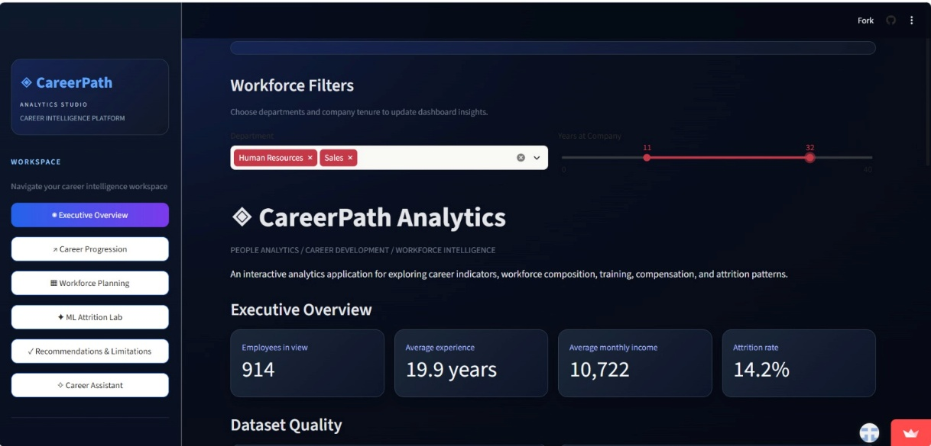
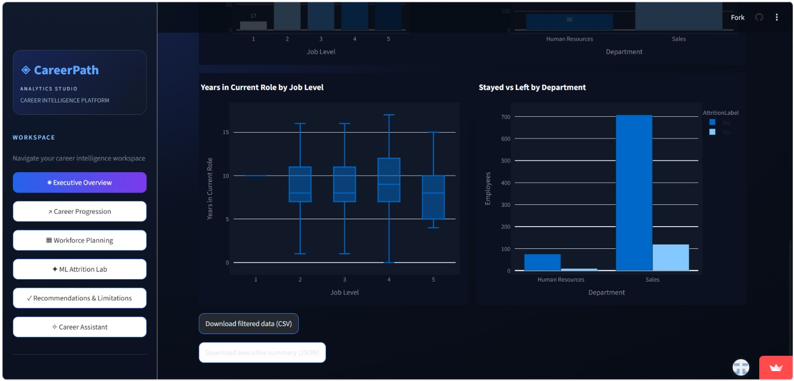
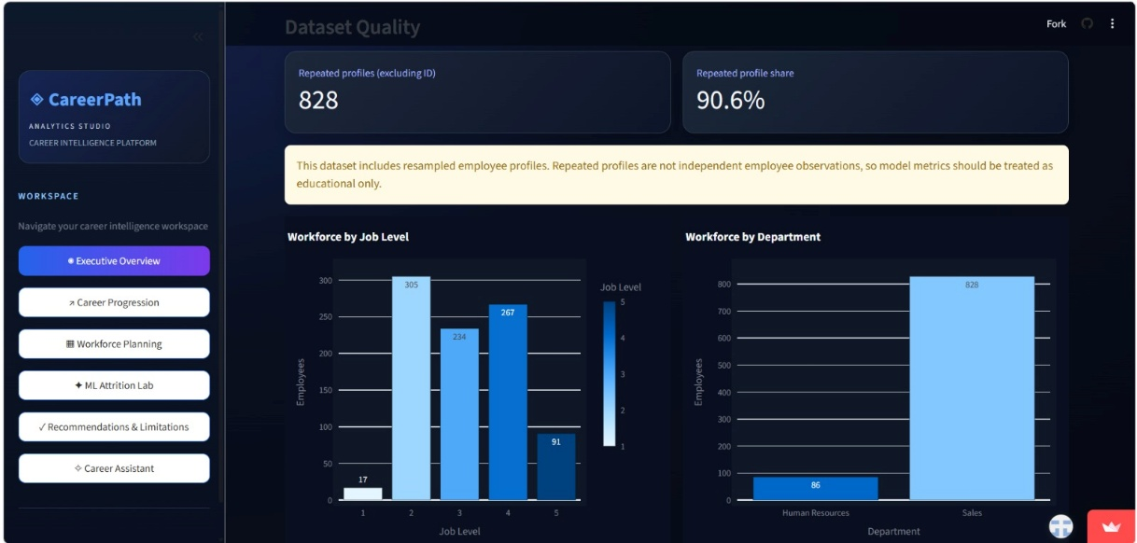
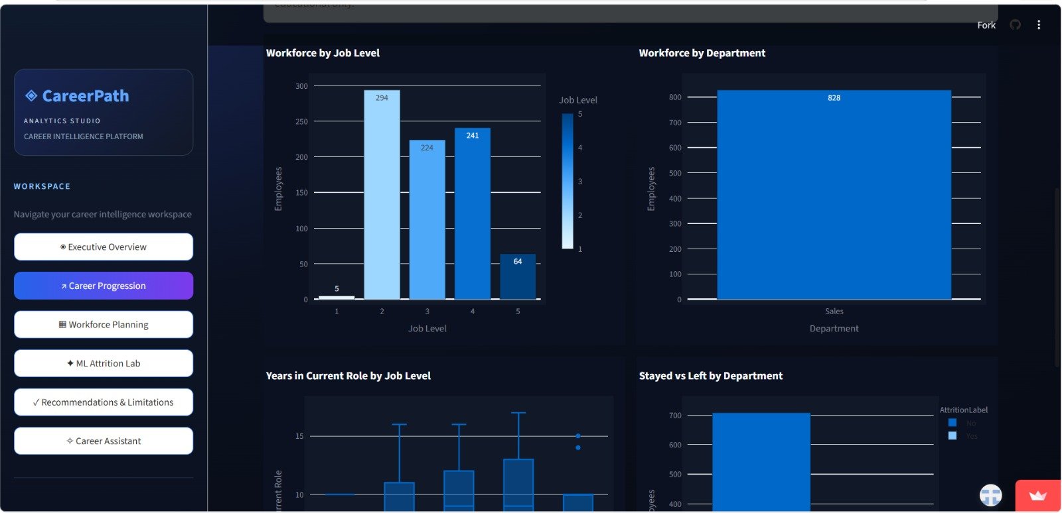
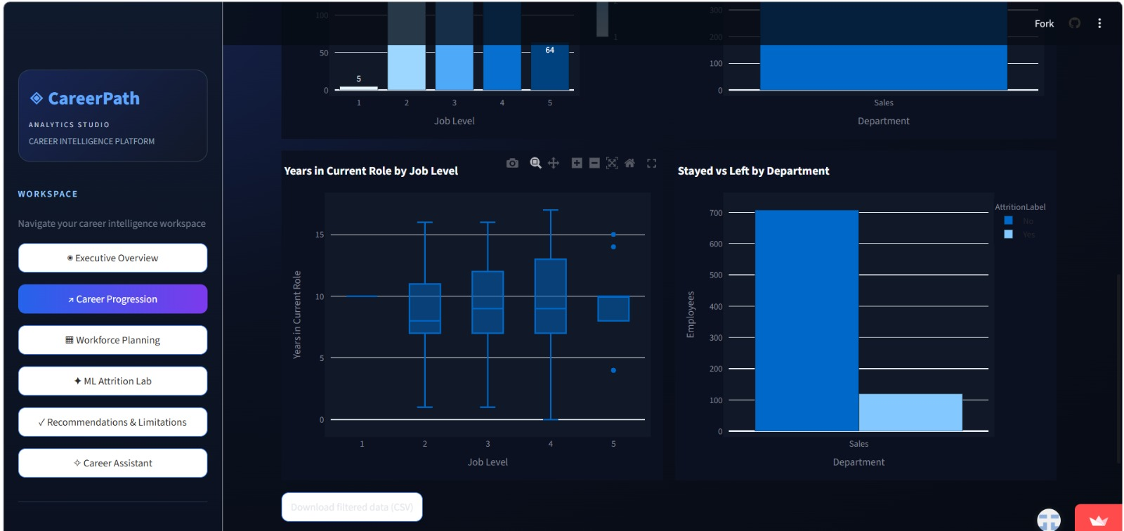
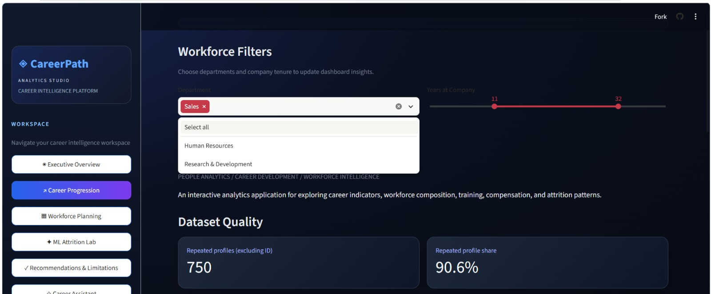
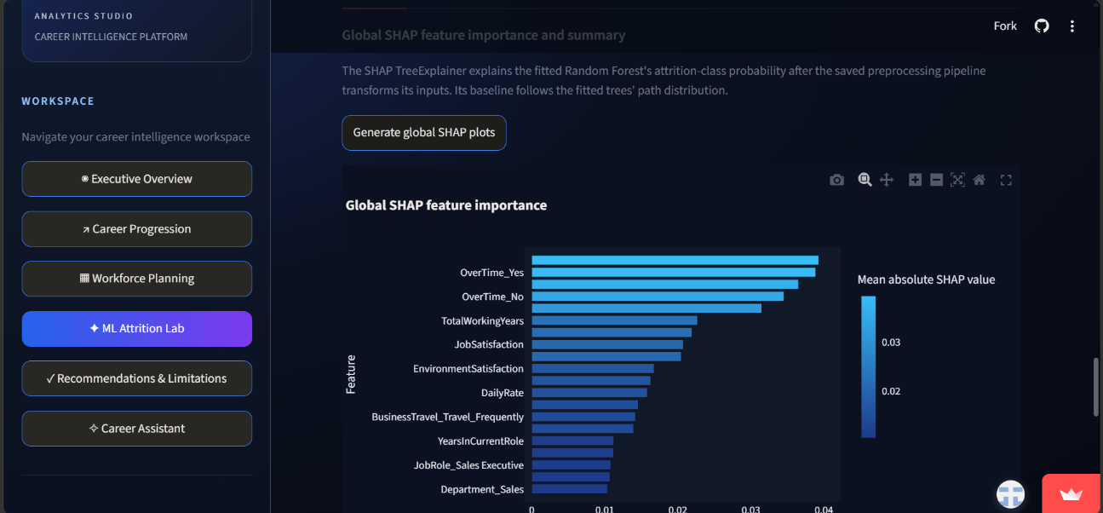
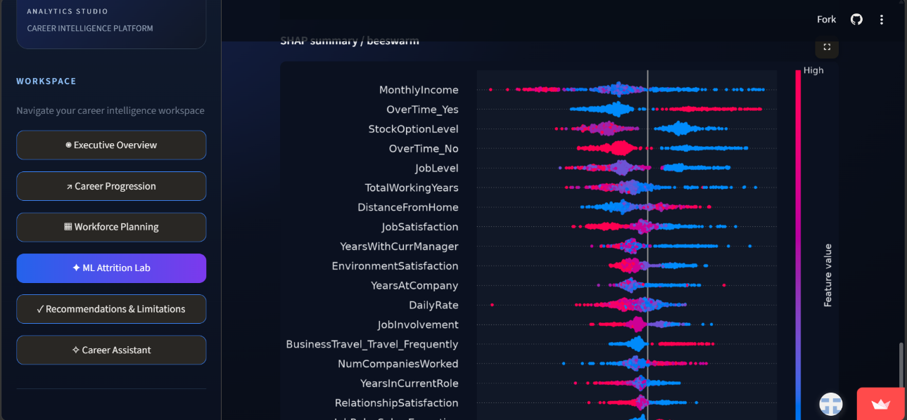
DATA ANALYTICS | MACHINE LEARNING | WORKFORCE INSIGHTS

