Infosys Springboard Virtual Internship 6.0 Completion Report

Team Details
Batch Number:13
Start date: 2 FEB 2026
Names: KANCHUMARTHI SAI SRI VALLABHA , Sathvik, Priya, Saranya, Nithiya, Bhavana, Naveen, Kalash, Anjali, Seema, Sushmitha, Vishveswara.
Internship Duration: 8 Weeks

1. Project Title
Online Product Price Intelligence System.

2. Project Objective
The project aimed to develop a centralized intelligence platform that aggregates real-time pricing data from multiple e-commerce giants (Amazon, Walmart, Flipkart). The core objective was to empower users with "data-driven purchasing power" by providing automated price comparisons, historical trend analysis, and AI-powered product identification from images.

3. Project description in detail
The system utilizes a modern Full-Stack architecture, leveraging Flask for a high-concurrency backend and React.js for a dynamic frontend.
- Architectural Approach: We implemented a hybrid search engine supporting both semantic text queries and visual input analysis.
- Technology Stack: The UI features a premium Glassmorphism design. The backend integrates SQLAlchemy for relational data persistence, Chart.js for advanced time-series visualization, and a TensorFlow/OpenCV pipeline for localized image preprocessing and object classification.
- Real-World Impact: By mitigating "dynamic pricing fatigue," the tool provides consumers with a systematic advantage. For enterprises, it offers a scalable framework for automated competitive benchmarking and market sentiment analysis.

4. Timeline Overview
Week | Activities Planned | Activities Completed
Week 1 | Requirement analysis and tech stack finalization. | Environment setup (React/Flask)
Week 2 | UI/UX Wireframing and Design System creation. | Developed Glassmorphism Dashboard.
Week 3 | Backend API development and Scraper logic. | Integrated Amazon/Flipkart search logic.
Week 4 | Database Schema design and User Auth. | Implemented SQLAlchemy & Google Auth.
Week 5 | AI Integration: Visual search implementation. | Developed preprocessing & model_integration
Week 6 | Analytics: Historical price charts. | Integrated Chart.js for Market Trends
Week 7 | Refinement: Dark mode and Pagination. | Fixed Dark Mode visibility and Google-style pagination.
Week 8 | Final testing and Documentation. | Milestone 3 completion and GitHub submission.

5a. Key Milestones
Milestone | Description | Date Achieved
Project Kickoff | Project scope and architecture defined. | 02 Feb 2026
Prototype/First Draft | Initial React UI with static search results. | 16 Feb 2026
Mid-Term Review | Working API with live data fetching. | 02 Mar 2026
Final Submission | Full system with AI Visual Search and Dark Mode. | 22 Mar 2026
Presentation | Final project walkthrough and demo. | 30 Mar 2026

5b. Project execution details
The project was executed using an Agile-Scrum methodology, characterized by iterative development cycles and rapid prototyping. The system architecture was strategically partitioned into three specialized layers to ensure modularity and scalability:
- Presentation Layer (Frontend Architecture): Developed using React.js, the interface focuses on a premium Glassmorphism design system. Key execution details included:
  - Adaptive Theme Engine: Engineering a seamless transition between Light and "Deep Space" Dark modes. We implemented a global CSS inheritance reset (* { color: inherit; }) to fix text visibility issues common in standard Bootstrap implementations.
  - Intelligence Dashboard: Creating high-fidelity product cards and interactive market trend charts using Chart.js.
  - UX Navigation: Implementing a custom Google-style pagination system (capped at 5 pages) to handle deep marketplace result counts without cluttering the viewport.
- Intelligence Layer (Backend & AI Logic): Powered by Python Flask, this layer serves as the core processing engine:
  - Neural Visual Search: Integrated a TensorFlow/OpenCV pipeline for product identification. We engineered a multi-tier fallback import logic in app.py to resolve complex module resolution errors within the preprocessing and model_integration scripts.
  - Real-time Aggregator: Developed scraper logic to synchronize live pricing data from Amazon, Walmart, and Flipkart.
  - Performance Optimization: Deployed Flask-Caching to reduce API latency for frequent product queries and implemented secure Google OAuth for user authentication.
- Data Layer (Persistence & Security): Utilized a structured SQLite database managed via SQLAlchemy to ensure data integrity:
  - Intelligence Vaults: Designed relational tables to store user wishlists, allowing for persistent tracking of "high-value targets."
  - Search Audit Trails: Automated the recording of every query and its associated price history, enabling the "Marketplace Analytics" feature.
  - Security: Implemented Werkzeug for password hashing and secure user session management, ensuring that all "Intelligence Vault" data remains private and protected.

6. Snapshots / Screenshot

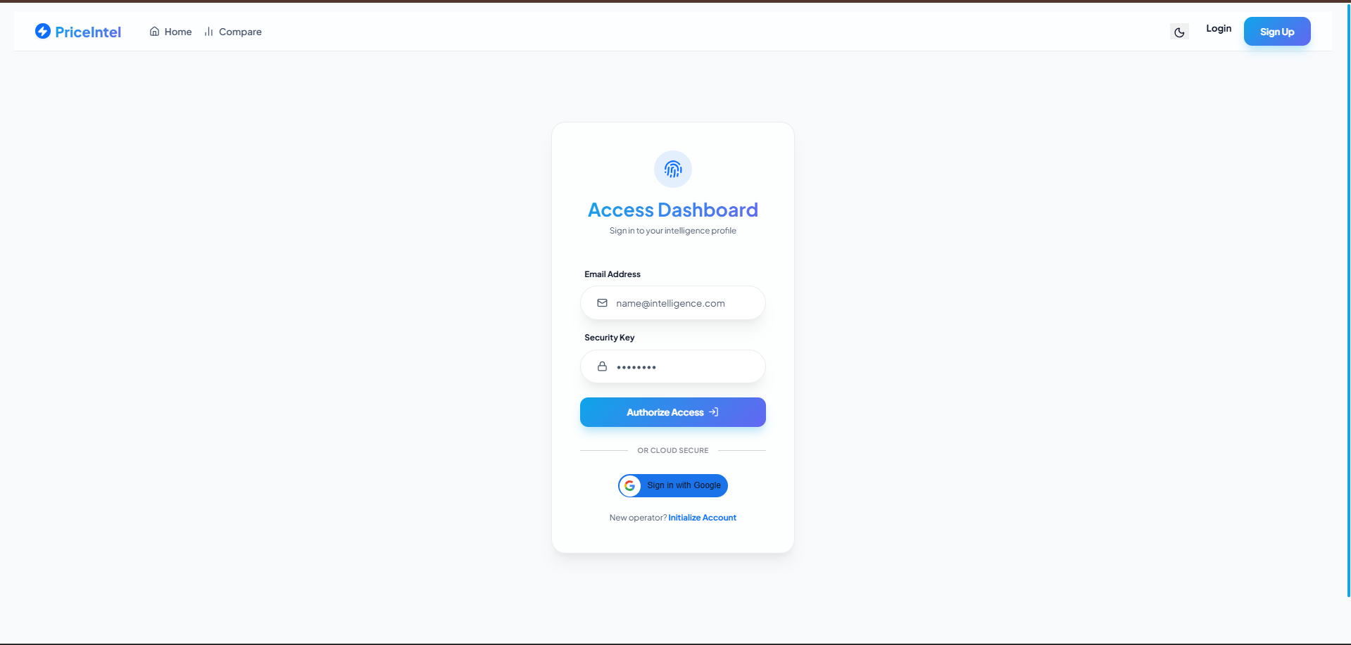
User Authentication Framework (Login )
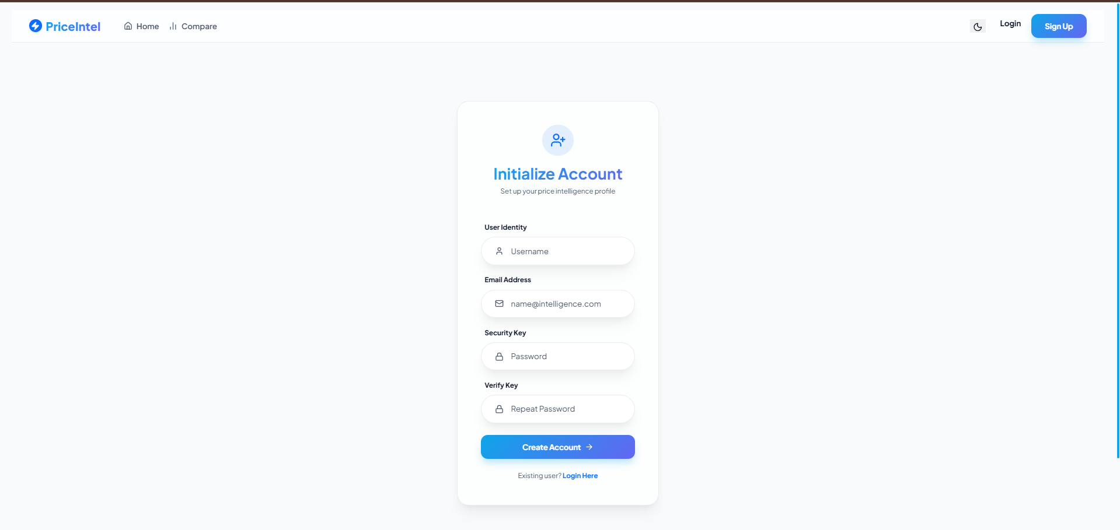
User Authentication Framework (Signup)

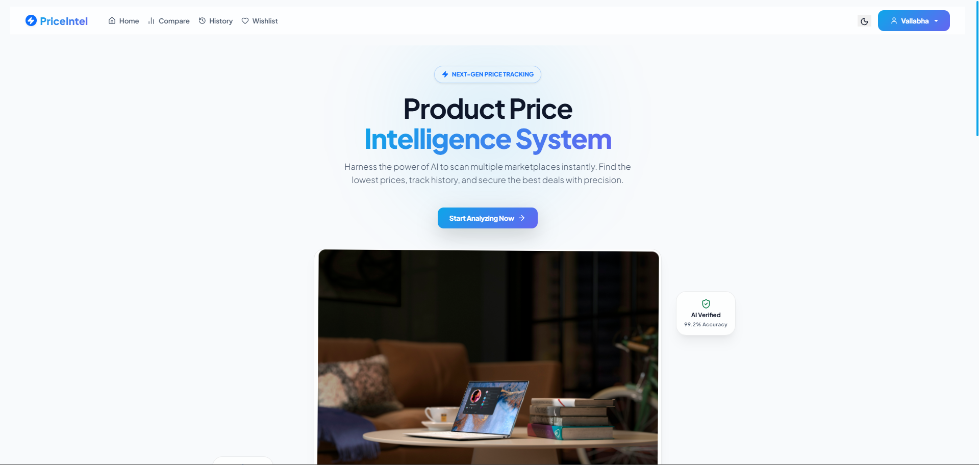
Primary Intelligence Dashboard (Home Page)
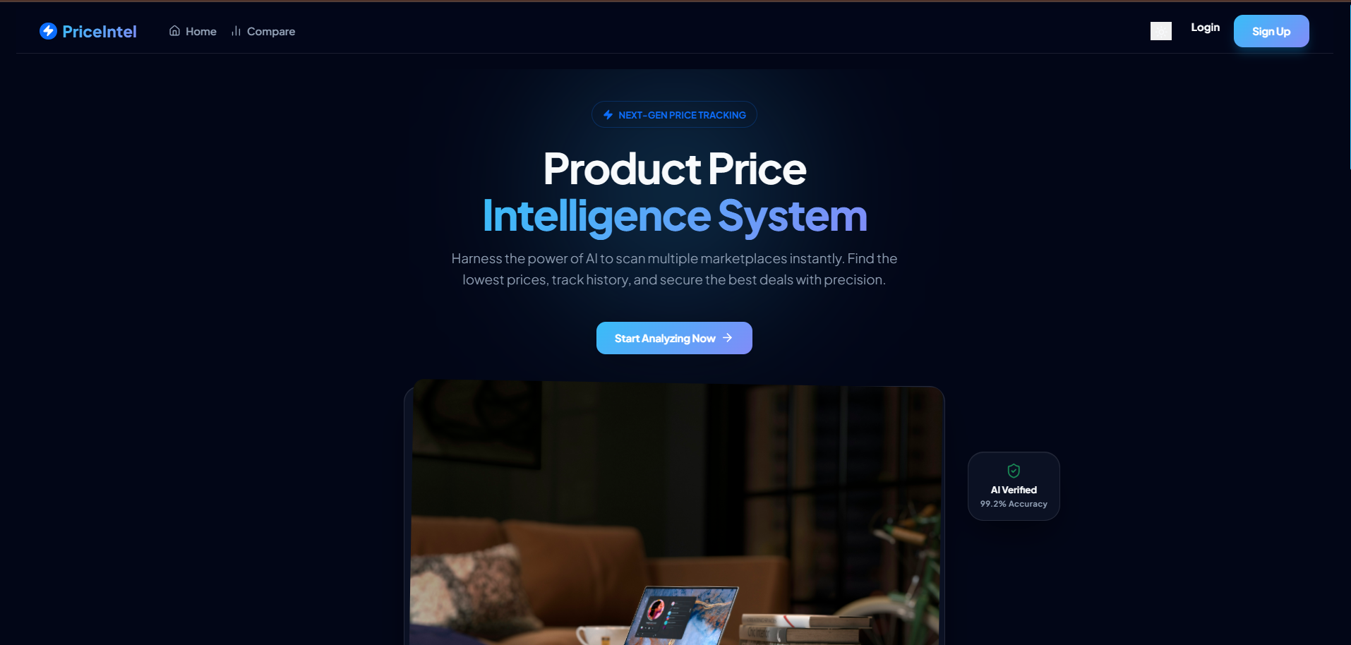
Primary Intelligence Dashboard (Home Page)
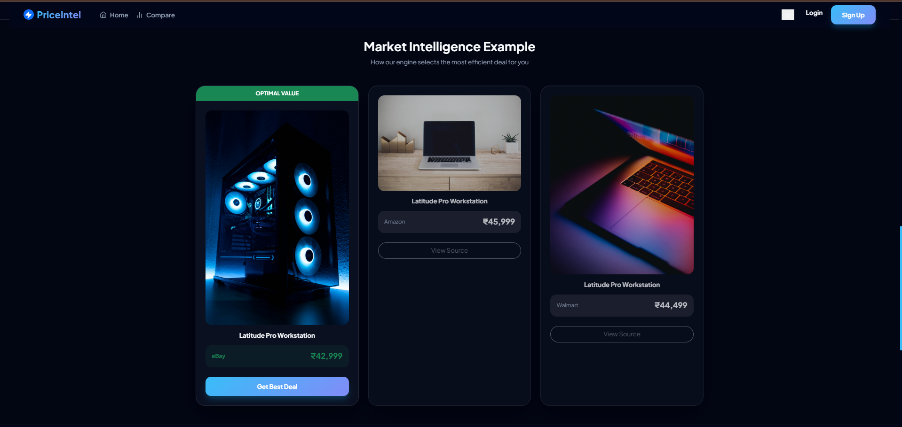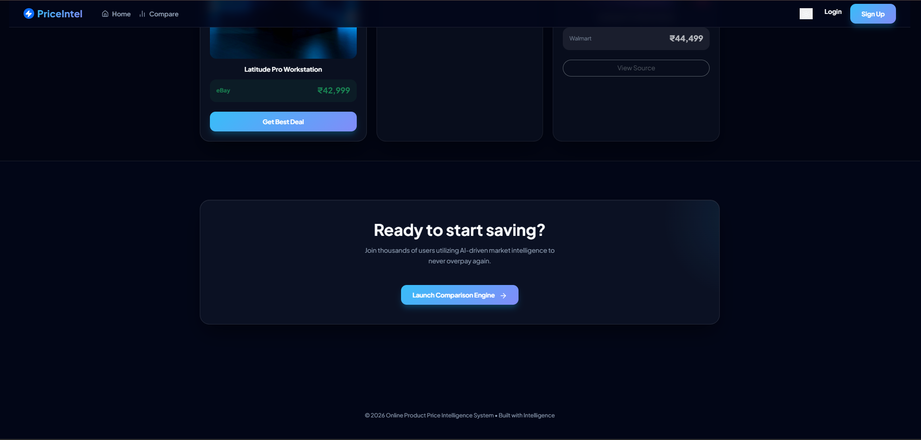

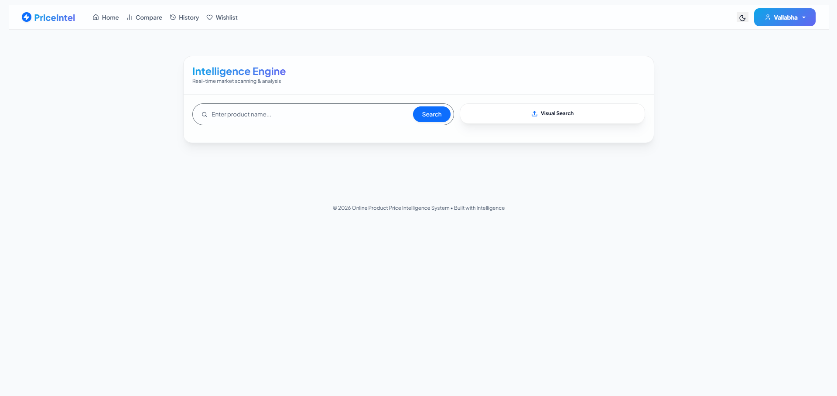
Price Intelligence Comparison Engine (Compare Page)
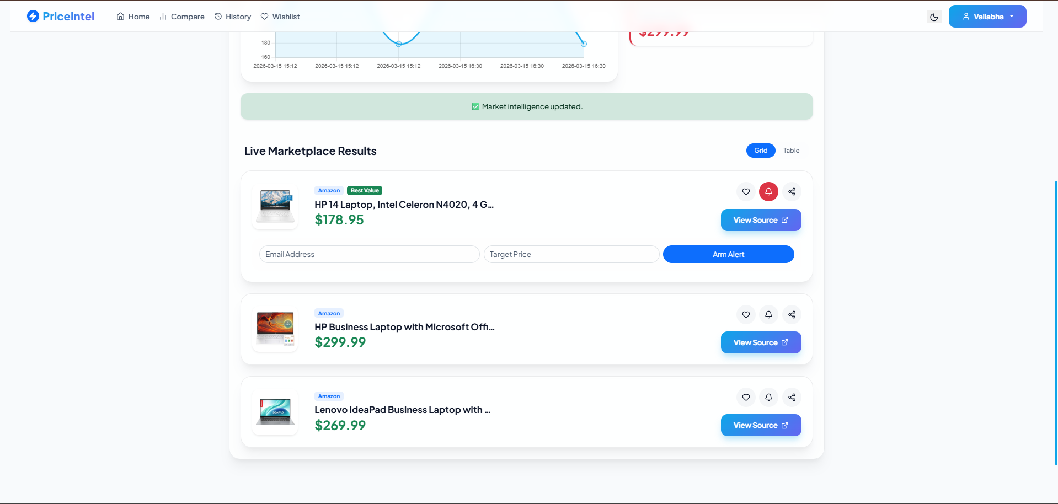
Historical Market Trends (Analytics Dashboard)
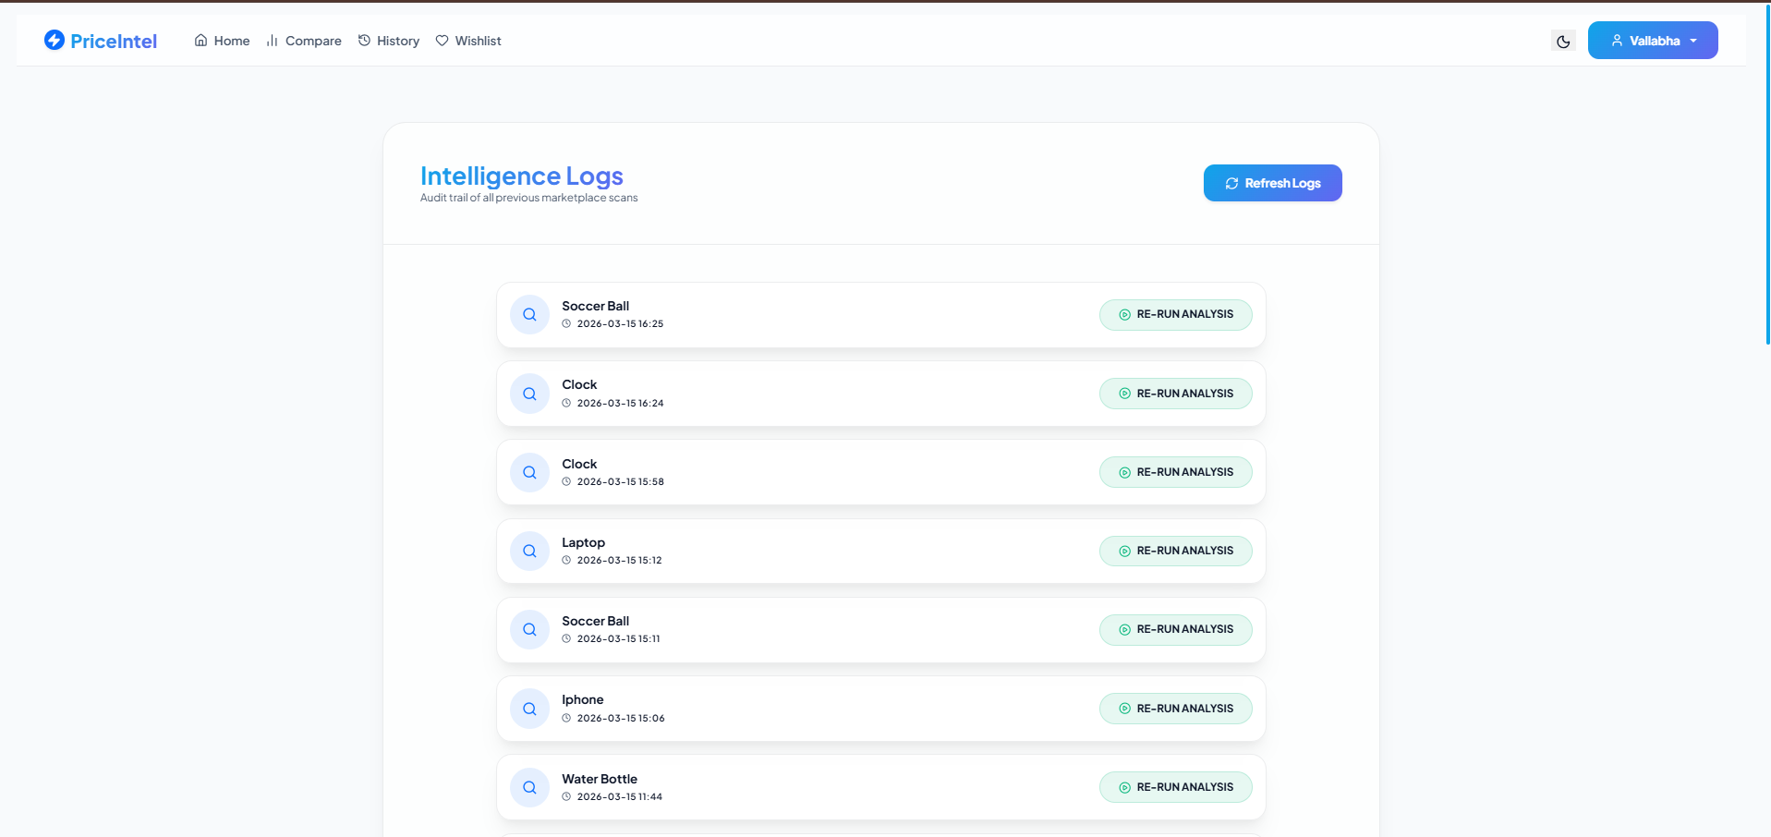
History Page
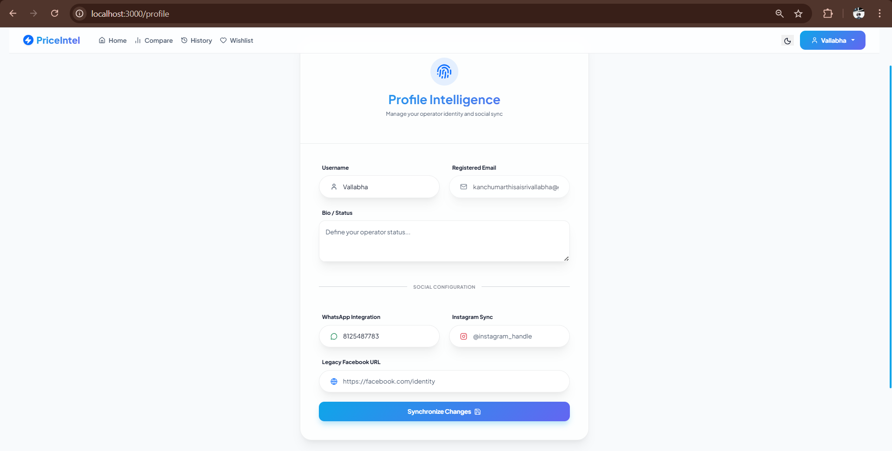
Profile Page
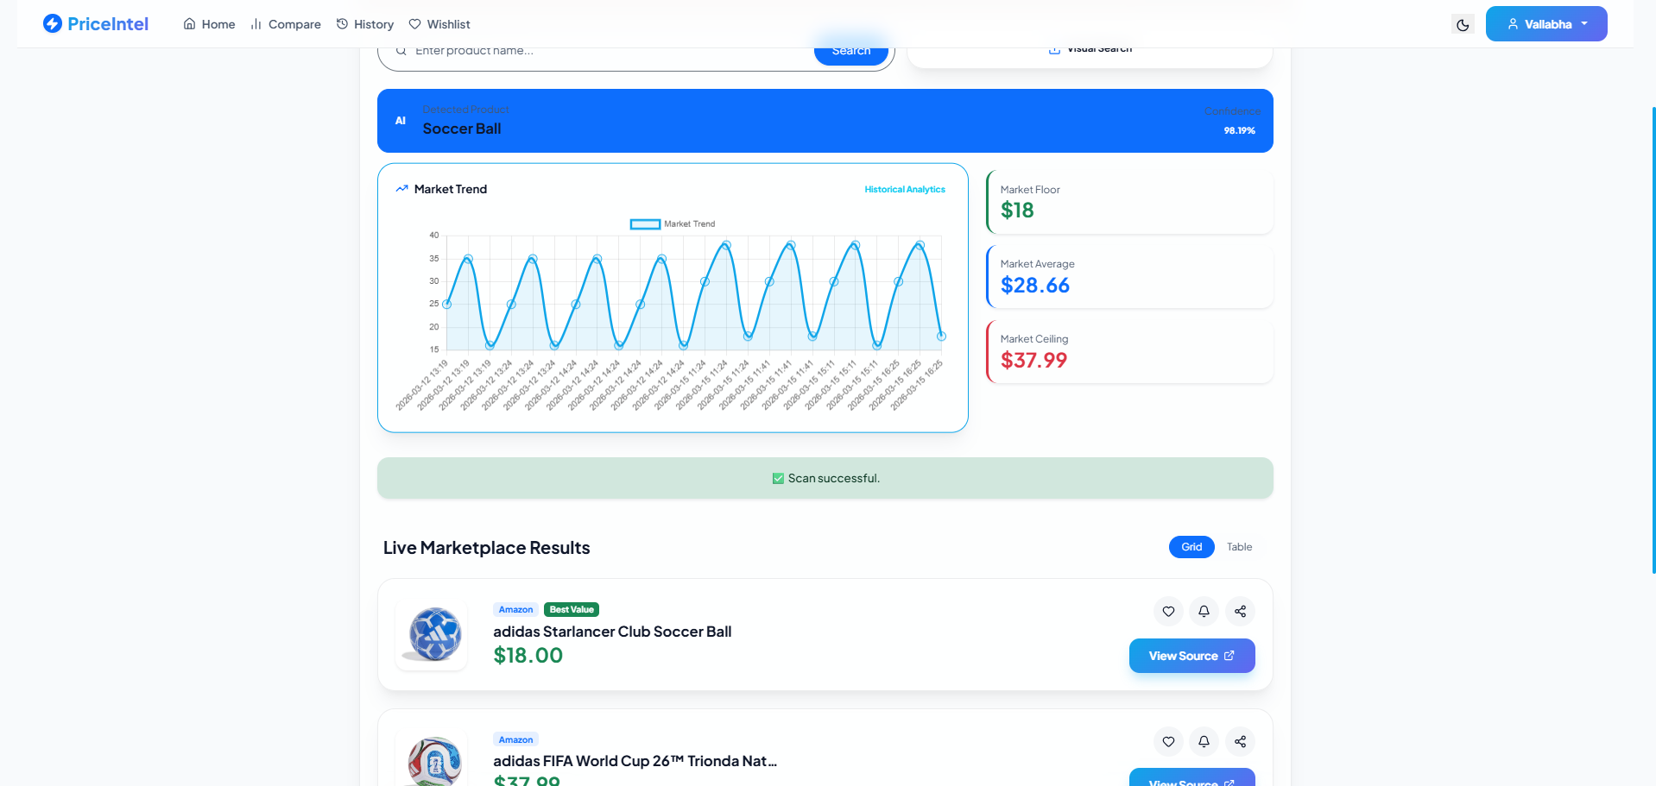
Neural Visual Recognition (Search by Image)

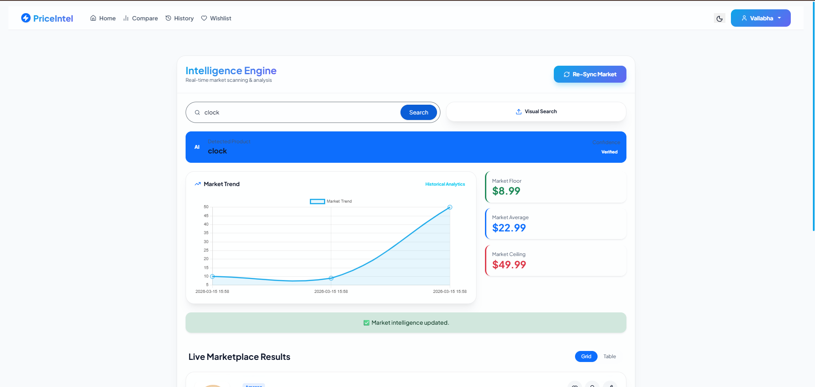 Neural Visual Recognition (Search by Name)

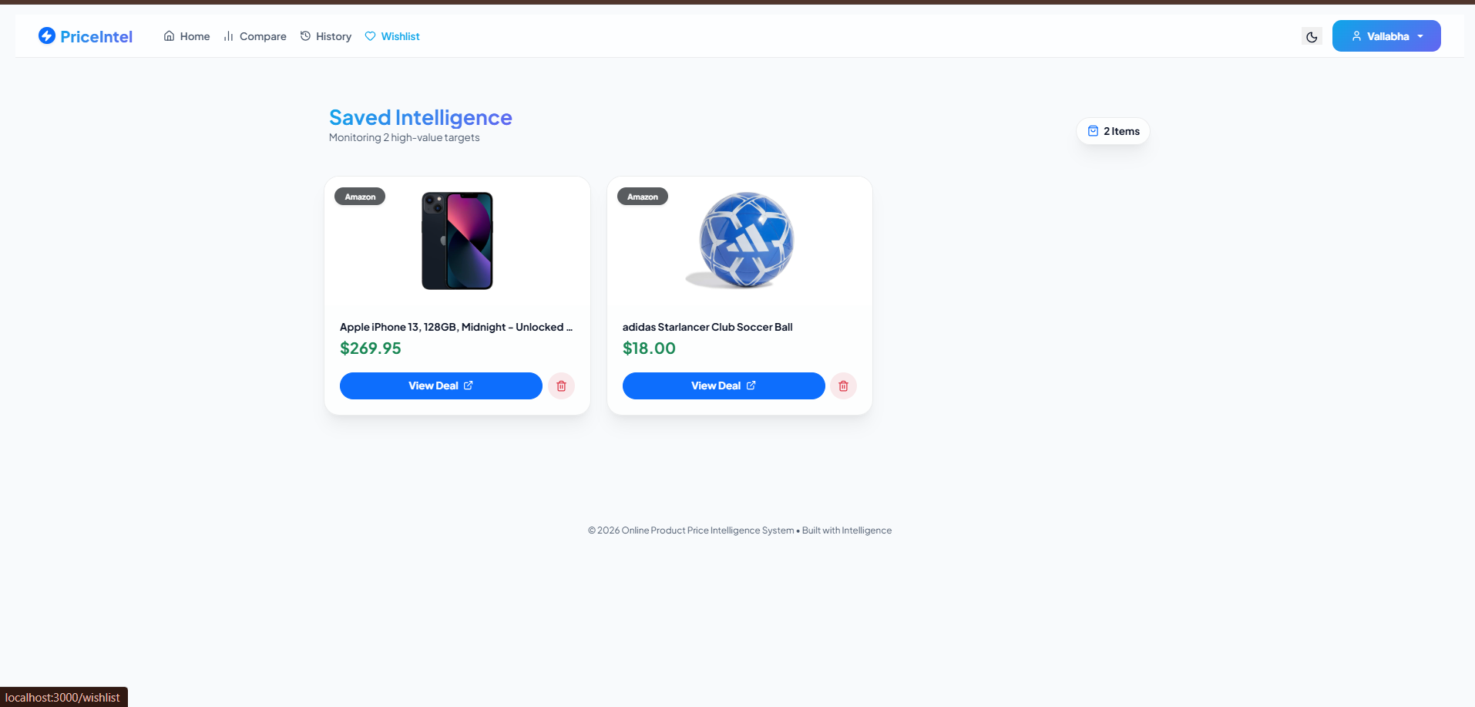
WishList Page

7. Challenges Faced
• Text Visibility in Dark Mode: Standard Bootstrap classes ignored theme variables. Resolution: Implemented a global CSS inheritance reset (* { color: inherit; }).
• Import Errors in Flask: Ambiguity between folder and file names for the preprocessing module. Resolution: Created a multi-tier fallback import logic in app.py.
• Dynamic Data Depth: Handling more than 3 results without cluttering the UI. Resolution: Built a custom "Google-style" pagination system capped at 5 pages.

8. Learnings & Skills Acquired
• Technical: Full-stack development (React/Flask), AI Model Integration, REST API design, and Database normalization.
• Tools: Git/GitHub for version control, VS Code, and Postman for API testing.
• Soft Skills: Problem-solving under technical constraints, documentation, and attention to detail in UI/UX design.

9. Testimonials from team
"This internship allowed me to transition from writing simple scripts to building a complex, production-ready intelligence system. Successfully solving the dark mode visibility and AI import issues was a significant confidence booster." — K.S.S. Vallabha

10. Conclusion
The Infosys Springboard Virtual Internship 6.0 has been a transformative milestone in my journey as a computer science student. Developing the Online Product Price Intelligence System provided me with a hands-on opportunity to tackle real-world software engineering challenges—specifically in merging Full-Stack development with AI-driven automation.
Impact and Experience: The project had a significant impact on my technical proficiency. Moving beyond basic coding, I learned how to manage a professional project lifecycle, including environment configuration, database normalization, and premium UI/UX design using Glassmorphism. Successfully resolving critical issues, such as dark mode visibility resets and complex Python module imports, strengthened my diagnostic skills and technical resilience.
Alignment with Goals: This experience directly aligns with my career goal of becoming a Full-Stack AI Engineer. By integrating TensorFlow-based visual recognition with a React-Flask architecture, I have gained a practical understanding of how to build intelligence-driven applications. The internship has not only bolstered my academic foundation in computer science but has also equipped me with the industry-relevant skills necessary to contribute to high-impact software projects in the future.

11. Acknowledgements
We express our sincere gratitude to Infosys Springboard for designing and hosting the Virtual Internship 6.0 programme and for providing a structured, industry-aligned learning environment. The clear milestone framework, curated task breakdowns, and comprehensive access to learning resources made this internship an exceptionally productive and transformative experience.
We extend our deepest appreciation to our mentors and programme coordinators for their strategic guidance throughout the eight-week duration. Their prompt feedback during milestone reviews and their technical encouragement whenever the team encountered challenges—such as AI module resolution and theme-aware UI scaling—were instrumental. Their expertise helped us navigate complex architectural problems and deliver a high-quality, production-ready final product.
Finally, we thank all team members of Batch 13 for their unwavering dedication, collaborative spirit, and commitment to delivering every milestone on schedule. This project was a true collective effort and stands as a testament to what can be achieved through focused collaboration, technical synergy, and a commitment to continuous learning.
.

