AWS VPC

AWS provides 1 VPC by default in each region. This VPC is having a default Internet Gateway, a Route Table, which contains a Route from everywhere i.e., 0.0.0.0/0 to the default Internet Gateway and Subnets for each availability zone associated with it. So, for creating our own VPC we need to take following steps.

step 1: Go to VPC Dashboard from AWS console by search for VPC and hit Enter.

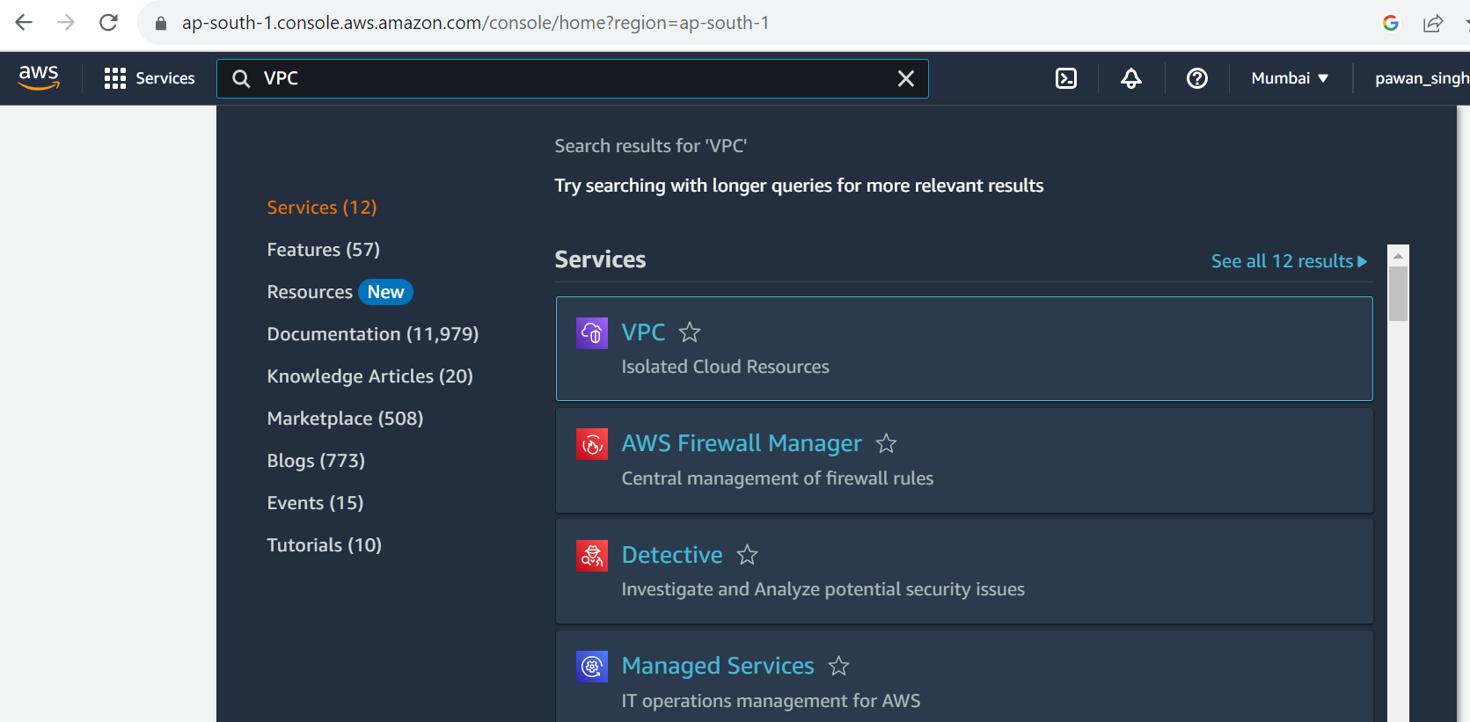

This will take you to the VPN Dashboard.

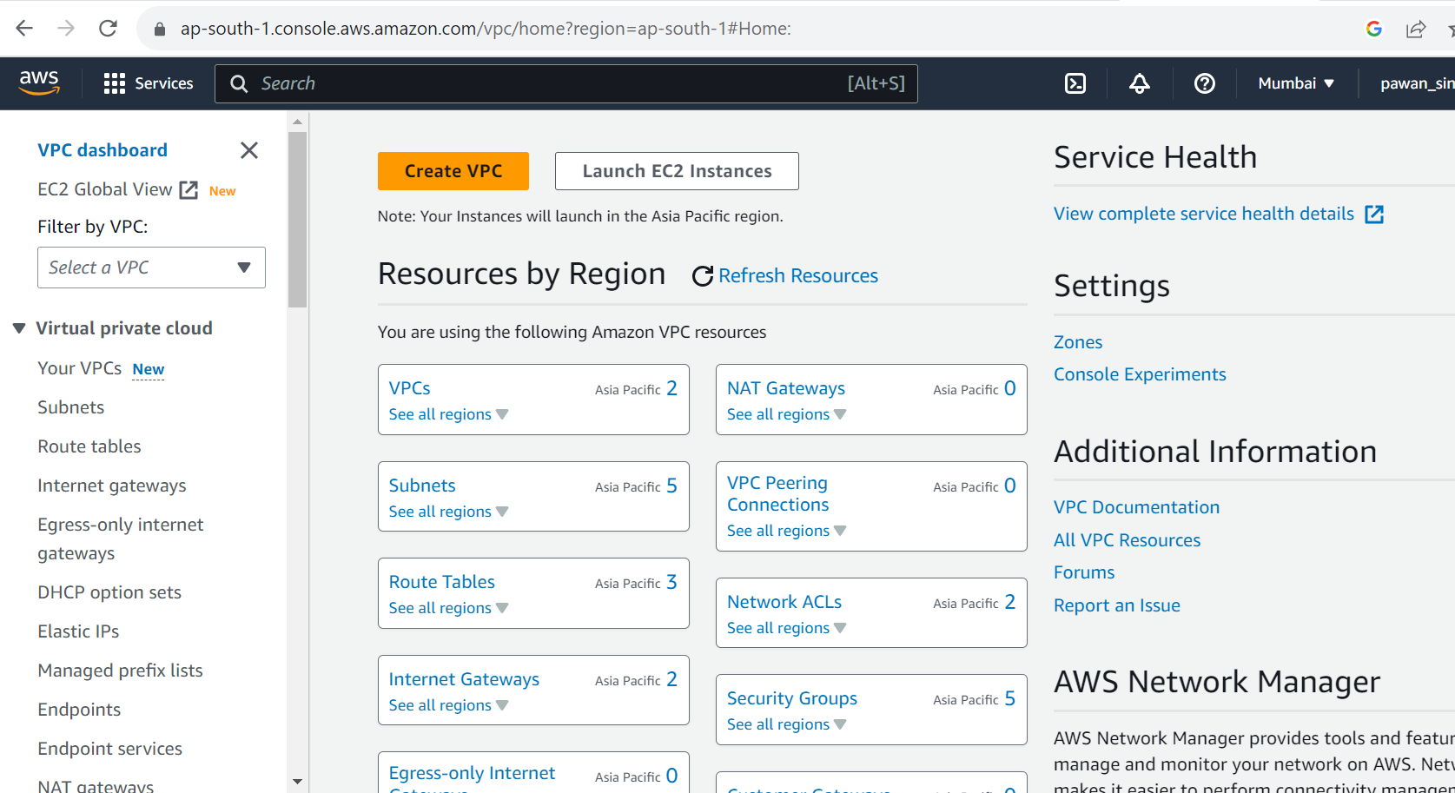

step 2: Now click "Create VPC" and will land to following page-

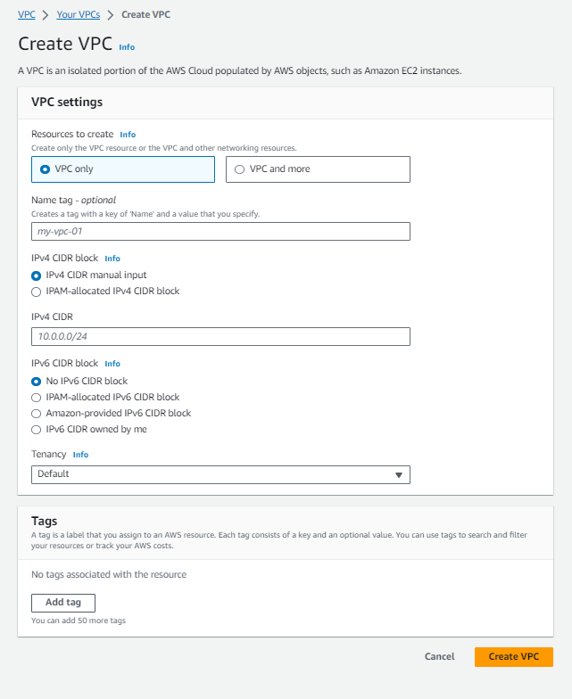

step 3: choose a name to VPC e.g. - "my-VPC"

step 4: choose a starting IPv4 and the range by giving CIDR. e.g.-

10.0.0.0/18

step 5: then hit create VPC.

Note- There is another option/Tab ‘VPN and more’ besides ‘VPN only’, which looks like with a preview-

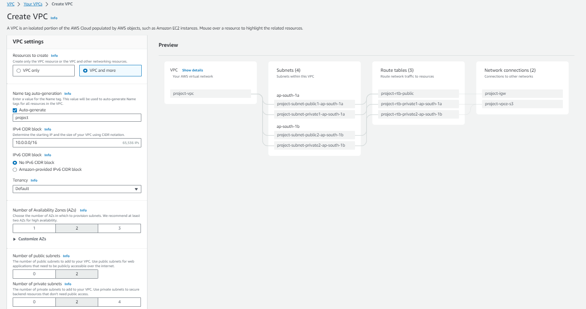

This will create your VPC, along with the main route table for it. Now we'll create as many subnets as we need under our VPC. So next we'll choose subnet from the left side pane, and follow the steps below to create subnets. The page looks like as follows-

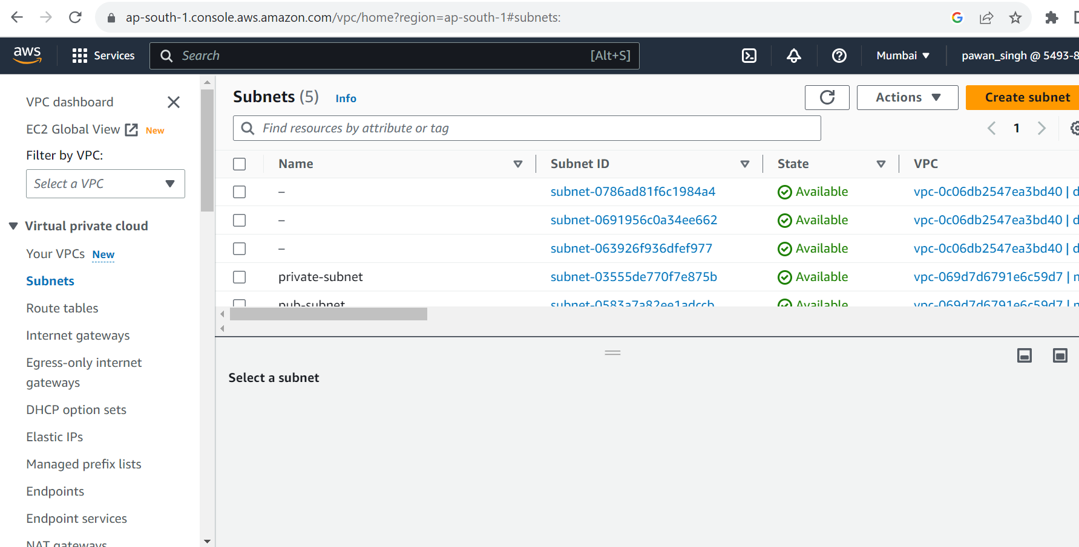

* click Create subnet.

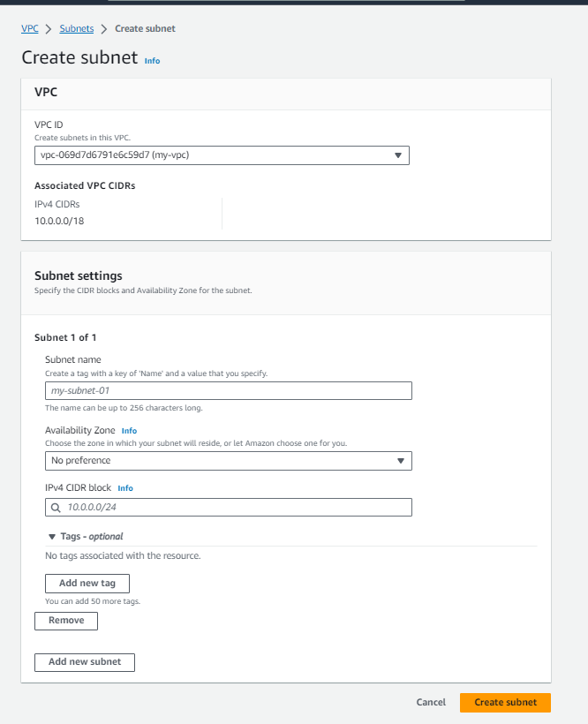

* choose your VPC from the drop-down. e.g.- "my-VPC"
* give your subnet name-space e.g., public-subnet
* give IPV4 range e.g. - 10.0.0.0/22
* choose availability Zone (this is optional)
* Hit ‘Create Subnet’.

Hence, we are done with subnets, we need to make the subnets work accordingly as Public/Private. So, for public subnets we need a public Route table and same for private, but the route table for public subnets must have a Route to Internet Gateway. So, we need an Internet Gateway too.

So next we'll choose Internet Gateways from the left side pane, and follow the steps below to create Internet Gateways.

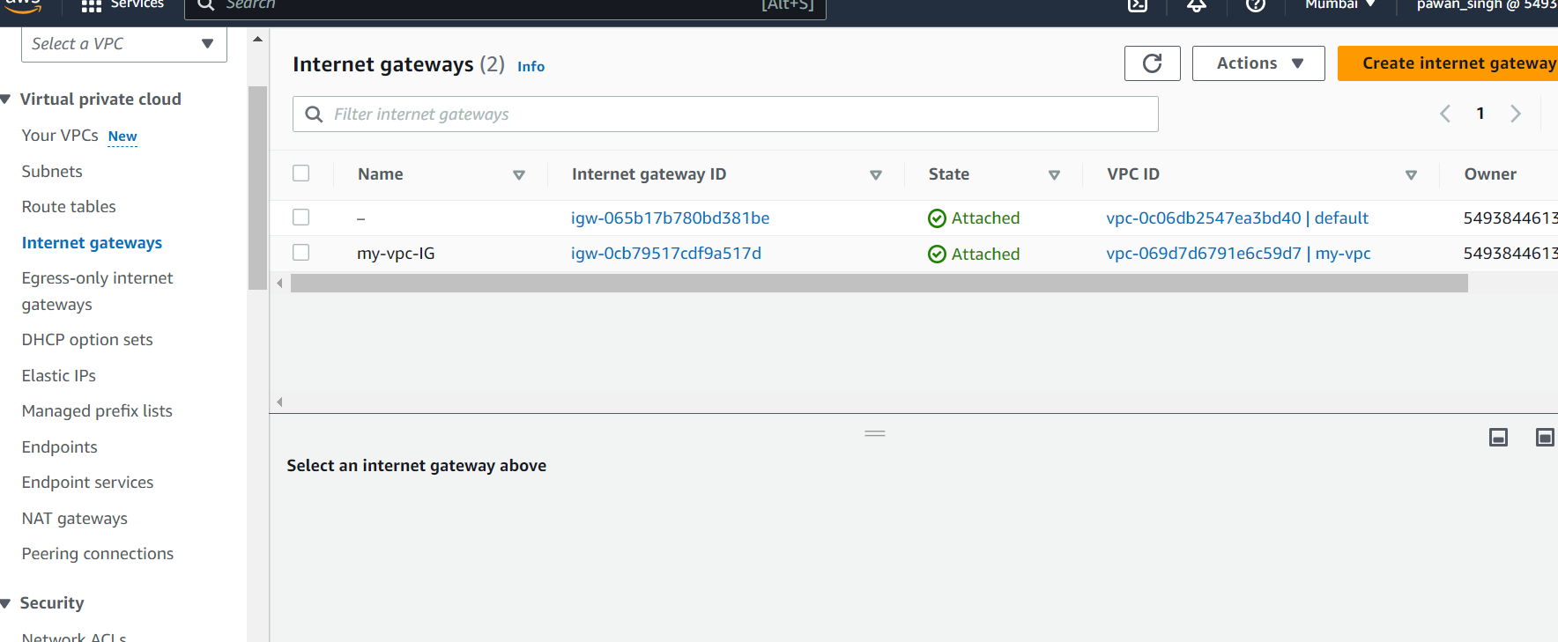

* Click ‘Create Internet Gateway’.

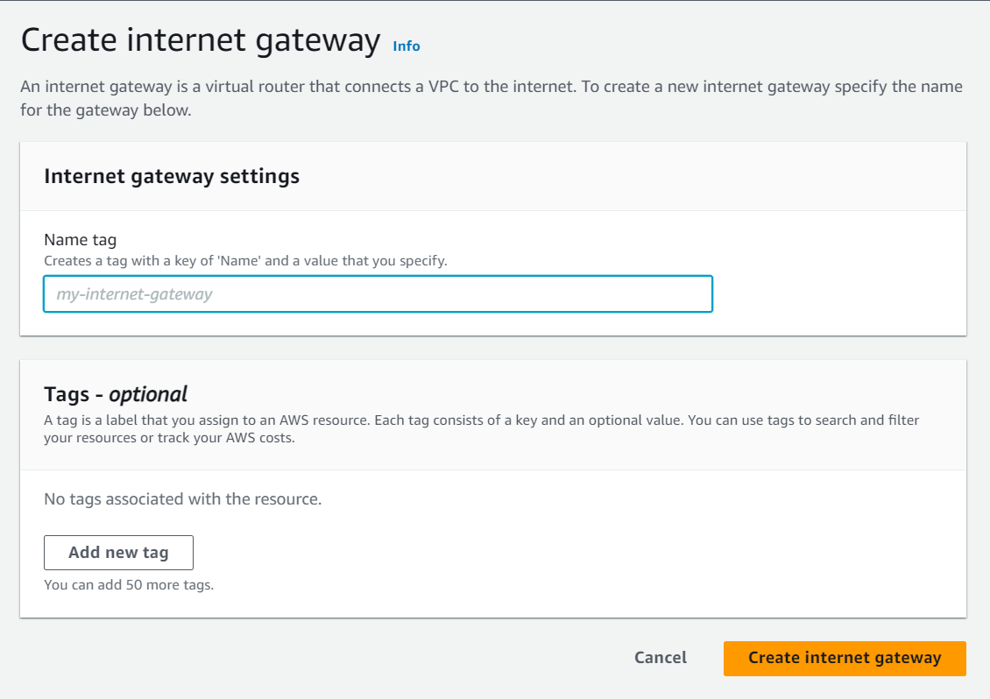

* give a name to your Internet Gateway e.g., “my-IG”.
* Hit ‘Create internet Gateway’.
* Now, attach the Gateway with your VPC from the drop-down. e.g.- "my-VPC"

Once, Gateway is created, we should focus on creating Route table for Public and Private. So here we use main Route table of our VPC as a public Route-table and for private will create a new one. So, we'll choose ‘Routes’ from the left side pane, and follow the steps below to create Route table.

Find the Route table from left navigation pane as-

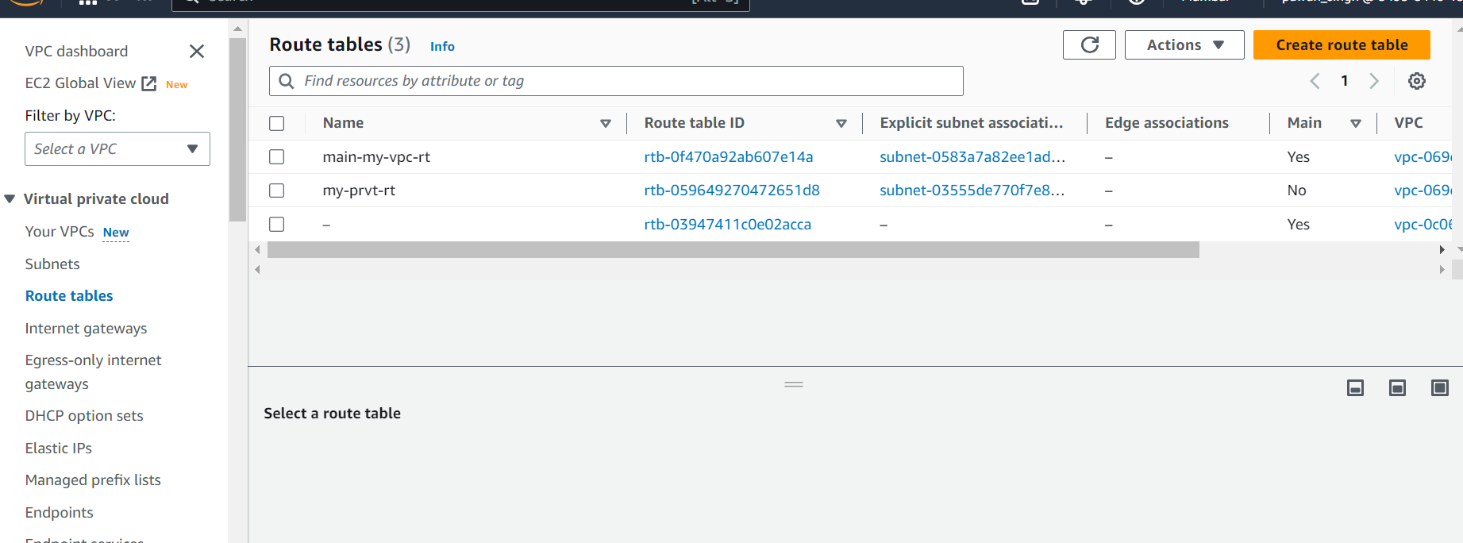

* click Create Route table.

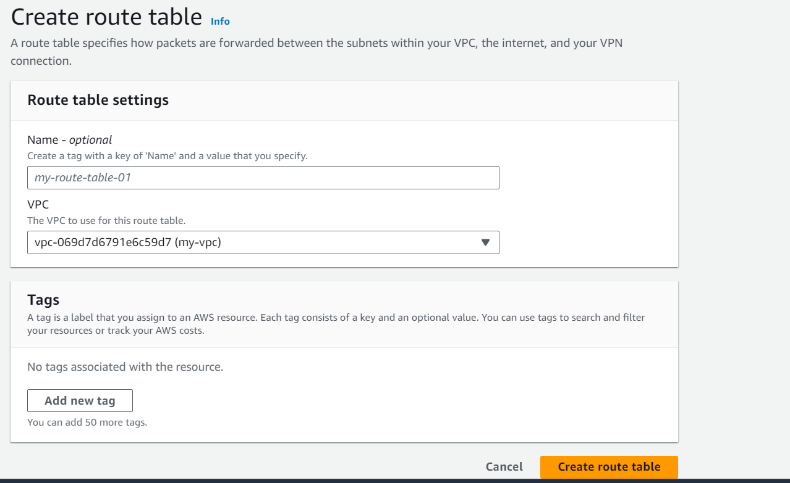

* give a name to your Route-table e.g., “my-private-rt”
* choose your VPC from the drop-down. e.g.- "my-VPC"
* Hit ‘Create Route Table’

So, now we are having our private route table. We will use the main route table as a public route table, but before that we need to add a route as traffic from everywhere (0.0.0.0/0) to our Internet Gateway (my-IG). So, lets add that Route to the main route table-

* Select the main route table associated with ‘my-VPC’ by default.
* From the bottom properties pane select Routes tab.
* Then hit ‘Edit Routes’.
* Add Routes
* Under destination put everywhere i.e. – 0.0.0.0/0 and under target select the Gateway you have created.
* Save the changes.

Now this route table becomes, public route table. Now associate all public Subnets to this route. We can do this by following.

* Select the main route table associated with ‘my-VPC’ by default.

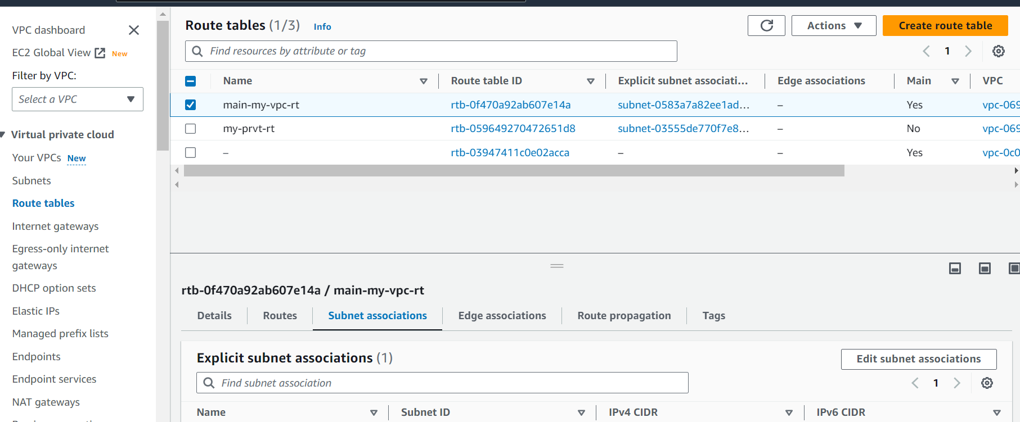

* From the bottom properties pane select ‘Subnet Association’ tab.
* Then hit ‘Edit Subnet Association’

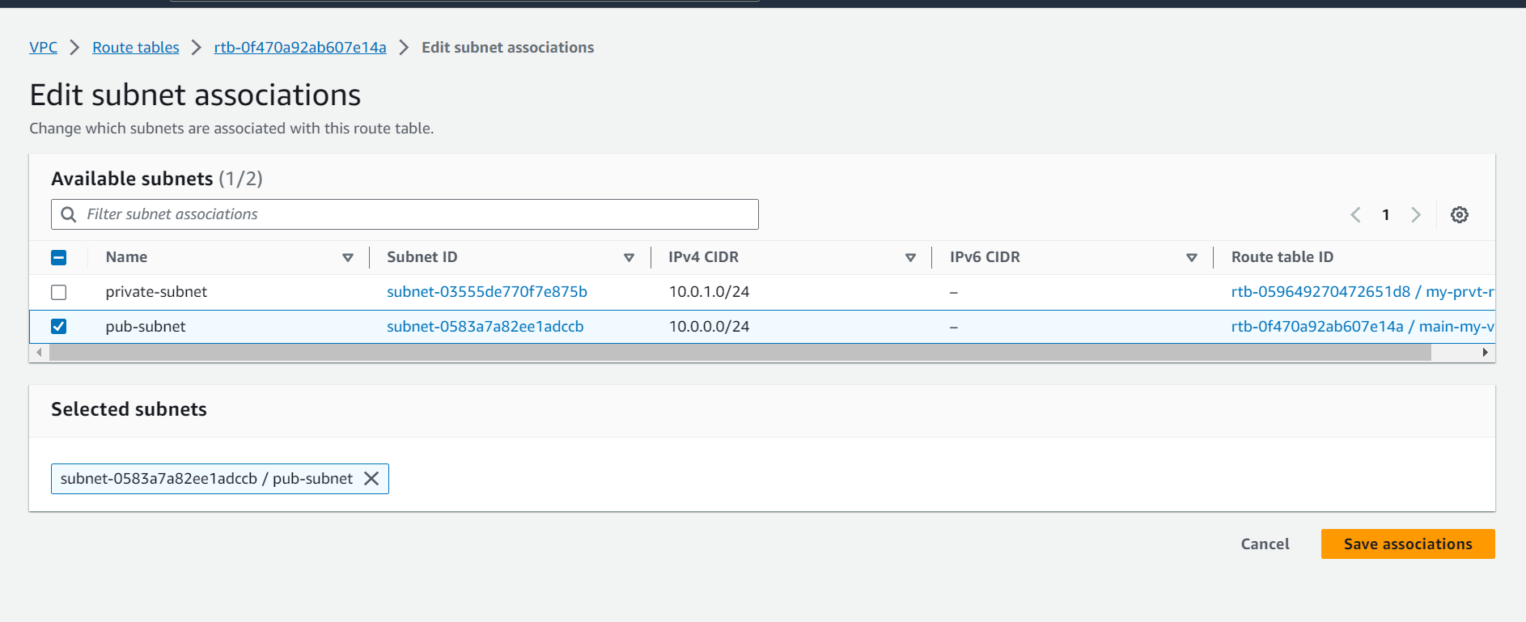

* Select the all-Public Subnet and associate with Public Route table.
* Save the changes.

Similarly, now we’ll associate all private subnets to private route table i.e. – ‘my-private-rt’.

Finally, we are done with the ‘AWS VPC’ setup. One more optional setting left is ‘NAT Gateways’. This feature requires only if we need outgoing traffic to Internet from our Private subnets.

Finally, we are done with creating and configuring our VPC and subnets.