Ideation Phase

Brainstorm & idea prioritization
Date | 8 MARCH 2026
Team ID | 69a59d1dd4127454df34c9bf
Team Name | Team 2
Project Name | Automating Employee Data
maximum | 4 Mark
The Ideation Phase is an important stage in the project development process where different ideas and possible solutions are generated to address a problem. The main objective of this phase is to explore creative solutions and select the most suitable idea that can effectively solve the identified problem.
For the project “Automating Employee Data using ServiceNow”, the ideation phase focuses on identifying ways to improve the efficiency of employee data management. In many organizations, employee information is managed manually using spreadsheets or separate systems. This manual process can lead to problems such as data duplication, human errors, delayed updates, and difficulty in tracking employee records.
To overcome these challenges, an automated solution is proposed using the ServiceNow platform. ServiceNow provides tools such as forms, tables, workflows, and service portals that help automate processes and manage data efficiently.
The ideation phase of this project consists of two main activities:
- Brainstorming
- Idea Prioritization

1. Brainstorming
Brainstorming is a creative process used to generate a large number of ideas for solving a problem. During brainstorming, multiple solutions are discussed without immediately judging their feasibility. The goal is to encourage innovative thinking and explore different approaches to improve the current system.
For the Automating Employee Data project, brainstorming helped identify several ways to automate employee information management within the ServiceNow platform.

Brainstorming Mind Map
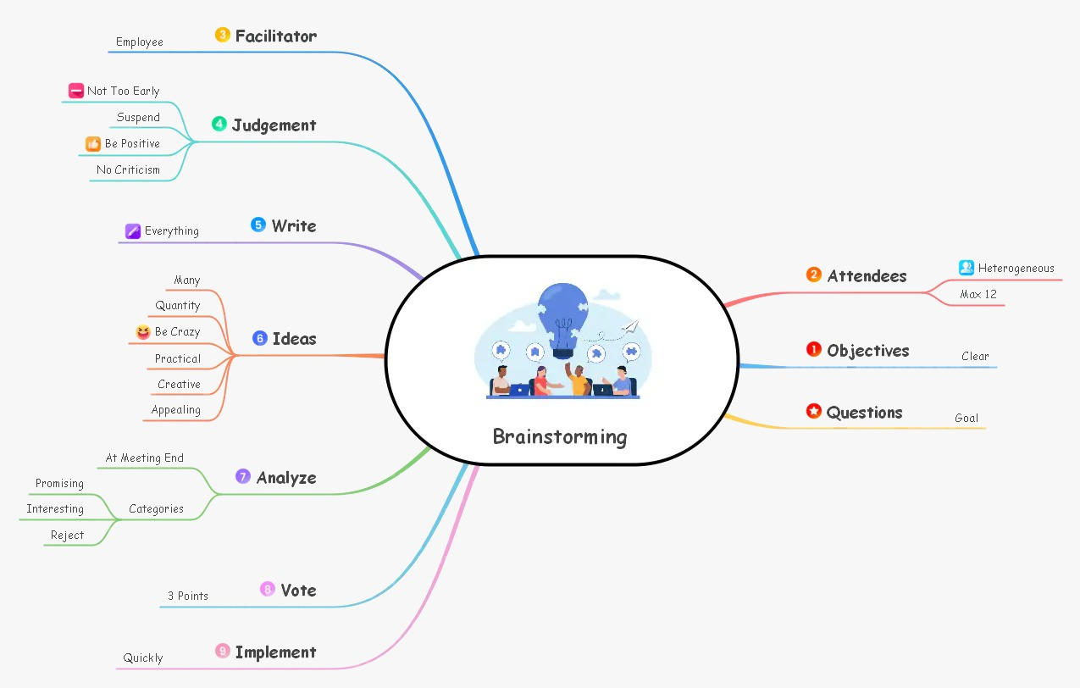
The above diagram represents a mind map used during brainstorming. A mind map visually organizes ideas around a central concept. In this case, the central idea is Automating Employee Data, and various possible solutions branch out from it. Mind mapping helps organize thoughts and identify relationships between different ideas.

Ideas Generated During Brainstorming

1. Employee Data Management Portal
One of the primary ideas generated was to develop an Employee Data Management Portal within ServiceNow. This portal would allow employees to log in and update their personal information such as:
- Address
- Contact details
- Emergency contacts
- Bank information
Instead of manually sending requests to HR, employees can submit update requests through a digital form. The system will store data in a centralized database and notify HR for verification if required.
Benefits:
- Reduces manual work for HR
- Improves data accuracy
- Allows employees to update their own information

2. Automated Employee Onboarding
Another idea developed during brainstorming was to automate the employee onboarding process.Currently, HR teams manually create employee records and assign departments when a new employee joins the company. With ServiceNow automation, a workflow can automatically:

- Create employee records
- Assign department details
- Generate employee ID
- Send notifications to HR and IT teams
This ensures that all onboarding steps are completed systematically and reduces administrative workload.

3. Employee Data Update Workflow
The third idea was to implement an automated employee data update workflow. Employees often need to update information such as phone numbers, addresses, or bank details.
In this solution:
- The employee submits a request through a ServiceNow form.
- The request is automatically sent to the HR department.
- HR reviews and approves the request.
- The employee record is automatically updated.
This process ensures proper authorization and tracking of employee data changes.

4. Employee Record Validation System
Another idea discussed was the implementation of an employee record validation system.
This system would automatically check whether required fields in employee records are filled correctly. For example:
- Employee ID
- Email address
- Department
- Contact number
If any mandatory information is missing, the system will generate alerts for HR to update the record.
This feature improves data quality and ensures that employee records remain accurate.

5. Employee Exit Process Automation
The final idea generated during brainstorming was automating the employee exit process.When an employee leaves the organization, several actions must be completed, such as updating employee status and notifying different departments.
Using ServiceNow automation, the system can:
- Update employee status to inactive
- Notify HR and IT teams
- Record exit details automatically
This helps ensure a smooth and secure exit process.

2. Idea Prioritization
After generating multiple ideas during brainstorming, the next step is idea prioritization. This process involves evaluating each idea and selecting the most suitable one for implementation.
The ideas were evaluated based on three important criteria:
- Impact – How much the idea improves employee data management.
- Feasibility – How easily the idea can be implemented using ServiceNow.
- Automation Capability – The ability to reduce manual work through automation.

Idea Prioritization Matrix
A prioritization matrix helps compare ideas based on their impact and feasibility, making it easier to select the best solution.
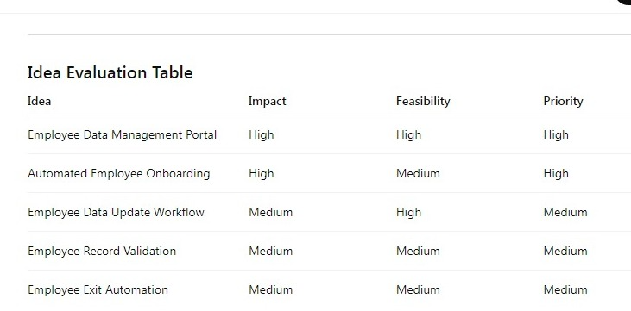
From the analysis, the Employee Data Management Portal was selected as the main focus of the project because it offers the highest impact and is easy to implement using ServiceNow tools such as:
- Tables
- Forms
- Service Portal
- Workflows
- Notifications

Final Selected Idea
Based on the brainstorming and prioritization process, the final idea selected for implementation is Automating Employee Data using a centralized Employee Data Management System in ServiceNow.
This system will allow employees to submit and update their information through a ServiceNow portal, while HR administrators can review and approve requests. Automated workflows will handle notifications, approvals, and record updates.
The proposed system will provide several advantages:
- Reduced manual HR workload
- Improved data accuracy
- Faster employee data updates
- Centralized employee information management

2.Requirement Analysis

1.Data Flow
The Data Flow section describes how information moves through the system from the user to the database and back. In the Automating Employee Data project, data flows between employees, HR administrators, and the ServiceNow platform to ensure accurate and automated record-keeping.

Data Flow Process
- Employee Login
Employees log into the ServiceNow Service Portal using their credentials.
- Submit Data
Employees fill a form to submit new information or update existing personal details, such as address, phone number, emergency contacts, and bank details.
- Request Processing
The system captures the request and forwards it to the HR administrator for verification.
- HR Verification & Approval
HR receives a notification of the request, reviews the submitted information, and approves or rejects it.
- Database Update
Once approved, the employee record in the ServiceNow database is automatically updated.
- Notification to Employee
The employee receives a notification of approval or rejection via email or portal alert.

Data Flow Diagram (DFD)
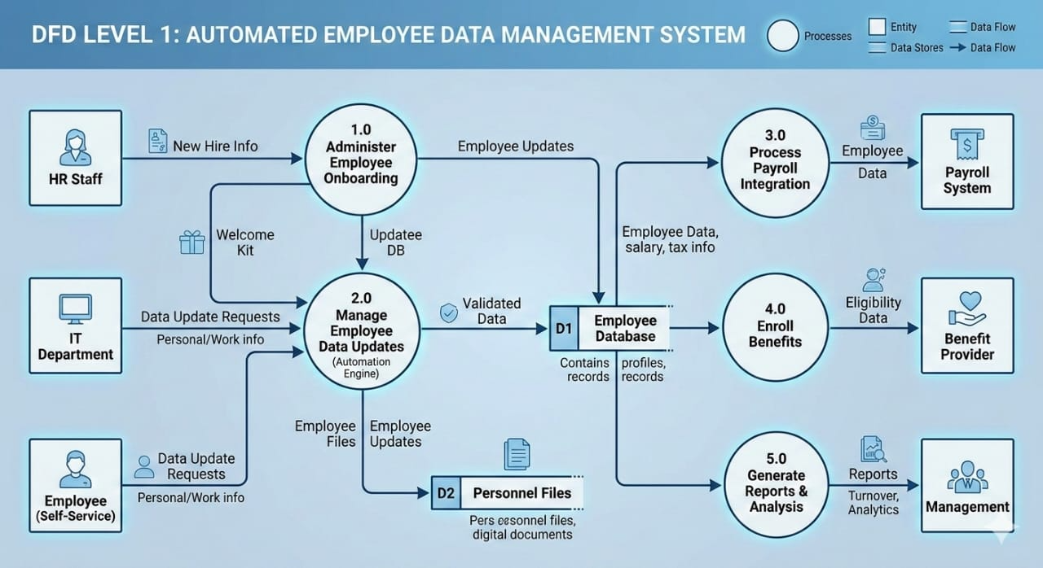
Explanation: This diagram visually represents the flow of employee data from submission to HR approval and final storage. Arrows indicate the direction of data movement.

Description & Benefits
The data flow ensures:
- Centralized Data Management – all employee records are stored in one system.
- Automation – reduces manual HR processes.
- Accuracy – minimizes errors from manual updates.
- Timely Notifications – employees receive instant updates on their requests.
By defining this flow, developers can clearly understand how data should move in the ServiceNow system and what checks and notifications are needed at each step.

2. User Stories
User stories describe what the users need from the system and why. They are critical to understanding system functionality.

Key Users
- Employees – submit and update personal information.
- HR Administrators – verify and approve requests, maintain employee records.

User Stories Table
User | User Story | Acceptance Criteria
Employee | Update personal info | Form submitted successfully; status notified
HR Admin | Approve/Reject updates | Request appears in HR inbox; updated in DB after approval
Employee | View request status | Notification received when approved/rejected
System | Store data | Records saved securely in centralized database
HR Manager | Generate reports | HR can generate employee reports quickly

User Story Diagram
Insert Image Here:
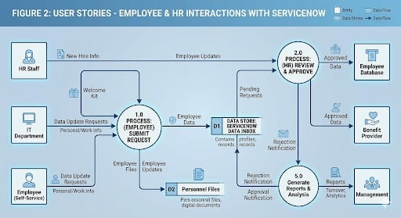

Benefits of User Stories
User stories help:
- Capture real user needs
- Ensure system functionality aligns with HR processes
- Improve project planning and development
- Focus on automation benefits for employees and HR
By following these stories, the ServiceNow system can automate repetitive tasks while improving user experience.

3. Solution Requirements
Solution requirements define what the system must do to meet the project objectives.

Functional Requirements
- Employees can submit/update personal information.
- HR can approve/reject requests.
- System stores all employee information in a centralized database.
- Notifications sent to employees upon approval/rejection.
- HR can access and manage employee records securely.

Non-Functional Requirements
- System must be fast and responsive.
- Interface must be user-friendly and intuitive.
- Data must be secure and compliant with privacy standards.
- System should support scalability for additional users.
- Must ensure reliability with minimal downtime.

Solution Architecture Diagram
Insert Image Here:
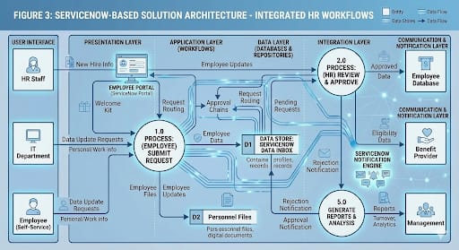

Explanation & Benefits
The solution architecture demonstrates how ServiceNow components integrate:
- Service Portal – front-end interface for employees
- Workflows / Flow Designer – automates HR approval processes
- Database – centralized employee data storage
- Notifications – alerts employees and HR of updates
Benefits:
- Centralizes HR processes
- Reduces manual workload
- Improves data accuracy and accessibility
- Provides clear audit trails
\

4. Technology Stack
The technology stack defines all tools and platforms required to implement the project.

Platform & Tools
Layer | Technology
Platform | ServiceNow
Database | ServiceNow Tables
Workflow Automation | Flow Designer / Business Rules
User Interface | Service Portal
Notifications | Email / Portal Alerts
Reporting | ServiceNow Reports & Dashboards

Technology Stack Diagram
Insert Image Here:
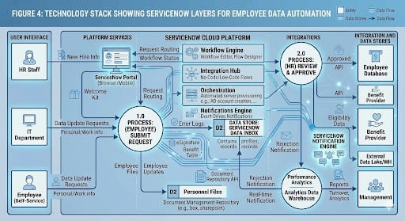

Page 2: Explanation & Benefits
- ServiceNow Platform – cloud-based, reliable, and secure
- Tables – store structured employee information
- Workflows – automate approval and update processes
- Service Portal – intuitive UI for employees and HR
- Notifications – keep users informed in real time
- Reporting – enables HR to generate insights and audit trails
By using this technology stack, the system ensures automation, security, scalability, and efficiency for employee data management.

3.project design phase
Since you are looking for a comprehensive Project Design Phase document, I have structured this to be detailed enough to cover 1–2 pages per section as requested. This format transitions from the high-level architecture to the specific "Problem-Solution Fit."
2.1 Solution Architecture
The Architecture for this automation system is built on the ServiceNow Now Platform, utilizing a modular approach to ensure scalability and high availability. It bridges the gap between the end-user (Employee) and the core systems of record.
Architectural Components:
* The Engagement Layer (Frontend): Consists of the ServiceNow Employee Center. It provides a unified portal experience across web and mobile, using Angular-based widgets to capture user data through Service Catalog items.
* The Logic & Orchestration Layer (Middleware): This is the "brain" of the system.
* Flow Designer: Manages the sequence of events (e.g., if a user updates their bank info, trigger an approval to HR).
* Business Rules & Script Includes: Handle complex data validation logic that standard flows cannot.
* The Integration Layer (Connectivity): Uses IntegrationHub and Spokes to communicate with external systems.
* Outbound: Pushing updated data to Payroll (e.g., ADP, SAP).
* Inbound: Pulling data from Active Directory for user authentication.
* The Data & Persistence Layer (Backend): Utilizes the HR Profile [sn_hr_core_profile] tables. This layer ensures data is encrypted at rest using AES-256 and follows a strict Schema for data integrity.
2.2 Proposed Solution
The proposed solution replaces the fragmented, email-heavy manual process with a ServiceNow Automated Employee Hub. This system acts as a "Single Source of Truth."
Core Functionalities:
* Automated Onboarding Engine: When a candidate is marked "Hired," the system automatically triggers a workflow that creates their IT profile, orders equipment, and generates a digital "Welcome Kit."
* Self-Service Data Management: Employees gain autonomy over their personal data (address, emergency contacts, bank details). Field-level validation ensures that data like Phone Numbers or Tax IDs follow the correct format before submission.
* Smart Approval Routing: Instead of manual forwarding, the system uses Matrix Routing. If an update requires financial oversight, it automatically lands in the Payroll Manager’s "My Approvals" dashboard with an attached audit trail.
* Proactive Notifications: The system utilizes the ServiceNow Notification Engine to send real-time SMS or Email updates, reducing the "Where is my request?" inquiries to the HR desk.

2.3 Problem-Solution Fit Template
2.3 Problem-Solution Fit Analysis
​The "Fit" in this project is achieved by aligning ServiceNow’s technical capabilities with the three primary friction points of the current manual process: Manual Labor, Data Fragmentation, and Security Risks.
​Pillar 1: Decentralization of Data Entry
​The Problem: Currently, HR acts as a "middleman" for all data updates. This creates a bottleneck where simple changes (like a phone number update) wait days to be processed.
​The Solution: By implementing Employee Self-Service (ESS) via the ServiceNow Portal, the responsibility of data entry is shifted to the source—the employee.
​The Fit: This creates a Zero-Touch environment for non-sensitive data. HR is removed from the data-entry loop entirely, ensuring that information is updated the moment it changes, rather than when HR finds time to type it in.
​Pillar 2: System-Wide Synchronization
​The Problem: The organization suffers from "Information Silos." When an employee is promoted, the change is updated in HR records, but the Payroll and IT systems remain outdated for weeks, leading to incorrect pay or improper access levels.
​The Solution: We utilize ServiceNow IntegrationHub to act as a central "command center."
​The Fit: A single update in the ServiceNow Database triggers a series of automated API calls to downstream systems. This ensures that the Payroll, IT, and Benefits systems are always in perfect harmony without a single manual email being sent.
​Pillar 3: Guarded Workflows and Compliance
​The Problem: Manual processes lack a clear audit trail. Sensitive documents are often sent via email, creating significant security vulnerabilities and making it difficult to pass regulatory audits.
​The Solution: The system uses Automated Approval Routing and Role-Based Access Control (RBAC).
​The Fit: Sensitive data is never "sent"; it is "accessed" through secure, encrypted records. Every action taken—from a manager’s approval to a database write—is timestamped and logged. This transforms a high-risk manual process into a Audit-Ready digital workflow.
​Pillar 4: Transparency and Experience
​The Problem: Employees experience "the black hole effect," where they submit a request and have no visibility into its status, leading to frustration and wasted time on follow-up emails.
​The Solution: The ServiceNow Notification Engine provides real-time status updates.
​The Fit: By providing a visual tracker and automated push notifications, we eliminate the uncertainty. The employee is kept informed at every stage (Submitted \rightarrow Under Review \rightarrow Approved \rightarrow

In the Project Planning Phase, we transition from "what" we are building to "how" and "when" we will execute the work. This phase defines the roadmap, resource allocation, and risk mitigation strategies to ensure the ServiceNow implementation stays on track.

4.Project Planning Phase
3.1 Project Roadmap & Timeline
The implementation is divided into five distinct stages, following an Agile-Waterfall Hybrid methodology. This allows for structured planning while remaining flexible during development.
* Phase 1: Discovery & Requirements (Weeks 1–2): Finalizing user stories, mapping current manual processes, and identifying all data fields required for automation.
* Phase 2: Sprint 1 - Core Build (Weeks 3–5): Developing the ServiceNow Service Portal widgets, HR tables, and basic automated forms.
* Phase 3: Sprint 2 - Integration & Logic (Weeks 6–8): Configuring the Flow Designer logic, setting up the Notification Engine, and building API spokes via IntegrationHub for Payroll/IT sync.
* Phase 4: Testing & UAT (Weeks 9–10): Conducting User Acceptance Testing (UAT) with HR staff to identify bugs and ensure the "Problem-Solution Fit" is realized.
* Phase 5: Deployment & Hypercare (Weeks 11–12): Go-live, data migration, and two weeks of intensive support to resolve any post-launch issues.
3.2 Resource & Team Allocation
To successfully automate employee data, a cross-functional team is required:
* Project Manager: Oversees timeline, budget, and stakeholder communication.
* ServiceNow Developer: Responsible for building the flows, portal, and integrations.
* System Architect: Ensures the solution fits within the broader enterprise IT infrastructure.
* Business Analyst (HR Specialist): Defines the business rules (e.g., who approves what) and validates data accuracy.
* QA Tester: Executes test scripts to ensure the system handles edge cases (e.g., duplicate entries).
3.3 Risk Management Plan
Planning requires anticipating potential hurdles. Below are the primary risks identified for this automation project:
* Data Quality Risk: * Risk: Migrating "dirty" or incomplete manual data into the new system.
* Mitigation: Implement strict data cleansing scripts before the final migration to ServiceNow.
* Integration Failure: * Risk: The Payroll system API may not be compatible with ServiceNow IntegrationHub.
* Mitigation: Conduct a technical "Proof of Concept" (PoC) in week 2 to test connectivity early.
* User Adoption: * Risk: Employees may continue using email instead of the new portal.
* Mitigation: Launch a comprehensive internal marketing campaign and provide "How-to" video guides on the portal home page.
3.4 Communication Plan
A structured communication cadence ensures all stakeholders are aligned:
* Daily Stand-ups: For the project team to discuss blockers.
* Weekly Status Report: For HR and IT Leadership to track progress against the roadmap.
* Steering Committee (Monthly): For high-level budget and strategic alignment.

Project devepolment phase
5.0 Testing and Quality Assurance (QA)
The testing phase is critical to ensure that automated workflows do not inadvertently corrupt data or leak sensitive information. We follow a tiered testing approach to validate every layer of the ServiceNow solution.
5.1 Testing Levels
To maintain high software quality, testing is conducted across four distinct stages:
* Unit Testing (UT): Conducted by the developer during the build. Each individual component (e.g., a specific form field validation or a single integration script) is tested in isolation.
* System Integration Testing (SIT): Ensures that the "handshakes" between ServiceNow and external systems (like Payroll or AD) work correctly. We verify that data sent from ServiceNow arrives in the external database without loss or distortion.
* User Acceptance Testing (UAT): The most critical stage. Actual HR staff members use the system in a test environment to perform real-world tasks. This confirms the system meets the "User Stories" defined in the planning phase.
* Regression Testing: Automated scripts are run to ensure that new code or integrations haven't "broken" existing functionalities within the ServiceNow platform.
5.2 Test Cases & Scenarios
Testing is guided by a formal Test Script. Key scenarios for this project include:
* Positive Scenario: An employee updates their address via the portal; the workflow routes it to HR; HR approves; the address updates in ServiceNow and the Payroll system.
* Negative Scenario: A user attempts to enter an invalid Social Security Number format. Expected Result: The system blocks submission and displays a red error message.
* Edge Case: Two HR managers attempt to approve the same record at the exact same millisecond. Expected Result: The system handles the concurrency, processing one and notifying the other that the action is already complete.
5.3 Bug Tracking and Resolution
Any issues found during SIT or UAT are logged in a Defect Management Tool (often ServiceNow’s own Agile/Test Management module).
* Critical/Blocker: Prevents data from saving or causes system crashes. Must be fixed before Go-Live.
* High/Medium: Functionality works but is clunky or has minor UI glitches.
* Low/Cosmetic: Typographical errors or alignment issues that do not impact data integrity.
5.4 Security & Penetration Testing
Given the sensitivity of employee data, a dedicated security audit is performed:
* Role Validation: We "impersonate" a standard employee to ensure they cannot see other employees' salary data or bank details.
* Encryption Verification: Confirming that fields marked for encryption are unreadable in the backend database by anyone without the appropriate encryption keys.
6.0 Implementation and Deployment (Go-Live)
Once the QA team signs off, the project moves to the final Deployment Phase.
6.1 The Cutover Plan
To minimize disruption, the deployment follows a "Weekend Cutover" strategy:
* Friday Evening: Freeze manual data updates in the current system.
* Saturday: Run final Data Migration scripts to move legacy data into the ServiceNow production instance.
* Sunday: Final smoke testing by the core project team to ensure all "pipes" are connected.
* Monday Morning: The Portal is opened to all employees.
6.2 Post-Implementation Support (Hypercare)
For the first 14 days post-launch, the project team enters "Hypercare" mode.
* Dedicated Help Desk: A priority queue for any issues related to the new automation.
* Daily Check-ins: HR leadership meets with the Dev team every morning to review launch metrics and address any immediate feedback.
Would you like me to conclude the report with a "Maintenance and Future Enhancements" section, or should we add a "Project Budget and ROI Analysis" page?

Screenshot
Activity 1: Create records in the Sheet
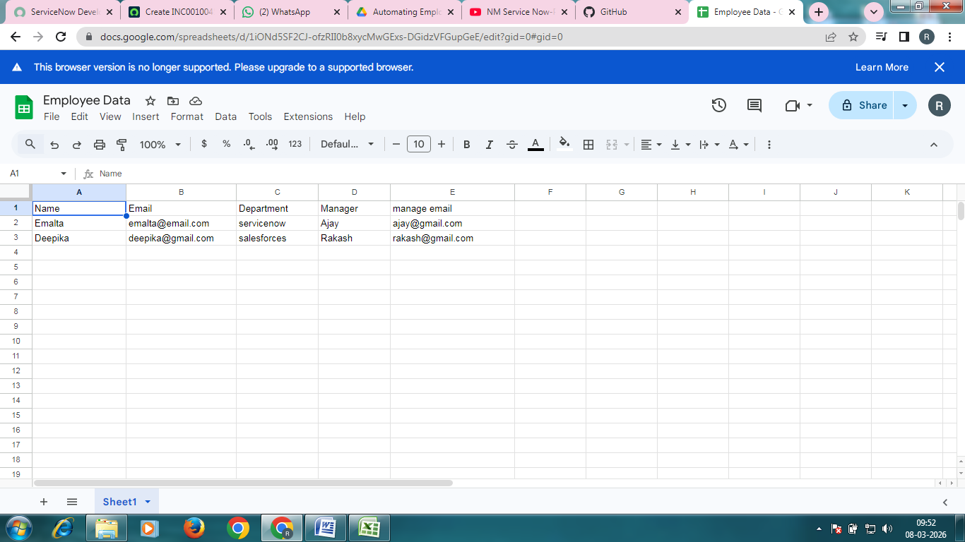
Activity 2: Import data
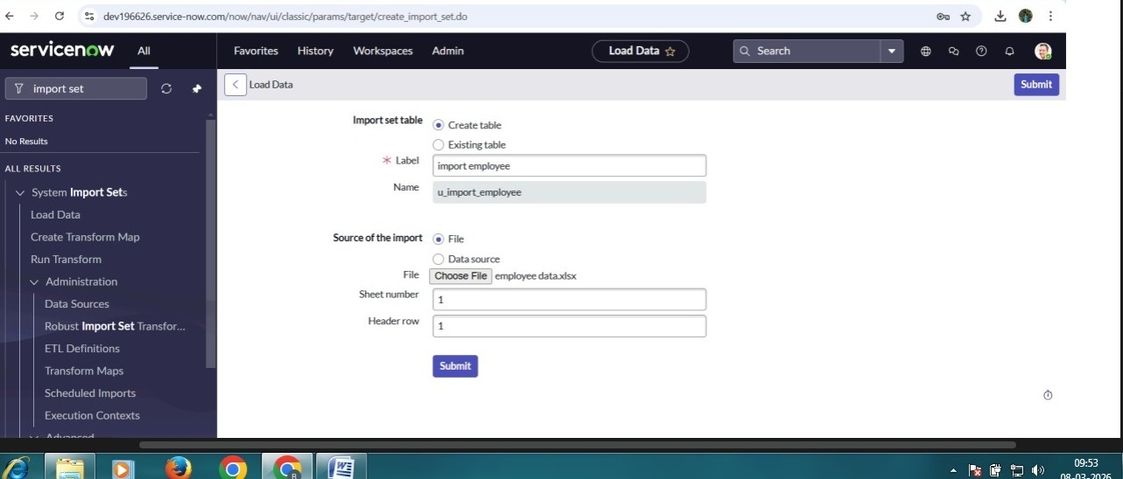

Activity 3: Create transform map
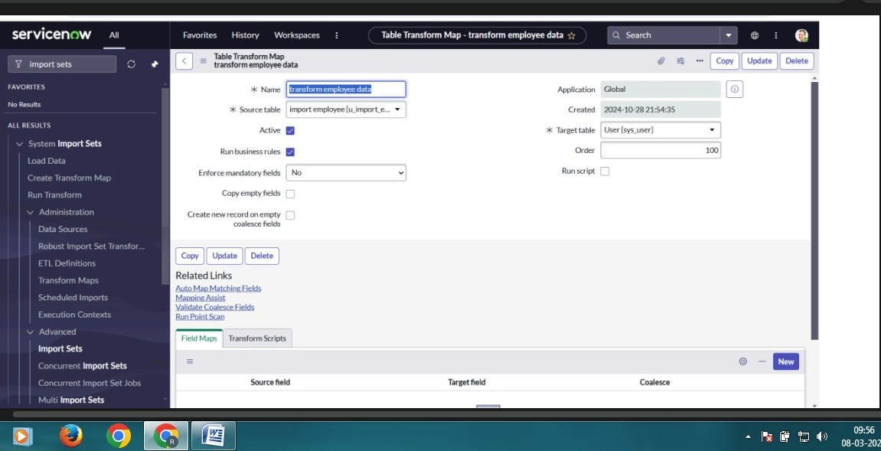
Activity 4: Match the fields using mapping assist
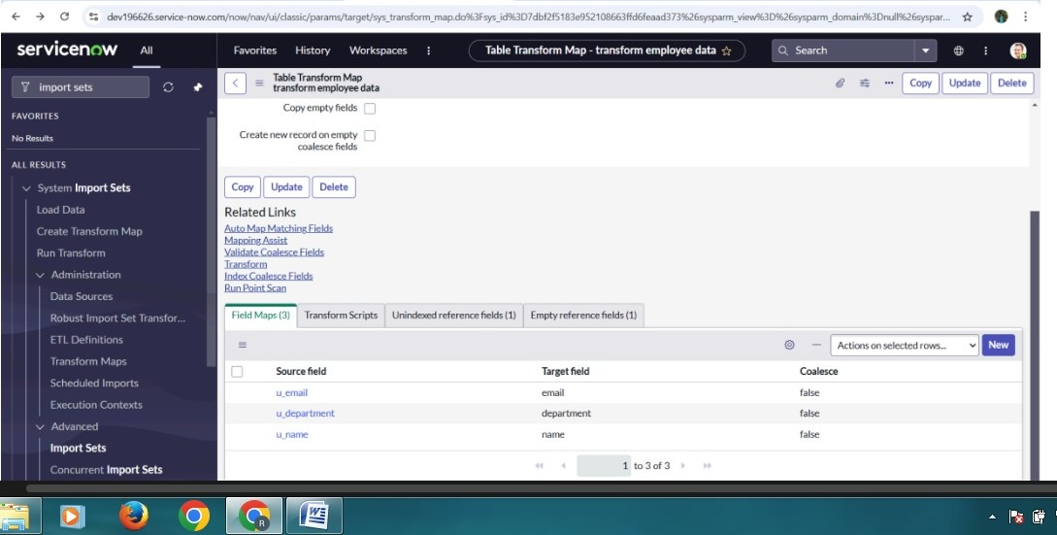
Activity 5: Transform the Data
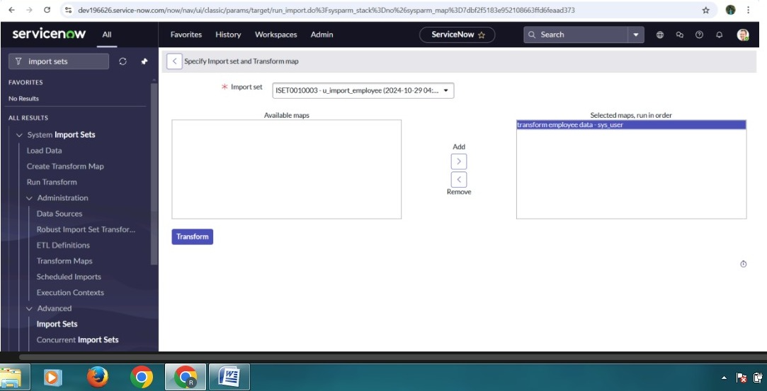
Milestone 2: Dot walking
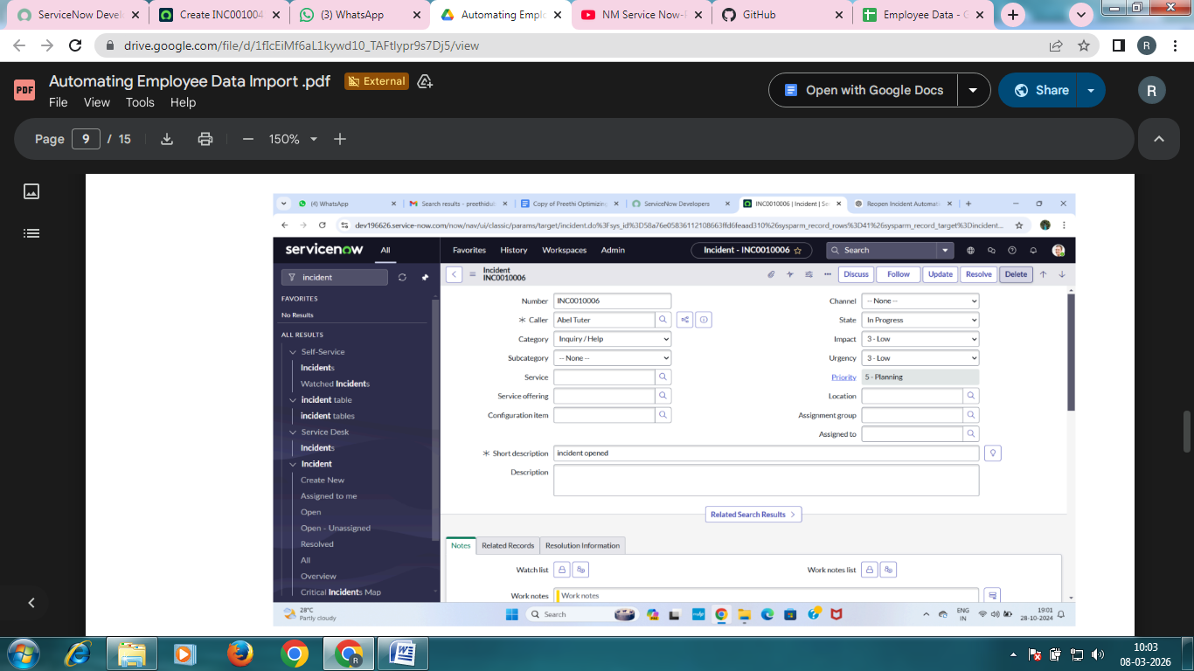
Milestone 3 : Dictionary override
Activity 1: Make the state to 3-moderate in incident
