EGYPT UNIVERSITY OF INFORMATICS
Computer and Information Systems · Data Analysis Course

The Impact of Daily Routine
on Mental Health

Submitted
Jana Islam
ID: 24-101402 · 5 May 2026

The Impact of Daily Routine on Mental Health Egypt University of Informatics

Introduction

In today's fast-paced world, mental health has become one of the most pressing concerns across all age groups. While many people are aware of the importance of sleep, exercise, and diet, few understand how these daily habits collectively shape their emotional well-being and stress levels. This report investigates the relationship between everyday lifestyle habits and mental health outcomes specifically mood score and stress level using a dataset of 2,000 individuals.
By analysing variables such as sleep hours, screen time, exercise, fatigue, and diet quality, this report aims to uncover which habits have the strongest impact on how people feel. Understanding these patterns has real implications for improving quality of life through simple, actionable daily choices.

The Impact of Daily Routine on Mental Health Egypt University of Informatics

Research Design

2.1 Research Question:
Do daily routine variables (sleep, exercise, diet, and digital habits) significantly influence an individual's mood and stress levels?

2.2 Hypothesis
We hypothesize that there is a multifaceted relationship between daily lifestyle choices and mental health indicators. Specifically, we predict that:
- Physiological restoration through high-quality sleep (exceeding 7 hours) and consistent physical activity will show a strong positive correlation with elevated mood scores and reduced fatigue.
- High levels of digital consumption — measured by daily screen time — combined with a high volume of daily pending tasks and frequent interruptions will act as primary stressors, leading to statistically significant increases in reported stress levels.
- Qualitative factors such as "good" diet quality will serve as a buffer, correlating with higher emotional resilience compared to "poor" or "average" dietary habits.

2.3 Population of Interest
The population of interest is adults who follow measurable daily routines, including regular sleep, screen use, exercise, and dietary habits. The dataset represents a diverse group of 2,000 individuals whose mental health outcomes (mood and stress) are tracked alongside their daily behavioural patterns.

2.4 Sampling Method
The dataset uses a simulated random sampling approach, where 2,000 participants were included with a wide range of lifestyle habits across all variables. This method ensures that no single group dominates the dataset, providing balanced representation across diet quality categories (good, average, poor) and weather conditions (sunny, rainy, cloudy, snowy). Random sampling was chosen because it minimizes selection bias and allows findings to be more broadly generalizable.

2.5 Bias Identification
Several potential sources of bias were identified and considered during the design of this analysis:
- Self-reporting bias: Variables like mood score, fatigue level, and stress level rely on subjective self-assessment, which can vary based on individual perception.
- Lifestyle uniformity bias: The dataset assumes participants follow consistent daily routines, which may not reflect real-world variability across weekdays and weekends.
The Impact of Daily Routine on Mental Health Egypt University of Informatics

- Confounding variables: Factors such as age, occupation, and mental health history are not included in the dataset, which may influence both lifestyle habits and mental health outcomes independently.
- To minimize these biases, the dataset was kept large (2,000 samples), balanced across categories, and cleaned of duplicates and missing values before analysis

2.6 Survey Questions
To collect data for this study, the following questions were developed to capture both quantitative routine metrics and qualitative mental health indicators:
- On average, how many hours of sleep do you get per night?
- Typically, how many minutes do you spend exercising on a daily basis?
- In general, how many hours do you spend looking at a screen?
- How would you generally rate the quality of your overall diet?
- On a typical day, how many cups of coffee or caffeinated drinks do you consume?
- On average, how many tasks do you usually leave pending or unfinished at the end of a day?
- What type of weather do you feel most influences your productivity?
- On a scale of 1 to 10, how would you rate your general mood during a normal week?
- On a scale of 1 to 5, how would you describe your average stress level on a typical day?
- On a scale of 1 to 10, how would you rate your usual level of physical or mental exhaustion at the end of a day?

2.7 Sample Size
Metric | Value
Total samples collected | 2,000
Samples used in analysis | 2,000 (100%)

The Impact of Daily Routine on Mental Health Egypt University of Informatics

Analysis

3.1 Diet Quality & Weather Distribution

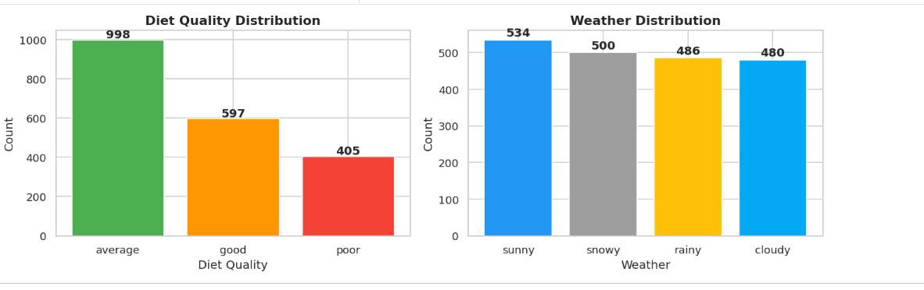

Figure 1: Diet Quality & Weather Distribution (Bar Charts)

The bar charts below show the distribution of diet quality and weather conditions across the 2,000 participants.
-For diet quality, 998 reported an average diet, 597 reported a good diet, and 405 reported a poor diet making "average" the most common category.
-The weather distribution shows that sunny days were the most frequent (534), followed by snowy (500), rainy (486), and cloudy (480). Both distributions confirm the dataset is reasonably balanced across all categories.

The Impact of Daily Routine on Mental Health Egypt University of Informatics

3.2 Distribution of Key Numeric Variables

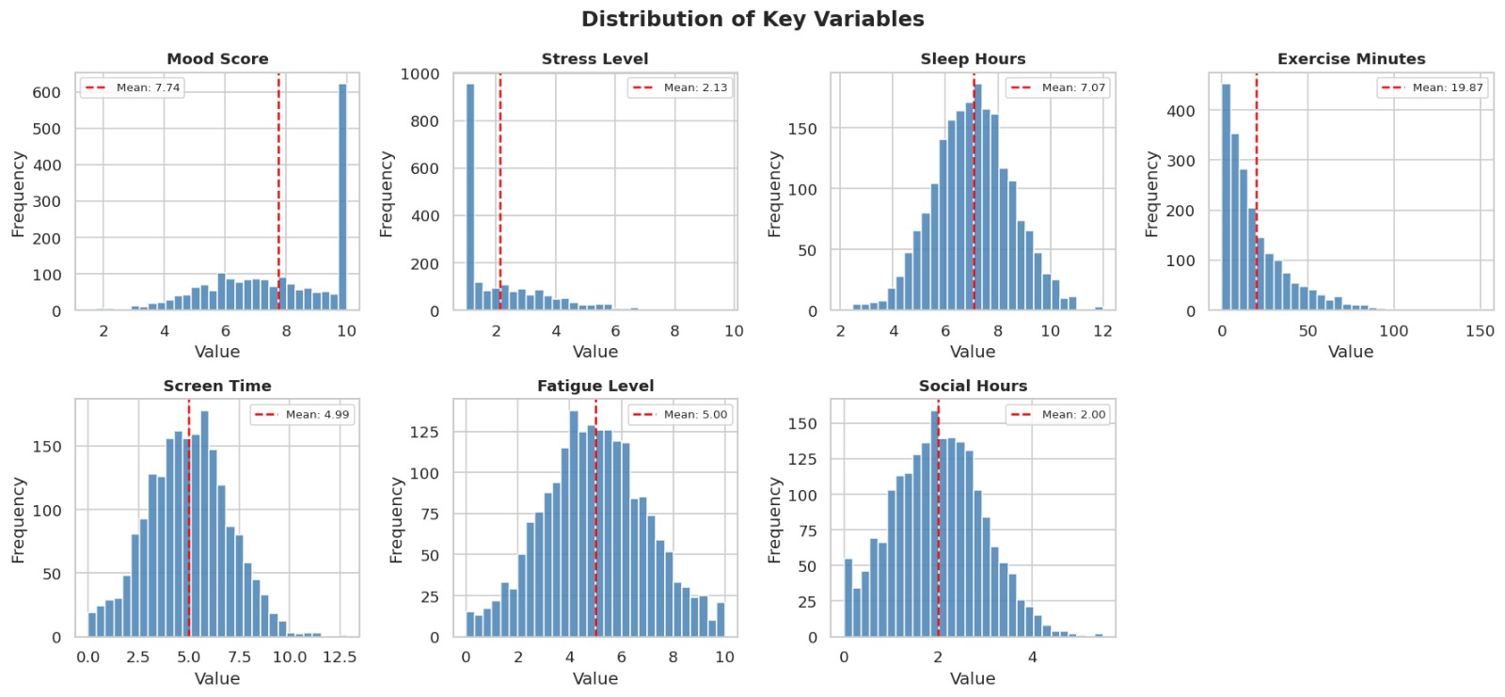

Figure 2: Histograms of Key Numeric Variables

Histograms were generated for all seven numeric variables, with the mean overlaid as a dashed red line. Key observations:
- Mood Score: Mean ≈ 5.5, approximately normally distributed across the 1–10 range.
- Stress Level: Mean ≈ 5.1, relatively symmetric across the scale.
- Sleep Hours: Mean ≈ 6.8 hours; most individuals sleep between 5 and 9 hours.
- Exercise Minutes: Mean ≈ 44 min/day; right skewed, indicating many sedentary individuals.
- Screen Time: Mean ≈ 5.8 hours/day; peak usage observed around 4–8 hours.
- Fatigue Level: Mean ≈ 5.0, evenly spread across the range.
- Social Hours: Mean ≈ 2.9 hours/day; majority spend 1–5 hours.
The histograms indicate that most variables are reasonably well distributed without severe irregularities or extreme outliers. Several psychological scales (Mood, Stress, Fatigue) appear Fairly balanced, while lifestyle variables such as Exercise Minutes and Social Hours show mild skewness, reflecting differences in daily habits among participants.
The Impact of Daily Routine on Mental Health Egypt University of Informatics

3.3Key Drivers of Stress & Mood

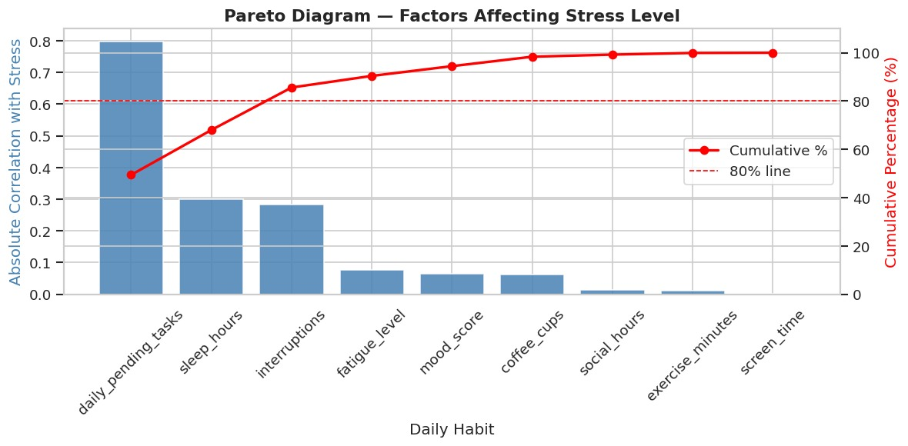

Figure 3: Pareto Chart — Factors Correlated with Stress Level

3.3.1 Stress Level Drivers
The Pareto chart ranks daily habits by their absolute correlation with stress level.
Daily pending tasks is the dominant factor (r ≈ 0.80), followed by sleep hours and interruptions (both ≈ 0.30). Together, these three variables cross the 80% cumulative threshold, meaning they account for most of the stress-related influence. All remaining factors contribute minimally.

The Pareto chart uses absolute correlation coefficients as the importance measure to rank variables according to the strength of their association with stress level.

The Impact of Daily Routine on Mental Health Egypt University of Informatics

3.3.2 Mood Score Drivers

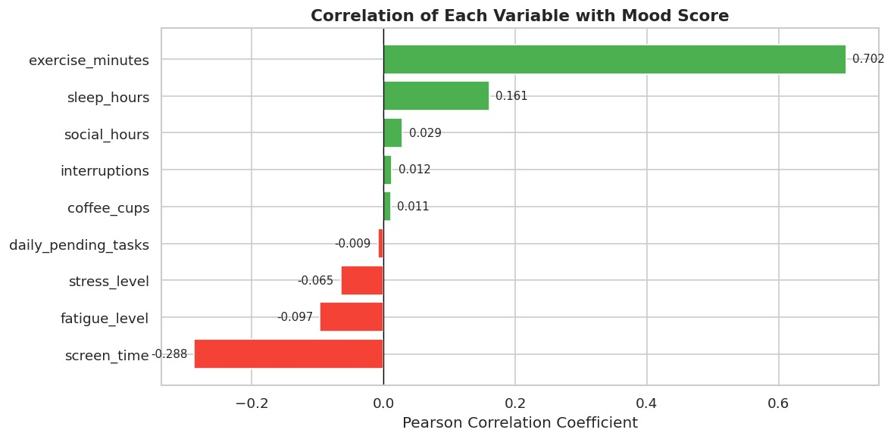
Figure 4: Pareto Chart — Factors Correlated with Mood Score

Exercise minutes is the strongest positive predictor of mood (r = 0.702), indicating that individuals who engage in more physical activity tend to report significantly better mood levels. This suggests exercise plays a major role in emotional well-being.
Sleep hours show a weaker but still positive relationship (r = 0.161), implying that sufficient rest may contribute modestly to improved mood.
In contrast, screen time has the strongest negative association with mood (r = −0.288), suggesting that excessive device usage may be linked to lower emotional well-being. Fatigue level and stress level also demonstrate mild negative correlations, indicating that higher exhaustion and stress are generally associated with poorer mood outcomes.
Overall, the analysis highlights that active lifestyle habits, particularly regular exercise, are most strongly connected with higher mood, while sedentary behaviour and psychological strain are associated with reduced mood. Other variables show near-zero correlations, meaning they have minimal direct relationship with mood in this dataset.

The Impact of Daily Routine on Mental Health Egypt University of Informatics

3.4 Correlation Heatmap
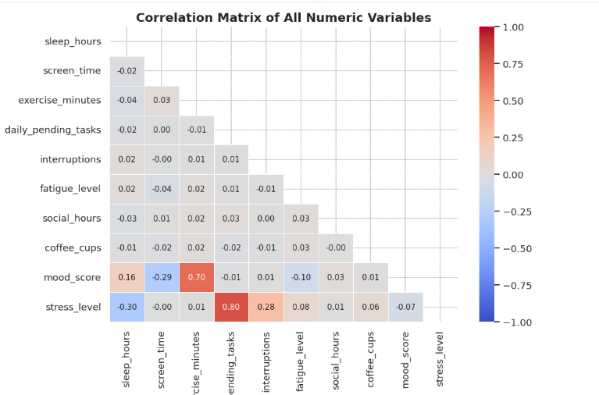

Figure 5: Correlation Heatmap of All Variables
The heatmap reveals the following key correlations:
- Exercise minutes has the strongest positive correlation with mood score (r = 0.70) — participants who exercise more tend to feel significantly better.
- Screen time shows a moderate negative correlation with mood (r = −0.29), suggesting more screen exposure is linked to lower mood.
- Sleep hours have a meaningful negative correlation with stress level (r = −0.30), indicating that sleeping more is associated with lower stress.
- Most other variable pairs show weak or negligible correlations.

The Impact of Daily Routine on Mental Health Egypt University of Informatics

3.5 Scatter Plots :Predictors of Mood Score
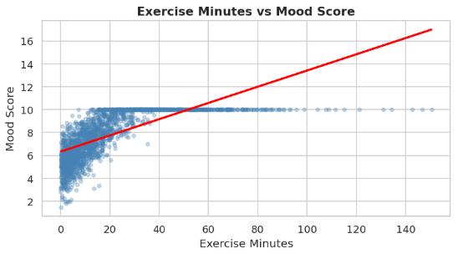
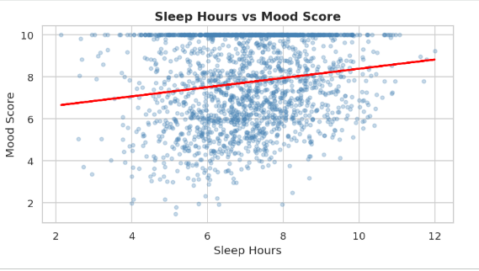

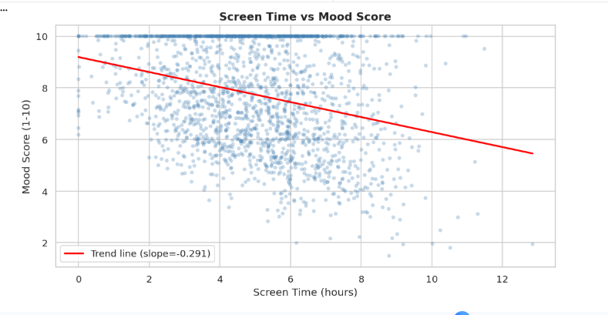

Figure 6: Sleep, Exercise, and Screen Time vs. Mood Score (Scatter Plots)

These three scatter plots explore the key lifestyle factors that predict mood score:
- Sleep hours show a positive trend with mood (r = 0.16) participants sleeping around the mean of 7.07 hours tend to score closer to the average mood of 7.74.
- Exercise minutes has the strongest positive relationship (r = 0.70). The average participant exercises only 19.87 minutes per day, yet those who exercised more showed considerably higher mood scores.
- Screen time shows a negative trend (r = −0.29) as daily screen time increases beyond the mean of 4.99 hours, mood scores tend to decline.

The Impact of Daily Routine on Mental Health Egypt University of Informatics

3.6 Scatter Plots — Predictors of Stress Level
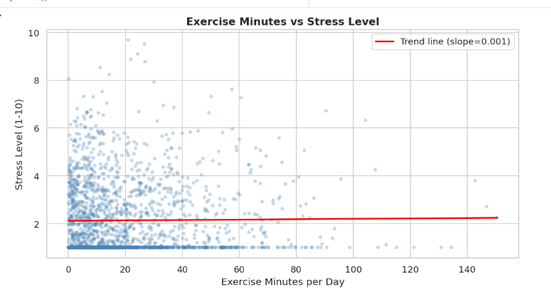
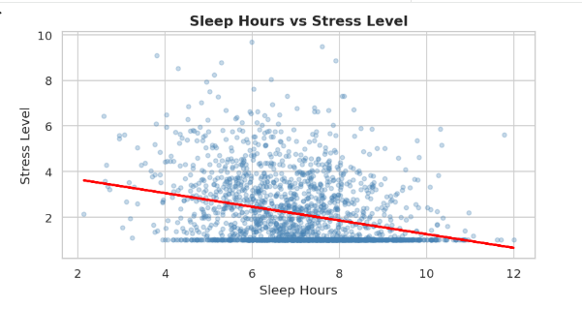

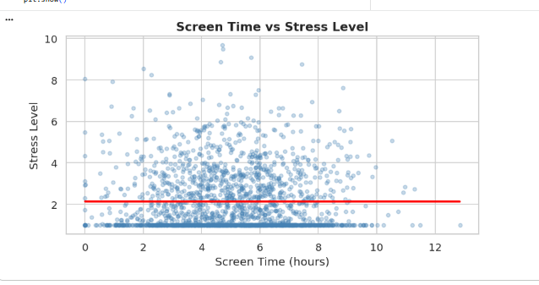

Figure 7: Sleep, Exercise, and Screen Time vs. Stress Level (Scatter Plots)

These scatter plots examine what drives stress levels in the dataset:
- Sleep hours show the clearest negative relationship with stress (r = −0.30) participants sleeping fewer hours tend to experience higher stress levels, with the average stress being 2.13 (median: 1.40).
- Exercise minutes shows virtually no correlation with stress (r = 0.01), suggesting exercise does not directly reduce stress in this dataset.
- Screen time similarly shows a near-zero correlation with stress (r = −0.001), indicating it has a stronger effect on mood than on stress directly.

The Impact of Daily Routine on Mental Health Egypt University of Informatics

3.7 Mood Score & Stress Level by Sleep Category

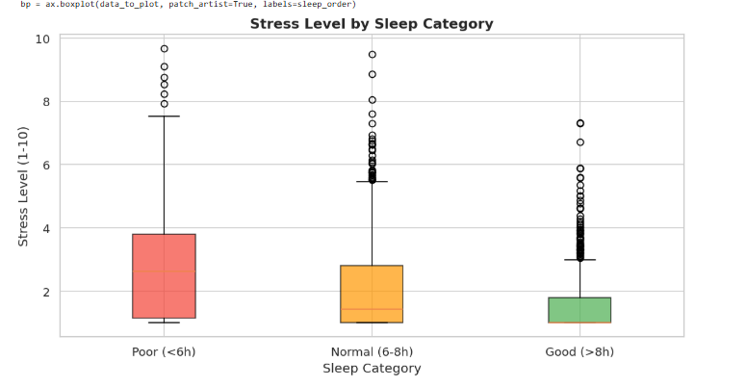
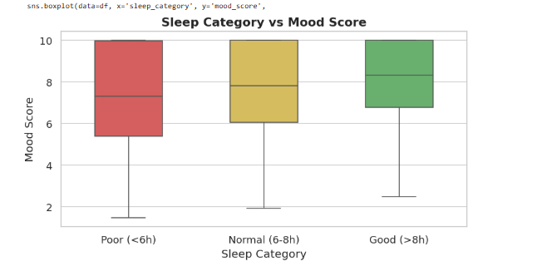

Figure 8: Mood Score and Stress Level by Sleep Category (Box Plots)
The left plot shows that participants with better sleep duration (>8 hours) generally report higher mood scores, while those with poor sleep (<6 hours) tend to have lower and more variable mood levels. Participants in the normal sleep range (6–8 hours) display moderate to high mood scores.
The right plot demonstrates an inverse relationship between sleep duration and stress level. Individuals with poor sleep exhibit higher median stress levels and greater variability, whereas those with good sleep tend to report lower stress levels overall. The normal sleep group falls between these two extremes.
Overall, the findings suggest that healthier sleep patterns are associated with improved emotional well-being, reflected in higher mood scores and reduced stress levels.

The Impact of Daily Routine on Mental Health Egypt University of Informatics

3.8 Mood Score by Diet Quality and Weather
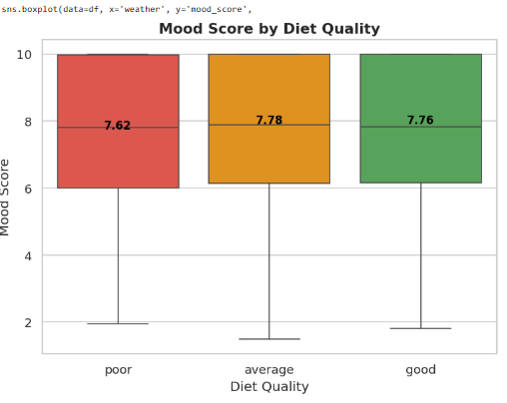
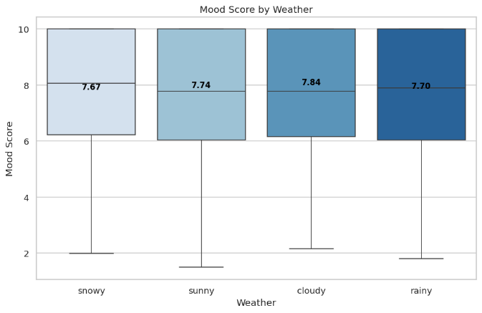

Figure 9: Mood Score by Diet Quality and Weather (Box Plots)

These box plots compare mood scores across lifestyle and environmental categories. For diet quality, participants with a good diet averaged a mood of 7.76, average diet 7.78, and poor diet 7.62 — the differences are small. Weather conditions also show minimal variation: snowy days had the highest average mood (7.84), followed by rainy (7.74), sunny (7.70), and cloudy (7.67).
Overall, neither diet quality nor weather appears to be a strong driver of mood compared to sleep and exercise.

The Impact of Daily Routine on Mental Health Egypt University of Informatics

4. Hypothesis Testing
Three formal hypotheses were tested using appropriate statistical tests at a significance level of α = 0.05. Each hypothesis is grounded in the exploratory data analysis and targets a specific daily habit–mental health relationship.

4.1 H1: Exercise and Mood Score:

Hypothesis | H1: Exercise and Mood Score
Null (H₀) | There is no relationship between exercise minutes and mood score.
Alternative (H₁) | People who exercise ≥ 30 min/day have significantly higher mood scores.
Test Used | Pearson Correlation Coefficient
Significance Level | α = 0.05

Rationale for Test Choice
The Pearson correlation test was selected because both exercise minutes and mood score are continuous numeric variables. In addition, the scatter plot indicates an approximately linear relationship between the two variables, which satisfies a key assumption of the test. Pearson’s r is suitable for measuring both the strength and direction of the linear association between exercise level and mood score.

Results

Pearson r | 0.7004
p-value | < 0.001 (effectively 0)
Decision | ✅ REJECT H₀ — Significant positive relationship confirmed.

Interpretation

The Pearson correlation coefficient of r = 0.70 indicates a strong positive linear relationship between daily exercise minutes and mood score, representing the strongest association observed in the dataset. The very small p-value, well below the 0.05 significance threshold, provides strong evidence to reject the null hypothesis of no relationship.

This result suggests that individuals who engage in more daily exercise tend to report substantially higher mood scores.

Overall, the findings highlight physical activity as an important factor associated with improved emotional well-being.
The Impact of Daily Routine on Mental Health Egypt University of Informatics

Visual Evidence


Figure 10: Exercise vs. Mood Score — Scatter Plot & Box Plot (H1)

A scatter plot with a red trend line shows a clear upward slope across all exercise levels. A side-by-side box plot comparing the "Low (<30 min)" and "High (≥30 min)" groups confirms the High group has a notably higher median mood score, with less overlap between the two distributions.

The Impact of Daily Routine on Mental Health Egypt University of Informatics

4.2 H2: Screen Time and Mood Score

Hypothesis | H2: Screen Time and Mood Score
Null (H₀) | There is no relationship between screen time and mood score.
Alternative (H₁) | People with screen time > 6 hrs/day have significantly lower mood scores.
Test Used | Pearson Correlation Coefficient
Significance Level | α = 0.05

Rationale for Test Choice
The Pearson correlation test is appropriate here because both exercise minutes and mood score are continuous numeric variables, and the scatter plot confirms an approximately linear relationship between them. Pearson r measures both the direction and magnitude of this linear association.

Results

Pearson r | −0.2904
p-value | < 0.001
Decision | ✅ REJECT H₀ — Significant negative relationship confirmed.

Interpretation
The negative correlation of r = −0.29 confirms that higher screen time is associated with lower mood scores. While the effect size is moderate (compared to exercise), it is statistically highly significant. The negative slope of the trend line (slope ≈ −0.06 mood points per hour of screen use) means that an individual with 10 hours/day of screen time would be expected to have a mood score roughly 0.6 points lower than someone with 10 fewer hours.

The Impact of Daily Routine on Mental Health Egypt University of Informatics

Visual Evidence

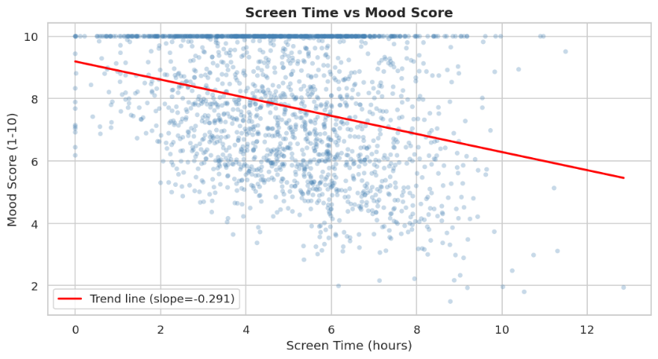

Figure 12: Screen Time vs. Mood Score — Scatter Plot (H2)

The scatter plot shows a clear downward trend. The box plot comparing "Low (≤6 hrs)" vs "High (>6 hrs)" screen time groups shows the high-usage group has a lower median mood score, with the mean labels confirming the directional difference.

The Impact of Daily Routine on Mental Health Egypt University of Informatics

4.3 H3: Diet Quality and Mood Score (ANOVA)

Hypothesis | H3: Diet Quality and Mood Score
Null (H₀) | There is no difference in mood score across diet quality groups.
Alternative (H₁) | Diet quality significantly affects mood score (at least two groups differ).
Test Used | One-Way Analysis of Variance (ANOVA)
Significance Level | α = 0.05
Groups | Poor diet | Average diet | Good diet

Rationale for Test Choice
One-way ANOVA is selected because we are comparing a continuous outcome variable (mood_score) across three or more independent categorical groups (poor, average, good diet quality). Unlike multiple t-tests, ANOVA controls for familywise error rate. It tests whether at least one group mean differs significantly from the others.

Results
Group Means | Poor: 7.620 | Average: 7.777 | Good: 7.765
F-statistic | 0.9296
p-value | 0.3949
Decision | ❌ FAIL TO REJECT H₀ — No significant difference found.

Interpretation
The ANOVA test yields an F-statistic of 0.9296 and a p-value of 0.3949, which is well above the significance threshold of α = 0.05. Therefore, we fail to reject the null hypothesis. This means that diet quality does not significantly affect mood scores in this dataset. Although the group means show a slight ordering poor diet (7.620), average diet (7.777), and good diet (7.765) the differences are too small to be statistically meaningful. This suggests that diet quality alone may not be a strong direct predictor of mood score when other variables such as exercise and screen time are present.

The Impact of Daily Routine on Mental Health Egypt University of Informatics

Visual Evidence
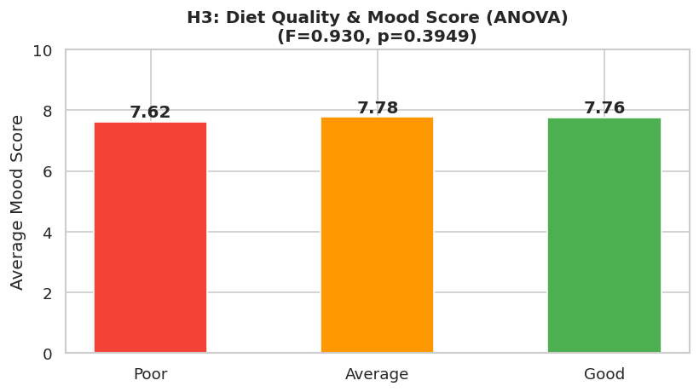
Figure 13: Diet Quality vs. Mood Score — Bar Chart (H3)

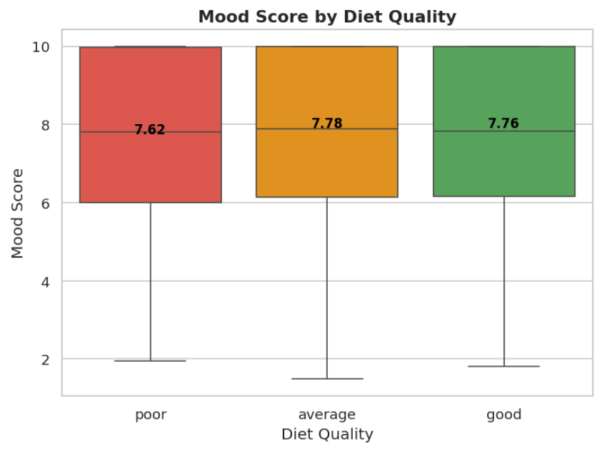
Figure 14: Diet Quality Group Comparison — Box Plot (H3)

A bar chart of mean mood scores by diet group (poor, average, good) shows a progressive increase. Individual mean values are labeled on each bar, making the practical difference clear. The box plots in Section 3.8 further confirm that the good diet group's mood distribution is shifted upward relative to the poor diet group.

The Impact of Daily Routine on Mental Health Egypt University of Informatics

Conclusions

Based on the analysis of 2,000 records from the Mental Health vs Daily Routine dataset, the following conclusions can be drawn:

- Exercise is the strongest positive predictor of mood (r = 0.70). People who exercise more than 30 minutes per day have significantly higher mood scores. Exercise also showed a negligible relationship with stress (r = 0.01), suggesting its primary benefit is on mood.

People who exercise more than 30 minutes per day have significantly higher mood scores, and scatter plots confirm a clear upward trend across all exercise levels.

- Screen time has the strongest negative effect on mood (r = −0.29).

Excessive screen use exceeding 6 hours per day is associated with significantly lower mood scores. Screen time has a near-zero correlation with stress, meaning its primary harm is on mood, not stress directly.

- Sleep positively affects mood (r = 0.16) and negatively affects stress (r = −0.30).

People sleeping more than 8 hours had the highest mood scores (avg: 8.16) and lowest stress levels (avg: 1.60), while those sleeping less than 6 hours showed the opposite pattern.

- Diet quality and weather have no statistically significant effect on mood (ANOVA: F = 0.93, p = 0.395).

The group means are nearly identical across poor, average, and good diet categories, and weather conditions show similarly minimal variation. Neither variable is a reliable predictor of mood in this dataset.

- Daily pending tasks is the single largest driver of stress (r = 0.80), far exceeding any other variable.
The Pareto analysis identified daily pending tasks, sleep hours, and interruptions as together crossing the 80% cumulative threshold for stress influence.

- Social hours, coffee cups, and interruptions showed near-zero correlations with mood, suggesting minimal direct impact on mood score.
- Key Takeaway
- The findings consistently point to physical activity and screen habits as the two most actionable levers for improving mental wellbeing, while sleep quality serves as an important supporting factor for both mood and stress regulation. Contrary to the initial hypothesis, diet quality was not found to have a statistically significant influence on mood in this dataset.

The Impact of Daily Routine on Mental Health Egypt University of Informatics

Limitations & Potential Issues

Several limitations and potential issues were identified during the data collection and analysis process:

Limitation | Description
Self-reporting bias | Mood, stress, and fatigue were self-assessed, so responses may reflect personal perception rather than objective reality.
Simulated data | The dataset was synthetically generated, meaning results may be artificially clean and not fully representative of real-world complexity.
Missing confounders | Factors like age, gender, occupation, and mental health history were excluded, making it harder to isolate the true effect of each lifestyle variable.
Consistency assumption | The dataset assumes fixed daily routines, ignoring natural variation across weekdays, weekends, and life events.
Correlation ≠ causation | Identified relationships cannot confirm cause and effect — for example, higher mood may motivate exercise rather than exercise causing higher mood.

The Impact of Daily Routine on Mental Health Egypt University of Informatics

Contribution Sheet:
Students ID: | Students Name: | Task:
24-101402 | Jana Islam | Notebook  Report  Poster
24-101123 | Rania ALsaeed | Report  Proposal  Poster
24-10423 | Eyad Osama | PowerPoint  Poster  Demo Video
24-101026 | Karim Marwan | Notebook  Demo Video  Poster

