EMBEDDED IoT SYSTEMS
HOMEWORK-01: GPIO, Timers, Interrupts, Debouncing & OLED Display

PART#1:

Q1. GPIO configuration and operation:

Pin modes:

Mode | Behaviour on the ESP32
INPUT | Pin only reads the voltage. It has no internal pull resistor, so if nothing is connected the pin “floats” and gives random HIGH/LOW readings. An external pull-up or pull-down resistor is needed.
INPUT_PULLUP | Same as INPUT but an internal pull-up resistor (roughly 45 kΩ) connects the pin to 3.3 V. The pin reads HIGH by default, so no external resistor is needed for a button.
OUTPUT | The pin actively drives 3.3 V (HIGH) or 0 V (LOW) using digitalWrite(). It is used for LEDs, relays (through a driver), etc.

Button wiring with INPUT_PULLUP:

One leg of the push button goes to the GPIO pin (e.g. GPIO 18) and the other leg goes to GND. The pin is set with pinMode(18, INPUT_PULLUP). When the button is released, the internal pull-up keeps the pin at HIGH. When the button is pressed, the pin is connected directly to GND, so the logic level read is LOW (0). This is called active-low logic.
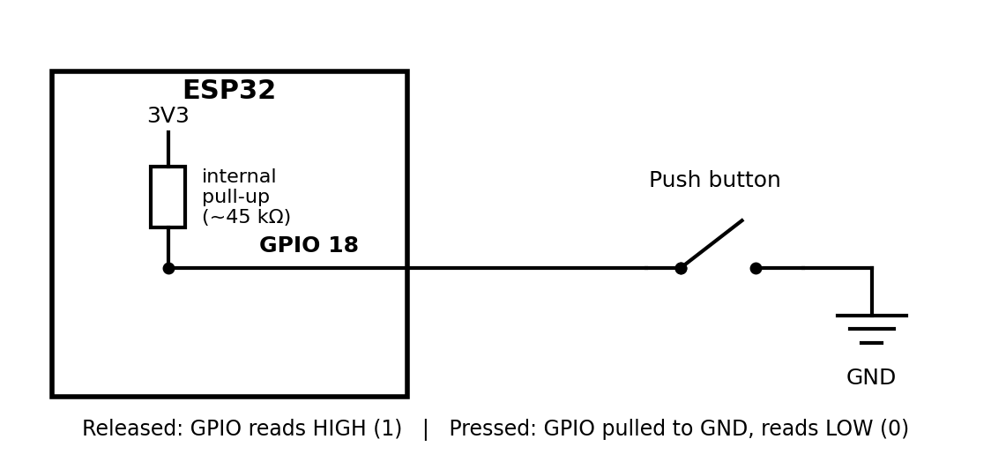

Why GPIO selection and voltage limits matter:

- Voltage: ESP32 GPIOs work at 3.3 V logic and are not 5 V tolerant. Applying 5 V can permanently damage the chip.
- Current: Each pin can supply only a small current (about 12 mA is recommended), so loads such as motors must use a transistor or driver.
- Pin choice: GPIO 6–11 are used by the internal flash and must be avoided. GPIO 34–39 are input-only and have no internal pull-up. Strapping pins (e.g. GPIO 0, 2, 12, 15) affect boot, so a button or load on them can cause boot problems. GPIO 18 is a safe general-purpose choice.

Q2. Timers and non-blocking design:

A timer measures time and generates events at the correct moment, such as “do this every 500 ms” or “check whether 50 ms have passed”. Timers let a microcontroller schedule several jobs without wasting CPU time.
Feature | delay()-based | millis()/timer-based (non-blocking)
CPU behaviour | Stops the program for the whole delay time. | Program keeps running; it only checks the elapsed time.
Responsiveness | Button presses and display updates are missed or late. | All tasks stay responsive.
Multitasking | Very difficult. | Easy; each task has its own timestamp.
Typical use | Quick tests only. | Real projects.

Practical example: In one loop(), an LED blinks every 500 ms, the OLED refreshes every 200 ms, and the button is read on every pass. Each task keeps its own previous-time variable:
unsigned long now = millis();
if (now - lastBlink >= 500) { lastBlink = now; toggleLed(); }
if (now - lastDisplay >= 200) { lastDisplay = now; updateOLED(); }
readButton(); // runs every loop, never blocked

With delay(500) the button would be ignored for half a second and presses could be lost. The subtraction (now - last) also works correctly when millis() overflows after about 49.7 days.

Q3. Interrupts and ISR:

An interrupt is a hardware signal (for example a pin change or timer expiry) that makes the CPU temporarily stop its normal program to handle an urgent event. An Interrupt Service Routine (ISR) is the special function that runs in response to that interrupt.

Sequence from event to ISR execution:

Step | What happens
1 | The program registers the ISR, e.g. attachInterrupt(digitalPinToInterrupt(18), isr, FALLING).
2 | An event occurs (the pin goes from HIGH to LOW) and the interrupt controller raises an interrupt request.
3 | The CPU finishes the current instruction and saves its context (registers and return address).
4 | The CPU jumps to the ISR and executes it.
5 | The ISR returns, the context is restored, and the main program continues from where it stopped.

Good ISR practices (ESP32 Arduino):
- Keep it very short: only set a flag or increment a counter, and do the real work in loop().
- Use IRAM_ATTR on the ISR so it runs from internal RAM, not from flash.
- Declare shared variables volatile and protect multi-byte data with a critical section (portENTER_CRITICAL_ISR) when the main code also uses it.
- Avoid delay(), Serial, I²C/Wire, and dynamic memory inside the ISR.

Why not update the display or use Serial in an ISR:
An OLED refresh sends about 1 KB over I²C, which takes tens of milliseconds, and Serial printing uses buffers and can block. During this time other interrupts are delayed, events are missed, and the watchdog may reset the ESP32. The Wire and Serial libraries are also not designed to be called from interrupt context and can cause a crash. The correct approach is: ISR sets a flag → loop() sees the flag → loop() updates the OLED and prints to Serial.

Q4. Switch debouncing:

A mechanical switch has metal contacts that do not close cleanly. When pressed, the contacts physically vibrate and make and break the connection several times within roughly 1–20 ms. The fast ESP32 sees every one of these transitions, so one physical press may be read as several presses and the counter increases more than once.
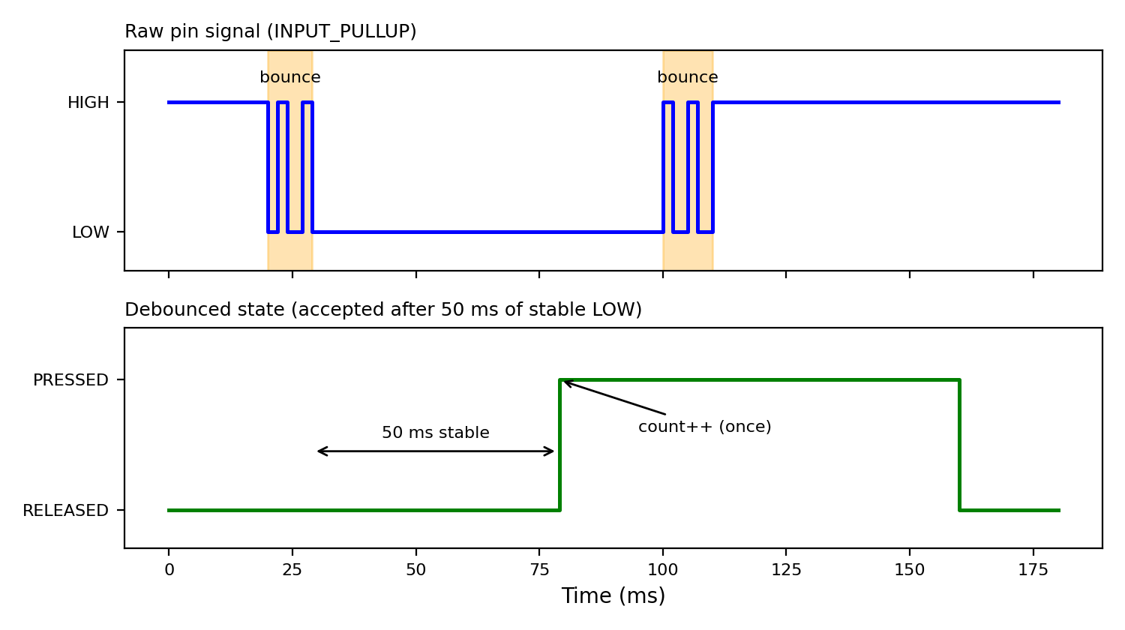
Raw bouncing signal and the debounced output (one accepted press).

Feature | delay()-based debounce | millis()-based debounce
Method | Detect an edge, then delay(50) and read again. | Store the time of the last change and compare with millis().
CPU | Blocked for 50 ms every time. | Never blocked.
Side effects | OLED, Serial, and other tasks freeze; presses can be missed. | Other tasks run normally.

Reliable state-based method:

The input is accepted as a new state only after it has stayed unchanged for the debounce interval (e.g. 50 ms). Any change in the raw reading restarts the timer. The press is counted only when the stable state changes to LOW:

const unsigned long DEBOUNCE_MS = 50;
int lastReading = HIGH, stableState = HIGH;
unsigned long lastChangeTime = 0;

int reading = digitalRead(BUTTON_PIN);
if (reading != lastReading) { // signal changed (maybe bounce)
lastChangeTime = millis(); // restart the stability timer
lastReading = reading;
}
if (millis() - lastChangeTime >= DEBOUNCE_MS && reading != stableState) {
stableState = reading; // stable for 50 ms: accept it
if (stableState == LOW) pressCount++; // count once per press
}

Q5. OLED display and I²C:

The SSD1306 OLED (typically 128×64 pixels) uses the I²C protocol, a two-wire serial bus. The ESP32 acts as the master and the OLED as a slave with a fixed 7-bit address. The master sends the address, and only the matching device responds. Both lines are open-drain with pull-up resistors (usually already on the OLED module).

Pin | Purpose | Usual ESP32 connection
VCC | Power supply for the display | 3V3
GND | Common ground reference | GND
SDA | Serial Data: bidirectional data line | GPIO 21
SCL | Serial Clock: clock generated by the master | GPIO 22

I²C address: 0x3C is the usual address for SSD1306 modules (0x3D is the alternative). In our lab setup the address used is 0x3C.

Roles of the main steps:

- Initialization: Wire.begin(21, 22) starts the I²C bus and display.begin(SSD1306_SWITCHCAPVCC, 0x3C) sets up the SSD1306 controller (charge pump, contrast, memory mode) and prepares a frame buffer in the ESP32 RAM. If it fails, the display stays blank.
- Drawing text: Functions such as clearDisplay(), setTextSize(), setTextColor(), setCursor() and print() only write pixels into the frame buffer in RAM. Nothing appears on the screen yet.
- display.display(): Sends the whole frame buffer over I²C to the SSD1306 display memory, which makes the new content visible. It must be called after every change.

PART#2:

1. Objective:
The aim of this lab is to build one integrated embedded system on the ESP32: an SSD1306 OLED that shows a title, the button status (PRESSED / RELEASED) and a press counter that starts at 0. A push button is read with a non-blocking, millis()-based debounce so that each physical press increases the counter exactly once. The same project was built in Wokwi (VS Code + PlatformIO) and on a physical ESP32 kit.

2. Components and Wiring / Pin Table:

Component / Pin | ESP32 connection | Notes
SSD1306 OLED VCC | 3V3 | 3.3 V supply
SSD1306 OLED GND | GND | Common ground
SSD1306 OLED SDA | GPIO 21 | I²C data line
SSD1306 OLED SCL | GPIO 22 | I²C clock line
Push button (one leg) | GPIO 18 | Configured as INPUT_PULLUP; pressed reads LOW
Push button (other leg) | GND | No external resistor needed

OLED I²C address: 0x3C. Display size: 128×64 pixels. Serial baud rate: 115200.

3. Implementation Explanation:

- Setup:
Serial is started at 115200 baud, GPIO 18 is set to INPUT_PULLUP, the I²C bus is started on GPIO 21/22, and the OLED is initialized at address 0x3C. The first screen shows the title, “Button: RELEASED” and “Count: 0”.

- Non-blocking debounce:
In every loop() pass the raw button reading is compared with the previous reading. If it changed, the time is stored in lastChangeTime. Only when the reading has stayed the same for 50 ms (DEBOUNCE_MS) is it accepted as the new stable state. No delay() is used, so the program never blocks.

- Counting:
The counter increases only when the stable state changes from HIGH to LOW (button pressed), so one press gives one count even if the contacts bounce, and holding the button does not add extra counts.

- Display and Serial:
The OLED is redrawn only when the stable state changes (press or release). The Serial Monitor prints the accepted press count for debugging.

5. Evidence (Wokwi and Hardware)
They are placed in the same order as the evidence table (W1, W2, W3, H1, H2, H3).

4. Source Code

platformio.ini
[env:esp32dev]
platform = espressif32
board = esp32dev
framework = arduino
monitor_speed = 115200
lib_deps =
adafruit/Adafruit GFX Library
adafruit/Adafruit SSD1306

src/main.cpp

#include <Arduino.h>
#include <Wire.h>
#include <Adafruit_GFX.h>
#include <Adafruit_SSD1306.h>

#define SCREEN_WIDTH 128
#define SCREEN_HEIGHT 64
#define OLED_ADDRESS 0x3C
#define SDA_PIN 21
#define SCL_PIN 22
#define BUTTON_PIN 18

Adafruit_SSD1306 display(SCREEN_WIDTH, SCREEN_HEIGHT, &Wire, -1);

const unsigned long DEBOUNCE_MS = 50; // input must stay stable this long
int lastReading = HIGH; // previous raw reading
int stableState = HIGH; // debounced (accepted) state
unsigned long lastChangeTime = 0; // time of the last raw change
unsigned int pressCount = 0; // number of accepted presses

void drawScreen() {
display.clearDisplay();
display.setTextColor(SSD1306_WHITE);
display.setTextSize(1);
display.setCursor(0, 0);
display.println("ESP32 Button Counter");
display.setCursor(0, 20);
display.print("Button: ");
display.println(stableState == LOW ? "PRESSED" : "RELEASED");
display.setTextSize(2);
display.setCursor(0, 42);
display.print("Count:");
display.print(pressCount);
display.display(); // send buffer to the OLED
}

void setup() {
Serial.begin(115200);
pinMode(BUTTON_PIN, INPUT_PULLUP); // pressed = LOW
Wire.begin(SDA_PIN, SCL_PIN);
if (!display.begin(SSD1306_SWITCHCAPVCC, OLED_ADDRESS)) {
Serial.println("SSD1306 not found");
while (true) { delay(1000); }
}
drawScreen();
Serial.println("System ready. Press count = 0");
}

void loop() {
int reading = digitalRead(BUTTON_PIN);

// Any change in the raw signal (possible bounce) restarts the timer
if (reading != lastReading) {
lastChangeTime = millis();
lastReading = reading;
}

// Accept the new state only after it was stable for DEBOUNCE_MS
if ((millis() - lastChangeTime) >= DEBOUNCE_MS && reading != stableState) {
stableState = reading;
if (stableState == LOW) { // one valid press
pressCount++;
Serial.print("Accepted press count: ");
Serial.println(pressCount);
}
drawScreen(); // update OLED on every state change
}
}

5. Evidence (Wokwi and Hardware):
All images below are my own work. They are placed in the same order as the evidence table (W1, W2, W3, H1, H2, H3)

5.1 Wokwi simulation evidence:

ESP32, OLED, button, all wires and component labels:

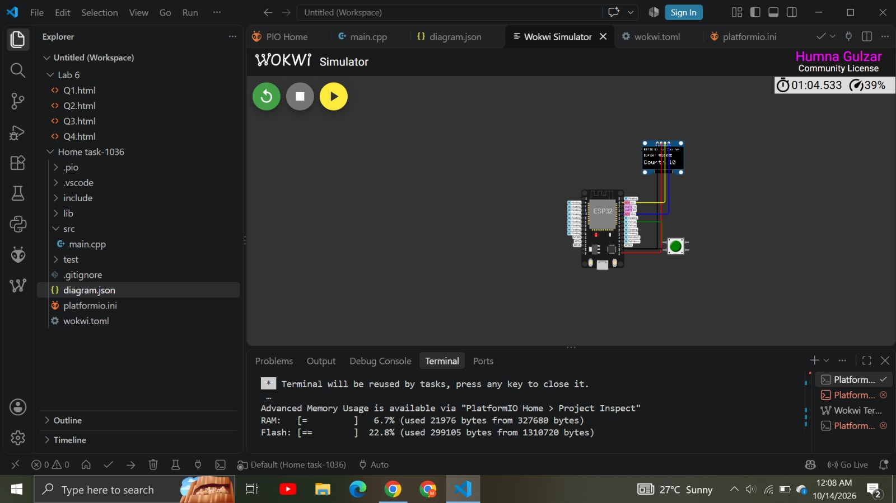
1036_W1_WokwiCircuit.png

OLED with title, status and a NON-ZERO count, plus the circuit:

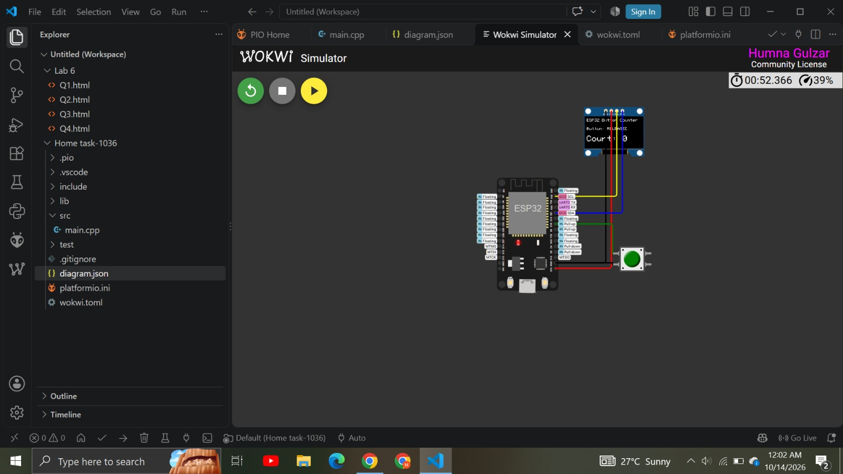
1036_W2_WokwiCircuit.png

Project files (platformio.ini, src/main.cpp, diagram.json, wokwi.toml) and the SUCCESS build message

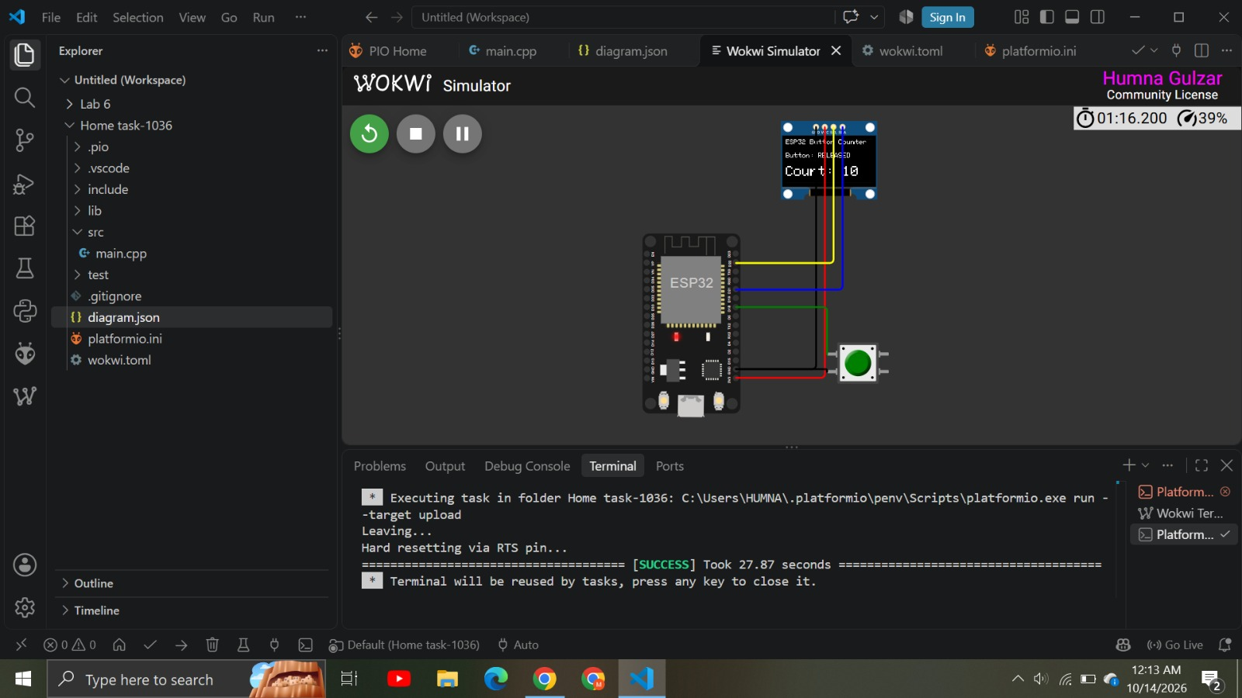

1036_W3_WokwiCircuit.png

5.2 Physical hardware evidence:

Real ESP32 kit, OLED and button with the wiring clearly visible

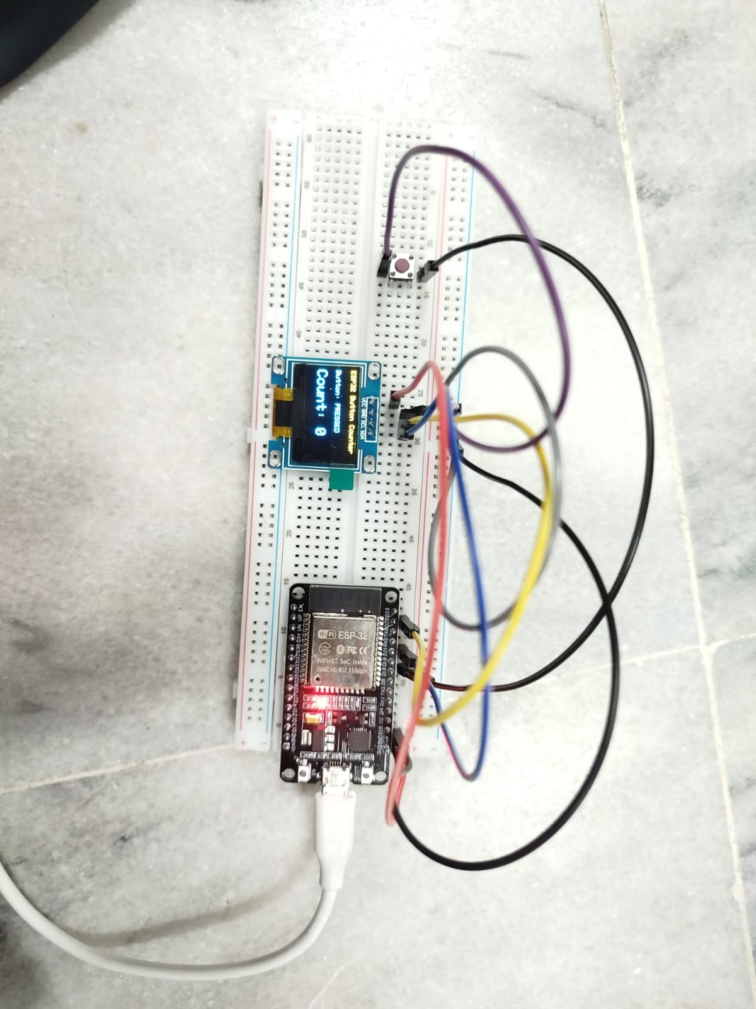

1036_H1_HardwareSetup.jpeg

Real OLED showing the project and a NON-ZERO count, with enough of the kit visible

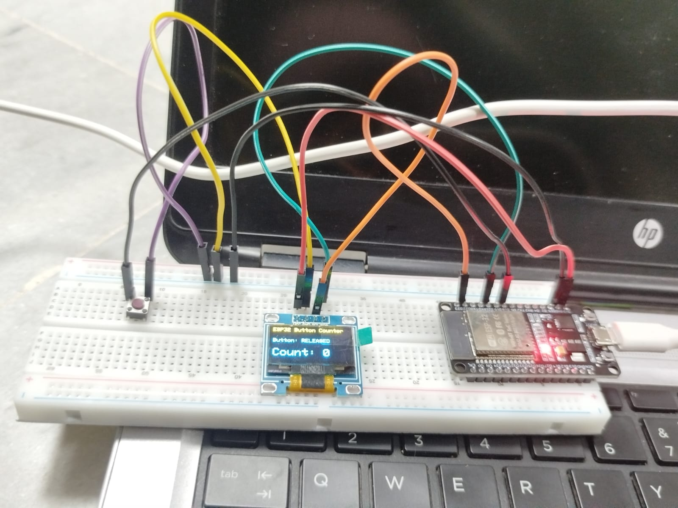

1036_H2_HardwareSetup.jpeg

Serial Monitor after several presses showing the accepted press count (include the application window)

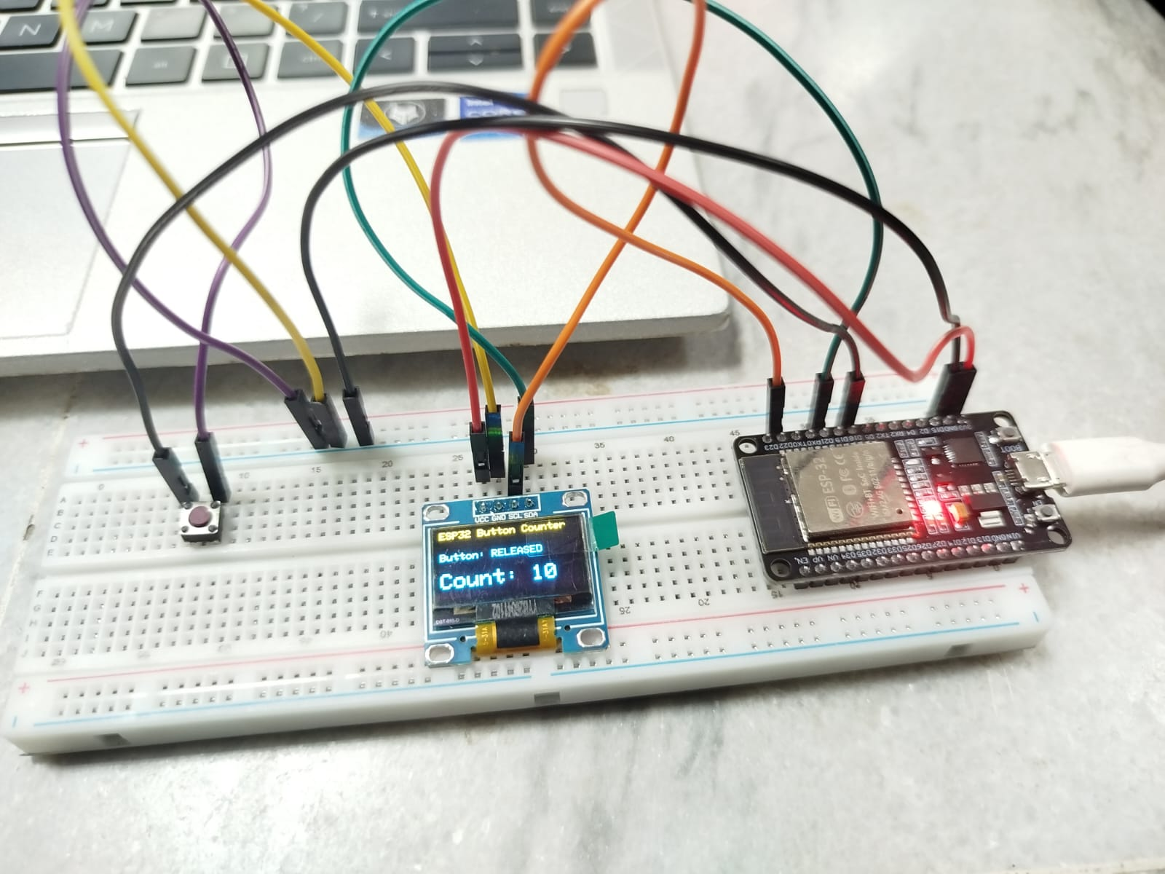

1036_H3_HardwareSetup.jpeg

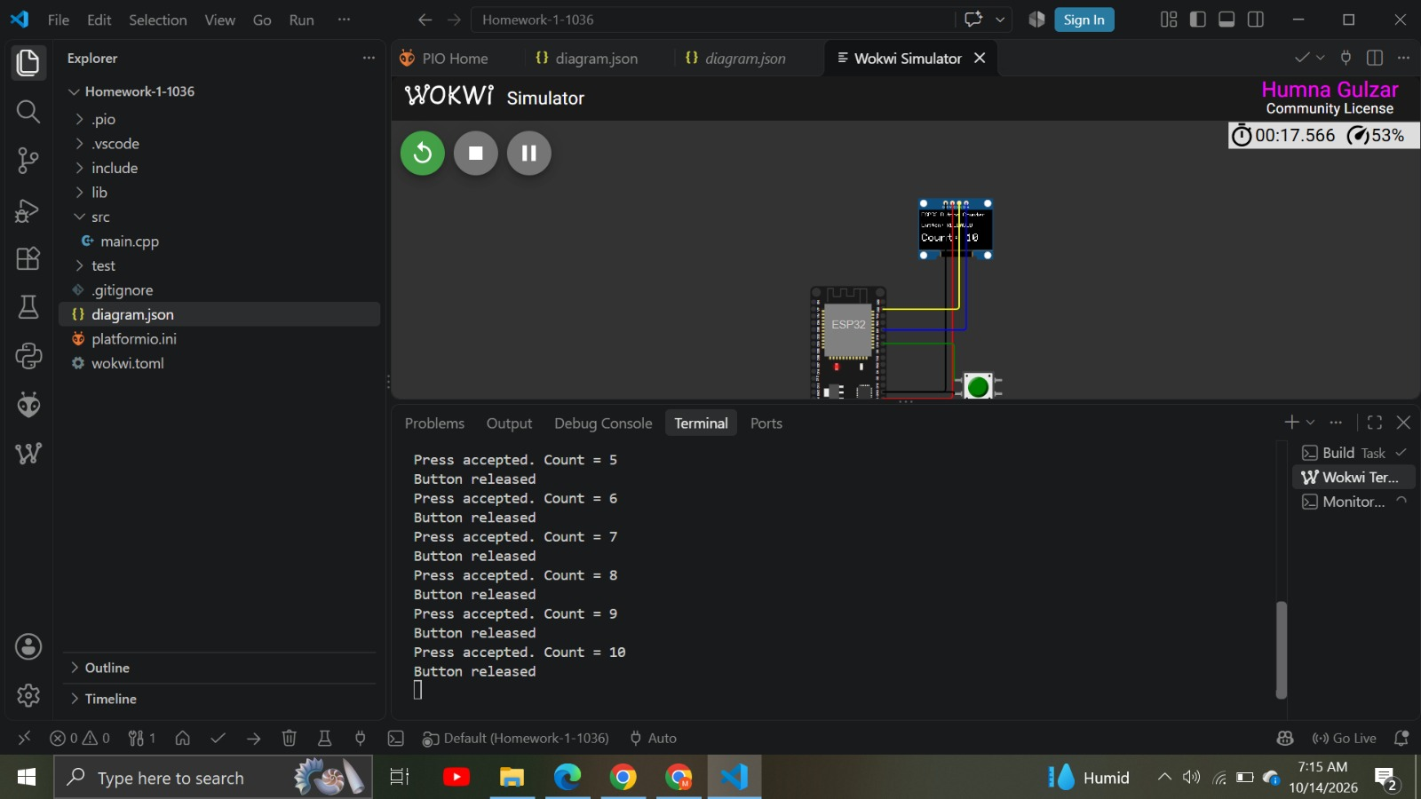

Summary:

Environment | Presses | Expected final count | Observed final count | Pass?
Wokwi | 10 | 10 | 10 | yes
Hardware | 10 | 10 | 10 | yes

. Comparison of Simulation and Hardware, Issues and Fixes

Cost, Scalability, and Deployment Overhead:
IoT simulation provides a highly cost-effective and scalable environment where thousands of virtual edge devices, network gateways, and cloud endpoints can be deployed instantly without physical hardware expenses. In contrast, testing on physical IoT hardware incurs significant costs, wiring complexity, and logistical limits when scaling up. A primary issue in physical deployments is the severe difficulty of manually managing, updating, and scaling hardware across distributed locations. The fix is to use simulation platforms during the initial design and stress-testing phases to validate network topology and protocols before committing capital to hardware procurement.
• Environmental Fidelity and the "Reality Gap":
Hardware provides absolute real-world accuracy, capturing physical anomalies such as signal degradation, thermal variations, radio frequency (RF) interference, and battery depletion. Conversely, simulation tools often rely on ideal physical-layer models that fail to mimic harsh operational conditions. This disconnect leads to the "reality gap" issue, where algorithms that function perfectly in software crash or drop packets when flashed onto real microcontrollers. The fix is to implement Hardware-in-the-Loop (HIL) hybrid testing and introduce stochastic noise models into simulators to approximate real-world channel fading and interference.
• Debugging Capabilities and Firmware Reliability:
Simulators excel at diagnostics, allowing developers to pause execution, inspect virtual memory, trace packet flows, and debug firmware logic without hardware access. Debugging physical IoT hardware is significantly harder, requiring logic analyzers, serial monitors, and physical JTAG interfaces. A critical issue on physical hardware is the risk of "bricking" a remote device during Over-The-Air (OTA) firmware updates due to sudden power loss or corrupted packet delivery. The fix is to enforce dual-partition (A/B) memory architectures on physical nodes so devices automatically roll back to a known stable firmware version if an update fails.
• Power Management and Network Resiliency:
In simulated environments, power supplies are assumed constant unless programmed otherwise, whereas edge hardware relies on strictly limited battery capacity and variable wireless link quality. The main issue with real-world deployments is rapid battery drain caused by unoptimized transmission cycles or silent data loss when local gateways disconnect. The fix involves programming microcontrollers with aggressive deep-sleep states and wake-up interrupts, utilizing lightweight protocols like MQTT-SN or CoAP, and implementing local flash-memory buffering so nodes store data locally during network outages and sync upon reconnection.

GitHub repository link:

_______________________________________

