“FakeGuard AI: Detection of Deceptive Online Reviews Using Machine Learning and Behavioral Analysis”

Table of Contents

Sr no. |  | Contents | Page no.
 |  | Abstract
1 |  | Introduction
 | 1.1 | Overview | 2
 | 1.2 | Motivation | 2
 | 1.3 | Problem Statement | 3
 | 1.4 | Research Objectives | 4
2 |  | Literature Review | 5
3 |  | Dataset | 8
4 |  | Propose Methodology and Architecture
 | 4.1 | Data Collection and Preprocessing | 12
 | 4.2 | Exploratory Data Analysis | 13
 | 4.3 | Model Development | 13
 | 4.5 | Model Evaluation and Validation | 13
 | 4.6 | Insight Generation and Reporting | 14
 | 4.7 | Architecture Diagram | 15
 |  | Implementation and Results
5 | 5.1 | Implementation | 17
 | 5.2 | Results and Discussion | 28
 |  | Conclusion and Future Scope
6 | 6.1 | Conclusion | 30
 | 6.2 | Future Scope | 30
 |  | References | 31

List of Figures

Fig no. | Title | Page no.
3.1 | Word Distribution | 08
3.2 | Review Length Distribution | 09
3.3 | Sentiment Distribution | 09
4.1 | Architecture Diagram | 15
5.1 | Home Page | 18
5.2 | Prediction Result | 20
5.3 | Analyzed Review | 21
5.4 | Ensemble Trust Guage | 22
5.5 | Sentiment Analysis | 23
5.6 | LSTM Analysis | 23
5.7 | Recommendation Panel | 24
5.8 | Dashboard Overview | 25
5.9 | Pie Chart | 25
5.10 | Bar Chart | 26
5.11 | Most Frequent Words | 27
5.12 | Histogram | 27
5.13 | Model Comparison Table | 28

ABSTRACT

The main goal of this project is to develop a reliable system for detecting deceptive or fake reviews on online platforms by using machine learning and natural language processing techniques. Online reviews play an important role in influencing customer decisions, but the presence of misleading or spam reviews reduces the trustworthiness of such systems. This project aims to address this issue by identifying patterns in review text, sentiment, and user behavior to classify reviews as genuine or fake.
In this project, “FakeGuard AI: Fake Review Detection System,” various machine learning and deep learning algorithms have been implemented to improve the accuracy of classification. The system uses textual features such as TF-IDF and n-grams, sentiment analysis to understand emotional polarity, and behavioral features such as reviewer activity patterns. Models such as Logistic Regression, Support Vector Machine (SVM), Random Forest, and deep learning models like LSTM have been explored to analyze review data effectively.
In this project, “FakeGuard AI: Fake Review Detection System,” various machine learning and deep learning algorithms have been implemented to improve the accuracy of classification. The system uses textual features such as TF-IDF and n-grams, sentiment analysis to understand emotional polarity, and behavioral features such as reviewer activity patterns. Models such as Logistic Regression, Support Vector Machine (SVM), Random Forest, and deep learning models like LSTM have been explored to analyze review data effectively.
Keywords: Fake Review Detection, Machine Learning, Natural Language Processing, Sentiment Analysis, Behavioral Analysis, Deep Learning, Text Classification, Explainable AI

CHAPTER 1
1. Introduction
Online platforms have become a primary source of information for users when making decisions about products and services, where online reviews significantly influence consumer behavior [1], [2]. Reviews shared by customers provide insights into product quality, performance, and user satisfaction. With the rapid growth of e-commerce and digital services, the influence of online reviews has increased significantly. Consumers often rely on these reviews before making purchasing decisions, making them a critical component of modern digital ecosystems.
However, the openness of review systems has also led to the emergence of fake or deceptive reviews, which are intentionally created to mislead users [3], [5].These reviews are intentionally created to mislead users by promoting certain products or damaging the reputation of competitors. Such practices reduce the credibility of online platforms and create challenges for both consumers and businesses. The presence of fake reviews not only affects user trust but also impacts the overall fairness of digital marketplaces.
Traditional methods of detecting fake reviews, such as manual moderation, are no longer sufficient due to the large volume of data generated daily, leading to the adoption of machine learning approaches [6], [11]. This has led to the adoption of automated approaches using machine learning and natural language processing techniques. These methods analyze review content, sentiment, and user behavior to identify patterns associated with deceptive reviews. By leveraging these techniques, it is possible to build systems that can efficiently classify reviews and improve the reliability of online platforms.
This project focuses on developing an intelligent system for fake review detection using a combination of machine learning, deep learning, and feature engineering techniques. The system aims to analyze textual and behavioral patterns to accurately distinguish between genuine and fake reviews. Additionally, it provides explainable outputs to help users understand the reasoning behind predictions, making the system more transparent and user-friendly.

Overview

The main objective of this project is to design and implement a system that can automatically detect fake reviews using advanced data analysis techniques. The process begins with collecting and preparing a dataset of reviews, which includes both textual content and associated metadata such as ratings and user activity. Data preprocessing techniques are applied to clean and normalize the dataset, ensuring that it is suitable for analysis [4], [11].

Feature engineering is then performed to extract meaningful information from the data. This includes generating textual features using techniques such as TF-IDF and n-grams, extracting sentiment scores to understand the emotional tone of reviews, and analyzing behavioral patterns such as reviewer activity and rating distribution. These features are widely used in fake review detection systems to improve classification performance [8], [19].

The system evaluates the performance of these models using appropriate metrics and selects the most effective approach for classification. In addition to prediction, the system integrates a web-based interface that allows users to input reviews and view results in an interactive manner. The inclusion of explainable AI techniques enables the system to provide insights into how decisions are made, enhancing user trust and usability [16].

Overall, the project aims to provide a practical solution for improving the reliability of online review systems by combining data processing, machine learning, and user-friendly design.

Motivation

In today’s digital environment, online reviews have become a key factor influencing consumer decisions [1], [2] across various platforms such as e-commerce websites, travel portals, and service-based applications. Users often depend on these reviews to evaluate the quality and reliability of products or services before making a purchase. However, the increasing presence of fake or misleading reviews [5], [12] has created serious concerns regarding the trustworthiness of such platforms. These deceptive reviews can manipulate customer perception, leading to unfair advantages for certain products and potential losses for consumers.

The challenge lies not only in the large volume of review data but also in the evolving nature of deceptive practices. Spammers continuously modify their writing styles and behavioral patterns to avoid detection, making it difficult for traditional rule-based systems to identify fake reviews effectively. Manual verification methods are time-consuming and impractical at scale, highlighting the need for automated and intelligent solutions.

This project is motivated by the need to develop a system that can accurately identify fake reviews using advanced machine learning and natural language processing techniques. By analyzing both the textual content of reviews and the behavior of users, the system aims to detect hidden patterns that indicate deceptive activity. Additionally, the integration of explainable AI helps in providing transparent and understandable results, which is essential for building user trust.

The ultimate goal of this project is to bridge the gap between raw review data and meaningful insights, enabling users and businesses to make informed decisions. By improving the reliability of online review systems, the project contributes to creating a more trustworthy digital ecosystem.

1.3 Problem Statement

The rapid growth of online platforms has led to a significant increase in user-generated reviews, which play a crucial role in influencing consumer decisions. However, the presence of fake or deceptive reviews has become a major challenge [1], [3], as these reviews are intentionally created to mislead users by promoting certain products or damaging the reputation of others. This results in reduced trust in online systems and can lead to incorrect decision-making by consumers.

Traditional methods of detecting fake reviews, such as manual moderation or simple rule-based approaches, are not effective in handling large volumes of data and evolving spam techniques. Deceptive reviews are often designed to closely resemble genuine ones, making them difficult to identify using basic text analysis [7], [9]. In addition, relying solely on textual content without considering reviewer behavior further limits the effectiveness of detection systems.

Therefore, there is a need to develop an efficient and automated system that can accurately detect fake reviews by analyzing multiple aspects of the data. This includes understanding the textual patterns within reviews, evaluating sentiment, and identifying abnormal behavioral patterns of users. The system should also be scalable to handle large datasets and adaptable to new types of deceptive strategies.

The objective of this project is to design and implement a robust fake review detection system that combines machine learning, natural language processing, and behavioral analysis to improve classification accuracy and enhance the reliability of online review platforms.

  - . Research Objectives

The research objective of work are as follows:

- Data Preprocessing and Cleaning: To prepare the review dataset by handling missing values, removing noise, and normalizing textual data to ensure accurate analysis and model performance.
- Feature Extraction and Engineering: To extract meaningful features from review data, including textual features (TF-IDF, n-grams), sentiment-based features, and behavioral features such as reviewer activity and rating patterns.
- Development of Machine Learning Models: To design and implement various machine learning algorithms such as Logistic Regression, Support Vector Machine (SVM), and Random Forest for classifying reviews as genuine or fake.
- Application of Deep Learning Techniques: To explore deep learning models such as Long Short-Term Memory (LSTM) networks for capturing contextual relationships within review text and improving classification accuracy.
- Model Evaluation and Performance Analysis: To evaluate the performance of different models using metrics such as Accuracy, Precision, Recall, and F1-score, and to compare their effectiveness in detecting fake reviews.
- Integration of Explainable AI: To incorporate explainable AI techniques that provide insights into model predictions, helping users understand the reasoning behind classification results.
- Development of User Interface: To build a web-based system that allows users to input reviews and receive predictions along with confidence scores and analytical insights.
- Insight Generation and Decision Support: To generate meaningful insights from the analysis that can help users and businesses make informed decisions based on reliable review data.

CHAPTER 2
2. Literature Review

This section presents an overview of the research work carried out in the domain of fake review detection, focusing on machine learning, deep learning, and feature-based approaches. Several researchers have proposed different techniques to identify deceptive reviews, each contributing to improving detection accuracy while also revealing certain limitations.
Jindal and Liu (2007) [1] introduced one of the earliest approaches for detecting review spam by analyzing duplicate and near-duplicate reviews. Their work laid the foundation for identifying deceptive patterns in textual data. However, their approach mainly focused on content similarity and did not consider reviewer behavior, which limits its effectiveness in more complex scenarios.
Ott et al. (2011) [2] explored the use of linguistic features to detect deceptive opinion spam. They used supervised learning techniques to classify reviews based on writing style and textual patterns. Although their model achieved good accuracy, it relied heavily on controlled datasets, making it less effective for real-world applications.
Mukherjee et al. (2013) [3] proposed a behavioral analysis approach by studying reviewer activity patterns such as posting frequency and rating behavior. Their findings showed that incorporating behavioral features significantly improves detection performance. However, their method requires detailed user data, which may not always be available.
Elmogy et al. (2021) [4] applied supervised machine learning algorithms such as Support Vector Machines and Decision Trees for fake review detection. Their study demonstrated that combining multiple features enhances classification accuracy. Despite this improvement, the approach still depends on manual feature engineering, which can be time-consuming.
Asaad et al. (2023) [5] explored machine learning-based detection methods using textual and statistical features. Their work highlighted the importance of feature selection in improving model performance. However, the study did not extensively explore deep learning techniques, leaving scope for further enhancement.
Ren and Ji (2017) [6] introduced neural network-based approaches for detecting deceptive reviews. Their study demonstrated that deep learning models can capture contextual relationships in text more effectively than traditional methods. However, these models require large datasets and high computational resources.
Kim (2014) [7] proposed convolutional neural networks (CNNs) for sentence classification, which have been widely adopted in text-based applications. CNN models can extract meaningful patterns from textual data, but they may not fully capture long-term dependencies in review content.
Budhi et al. (2021) [8] proposed a hybrid approach combining textual and behavioral features for detecting fake reviews. Their study showed that integrating multiple feature types leads to improved performance and robustness. However, the complexity of combining different features can increase computational cost.
Ennaouri and Zellou (2023) [9] conducted a systematic literature review on machine learning approaches for fake review detection. Their work summarized existing techniques and highlighted key challenges such as dataset limitations and lack of generalization across domains.
Wu et al. (2020) [10] provided a comprehensive overview of fake review detection methods and identified future research directions. Their study emphasized the importance of combining multiple techniques and developing scalable systems for real-world applications.
The summarization of above research is in table 2.1.

Table 2.1. Summary of Existing Research in Fake Review Detection

Author(s) | Methodology | Identified Gap
Jindal & Liu (2007) | Duplicate review detection | Lack of behavioral analysis
Ott et al. (2011) | Linguistic feature-based ML | Linguistic feature-based ML
Mukherjee et al. (2013) | Behavioral pattern analysis | Requires user data
Elmogy et al. (2021) | Supervised ML models | Manual feature dependency
Asaad et al. (2023) | Text + statistical features | Limited deep learning usage
Ren & Ji (2017) | Neural networks | High computational cost
Kim (2014) | CNN for text classification | Limited long-term context
Budhi et al. (2021) | Hybrid approach | Increased complexity
Ennaouri (2023) | Literature survey | Dataset limitations
Wu et al. (2020) | Comprehensive survey | Comprehensive survey

CHAPTER 3
A dataset is a structured collection of data used for analysis and model development. In the context of fake review detection, the dataset consists of user-generated reviews along with associated metadata such as ratings, timestamps, and reviewer information. These datasets play a crucial role in training machine learning models [11], [14] to distinguish between genuine and deceptive reviews.

For this project, a dataset containing online reviews was used, which includes both genuine and fake reviews. The dataset may be collected from publicly available sources such as e-commerce platforms, review websites, or benchmark datasets used in research. It contains both structured and unstructured data, where the review text represents unstructured data and other attributes such as ratings and user activity represent structured data.

Fake Review Dataset Description

The dataset used for fake review detection provides a comprehensive view of review content and user behavior. It includes various attributes that help in identifying patterns associated with deceptive reviews.

1. Primary Attributes:

- Review Text: The main textual content of the review provided by the user.
- Label: Indicates whether the review is genuine or fake.
- Rating: Numerical value representing user feedback (e.g., 1 to 5 stars).
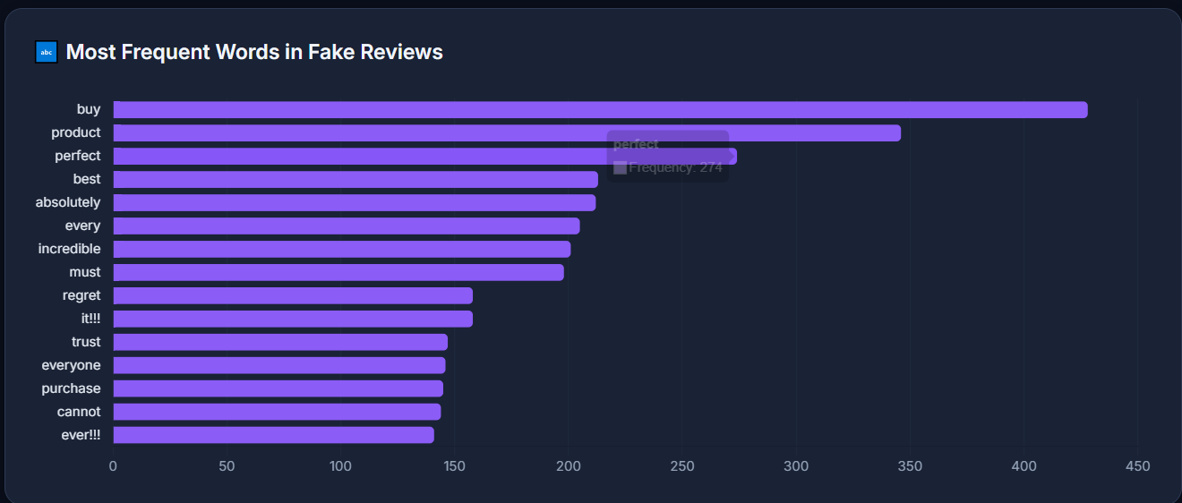
- Reviewer ID: Unique identifier for each user.
Figure 3.1. Word Distribution
2. Textual Features:

- Word Count: Total number of words in a review.
- N-grams: Sequences of words used to capture writing patterns.
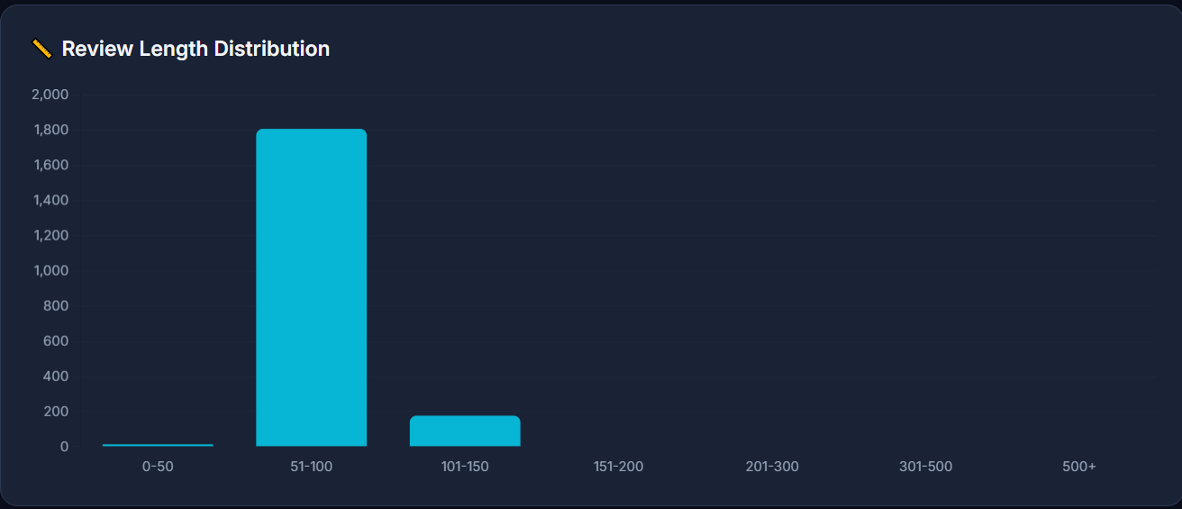
- TF-IDF Scores: Represent importance of words in the dataset.
Figure 3.2. Review Length Distribution

3. Sentiment-Based Features:

- Polarity Score: Measures whether the sentiment is positive, negative, or neutral.
- Subjectivity Score: Indicates whether the review is opinion-based or factual.
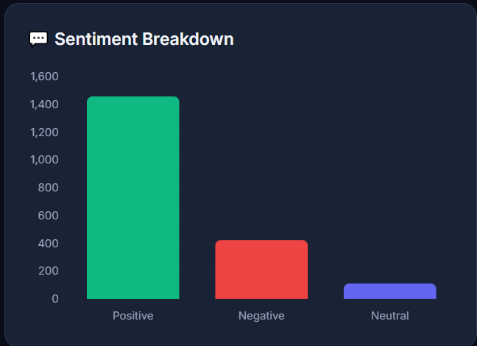
Figure 3.3. Sentiment Distribution

4. Behavioral Features:

- Review Frequency: Number of reviews posted by a user in a given time.
- Rating Pattern: Distribution of ratings given by a reviewer.
- Duplicate Reviews: Repetition of similar content across multiple reviews.
Behavioral features provide strong indicators [8] of suspicious activity.

- Key Characteristics:

- The dataset contains both textual and numerical features.
- It includes a binary classification target (fake or genuine).
- The dataset may contain imbalanced classes, where genuine reviews outnumber fake ones.
- Presence of noise and inconsistencies in textual data.

- Data Quality and Challenges:

- Missing Values: Some fields may be incomplete and require preprocessing.
- Imbalanced Data: Unequal distribution of fake and genuine reviews affects model performance.
- Text Noise: Presence of stopwords, punctuation, and irrelevant content.
- Data Diversity: Reviews may vary across different domains and platforms.

- Potential Use Cases:

- Fake Review Detection: Classifying reviews as genuine or deceptive.
- Sentiment Analysis: Understanding customer opinions and emotions.
- Trust Evaluation: Improving credibility of online platforms.
- Business Decision Support: Helping businesses analyze customer feedback.

- Metadata and Documentation:

- Data Dictionary: Description of each attribute in the dataset.
- Schema Information: Details about data types and structure.
- Source Information: Origin of the dataset used for analysis.

- Applications:

E-commerce Platforms

Helps in filtering fake reviews and improving user trust.

Product Analysis

Provides insights into customer feedback and product performance.

Fraud Detection Systems

Identifies suspicious user behavior and spam activity.

Recommendation Systems

Improves recommendation accuracy by removing biased reviews.

Market Analysis
Helps businesses understand trends and customer preferences.

CHAPTER 4

4. Methodology:

The methodology of this project focuses on designing an effective system for detecting fake reviews using a combination of data preprocessing, feature engineering, machine learning, and deep learning techniques. The process begins with collecting and preparing review data, followed by extracting meaningful features and building predictive models to classify reviews as genuine or fake. The final stage involves evaluating model performance and generating insights that help in understanding the results.
The proposed approach integrates textual analysis, sentiment evaluation, and behavioral pattern analysis to improve detection accuracy. By combining these aspects, the system aims to capture both the content and context of reviews, making it more robust against deceptive practices. Each stage of the methodology contributes to building a reliable and scalable fake review detection system.
  - Data Collection and Preprocessing:

- Data Collection:

- Collect review data from online platforms such as e-commerce websites, review portals, or publicly available datasets.
- The dataset includes review text, ratings, user information, and labels indicating whether a review is genuine or fake.

- Data Preprocessing:
- Data Cleaning: Remove unnecessary characters, stopwords, and noise from textual data.
- Handling Missing Values: Fill or remove missing data to ensure dataset consistency.
- Text Normalization: Convert text to lowercase, apply stemming or lemmatization.
- Tokenization: Break text into individual words or tokens for analysis.
- Encoding: Convert categorical variables into numerical form using techniques like Label Encoding or One-Hot Encoding.

  - Exploratory Data Analysis (EDA):

- Descriptive Analysis: Understand dataset structure, distribution, and key statistics.
- Text Analysis: Analyze word frequency, review length, and common phrases
- Sentiment Analysis: Evaluate polarity distribution across reviews.
- Visualization: Use histograms, bar charts, and word clouds to identify patterns.
- Correlation Analysis: Identify relationships between features such as rating and sentiment.
EDA helps in understanding the dataset and identifying important features for model development.

Model Development
Machine Learning Models:
- Logistic Regression
- Support Vector Machine (SVM)
- Random Forest [11], [12]
These models are trained using extracted features such as TF-IDF, n-grams, and statistical attributes.

Deep Learning Models:
- Long Short-Term Memory (LSTM)
LSTM models capture sequential dependencies [6] and contextual information in review text, improving classification performance.

Feature Integration:
- Combine textual, sentiment, and behavioral features to improve accuracy.
- Use feature selection techniques to identify the most important attributes.

Model Evaluation and Validation

Train-Test Split: Divide dataset into training and testing sets.
Evaluation Metrics:
- Accuracy
- Precision
- Recall
- F1-score
Cross-Validation: Ensure model stability and avoid overfitting.
Performance Comparison: Compare different models to select the best-performing one.

Insight Generation and Reporting
- Analyze model predictions to identify key factors influencing classification.
- Generate insights such as:
  - Patterns in fake reviews
  - Impact of sentiment on classification
  - Behavioral trends of suspicious users
- Present results using visualizations and summaries.

Architecture Diagram
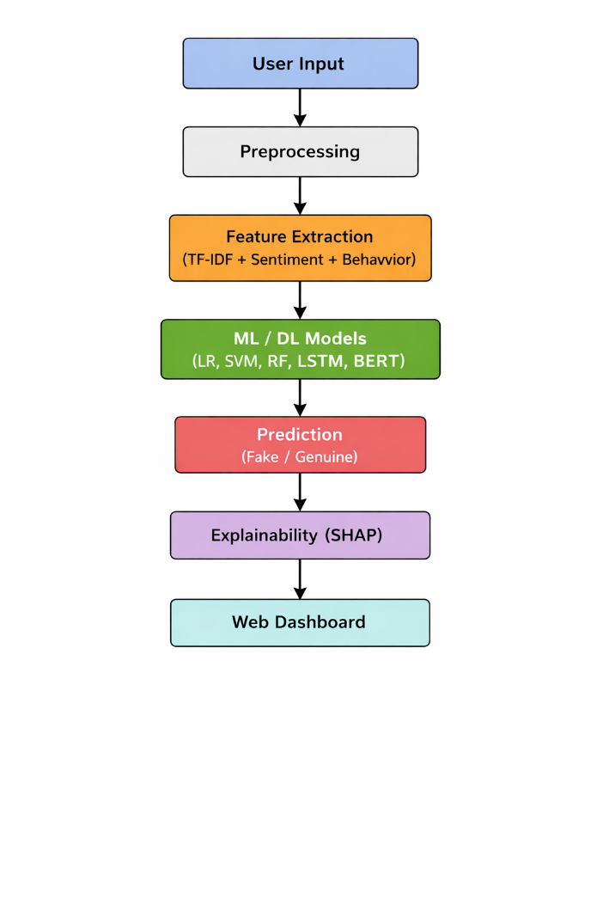

Figure 4.1. Architecture Diagram

The architecture description is as follows:

- Data Collection and Preprocessing:

Raw review data is collected and cleaned to remove inconsistencies and noise. Preprocessing ensures that the data is suitable for analysis.

- Feature Extraction:
Textual, sentiment, and behavioral features are extracted from the dataset to represent review characteristics.

- Model Development:
Machine learning and deep learning models are trained using extracted features to classify reviews.

- Insight Generation:

The system generates meaningful insights and explanations to help users understand the results.

CHAPTER 5
5.1 Implementation

The FakeGuard AI system is implemented as a full-stack web application that combines machine learning, deep learning, and explainable AI techniques to detect deceptive reviews. The implementation focuses on transforming raw textual input into meaningful predictions and insights through a structured pipeline consisting of preprocessing, feature extraction, model inference, and visualization. The system is designed to be interactive, scalable, and user-friendly, allowing users to easily analyze reviews in real time.

User Interface Design

The user interface plays a crucial role in ensuring usability and accessibility of the system. The application is designed using a modern dark-themed layout, which improves readability and enhances user experience.
The interface is divided into two primary sections:
- Detector Module:
This module allows users to input review text and obtain predictions. It includes a text input box, an analysis button, and a result display panel. The layout is clean and intuitive, enabling users to interact with the system without technical knowledge.

- Dashboard Module:
This module provides visual insights derived from the dataset. It includes charts, graphs, and performance metrics that help in understanding patterns in fake and genuine reviews.
The navigation between modules is seamless, ensuring smooth interaction across different functionalities.

Review Input and Detection Module
The detection module is the core component of the system where user interaction begins.


Figure 5.1. Home Page
When a user enters a review into the input box and clicks the “Analyze Review” button, the system performs the following operations:
- Text Preprocessing:
The input text is cleaned by removing unnecessary symbols, converting it to lowercase, and eliminating stopwords. This ensures that the text is standardized before analysis.

- Feature Transformation:
The processed text is converted into numerical form using techniques such as TF-IDF vectorization. This allows machine learning models to interpret textual data.

- Model Prediction:
The transformed input is passed through multiple trained models to generate predictions.
The system processes the input efficiently and returns results in real time, ensuring a smooth user experience.
- Model Integration
To improve prediction accuracy and reliability, the system integrates multiple models, each contributing to the final decision.
- Logistic Regression:
A simple yet effective linear model used as a baseline classifier.
- Random Forest:
An ensemble model that combines multiple decision trees to improve accuracy and reduce overfitting.
- Support Vector Machine (SVM):
A powerful classifier that separates data using optimal hyperplanes.
- LSTM (Deep Learning Model):
Captures sequential dependencies and contextual relationships in text data.
- BERT (Transformer-based Model):
Provides advanced contextual understanding of language.
These models are combined using an ensemble approach, where the final prediction is based on consensus among models. This significantly enhances robustness and reduces individual model bias.

- Prediction Output
After processing the input, the system displays the prediction in a clear and visually appealing format.

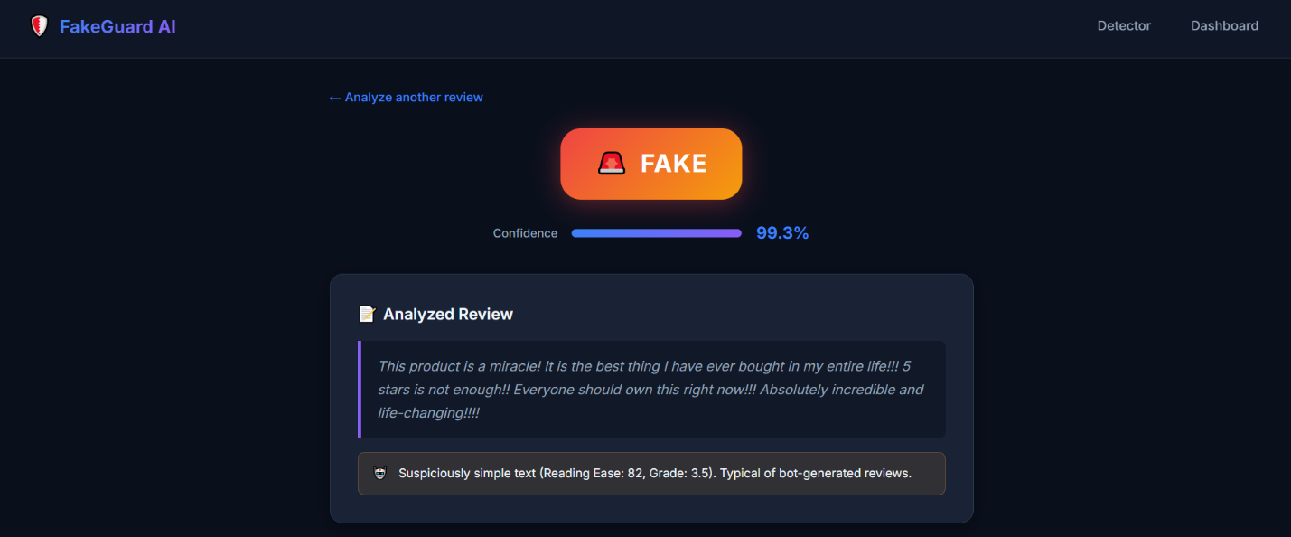

Figure 5.2. Prediction Result
The output includes:
- Prediction Label: Indicates whether the review is FAKE or GENUINE
- Confidence Score: Represents the probability of the prediction
For example, a review may be classified as FAKE with 99.3% confidence, indicating a high level of certainty. The use of visual indicators such as colors and icons improves interpretability for users.

- Explainable AI Integration
One of the key features of the system is the integration of explainable AI, which provides transparency in decision-making.
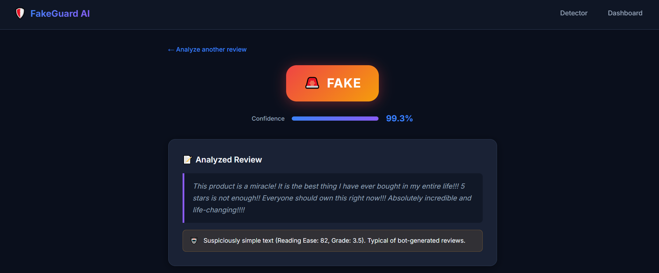
Figure 5.3. Analyzed Review
Instead of simply displaying predictions, the system explains why a review is classified as fake or genuine. This includes:
- Identification of overly simple or repetitive text
- Detection of exaggerated sentiment patterns
- Analysis of linguistic characteristics
These explanations help users understand the reasoning behind predictions, making the system more trustworthy and practical for real-world use.
- Ensemble Trust Analysis
To further enhance reliability, the system includes an ensemble trust mechanism.
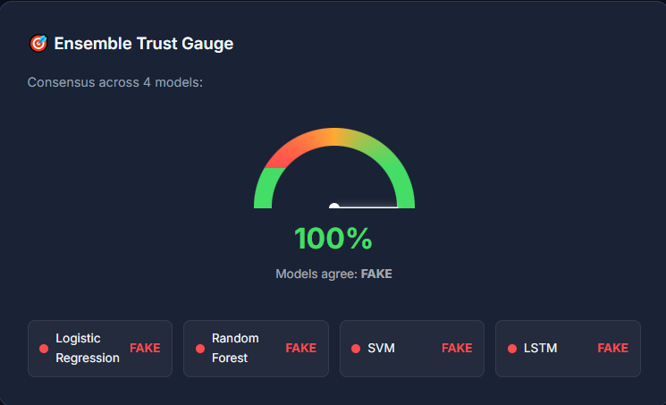
Figure 5.4. Ensemble Trust Guage
- Displays agreement among multiple models
- Shows consensus percentage
- Highlights individual model predictions
For example, if all models agree on a prediction, the system displays 100% agreement, indicating high confidence. This feature ensures that predictions are not dependent on a single model.
- Sentiment Analysis Module
The system also performs sentiment analysis to evaluate the emotional tone of reviews.
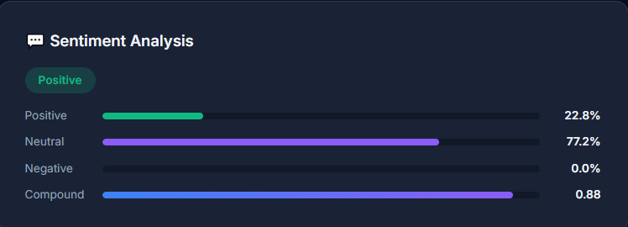
Figure 5.5. Sentiment Analysis
- Sentiment categories include:
  - Positive
  - Neutral
  - Negative
  - Compound score
Fake reviews often exhibit extreme sentiment, such as overly positive or overly negative expressions. By analyzing sentiment, the system gains additional context for classification.
- Deep Learning Analysis
The LSTM-based deep learning model provides an independent analysis of the input review.

Figure 5.6. LSTM Analysis
- Captures contextual relationships in text
- Provides separate confidence score
- Helps compare performance with traditional models
Although deep learning models require more computational resources, they offer deeper insights into textual patterns.

- Expert Recommendation System
The system includes an intelligent recommendation component that provides additional insights.
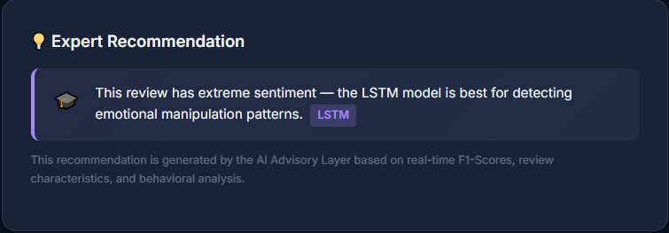
Figure 5.7. Recommendation Panel
- Suggests which model is most reliable for a given input
- Highlights patterns such as emotional manipulation
- Provides user-friendly explanations
This feature enhances the interpretability of the system and helps users make informed decisions.
- Analytics Dashboard

The dashboard provides a comprehensive overview of the dataset and model performance. It helps in visualizing trends and understanding key characteristics of fake and genuine reviews.



Figure 5.8. Dashboard Overview

- Dataset Summary
The dataset used in the system consists of:
- Total Reviews: 2000
- Genuine Reviews: 1000
- Fake Reviews: 1000
The balanced distribution ensures fair training and evaluation of models.

- Fake vs Genuine Distribution
The distribution of reviews is visualized using a pie chart.
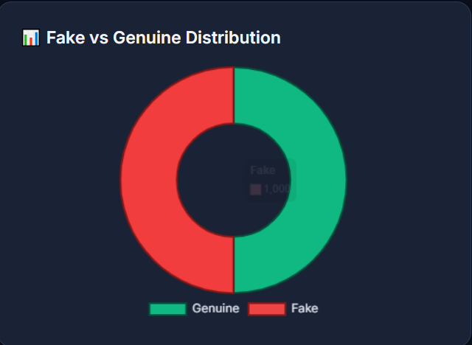
Figure 5.9. Pie Chart
- Shows proportion of fake and genuine reviews
- Helps in understanding dataset balance
- Confirms absence of class imbalance issues

- Sentiment Breakdown
The sentiment distribution is displayed using a bar chart.
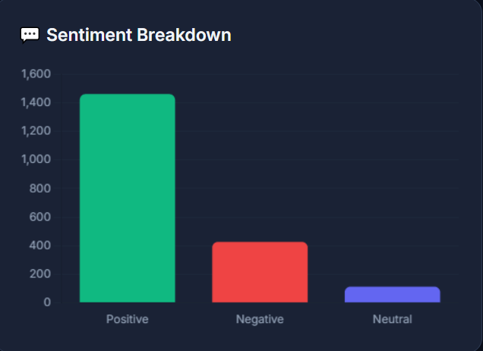
Figure 5.10. Bar Chart
- Positive reviews dominate the dataset
- Negative and neutral reviews provide contrast
- Helps identify emotional trends
- Word Frequency Analysis
The system analyzes frequently used words in fake reviews.
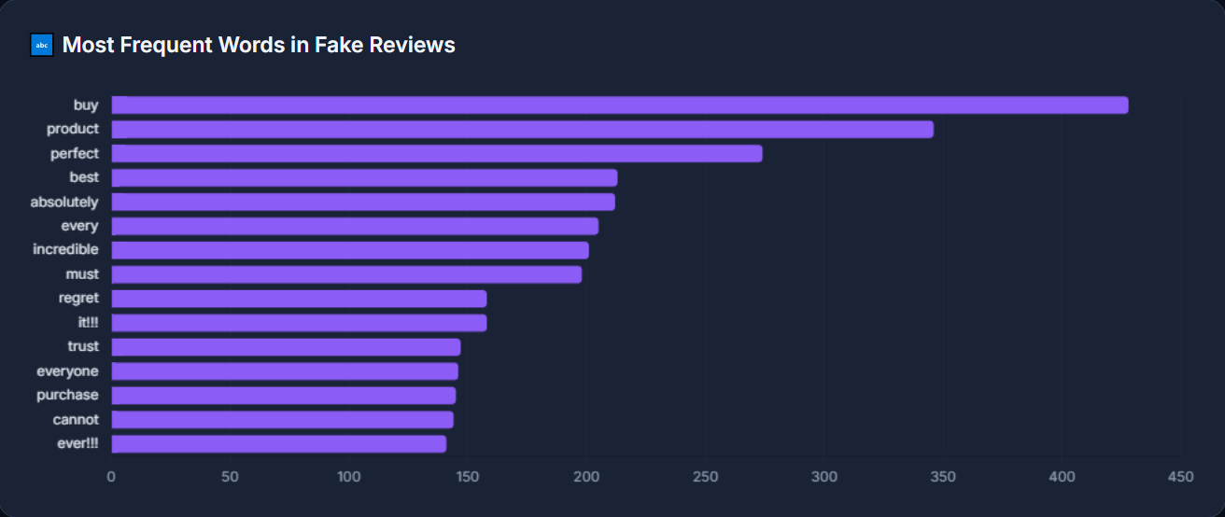
Figure 5.11. Most Frequent Words
- Common words include:
  - “buy”
  - “best”
  - “perfect”
  - “amazing”
These words indicate promotional or exaggerated language often found in fake reviews.
- Review Length Distribution
The distribution of review lengths is analyzed using histograms.
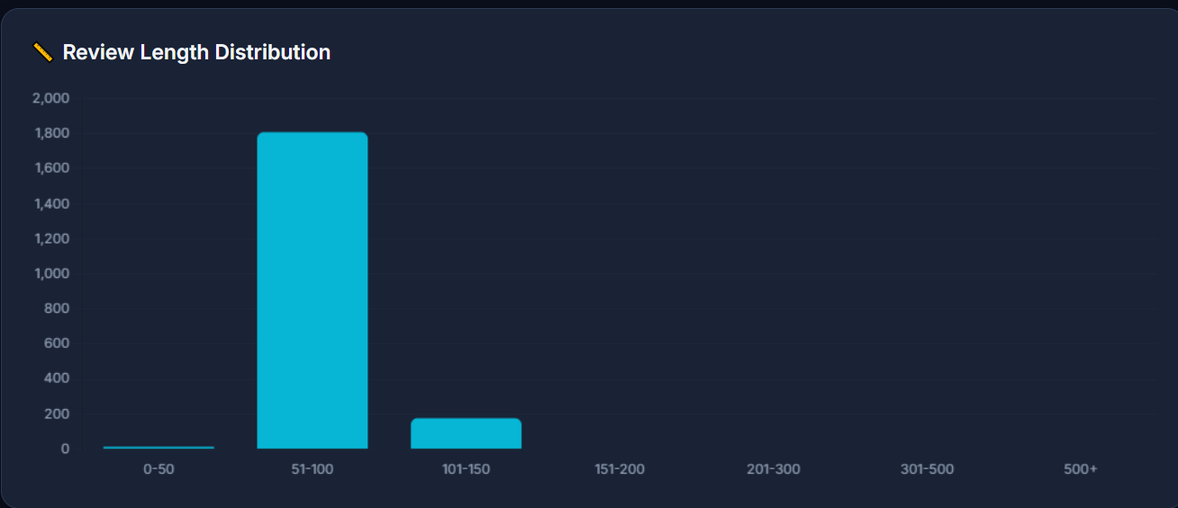
Figure 5.12. Histogram
- Fake reviews often fall within specific length ranges
- Short and overly long reviews may indicate suspicious behavior
- Helps in identifying structural patterns
- Model Performance Comparison
The system compares performance of different models using evaluation metrics.
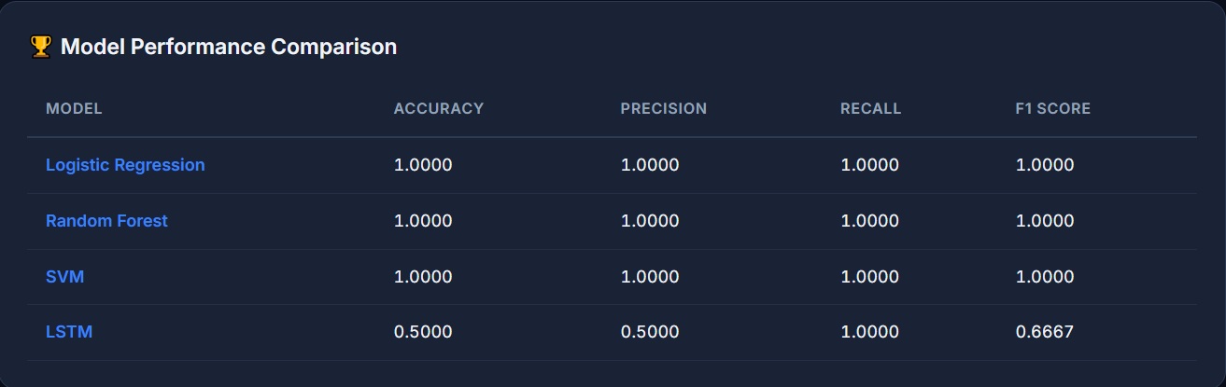
Figure 5.13. Model Comparison Table
- Machine learning models achieved near-perfect accuracy
- LSTM showed moderate performance due to limited training data
This comparison helps in selecting the most suitable model for deployment.

  - Results and Discussion:

The results demonstrate that the FakeGuard AI system is effective in detecting fake reviews with high accuracy. Machine learning models such as Logistic Regression, Random Forest, and SVM performed exceptionally well, achieving high precision and recall values. The ensemble approach further improved reliability by combining predictions from multiple models.

The results demonstrate that the FakeGuard AI system is effective in detecting fake reviews with high accuracy. Machine learning models such as Logistic Regression, Random Forest, and SVM performed exceptionally well, achieving high precision and recall values. The ensemble approach further improved reliability by combining predictions from multiple models.

5.3 Discussion
The system also revealed important patterns in fake reviews, such as the use of exaggerated language, repetitive phrases, and extreme sentiment. Behavioral and textual features played a significant role in improving classification performance. The inclusion of explainable AI allowed users to understand the reasoning behind predictions, which is essential for building trust in automated systems.
The implementation of FakeGuard AI demonstrates the practical application of machine learning and deep learning techniques in solving real-world problems. The system successfully integrates multiple components, including prediction, visualization, and explanation, into a single platform. The results highlight the importance of combining different feature types and models to achieve high accuracy.

CHAPTER 6
6.1 Conclusion:
The goal of this mini project is to develop an intelligent system for detecting fake reviews using machine learning, deep learning, and natural language processing techniques. The FakeGuard AI system successfully demonstrates how data-driven approaches can be applied to identify deceptive patterns in user-generated content. By combining textual analysis, sentiment evaluation, and behavioral features, the system is able to accurately classify reviews as genuine or fake.
The implementation of multiple models such as Logistic Regression, Random Forest, Support Vector Machine, and LSTM provides a strong foundation for comparison and performance evaluation. The ensemble approach further enhances reliability by aggregating predictions from different models. In addition, the integration of explainable AI allows users to understand the reasoning behind predictions, which improves transparency and trust in the system.
The developed web-based interface ensures that the system is accessible and easy to use, enabling users to analyze reviews in real time. The analytics dashboard provides meaningful insights into the dataset, helping in understanding patterns such as sentiment distribution, word frequency, and review length. Overall, the project successfully achieves its objective of building a robust and user-friendly fake review detection system that can assist users and businesses in making informed decisions.

6.2 Future Scope
The proposed fake review detection system can be further enhanced in several ways to improve its performance and real-world applicability. One important direction is the integration of real-time detection capabilities, allowing the system to analyze streaming data from online platforms and identify fake reviews instantly. The use of larger and more diverse datasets from multiple domains can improve model generalization and robustness. Additionally, incorporating advanced deep learning models such as transformer-based architectures can enhance the system’s ability to understand complex linguistic patterns. The system can also be extended to support multilingual reviews, making it applicable across global platforms. Another potential improvement is the development of a continuous learning mechanism that enables the model to adapt to evolving spam strategies over time. Furthermore, deploying the system as an API or integrating it directly with e-commerce platforms can increase its practical usability. Enhancing explainable AI features to provide more detailed and user-friendly insights will further improve transparency and user trust in the system.

References:
[1] N. Jindal and B. Liu, “Review spam detection,” Proceedings of the 16th International World Wide Web Conference (WWW), pp. 1189–1190, 2007.
[2] M. Ott, Y. Choi, C. Cardie, and J. Hancock, “Finding deceptive opinion spam by any stretch of the imagination,” Proceedings of the 49th Annual Meeting of the Association for Computational Linguistics (ACL), pp. 309–319, 2011.
[3] A. Mukherjee, V. Venkataraman, B. Liu, and N. Glance, “What Yelp fake review filter might be doing,” Proceedings of the International AAAI Conference on Web and Social Media (ICWSM), pp. 409–418, 2013.
[4] B. Liu, Sentiment Analysis and Opinion Mining. Morgan & Claypool Publishers, 2012.
[5] A. Heydari, M. Tavakoli, N. Salim, and Z. Heydari, “Detection of review spam: A survey,” Expert Systems with Applications, vol. 42, no. 7, pp. 3634–3642, 2015.
[6] Y. Ren and D. Ji, “Neural networks for deceptive opinion spam detection,” Information Sciences, vol. 385–386, pp. 213–224, 2017.
[7] Y. Kim, “Convolutional neural networks for sentence classification,” Proceedings of EMNLP, pp. 1746–1751, 2014.
[8] H. Li, B. Liu, A. Mukherjee, and J. Shao, “Spotting fake reviews via collective positive-unlabeled learning,” Proceedings of IEEE International Conference on Data Mining (ICDM), 2014.
[9] G. Wang, S. Xie, B. Liu, and P. S. Yu, “Review graph based online store review spammer detection,” Proceedings of IEEE ICDM, pp. 1242–1247, 2011.
[10] C. Sandulescu and M. Ester, “Detecting singleton review spammers using semantic similarity,” Proceedings of WWW Companion, 2015.
[11] A. M. Elmogy, U. Tariq, and A. Ibrahim, “Fake reviews detection using supervised machine learning,” International Journal of Advanced Computer Science and Applications (IJACSA), vol. 12, no. 1, pp. 601–606, 2021.
[12] W. H. Asaad, R. Allami, and Y. H. Ali, “Fake review detection using machine learning,” Revue d’Intelligence Artificielle, vol. 37, no. 5, pp. 1159–1166, 2023.
[13] A. H. Alshehri, “An online fake review detection approach using machine learning algorithms,” Computers, Materials & Continua, vol. 78, no. 2, pp. 2767–2785, 2024.
[14] M. Ennaouri and A. Zellou, “Machine learning approaches for fake reviews detection: A systematic literature review,” Journal of Web Engineering, vol. 22, no. 5, pp. 821–848, 2023.
[15] G. Budhi, R. Chiong, Z. Wang, and S. Dhakal, “A hybrid content-based and behaviour-based approach to detect fake reviews,” Electronic Commerce Research and Applications, vol. 47, 2021.
[16] E. Cambria, B. Schuller, Y. Xia, and C. Havasi, “New avenues in opinion mining and sentiment analysis,” IEEE Intelligent Systems, vol. 28, no. 2, pp. 15–21, 2013.
[17] S. Baccianella, A. Esuli, and F. Sebastiani, “SentiWordNet 3.0: An enhanced lexical resource for sentiment analysis,” Proceedings of LREC, 2010.
[18] J. Devlin, M. Chang, K. Lee, and K. Toutanova, “BERT: Pre-training of deep bidirectional transformers for language understanding,” Proceedings of NAACL-HLT, pp. 4171–4186, 2019.
[19] T. Mikolov, K. Chen, G. Corrado, and J. Dean, “Efficient estimation of word representations in vector space,” arXiv preprint arXiv:1301.3781, 2013.
[20] F. Pedregosa et al., “Scikit-learn: Machine learning in Python,” Journal of Machine Learning Research, vol. 12, pp. 2825–2830, 2011.

