2-JUNE-2026
SUBMITTED BY : TUHINSH SHARMA

DB_Connection.java
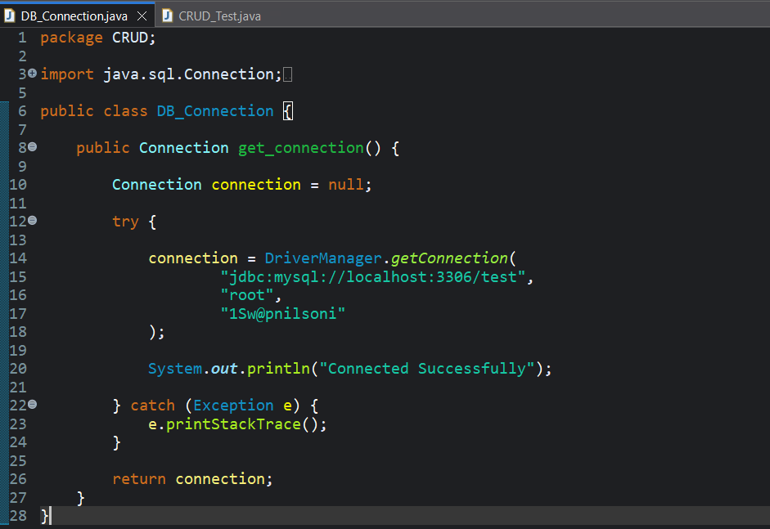

CRUD_Test.java
package CRUD;

import java.sql.Connection;
import java.sql.PreparedStatement;
import java.sql.ResultSet;

public class CRUD_Test {

public static void main(String[] args) {

CRUD_Test obj = new CRUD_Test();

// CREATE
obj.create_data("Swapnil", "swapnil@gmail.com");
obj.create_data("Ana", "ana@gmail.com");
obj.create_data("Manas", "manas@gmail.com");
obj.create_data("Tuhinsh", "tuhinsh@gmail.com");

// READ
System.out.println("\n===== DATA =====");
obj.read_data();
}

// CREATE
public void create_data(String name, String email) {

DB_Connection db = new DB_Connection();
Connection connection = db.get_connection();

try {

String query =
"INSERT INTO users(name,email) VALUES(?,?)";

PreparedStatement ps =
connection.prepareStatement(query);

ps.setString(1, name);
ps.setString(2, email);

int rows = ps.executeUpdate();

System.out.println(rows + " row inserted");

ps.close();
connection.close();

} catch (Exception e) {
e.printStackTrace();
}
}

// READ
public void read_data() {

DB_Connection db = new DB_Connection();
Connection connection = db.get_connection();

try {

String query = "SELECT * FROM users WHERE sl_no = 2";

PreparedStatement ps =
connection.prepareStatement(query);

ResultSet rs = ps.executeQuery();

while (rs.next()) {

System.out.println(
rs.getInt("sl_no") + " | " +
rs.getString("name") + " | " +
rs.getString("email")
);
}

rs.close();
ps.close();
connection.close();

} catch (Exception e) {
e.printStackTrace();
}
}

}

MySQL Workbench
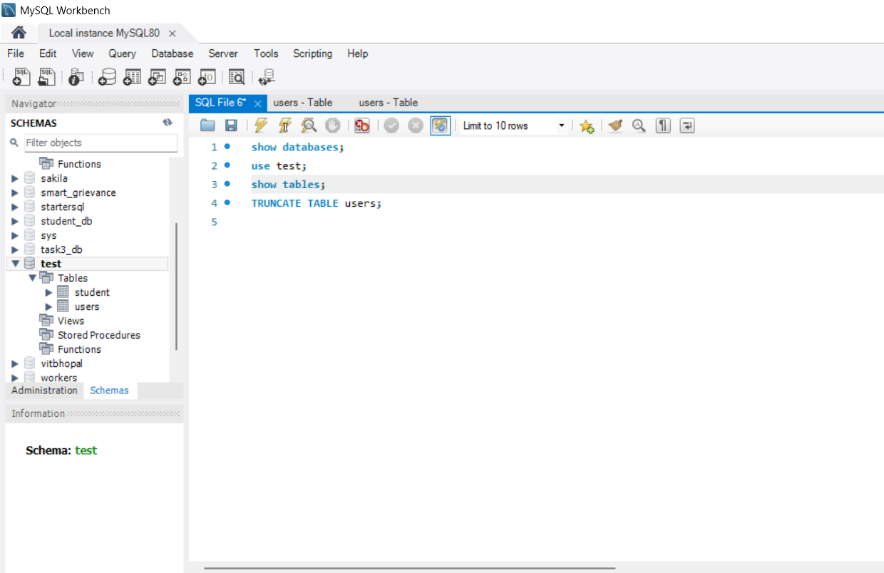

OUTPUT
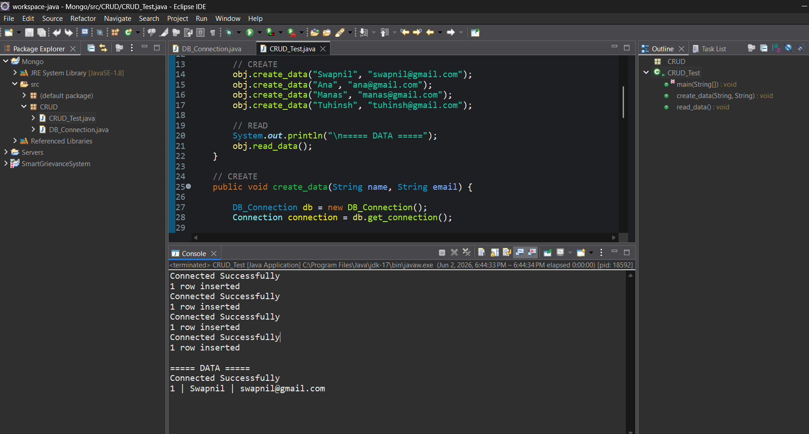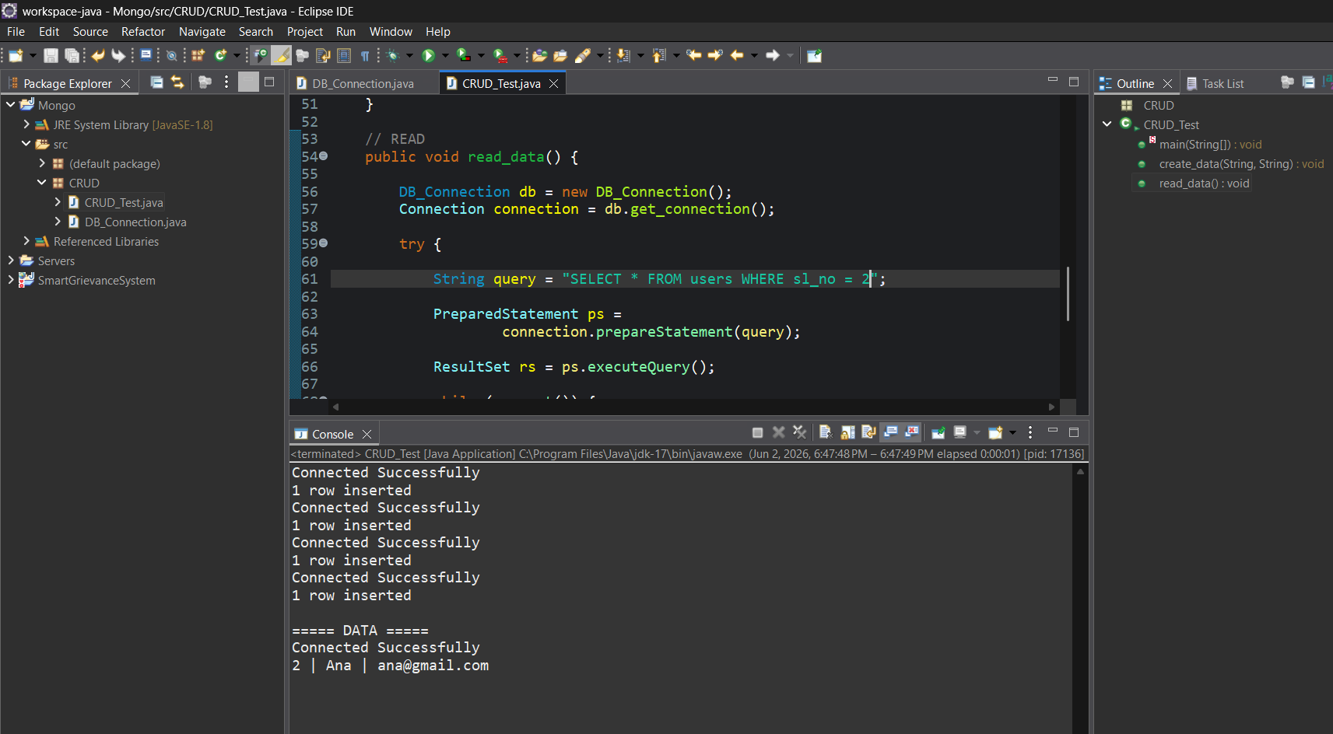

READ TO EDIT CALLING SERIAL WISE
package CRUD;

import java.sql.Connection;
import java.sql.PreparedStatement;
import java.sql.ResultSet;

public class CRUD_Test {

public static void main(String[] args) {

CRUD_Test obj = new CRUD_Test();

// CREATE
obj.create_data("Swapnil", "swapnil@gmail.com");
obj.create_data("Ana", "ana@gmail.com");
obj.create_data("Manas", "manas@gmail.com");
obj.create_data("Tuhinsh", "tuhinsh@gmail.com");

obj.edit_data("2");
}

// CREATE
public void create_data(String name, String email) {

DB_Connection db = new DB_Connection();
Connection connection = db.get_connection();

try {

String query =
"INSERT INTO users(name,email) VALUES(?,?)";

PreparedStatement ps =
connection.prepareStatement(query);

ps.setString(1, name);
ps.setString(2, email);

int rows = ps.executeUpdate();

System.out.println(rows + " row inserted");

ps.close();
connection.close();

} catch (Exception e) {
e.printStackTrace();
}
}

public void edit_data(String sl_no){

DB_Connection obj_DB_Connection = new DB_Connection();
Connection connection = obj_DB_Connection.get_connection();

PreparedStatement ps = null;
ResultSet rs = null;

try {

String query = "SELECT * FROM users WHERE sl_no=?";

ps = connection.prepareStatement(query);

ps.setString(1, sl_no);

System.out.println(ps);

rs = ps.executeQuery();

if(rs.next()) {

System.out.println("Sl no - " + rs.getString("sl_no"));
System.out.println("Name - " + rs.getString("name"));
System.out.println("Email - " + rs.getString("email"));
System.out.println("------------------");

} else {

System.out.println("Record Not Found");
}

rs.close();
ps.close();
connection.close();

} catch (Exception e) {
System.out.println(e);
}
}
}

Output :
Connected Successfully
1 row inserted
Connected Successfully
1 row inserted
Connected Successfully
1 row inserted
Connected Successfully
1 row inserted
Connected Successfully
com.mysql.cj.jdbc.ClientPreparedStatement: SELECT * FROM users WHERE sl_no='2'
Sl no - 2
Name - Anx
Email - anx@gmail.com

CREATE +READ+ALTER+TRUNCATE
package CRUD;

import java.sql.Connection;
import java.sql.PreparedStatement;
import java.sql.ResultSet;

public class CRUD_Test {

public static void main(String[] args) {

CRUD_Test obj = new CRUD_Test();

// CREATE
obj.create_data("Swapnil", "swapnil@gmail.com");
obj.create_data("Ana", "ana@gmail.com");
obj.create_data("Manas", "manas@gmail.com");
obj.create_data("Tuhinsh", "tuhinsh@gmail.com");

obj.edit_data("1");

// ALTER TABLE
obj.alter_table();

// TRUNCATE TABLE
obj.truncate_table();
}

// CREATE
public void create_data(String name, String email) {

DB_Connection db = new DB_Connection();
Connection connection = db.get_connection();

try {

String query =
"INSERT INTO users(name,email) VALUES(?,?)";

PreparedStatement ps =
connection.prepareStatement(query);

ps.setString(1, name);
ps.setString(2, email);

int rows = ps.executeUpdate();

System.out.println(rows + " row inserted");

ps.close();
connection.close();

} catch (Exception e) {
e.printStackTrace();
}
}

public void edit_data(String sl_no){

DB_Connection obj_DB_Connection = new DB_Connection();
Connection connection = obj_DB_Connection.get_connection();

PreparedStatement ps = null;
ResultSet rs = null;

try {

String query = "SELECT * FROM users WHERE sl_no=?";

ps = connection.prepareStatement(query);

ps.setString(1, sl_no);

System.out.println(ps);

rs = ps.executeQuery();

if(rs.next()) {

System.out.println("Sl no - " + rs.getString("sl_no"));
System.out.println("Name - " + rs.getString("name"));
System.out.println("Email - " + rs.getString("email"));
System.out.println("------------------");

} else {

System.out.println("Record Not Found");
}

rs.close();
ps.close();
connection.close();

} catch (Exception e) {
System.out.println(e);
}
}
public void alter_table() {

DB_Connection db = new DB_Connection();
Connection connection = db.get_connection();

try {

String query =
"ALTER TABLE users ADD phone VARCHAR(20)";

PreparedStatement ps =
connection.prepareStatement(query);

ps.execute();

System.out.println("Table Altered Successfully");

ps.close();
connection.close();

} catch (Exception e) {
System.out.println(e);
}
}

public void truncate_table() {

DB_Connection db = new DB_Connection();
Connection connection = db.get_connection();

try {

String query = "TRUNCATE TABLE users";

PreparedStatement ps =
connection.prepareStatement(query);

ps.execute();

System.out.println("Table Truncated Successfully");

ps.close();
connection.close();

} catch (Exception e) {
System.out.println(e);
}
}
}

Output:-
Connected Successfully
1 row inserted
Connected Successfully
1 row inserted
Connected Successfully
1 row inserted
Connected Successfully
1 row inserted
Connected Successfully
com.mysql.cj.jdbc.ClientPreparedStatement: SELECT * FROM users WHERE sl_no='1'
Sl no - 1
Name - tuhinsh
Email - tuhinsh@gmail.com
------------------
Connected Successfully
Table Altered Successfully

Now Truncate OUTPUT :
Connected Successfully
1 row inserted
Connected Successfully
1 row inserted
Connected Successfully
1 row inserted
Connected Successfully
1 row inserted
Connected Successfully
com.mysql.cj.jdbc.ClientPreparedStatement: SELECT * FROM users WHERE sl_no='1'
Sl no - 1
Name - Swapnil
Email - swapnil@gmail.com
------------------
Connected Successfully
java.sql.SQLSyntaxErrorException: Duplicate column name 'phone'
Connected Successfully
Table Truncated Successfully

Connection of Mongodb-

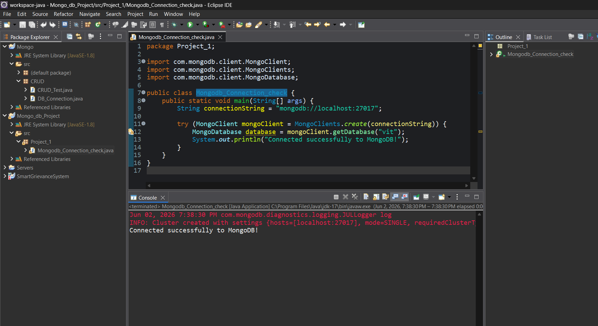
THANK YOU

