3-JUNE-2026
SUBMITTED TO : TUHINSH SHARMA

Creating CRUD class and CREATE

package Project_1;

import org.bson.Document;

import com.mongodb.client.FindIterable;
import com.mongodb.client.MongoClient;
import com.mongodb.client.MongoClients;
import com.mongodb.client.MongoCollection;
import com.mongodb.client.MongoDatabase;
import com.mongodb.client.model.Filters;
import com.mongodb.client.model.Updates;

public class CRUD{

public static void main(String[] args) {

String connectionString = "mongodb://localhost:27017";

try(MongoClient mongoClient =
MongoClients.create(connectionString))
{

MongoDatabase database =
mongoClient.getDatabase("vit");

MongoCollection<Document> collection =
database.getCollection("students");

// CREATE
Document student = new Document("id",101)
.append("name","tuhinsh")
.append("branch","CSE")
.append("cgpa",9.0);

collection.insertOne(student);

System.out.println("Document Inserted Successfully");

}
}
}

OUTPUT :-

Jun 03, 2026 6:31:44 PM com.mongodb.diagnostics.logging.JULLogger log
INFO: Cluster created with settings {hosts=[localhost:27017], mode=SINGLE, requiredClusterType=UNKNOWN, serverSelectionTimeout='30000 ms', maxWaitQueueSize=500}
Jun 03, 2026 6:31:44 PM com.mongodb.diagnostics.logging.JULLogger log
INFO: Cluster description not yet available. Waiting for 30000 ms before timing out
Jun 03, 2026 6:31:44 PM com.mongodb.diagnostics.logging.JULLogger log
INFO: Opened connection [connectionId{localValue:1, serverValue:17}] to localhost:27017
Jun 03, 2026 6:31:44 PM com.mongodb.diagnostics.logging.JULLogger log
INFO: Monitor thread successfully connected to server with description ServerDescription{address=localhost:27017, type=STANDALONE, state=CONNECTED, ok=true, version=ServerVersion{versionList=[8, 3, 2]}, minWireVersion=0, maxWireVersion=28, maxDocumentSize=16777216, logicalSessionTimeoutMinutes=30, roundTripTimeNanos=3172500}
Jun 03, 2026 6:31:44 PM com.mongodb.diagnostics.logging.JULLogger log
INFO: Opened connection [connectionId{localValue:2, serverValue:18}] to localhost:27017
Document Inserted Successfully

Mongodb Verification :-
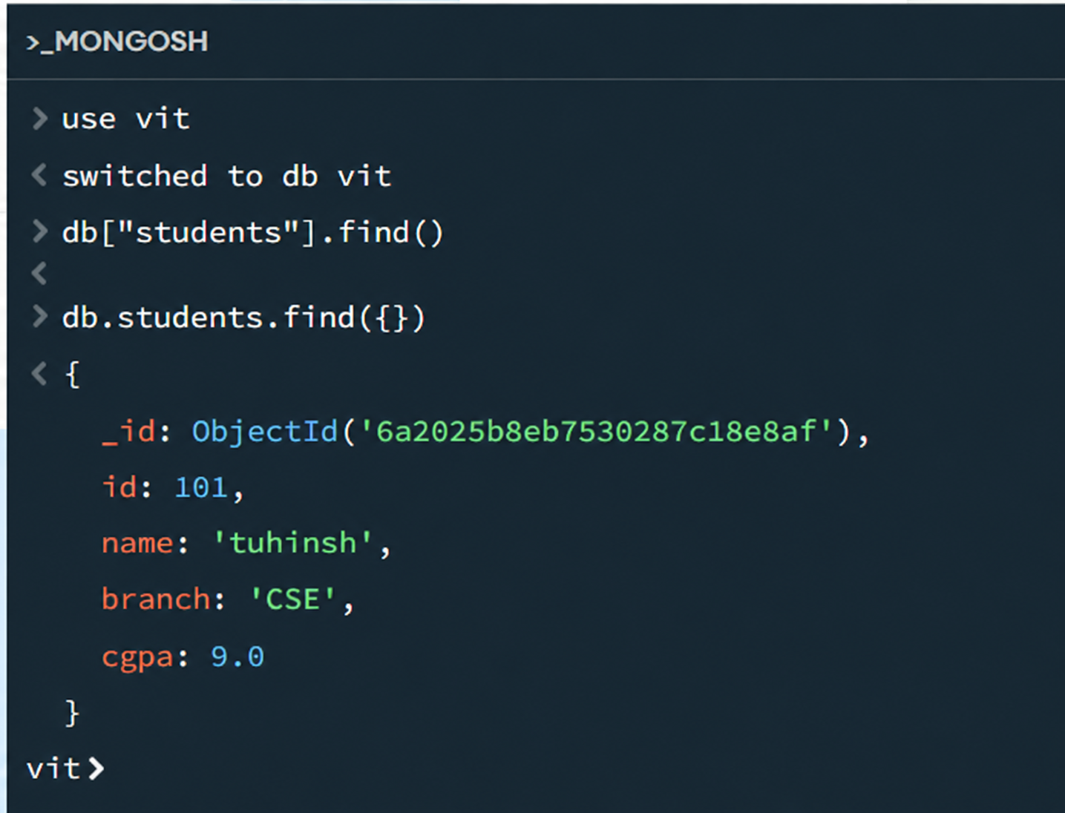

Implementing READ :-
package Project_1;

import org.bson.Document;

import com.mongodb.client.FindIterable;
import com.mongodb.client.MongoClient;
import com.mongodb.client.MongoClients;
import com.mongodb.client.MongoCollection;
import com.mongodb.client.MongoDatabase;

public class CRUD {

public static void main(String[] args) {

String connectionString = "mongodb://localhost:27017";

try (MongoClient mongoClient =
MongoClients.create(connectionString)) {

MongoDatabase database =
mongoClient.getDatabase("vit");

MongoCollection<Document> collection =
database.getCollection("students");

// ==========================
// CREATE (Insert)
// ==========================

Document student = new Document("id", 101)
.append("name", "tuhinsh")
.append("branch", "CSE")
.append("cgpa", 9.0);

collection.insertOne(student);

System.out.println("Document Inserted Successfully");

// ==========================
// READ (Find)
// ==========================

System.out.println("\nStudent Records:");

FindIterable<Document> students =
collection.find();

for (Document doc : students) {
System.out.println(doc.toJson());
}

} catch (Exception e) {
e.printStackTrace();
}
}
}

Output:-
Jun 03, 2026 6:40:14 PM com.mongodb.diagnostics.logging.JULLogger log
INFO: Cluster created with settings {hosts=[localhost:27017], mode=SINGLE, requiredClusterType=UNKNOWN, serverSelectionTimeout='30000 ms', maxWaitQueueSize=500}
Jun 03, 2026 6:40:14 PM com.mongodb.diagnostics.logging.JULLogger log
INFO: Cluster description not yet available. Waiting for 30000 ms before timing out
Jun 03, 2026 6:40:14 PM com.mongodb.diagnostics.logging.JULLogger log
INFO: Opened connection [connectionId{localValue:1, serverValue:21}] to localhost:27017
Jun 03, 2026 6:40:14 PM com.mongodb.diagnostics.logging.JULLogger log
INFO: Monitor thread successfully connected to server with description ServerDescription{address=localhost:27017, type=STANDALONE, state=CONNECTED, ok=true, version=ServerVersion{versionList=[8, 3, 2]}, minWireVersion=0, maxWireVersion=28, maxDocumentSize=16777216, logicalSessionTimeoutMinutes=30, roundTripTimeNanos=2217300}
Jun 03, 2026 6:40:14 PM com.mongodb.diagnostics.logging.JULLogger log
INFO: Opened connection [connectionId{localValue:2, serverValue:22}] to localhost:27017
Document Inserted Successfully

Student Records:
{"_id": {"$oid": "6a2027b6187fff70b0dc3e68"}, "id": 101, "name": "tuhinsh", "branch": "CSE", "cgpa": 9.0}

Update:-
package Project_1;

import org.bson.Document;

import com.mongodb.client.FindIterable;
import com.mongodb.client.model.Filters;
import com.mongodb.client.model.Updates;
import com.mongodb.client.MongoClient;
import com.mongodb.client.MongoClients;
import com.mongodb.client.MongoCollection;
import com.mongodb.client.MongoDatabase;

public class CRUD {

public static void main(String[] args) {

String connectionString = "mongodb://localhost:27017";

try (MongoClient mongoClient =
MongoClients.create(connectionString)) {

MongoDatabase database =
mongoClient.getDatabase("vit");

MongoCollection<Document> collection =
database.getCollection("students");

// ==========================
// CREATE (Insert)
// ==========================

Document student = new Document("id", 101)
.append("name", "Tuhinsh")
.append("branch", "CSE")
.append("cgpa", 9.0);

collection.insertOne(student);

System.out.println("Document Inserted Successfully");

// ==========================
// READ (Find)
// ==========================

System.out.println("\nStudent Records:");

FindIterable<Document> students =
collection.find();

for (Document doc : students) {
System.out.println(doc.toJson());
}
// ==========================
// UPDATE
// ==========================

collection.updateOne(
Filters.eq("id", 101),
Updates.set("cgpa", 9.2)
);

System.out.println("\nDocument Updated Successfully");

} catch (Exception e) {
e.printStackTrace();
}
}
}

Output :-
Jun 03, 2026 6:43:01 PM com.mongodb.diagnostics.logging.JULLogger log
INFO: Cluster created with settings {hosts=[localhost:27017], mode=SINGLE, requiredClusterType=UNKNOWN, serverSelectionTimeout='30000 ms', maxWaitQueueSize=500}
Jun 03, 2026 6:43:01 PM com.mongodb.diagnostics.logging.JULLogger log
INFO: Cluster description not yet available. Waiting for 30000 ms before timing out
Jun 03, 2026 6:43:01 PM com.mongodb.diagnostics.logging.JULLogger log
INFO: Opened connection [connectionId{localValue:1, serverValue:23}] to localhost:27017
Jun 03, 2026 6:43:01 PM com.mongodb.diagnostics.logging.JULLogger log
INFO: Monitor thread successfully connected to server with description ServerDescription{address=localhost:27017, type=STANDALONE, state=CONNECTED, ok=true, version=ServerVersion{versionList=[8, 3, 2]}, minWireVersion=0, maxWireVersion=28, maxDocumentSize=16777216, logicalSessionTimeoutMinutes=30, roundTripTimeNanos=2168100}
Jun 03, 2026 6:43:01 PM com.mongodb.diagnostics.logging.JULLogger log
INFO: Opened connection [connectionId{localValue:2, serverValue:24}] to localhost:27017
Document Inserted Successfully

Student Records:
{"_id": {"$oid": "6a20285de931e66d36d4387c"}, "id": 101, "name": "tuhinsh", "branch": "CSE", "cgpa": 9.0}

Document Updated Successfully

READ UPDATED RECORD

package Project_1;

import org.bson.Document;

import com.mongodb.client.FindIterable;
import com.mongodb.client.model.Filters;
import com.mongodb.client.model.Updates;
import com.mongodb.client.MongoClient;
import com.mongodb.client.MongoClients;
import com.mongodb.client.MongoCollection;
import com.mongodb.client.MongoDatabase;

public class CRUD {

public static void main(String[] args) {

String connectionString = "mongodb://localhost:27017";

try (MongoClient mongoClient =
MongoClients.create(connectionString)) {

MongoDatabase database =
mongoClient.getDatabase("vit");

MongoCollection<Document> collection =
database.getCollection("students");

// ==========================
// CREATE (Insert)
// ==========================

Document student = new Document("id", 101)
.append("name", "tuhinsh")
.append("branch", "CSE")
.append("cgpa", 9.0);

collection.insertOne(student);

System.out.println("Document Inserted Successfully");

// ==========================
// READ (Find)
// ==========================

System.out.println("\nStudent Records:");

FindIterable<Document> students =
collection.find();

for (Document doc : students) {
System.out.println(doc.toJson());
}
// ==========================
// UPDATE
// ==========================

collection.updateOne(
Filters.eq("id", 101),
Updates.set("cgpa", 9.2)
);

System.out.println("\nDocument Updated Successfully");

// ==========================
// READ UPDATED RECORD
// ==========================

Document updatedStudent =
collection.find(Filters.eq("id", 101))
.first();

System.out.println("\nUpdated Record:");
System.out.println(updatedStudent.toJson());

} catch (Exception e) {
e.printStackTrace();
}
}
}

Output:-
Jun 03, 2026 6:45:44 PM com.mongodb.diagnostics.logging.JULLogger log
INFO: Cluster created with settings {hosts=[localhost:27017], mode=SINGLE, requiredClusterType=UNKNOWN, serverSelectionTimeout='30000 ms', maxWaitQueueSize=500}
Jun 03, 2026 6:45:44 PM com.mongodb.diagnostics.logging.JULLogger log
INFO: Cluster description not yet available. Waiting for 30000 ms before timing out
Jun 03, 2026 6:45:44 PM com.mongodb.diagnostics.logging.JULLogger log
INFO: Opened connection [connectionId{localValue:1, serverValue:25}] to localhost:27017
Jun 03, 2026 6:45:44 PM com.mongodb.diagnostics.logging.JULLogger log
INFO: Monitor thread successfully connected to server with description ServerDescription{address=localhost:27017, type=STANDALONE, state=CONNECTED, ok=true, version=ServerVersion{versionList=[8, 3, 2]}, minWireVersion=0, maxWireVersion=28, maxDocumentSize=16777216, logicalSessionTimeoutMinutes=30, roundTripTimeNanos=2964000}
Jun 03, 2026 6:45:44 PM com.mongodb.diagnostics.logging.JULLogger log
INFO: Opened connection [connectionId{localValue:2, serverValue:26}] to localhost:27017
Document Inserted Successfully

Student Records:
{"_id": {"$oid": "6a2029003c8eb918adac81e4"}, "id": 101, "name": "tuhinsh", "branch": "CSE", "cgpa": 9.0}

Document Updated Successfully

Updated Record:
{"_id": {"$oid": "6a2029003c8eb918adac81e4"}, "id": 101, "name": "tuhinsh", "branch": "CSE", "cgpa": 9.2}

Delete one
package Project_1;

import org.bson.Document;

import com.mongodb.client.FindIterable;
import com.mongodb.client.model.Filters;
import com.mongodb.client.model.Updates;
import com.mongodb.client.MongoClient;
import com.mongodb.client.MongoClients;
import com.mongodb.client.MongoCollection;
import com.mongodb.client.MongoDatabase;

public class CRUD {

public static void main(String[] args) {

String connectionString = "mongodb://localhost:27017";

try (MongoClient mongoClient =
MongoClients.create(connectionString)) {

MongoDatabase database =
mongoClient.getDatabase("vit");

MongoCollection<Document> collection =
database.getCollection("students");

// ==========================
// CREATE (Insert)
// ==========================

Document student = new Document("id", 101)
.append("name", "tuhinsh")
.append("branch", "CSE")
.append("cgpa", 9.0);

collection.insertOne(student);

System.out.println("Document Inserted Successfully");

// ==========================
// READ (Find)
// ==========================

System.out.println("\nStudent Records:");

FindIterable<Document> students =
collection.find();

for (Document doc : students) {
System.out.println(doc.toJson());
}
// ==========================
// UPDATE
// ==========================

collection.updateOne(
Filters.eq("id", 101),
Updates.set("cgpa", 9.2)
);

System.out.println("\nDocument Updated Successfully");

// ==========================
// READ UPDATED RECORD
// ==========================

Document updatedStudent =
collection.find(Filters.eq("id", 101))
.first();

System.out.println("\nUpdated Record:");
System.out.println(updatedStudent.toJson());

// ==========================
// DELETE
// ==========================

collection.deleteOne(
Filters.eq("id", 101)
);

System.out.println("\nDocument Deleted Successfully");

} catch (Exception e) {
e.printStackTrace();
}
}
}
Output :-
Jun 03, 2026 6:49:06 PM com.mongodb.diagnostics.logging.JULLogger log
INFO: Cluster created with settings {hosts=[localhost:27017], mode=SINGLE, requiredClusterType=UNKNOWN, serverSelectionTimeout='30000 ms', maxWaitQueueSize=500}
Jun 03, 2026 6:49:06 PM com.mongodb.diagnostics.logging.JULLogger log
INFO: Cluster description not yet available. Waiting for 30000 ms before timing out
Jun 03, 2026 6:49:06 PM com.mongodb.diagnostics.logging.JULLogger log
INFO: Opened connection [connectionId{localValue:1, serverValue:29}] to localhost:27017
Jun 03, 2026 6:49:06 PM com.mongodb.diagnostics.logging.JULLogger log
INFO: Monitor thread successfully connected to server with description ServerDescription{address=localhost:27017, type=STANDALONE, state=CONNECTED, ok=true, version=ServerVersion{versionList=[8, 3, 2]}, minWireVersion=0, maxWireVersion=28, maxDocumentSize=16777216, logicalSessionTimeoutMinutes=30, roundTripTimeNanos=2654800}
Jun 03, 2026 6:49:06 PM com.mongodb.diagnostics.logging.JULLogger log
INFO: Opened connection [connectionId{localValue:2, serverValue:30}] to localhost:27017
Document Inserted Successfully

Student Records:
{"_id": {"$oid": "6a2029ca76c51739a0076665"}, "id": 101, "name": "tuhinsh", "branch": "CSE", "cgpa": 9.0}

Document Updated Successfully

Updated Record:
{"_id": {"$oid": "6a2029ca76c51739a0076665"}, "id": 101, "name": "tuhinsh", "branch": "CSE", "cgpa": 9.2}

Document Deleted Successfully

THANK YOU

