

SOA Programming and Microservices
Course Code : 24SDCS03A
Professor : Dr. Phani Kumar Sindhe

Reg No | Name
2400030560 | N. Meghana Jayasri
2400030907 | Sai Aishwarya
2400032105 | K. Bhavya Sri

Problem Statement

PS032 – Enterprise Real Estate Listings & Property Inspection Scheduling Platform

Problem Analysis
The real estate property management process involves handling property listings, customer inquiries, property status, and site-visit appointments. When these activities are managed manually or through separate systems, it can lead to outdated property information, delayed customer responses, appointment conflicts, and difficulty tracking property availability.
PrimeHaven Real Estate Network requires a centralized platform to simplify these activities and improve communication between customers and agents. The system should allow customers to view available properties, submit inquiries, and schedule property visits, while agents can manage listings and appointments efficiently.
To address these challenges, the proposed system uses a microservices architecture, where different business functionalities are separated into independent services. The Property Service manages property listings and status, the Visit Service handles site-visit scheduling, and the Inquiry Service manages customer queries. An Auth Service provides secure authentication using JWT, while Eureka Server enables service discovery and the API Gateway provides centralized request routing and load balancing.
The main problems identified are:
- Difficulty in maintaining updated property information.
- Lack of centralized customer inquiry management.
- Manual and inefficient visit scheduling.
- Difficulty tracking property status.
- Security and authentication requirements.
- Need for scalability during high-volume property launches.
Therefore, the proposed platform aims to provide a secure, scalable, and modular solution for managing PrimeHaven's property listings, customer inquiries, and property inspection visits.

Requirement Specification
The proposed PrimeHaven platform requires the following functional and non-functional requirements.
Functional Requirements
- User Authentication: Users and agents should be able to register and log in securely using JWT authentication.
- Property Management: Agents should be able to add, update, delete, and view property listings.
- Property Search: Customers should be able to view and search available properties based on relevant details.
- Property Status: The system should maintain the current status of each property, such as available or sold.
- Visit Scheduling: Customers should be able to schedule, view, and cancel property visits.
- Inquiry Management: Customers should be able to submit inquiries related to properties, and agents should be able to manage them.
- Service Communication: The microservices should communicate with each other when required.
- Service Discovery: All microservices should register with Eureka Server.
- API Gateway: Client requests should be routed through the API Gateway.
- Load Balancing: Requests should be distributed across available service instances.
Non-Functional Requirements
- Security: Unauthorized users should not access protected resources.
- Scalability: Services should support increasing numbers of users and requests.
- Availability: The system should remain accessible when individual service instances are unavailable.
- Performance: Requests should be processed with minimal delay.
- Maintainability: Each microservice should be independently developed and maintained.
- Reliability: Property, inquiry, and appointment data should be handled consistently and securely.

Survey Conducted
A survey was conducted to understand the common difficulties faced by prospective property buyers while searching for properties and arranging site visits. The survey focused on property availability, communication with agents, and visit scheduling.
Common Issues Identified
- Difficulty finding updated property availability and details.
- Delays in receiving responses from property agents.
- Difficulty coordinating suitable property-visit timings.
- Lack of a centralized platform for inquiries and appointments.
- Need for clear property information before scheduling a visit.
Based on these findings, the proposed PrimeHaven system focuses on updated property listings, centralized inquiries, convenient visit scheduling, and better customer-agent communication.

Survey Conducted
A survey was conducted to understand the common difficulties faced by prospective property buyers while searching for properties and arranging site visits. The survey focused on property availability, communication with agents, and visit scheduling.
Common Issues Identified
- Difficulty finding updated property availability and details.
- Delays in receiving responses from property agents.
- Difficulty coordinating suitable property-visit timings.
- Lack of a centralized platform for inquiries and appointments.
- Need for clear property information before scheduling a visit.
Based on these findings, the proposed PrimeHaven system focuses on updated property listings, centralized inquiries, convenient visit scheduling, and better customer-agent communication.

DTI Concepts

1. Empathy Map
The empathy map helps us understand the customer's needs, thoughts, feelings, and difficulties while searching for a property and scheduling a visit. The major pain points identified are outdated property information, delayed agent responses, and difficulty coordinating visit timings.
Says | Thinks
“I want updated property details.” | “Is this property really available?”
“I need a convenient visit time.” | “Will the agent respond quickly?”
“I want to compare different properties.” | “Can I trust the information provided?”

Does | Feels
Searches for properties online | Confused by outdated information
Compares price, location and features | Frustrated by delayed responses
Contacts agents for inquiries | Wants convenience and transparency
Schedules property visits | Anxious about appointment conflicts

Persona
Persona: Ananya, 25-year-old working professional looking to purchase an apartment. She prefers updated property details, quick communication with agents, and an easy online process for scheduling property visits.

Customer Journey Map

Stage | Customer Action | Pain Point | System Response
Search | Searches for properties | Difficult to find suitable listings | Property Service
Explore | Views property details | Unclear availability | Property Status
Inquire | Sends inquiry to agent | Delayed response | Inquiry Service
Schedule | Requests a site visit | Appointment conflicts | Visit Service
Visit | Visits the property | Coordination issues | Visit Management
Decide | Evaluates the property | Need accurate information | Updated Listings

Proposed Solution

PrimeHaven proposes a microservices-based real estate platform to manage property listings, customer inquiries, property status, and site-visit scheduling. The system separates major functionalities into independent services, making the application easier to maintain, scale, and update.
The Property Service manages property details and availability, the Visit Service handles visit appointments, and the Inquiry Service manages customer queries. JWT Authentication secures users and agents, while Eureka Server provides service discovery. An API Gateway acts as the single entry point for client requests and supports routing and load balancing.

2. System Architecture
The system follows a microservices architecture with an API Gateway and Eureka Service Registry.
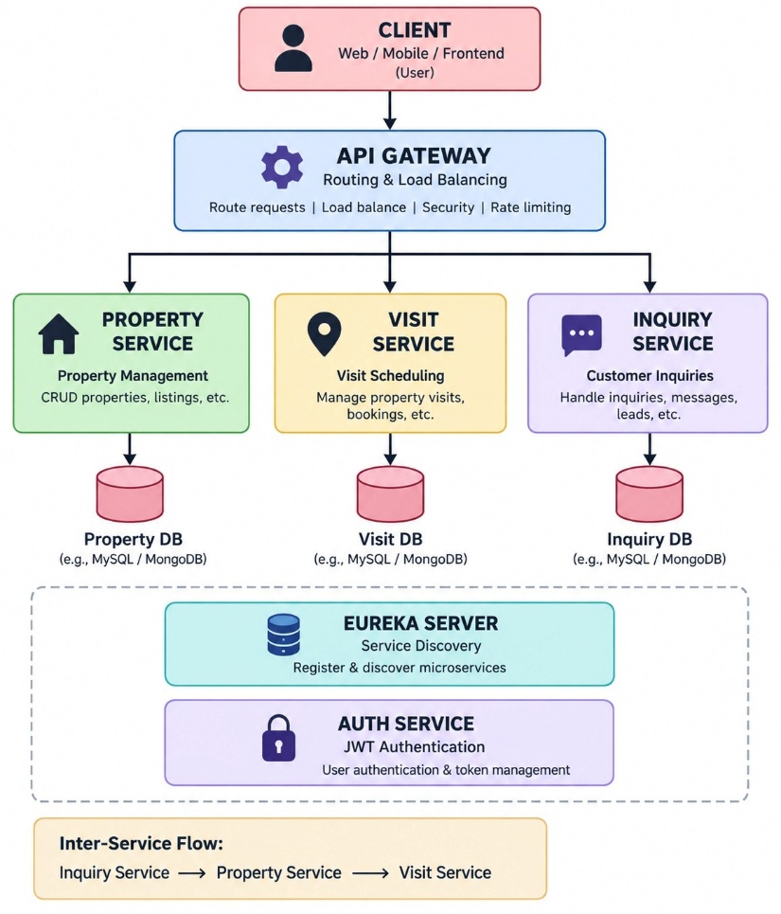

Modules:

The PrimeHaven system is divided into the following major modules:

User & Authentication Module – Handles user registration, login, roles, and JWT authentication.

Property Management Module – Manages property listings, details, availability, and status.

Visit Scheduling Module – Handles property visit booking, rescheduling, and cancellation.

Inquiry Management Module – Manages customer inquiries and agent responses.

Service Discovery Module – Registers and discovers microservices using Eureka.

API Gateway Module – Provides centralized routing, authentication, and load balancing.

Microservices Listing:

Microservice | Main Responsibility
Auth Service | User authentication, roles, and JWT token generation
Property Service | Property listing, details, search, and status management
Visit Service | Property visit scheduling and appointment management
Inquiry Service | Customer inquiries and agent communication
Eureka Server | Service registration and discovery
API Gateway | Request routing, security, and load balancing

Service Integration:
Client
↓
API Gateway
↓
Inquiry Service
↓
Property Service
↓
Visit Service

Auth Service → JWT Authentication
Eureka Server → Service Discovery
1. Security — JWT
JSON Web Token (JWT) is used to provide secure authentication and authorization in the PrimeHaven platform. Users and agents must log in with valid credentials to access protected resources.
JWT Authentication Flow
User / Agent
↓
Login
↓
Auth Service
↓
Validate Credentials
↓
Generate JWT
↓
Client receives Token
↓
Send Token with Request
↓
API Gateway / Service
↓
Validate JWT
↓
Access Granted

Eureka Service Discovery:

Eureka Server is used as a service registry in the PrimeHaven microservices architecture. Each microservice registers itself with Eureka, allowing other services to discover its location without using hardcoded IP addresses or ports.

Working
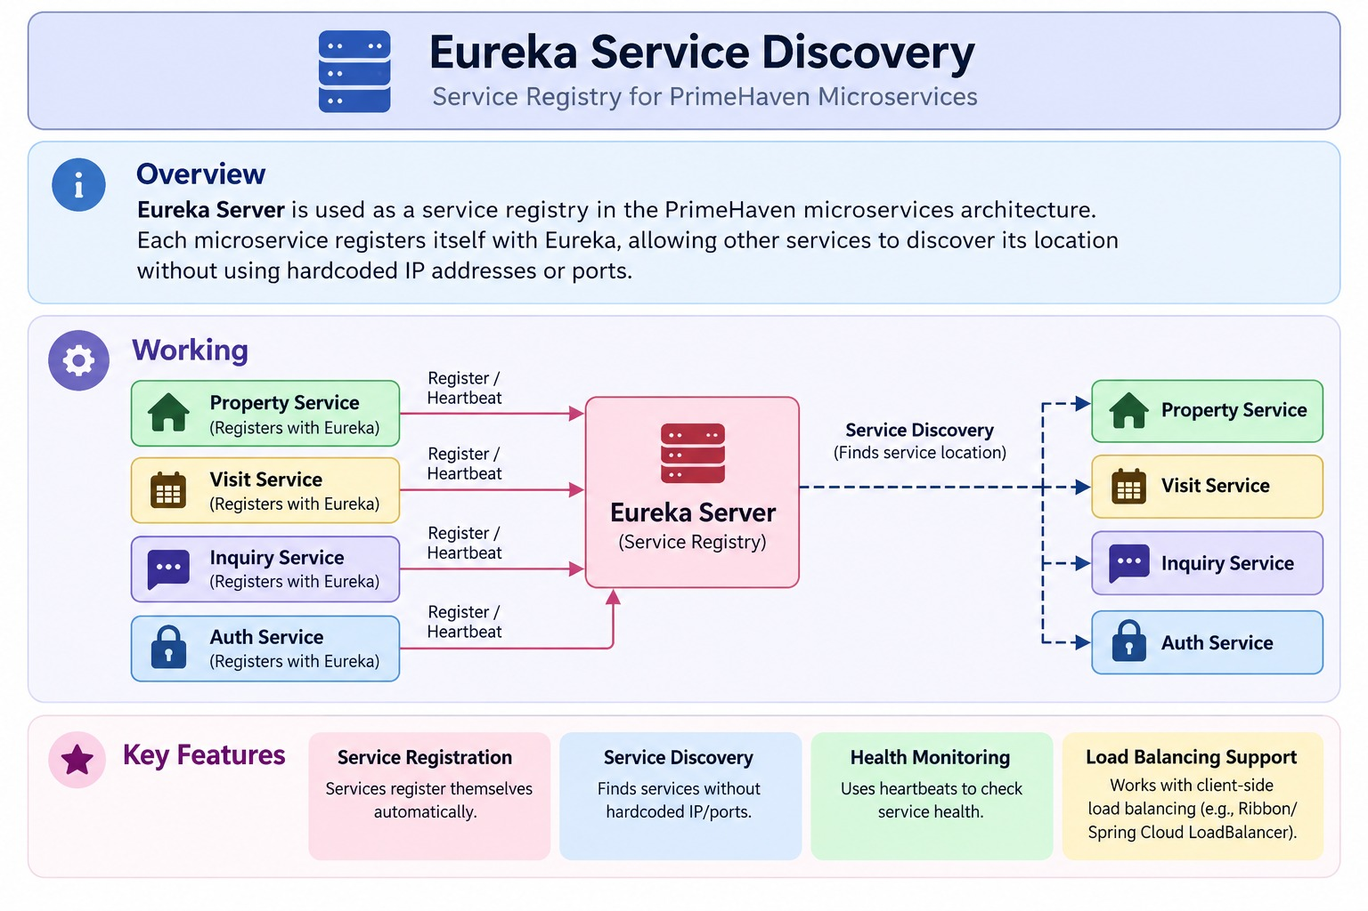
Key Features
- Registers all microservices with Eureka.
- Allows services to discover each other dynamically.
- Avoids hardcoded service URLs.
- Supports multiple instances of a service.
- Helps with load balancing and scalability.
- Detects service availability through periodic health/registration updates.

Example: If the Inquiry Service needs to communicate with the Property Service, it can discover the available Property Service instance through Eureka instead of directly using a fixed IP address.
1. API Gateway & Load Balancing
The API Gateway acts as a single entry point between clients and the PrimeHaven microservices. It receives client requests and routes them to the appropriate service. Load balancing distributes requests across multiple instances of a service to improve performance and availability.
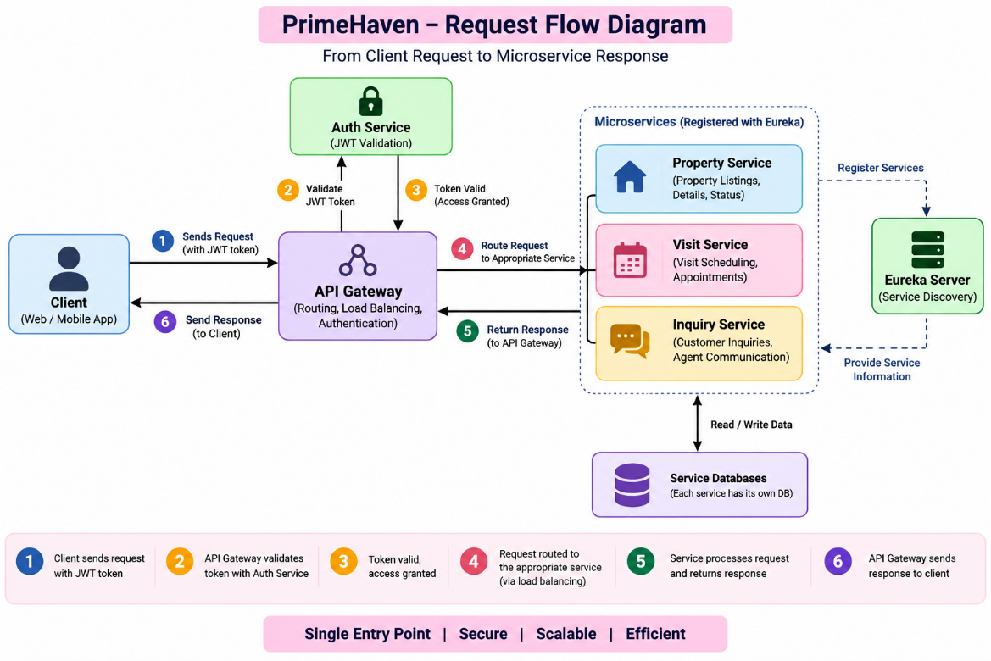

2. Innovative Ideas
The PrimeHaven platform can be enhanced with the following innovative features:
1. Smart Property Recommendations
Recommend properties to customers based on their budget, location, property type, and preferences.
2. Automated Visit Conflict Detection
Check agent and property availability before confirming a visit to prevent double-booking and scheduling conflicts.
3. Real-Time Property Status
Provide customers with updated property statuses such as Available, Visit Scheduled, Under Consideration, and Sold.

4. Inquiry Priority Management
Classify customer inquiries as High, Medium, or Low priority to help agents respond efficiently.
5. Scalable Property Launch
Use load balancing and multiple service instances to handle increased traffic during major property launches.

Innovative Ideas
- Smart Property Recommendation: Suggest properties based on the customer's budget, preferred location, property type, and requirements.
- Visit Conflict Detection: Check property and agent availability before confirming a visit to avoid double-booking.
- Real-Time Property Status: Keep customers informed about property status such as Available, Visit Scheduled, Under Consideration, and Sold.
- Inquiry Priority: Classify inquiries as High, Medium, or Low priority to help agents respond efficiently.
- Scalable Property Launch: Use multiple service instances and load balancing to handle high traffic during major property launches.

Expected Outcomes
The proposed PrimeHaven platform is expected to achieve the following outcomes:
- Efficient Property Management: Centralized management of property listings and their status.
- Easy Visit Scheduling: Customers can conveniently schedule and manage property visits.
- Improved Inquiry Handling: Faster and organized management of customer inquiries.
- Secure Access: JWT-based authentication and role-based authorization for users and agents.

- Scalable Architecture: Microservices can be independently scaled during high-traffic periods.
- Reliable Service Communication: Eureka enables dynamic service discovery between microservices.
- Centralized API Access: API Gateway provides secure routing and load balancing.
- Better Customer Experience: Faster access to property information and smoother communication with agents.

Current Progress / Implementation Status
- Problem Analysis & Requirements: Completed.
- Survey, Persona & DTI Analysis: Completed.
- System Architecture: Designed.
- Microservices Structure: Planned for Property, Visit, Inquiry, and Auth Services.
- JWT Authentication: Authentication flow designed and implementation is in progress.
- Eureka Service Discovery: Configuration planned for microservice registration and discovery.
- API Gateway: Routing and load-balancing configuration is in progress.
- Database Design: Separate data storage planned for each major microservice.
- Service Integration: Inter-service communication flow has been designed.
- Testing & Deployment: Planned for the next implementation phase.

Conclusion :

The PrimeHaven Real Estate Listings & Property Inspection Scheduling Platform provides a structured solution for managing property listings, customer inquiries, and property visits. The proposed microservices architecture enables independent and scalable services, while JWT authentication, Eureka Service Discovery, and API Gateway improve security, communication, and system management.

The DTI analysis helped identify customer needs and translate them into relevant system features. The project will be further developed through service integration, testing, load balancing, and deployment to provide a secure, scalable, and user-friendly real estate management platform.

