<!DOCTYPE html>
<html lang="en">
<head>
<meta charset="UTF-8">
<meta name="viewport" content="width=device-width, initial-scale=1.0">
<title>PRP Village Foods</title>

<link rel="stylesheet" href="https://cdnjs.cloudflare.com/ajax/libs/font-awesome/6.5.0/css/all.min.css">
<style>

body {
margin: 0;
font-family: Arial, sans-serif;
background-image: url("https://www.theindiaforum.in/sites/default/files/field/image/2022/06/21/ramkumar-radhakrishnan-wikimedia-1622193304-1622193304.jpeg");
background-size: cover;
background-position: center;
background-attachment: fixed;
}

nav {
position: fixed;
top: 0;
width: 100%;
background-color: rgba(34, 169, 34, 0.9);;
padding: 10px 20px;
display: flex;
justify-content: center;
gap: 30px;
z-index: 1000;
}

nav a {
color: white;
font-size: 20px;
text-decoration: none;
cursor: pointer;
transition: all 0.3s ease;
}

nav a:hover {
text-decoration: underline;
color: wheat;
}

.transparent-text {
background-color: rgba(255, 255, 255, 0.6);
color: black;
padding: 40px;
text-align: center;
border-radius: 15px;
max-width: 400px;
margin: 150px auto 50px auto;
}

.section {
height: 100vh;
display: flex;
flex-direction: column;
justify-content: center;
align-items: center;
text-align: center;
color: rgb(18, 13, 13);
background-size: cover;
background-position: center;
}

.section h1, .section p {
cursor: pointer;
transition: all 0.3s ease;
}

.section h1:hover, .section p:hover {
text-decoration: underline;
}

html {
scroll-behavior: smooth;
}
</style>
</head>
<body>

<nav>
<h1 align="center">PRP Village Foods</h1>
<b><a href="#home"><i class="fas fa-home"></i> Home</a></b>
<b><a href="product.html"><i class="fas fa-info-circle"></i> product</a></b>
<b><a href="contact.html"><i class="fas fa-phone"></i> Contact</a></b>
<b><a href="#profile"><i class="fas fa-user"></i> Profile</a></b>
<b><a href="home.html"><i class="fas fa-shopping-cart"></i> Shop</a></b>

</nav>

<div class="transparent-text">
<h1>Welcome to PRP Village Foods</h1>
<p>Fresh food from the village to your home.</p>
</div>

<section id="home" class="section">
<h1>Home</h1>
<p align="center">PRP Village Foods is a modern web platform dedicated to transforming traditional farming into a global opportunity We help farmers not only sell their crops but also turn them <br>into high-value products — from processed foods to handmade village goods By bridging the gap between rural producers and global buyers, we bring village freshness to your doorstep.</p>

</section>

<section id="about" class="section">
<h1>About</h1>
<p>We connect farmers directly to customers Our platform is more than just a marketplace — it's a movement to empower rural farmers through technology. Whether you’re a grower,
<br>a producer, or a buyer, PRP Village Foods makes it easier for you to connect, trade, and grow.</p>
</section>

<section id="contact" class="section">
<h1>Contact</h1>
<p>Email: info@prpvillagefoods.com | Phone: 123-456-7890</p>
</section>

<section id="profile" class="section">
<h1>Profile</h1>
<p>Manage your account and preferences here.Welcome to your PRP Village Foods profile. This is your personal space to manage <br> your
account, preferences,and activity on the platform.

</section>

</body>
</html>

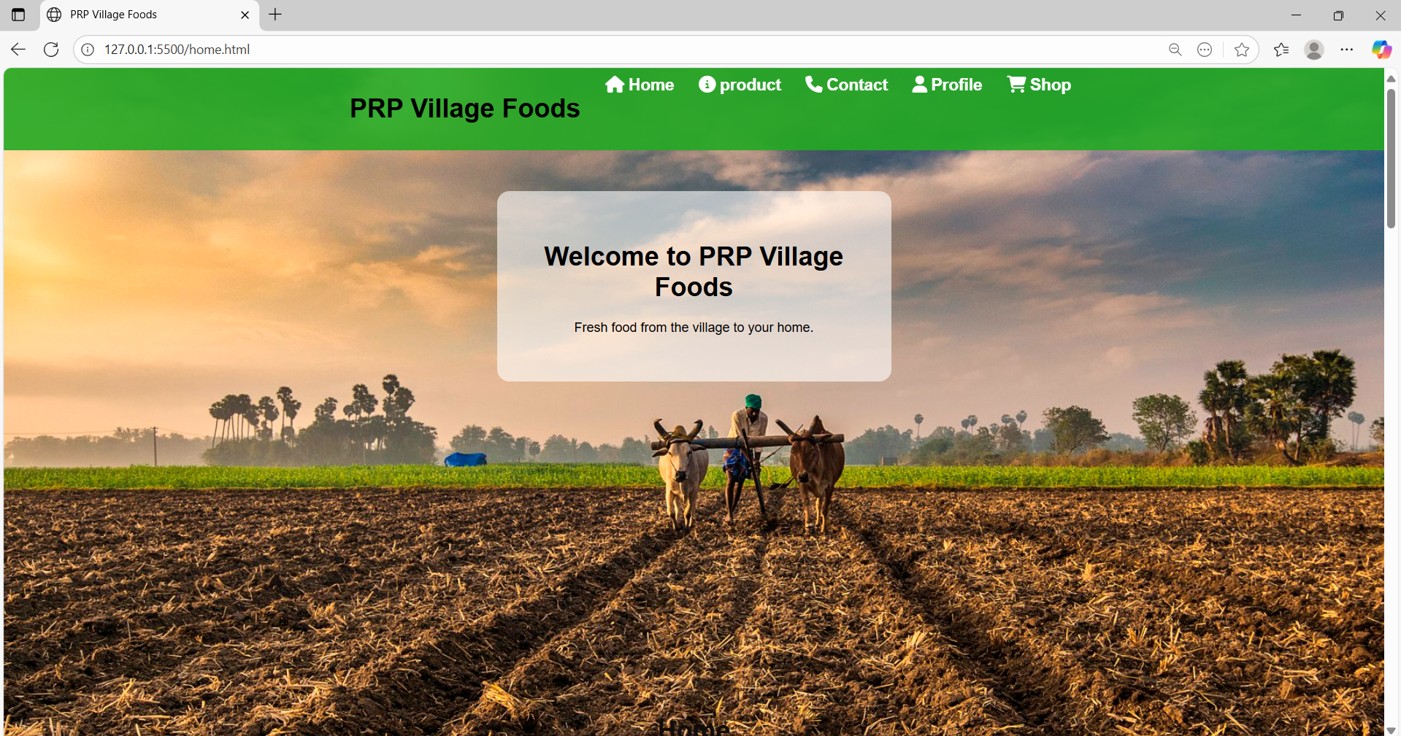

<!DOCTYPE html>
<html lang="en">
<head>
<meta charset="UTF-8">
<meta name="viewport" content="width=device-width, initial-scale=1.0">
<title>Agriculture</title>

<style>
.item {
display: inline-block;
text-align: left;
margin: 30px;
font-size: larger;
}
.item img {
width: 400px;
height: 300px;
display: block;
margin-bottom: 50px;
}
button{
color: rgb(5, 12, 14);
background-color: rgb(234, 230, 224);
border-width: 10px;

}

nav{
background-color:rgba(34, 169, 34, 0.9);;
font-size:40px;
gap: 10px;
color: black;
padding: 25px;
border: 30px;

}

.nav a{
font-size:30px;
margin-right: 90px;
color: black;
text-decoration: none;

}
.nav ul{
width: 80px;
height: auto;
display: block;
margin-bottom: 50px;
}
.nav h2{
font-family: Verdana, Geneva, Tahoma, sans-serif;
}

</style>
</head>
<body>
<div class="nav">
<nav>
<b> <a href="#"><i class="fas fa-bars">≡</i></a></b>
<b><a href="home.html"><i class="fas fa-home"></i> Home</a></b>
<b><a href="product.html"><i class="fas fa-home"></i> product</a></b>
<b><a href="#"><i class="fas fa-info-circle"></i> About</a></b>
<b><a href="contact.html"><i class="fas fa-phone"></i> Contact</a></b>
<b><a href="#"><i class="fas fa-user"></i> Profile</a></b>

</nav>
<h2></h2>

<div class="item">
<img src="https://th.bing.com/th/id/OIP.-6W9sGg6KL92UVUkmd3ZgAHaGW?w=224&h=192&c=7&r=0&o=7&dpr=1.3&pid=1.7&rm=3" alt="First Image">
<h3>Rice flour</h3>
<p>rating :★★★★☆</p>
<h2>cost: ₹150</h2>
<button>Add to cart </button>

</div>
<div class="item">
<img src="https://www.pentastar.in/wp-content/uploads/2024/02/red-chilli-powder-min-1620x1080.jpg"="Second Image">
<h3>Chilli powder</h3>
<p>rating :★★★★☆</p>
<h2>cost: ₹250</h2>
<b><button>Add to cart </button></b>
</div>
<div class="item">
<img src="https://img.emedihealth.com/wp-content/uploads/2020/10/turmeric-feat-1.jpg" alt="Second Image">
<h3>Turmeric</h3>
<p>rating :★★★★☆</p>
<h2>cost: ₹100</h2>
<button>Add to cart </button>
</div>
<br><br><br><br><br><br>

<div class="item">
<img src="https://th.bing.com/th/id/OIP.9xxx61ly5Lf3jVDrXEGhxwHaEj?w=294&h=181&c=7&r=0&o=7&dpr=1.3&pid=1.7&rm=3" alt="Second Image">
<h3>Wheat flour</h3>
<p>rating :★★★★☆</p>
<h2>cost: ₹100</h2>
<button>Add to cart </button>
</div>

<div class="item">
<img src="https://th.bing.com/th/id/OIP.Xa-aAl3CknBDmhL7iJYcbwHaE8?w=235&h=180&c=7&r=0&o=7&dpr=1.3&pid=1.7&rm=3" alt="Second Image">
<h3>Corn flour</h3>
<p>rating :★★★★☆</p>
<h2>cost: ₹100</h2>
<button>Add to cart </button>
</div>

<hr>
<h2>FOOD ITEMS</h2>
<div class="item">
<img src="https://nmfoodsofficial.com/wp-content/uploads/2024/08/nm-foods-dry-fruit-laddu-min-1.jpg" alt="Second Image">
<h3>Dry fruits laddu</h3>
<p>rating :★★★★☆</p>
<h2>cost: ₹100</h2>
<button>Add to cart </button>
</div>
<div class="item">
<img src="https://tiimg.tistatic.com/fp/1/007/812/a-grade-crispy-spicy-yellow-mixture-namkeen-snack-318.jpg" alt="Second Image">
<h3>Mixture</h3>
<p>rating :★★★★☆</p>
<h2>cost: ₹150</h2>
<button>Add to cart </button>
</div>
<div class="item">
<img src="https://vellankifoods.com/cdn/shop/files/bellam_jilebi1_2048x.jpg?v=1690537379" alt="Second Image">
<h3>jilebi</h3>
<p>rating :★★★★☆</p>
<h2>cost: ₹200</h2>
<button>Add to cart </button>
</div>
<div class="item">
<img src="https://chittipickles.in/cdn/shop/files/nuvvula_til_karam_380x446.webp?v=1750130789" alt="Second Image">
<h3>Nuvvu pappu karapodi</h3>
<p>rating :★★★★☆</p>
<h2>cost: ₹250</h2>
<button>Add to cart </button>
</div>
<div class="item">
<img src="https://chittipickles.in/cdn/shop/files/ChatGPTImageAug8_2025_11_53_20AM_52b10f44-cb09-4733-9f31-1273b8706aa7_380x446.png?v=1754634332" alt="Second Image">
<h3>Sunnundalu</h3>
<p>rating :★★★★☆</p>
<h2>cost: ₹100</h2>
<button>Add to cart </button>
</div>
<div class="item">
<img src="https://tse3.mm.bing.net/th/id/OIP.0XPRF9ztEgHoOgo9h2OvsQHaGi?rs=1&pid=ImgDetMain&o=7&rm=3" alt="Second Image">
<h3>Murukullu</h3>
<p>rating :★★★★☆</p>
<h2>cost: ₹100</h2>
<button>Add to cart </button>
</div>

</body>
</html>

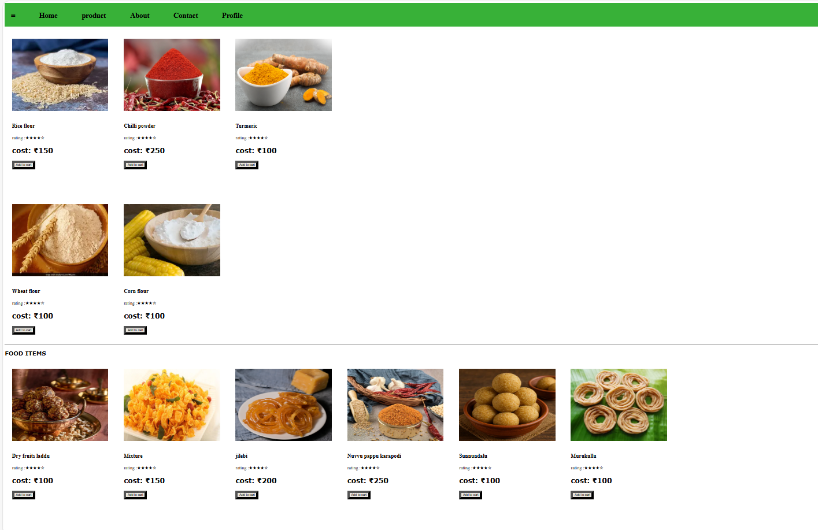

<!DOCTYPE html>
<html lang="en">
<head>
<meta charset="UTF-8">
<meta name="viewport" content="width=device-width, initial-scale=1.0">
<title>contact</title>
</head>
<style>
nav{
background-color: rgba(34, 169, 34, 0.9);
font-size:40px;
gap: 10px;
color: black;

padding: 40px;

}
.nav a{
font-size:30px;
margin-bottom: 90px;
color: black;
text-decoration: none;
margin-right : 100px;
}
.h1{
font-size: xx-large;
font-family: 'Times New Roman', Times, serif;
}
.details h2{
margin-right: 50px;
color: blueviolet;
gap: 150PX;
}
form {
width: 500px;
margin: 50px auto;
padding: 40px; /* smaller padding reduces height */
border: 3px solid #060806;
border-radius: 30px;
background-color: rgba(34, 169, 34, 0.9);;

}

label {

display: block;
margin-bottom: 5px;
font-weight: bold;
}

input[type="text"],
input[type="email"],
input[type="tel"],
input[type="feedback"] {
width: 100%;
padding: 15px;
margin: 8px 0 8px 0;
border: 1px solid #ccc;
box-shadow: 2px 2px 12px rgba(0, 0, 0, 0.1);
border-radius: 15px;
font-size: 14px;
box-sizing: border-box;
}

button,
input[type="submit"] {
width: 100%;
padding: 10px;
background-color: #111511;
color: white;
font-size: 16px;
box-shadow: 2px 2px 12px rgba(0, 0, 0, 0.1);
border: 2px solid #060806;
border-radius: 10px;
cursor: pointer;
transition: 0.3s;
}

button:hover,
input[type="submit"]:hover {
background-color: #dce5dc;
}
textarea {
width: 100%;
padding: 15px;
margin: 8px 0 8px 0;
border: 1px solid #ccc;
box-shadow: 2px 2px 12px rgba(0, 0, 0, 0.1);
border-radius: 15px;
font-size: 14px;
font-family: Arial, sans-serif;
box-sizing: border-box;
resize: vertical; /* allow resizing up & down */
}

</style>
<body>
<div class="nav">
<nav>
<b> <a href="#"><i class="fas fa-bars">≡</i></a></b>
<b><a href="home.html"><i class="fas fa-home"></i> Home</a></b>
<b><a href="product.html"><i class="fas fa-home"></i> product</a></b>
<b><a href="#"><i class="fas fa-info-circle"></i> About</a></b>
<b><a href="contact.html"><i class="fas fa-phone"></i> Contact</a></b>
<b><a href="#"><i class="fas fa-user"></i> Profile</a></b>

</nav>
</div>
<div class="h1">
<dd>
<b><h1 align="center">Contact our team</h1></b>
</dd>
<dt>
<p align="center">Have any questions? We’d love to hear from you! Please fill out the form below,
<br> or feel free to reach out to at <a href="https://www.bing.com/ck/a?!&&p=f522610ee78c6ef0af4585606121876466e2d367fd9ec56d483bd1e5b5de0885JmltdHM9MTc1ODU4NTYwMA&ptn=3&ver=2&hsh=4&fclid=3aae7b8a-4b1d-65ea-3d4e-6f434ab064fd&psq=farmers+supporting+government+websites+in+andhra+government&u=a1aHR0cHM6Ly9hbm5hZGF0aGFzdWtoaWJoYXZhLmFwLmdvdi5pbi9pbmRleC5odG1s">Government website</a> or 123-456-7890.</p>
</dt>

<h2 align="center">Feedback form</h2>
<form align="center" action="#" method="post" onsubmit="return saveFormData()">
<label>Name:</label>
<input type="text" name="sname" id="sname" required><br><br>

<label>Email-Id:</label>
<input type="email" name="emailid" id="emailid" required><br><br>

<label>Mobile No:</label>
<input type="tel" name="phno" id="phno" required><br><br>

<label>Your Feedback:</label>
<textarea name="feedback" id="feedback" rows="5" cols="40" required></textarea><br><br>

<br>
<input type="submit" value="Submit">

</form>

</body>
</html>

