PROJECT REPORT
Cloud Logging Sink to BigQuery
for Log Analytics

PROJECT TEAM MEMBERS
This project is prepared and presented by the following team of four students.
S. No. | Student Name | Student ID
1 | D. Gnana Prasanna Maruthi | 2400039070
2 | V. Sudheer | 2400039069
3 | Sk. Abdul Habeeb | 2400039068
4 | K. Srilakshmi | 2400039067
Project title: Cloud Logging Sink to BigQuery for Log Analytics

1. Abstract
This project demonstrates how log entries produced by Google Cloud services or applications can be routed through Cloud Logging to a BigQuery dataset. A log sink applies a filter and sends matching entries to the configured destination. BigQuery can then be used to query and summarize the log data with SQL. The project introduces log routing, troubleshooting, and operational reporting.

2. Problem Statement
Logs help explain application activity, warnings, failures, and system events. Searching many entries manually can be difficult. This project routes selected logs to BigQuery so they can be explored in tables and analyzed with SQL.

3. Objectives
- Understand log entries, Cloud Logging, Log Router, and log sinks.
- Create a Google Cloud project and prepare required services.
- Create a write-enabled BigQuery dataset.
- Configure a sink with an appropriate filter.
- Set required permissions for the sink writer identity.
- Verify that matching logs arrive in BigQuery.
- Use SQL to summarize log data.

4. Tools and Services Required
Tool / service | Purpose
Google Cloud project | Project boundary and resource context.
Cloud Logging | Collects and stores log entries.
Log Router / sink | Filters and routes matching entries.
BigQuery | Stores routed entries in tables and runs SQL analytics.
IAM permissions | Controls configuration and destination write access.

5. System Architecture
The diagram shows the data flow. A sink does not generate logs; it routes entries that already exist and match its filter.
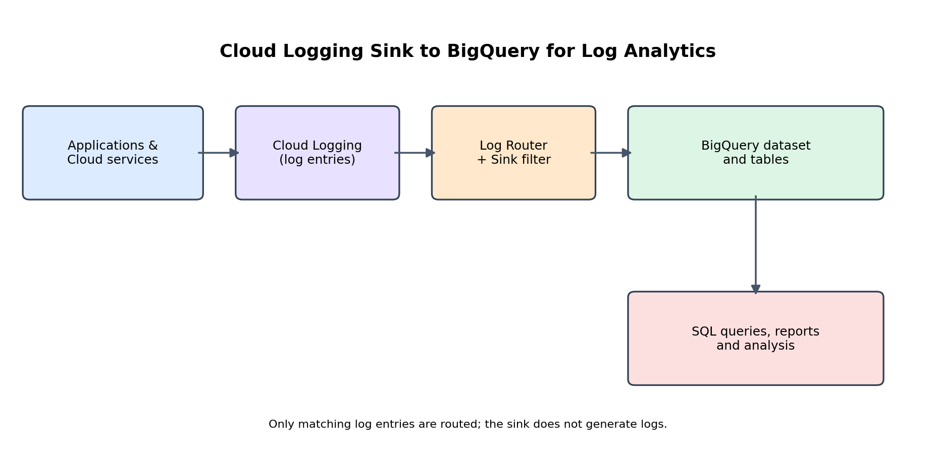

6. How the Project Works

Step 1 — Applications create logs
Google Cloud services and applications produce entries such as requests, warnings, errors, and audit events.

Step 2 — Cloud Logging receives entries
Cloud Logging stores entries and makes them available in Logs Explorer.

Step 3 — The sink evaluates filters
The Log Router checks inclusion and exclusion filters.

Step 4 — BigQuery receives matching entries
The sink routes matching entries to a write-enabled dataset. Its writer identity must have the required access.

Step 5 — SQL analyzes the data
SQL queries can count events, group by severity, and investigate trends.

7. Implementation Workflow
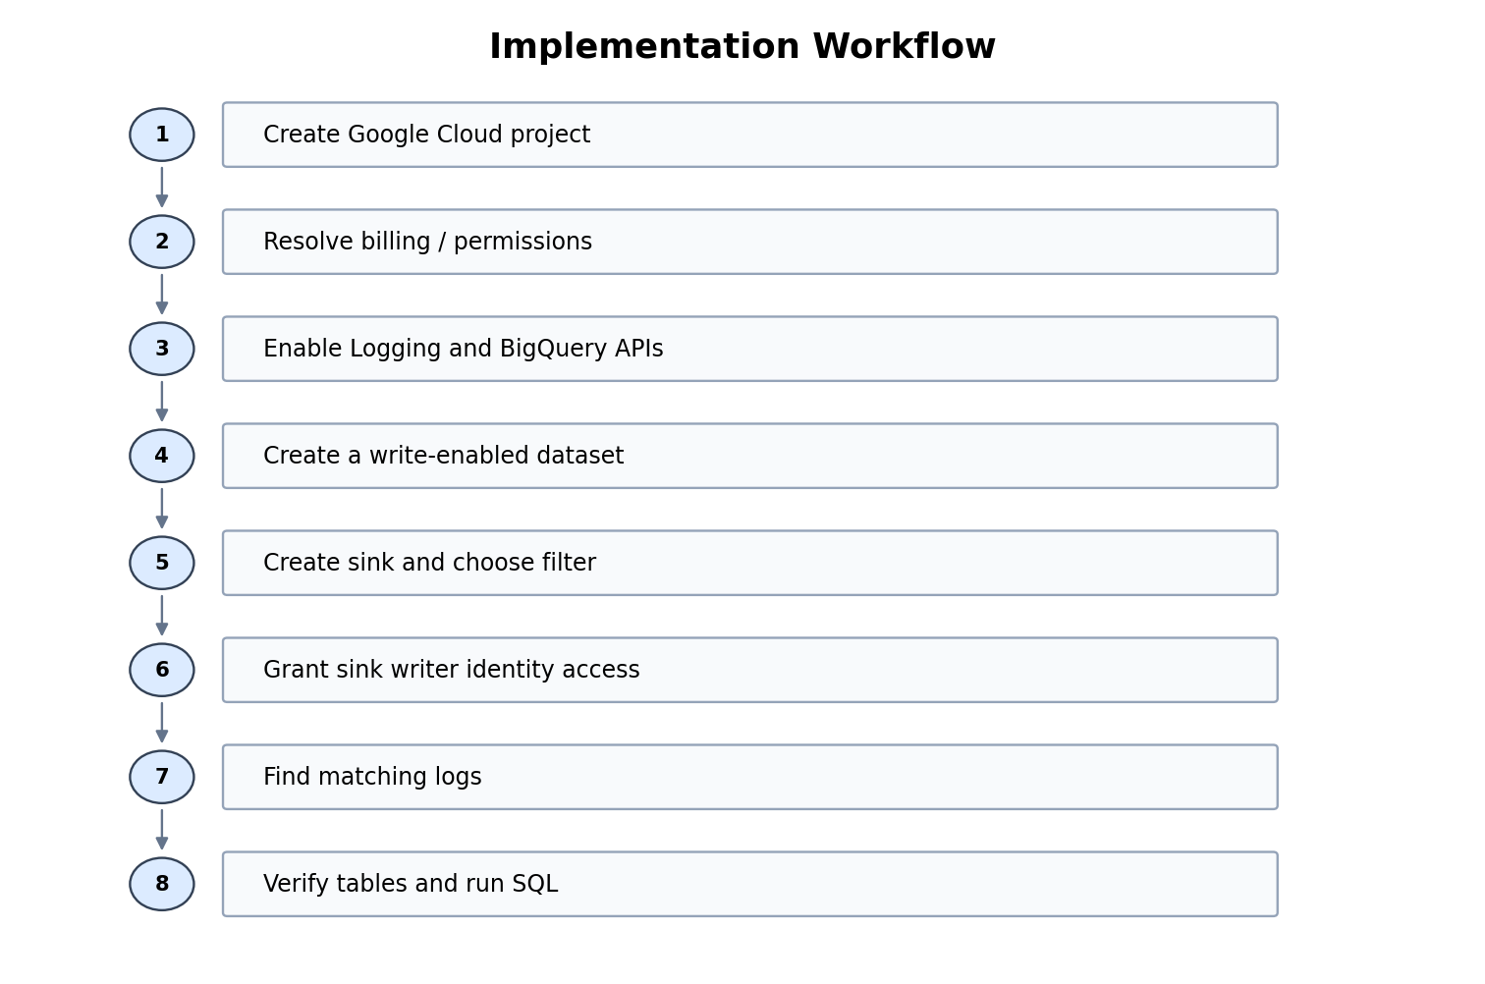

Create the Google Cloud project
Open the Google Cloud Console, select the project menu, choose New Project, enter a name, create it, and select it.

Resolve billing and permissions
If the console reports a billing permission error, stop and ask the billing account administrator to grant the required access or link the project. Do not create another billing account or add a payment method merely to bypass the error.

Enable APIs
Enable the Cloud Logging API and BigQuery API if they are not already enabled.

Create the dataset
In BigQuery Studio, create a dataset such as cloud_logs. Choose a suitable location. The dataset must be write-enabled.

Create the sink
In Logging → Log Router, choose Create sink, name it bigquery-log-sink, select BigQuery dataset, and choose cloud_logs.

Choose a filter
For a small demonstration, severity >= WARNING routes warning and higher-severity entries. An empty inclusion filter matches all eligible entries in scope, subject to exclusions. Choose deliberately to control volume.

Grant destination access
If prompted, grant the sink writer identity the required access, commonly BigQuery Data Editor on the destination dataset. Follow current console guidance and use least privilege.

Verify the result
Use Logs Explorer to find matching entries, then inspect the actual tables and schema in BigQuery.

8. Example SQL Queries
First inspect the table in BigQuery, then replace PROJECT_ID, DATASET_ID, and TABLE_NAME with the real values. Field names can vary with the routed log schema.

Example A — Inspect entries
SELECT
timestamp,
severity,
logName
FROM `PROJECT_ID.DATASET_ID.TABLE_NAME`
ORDER BY timestamp DESC
LIMIT 100;

Example B — Count entries by severity
SELECT
severity,
COUNT(*) AS total_logs
FROM `PROJECT_ID.DATASET_ID.TABLE_NAME`
GROUP BY severity
ORDER BY total_logs DESC;

9. Expected Results
- A Google Cloud project is created and required APIs are enabled.
- A write-enabled BigQuery dataset exists.
- A log sink is configured with a destination and filter.
- The sink writer identity has the required permissions.
- Matching log entries appear in BigQuery after routing begins.
- SQL queries return sample rows or counts.
These are expected outcomes, not a claim that deployment is complete. Verify each item in your own Google Cloud environment.

10. Troubleshooting

Billing permission error
Ask the billing account administrator to grant access or link the project. Do not bypass organizational controls.

No table or rows appear
Confirm the sink is enabled, its filter matches existing logs, the dataset is write-enabled, and the writer identity has access. A new table can take several minutes to receive entries.

Permission denied
Review IAM roles for both the person configuring the sink and the sink writer identity. Grant only necessary roles.

Table not found
Inspect the actual table names in BigQuery. Logging can create tables based on log names and dates.

Cost concerns
Review pricing and billing reports before enabling paid resources or generating large log volumes. Budget alerts notify you but do not cap spending.

11. Cost and Security Considerations
- Charges may depend on logging volume, storage, queries, and account configuration.
- Use a small test and narrow filter while learning.
- Do not put passwords, access tokens, or secrets into test logs.
- Limit dataset permissions to people and service identities that need them.
- A budget alert is not a hard spending limit.
The responsibilities below are a suggested division of work; the team should update them to reflect the work actually completed by each member.

Team Member Contributions
Team Member | Suggested Contribution
D. Gnana Prasanna Maruthi | Research on Cloud Logging, log types, and project objectives.
V. Sudheer | Project coordination, report preparation, and integration of the workflow.
Sk. Abdul Habeeb | BigQuery dataset, SQL analysis approach, and result verification planning.
K. Srilakshmi | Architecture/workflow documentation, testing checklist, and presentation preparation.

12. Conclusion
This project demonstrates a practical cloud log analytics pipeline. Cloud Logging collects entries, a sink routes matching entries to BigQuery, and SQL makes the data easier to summarize and investigate. The key requirements are a write-enabled destination dataset, a suitable filter, correct permissions, and access to the required Google Cloud services.

13. Official References
- Cloud Logging routing overview: https://docs.cloud.google.com/logging/docs/routing/overview
- Route logs to supported destinations: https://docs.cloud.google.com/logging/docs/export/configure_export_v2
- View logs routed to BigQuery: https://docs.cloud.google.com/logging/docs/export/bigquery
- Google Cloud Console: https://console.cloud.google.com/
- BigQuery documentation: https://cloud.google.com/bigquery/docs

