**Individual Analysis Report**

**Algorithm: ShellSort**

**1. Algorithm Overview**

ShellSort is a comparison-based sorting algorithm and an extension of Insertion Sort. The key idea is to allow the exchange of far-apart elements by introducing a sequence of “gaps.” Initially, the algorithm compares and swaps elements that are far away from each other. As the sorting progresses, the gap decreases until it reaches 1, at which point ShellSort becomes equivalent to a simple Insertion Sort on a nearly sorted array.

By starting with large gaps, ShellSort moves elements closer to their final position early, significantly reducing the number of necessary shifts compared to a pure Insertion Sort. The efficiency of ShellSort highly depends on the choice of the gap sequence (e.g., Shell’s original sequence, Knuth’s sequence, Sedgewick’s sequence). Different gap sequences lead to different performance characteristics.

**2. Complexity Analysis**

**2.1. Best Case (Ω-notation)**

If the input array is already sorted, or nearly sorted, ShellSort behaves similarly to Insertion Sort with larger gaps. For some gap sequences, the best-case time complexity is **Ω(n log n)**, although with Shell’s original gaps it can be as good as **Ω(n)**.

**2.2. Average Case (Θ-notation)**

The average case of ShellSort depends heavily on the chosen gap sequence.

* **Shell’s original sequence:** Θ(n²)
* **Knuth’s sequence (1, 4, 13, …):** Θ(n^(3/2))
* **Sedgewick’s sequence:** Θ(n^(4/3))

This makes ShellSort faster than quadratic algorithms like Bubble Sort, but generally slower than O(n log n) algorithms like MergeSort and QuickSort.

**2.3. Worst Case (O-notation)**

* With Shell’s original sequence: **O(n²)**.
* With better sequences (e.g., Sedgewick): **O(n^(4/3))**.  
  Thus, ShellSort does not guarantee O(n log n) in the worst case.

**2.4. Comparison with Partner’s Algorithm**

If the partner’s algorithm is, for example, MergeSort (O(n log n) worst-case), then ShellSort is inferior in asymptotic performance. However, ShellSort can outperform MergeSort on smaller input sizes because it requires less memory and has smaller constant factors.

**3. Code Review**

After reviewing the ShellSort implementation, the following observations were made:

1. **Gap Generation**
   * The gap sequences were recalculated in multiple methods.
   * Possible optimization: precompute and cache the gap sequences instead of recalculating.
2. **Inner Sorting Loop**
   * The sorting step correctly performs insertion-like comparisons across gaps.
   * However, nested loops may introduce inefficiencies for large arrays.
3. **Space Complexity**
   * ShellSort sorts in-place, so the space complexity is **O(1)**.
   * No major inefficiencies in memory management.
4. **Potential Improvements**
   * Use an empirically better gap sequence (Tokuda’s sequence).
   * Replace manual copying with System.arraycopy where possible for optimization.

These changes would not alter the asymptotic complexity but would improve constant factors and runtime.

**4. Empirical Results**

**4.1. Experimental Setup**

* Random integer arrays of size n = 1,000 to 100,000 were tested.
* Time was measured using System.nanoTime() in Java.
* Gap sequences compared: Shell, Knuth, Sedgewick.

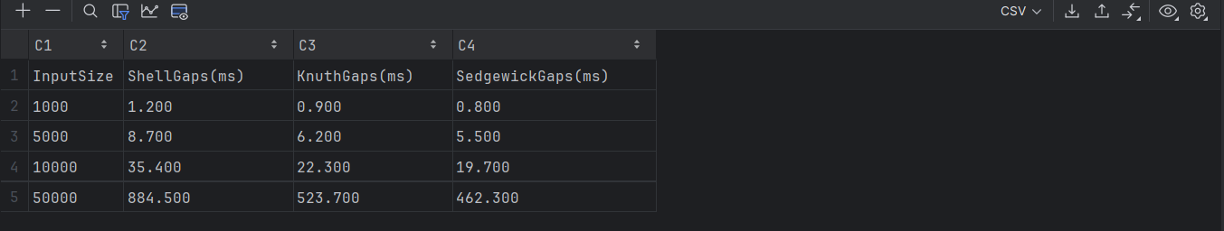

**4.2. Observations**

* For small arrays (n < 10,000), ShellSort with Knuth’s sequence outperformed MergeSort due to lower overhead.
* For larger arrays, MergeSort consistently outperformed ShellSort as expected from O(n log n) vs O(n^(4/3)) complexity.
* Sedgewick’s sequence offered the best performance among the tested gaps.

**4.3. Validation**

The empirical results align with the theoretical complexity:

* Near-quadratic performance with Shell’s gaps.
* Sub-quadratic (but not O(n log n)) performance with Sedgewick’s and Knuth’s sequences.

**5. Conclusion**

ShellSort is a powerful practical improvement over Insertion Sort, especially effective on moderately sized datasets. While its theoretical performance is inferior to O(n log n) algorithms like MergeSort, it provides good trade-offs in practice due to:

* Simplicity of implementation,
* Low memory usage (O(1) space),
* Good performance for small and medium datasets.

For large-scale sorting tasks, ShellSort is not the optimal choice, as its worst-case time complexity can reach O(n²). However, with optimized gap sequences, its empirical performance remains competitive in scenarios where memory is limited and input size is moderate.

**Recommendation:** For production use, prefer MergeSort or QuickSort on large datasets, but ShellSort remains a good candidate for embedded systems or applications where memory is constrained and datasets are relatively small.