Student ID: 24005786

Unit 4: Programming
Written report

Introduction & Project Overview
The purpose of this report is to design, develop, and evaluate a program which calculates the monthly costs for athletes who train at the North Sussex Judo Club. This application was built using Python within the Visual Studio Code (VS Code) Integrated Development Environment (IDE) and bring together three core programming paradigms: procedural, object-orientated, and event-driven programming. The program allows users to input key details such as the athlete’s name, training plan, weight, competition category, as well as private training hours. Based on these inputs, the program calculates the total monthly cost by combining training competition, and private coaching fees. Input validation and error handling were implemented to ensure that invalid data does not cause the program to crash, therefore making it both reliable and user-friendly. The program’s design followed a structured algorithm development process using pseudocode and flowcharts before implementation. Consequently, these tools therefore ensured logical flow, clear decision structures, as well as efficient data handling. The final version of the program includes a Graphical User Interface (GUI) created with Tkinter, providing a professional and efficient interface for users.
This project demonstrates the complete software lifecycle: “from algorithm design and code implementation to debugging and evaluation,” (GeeksforGeeks, 2025) whilst following industry coding standards and secure programming practices.

Algorithm Design
Before developing the North Sussex Judo Monthly Fees Calculator, it was essential to design a clear algorithm which outlines the logical order of operations. The software design process ensures that the process of “planning and structuring a software system before actual coding begins. It involves defining the architecture, components, interfaces, and data flow to ensure the software meets user requirements while being efficient, scalable, and maintainable.” (K, 2025). The program’s main purpose is to calculate an athlete’s total monthly training cost based upon their training plan, number of private coaching hours, and competitions entered. To make it both secure as well as user-friendly, the algorithm also implements input validation, data integrity checks and error handling.
Identifying Inputs, Processes & Outputs:
Stage | Description
Inputs | Athlete Name, Training Plan (Beginner, Intermediate, Elite), Weight (kg), Competition Category (Flyweight - Heavyweight), Private Training Hours (0 -20), Number of Competitions.
Processes | Validate all user inputs, auto-cap private hours at 20, prevent beginners from entering competitions, calculate weekly fees, private hour rate, and competition cost, then compute total monthly cost.
Outputs | Display a full breakdown of training, private, and competition fees, total cost, and a weight category feedback message.

Pseudocode Design
Before coding, pseudocode was created to outlines the logical flow and structure of the program. As a result, this helped ensure that the logic, calculation, and validation rules were correct before implementation.

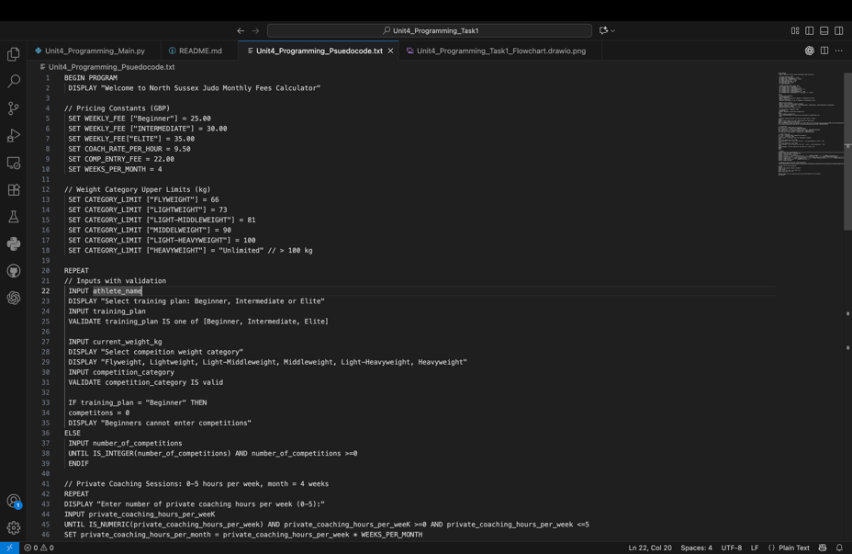
Figure 1: Pseudocode outlining the planned algorithm steps for data input, validation and monthly cost calculation
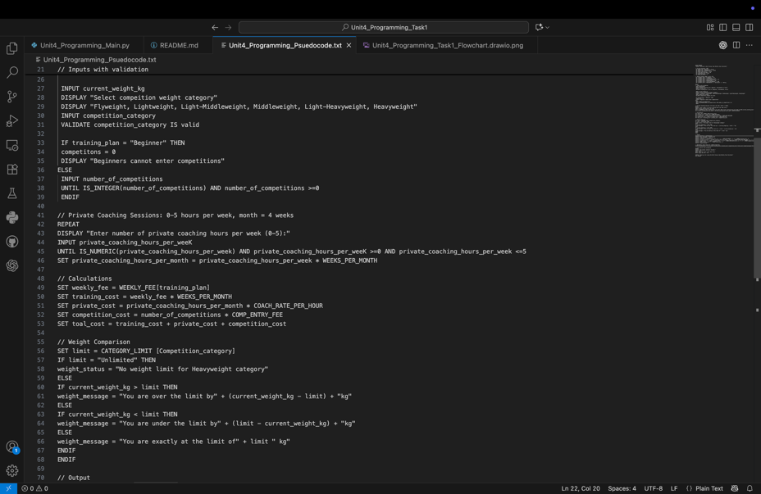
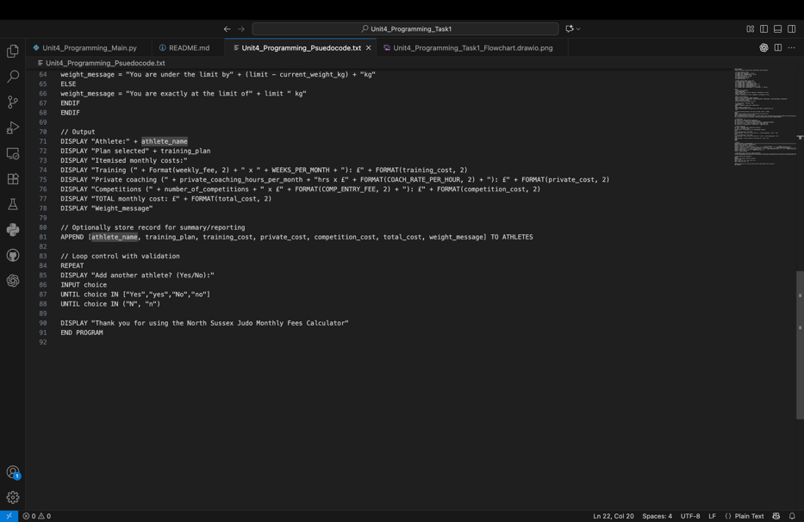
Flowchart Representation
The algorithm was represented visually through a flowchart created in Draw.io (diagrams.net). It shows decision structure, loops, and data flow from user input through to the final output.
Figure 2: Flowchart showing the decision-making process and cost calculation logic for the North Sussex Judo Monthly Fees Calculator.

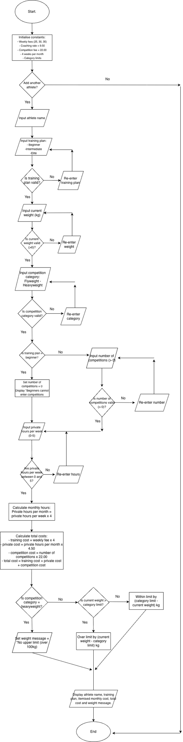
Choice of Programming Paradigms
This program integrates three programming paradigms to meet functional and performance requirements:
- Procedural Programming is a “programming paradigm that organises code into step-by-step instructions called procedures, routines, or functions.” (Ada Computer Science, no date). This ensures the program is executed in a logical, step-by-step program, therefore making it easy to test and maintain.
- Object-Orientated Programming (OOP) is a “programming paradigm based on the concept of ‘objects,’ which are self-contained units that combine data and the code (functions) that operate on that data.” (BBC Bitesize, no date). This approach increases reusability, readability, and minimising redundancy.
- Event-Driven Programming is a “paradigm where the program's flow is determined by external occurrences called "events," such as user actions, sensor inputs, or messages from other systems,” (Convex, 2024). For instance, the GUI, which was built using Tkinter responds to user interactions, therefore making the program interactive and responsive.
These paradigms complement each other. For example, procedural logic ensures control flow, OOP structures the data and logic neatly, and event-driven programming connects it all through the GUI.
Design Rational and Optimisation
The design process followed a structured approach to ensure both accuracy as well as efficiency:
- Input validation presents invalid data (e.g. negative hours, invalid categories).
- Constants are used for key values (fees, limits) to improve maintainability.
- The flowchart and pseudocode acted as roadmaps during implementation.
- OOP principle ensure scalability for future updates.
- GUI design ensures accessibility and user-friendliness, improving interaction quality.
This optimisation demonstrates careful planning and high level understanding of the algorithm design and program flow.
Evaluation of Algorithm Design
The final algorithm successfully meets the functional, technical, and user requirements set out in the problem statement.
- All inputs are validated correctly, preventing errors and crashes.
- Outputs are formatted clearly, improving user understanding.
- The logic is efficient, avoiding redundant calculations as well as nested conditions.
- The design could efficiently integrate future enhancements, such as data storage or login systems.
Steps from Algorithm to Code
After completing the design phase through pseudocode and flowchart development, the nest step was to translate these algorithmic representations into functional Python code. This process required careful consideration of programming paradigms, secure coding practices, and modular structure to ensure accuracy, maintainability, and performance.
Translating Pseudocode into Python
The pseudocode created earlier defined the step-by-step logical structure of the program - including user input, data validation, decision-making, and cost calculation. Each part of the pseudocode was converted into Python syntax while maintain readability and efficiency. For example, the pseudocode’s “IF training_plan = Beginner THEN competitions = 0” was implemented in Python as:
Similarly, the pseudocode’s repetition structure “REPEAT UNTIL choice = N” was adapted into an event-driven loop through the Tkinter GUI, where the user interacts repeatedly via the “Calculate” button. This ensured that the program remains active and user-controlled rather than sequentially looping in the terminal.
Implementing Flowchart Logic in Code
The flowchart, created using Draw.io, visually represented the program’s decision-making process - particularly around validation, cost calculation, and category checks. Each flowchart condition was translated into Python IF-ELIF-ELSE statements and summarised within functions or class methods for modularity. For example, “IF category limit = ‘Unlimited’ THEN display ‘No upper limit’ ELSE compare weight to limit.”
This is translated into Python as:
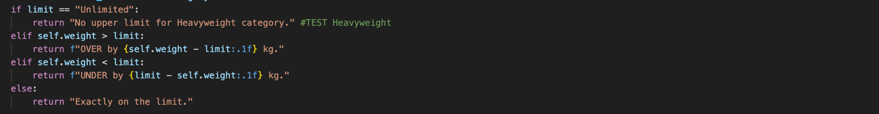
This ensured that the control flow mirrored the original flowchart and that all decision branches produced accurate and predictable results.
Justification of Python as the Chosen Programming Language
Python was used as the implementation language for this project because it supports multi-paradigm development, therefore allowing the integration of procedural, object-orientated, and event-driven programming within one application. This choice was also supported by Python’s “simplicity and readability as the language’s syntax is clean and intuitive, making it an excellent choice for beginners. Python’s code is often described as almost English-like, which allows developers to focus on solving problems rather than deciphering complex syntax.” (Singh, 2024).
Key reasons for choosing Python:
- Python’s syntax closely resembles pseudocode making it ideal for clear, step-by-step logic conversion.
- Support for OOP, by allowing “the creation of classes and objects, which group data (attributes) and behaviour (methods) together.” (Is Python Object-Oriented? 2024). This promotes encapsulation and modularity, therefore promoting maintainability.
- Python’s built-in GUI framework (Tkinter) can “abstract away low-level details of GUI programming, making it easier for developers to focus on the logic behind the application.” (Hernandez, 2024). This enhances the ability to write clean and maintainable code as well as reducing the chance of errors.
- In Python, using “try-except blocks is crucial for maintaining security by preventing unexpected crashes and managing errors effectively.” (Discover how to handle errors in Python effectively while maintaining security. Learn the best practices for robust and secure coding., 2024).
- Visual Studio’s Python is simple and comes with built features that enhance a developer’s experience. For instance, “features like syntax autocomplete, linting, debugging, unit testing, GitOps, virtual environments, notebooks, editing tools, and the ability to customize the editor.” (Awan, 2023).
Linking Algorithms to Code Structure
The following connections were made between design documentation and implementation:
Design Component | Implementation in Code | Explanation
Input Handling (pseudocode input lines0 | Tkinter Enter and OptionMenu widgets | GUI-based data entry replacing console input.
Validation | validate_inputs() function in Athlete class | Ensures data integrity (hours < 20, valid category, etc)
Decision Making | If-elif-else structures | Implements logical branching identical to the flowchart
Calculations | calculate_fees() method | Executes training, private, and competition cost formulas.
Output Display | result_text.set() | Updates GUI dynamically to show results.

Implementation Reflection and Professional Quality
Throughout development, both the pseudocode and flowchart were actively referenced to guide program structure as well as ensure logical consistency. Python’s indentation and naming conventions made the translation from design to code more readable. To maintain coding standards, the program used:
- Uppercase constant variables, (PRIVATE_HOUR_RATE, MAX_PRIVATE_HOURS).
- Consistent indentation and commenting for clarity.
- Docstrings (“”” …”””) to explain class as well as method functionality.
The close alignment between the algorithm and the final code ensured minimal errors during testing, any issues (such as invalid user input or missing validation) were quickly identified and resolved using IDE feedback tools like the Run and Debug feature in VS Code.
Development Process
Setting Up the Environment
Development began by configuring the VS Code IDE, installing Python and linking environment to a GitHub repository. This setup enabled real-time syntax checking version control and integrated debugging, all of which contributed to producing a clean, professional code.
A new file, main.py was created to implement the program, and support files such as (Unit4_Programming_Pseudocode.text and Unit4_Programming_Task1_Flowhcart_drawio.png) were added for documentation.
Figure 3: VS Code workspace showing main.py and other project files
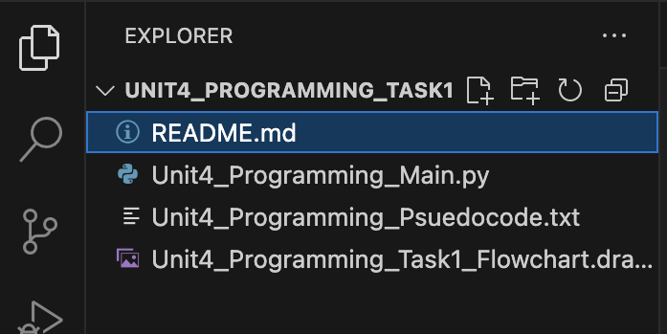
Building the Core Logic
The initial development phase involved writing the procedural structure of the program. Constants were declared at the top to define training fees, competition costs, and private training rates, ensuring readability, and easy modification. Each logical block from the pseudocode was implemented step by step, such as:
- Input validation.
- Cost calculation.
- Output formatting.
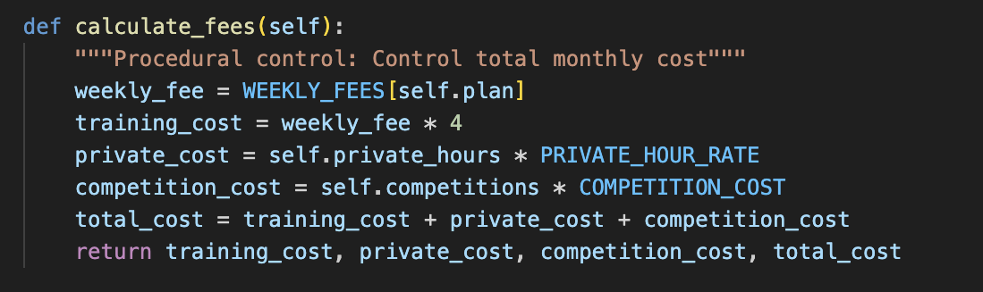
Object-Oriented Programming (OOP) Implementation
To make the system flexible and maintainable, the core logic was absorbed in a single class named Athlete. This class structure promoted data encapsulation and reusability, allowing future extensions such as saving athlete data or exporting reports. The class contained:
- Attributed: name, plan, weight, category, private hours, competitions.
- Methods: validate_inputs(), calculate_fees(), and weight_message().
For example, the validation logical was written to ensure robust, secure data entry:
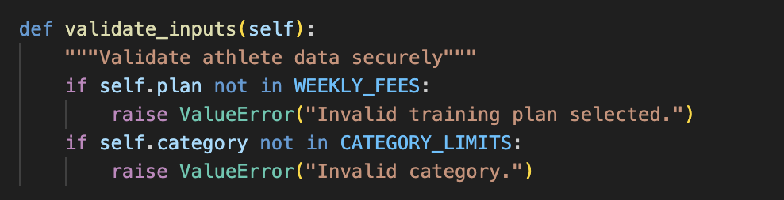
This flexible approach directly demonstrated OOP principles. Which are, “encapsulation, abstraction, inheritance, and polymorphism. These principles help organise and structure code by creating objects that contain both data and functions, making programs more modular, reusable, and easier to maintain.” (REVUTSKA, 2023).
Event-Driven Programming
The algorithm’s user input section was transformed into an interactive interface using Tkinter. Each input field from the pseudocode was represented by an Entry or OptionMenu widget. The GUI listens for user events, specifically the “Calculate Monthly Fees” button, which therefore triggers the calculate_button_clicked() event function:
This event-driven structure replaced the original REPEAT-UNTIL pseudocode loop, ensuring the program responds dynamically to user interactions instead of running in a static sequence
Figure 4: Tkinter GUI layout allowing user interaction and event-driven control.
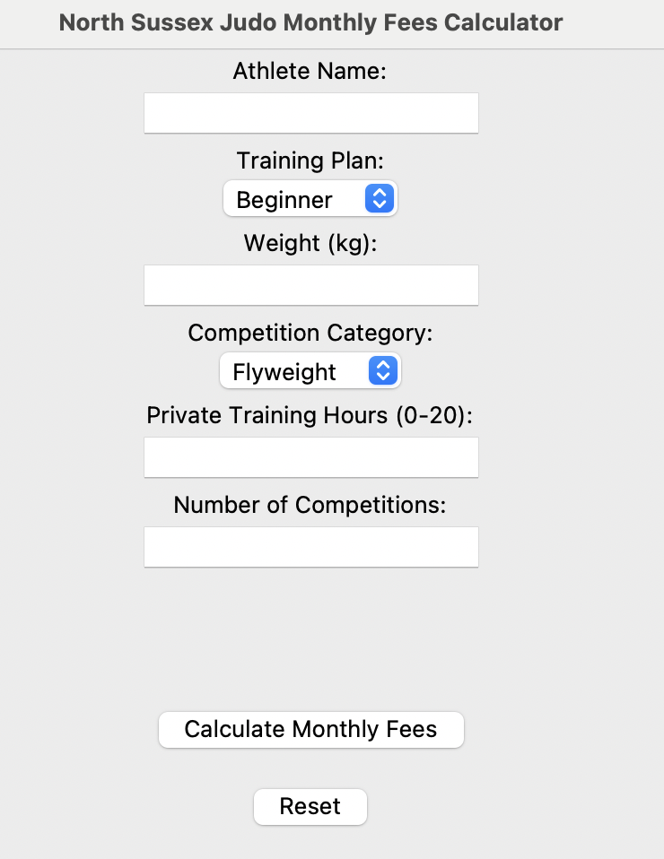
Implementing Validation and Error Handling
During testing, several validation and logic issues were identified and resolved:
Challenge | Solution
Program crashed when invalid inputs were entered. | Added try/except blocks to catch exceptions and show user-friendly error messages via messagebox.showerror().
Private training hours above 20 caused unrealistic values. | Added an auto-cap condition: if hours > 20, set to 20.
“Beginner athletes incorrectly included competition costs. | Introduced conditional logic to reset competitions to 0 for beginners.
Tkinter widgets sometimes failed to update output. | Implemented StringVar() binding to dynamically refresh GUI results.

Testing & Refinement
Test Case | Expected Result | Outcome
Beginner + any competition | Competition cost = £0.00 | Correct
Private hours = 21 | Auto-capped to 20 | Correct
Heavyweight category | “No upper limit…” message | Correct
Middleweight (81kg) with weight 82kg | “OVER by 1.0kg) | Correct
Figure 5: Program successfully calculating monthly fees and displaying output in GUI
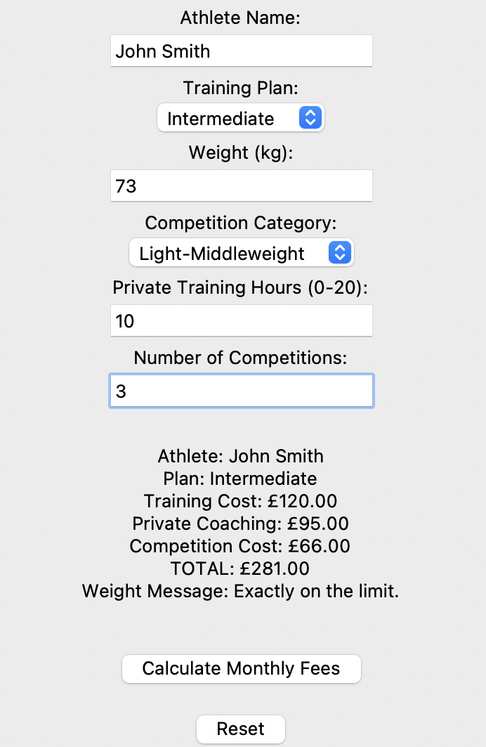
Challenges Faces and Solutions Implemented
Challenge | Description | Solution Implemented
GUI not displaying correctly. | Initial layout overlapped labels. | Adjusted. Pack() order and added spacing with pady.
“String literal is unterminated” syntax error | Missing closing quote in Tkinter label. | Fixed by reviewing suggestion in VS code.
Event order causing calculation error. | calculate_button_clicked() executed before user input validated. | Added try block with sequential validation checks.
Data reusability, | Difficult to manage repeated input. | Encapsulated logic in OOP class structure.

Version Control and Iterative Development
GitHub was used to track each development stage. Each iteration stage was committed and uploaded, allowing changes to be reviewed and rolled back if necessary. This reflects professional software engineering practice as well as supports maintainability.
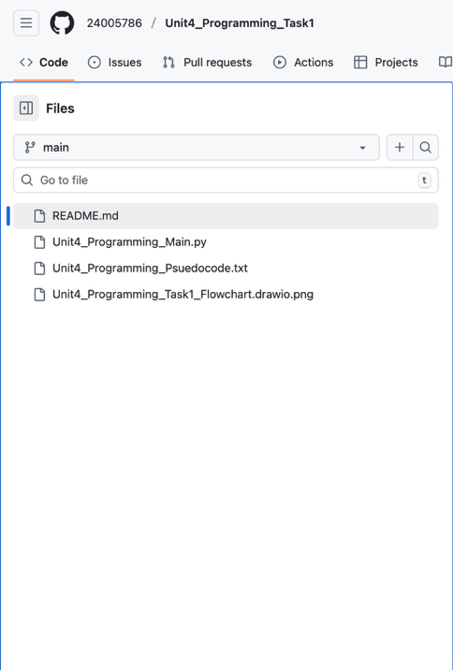
Figure 6: GitHub repository showing all projects.

Reflection and Quality Evaluation
The development process successfully met the requirements of the original algorithm while improving maintainability as well as user experience. The integration of procedural, object-orientated, as well as event-driven techniques produced a well-structured, reusable and professional application. The pseudocode and flowchart effectively guided the build and reduced errors, ensuring a seamless transition from theory to practice.
Debugging Process & IDE Features Used
Debugging was an essential part of the program’s development process as it ensured that the final Python code operated reliably, securely, and aligned with the original algorithm and flowchart logic.
Debugging Approach
This was carried out continuously using both manual testing (running and reviewing program output) and automated support from VS Code. Common debugging techniques used included:
- Reading terminal error messages after each test run.
- Using try/except blocks for runtime error handling.
- Testing one component at a time (procedural - OOP - GUI).

Common Errors Identified & Resolved
Issue | Cause | Resolution
“String literal is unterminated” | Missing quotation mark in a Tkinter label. | Fixed by reviewing error suggestions and correcting string syntax.
name_entry not defined | Widget referenced before name-entry creation | Moved declaration above event-driven function
Program crashed with invalid user input | Non-numeric entry for weight or hours. | Added try/except block in calculate_button_clicked() and displayed error with messagebox.showerror().
GUI not updating dynamically | Output label not bound to variable | Replaces with StringVar() and linked to result_text.set()
Incorrect validation for beginners. | Logic allowed competition fees for Beginner plan | Added conditional to set competitions = 0 when plan = “Beginner”

IDE Tools and Debugging Features
The VS Code IDE provided several integrated debugging features that improved program reliability:
- Pylance highlighted missing colons, quotation marks, or indentation errors before runtime.
- Run and Debug console allowed step-by-step monitoring of variables and logic flow.
- Terminal output lops helped trace logic errors and identify where incorrect values were written.
- Code commenting simplified the testing of specific sections without affecting the entire program.
Figure 7: Using the VS Code Debug Console to test logic and trace errors.
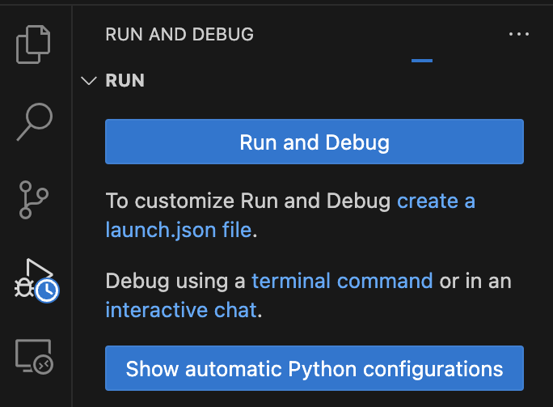
Error Handling & Secure Programming
To prevent crashes and improve user experience, structured handling was added across the program. For example, the event-driven GUI used a try/except block to catch errors when users entered invalid data.
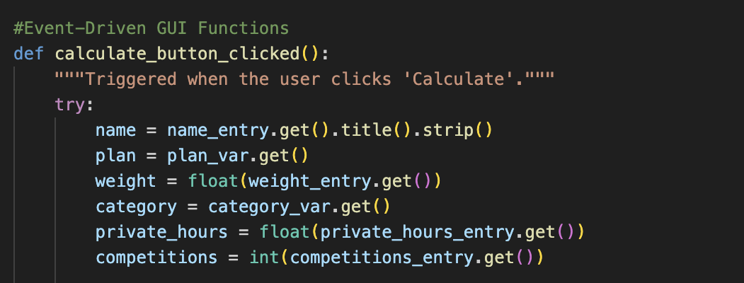
This ensured that the program remains stable, protecting it from invalid input, and aligns with secure programming standards outlined in coding guidelines.
Reflection on Debugging Effectiveness
The debugging process was both systematic and repeated. Each text cycle revealed minor syntax, logical, or event-driven issues, which were resolved efficiently using IDE feedback and gradual testing. Consequently, the final program operated reliably, validates user input correctly, and matches the design expectations outlined in the pseudocode and flowchart.
Coding Standards
Throughout the development of the North Sussex Judo Monthly Fees Calculator, strict coding standards were applied to ensure that the final program was readable, maintainable, secure and consistent with professional software practices. These standards contributed directly towards the program’s reliability, alignment, with design documentation and overall quality.
Consistent Naming Conventions
- Constants were written in uppercase (e.g. PRIVATE_HOUR_RATE, COMPETITON_COST) to differentiate them from regular variables.
- Variables used snake_case (e.g. weight_entry, total_cost) to, “improve readability, it enhances the readability of variable and function names, making them more accessible to other programmers and even your future self.” (Tuple, 2023).
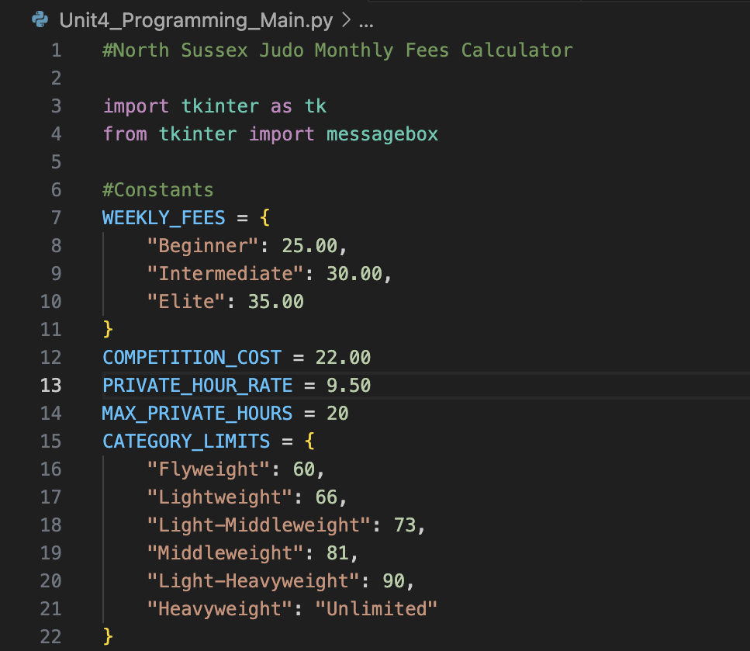
Figure 8: Consistent use of naming conventions and constants for readability and variable naming in main.py
Commenting and Documentation
Each function and class contain docstrings (“””…”””) to explain its purpose and return values. Inline comments were also added to clarify validation steps, calculation logic, and event-driven occurrences. This ensures that the purpose of every block of code was clearly documented for both the developer and moderators.
Proper documentation is crucial as “it supports various aspects of the software development lifecycle, primarily by enhancing clarity, maintainability, collaboration, and knowledge transfer.” (Fisher, 2024).
Indentation, Spacing & Readability
Python’s enforced indentation was used consistently across all structures, improving logical clarity and reducing the likelihood of syntax errors. Blank lines were added between sections to separate constants, classes and functions, and GUI code, enhancing overall code readability. This structure mirrors professional standards found in the PEP 8 (Python Enhancement Proposal). PEP 8’s primary goal is to “make code easier for humans to read and understand, since code is read far more often than it is written.” (Python, 2023).
Secure and Ethical Programming Practices
Secure coding practices were integrated through input validation exception handling, as well as restricted user interaction:
- Validation checks prevented invalid input.
- Exception handling with try/except ensure the program did not crash unexpectedly.
- Sensitive inputs were not stored or logged therefore protecting user privacy.
These practices align with professional expectations for ethical and responsible software design.
Enhancements & Optimisation of the Algorithm
Once the program was fully implemented and tested, several opportunities for enhancement and optimisation were identified. These improvements focused on increasing efficiency, maintainability, and user experience, while ensuring that the final program met professional and ethical software standards.
Performance and Logical Optimisation
During testing, certain processes were refined to improve the program’s efficiency and accuracy:
- The validation methos was enhanced to auto-cap private hours at 20 instead of displaying an error, reducing unnecessary user disappointment and making the program more efficient.
- IF-ELIF-ELSE structures reduced redundancy in weight categories.
- Constants were defined once and reused throughout the program, optimising performance and preventing errors.
These enhancements ensured smoother performance and better scalability for future updates.
Figure 9: Example of optimised validation logic to improve user experience
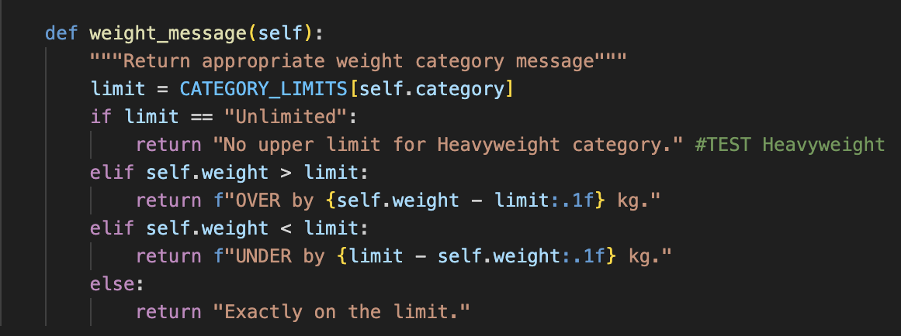
Code Readability & Maintainability
Refactoring was carried out to make the code more readable and maintainable:
- Repetitive calculations were encapsulated within the calculate_fees() method, therefore reducing duplication.
- Comments and docstrings were added to explain the logic behind each function and class.
- The program layout followed a consistent visual structure; constants, class definition, GUI setup, and event-driven functions were clearly separated with headings.
User Experience and Interface Enhancements
To make the program more user-friendly, a couple of interface improvements were introduced:
- A Reset button was added to allow users to clear results quickly and perform new calculations without restarting the program.
- The program now displays dynamic feedback messages (e.g. “No upper limit for Heavyweight category”) to improve user understanding of the results.
These updates improved usability and accessibility, aligning the system with professional software design principles.
Figure 10: User interface enhancements improving interaction and readability.
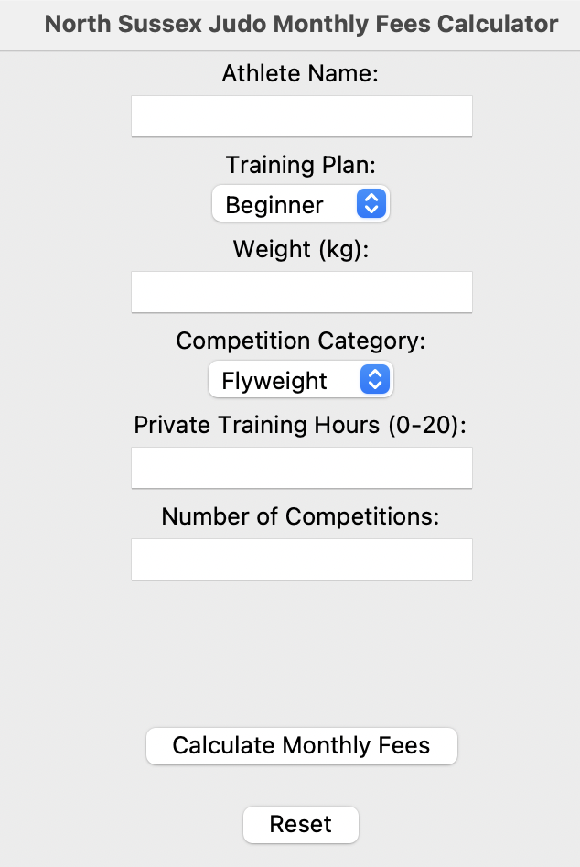
Future Improvement Opportunities
Although the current version meets all functional and technical requirements, further enhancements could be added to increase capability and efficiency:
- Exporting monthly cost reports into a PDF format.
- Adding basic authentication for coaches or admins to protect athlete data.
- Adapting the program for cloud deployment, allowing remote access and updates.
Evaluation
After completing the implementation and optimisation of the North Sussex Judo Monthly Fees Calculator, it was essential to evaluate the extent to which the final program matches the original and design documentation. This evaluation also reflects on the role of the IDE and coding standards in supporting the programs accuracy, usability and professional quality.
Comparison of Algorithm & Final Program
The final implementation remained consistent with the logic, structure, and decisions outlined in the pseudocode and flowchart. Key elements from the algorithm were successfully adapted in Python code.
Algorithm Feature | Implementation in Code | Evaluation
Input Validation. | Implemented via validate_input() and try/except error handling. | Prevents crashes and invalid entries.
Decision Structures. | Used IF-ELIF-ELSE to control training, weight, and competition logic. | Matches the flowchart’s decision nodes.
Loop | Replaced the REPEAT-UNTIL pseudocode loop with event-driven GUI buttons. | More efficient and user-friendly.
Output Display | Displayed dynamically via StringVar() in Tkinter. | Produces clear, formatted results.

This shows that the program’s logical flow mirrors the original design, demonstrating a successful transition from algorithm to implementation.
Figure 11: Comparison between pseudocode and final Python implementation showing structural alignment

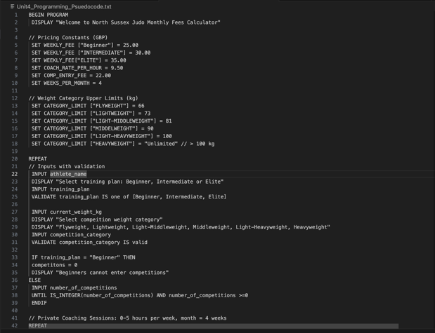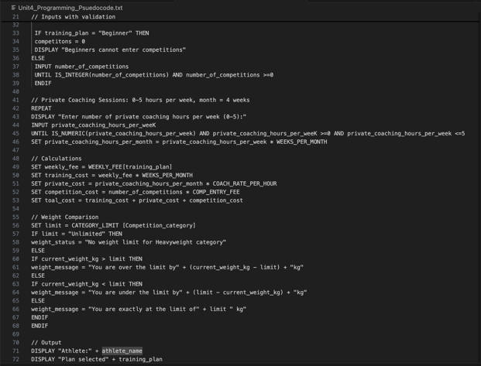
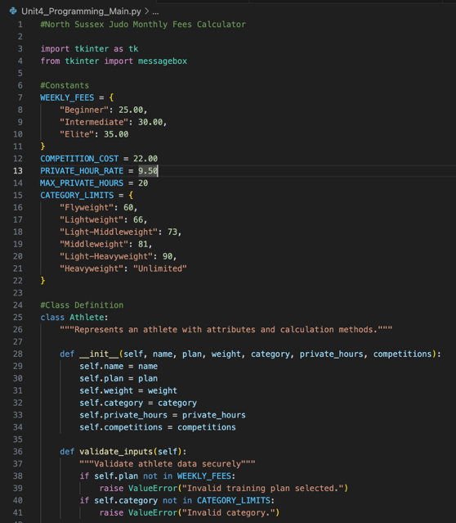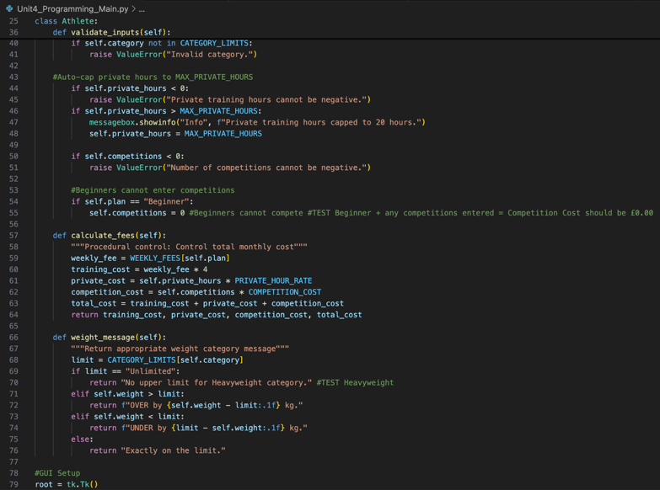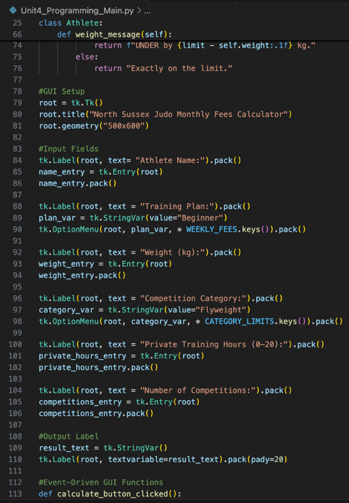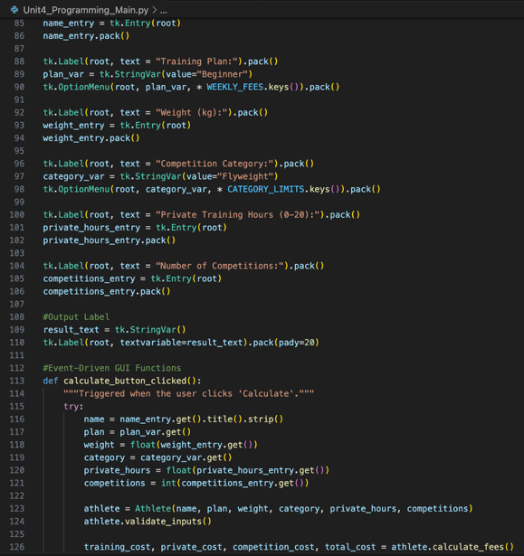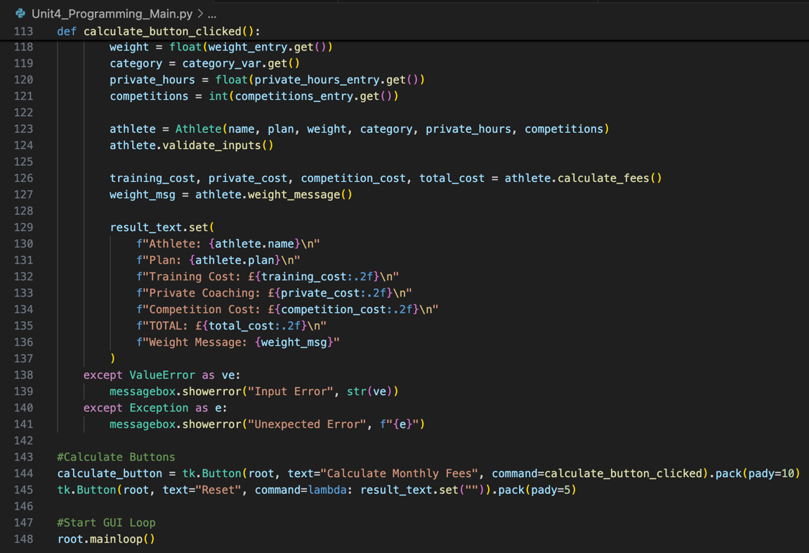
Evaluation of IDE Effectiveness
Using VS Code as the main development tool significantly improved the quality and maintainability of the program. The IDE’s features supported a professional iterative development process:
- Pylance provides real-time syntax and error detection, preventing runtime issues before running the program.
- Run and Debug Tools enable line-by-line testing and monitoring of different structures.
These tools directly contributed towards a more reliable program by reducing syntax errors improving testing accuracy and ensuring consistent version management.
Evaluation of Coding Standards
Coding standards are a “set of rules and guidelines for writing software code to ensure consistency, readability, and maintainability across a project. They include aspects like naming conventions, formatting, commenting, and error handling, and are followed by development teams to improve code quality, reduce bugs, and make collaboration easier.” (What coding standards in software engineering should we follow?, no date). For example, the program followed PEP 8 standards as:
- Constants were defined once and reused throughout the program to prevent redundancy.
- Function and class methods were well-commanded for clarity.
- Secure validation prevented unexpected vulnerabilities within the program.
These practices ensured the code was readable. reusable, and adaptable for future updates, aligning with professional expectations for secure, ethical programming.
Figure 12: Example of adhering to PEP 8 and professional coding standards.

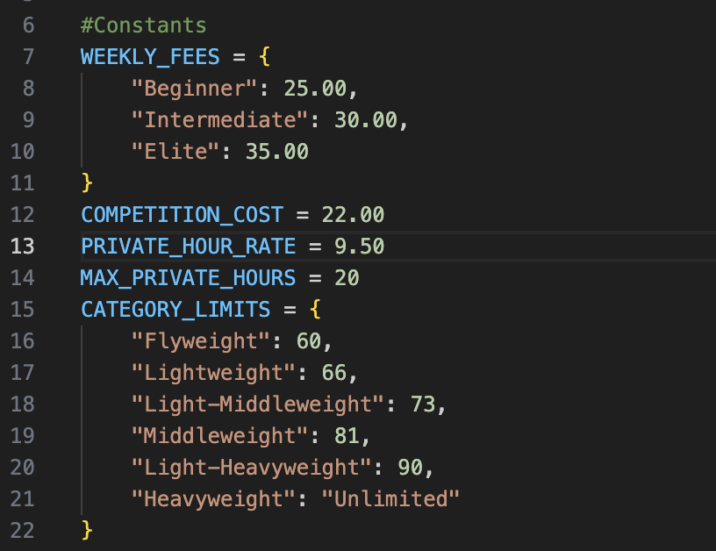
Evaluation of Programming Efficiency & User Experience
User experience was optimised through interactive design, fast calculations, and real-time error messages, all of which contribute towards a high-level solution:
- All calculations produced accurate and validated outputs.
- The interface was intuitive, allowing non-technical users to operate the calculator without difficulty.
- Error handling prevented any crashes, therefore enhancing reliability and efficiency.
Reflection & Scalability
The project demonstrates a theoretical design to an implemented, professional solution. Future scalability was considered throughout the process, ensuring that additional features could be easily added. This may include athlete database storage, reporting or authentication. The balance between functionality, validation and user experience shows strong adherence to professional standards.

Reference List:
Ada Computer Science (no date) Ada Computer Science. Available at: https://adacomputerscience.org/concepts/procprog_paradigm.
Awan, A.A. (2023) Setting Up VSCode For Python: A Complete Guide, Datacamp.com. DataCamp. Available at: https://www.datacamp.com/tutorial/setting-up-vscode-python.
BBC Bitesize (no date) Object Oriented Programming (OOP) - Contemporary trends in software development - CCEA - GCSE Digital Technology (CCEA) Revision, BBC Bitesize. Available at: https://www.bbc.co.uk/bitesize/guides/zc8pjty/revision/3.
Convex (2024) Event Driven Programming: A Definitive Guide, Convex.dev. Available at: https://stack.convex.dev/event-driven-programming.
Discover how to handle errors in Python effectively while maintaining security. Learn the best practices for robust and secure coding. (2024) Linkedin.com. Available at: https://www.linkedin.com/advice/3/what-best-practices-error-handling-python-qcvic (Accessed: January 2025).
Fisher, L. (2024) The Importance of Robust Documentation in Software Development, Acm.org. Communications of the ACM. Available at: https://cacm.acm.org/blogcacm/the-importance-of-robust-documentation-in-software-development/.
GeeksforGeeks (2025) Software Development Life Cycle (SDLC), GeeksforGeeks. Available at: https://www.geeksforgeeks.org/software-engineering/software-development-life-cycle-sdlc/.
Hernandez, M. (2024) What Are the Benefits of Using Python GUI Development?, ParallelStaff | Nearshore Software Development Company. Parallel Staff, Inc. Available at: https://parallelstaff.com/benefits-of-using-python-for-gui-development/.
Is Python Object-Oriented? (2024) Coursera. Available at: https://www.coursera.org/in/articles/is-python-object-oriented.
K, S. (2025) Software Design Process Explained: Everything You Should Know, EitBiz Blog - Updates on Technology and Innovative Digital Solutions. Available at: https://www.eitbiz.com/blog/software-design-process-everything-you-should-know/ (Accessed: 2025).
Python, R. (2023) How to Write Beautiful Python Code With PEP 8 – Real Python, realpython.com. Available at: https://realpython.com/python-pep8/.
REVUTSKA, N. (2023) What is Object-Oriented Programming (oop)? Explaining four major principles, Softserveinc.com. Available at: https://career.softserveinc.com/en-us/stories/what-is-object-oriented-programming-oop-explaining-four-major-principles.
Singh, P. (2024) 10 Advantages of Python Over Other Programming Languages, Analytics Vidhya. Available at: https://www.analyticsvidhya.com/blog/2024/01/advantages-of-python-over-other-programming-languages/.
Tuple (2023) Snake Case, Tuple.nl. Available at: https://www.tuple.nl/en/knowledge-base/snake-case (Accessed: 2025).
What coding standards in software engineering should we follow? (no date) SearchSoftwareQuality. Available at: https://www.techtarget.com/searchsoftwarequality/answer/What-coding-standards-in-software-engineering-should-we-follow.

