SAYFA 201 ÇÖZÜMLERİ

1.Soru
Graf:
V = {1,2,3,4}
E = {12,13,14,23,24} (yönsüz)
Dereceler:
d(1)=3, d(2)=3, d(3)=2, d(4)=2

Komşuluk Matrisi
A= $\left[\begin{matrix}0 & 1 & 1 & 1 \\ 1 & 0 & 1 & 1 \\ 1 & 1 & 0 & 0 \\ 1 & 1 & 0 & 0\end{matrix}\right]$

Derece Matrisi
D= $\left[\begin{matrix}3 & 0 & 0 & 0 \\ 0 & 3 & 0 & 0 \\ 0 & 0 & 2 & 0 \\ 0 & 0 & 0 & 2\end{matrix}\right]$

Laolacian Matrisi
L= $\left[\begin{matrix}3 & -1 & -1 & -1 \\ -1 & 3 & -1 & -1 \\ -1 & -1 & 2 & 0 \\ -1 & -1 & 0 & 2\end{matrix}\right]$

Etki Matrisi
B= $\left[\begin{matrix}1 & 1 & 1 & 0 & 0 \\ 1 & 0 & 0 & 1 & 1 \\ 0 & 1 & 0 & 1 & 0 \\ 0 & 0 & 1 & 0 & 1\end{matrix}\right]$

2.Soru
Kenarları bulma (i–j = 1 ise kenar var)
1 → 2, 3, 4, 5
2 → 1, 3, 5
3 → 1, 2, 4
4 → 1, 3, 5
5 → 1, 2, 4
Kenar Kümesi
V = {1,2,3,4,5}
E = {12,13,14,15,23,25,34,45}

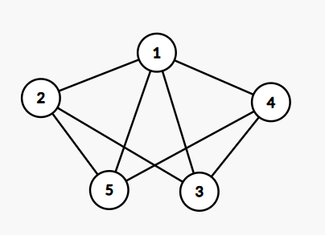

3.Soru
Komşuluk Matrisi
A= $\left[\begin{matrix}0 & 0 & 0 & 0 \\ 1 & 0 & 0 & 1 \\ 0 & 1 & 0 & 1 \\ 0 & 0 & 1 & 0\end{matrix}\right]$
Etki / Olay Matrisi
$\left[\begin{matrix}-1 & 0 & 0 & 0 & 0 \\ 1 & 1 & -1 & 0 & 0 \\ 0 & 0 & 1 & 1 & -1 \\ 0 & -1 & 0 & -1 & 1\end{matrix}\right]$

