**COMPARE TWO JSON HAVE THE SAME PROPERTIES WITHOUT ORDER**

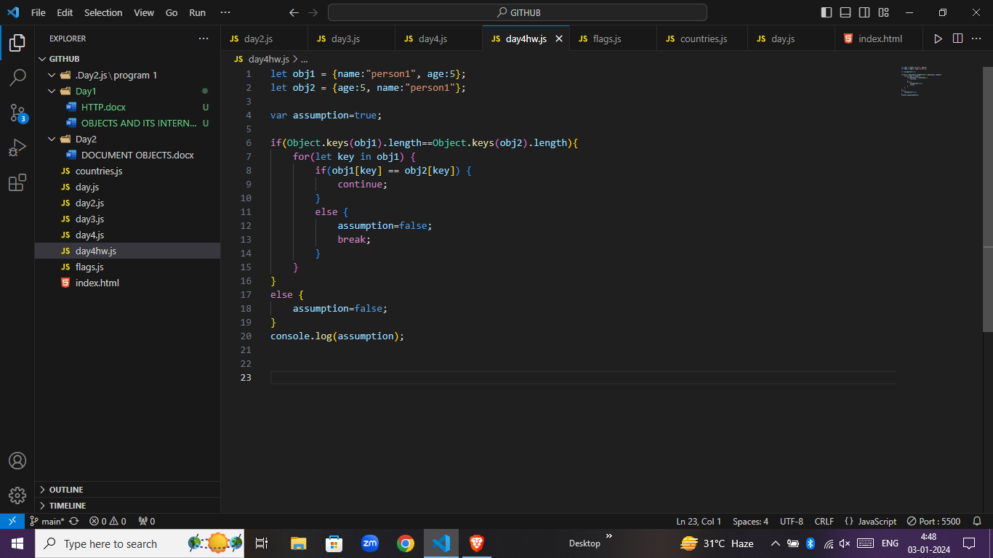

**OUTPUT**

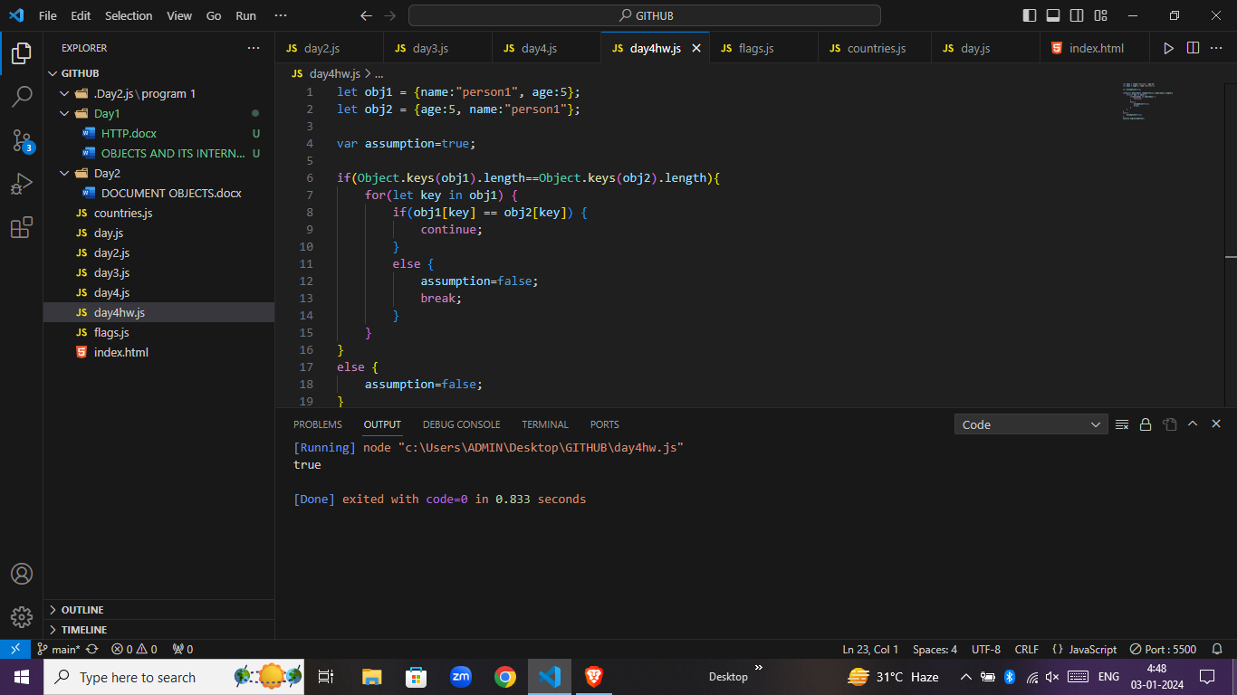

**DISLAY COUNTRIES FLAGS IN CONSOLE**

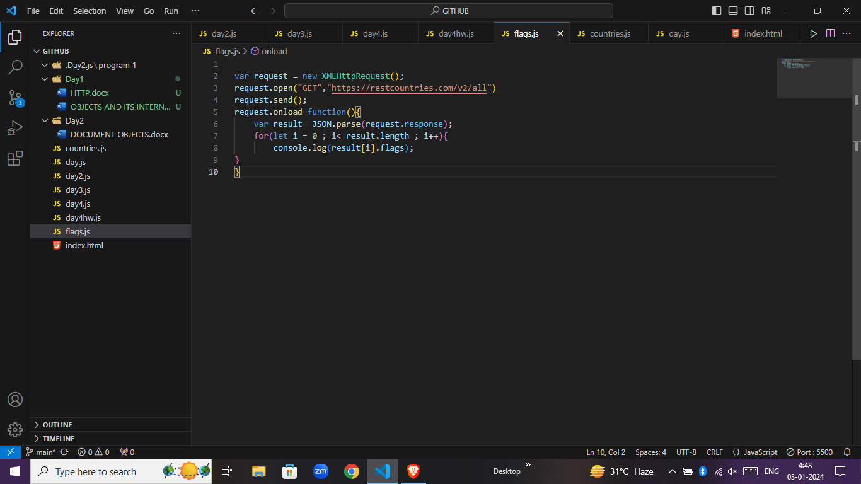

**OUTPUT**

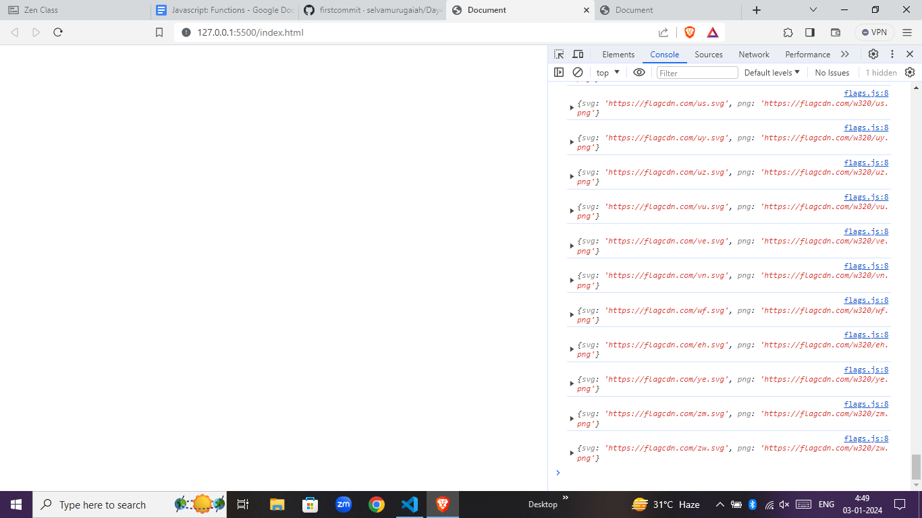

**DISLAY COUNTRIES NAMES,REGIONS,SUB-REGIONS AND POPULATIONS**

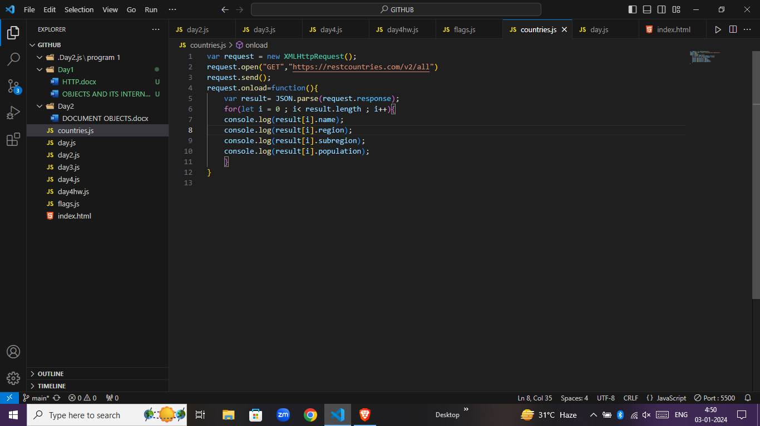

**OUTPUT**

