MPC-MAP Assignment No. 1 - Report

Author: Richard Dvořák

Date: 30.03.2026

Task 2
The histograms of all 8 LiDAR channels (figure 1) show approximately Gaussian distributions, indicating random measurement noise. The spread of the data (standard deviation) is relatively similar across most channels, suggesting that the LiDAR noise is largely consistent. However, slight differences in variance can be observed between channels, likely due to differences in measured distance or environment (e.g., obstacles vs. open space). Overall, the standard deviation is fairly consistent but not perfectly uniform across all channels.

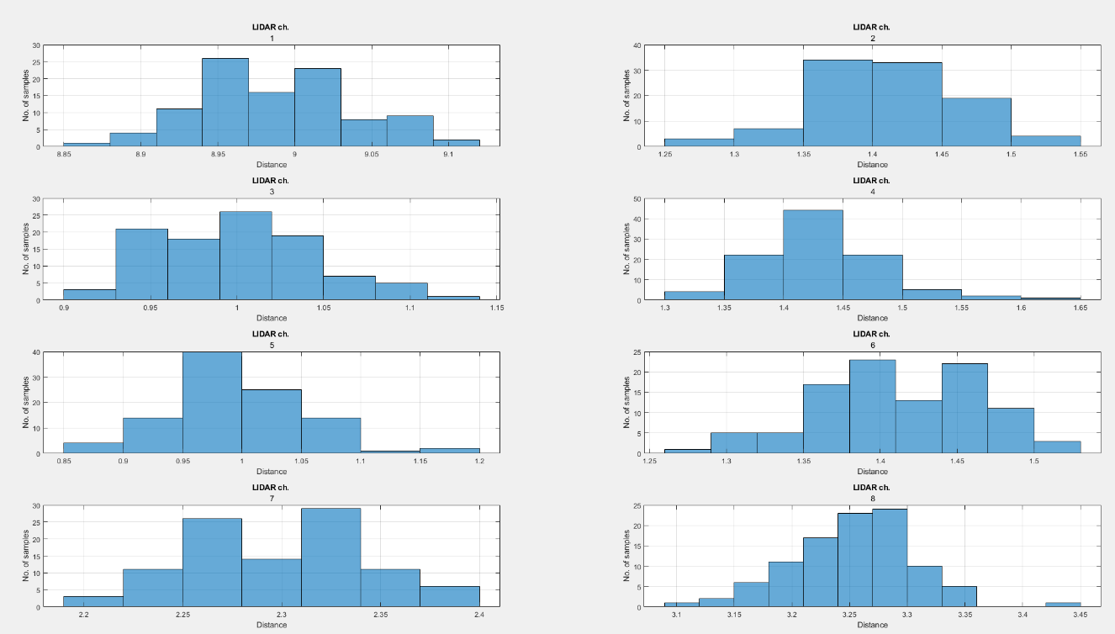
Figure 1 – Histograms of LiDAR measurements

The GNSS measurements (figure 2) in both axes exhibit approximately Gaussian distributions, indicating random noise. The spread of the data in the X and Y directions is similar, suggesting that the standard deviation is consistent across both axes. Minor differences in variance may be present, but overall the GNSS noise appears isotropic, with no significant bias or strong asymmetry observed.

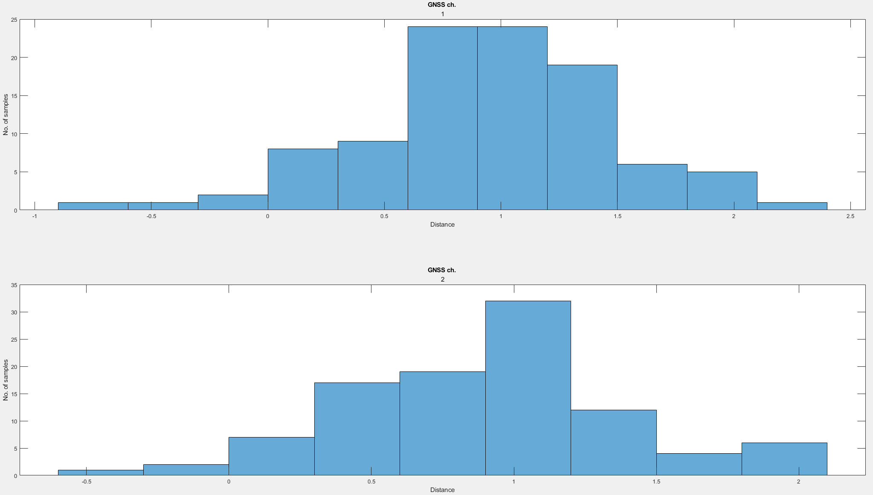
Figure 2 – Histograms of GNSS measurements

Task 3
Covariance matrix for LiDAR measurements:

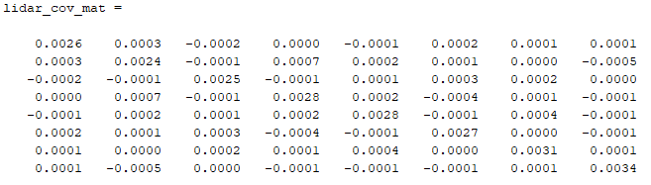
Figure 3 – LiDAR Covariance matrix

Covariance matrix for LiDAR measurements:

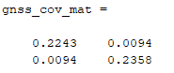
Figure 4 – GNSS Covariance matrix

Task 4
Sensor Noise Characteristics of the eighth Lidar channel and the x axis of GNSS are displayed in the figure 5. From the characteristics it can be concluded that GNSS has a greater position determination error in this channel than Lidar, for this case. The characteristics were measured on the map mixed_01.
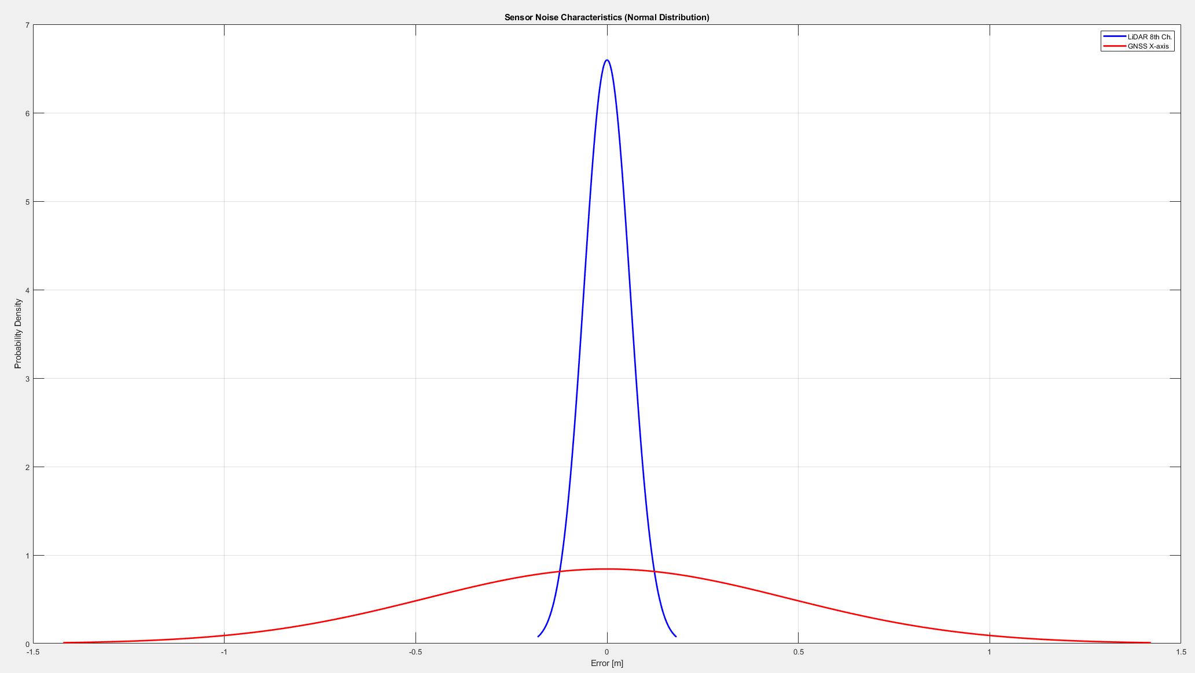
Figure 5 – Sensor Noise Characteristics

Task 5
Evidence that I achieved to navigate the robot to the goal location without using sensors:

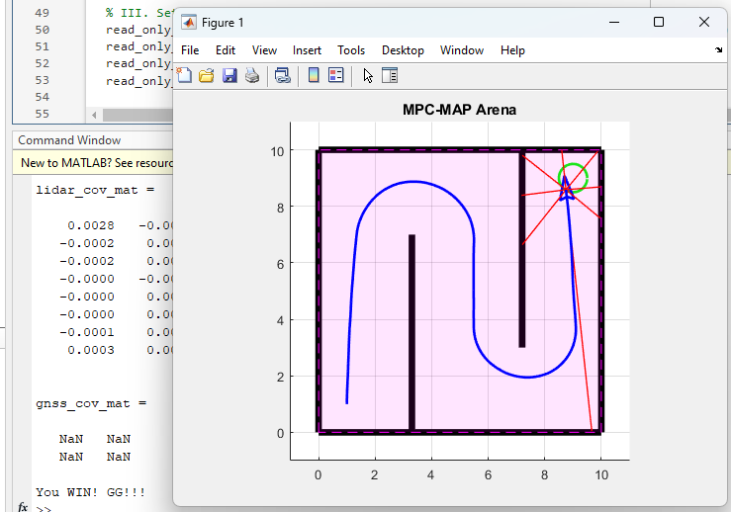
Figure 6 – Successful attempt

Sequence of commands used:

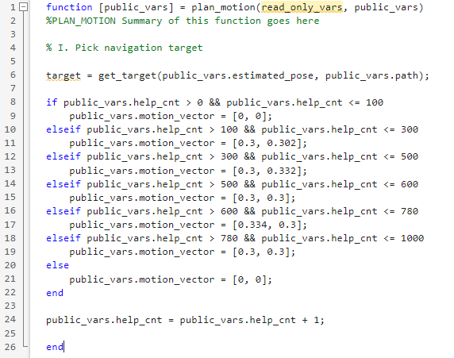
Figure 7 – Sequence of commands

