MPC-MAP Assignment No. 2 - Report

Author: Richard Dvořák (240335)

Date: 06.04.2026

Task 1
I tried to understand the meaning of parameters, from which I build my own custom map. The parameters are in figure 1 and the map itself is in figure 2.

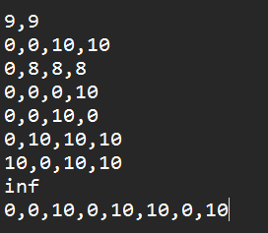
Figure 1 – Parameters of custom map

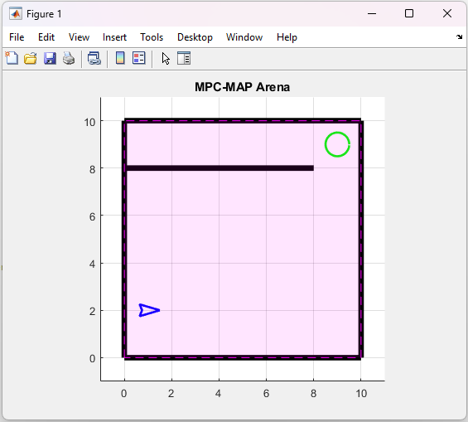
Figure 2 – Custom Map

Task 2
In this task I defined three paths. The paths are defined as sequence of x and y waypoints on the map. The code for generating those waypoints is in figure 3.

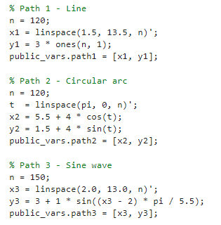
Figure 3 – Definition of various paths

Task 3
The implemented motion control is based on pure pursuit path following algorithm. The robot uses its current position obtained from MoCap system and follows a predefined path represented by a sequence of waypoints, as it is described in Task2. A look-ahead target point is selected at a fixed distance ahead on the path, ensuring smooth trajectory tracking.

The heading error between the robot orientation and the direction towards the target point is computed and normalized. Based on this error, the curvature of the path is calculated, which is then converted into angular velocity. The linear velocity is kept constant, while the difference between left and right wheel velocities determines the turning behavior of the differential drive robot. The robot stops when it reaches a predefined distance from the final waypoint.

