MPC-MAP Assignment No. 3 - Report

Author: Richard Dvořák (240335)

Date: 13.04.2026

Task 1
The prediction step propagates each particle according to the differential-drive motion model using wheel velocity commands. The translation and angular velocities are computed from wheel speeds and integrated over the simulation timestep. To model uncertainty in robot motion, Gaussian noise is added to both linear and angular velocity, increasing particle spread and enabling probabilistic localization.

Task 2
The measurement model simulates LiDAR readings for each particle by ray-casting from the particle pose into the known map. For each LiDAR direction, the nearest wall intersection is used as the expected range measurement. Particle weights are then computed by comparing the predicted LiDAR scan with the actual sensor measurements using a Gaussian likelihood function based on the Euclidean error between scans.

Task 3
Low-variance resampling was used to generate a new particle set based on particle weights. This method preferentially duplicates highly weighted particles while removing particles with low likelihood, thereby concentrating the particle distribution around more probable robot poses.
Figure 1 – Estimated position 1

Task 4
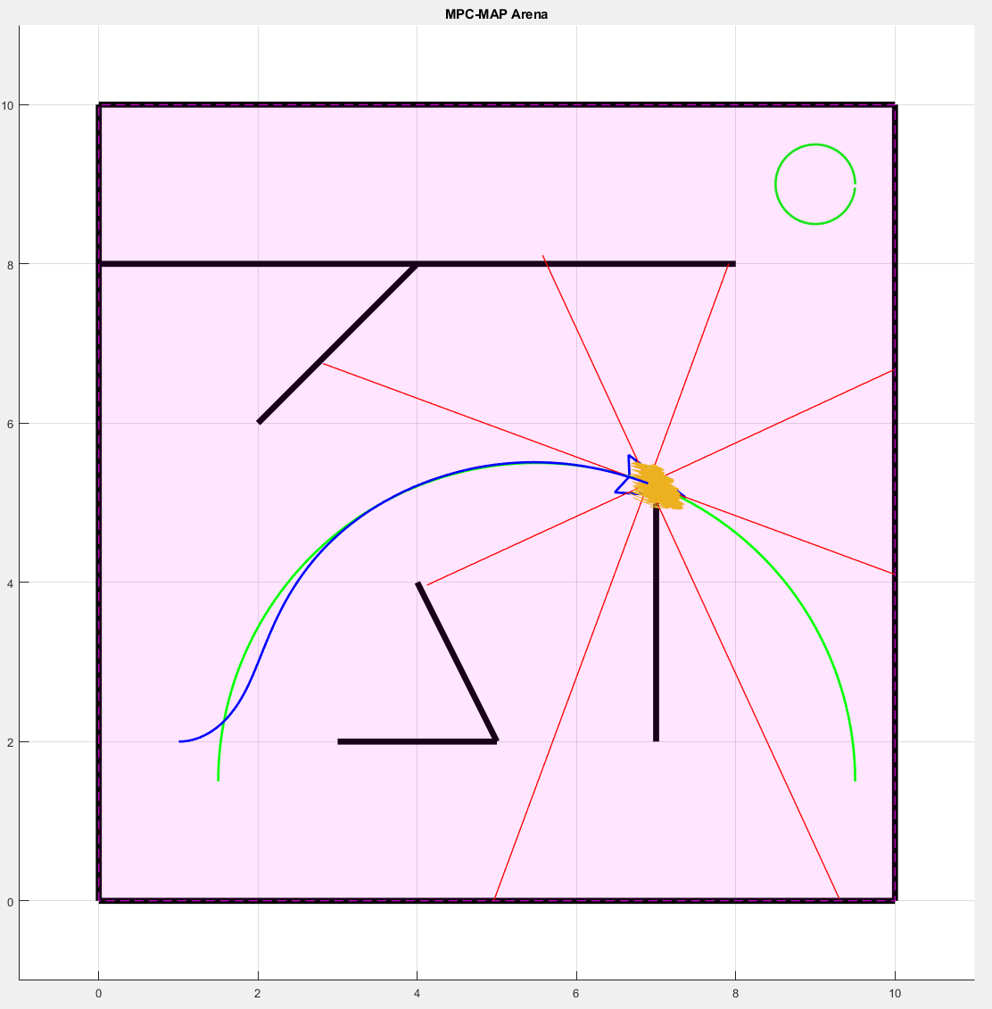

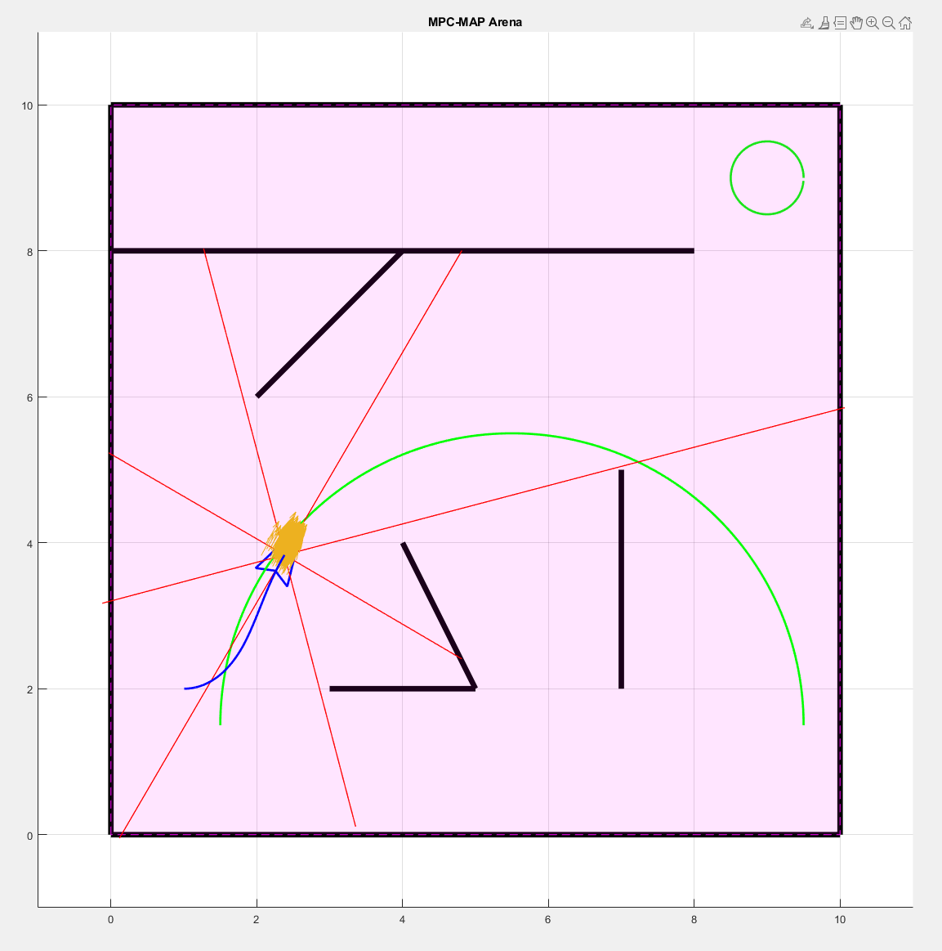
Figure 2 – Estimated position 2

