MPC-MAP Assignment No. 4 - Report

Author: Richard Dvořák (240335)

Date: 20.04.2026

Task 1
Already implemented as part of the first assignment.

Task 2
The prediction step of the Extended Kalman Filter (EKF) is used to estimate the robot’s next state based on its current state and control inputs. It was implemented in function ekf_predict. Since the system is nonlinear due to the differential drive kinematics, a nonlinear motion model is employed.

Task 3 & 4
The initial procedure consist of 110 time steps, 100 of them is for collecting data from sensors and the rest is intended for computing, graphics display and Kalman filter initialization(figure 1).

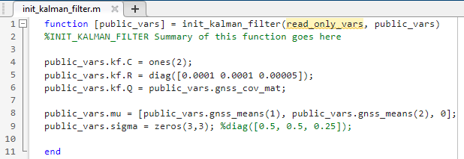
Figure 1 – init_kalman_filter.m
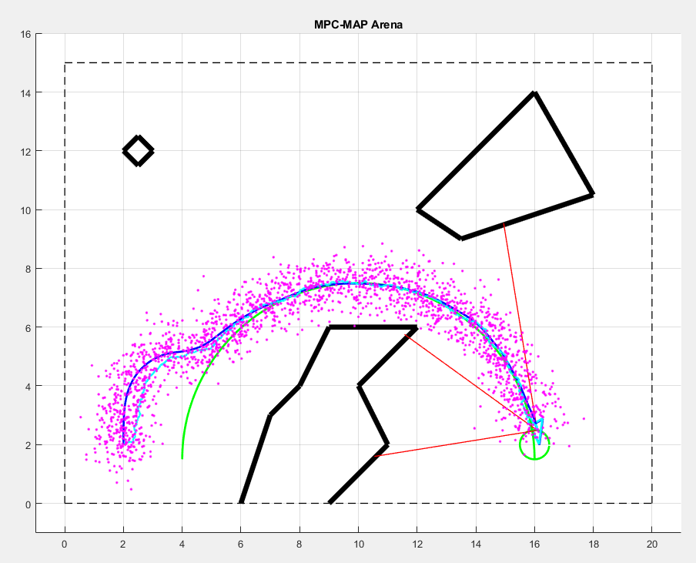
Figure 2 – Successful attempt

