MPC-MAP Assignment No. 5 - Report

Author: Richard Dvořák (240335)

Date: 27.04.2026

Task 1&2
The A* algorithm was chosen as the route search algorithm. I tested its funcionality on the outdoor1 map. The result of the route planning is shown in Figure 1.

Task 3
Unfortunately, I was not able to properly implement the route smoothing algorithm. Due to time constraints, I no longer have time to properly implement the algorithm.

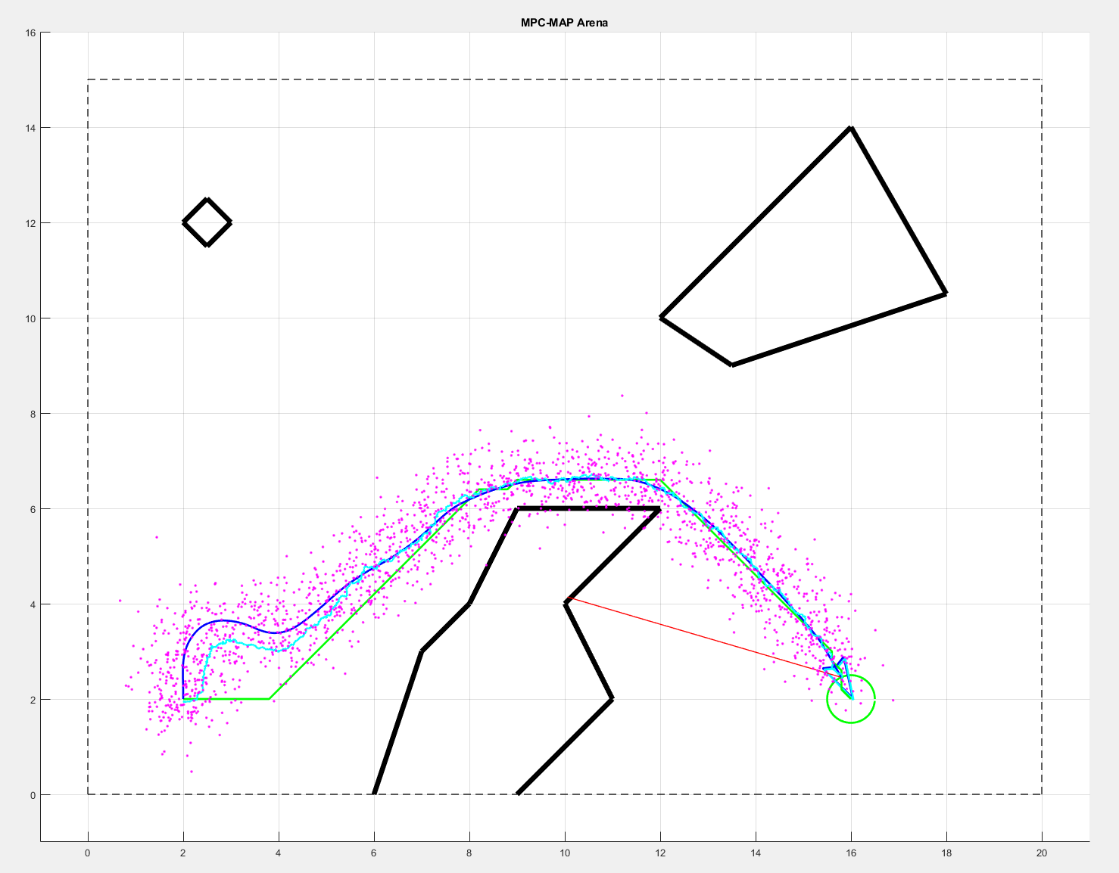
Figure 1 – Path that was found by A*

