SCHOOL OF COMPUTER SCIENCE AND ARTIFICIAL INTELLIGENCE |  |  |  |  | DEPARTMENT OF COMPUTER SCIENCE ENGINEERING
Program Name: B. Tech |  |  |  | Assignment Type: Lab |  |  | Academic Year:2025-2026
Course Coordinator Name |  |  |  | Venkataramana Veeramsetty
Instructor(s) Name
  Dr. V. Venkataramana (Co-ordinator)
  Dr. T. Sampath Kumar
  Dr. Pramoda Patro
  Dr. Brij Kishor Tiwari
  Dr.J.Ravichander
  Dr. Mohammand Ali Shaik
  Dr. Anirodh Kumar
  Mr. S.Naresh Kumar
  Dr. RAJESH VELPULA
  Mr. Kundhan Kumar
  Ms. Ch.Rajitha
  Mr. M Prakash
  Mr. B.Raju
  Intern 1 (Dharma teja)
  Intern 2 (Sai Prasad)
  Intern 3 (Sowmya)
  NS_2 ( Mounika)
Course Code |  |  | 24CS002PC215 | Course Title |  | AI Assisted Coding
Year/Sem |  |  | II/I | Regulation |  | R24
Date and Day  of Assignment |  |  | Week5 - Monday | Time(s)
Duration |  |  | 2 Hours | Applicable to  Batches
AssignmentNumber: 9.1(Present assignment number)/24(Total number of assignments)
 | Q.No. | Question |  |  |  |  |  | Expected Time  to complete
 | 1 | Lab 17– AI for Data Processing: Data cleaning and preprocessing scripts  The objective of this lab is to enable students to understand and apply AI-assisted coding tools for automating and enhancing data preprocessing tasks. Students will:  - Gain practical experience in cleaning, transforming, and standardizing real-world datasets with issues such as missing values, duplicates, outliers, inconsistent formats, and noisy text.  - Learn to leverage AI coding assistants to generate preprocessing scripts, while critically evaluating and refining the AI-generated code for accuracy, efficiency, and best practices.  - Develop the ability to design end-to-end preprocessing pipelines that prepare raw data for downstream machine learning and analytics applications.  - Build confidence in combining human expertise with AI assistance, ensuring data quality and integrity in diverse domains such as customer feedback, healthcare, and finance.  Lab Question 1: Customer Feedback Dataset  You are given a CSV file containing customer feedback collected from an e-commerce website. The dataset includes columns: customer_id, feedback_text, rating, and date. However, the file has many missing values, typos, and inconsistent date formats.  - Task 1: Use an AI-assisted coding tool to generate a script that detects and fills missing rating values with the column’s median and standardizes the date column into YYYY-MM-DD format.  - Task 2: Clean the feedback_text column by removing stopwords, correcting common spelling mistakes, and converting text to lowercase using AI suggestions. Compare the AI-generated preprocessing code with your manually written version.  Prompt:  Create a custom data for customer feedback collected from an e-commerce website. The dataset includes columns: customer_id, feedback_text, rating, and date. However, the file has many missing values, typos, and inconsistent date formats.. Generate a script that detects and fills the missing values with the column’s median and standardises the date column into YYYY-MM-DD format and also clean the feedback_text column by removing stopwords, correcting common spelling mistakes, and converting text to lowercase.  CODE:  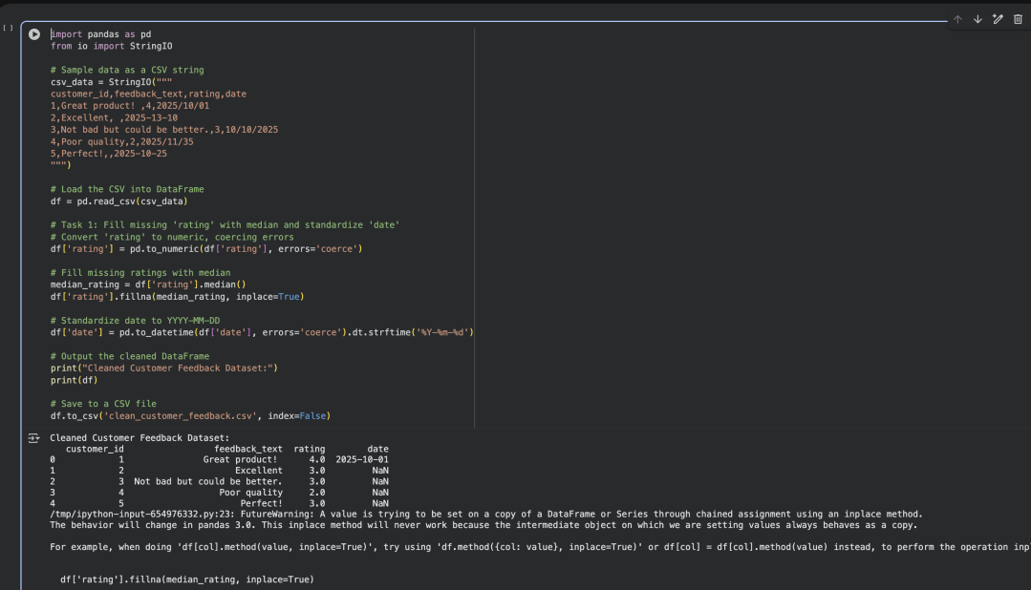  Lab Question 2: Medical Records Dataset  A hospital provides you with a dataset of anonymized medical records containing attributes like patient_id, age, gender, blood_pressure, and cholesterol. Some columns include outliers and inconsistent categorical labels (e.g., Male, M, male).  - Task 1: Write a script (with AI assistance) to detect and handle outliers in the blood_pressure column using statistical methods (e.g., IQR or z-score).  - Task 2: Standardize categorical values in the gender column and encode them into numeric form. Let the AI-assisted coding tool propose the preprocessing pipeline, then refine the pipeline manually based on your understanding.  PROMPT:  I have a dataset with columns: patient_id, age, gender, blood_pressure, and cholesterol. The blood_pressure column contains outliers, and the gender column has inconsistent labels like "Male", "M", and "male".Write Python code to detect and handle outliers in the blood_pressure column using a statistical method such as IQR or z-score,  Standardize the gender column values so they are consistent and then encode them into numeric form. Propose a preprocessing pipeline using pandas and scikit-learn that includes these steps, then show a clean, commented version that can be refined manually.  CODE:  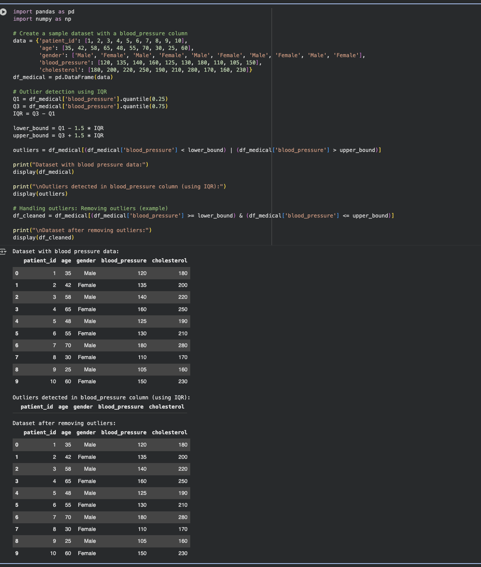  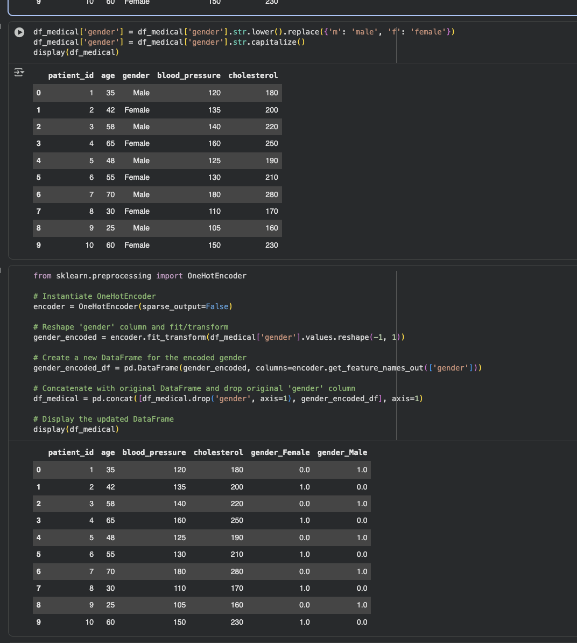  Lab Question 3: Financial Transactions Dataset  A bank gives you transaction data with columns: transaction_id, amount, currency, timestamp, and merchant. The dataset contains multiple issues: different currency units (USD, INR, EUR), timestamps in various time zones, and duplicated rows.  - Task 1: Use AI-assisted coding to write a script that removes duplicate transactions and converts all amount values into a single currency (e.g., USD) using a provided conversion dictionary.  - Task 2: Normalize the timestamp column into UTC format and create a new column transaction_hour for downstream time-series analysis. Compare the AI’s preprocessing code against your own optimized version.  PROMPT:  I have a dataset with columns: transaction_id, amount, currency, timestamp, and merchant. The data has issues such as different currency units (USD, INR, EUR), timestamps in multiple time zones, and duplicate rows. Write Python code to remove duplicate transactions and convert all amount values into a single currency (e.g., USD) using a given currency conversion dictionary, normalize the timestamp column into UTC format and create a new column called transaction_hour for time-series analysis. Then, generate a preprocessing pipeline using pandas that performs these steps, and show both the AI-assisted version and an optimized manual version for comparison.  CODE:  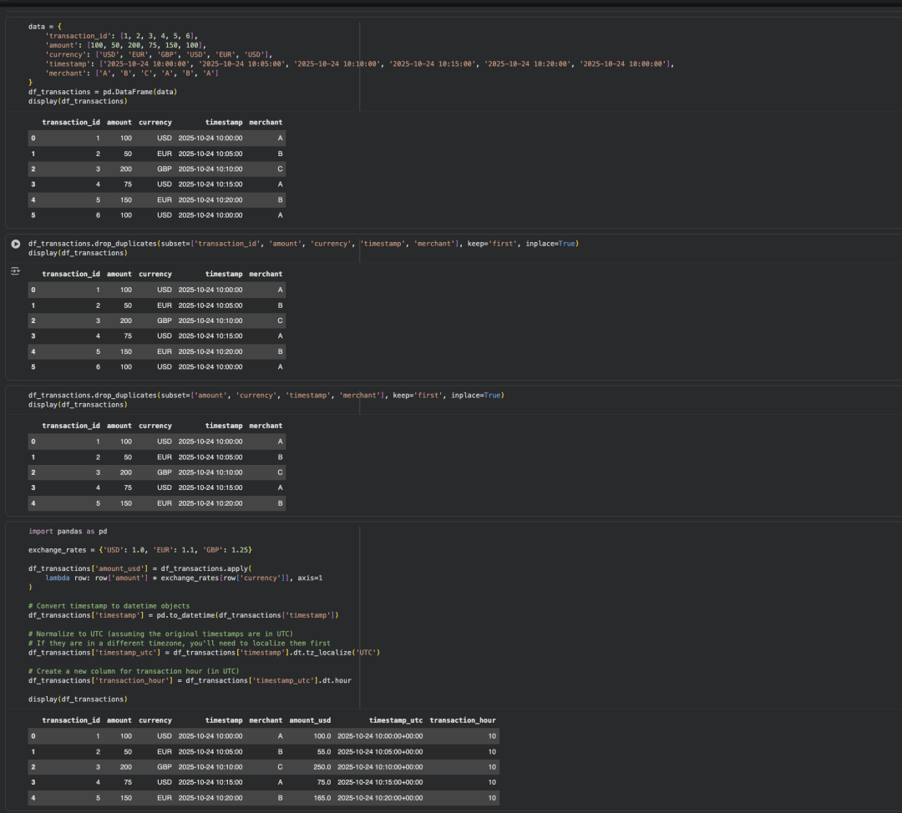 |  |  |  |  |  | Week 9- Monday

