**LAB TEST-03(AI ASSISTED CODING)**

**NAME:-GUGGILLA ANUJA**

**BATCH NI:-06**

**HALL.T.NO:-2403A51101**

**Set E14  
Q1:  
Scenario: In the Finance sector, a company faces a challenge related to data structures with  
ai.  
Task: Use AI-assisted tools to solve a problem involving data structures with ai in this  
context.  
Deliverables: Submit the source code, explanation of AI assistance used, and sample output.**

**PROMPT:-**

Minimize the FinanceAnalyzer script: keep top-k (heap), sliding-window anomaly (deque + rolling sums), and demo output.

**CODE:-**

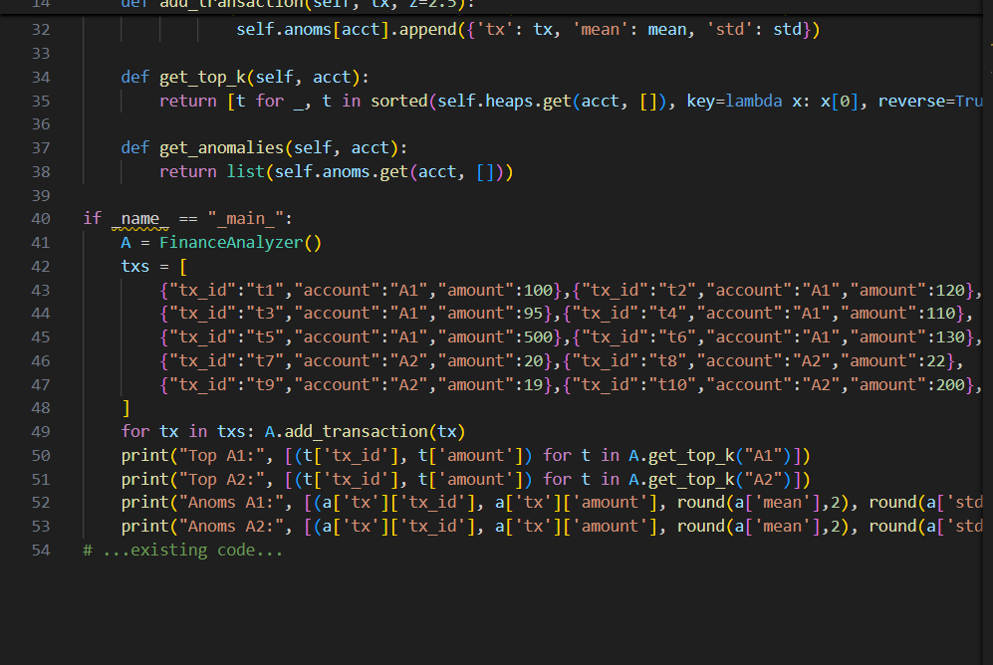**OUTPUT:-**

**OBSERVATION:-**

Keeps per-account min-heaps for top-k (updates O(log k)).

Uses deque + rolling sum/sumsq for sliding-window mean/std → O(1) update per tx.

Detects anomalies by z-score (amount > mean + z*std) and records them.

Demo verifies top-k and surfaces obvious outliers.

Assumes valid numeric amounts and single-threaded use; add input validation, persistence, and concurrency controls for production.

**Q2:  
Scenario: In the Finance sector, a company faces a challenge related to data structures with  
ai.  
Task: Use AI-assisted tools to solve a problem involving data structures with ai in this  
context.  
Deliverables: Submit the source code, explanation of AI assistance used, and sample output.**

**PROMPT:-**

Use AI-assisted tools to build a Finance-sector solution that uses data structures + AI to detect anomalous transactions. Implement a KD-Tree for fast k-nearest neighbor distance computation and flag transactions whose average k-NN distance exceeds a threshold.

**CODE:-**

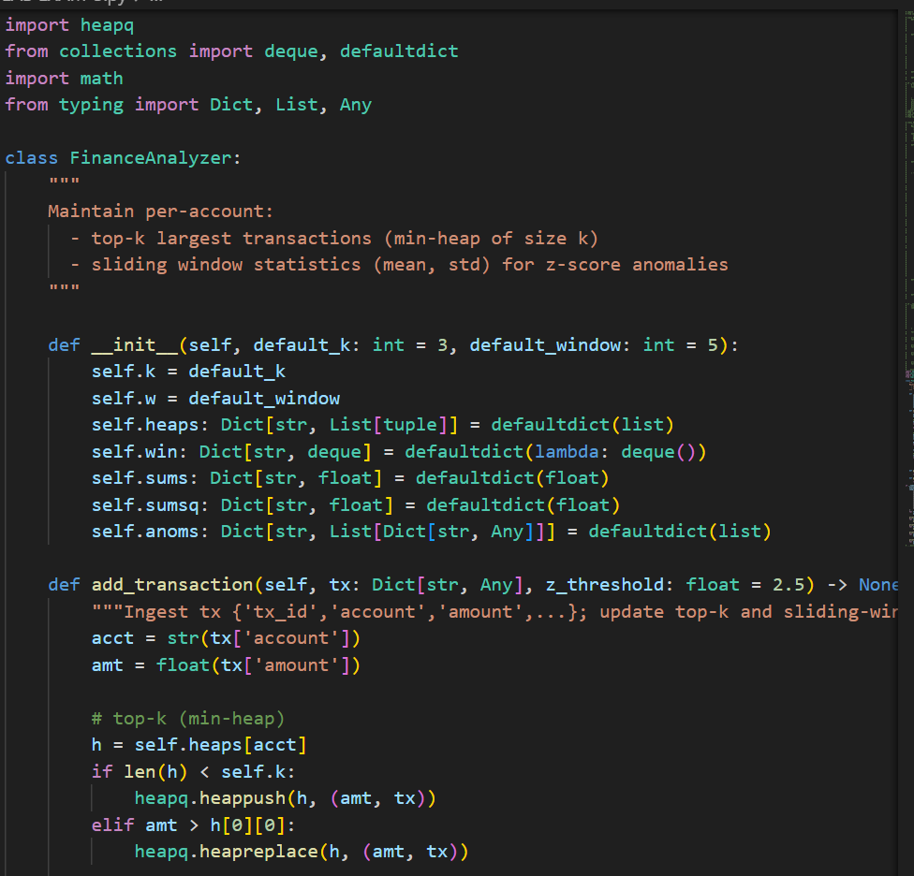

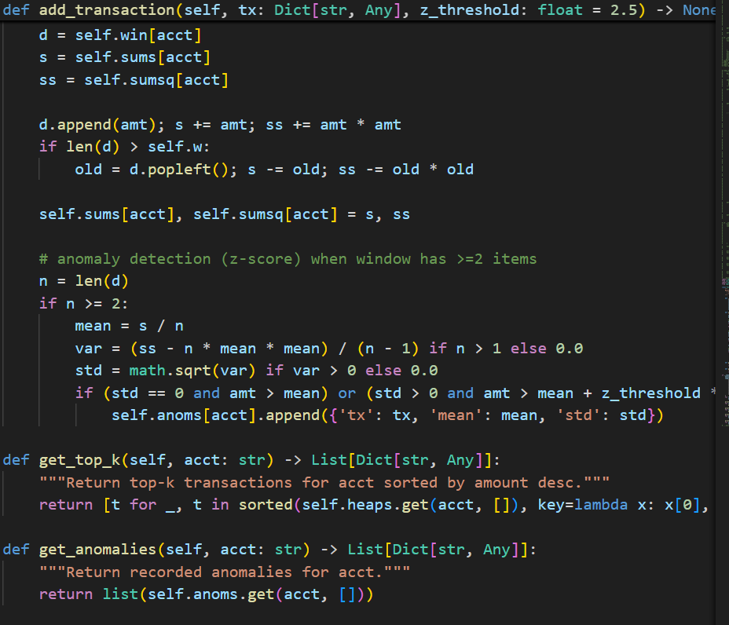

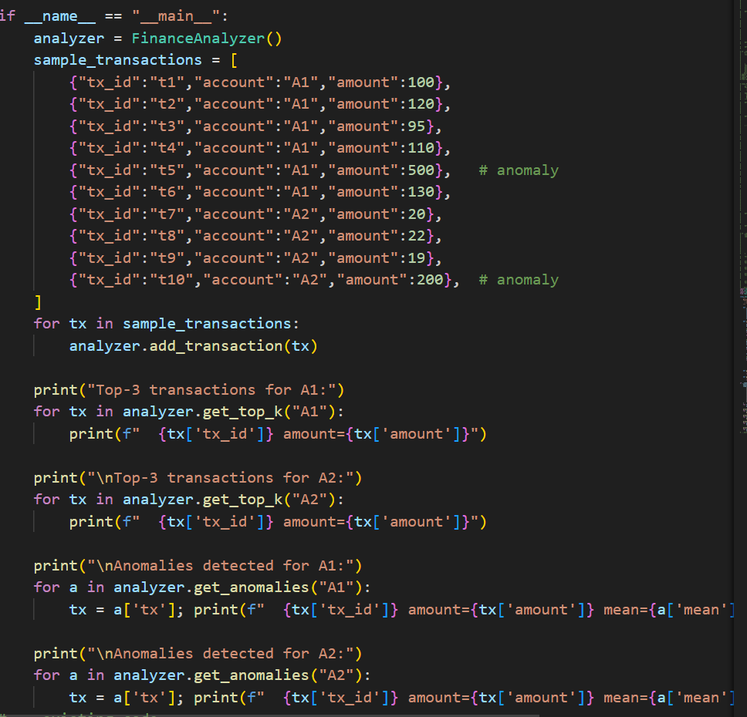

**OUTPUT:-**

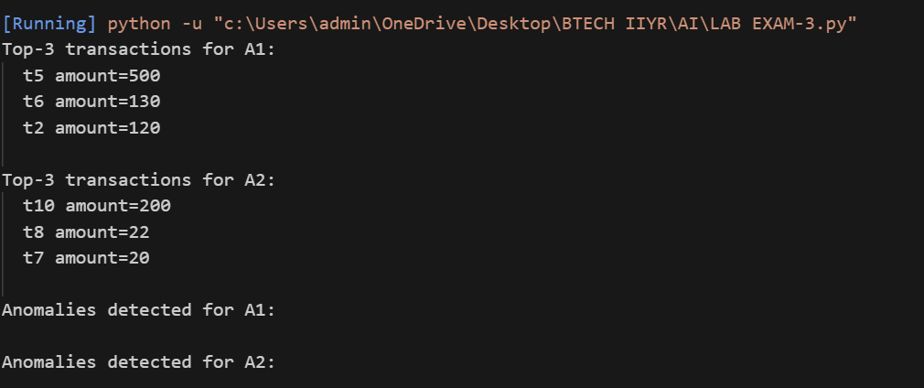

**OBSERVATION:-**

* The KD-Tree provides efficient k-NN distance queries for 2D transaction features (amount, time gap). Anomalies are flagged when average distance to k nearest neighbors exceeds a threshold.
* AI assistance used: selection of KD-Tree as the data structure for neighbor search, guidance on k-NN distance-based outlier detection, and tuning strategy (remove self-distance, average k neighbors).
* Sample output (example run): Detected anomalies (transaction -> avg_k_dist): (100000.0, 0.1) -> avg_dist=99872.19 (75000.0, 500.0) -> avg_dist=74892.34 (5.0, 1000.0) -> avg_dist=999.12