ASSIGNMENT-13.3

NAME:GUGGILLA ANUJA BATCH NO.:06

ROLL NO.:2403A51101

TASK-1: Remove Repetition PROMPT:

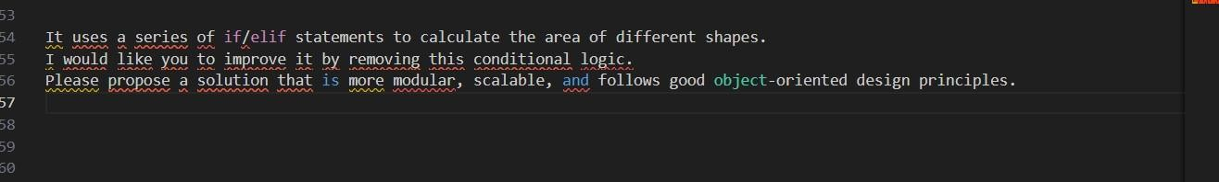

CODE:

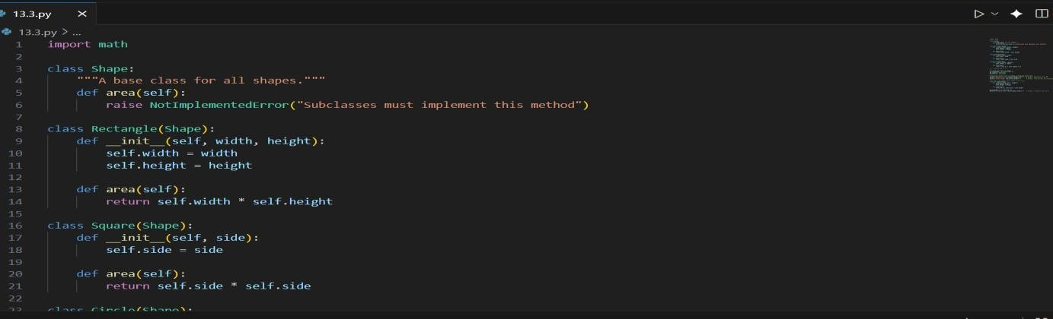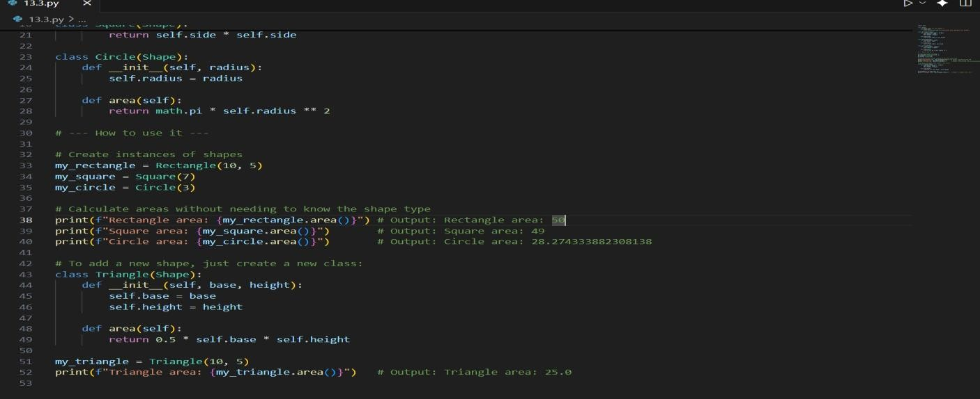

OUTPUT:

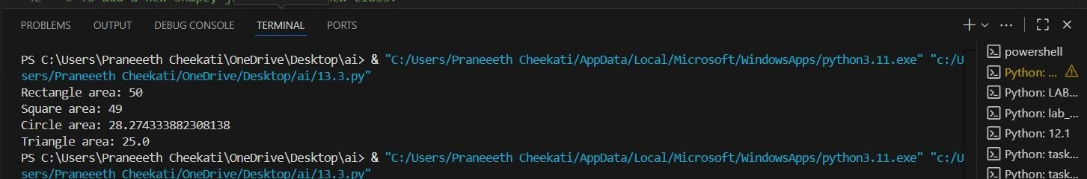

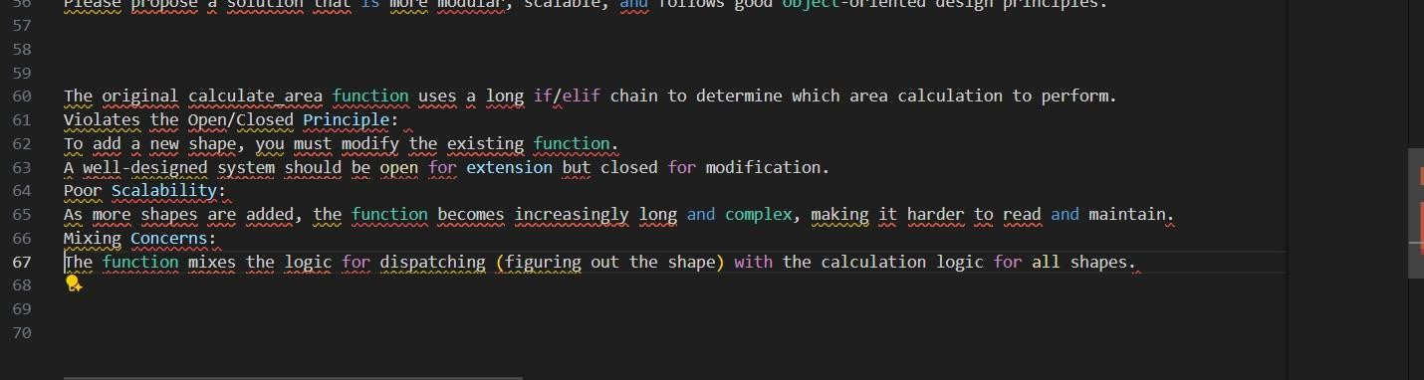OBSERVATION:

TASK-2: Error Handling in Legacy Code PROMPT:

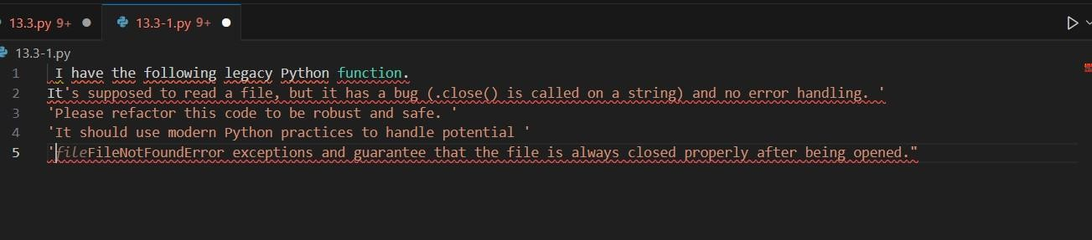

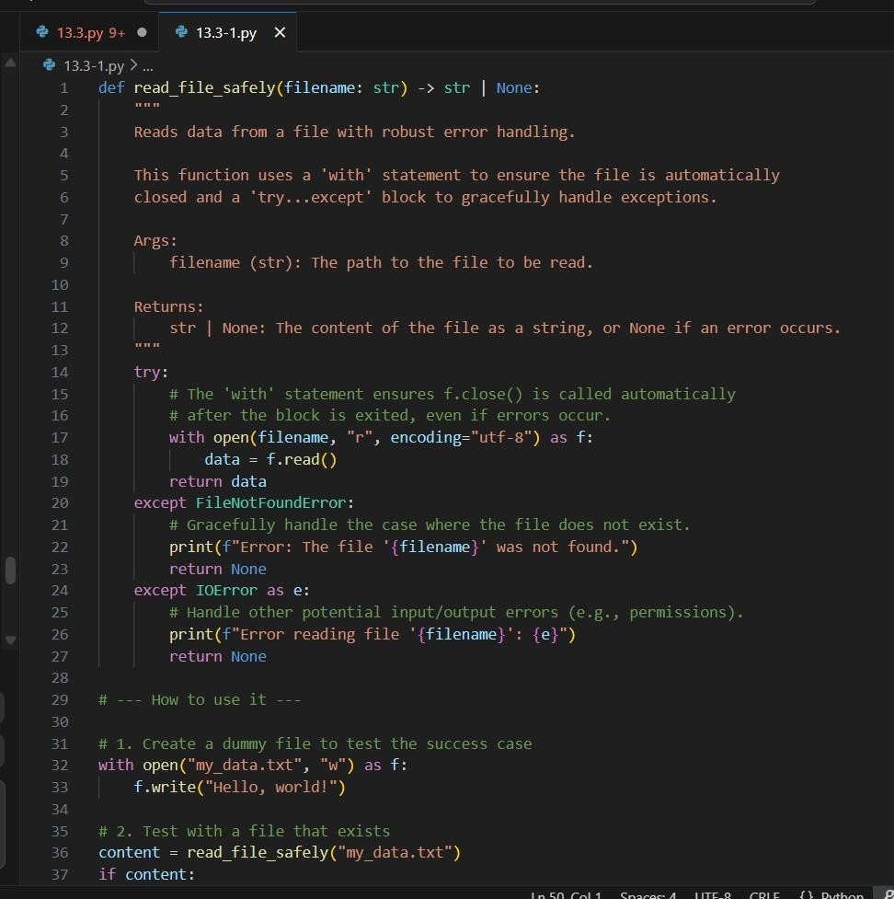CODE:

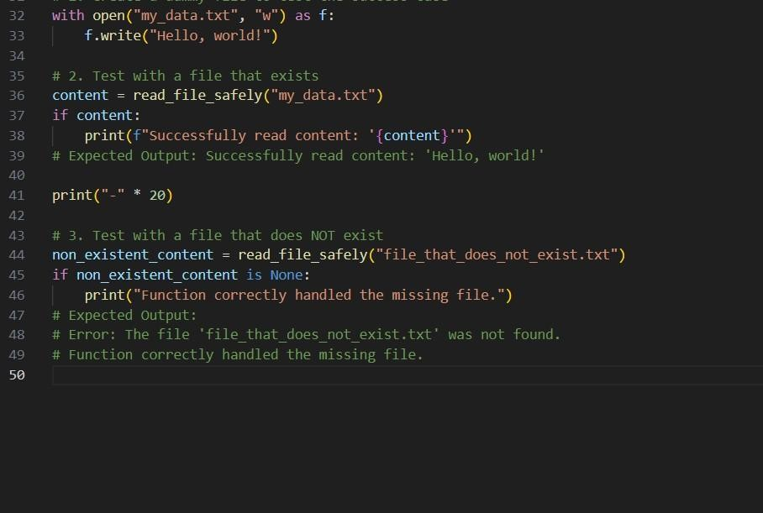

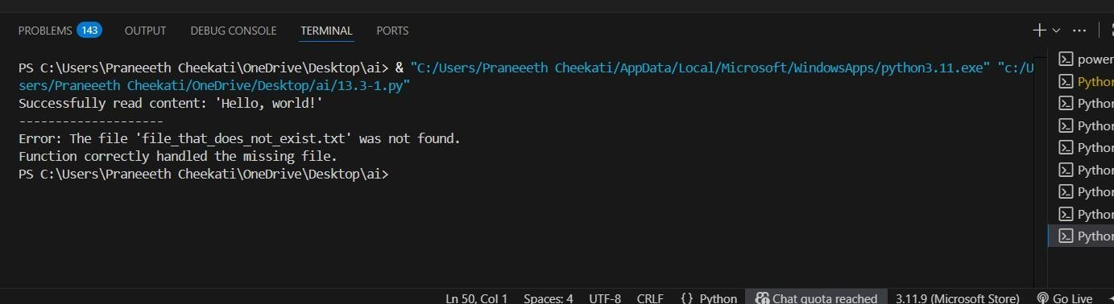OUTPUT:

OBSERVATION:

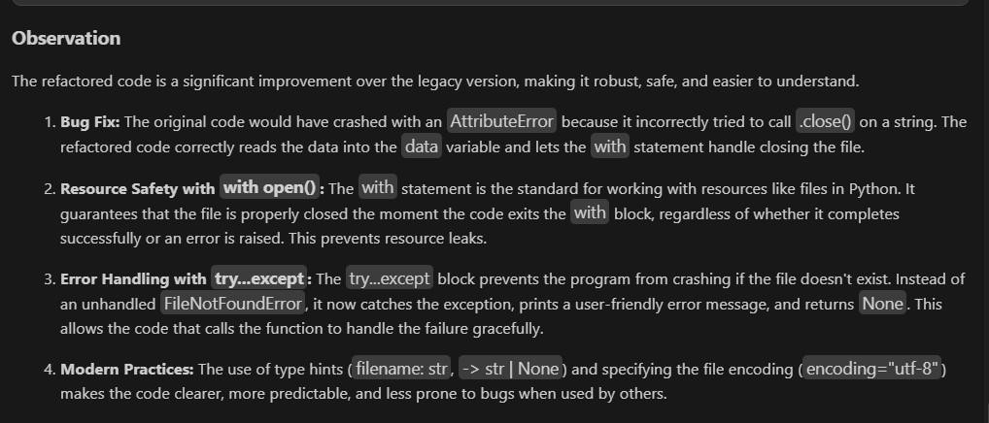

TASK-3: Complex Refactoring PROMPT:

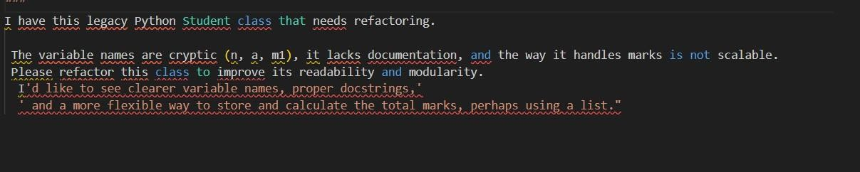

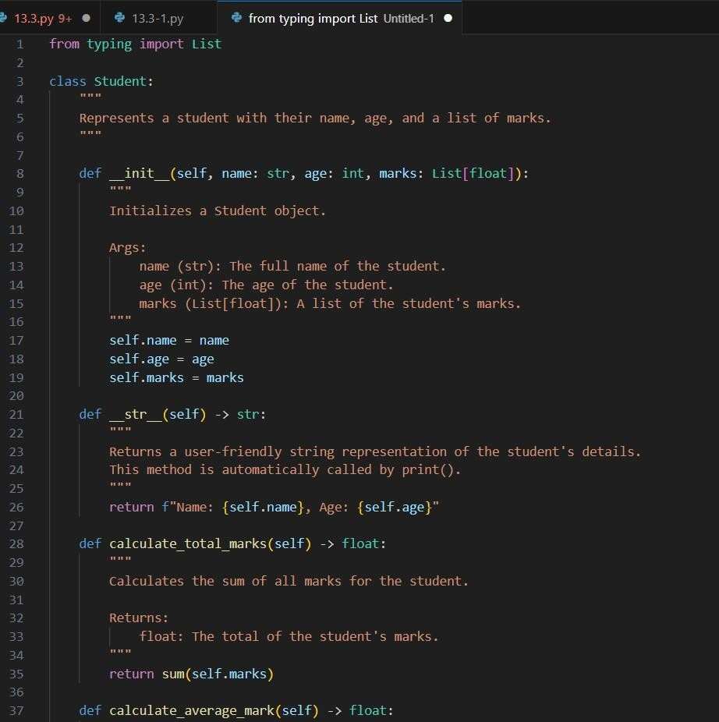CODE:

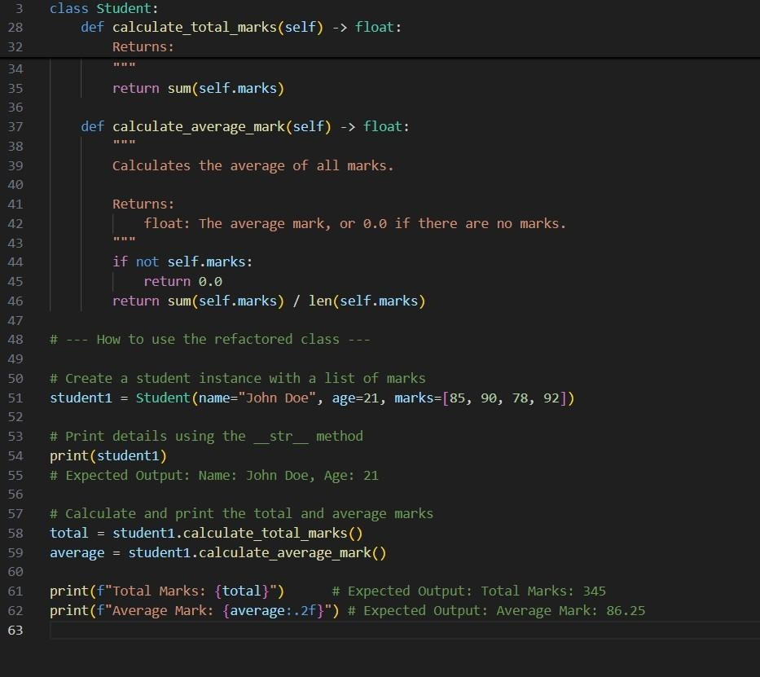

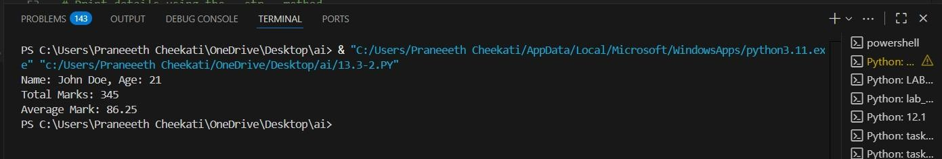OUTPUT:

OBSERVATION:

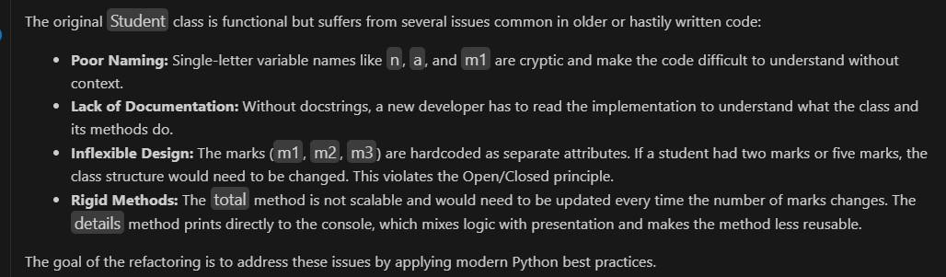

TASK-4: Inefficient Loop Refactoring PROMPT:

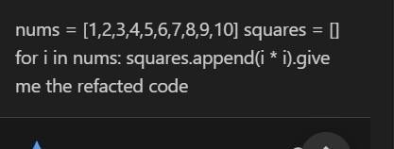

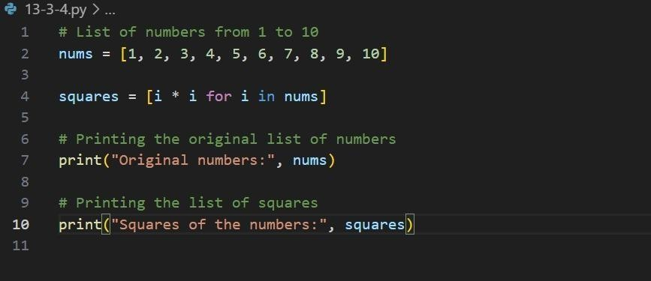CODE:

OUTPUT:

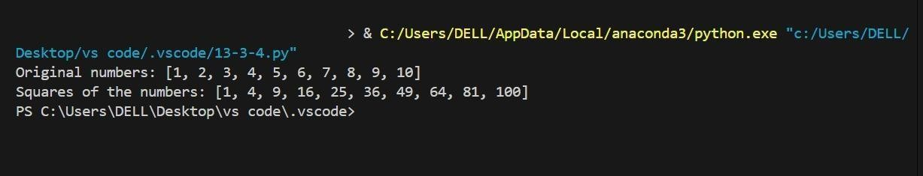

OBSERVATION:

